Table of Contents

# Sensitivity Analysis

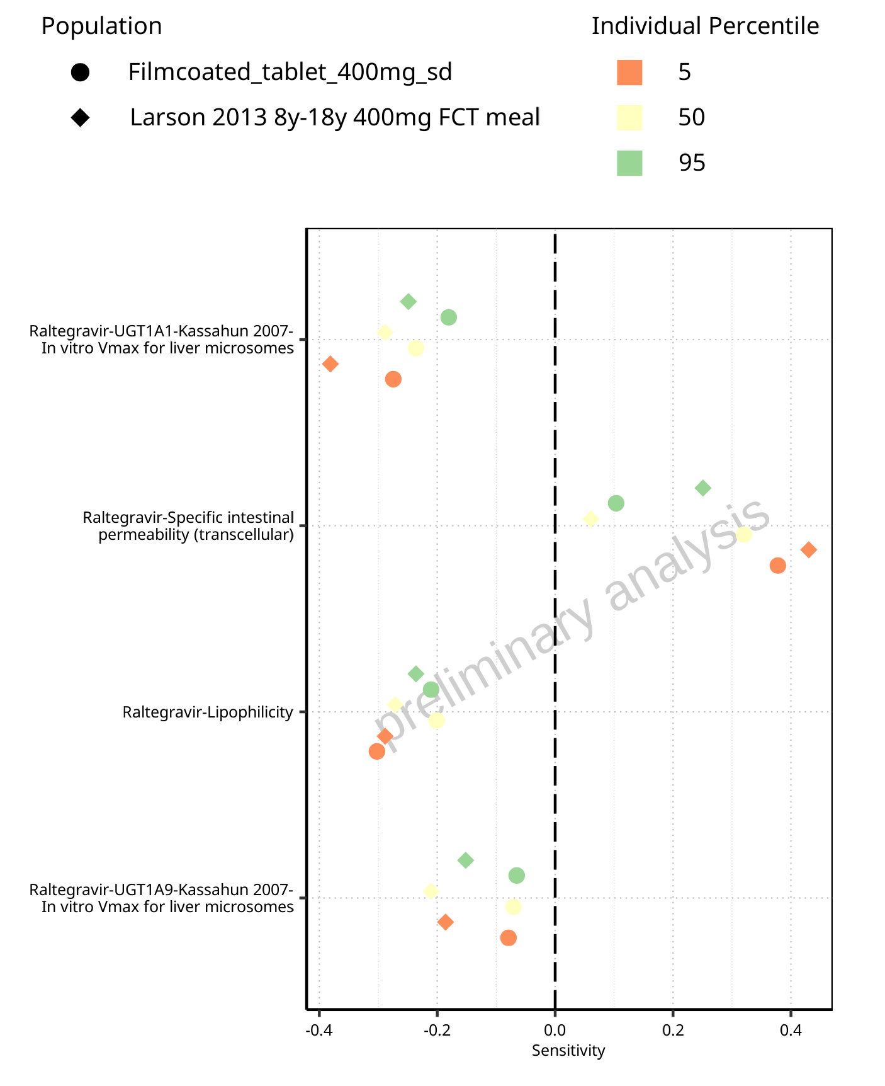

**Figure 1-1: Most sensitive parameters for C_max of Raltegravir for individuals at percentiles 5, 50, 95 for Larson 2013 8y-18y 400mg FCT meal, Filmcoated_tablet_400mg_sd.**

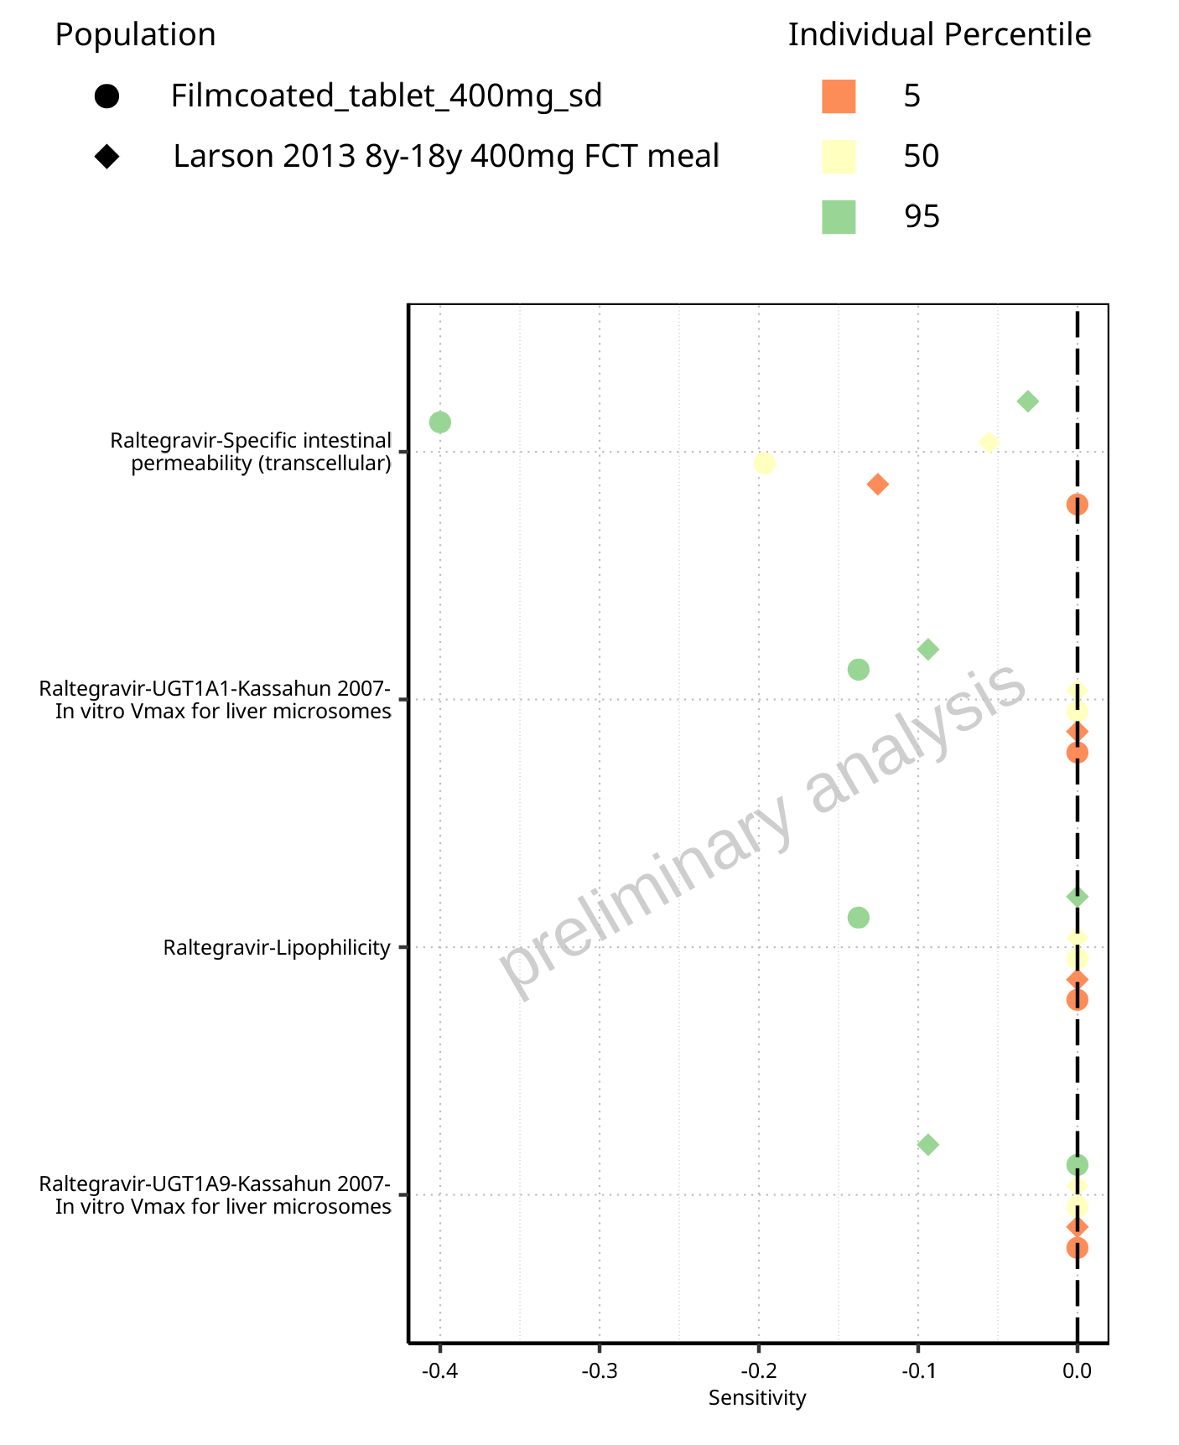

**Figure 1-2: Most sensitive parameters for t_max of Raltegravir for individuals at percentiles 5, 50, 95 for Filmcoated_tablet_400mg_sd, Larson 2013 8y-18y 400mg FCT meal.**

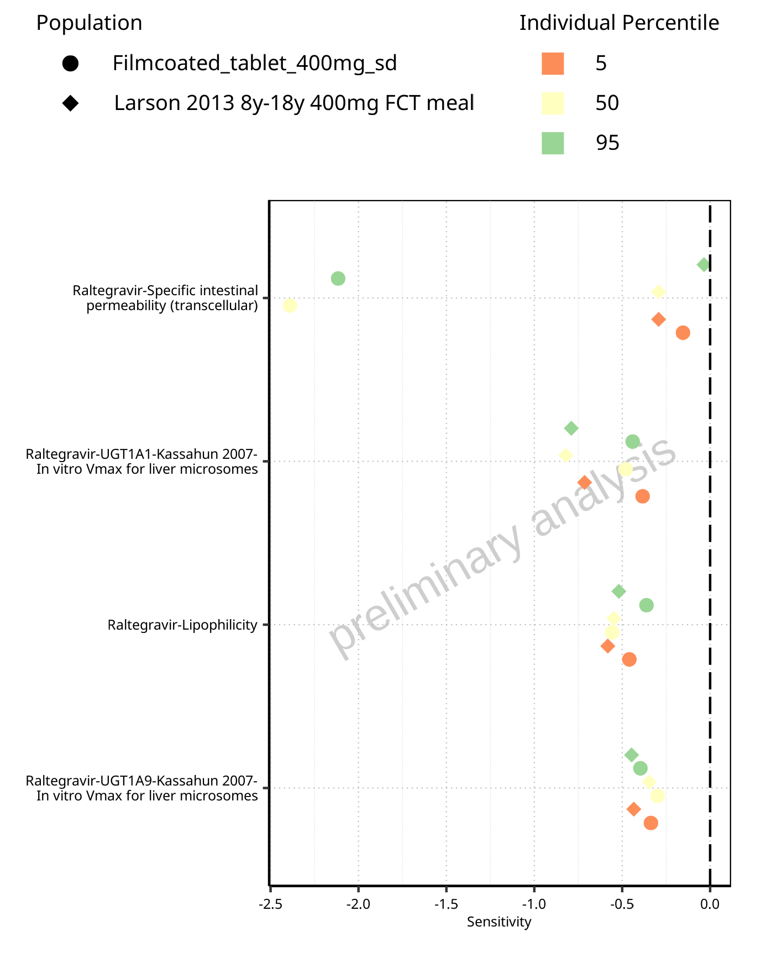

**Figure 1-3: Most sensitive parameters for C_tEnd of Raltegravir for individuals at percentiles 5, 50, 95 for Filmcoated_tablet_400mg_sd, Larson 2013 8y-18y 400mg FCT meal.**

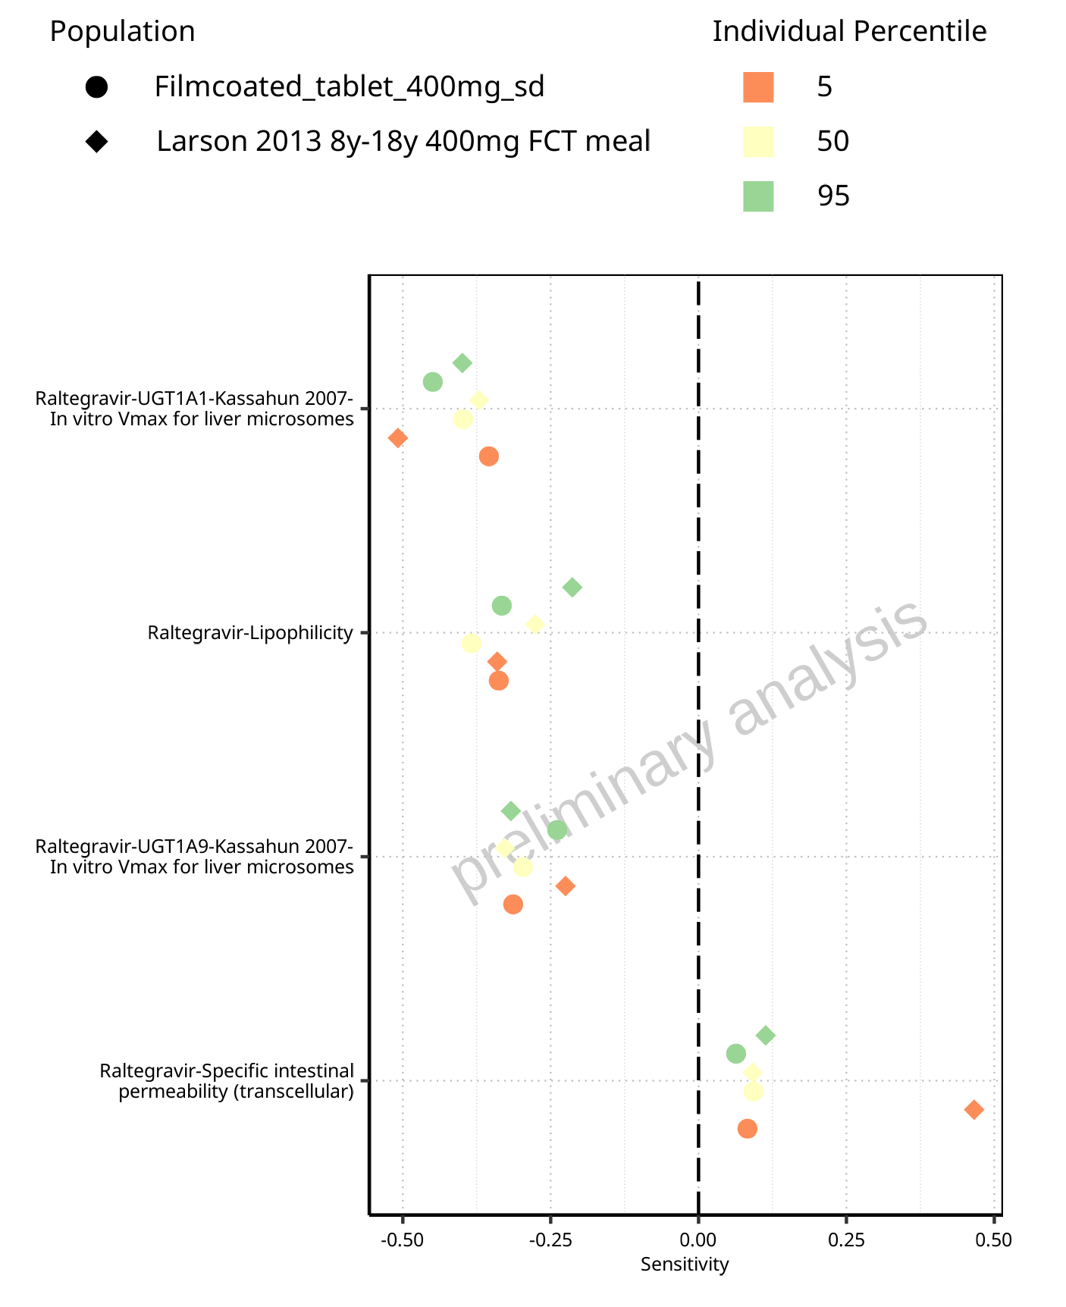

**Figure 1-4: Most sensitive parameters for AUC of Raltegravir for individuals at percentiles 5, 50, 95 for Larson 2013 8y-18y 400mg FCT meal, Filmcoated_tablet_400mg_sd.**

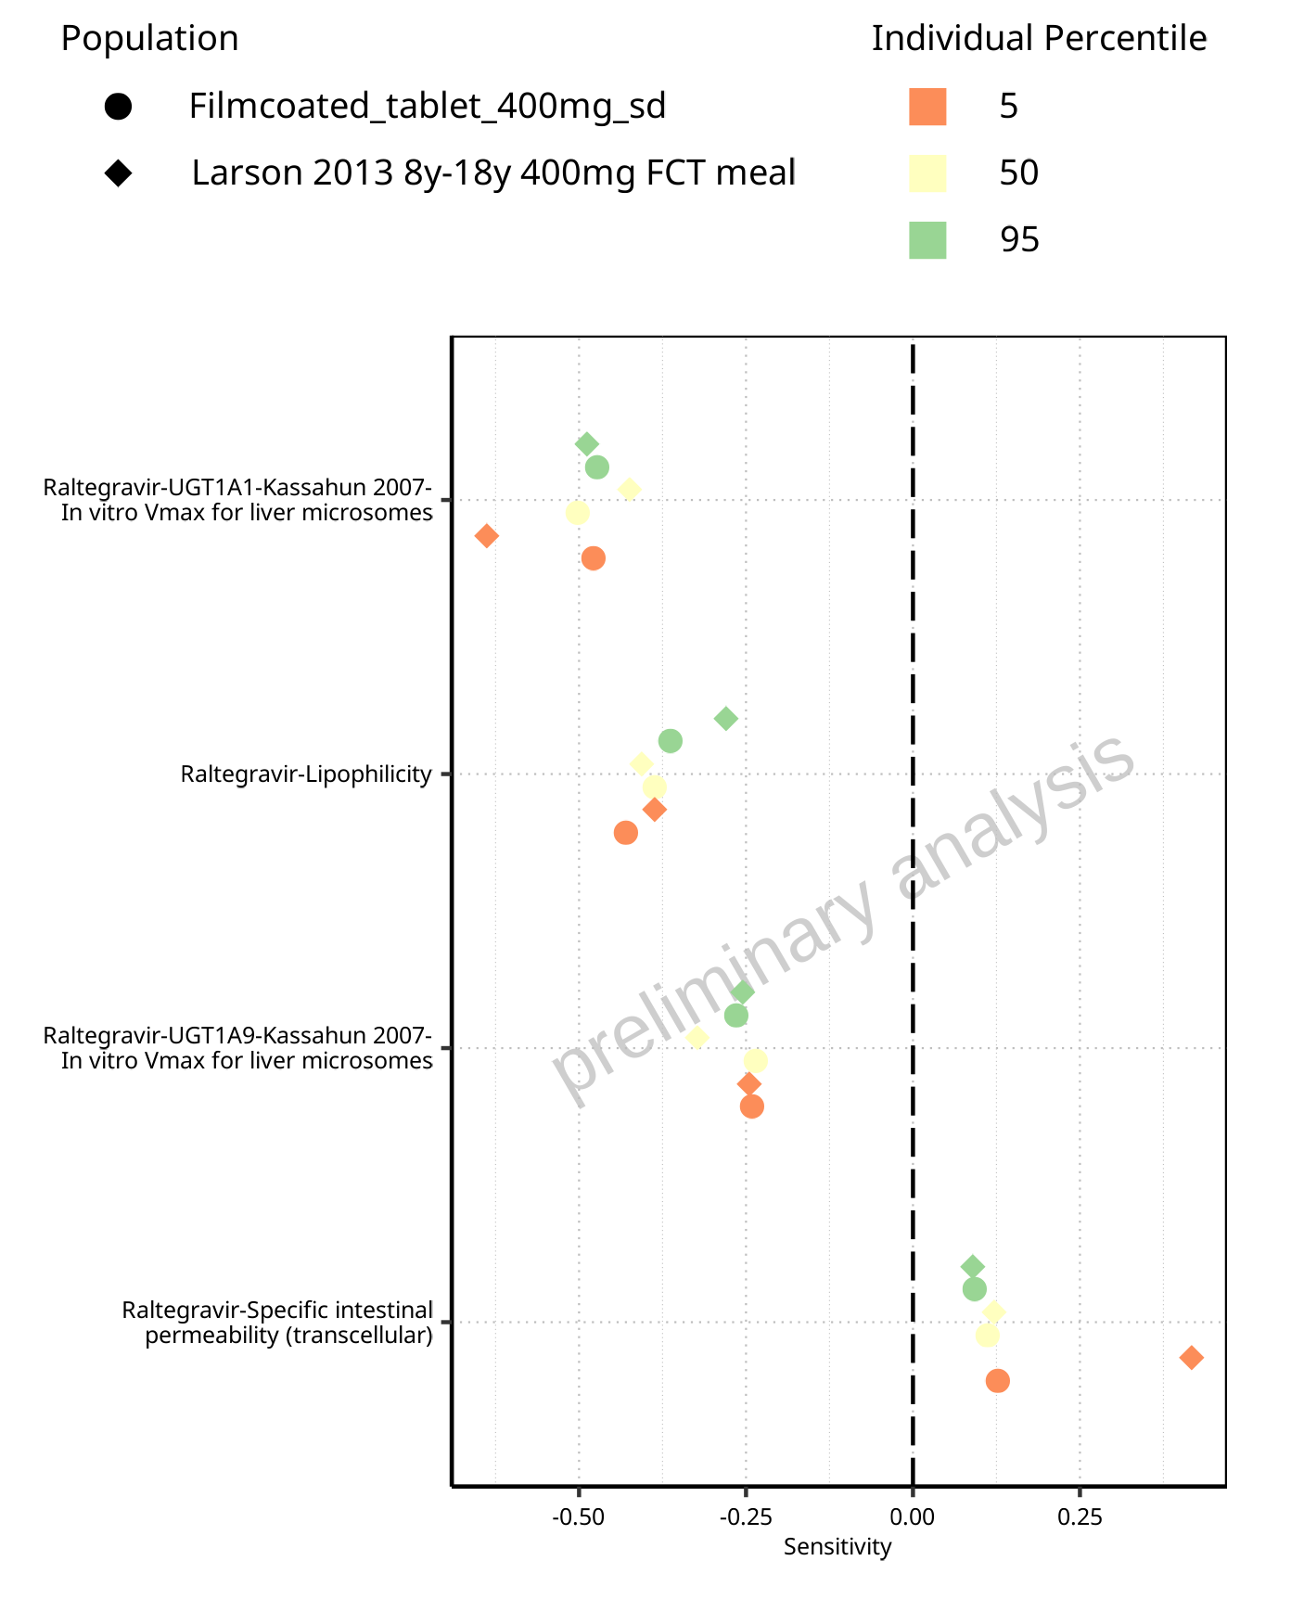

**Figure 1-5: Most sensitive parameters for AUC_inf of Raltegravir for individuals at percentiles 5, 50, 95 for Larson 2013 8y-18y 400mg FCT meal, Filmcoated_tablet_400mg_sd.**

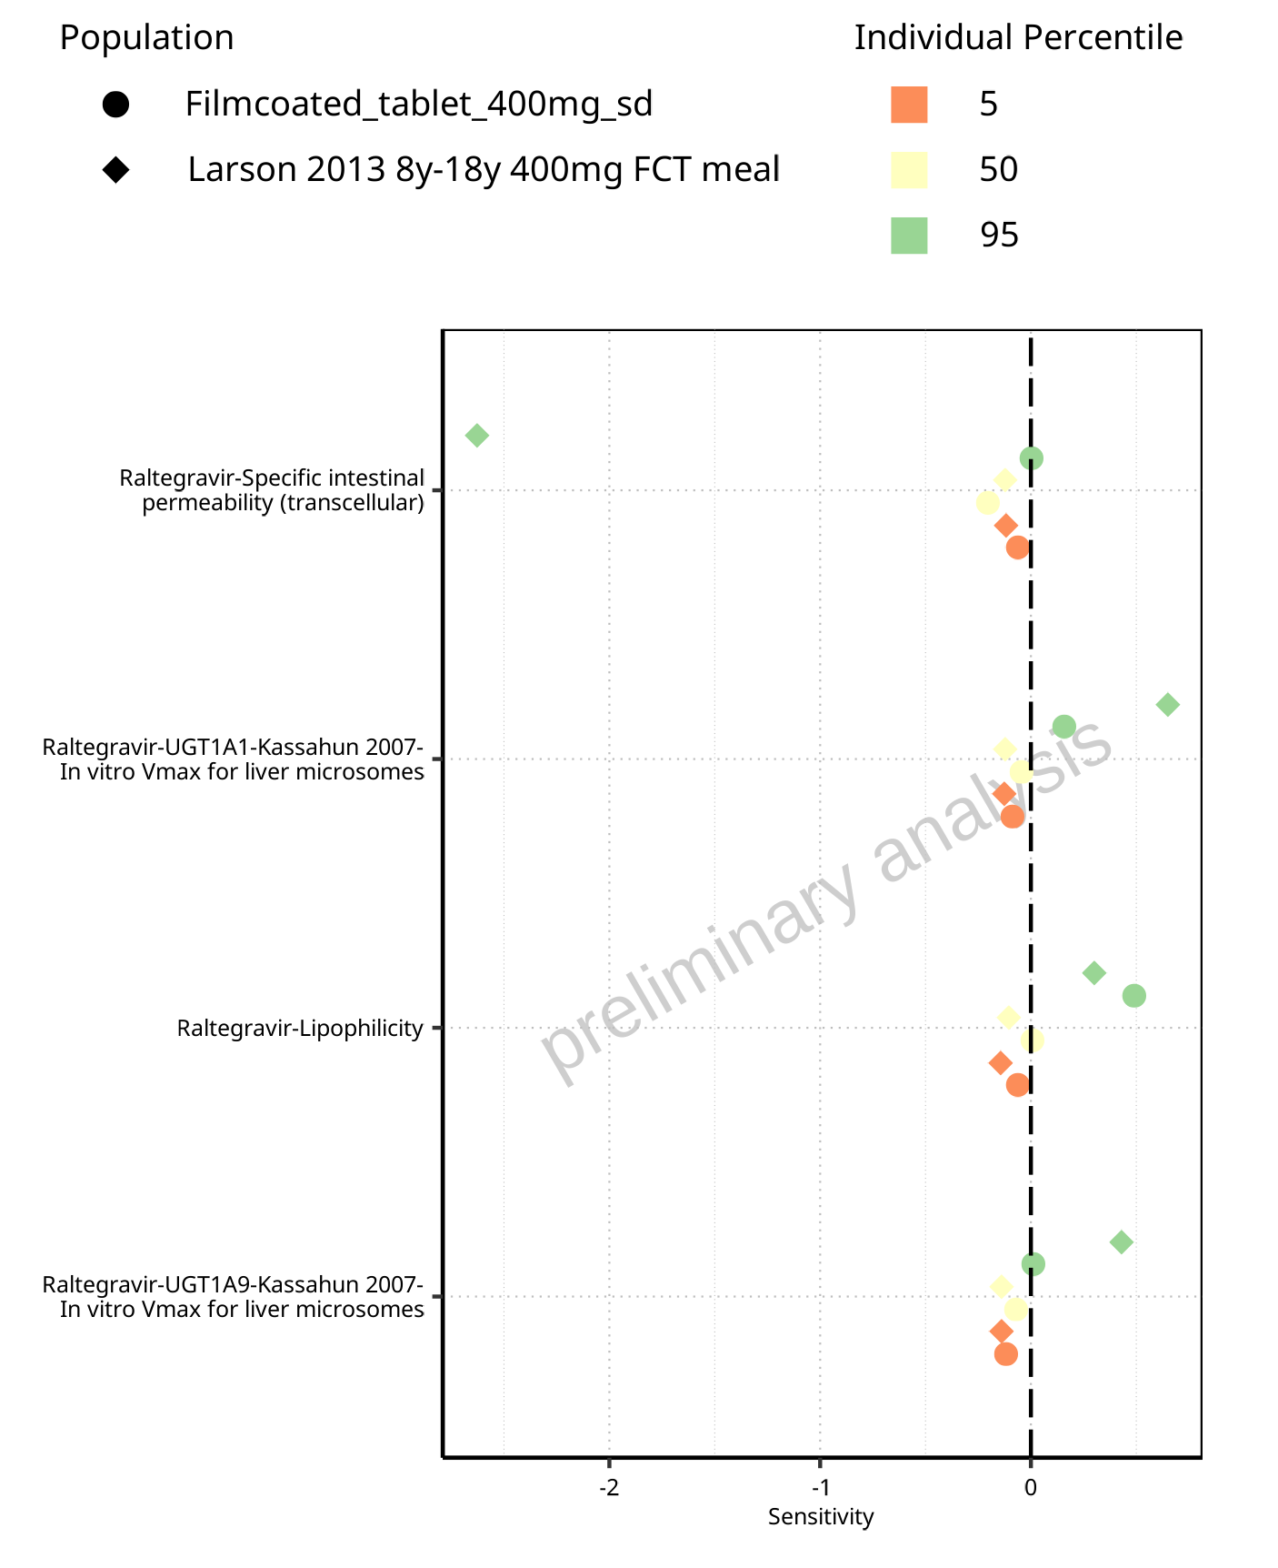

**Figure 1-6: Most sensitive parameters for MRT of Raltegravir for individuals at percentiles 5, 50, 95 for Larson 2013 8y-18y 400mg FCT meal, Filmcoated_tablet_400mg_sd.**

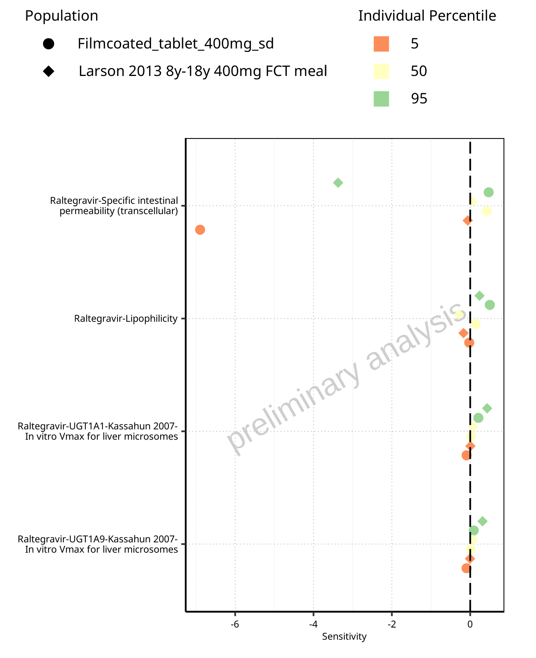

**Figure 1-7: Most sensitive parameters for Thalf of Raltegravir for individuals at percentiles 5, 50, 95 for Filmcoated_tablet_400mg_sd, Larson 2013 8y-18y 400mg FCT meal.**

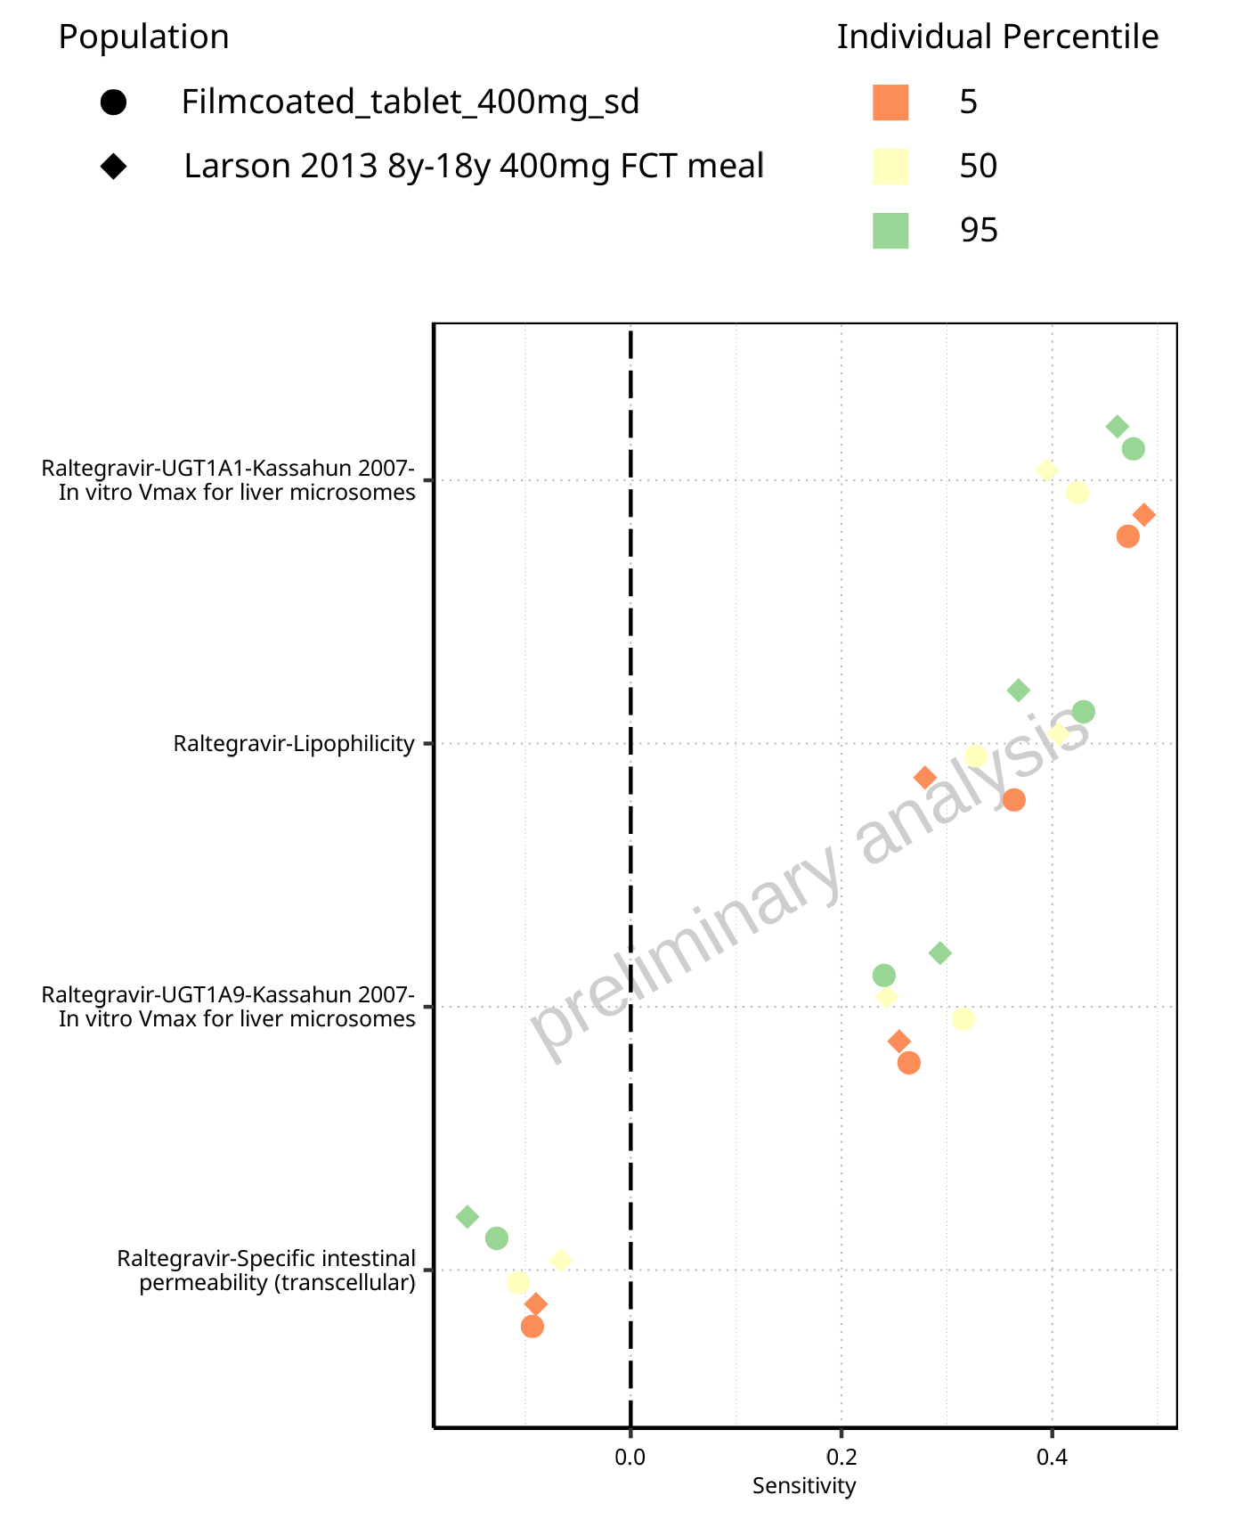

**Figure 1-8: Most sensitive parameters for CL of Raltegravir for individuals at percentiles 5, 50, 95 for Larson 2013 8y-18y 400mg FCT meal, Filmcoated_tablet_400mg_sd.**

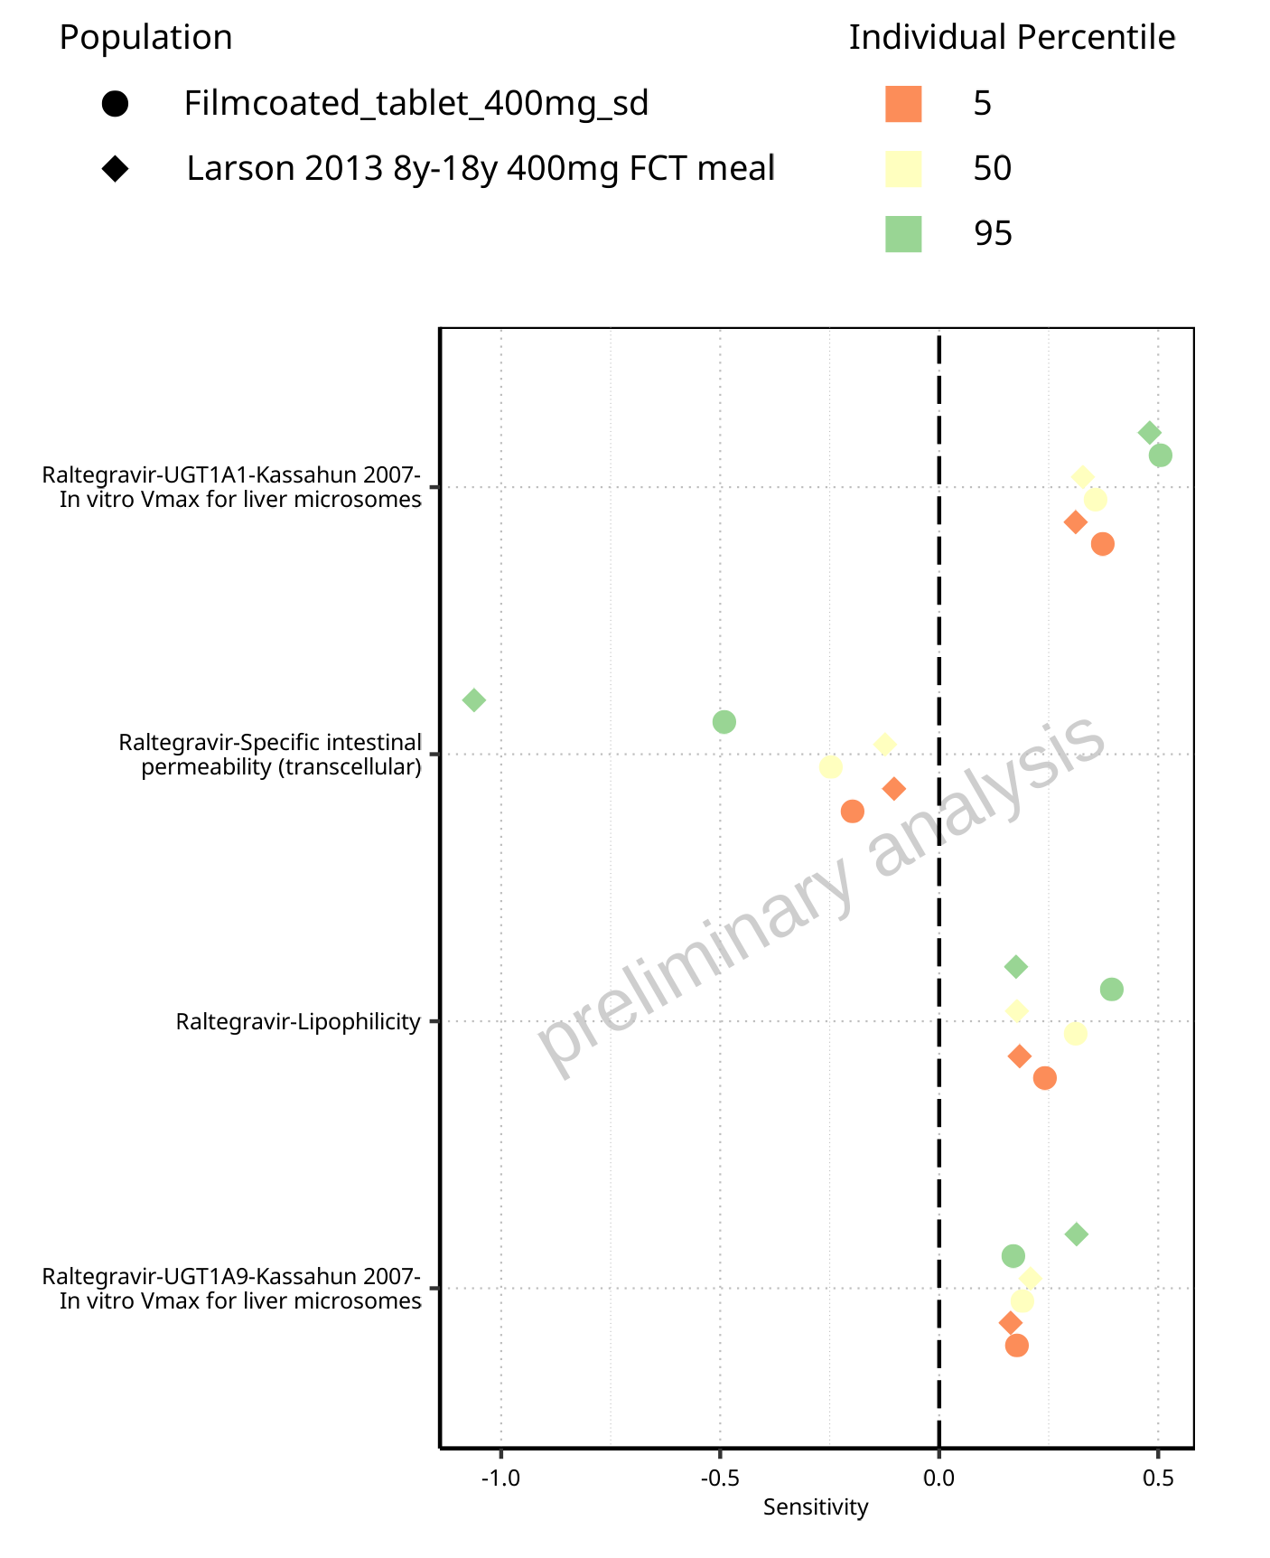

**Figure 1-9: Most sensitive parameters for Vss of Raltegravir for individuals at percentiles 5, 50, 95 for Larson 2013 8y-18y 400mg FCT meal, Filmcoated_tablet_400mg_sd.**

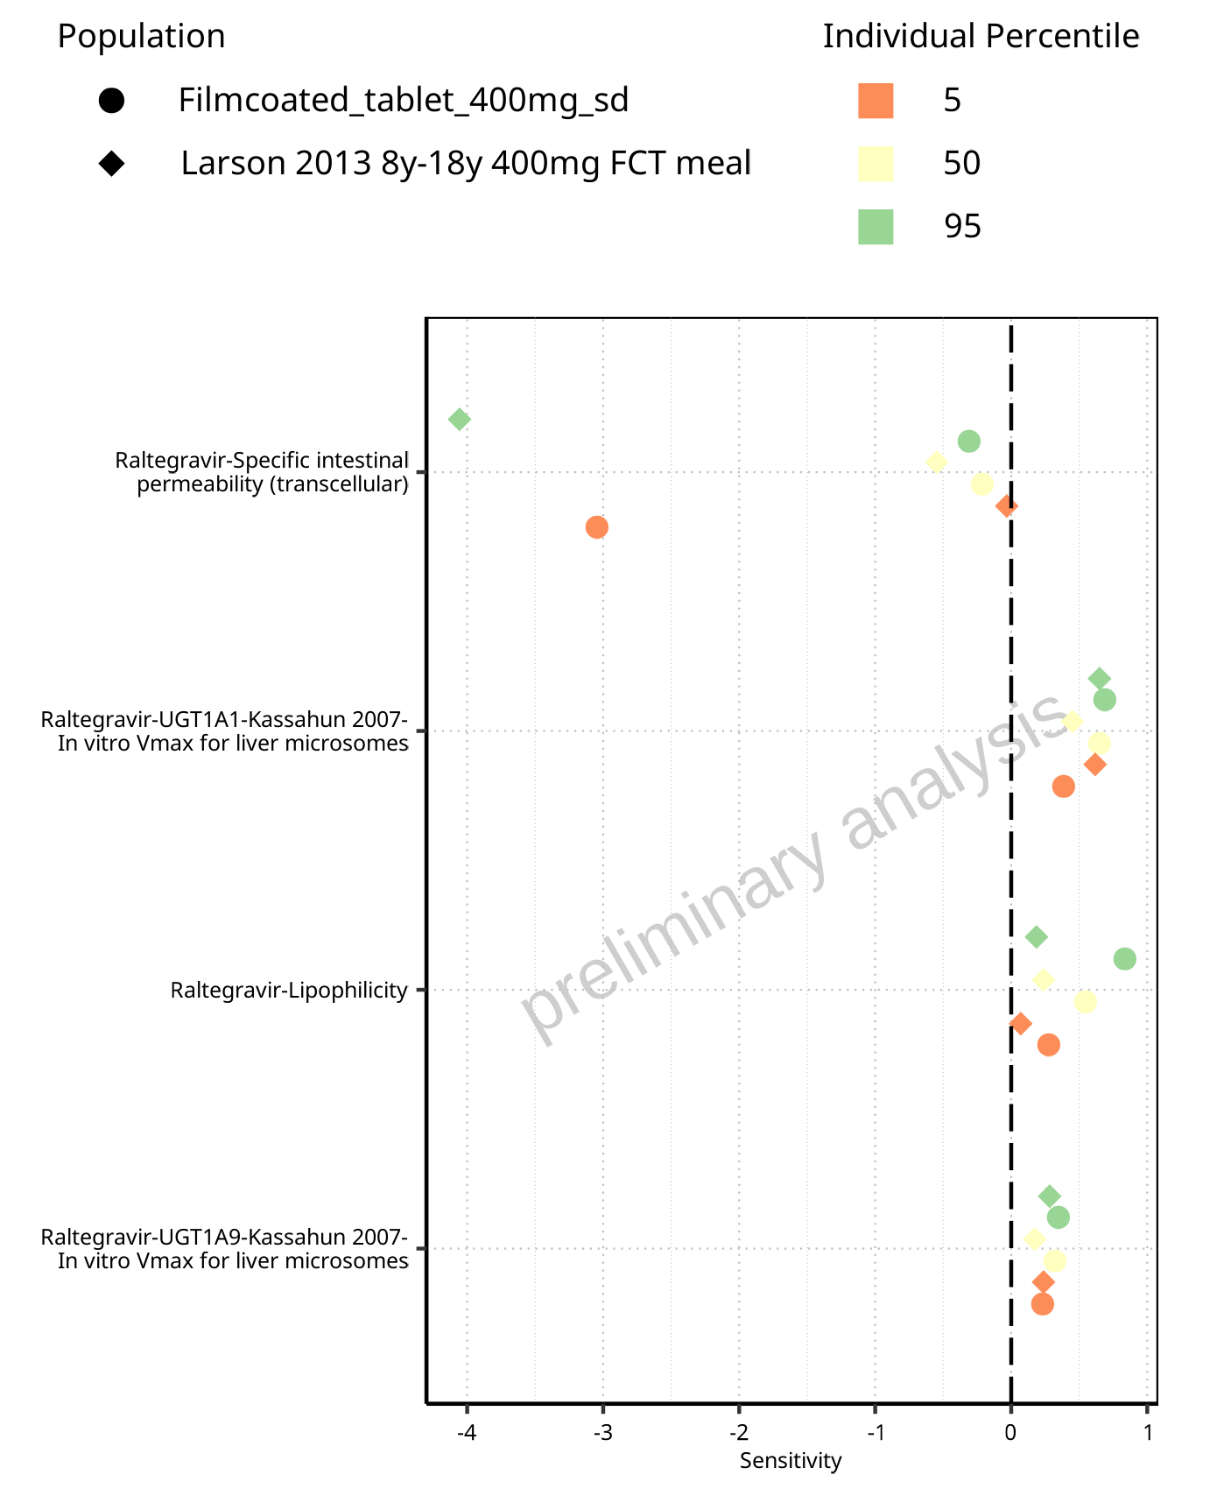

**Figure 1-10: Most sensitive parameters for Vd of Raltegravir for individuals at percentiles 5, 50, 95 for Larson 2013 8y-18y 400mg FCT meal, Filmcoated_tablet_400mg_sd.**

# PK parameters

## PK Parameters of Raltegravir

### C_max

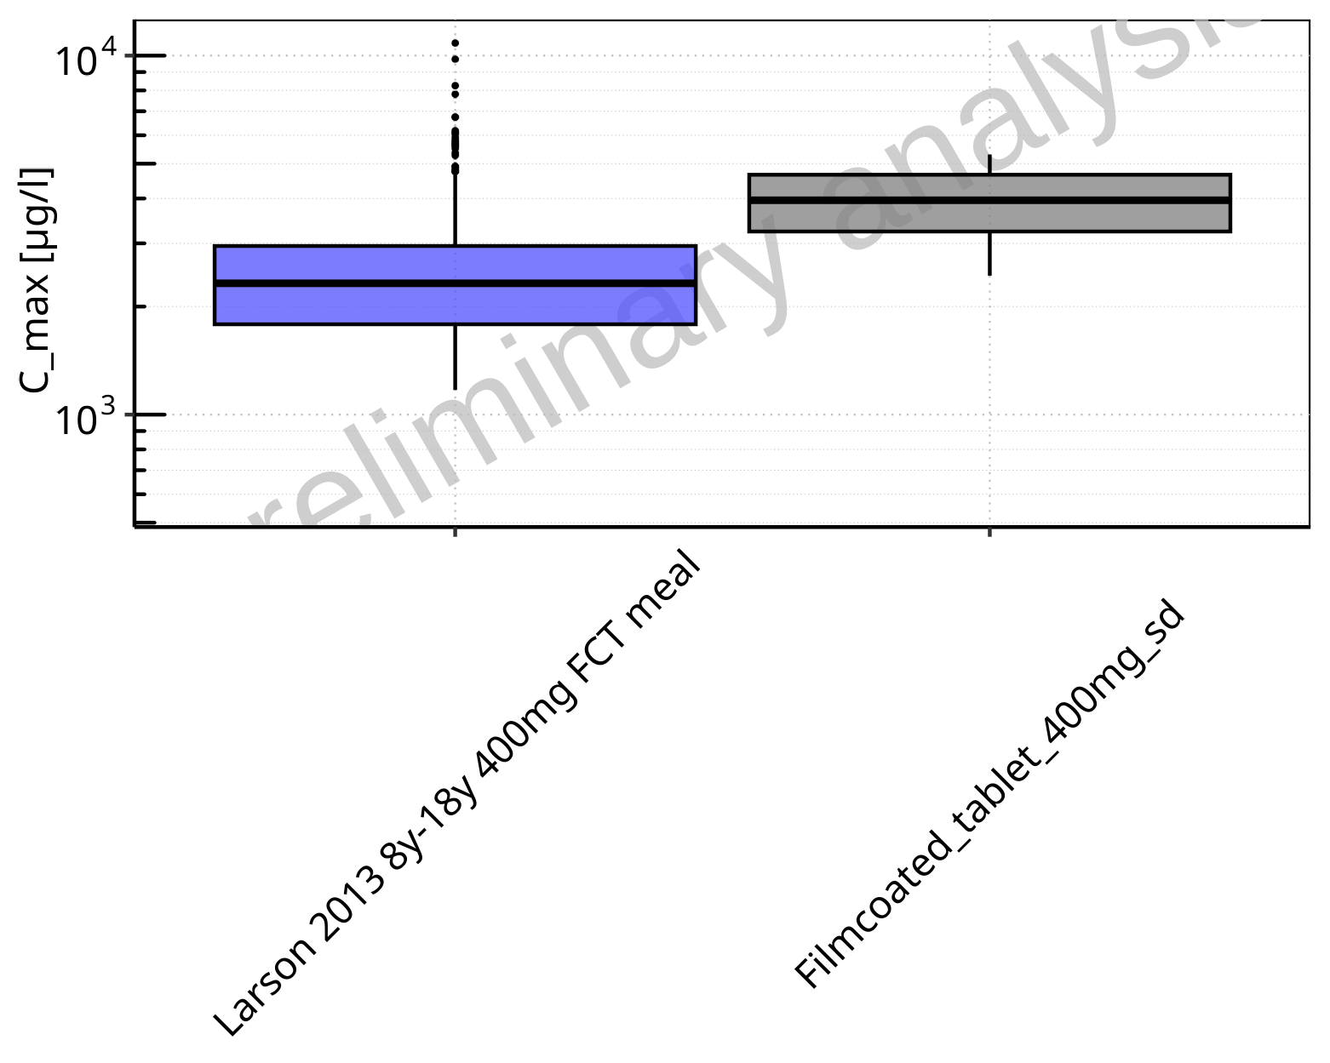

**Figure 2-1: C_max of Raltegravir for Larson 2013 8y-18y 400mg FCT meal, Filmcoated_tablet_400mg_sd shown as box-whisker plot, which indicates the 5th, 25th, 50th, 75th, 95th percentiles in logarithmic scale.**

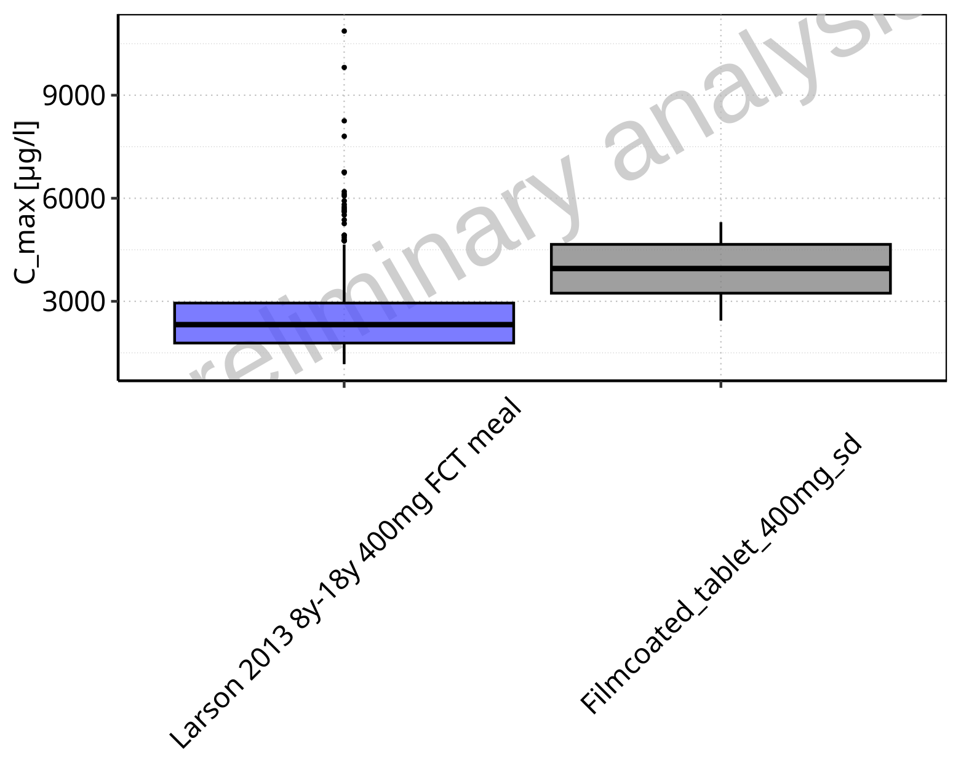

**Figure 2-2: C_max of Raltegravir for Larson 2013 8y-18y 400mg FCT meal, Filmcoated_tablet_400mg_sd shown as box-whisker plot, which indicates the 5th, 25th, 50th, 75th, 95th percentiles in linear scale.**

**Table 2-1: Population statistics summarizing C_max of Raltegravir for Larson 2013 8y-18y 400mg FCT meal, Filmcoated_tablet_400mg_sd reported in [µg/l]**

| Population | N | 5th pctl | 25th pctl | 50th pctl | 75th pctl | 95th pctl | Mean | SD | Geo Mean | Geo SD |
| --- | --- | --- | --- | --- | --- | --- | --- | --- | --- | --- |
| Larson 2013 8y-18y 400mg FCT meal | 500 | 1171.26 | 1784.94 | 2321.55 | 2949.24 | 4651.40 | 2549.83 | 1206.89 | 2326.87 | 1.52 |
| Filmcoated_tablet_400mg_sd | 100 | 2437.79 | 3236.54 | 3954.54 | 4657.56 | 5304.38 | 3940.92 | 908.89 | 3833.70 | 1.27 |

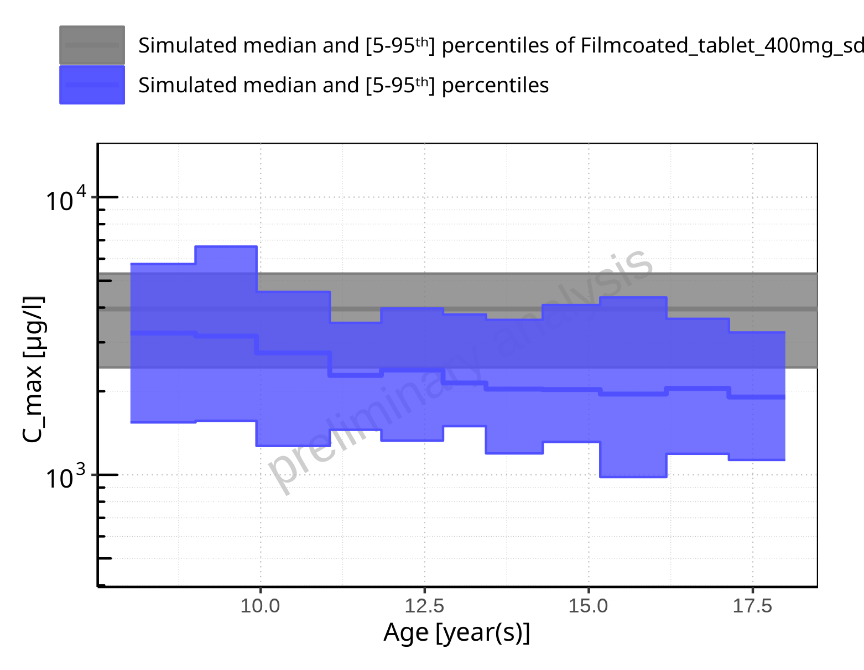

**Figure 2-3: Age-dependence of C_max for Larson 2013 8y-18y 400mg FCT meal in comparison to Filmcoated_tablet_400mg_sd. Profiles are plotted in a logarithmic scale.**

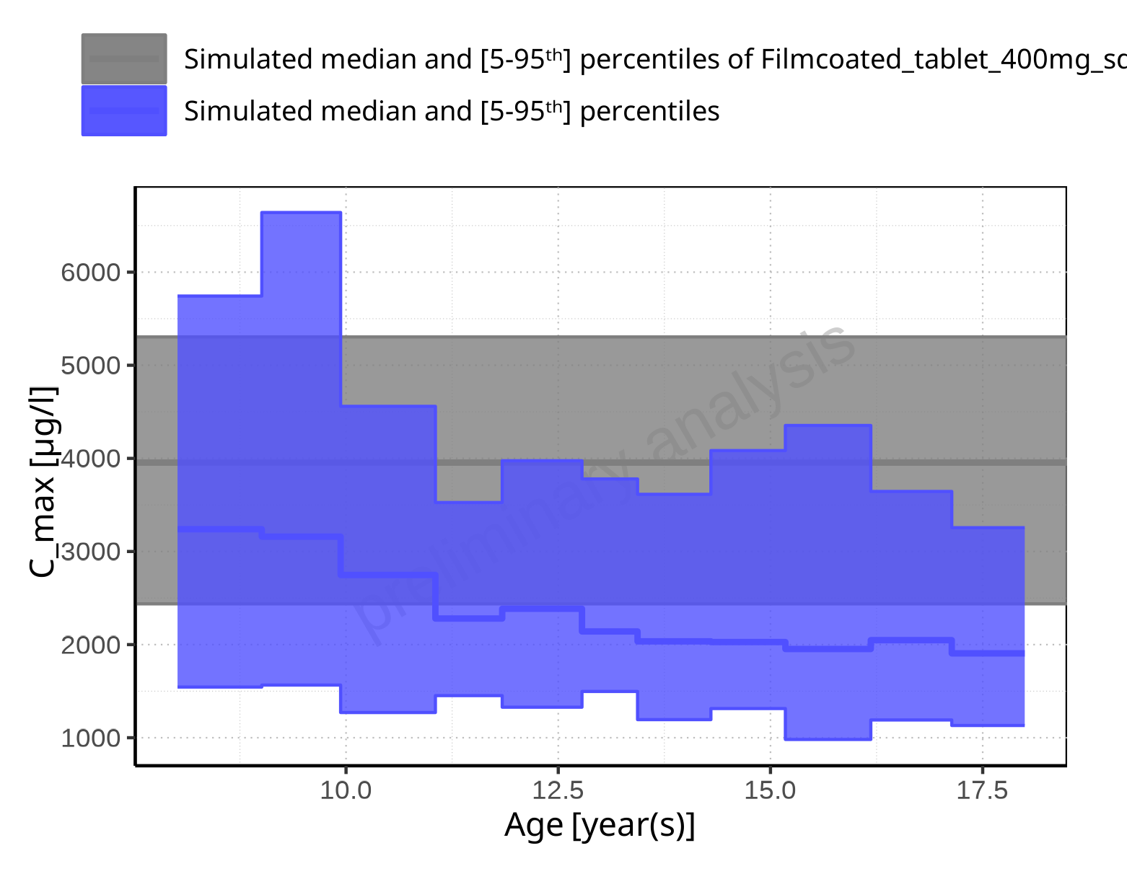

**Figure 2-4: Age-dependence of C_max for Larson 2013 8y-18y 400mg FCT meal in comparison to Filmcoated_tablet_400mg_sd. Profiles are plotted in a linear scale.**

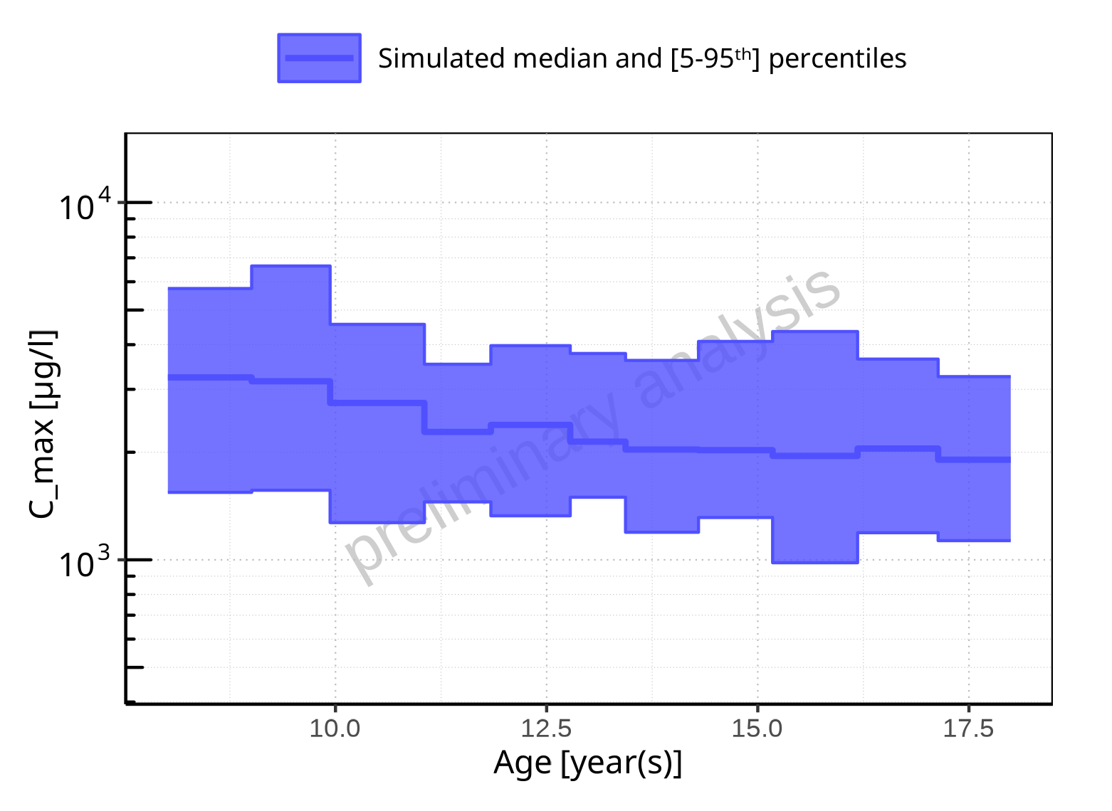

**Figure 2-5: Age-dependence of C_max for Larson 2013 8y-18y 400mg FCT meal. Profiles are plotted in a logarithmic scale.**

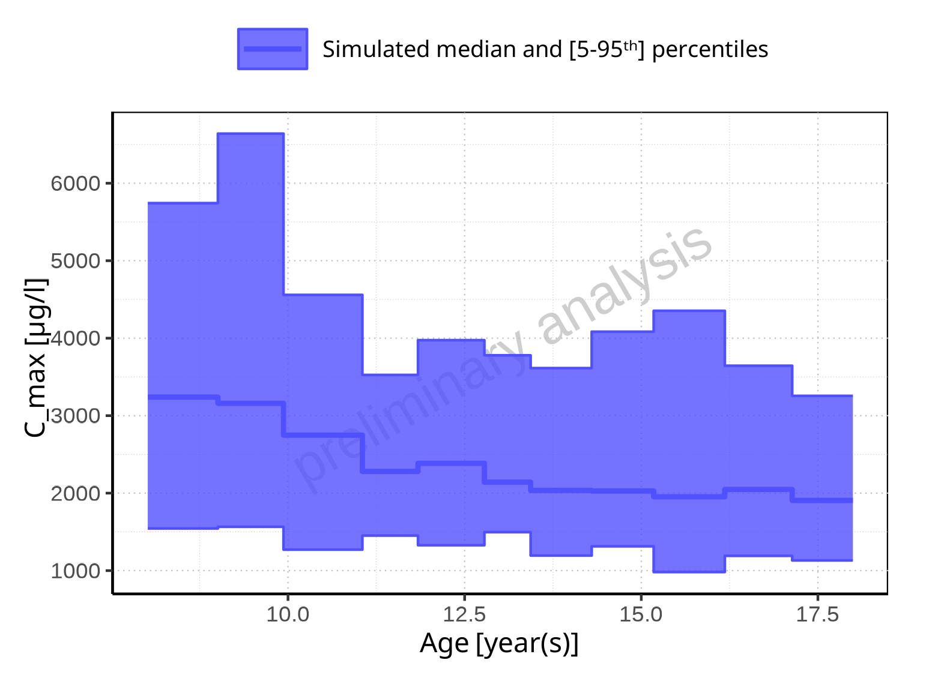

**Figure 2-6: Age-dependence of C_max for Larson 2013 8y-18y 400mg FCT meal. Profiles are plotted in a linear scale.**

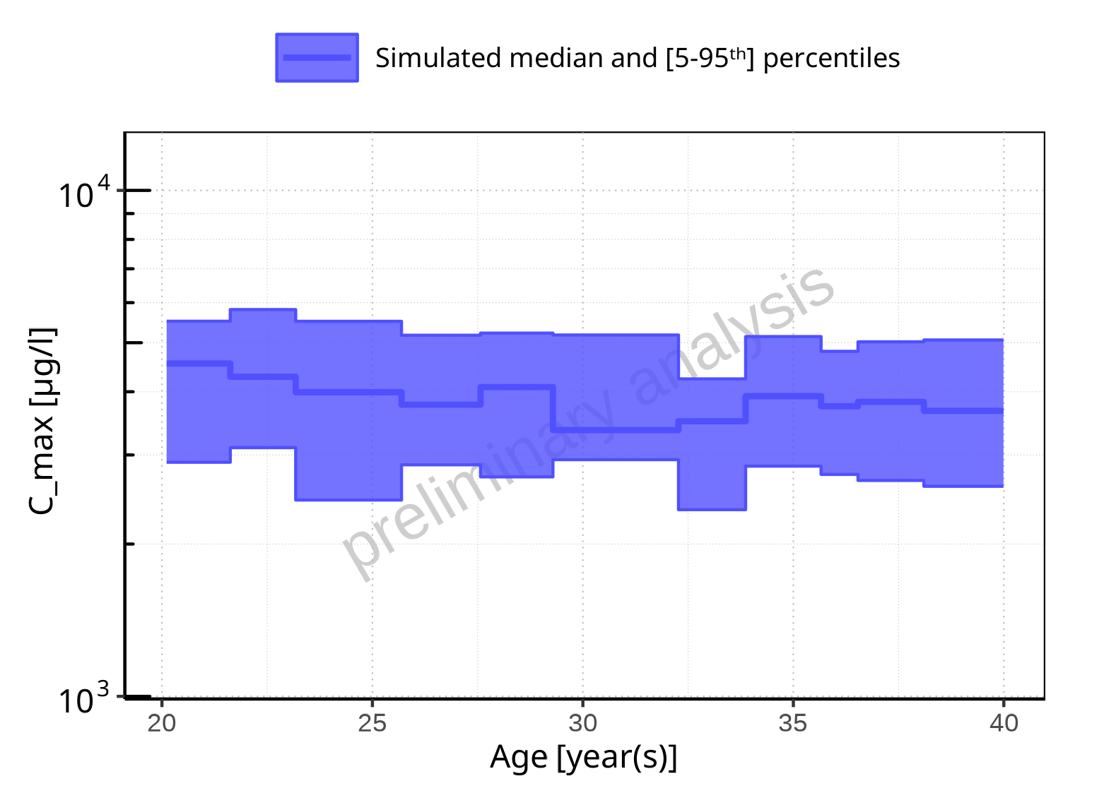

**Figure 2-7: Age-dependence of C_max for Filmcoated_tablet_400mg_sd. Profiles are plotted in a logarithmic scale.**

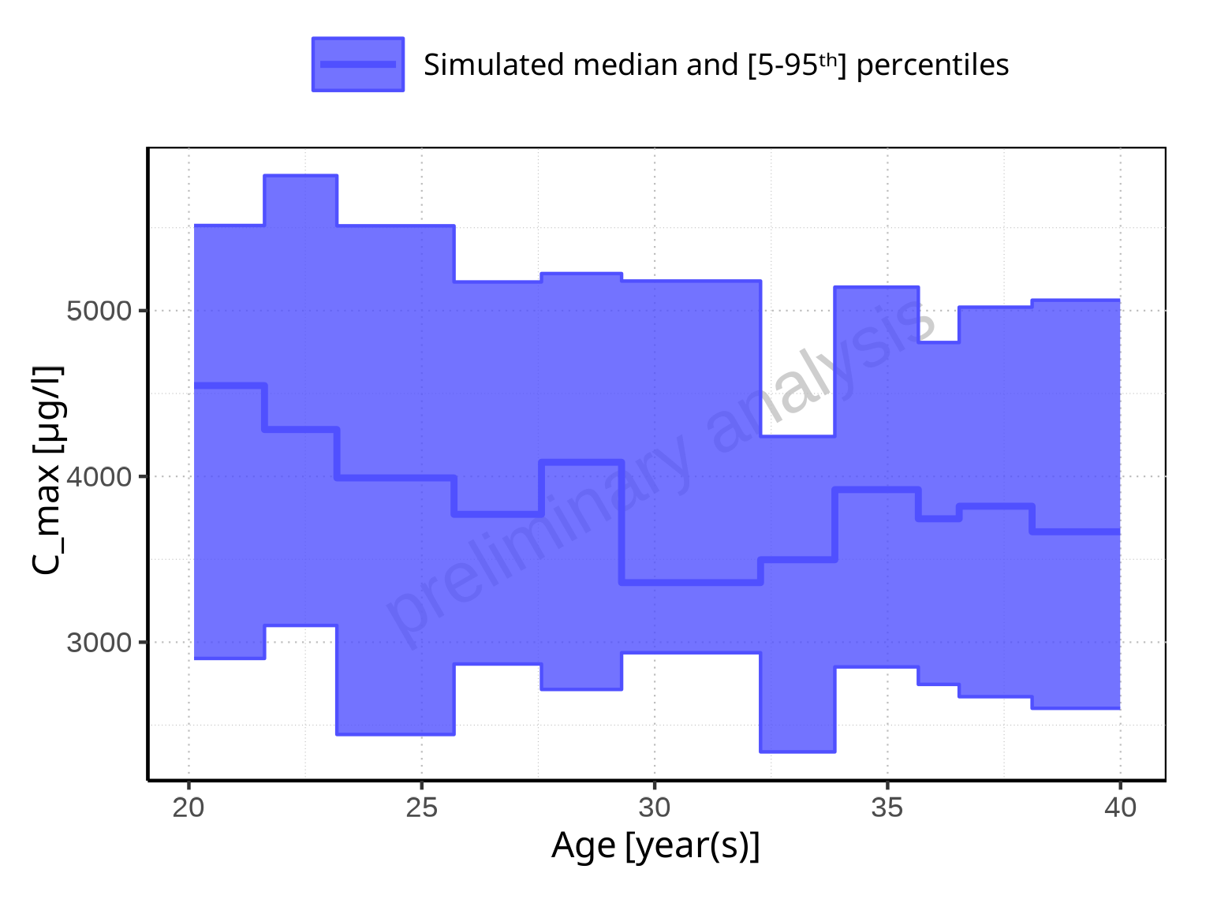

**Figure 2-8: Age-dependence of C_max for Filmcoated_tablet_400mg_sd. Profiles are plotted in a linear scale.**

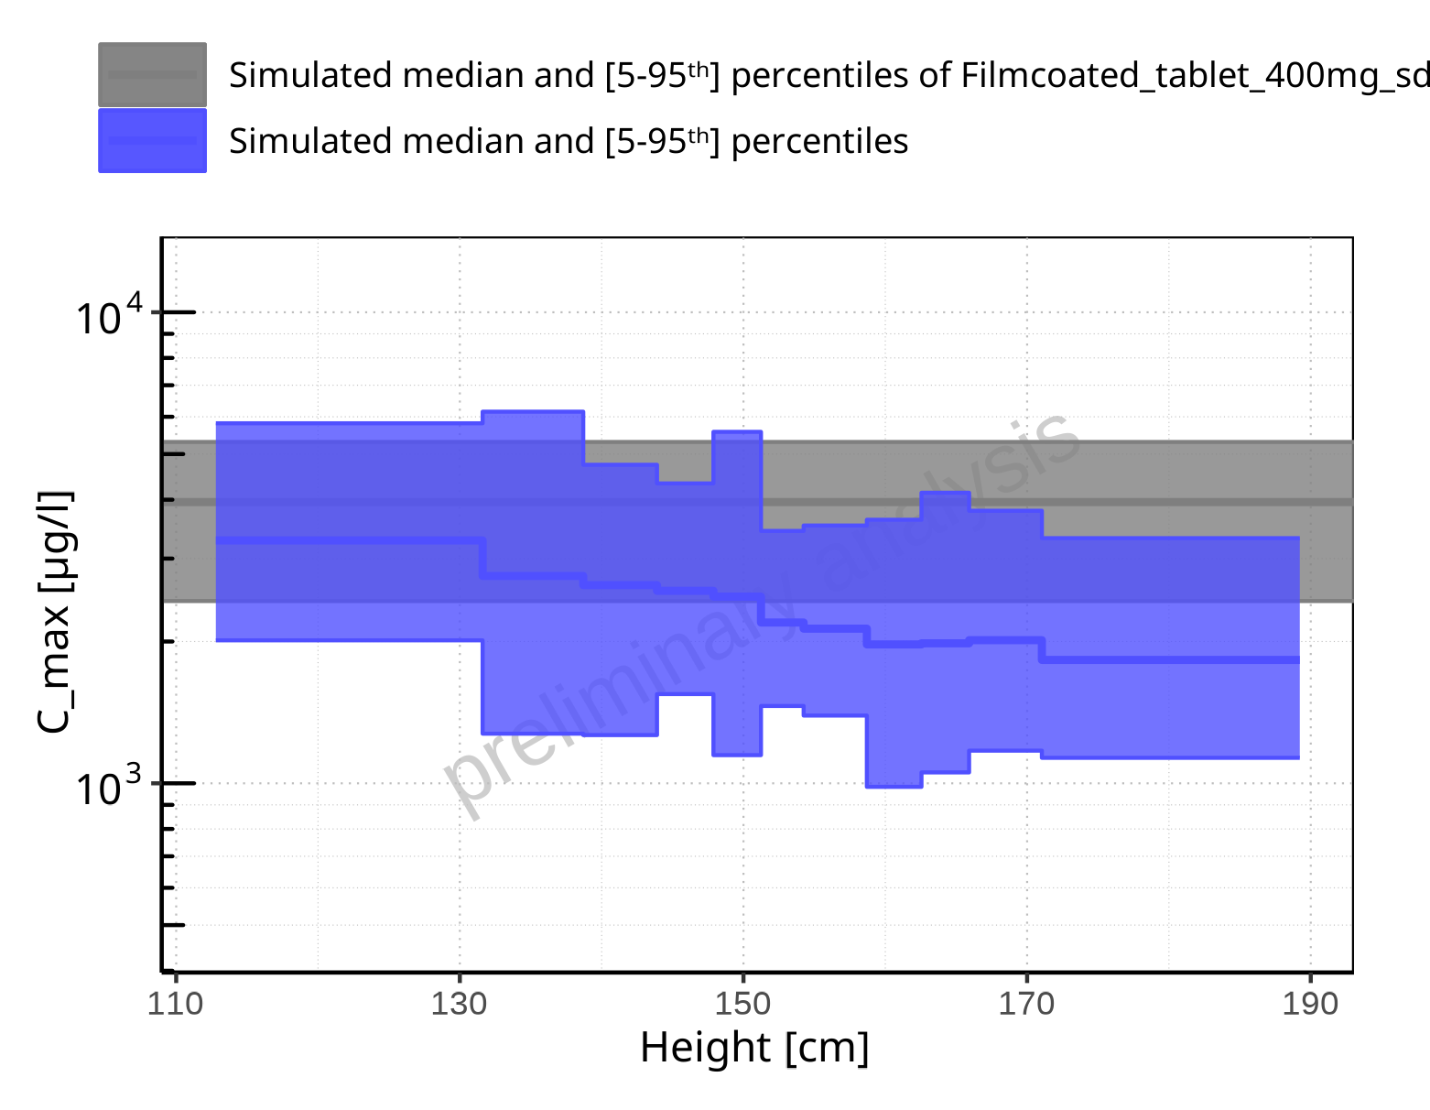

**Figure 2-9: Height-dependence of C_max for Larson 2013 8y-18y 400mg FCT meal in comparison to Filmcoated_tablet_400mg_sd. Profiles are plotted in a logarithmic scale.**

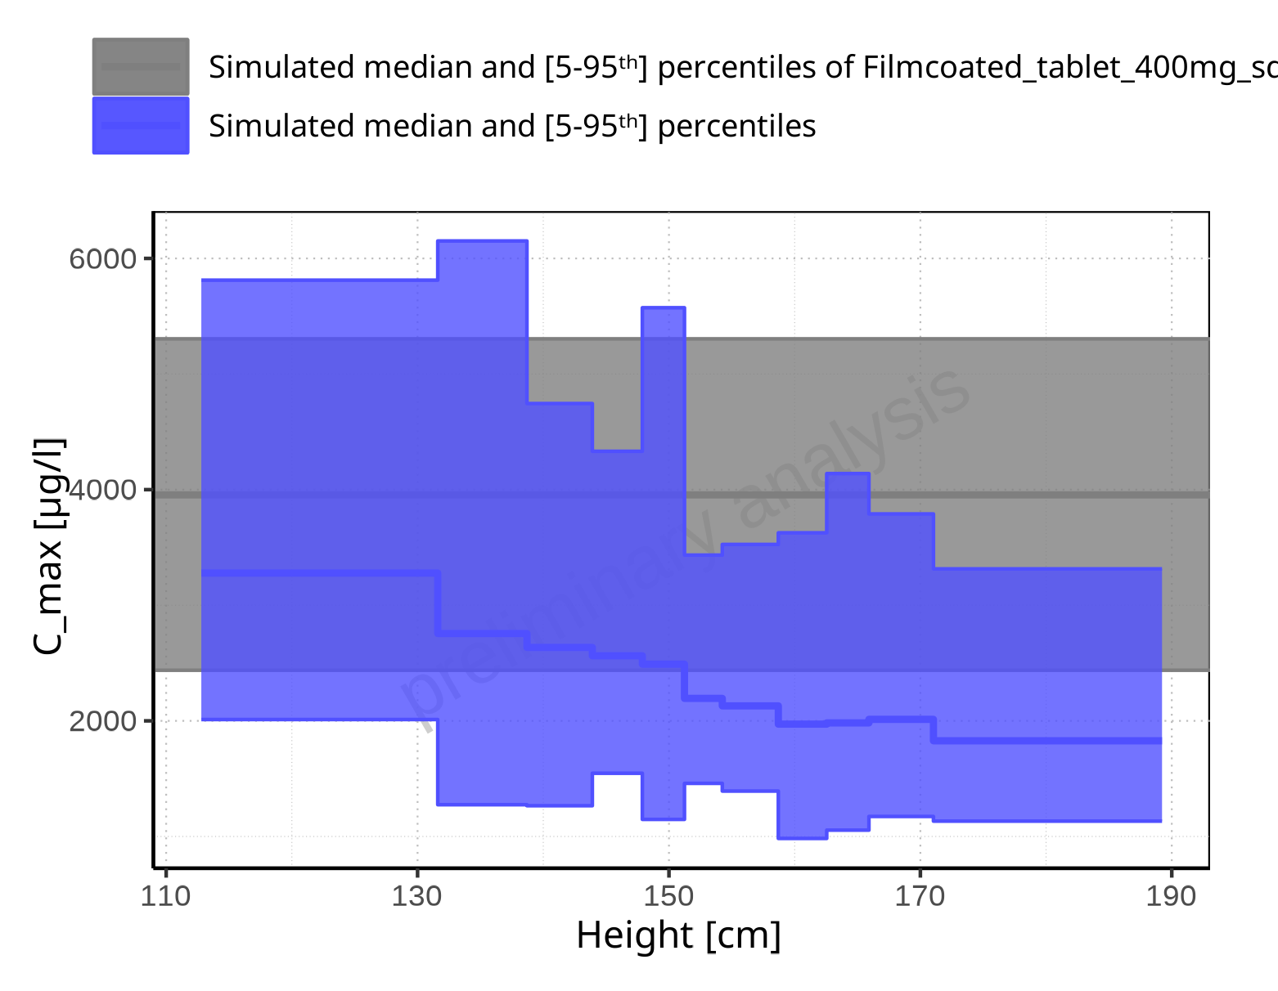

**Figure 2-10: Height-dependence of C_max for Larson 2013 8y-18y 400mg FCT meal in comparison to Filmcoated_tablet_400mg_sd. Profiles are plotted in a linear scale.**

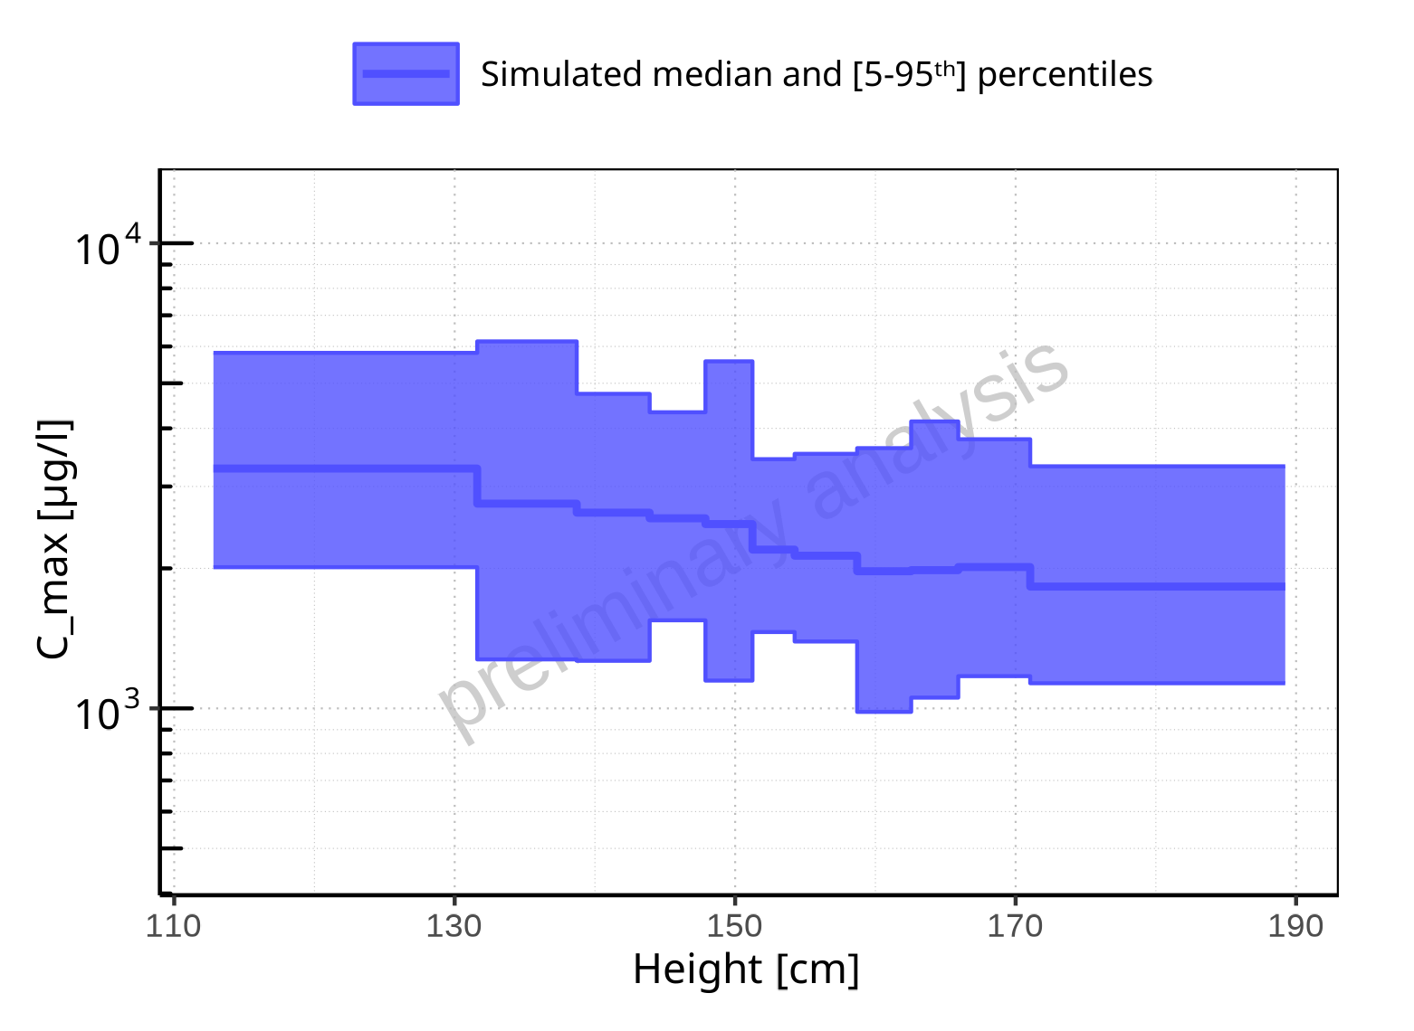

**Figure 2-11: Height-dependence of C_max for Larson 2013 8y-18y 400mg FCT meal. Profiles are plotted in a logarithmic scale.**

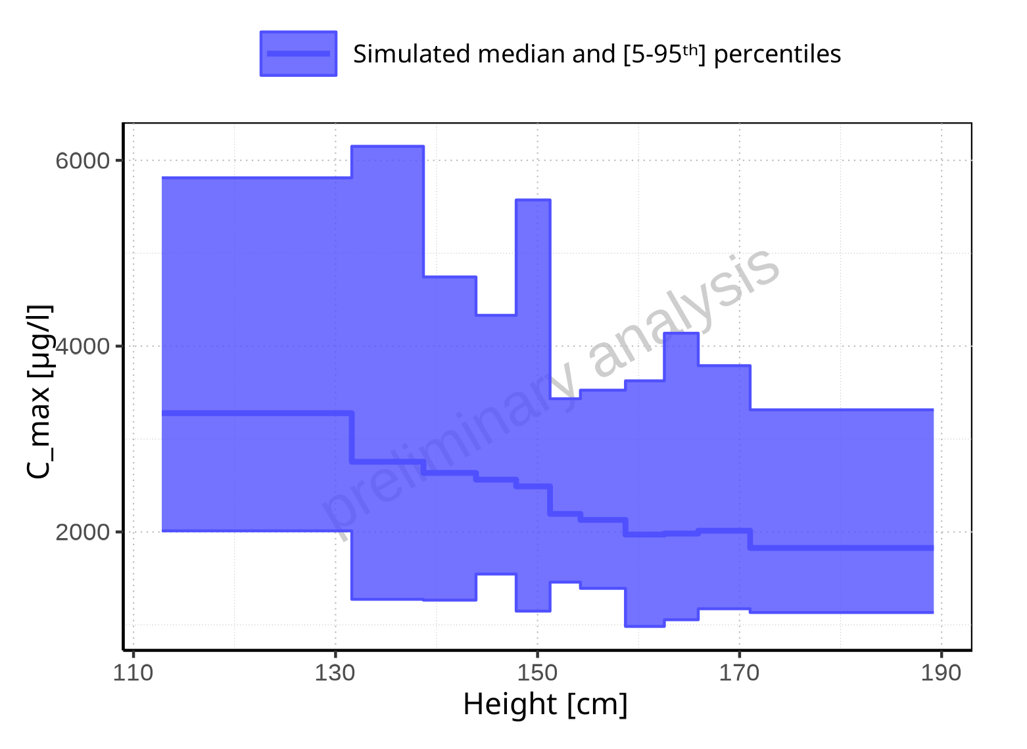

**Figure 2-12: Height-dependence of C_max for Larson 2013 8y-18y 400mg FCT meal. Profiles are plotted in a linear scale.**

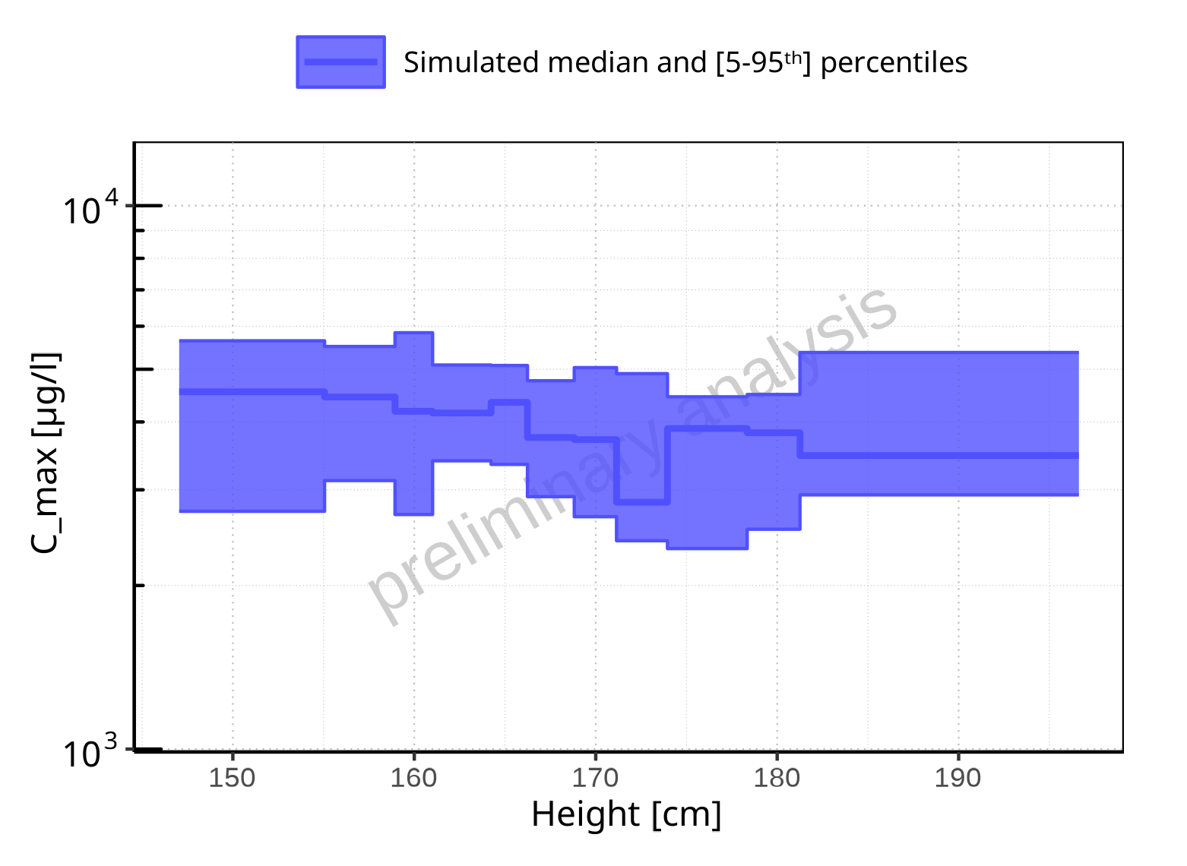

**Figure 2-13: Height-dependence of C_max for Filmcoated_tablet_400mg_sd. Profiles are plotted in a logarithmic scale.**

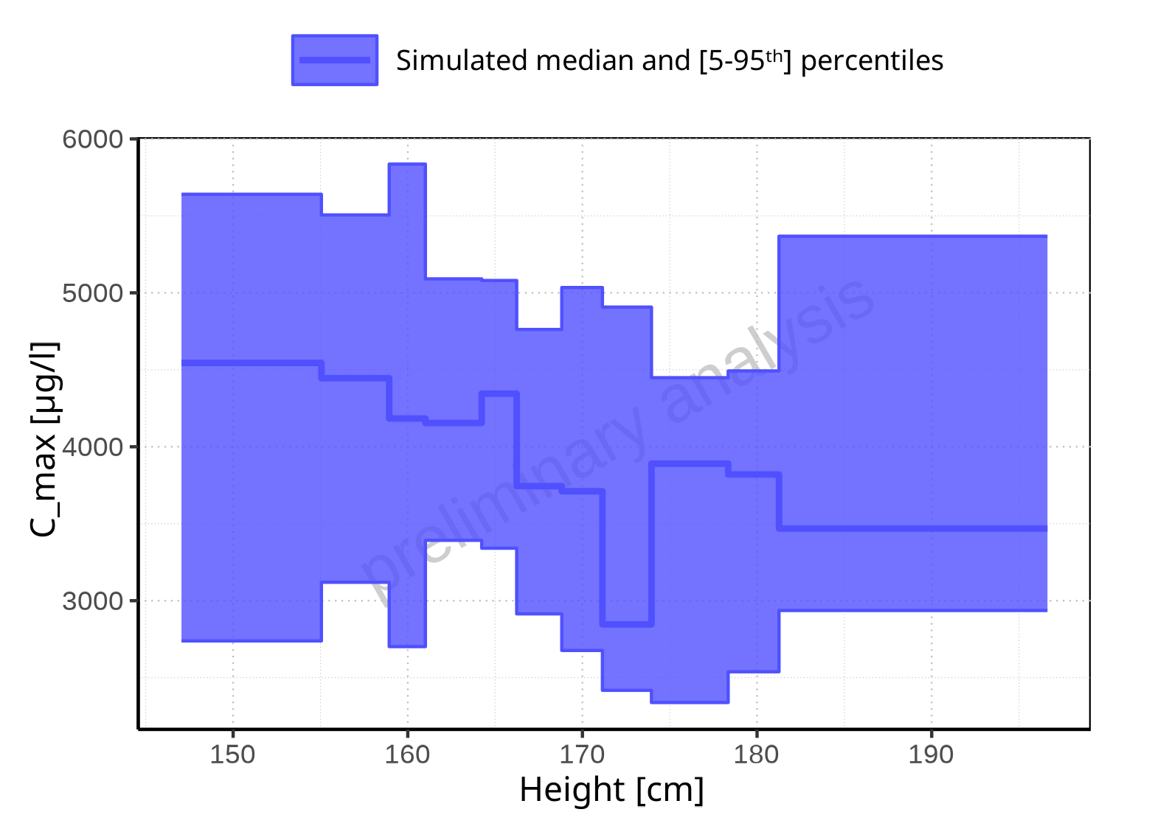

**Figure 2-14: Height-dependence of C_max for Filmcoated_tablet_400mg_sd. Profiles are plotted in a linear scale.**

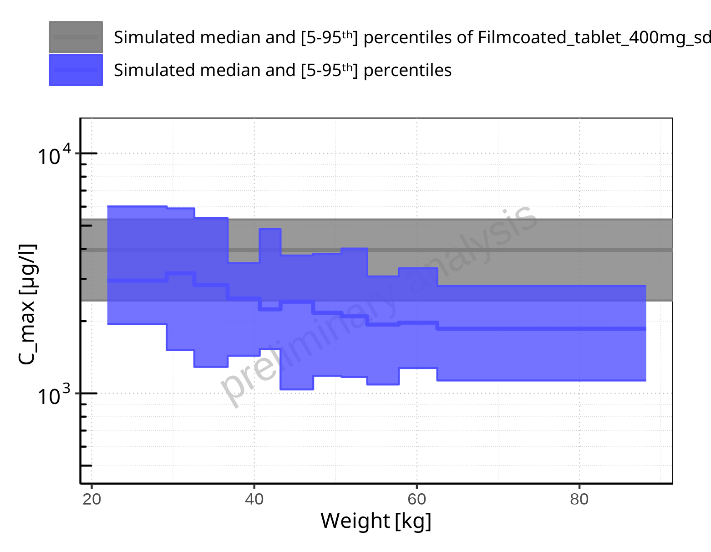

**Figure 2-15: Weight-dependence of C_max for Larson 2013 8y-18y 400mg FCT meal in comparison to Filmcoated_tablet_400mg_sd. Profiles are plotted in a logarithmic scale.**

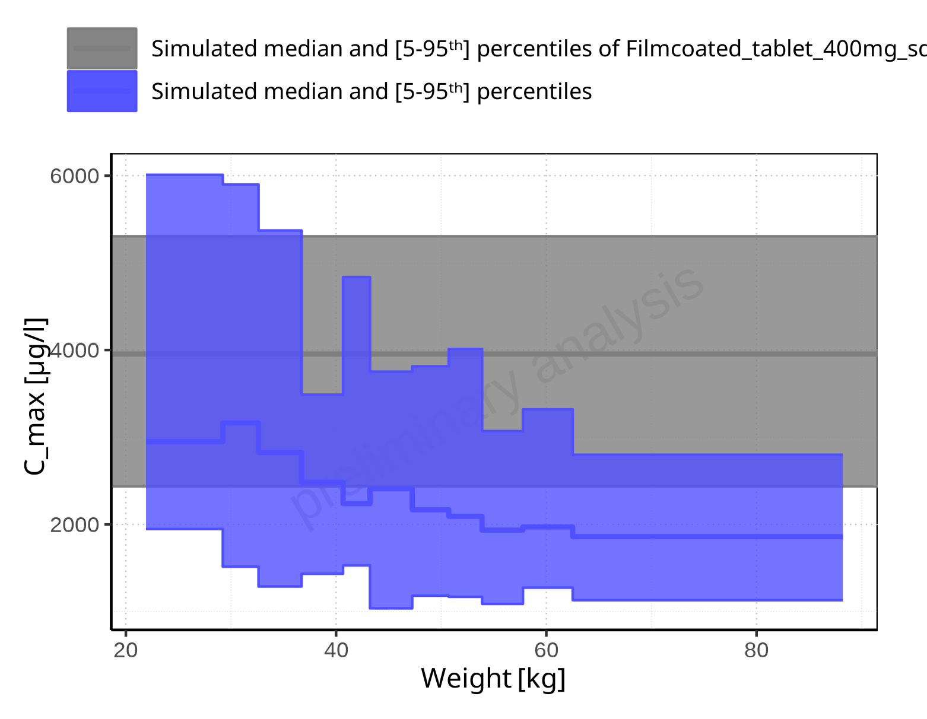

**Figure 2-16: Weight-dependence of C_max for Larson 2013 8y-18y 400mg FCT meal in comparison to Filmcoated_tablet_400mg_sd. Profiles are plotted in a linear scale.**

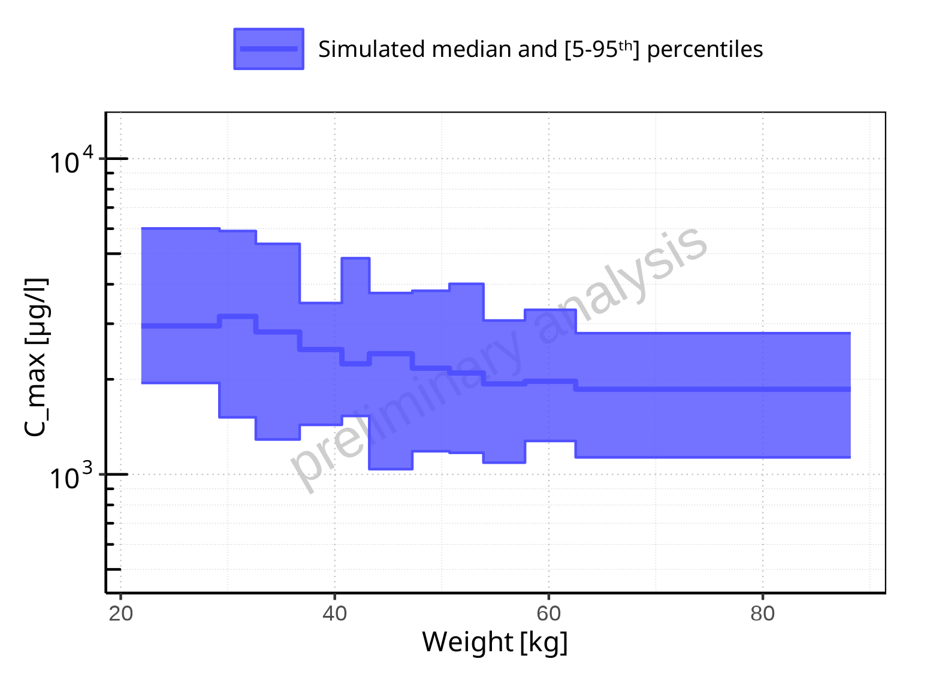

**Figure 2-17: Weight-dependence of C_max for Larson 2013 8y-18y 400mg FCT meal. Profiles are plotted in a logarithmic scale.**

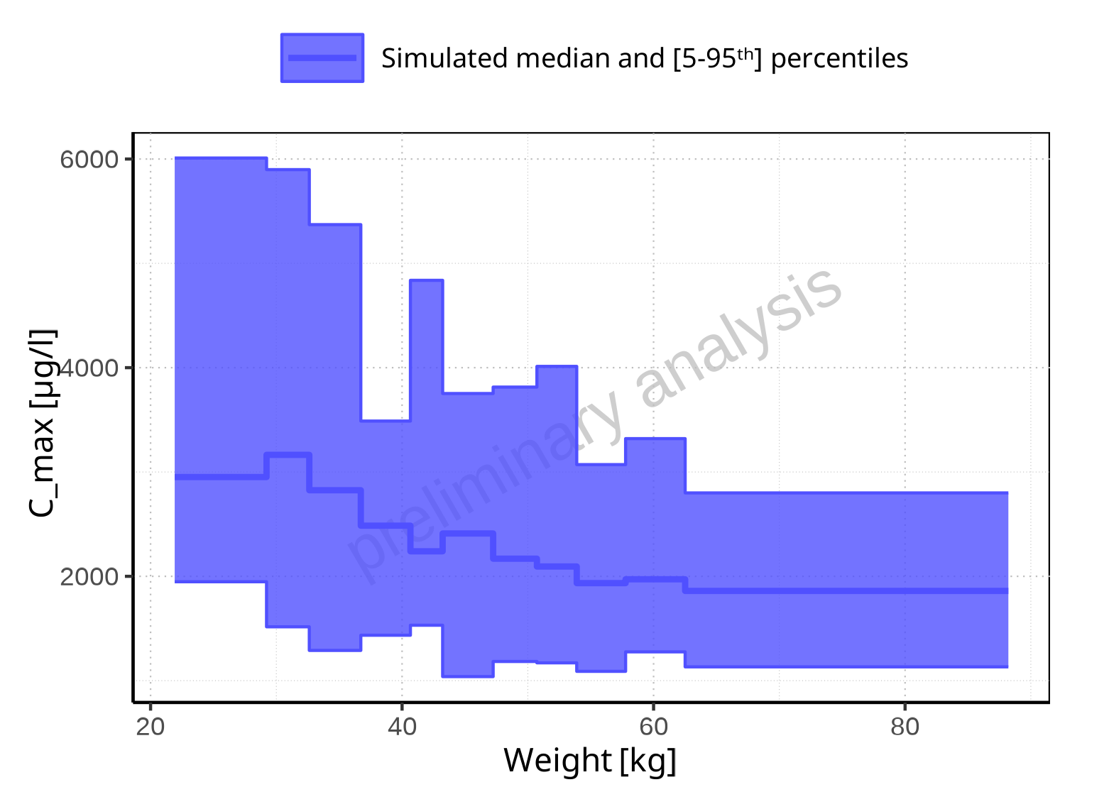

**Figure 2-18: Weight-dependence of C_max for Larson 2013 8y-18y 400mg FCT meal. Profiles are plotted in a linear scale.**

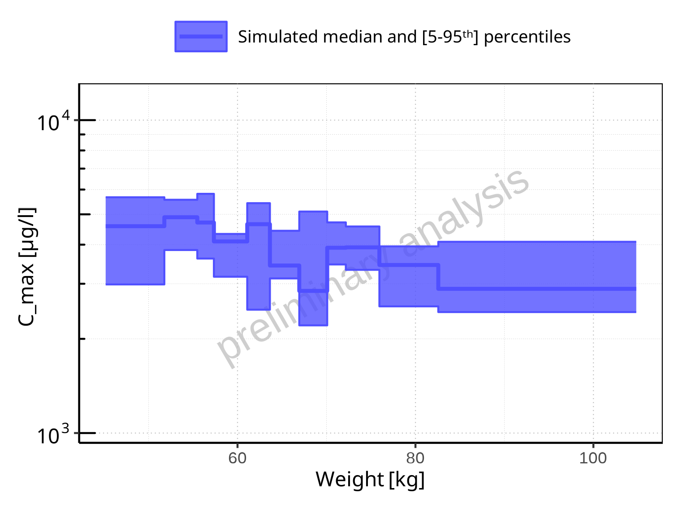

**Figure 2-19: Weight-dependence of C_max for Filmcoated_tablet_400mg_sd. Profiles are plotted in a logarithmic scale.**

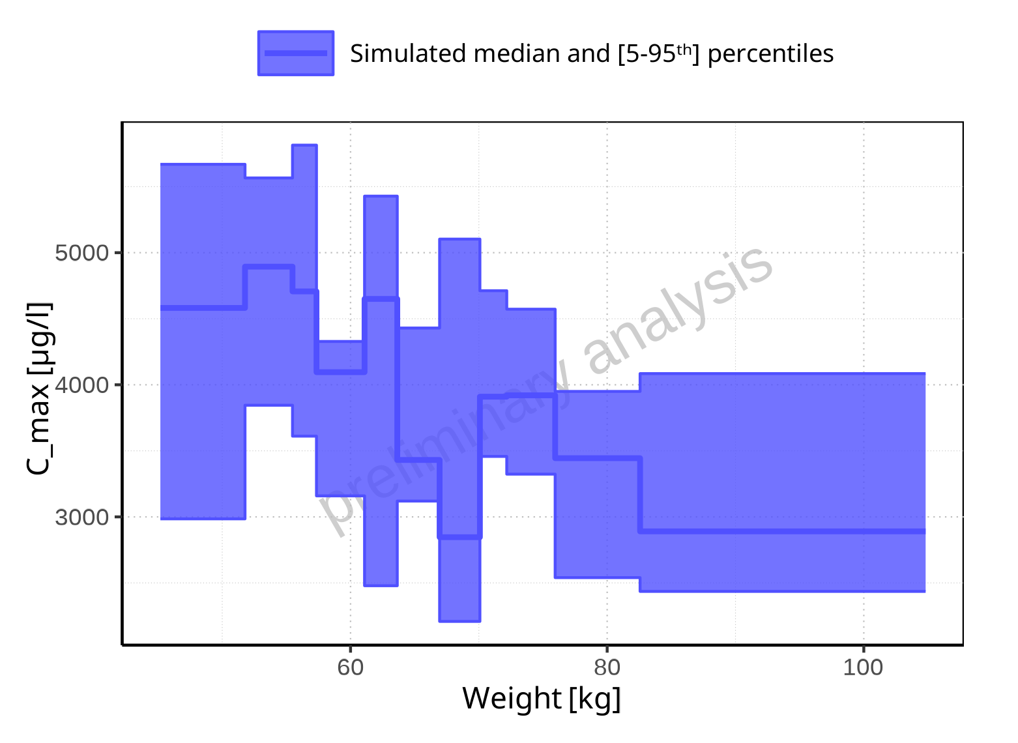

**Figure 2-20: Weight-dependence of C_max for Filmcoated_tablet_400mg_sd. Profiles are plotted in a linear scale.**

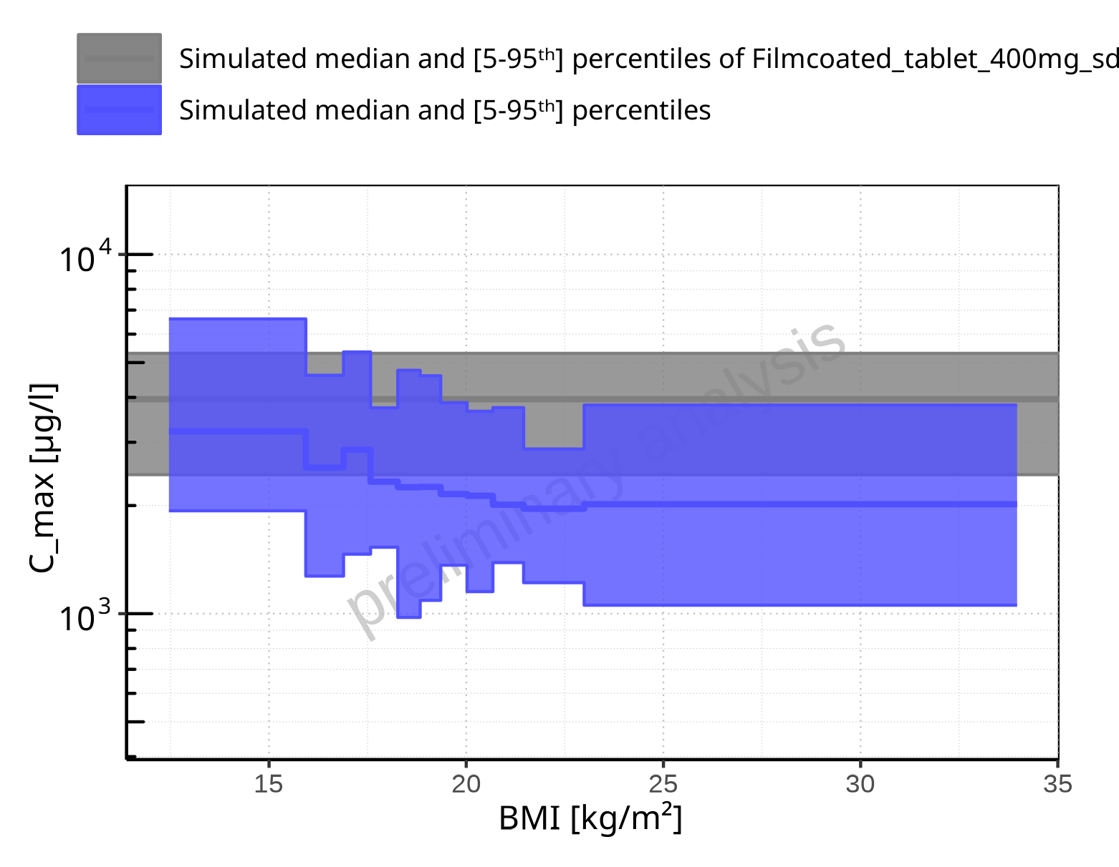

**Figure 2-21: BMI-dependence of C_max for Larson 2013 8y-18y 400mg FCT meal in comparison to Filmcoated_tablet_400mg_sd. Profiles are plotted in a logarithmic scale.**

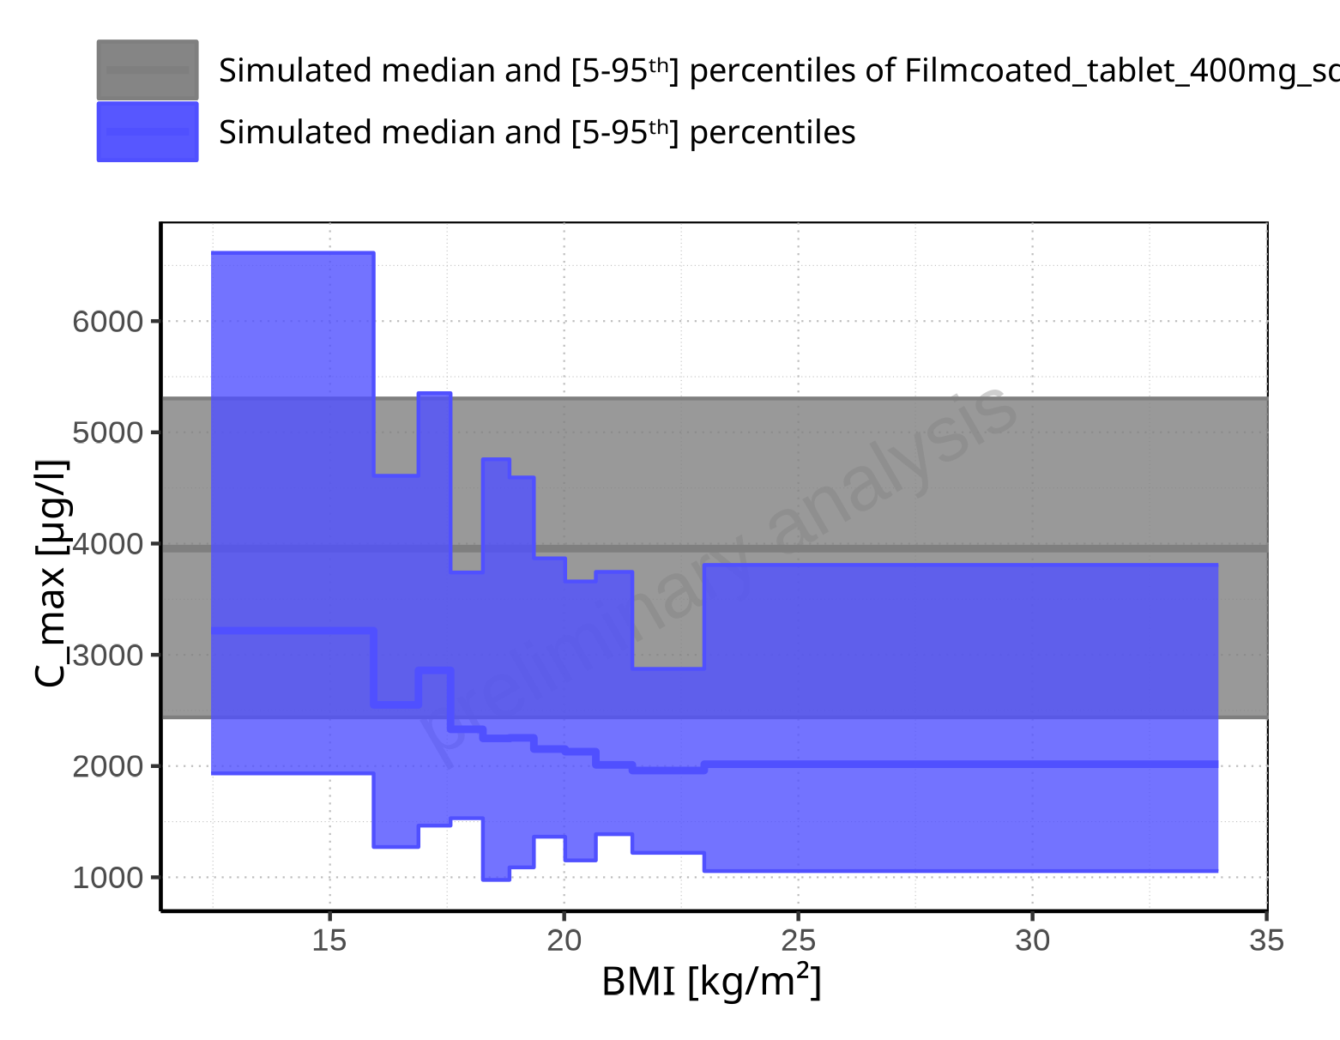

**Figure 2-22: BMI-dependence of C_max for Larson 2013 8y-18y 400mg FCT meal in comparison to Filmcoated_tablet_400mg_sd. Profiles are plotted in a linear scale.**

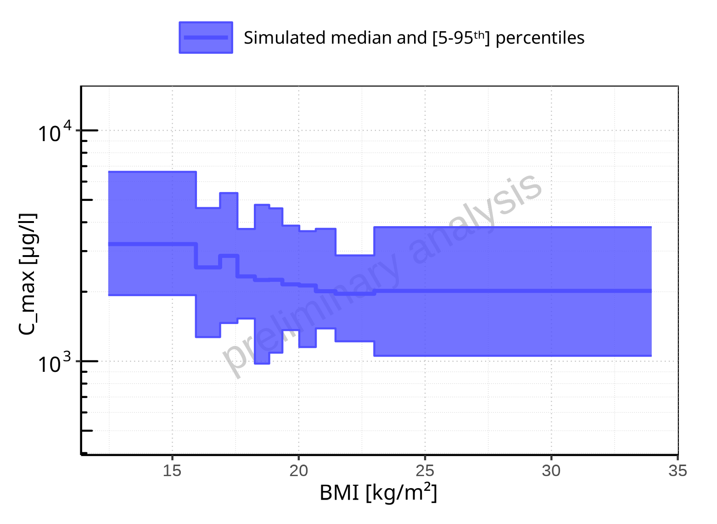

**Figure 2-23: BMI-dependence of C_max for Larson 2013 8y-18y 400mg FCT meal. Profiles are plotted in a logarithmic scale.**

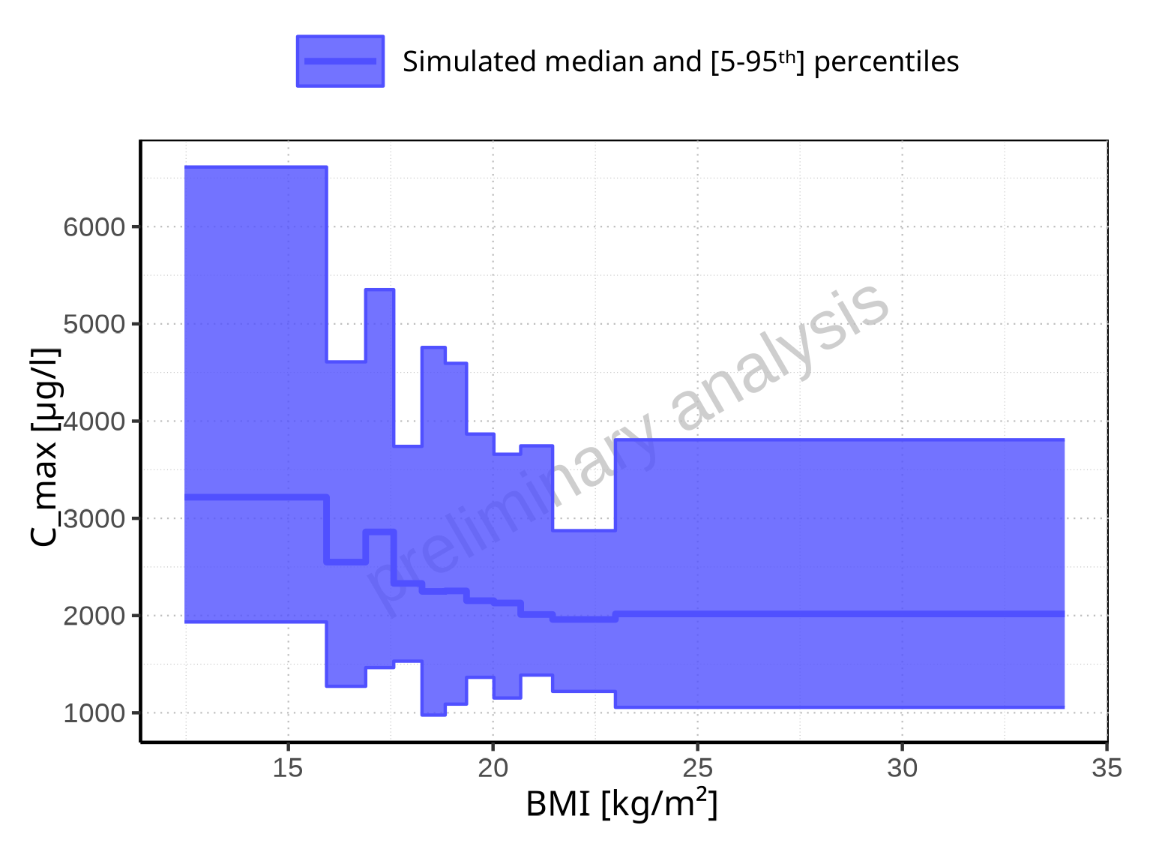

**Figure 2-24: BMI-dependence of C_max for Larson 2013 8y-18y 400mg FCT meal. Profiles are plotted in a linear scale.**

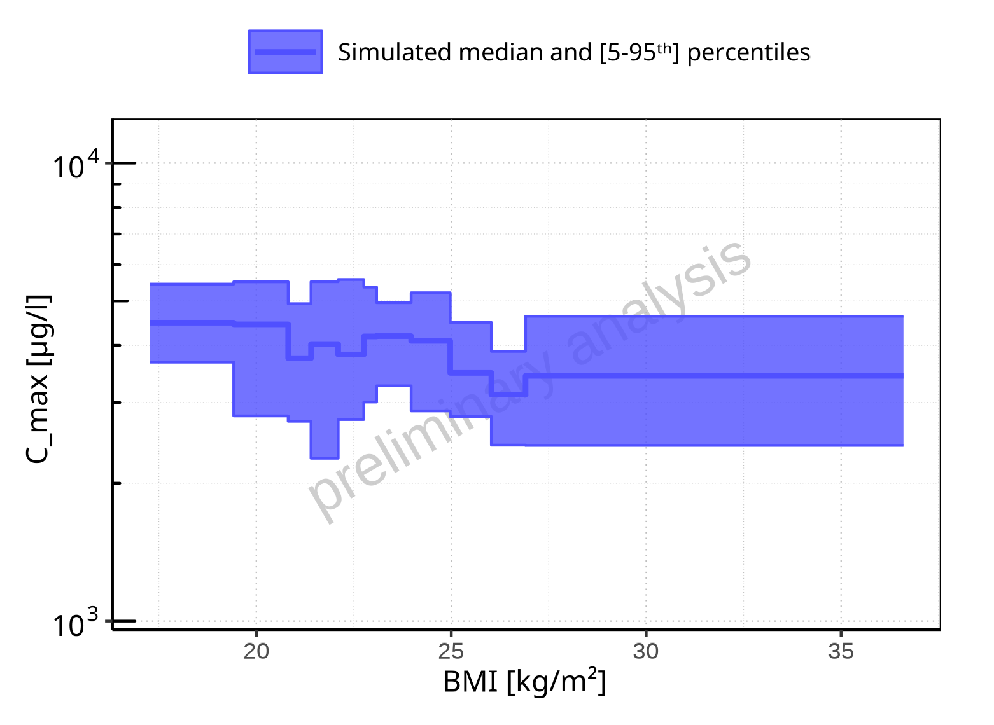

**Figure 2-25: BMI-dependence of C_max for Filmcoated_tablet_400mg_sd. Profiles are plotted in a logarithmic scale.**

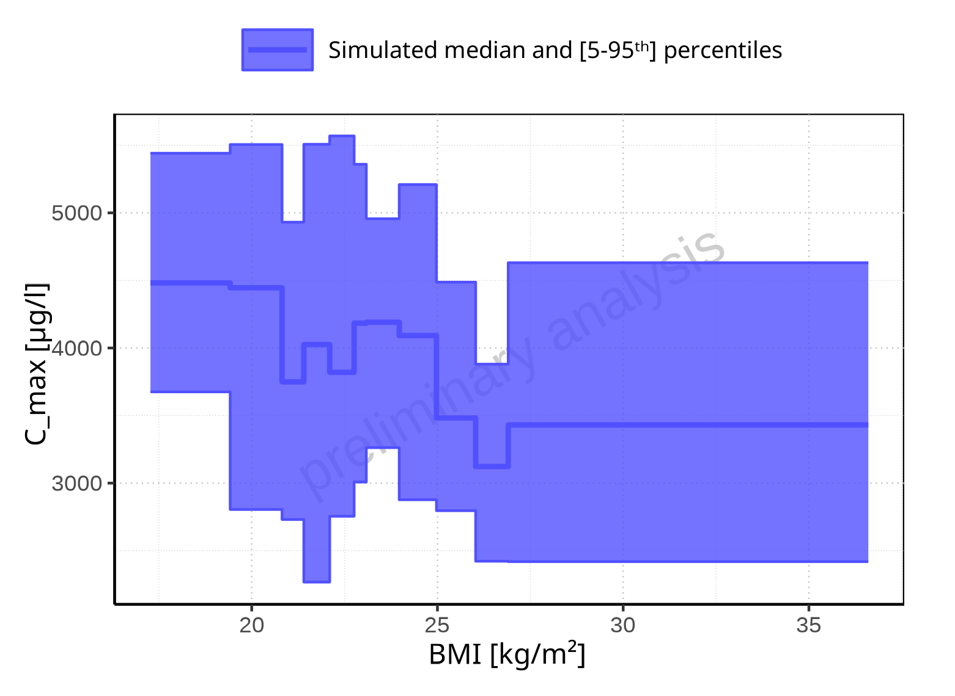

**Figure 2-26: BMI-dependence of C_max for Filmcoated_tablet_400mg_sd. Profiles are plotted in a linear scale.**

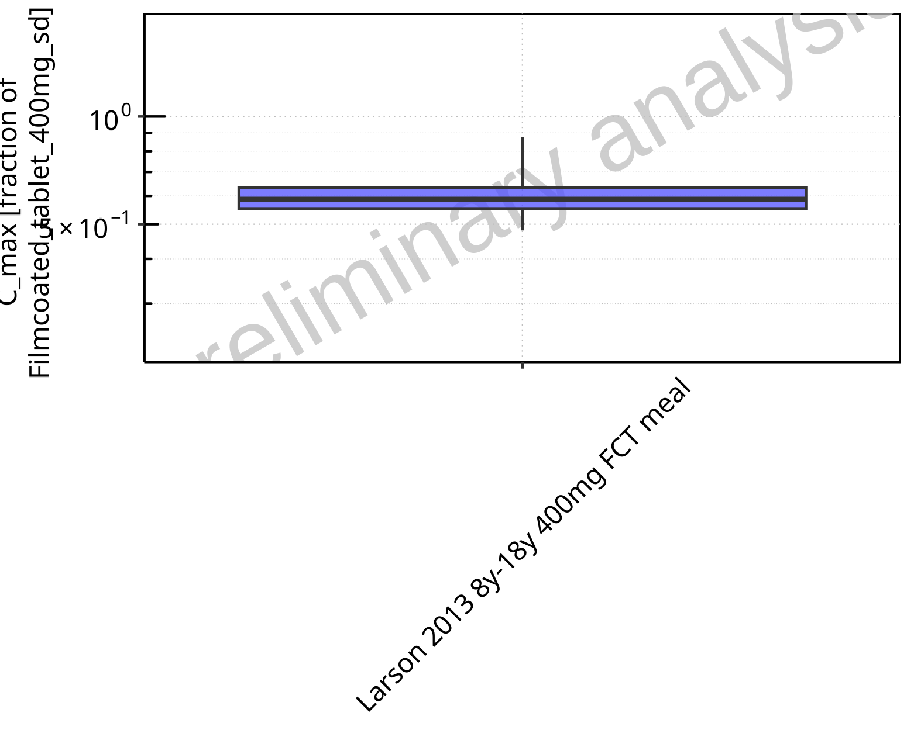

**Figure 2-27: Ratio of population summary statistics of C_max of Raltegravir for Larson 2013 8y-18y 400mg FCT meal in comparison to Filmcoated_tablet_400mg_sd shown as box-whisker plot, which indicates ratios of the 5th, 25th, 50th, 75th, 95th percentiles in logarithmic scale.**

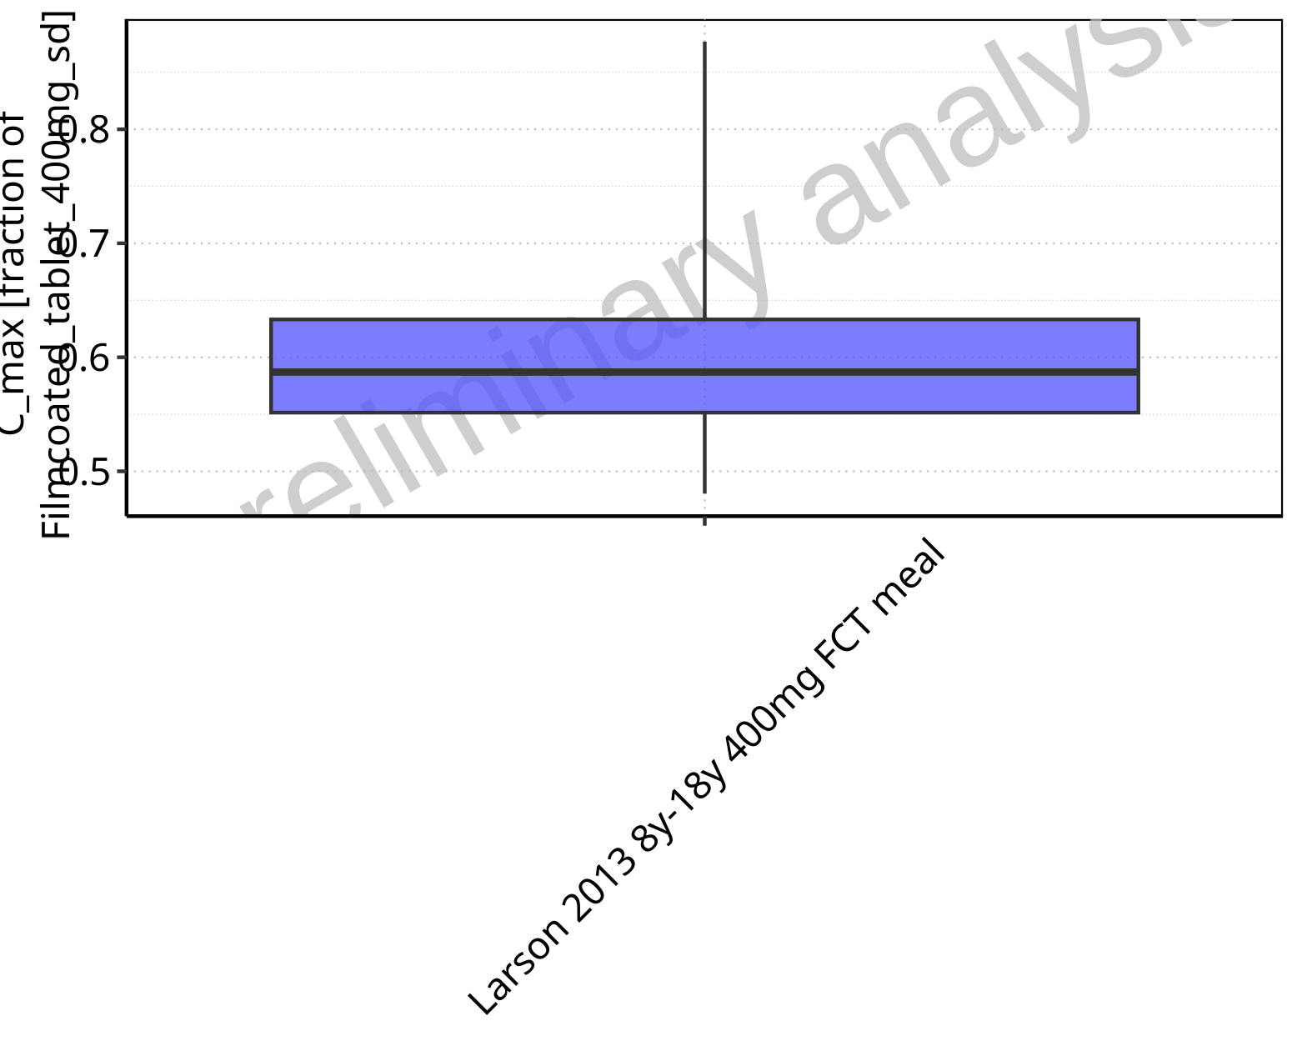

**Figure 2-28: Ratio of population summary statistics of C_max of Raltegravir for Larson 2013 8y-18y 400mg FCT meal in comparison to Filmcoated_tablet_400mg_sd shown as box-whisker plot, which indicates ratios of the 5th, 25th, 50th, 75th, 95th percentiles in linear scale.**

**Table 2-2: Ratio of population summary statistics of C_max of Raltegravir for Larson 2013 8y-18y 400mg FCT meal in comparison to Filmcoated_tablet_400mg_sd**

| Population | N | 5th pctl | 25th pctl | 50th pctl | 75th pctl | 95th pctl | Mean | SD | Geo Mean | Geo SD |
| --- | --- | --- | --- | --- | --- | --- | --- | --- | --- | --- |
| Larson 2013 8y-18y 400mg FCT meal | 500 | 0.48 | 0.55 | 0.59 | 0.63 | 0.88 | 0.65 | 1.33 | 0.61 | 1.20 |

### C_max_norm

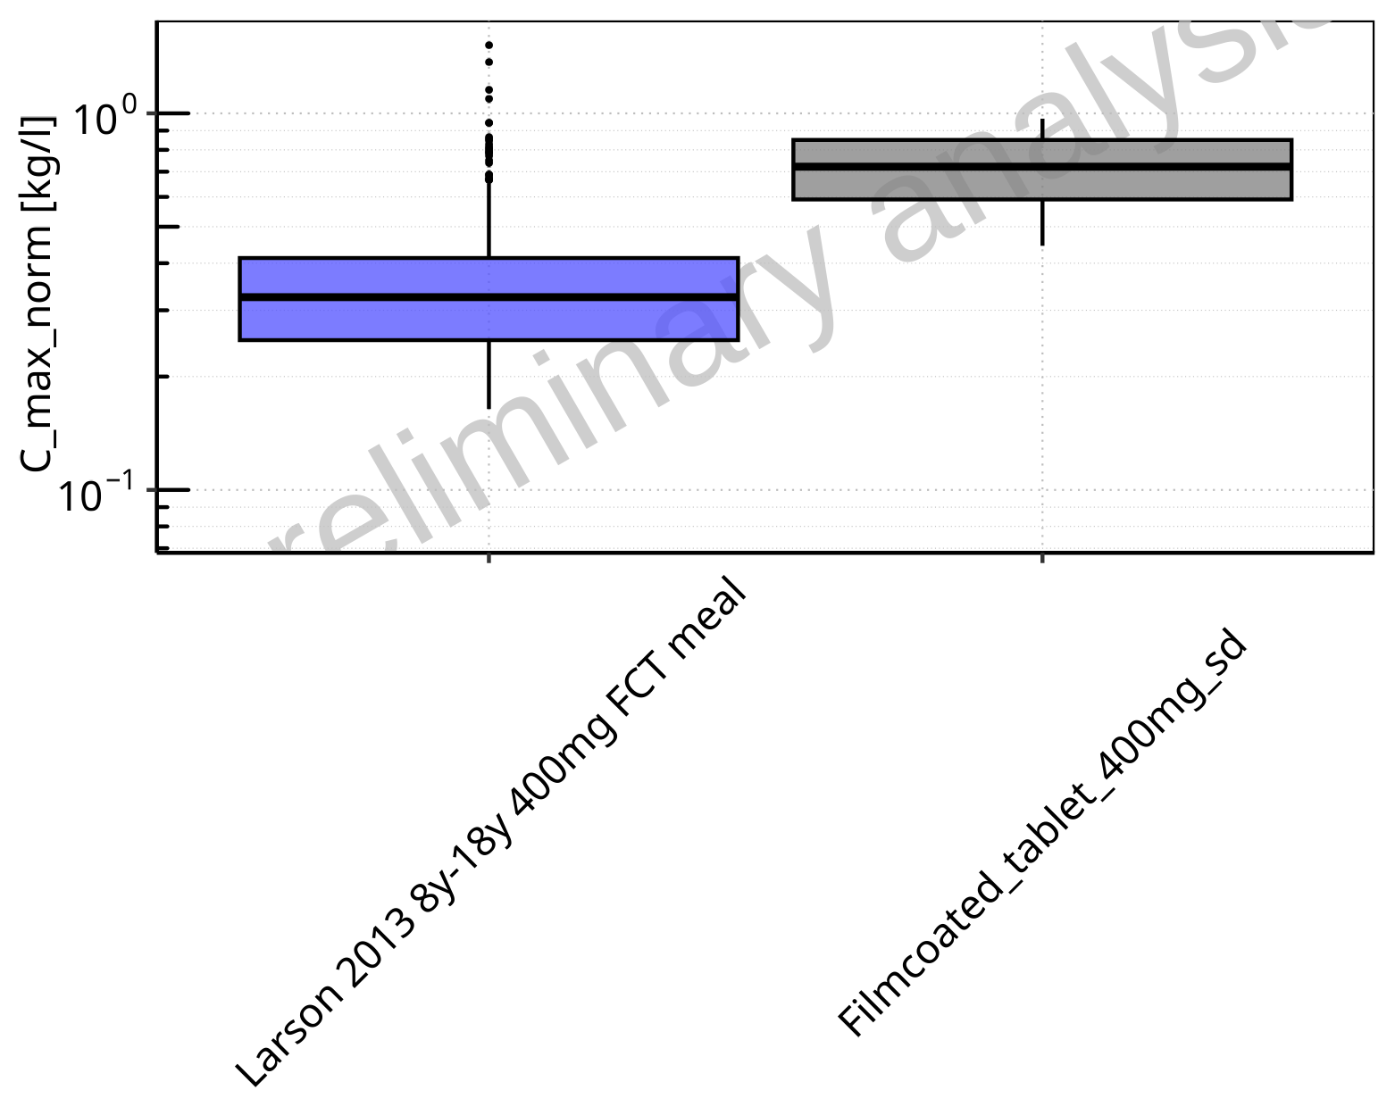

**Figure 2-29: C_max_norm of Raltegravir for Larson 2013 8y-18y 400mg FCT meal, Filmcoated_tablet_400mg_sd shown as box-whisker plot, which indicates the 5th, 25th, 50th, 75th, 95th percentiles in logarithmic scale.**

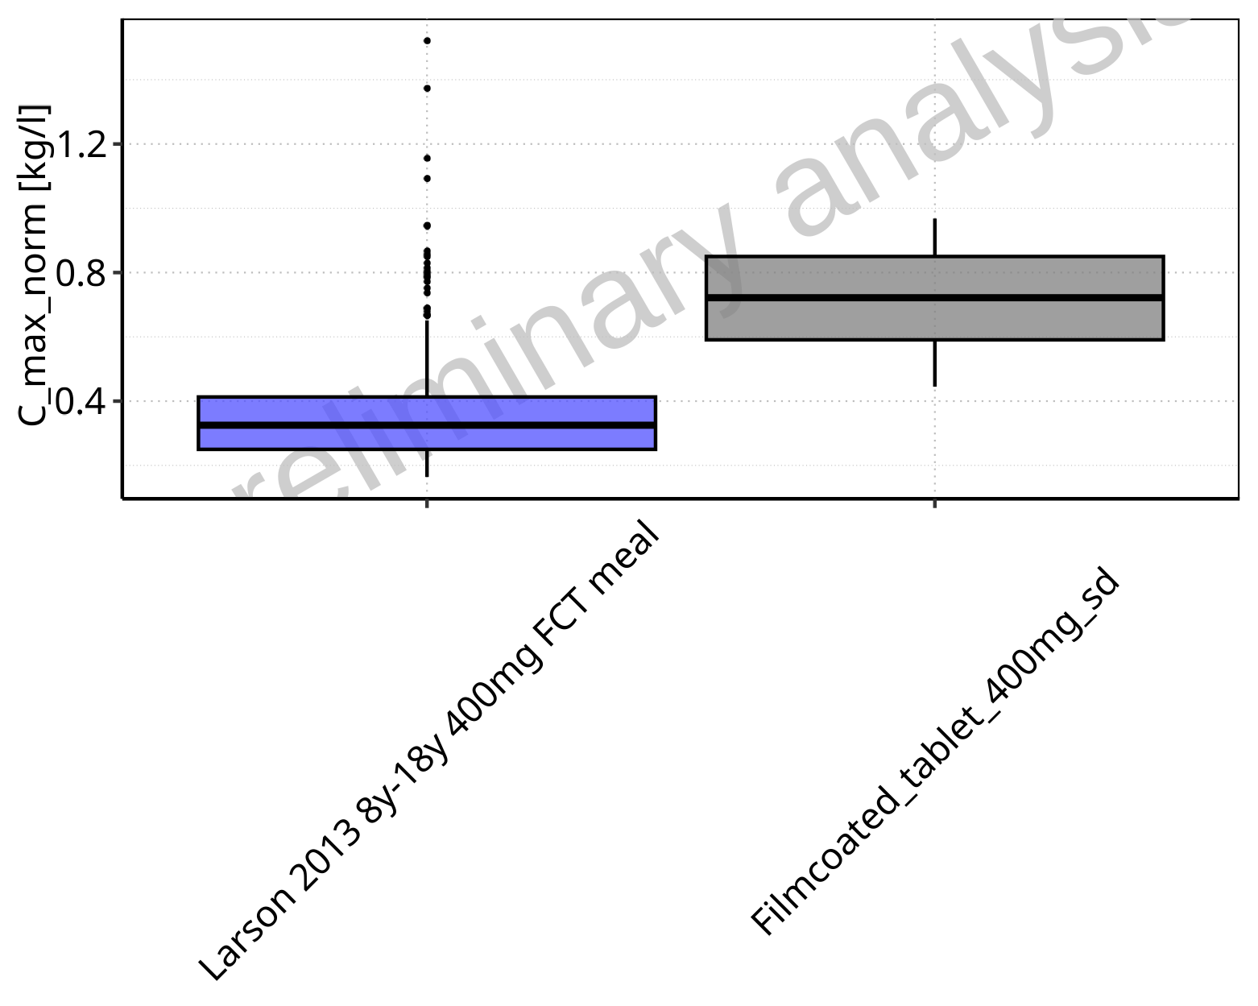

**Figure 2-30: C_max_norm of Raltegravir for Larson 2013 8y-18y 400mg FCT meal, Filmcoated_tablet_400mg_sd shown as box-whisker plot, which indicates the 5th, 25th, 50th, 75th, 95th percentiles in linear scale.**

**Table 2-3: Population statistics summarizing C_max_norm of Raltegravir for Larson 2013 8y-18y 400mg FCT meal, Filmcoated_tablet_400mg_sd reported in [kg/l]**

| Population | N | 5th pctl | 25th pctl | 50th pctl | 75th pctl | 95th pctl | Mean | SD | Geo Mean | Geo SD |
| --- | --- | --- | --- | --- | --- | --- | --- | --- | --- | --- |
| Larson 2013 8y-18y 400mg FCT meal | 500 | 0.16 | 0.25 | 0.33 | 0.41 | 0.65 | 0.36 | 0.17 | 0.33 | 1.52 |
| Filmcoated_tablet_400mg_sd | 100 | 0.44 | 0.59 | 0.72 | 0.85 | 0.97 | 0.72 | 0.17 | 0.70 | 1.27 |

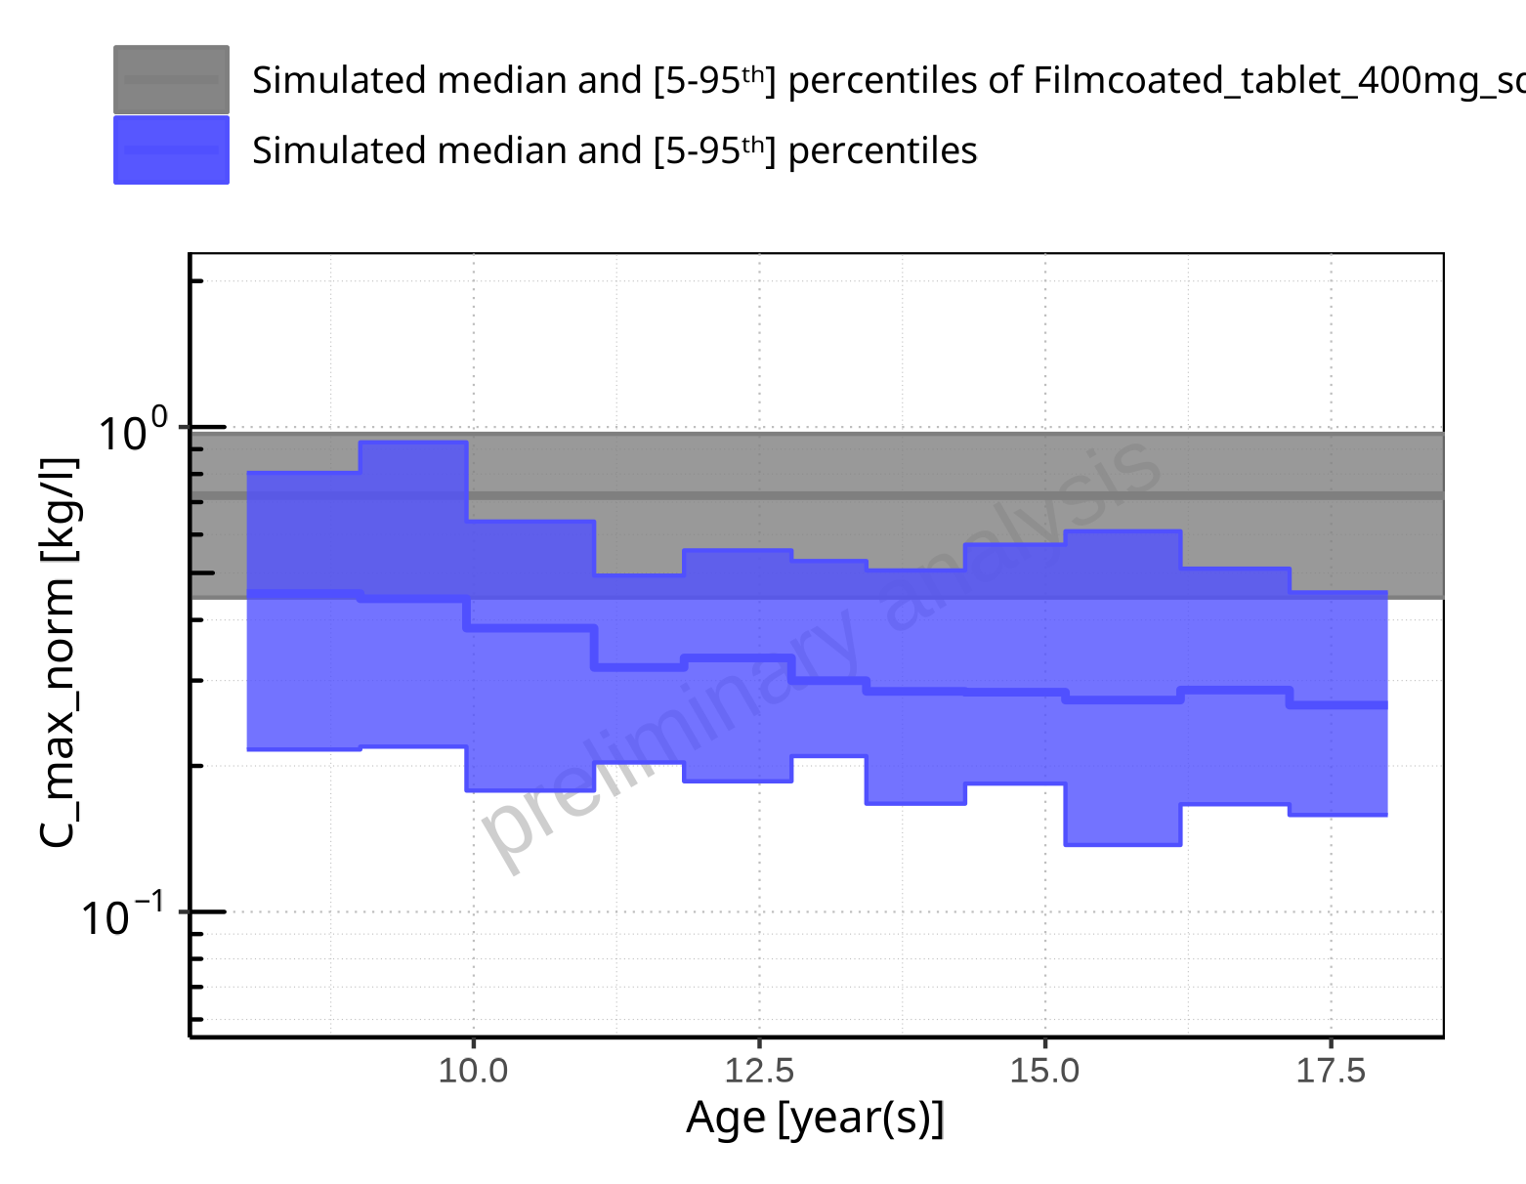

**Figure 2-31: Age-dependence of C_max_norm for Larson 2013 8y-18y 400mg FCT meal in comparison to Filmcoated_tablet_400mg_sd. Profiles are plotted in a logarithmic scale.**

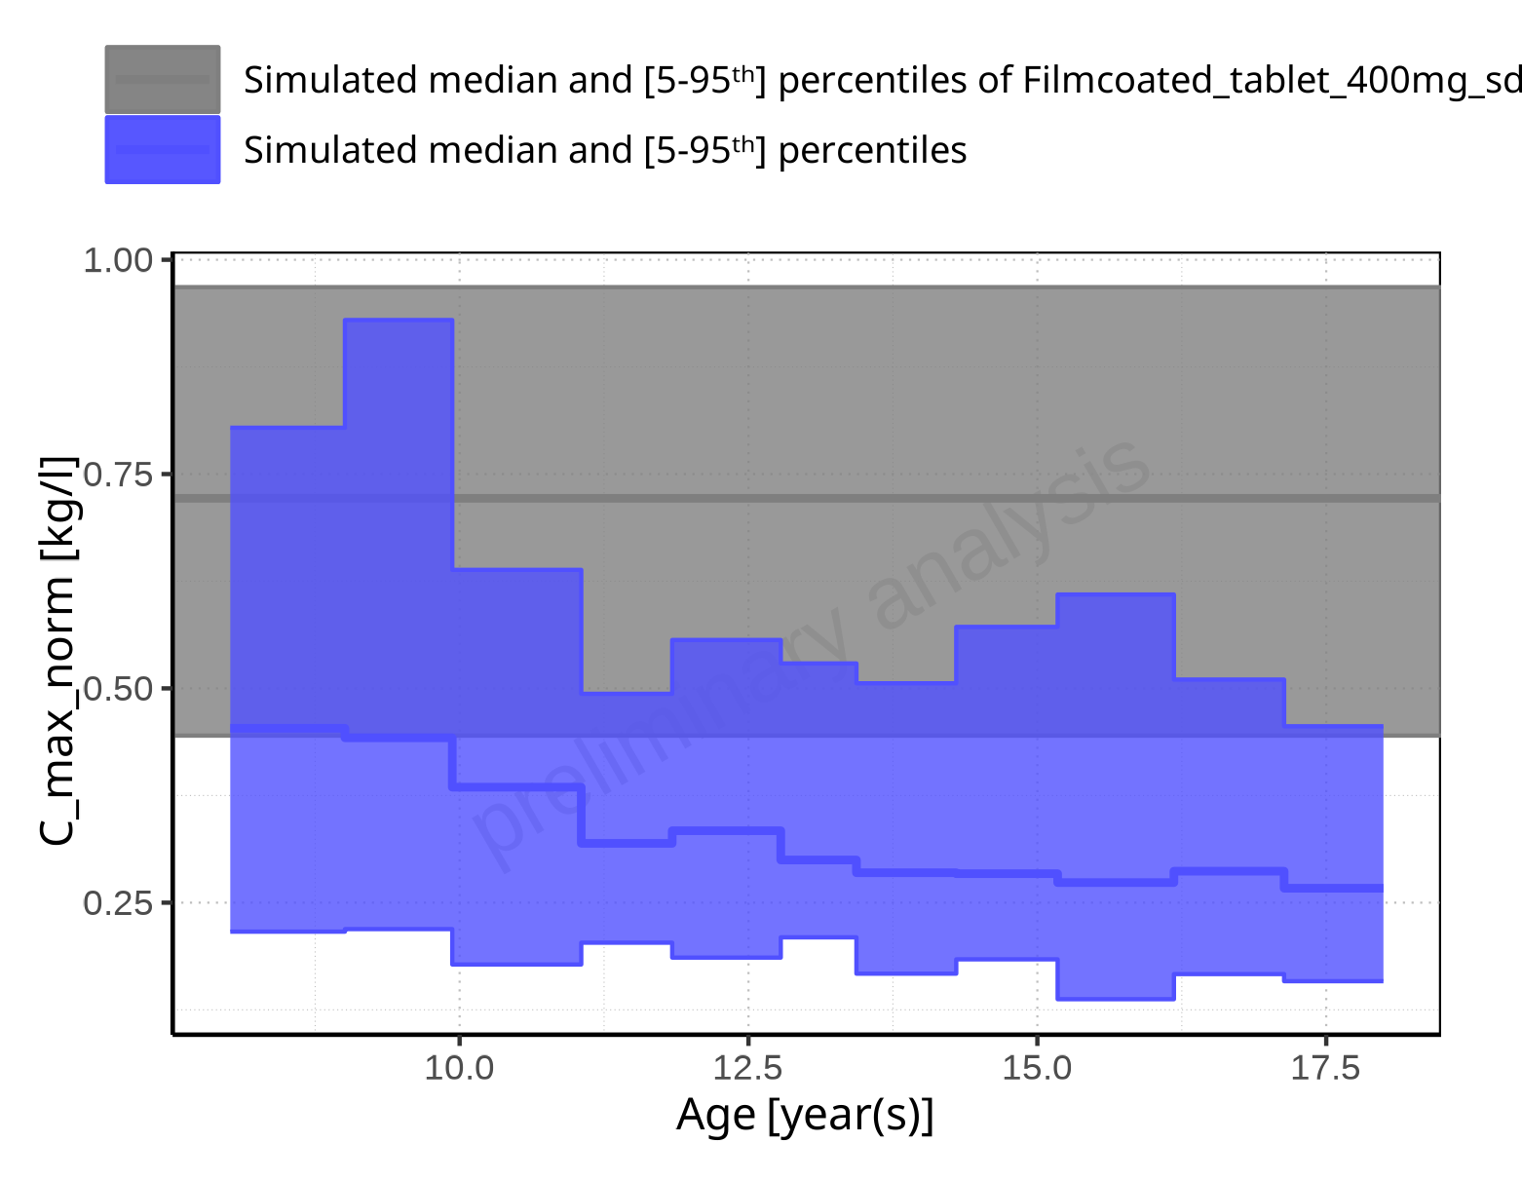

**Figure 2-32: Age-dependence of C_max_norm for Larson 2013 8y-18y 400mg FCT meal in comparison to Filmcoated_tablet_400mg_sd. Profiles are plotted in a linear scale.**

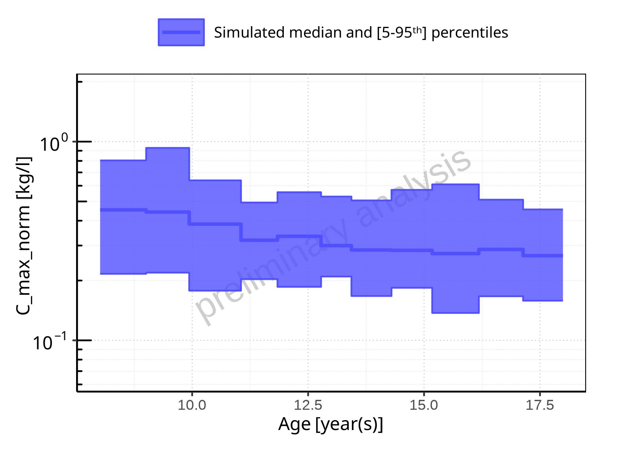

**Figure 2-33: Age-dependence of C_max_norm for Larson 2013 8y-18y 400mg FCT meal. Profiles are plotted in a logarithmic scale.**

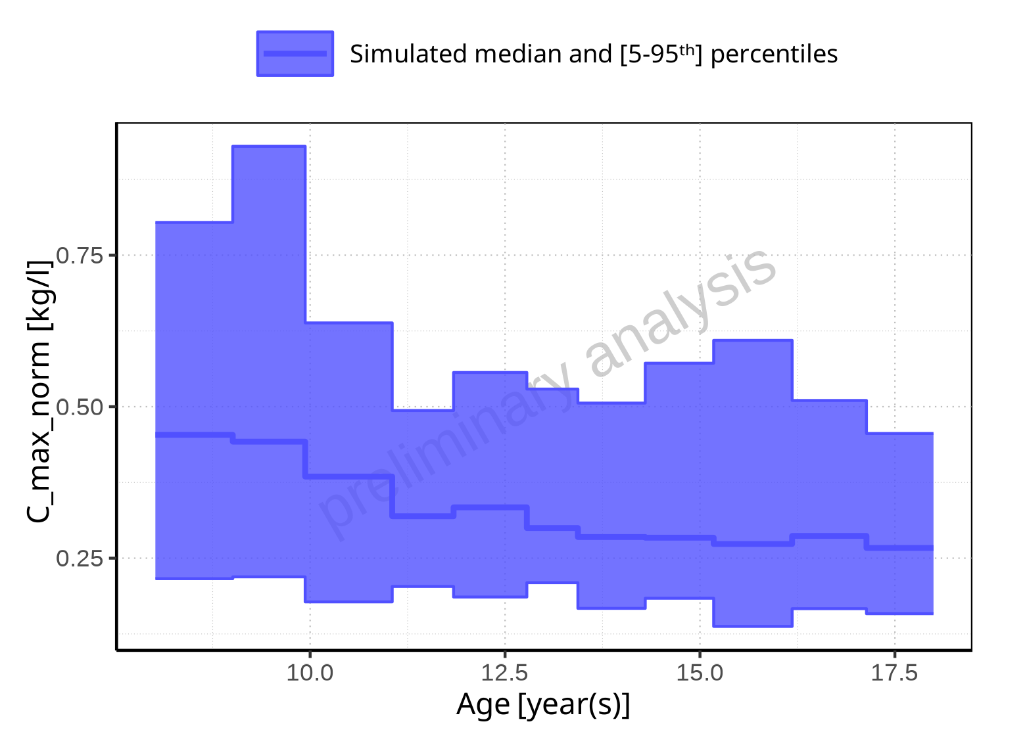

**Figure 2-34: Age-dependence of C_max_norm for Larson 2013 8y-18y 400mg FCT meal. Profiles are plotted in a linear scale.**

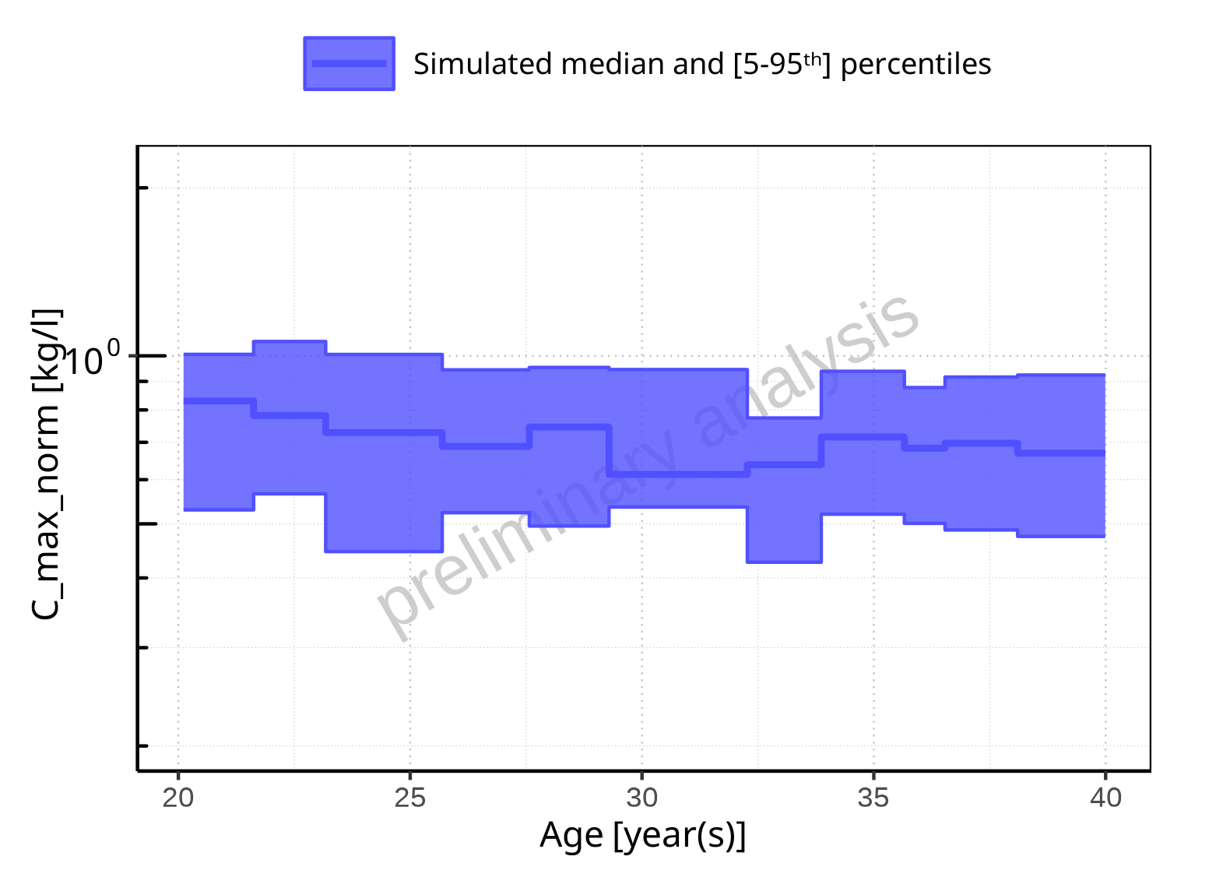

**Figure 2-35: Age-dependence of C_max_norm for Filmcoated_tablet_400mg_sd. Profiles are plotted in a logarithmic scale.**

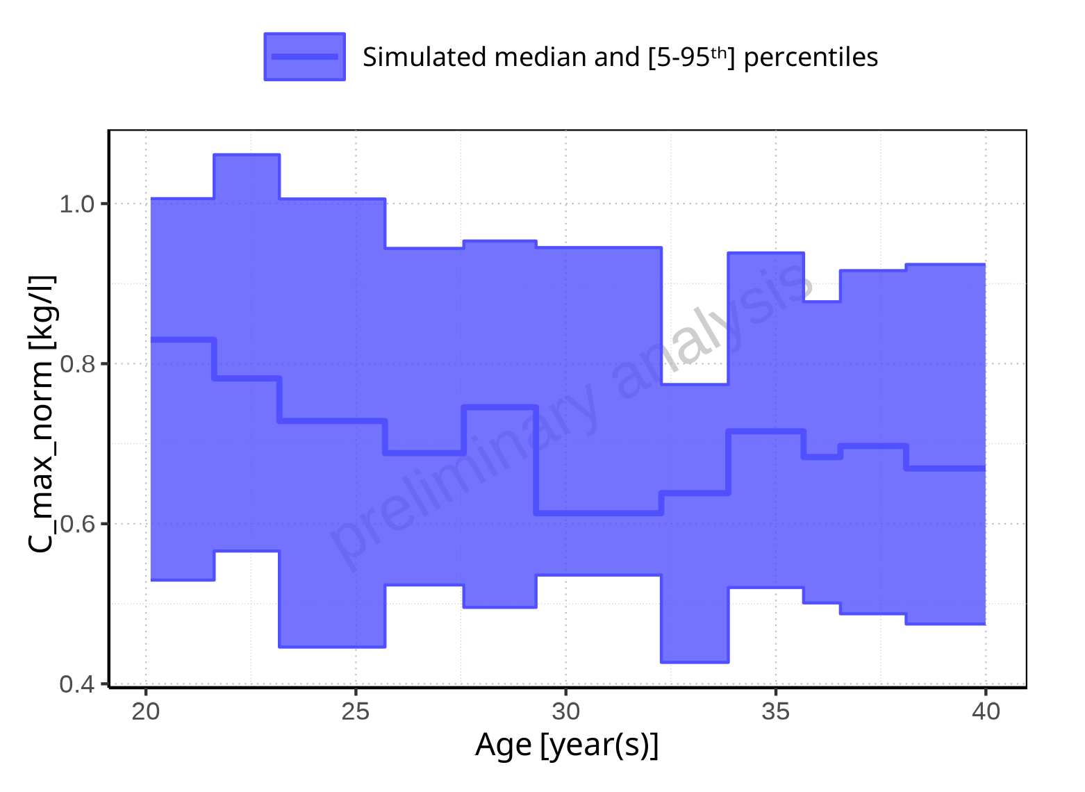

**Figure 2-36: Age-dependence of C_max_norm for Filmcoated_tablet_400mg_sd. Profiles are plotted in a linear scale.**

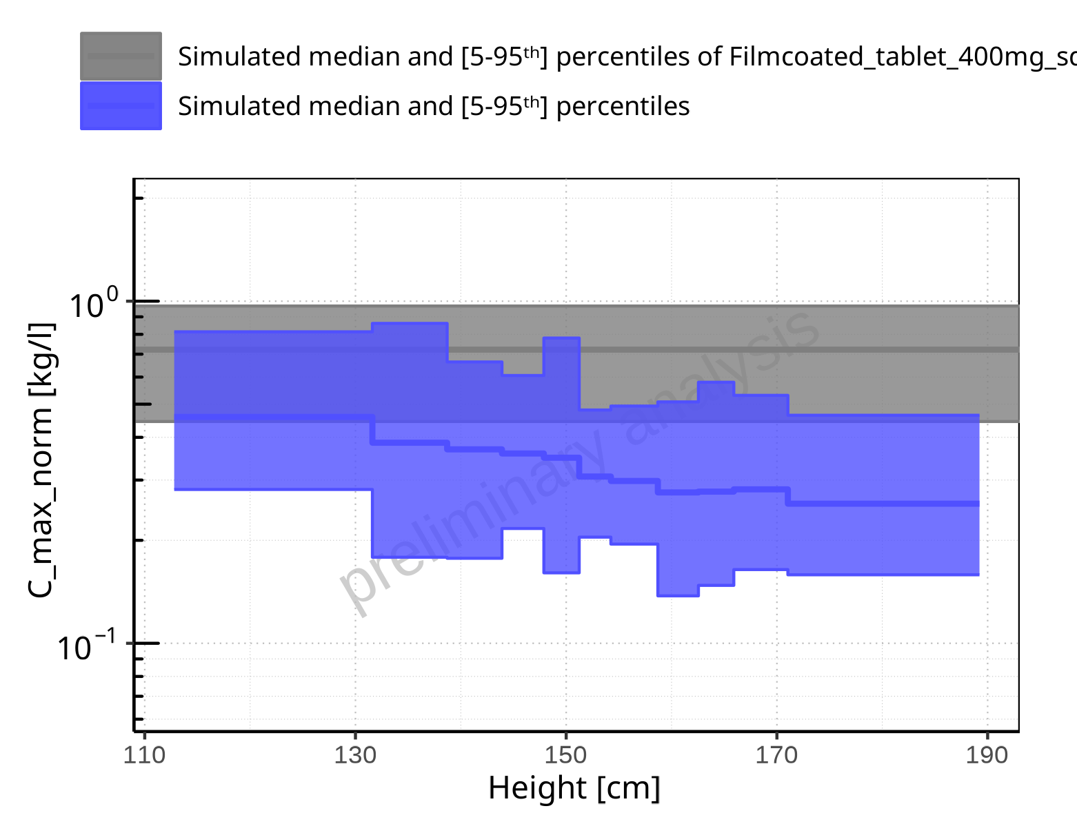

**Figure 2-37: Height-dependence of C_max_norm for Larson 2013 8y-18y 400mg FCT meal in comparison to Filmcoated_tablet_400mg_sd. Profiles are plotted in a logarithmic scale.**

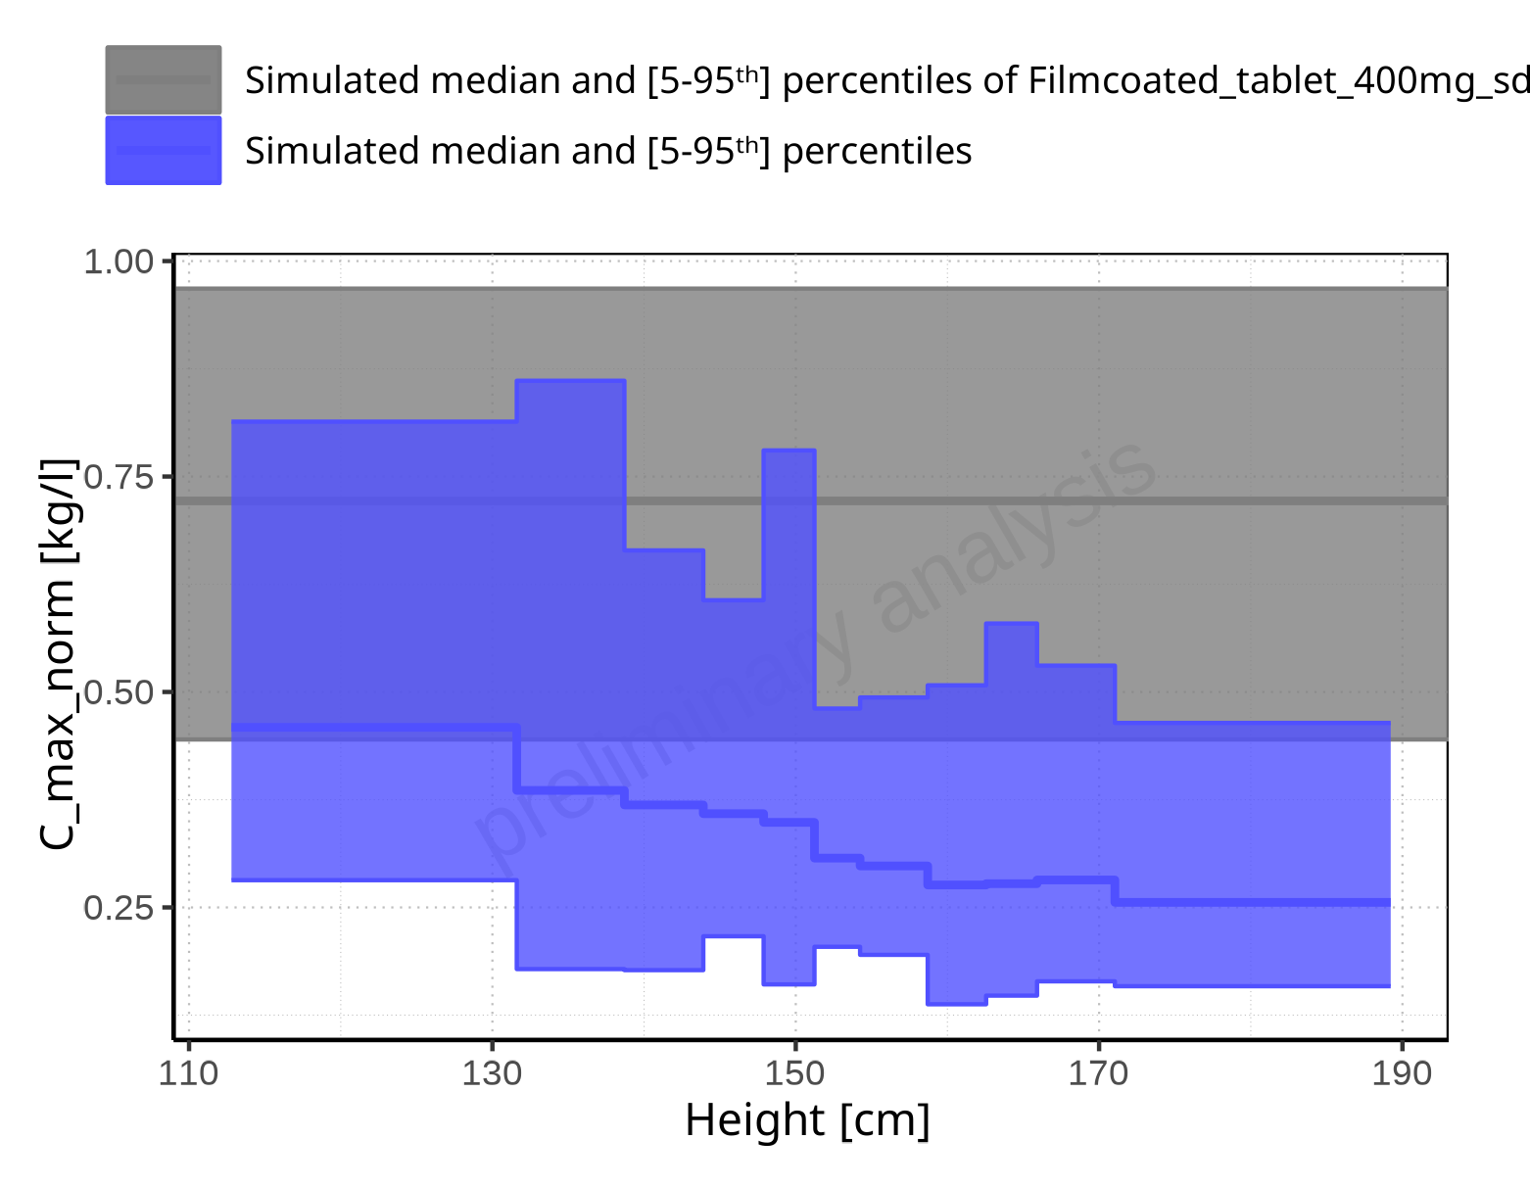

**Figure 2-38: Height-dependence of C_max_norm for Larson 2013 8y-18y 400mg FCT meal in comparison to Filmcoated_tablet_400mg_sd. Profiles are plotted in a linear scale.**

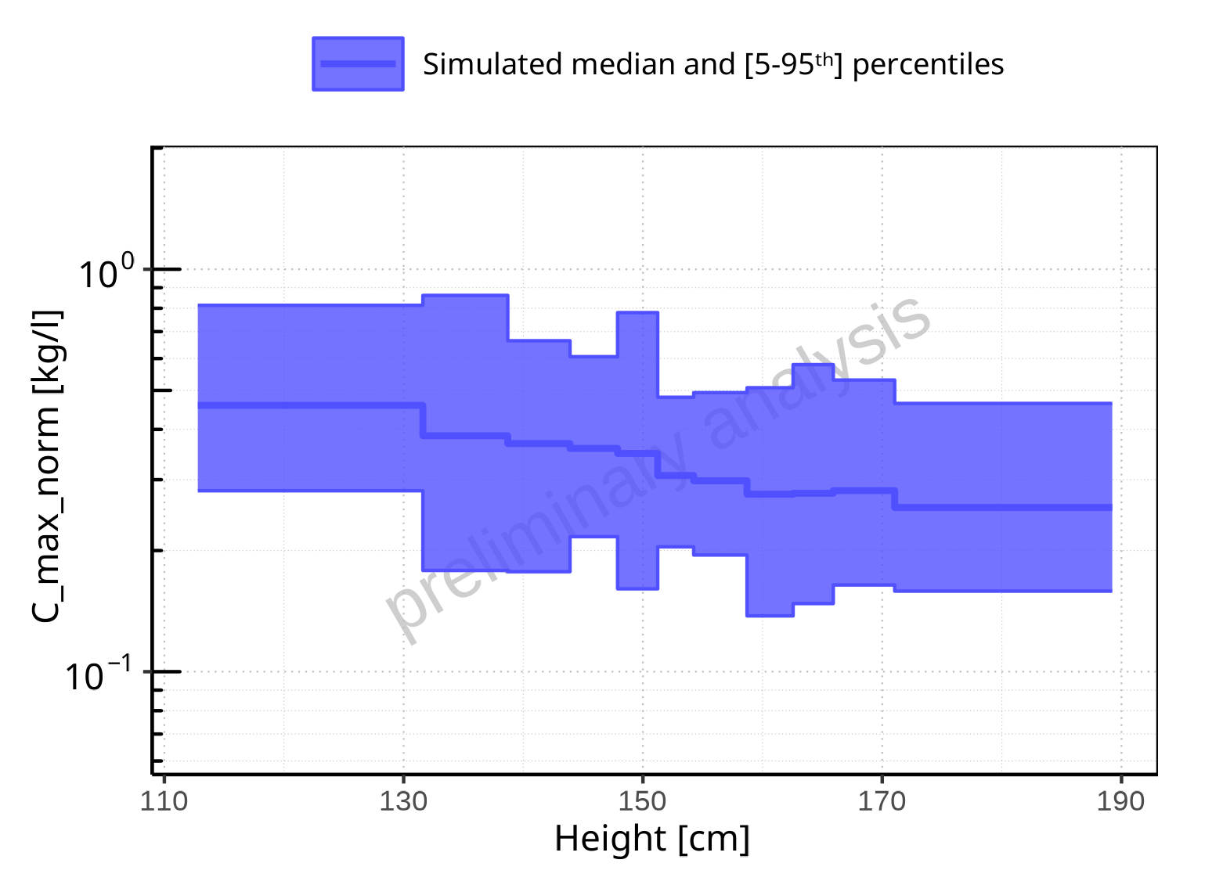

**Figure 2-39: Height-dependence of C_max_norm for Larson 2013 8y-18y 400mg FCT meal. Profiles are plotted in a logarithmic scale.**

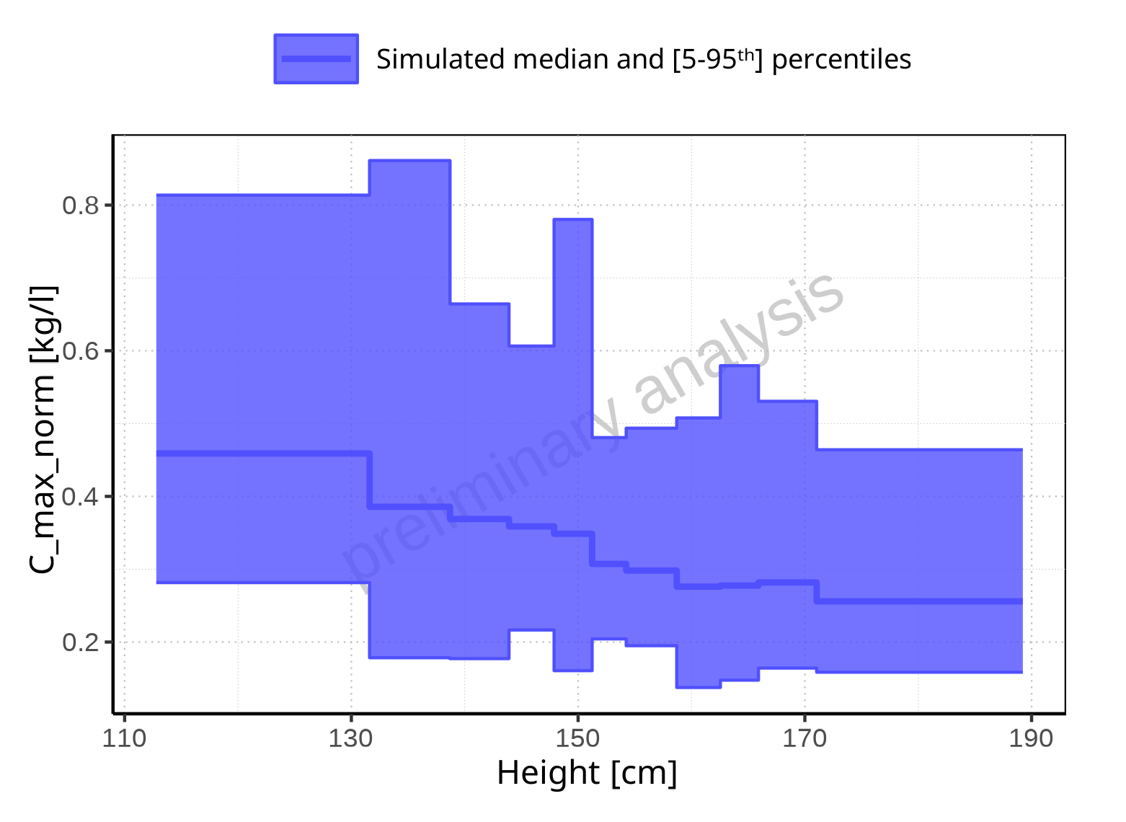

**Figure 2-40: Height-dependence of C_max_norm for Larson 2013 8y-18y 400mg FCT meal. Profiles are plotted in a linear scale.**

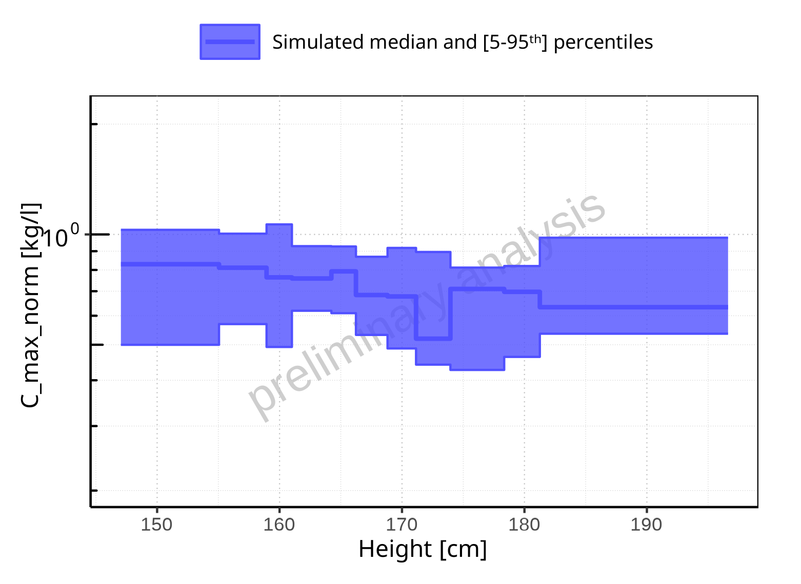

**Figure 2-41: Height-dependence of C_max_norm for Filmcoated_tablet_400mg_sd. Profiles are plotted in a logarithmic scale.**

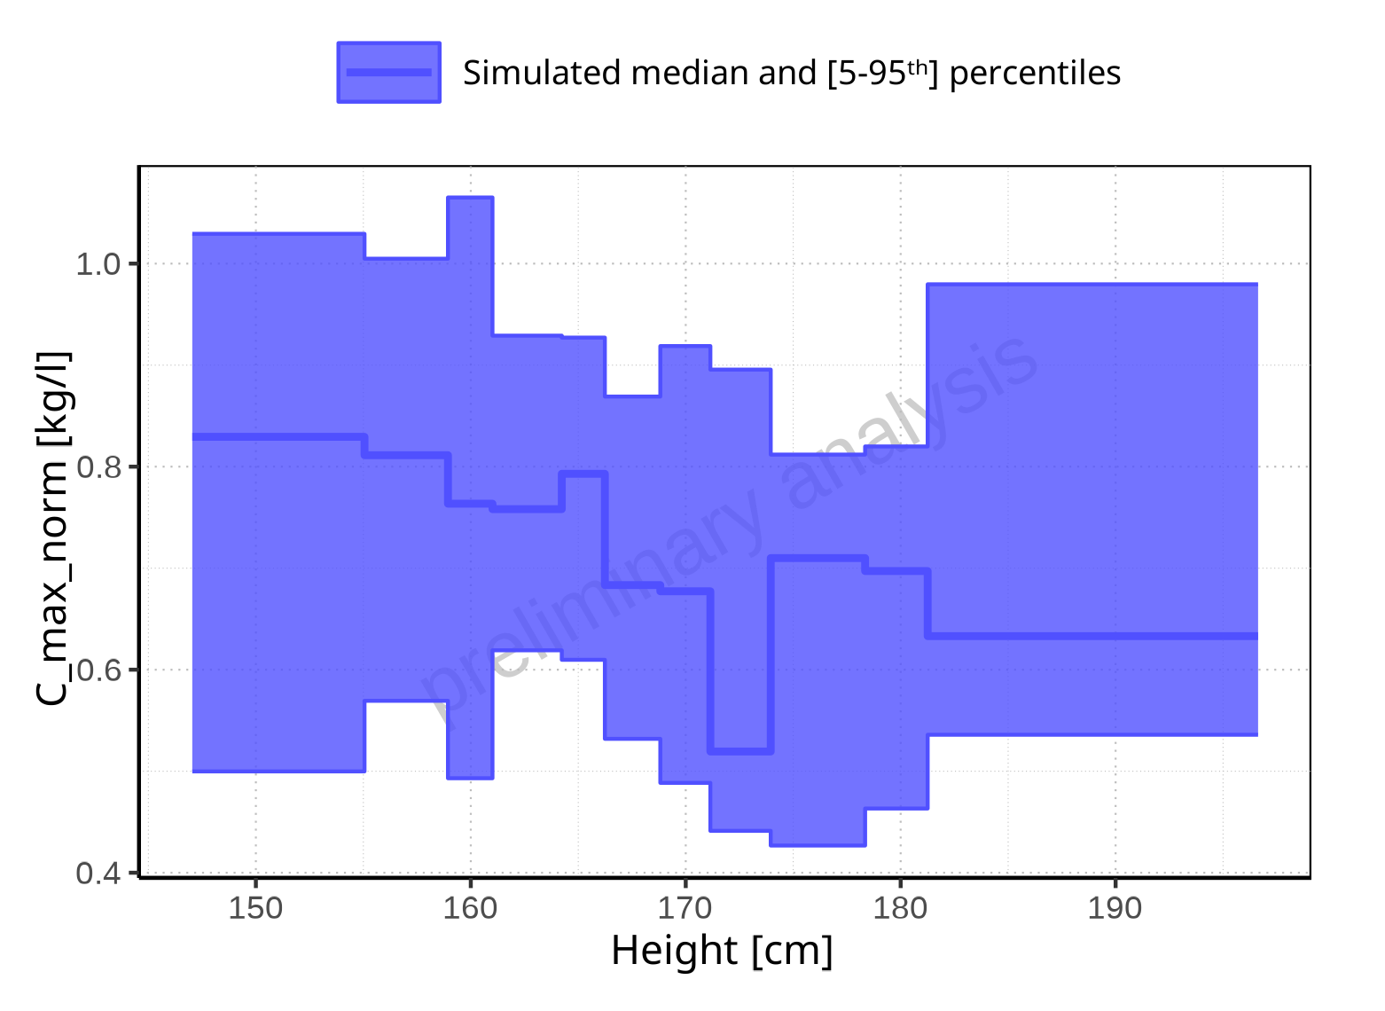

**Figure 2-42: Height-dependence of C_max_norm for Filmcoated_tablet_400mg_sd. Profiles are plotted in a linear scale.**

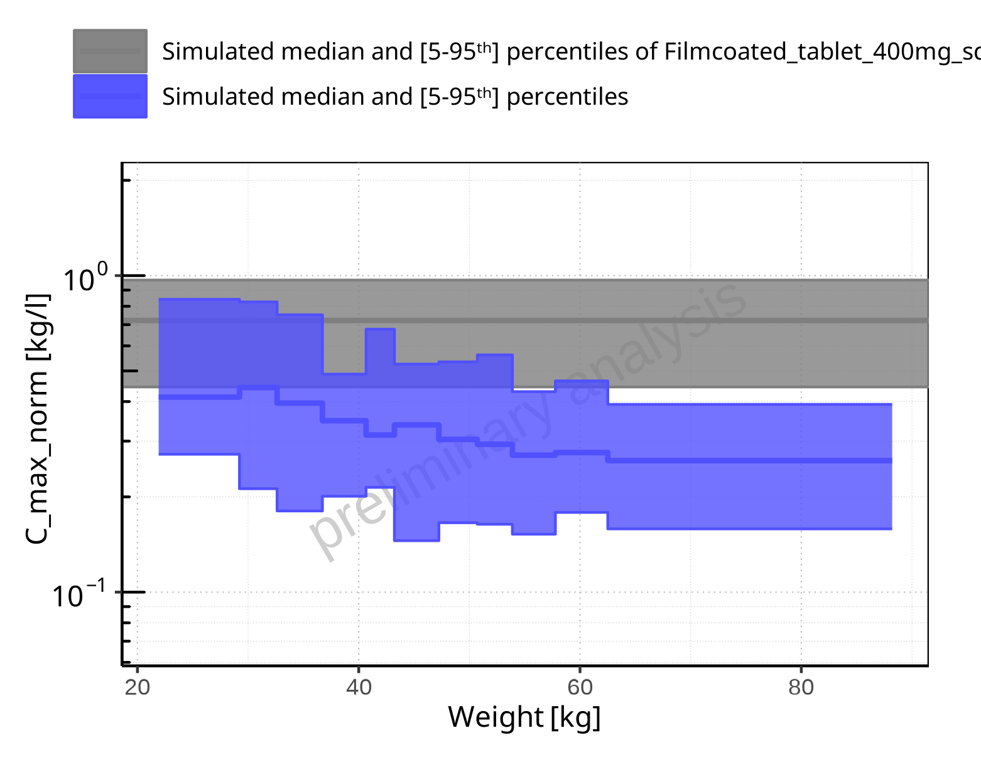

**Figure 2-43: Weight-dependence of C_max_norm for Larson 2013 8y-18y 400mg FCT meal in comparison to Filmcoated_tablet_400mg_sd. Profiles are plotted in a logarithmic scale.**

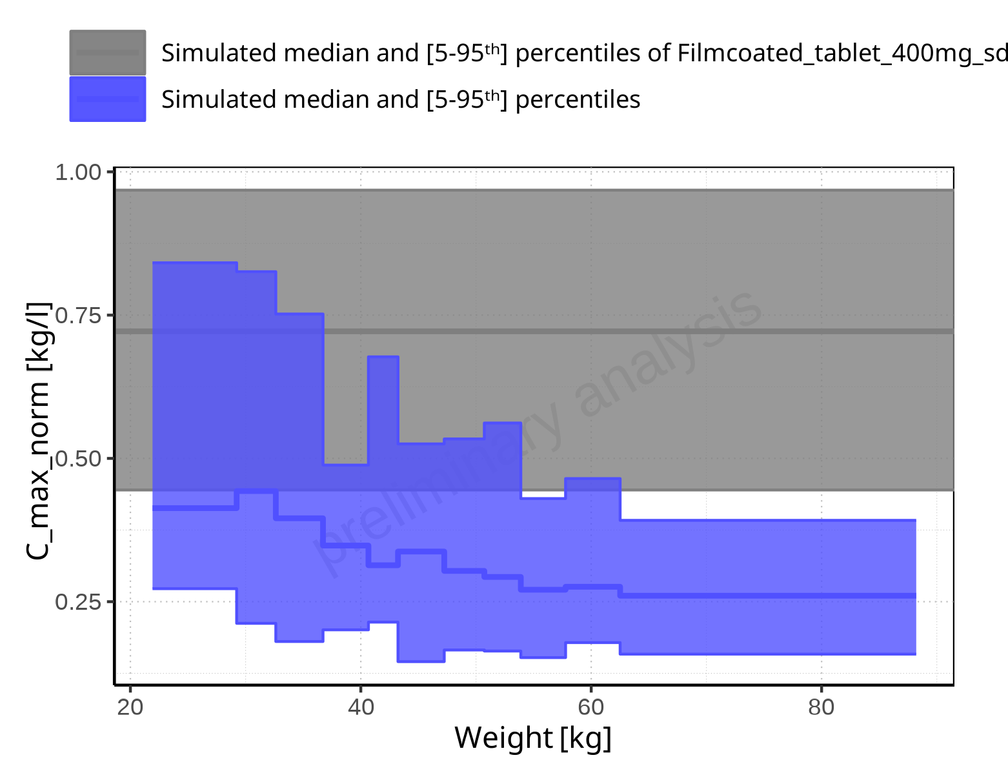

**Figure 2-44: Weight-dependence of C_max_norm for Larson 2013 8y-18y 400mg FCT meal in comparison to Filmcoated_tablet_400mg_sd. Profiles are plotted in a linear scale.**

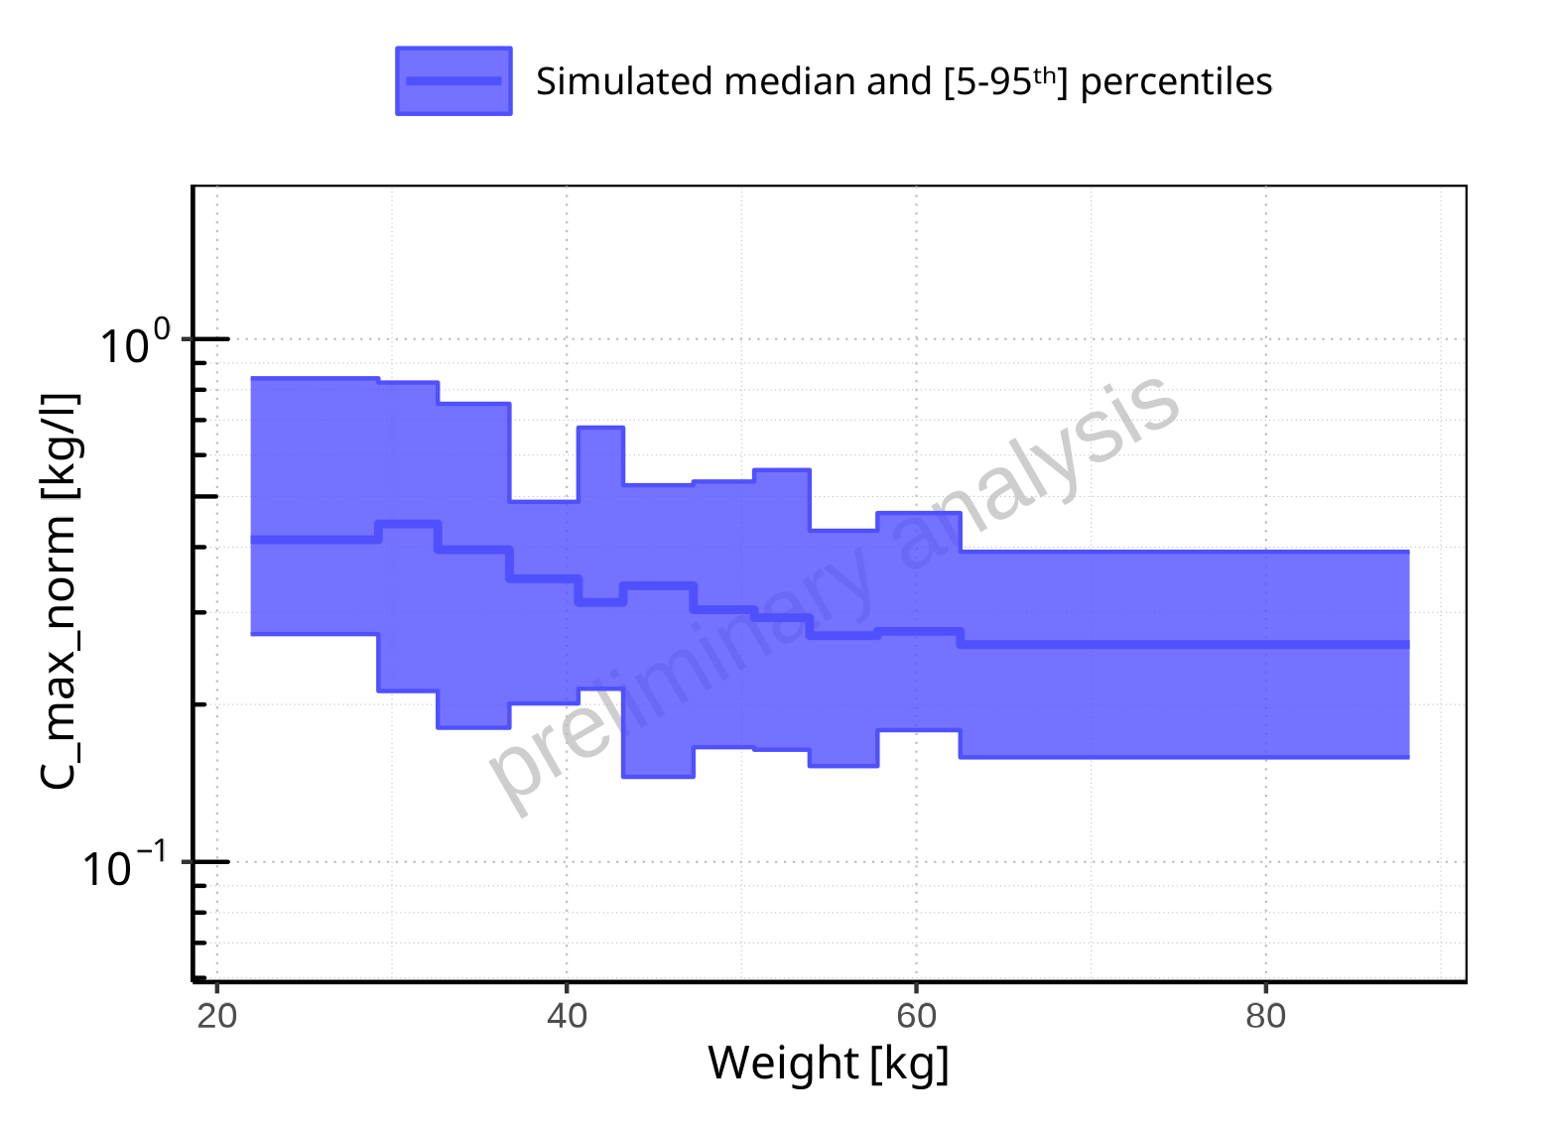

**Figure 2-45: Weight-dependence of C_max_norm for Larson 2013 8y-18y 400mg FCT meal. Profiles are plotted in a logarithmic scale.**

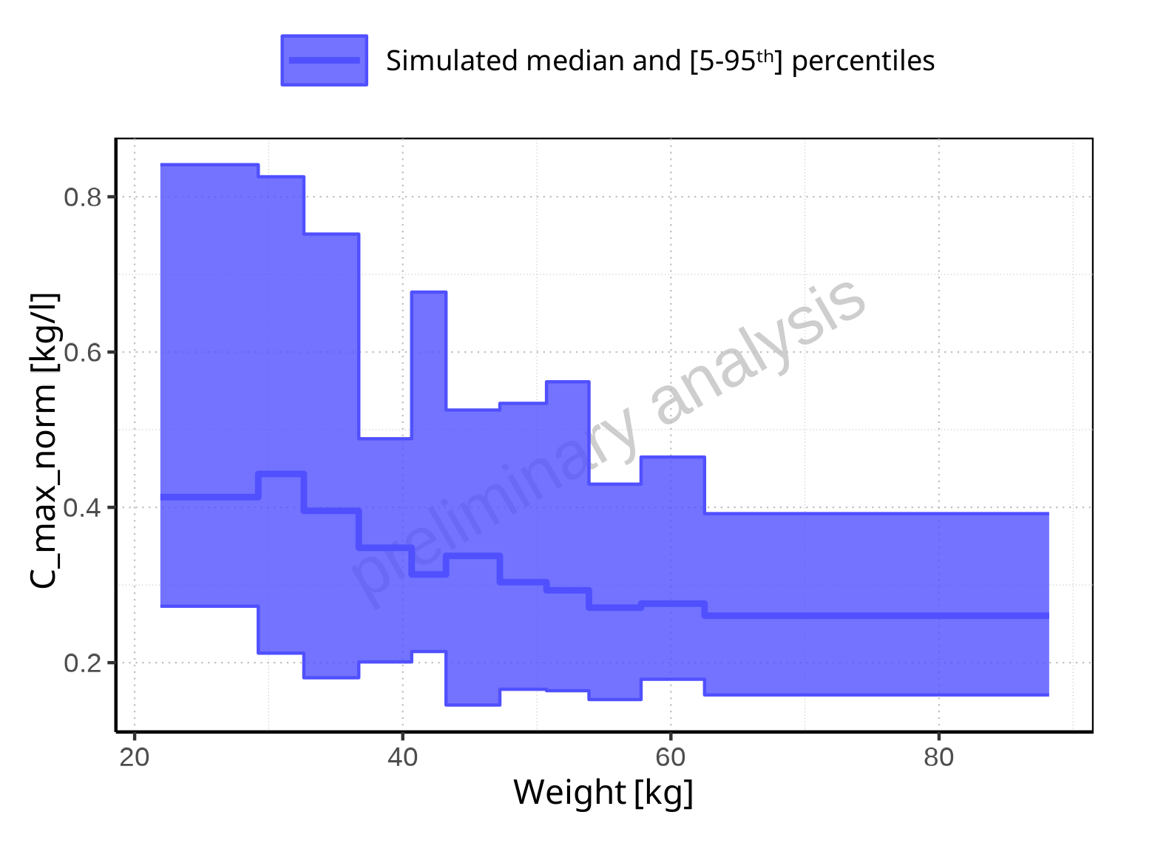

**Figure 2-46: Weight-dependence of C_max_norm for Larson 2013 8y-18y 400mg FCT meal. Profiles are plotted in a linear scale.**

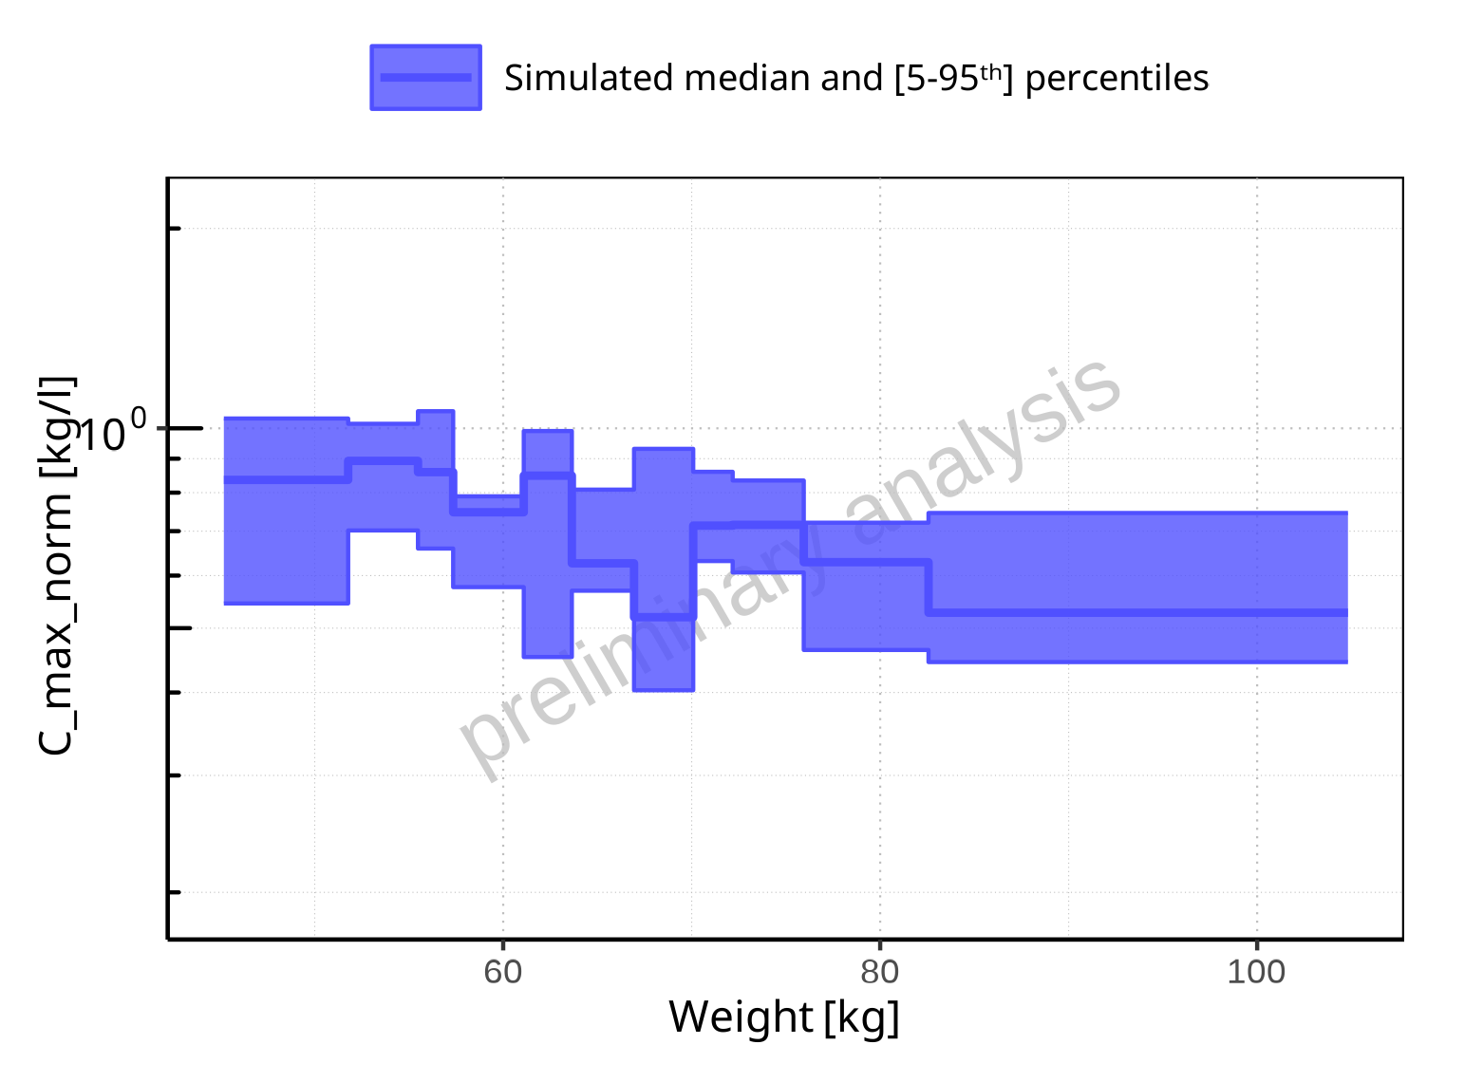

**Figure 2-47: Weight-dependence of C_max_norm for Filmcoated_tablet_400mg_sd. Profiles are plotted in a logarithmic scale.**

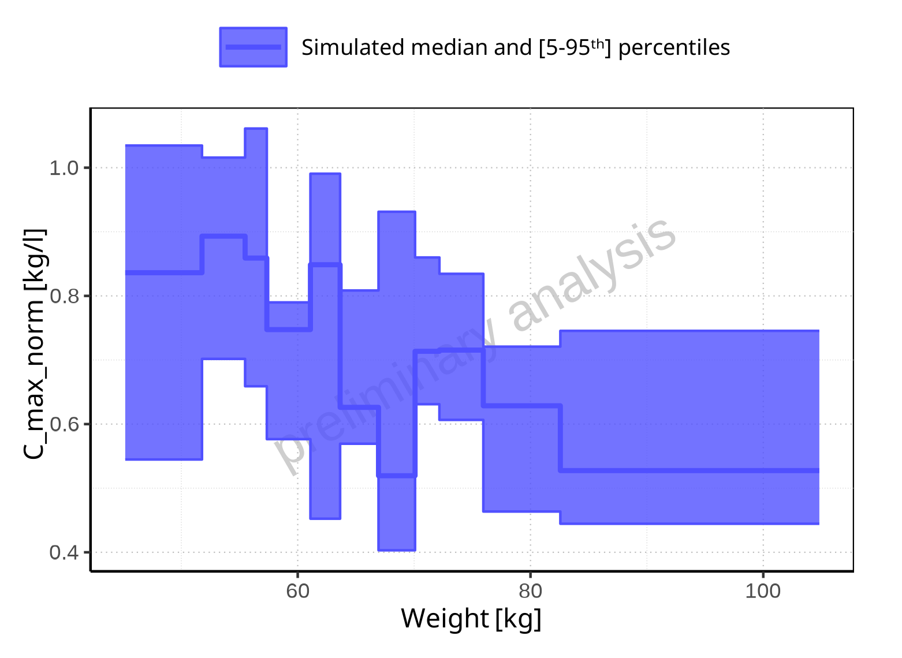

**Figure 2-48: Weight-dependence of C_max_norm for Filmcoated_tablet_400mg_sd. Profiles are plotted in a linear scale.**

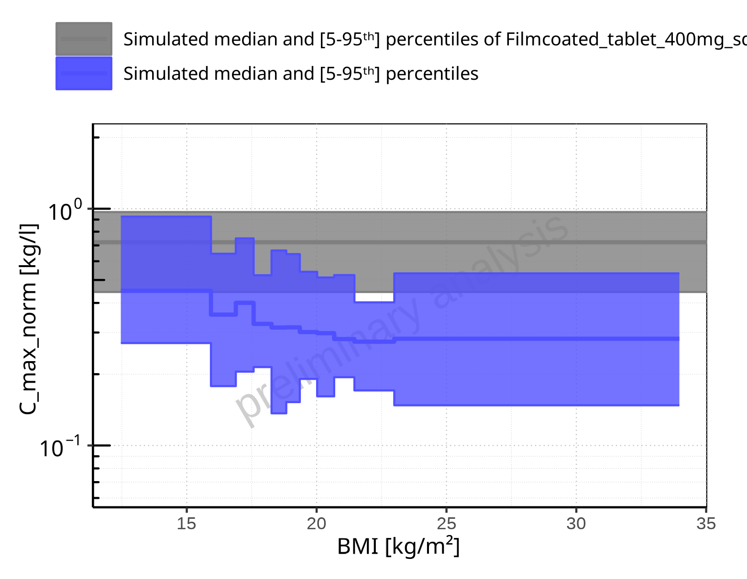

**Figure 2-49: BMI-dependence of C_max_norm for Larson 2013 8y-18y 400mg FCT meal in comparison to Filmcoated_tablet_400mg_sd. Profiles are plotted in a logarithmic scale.**

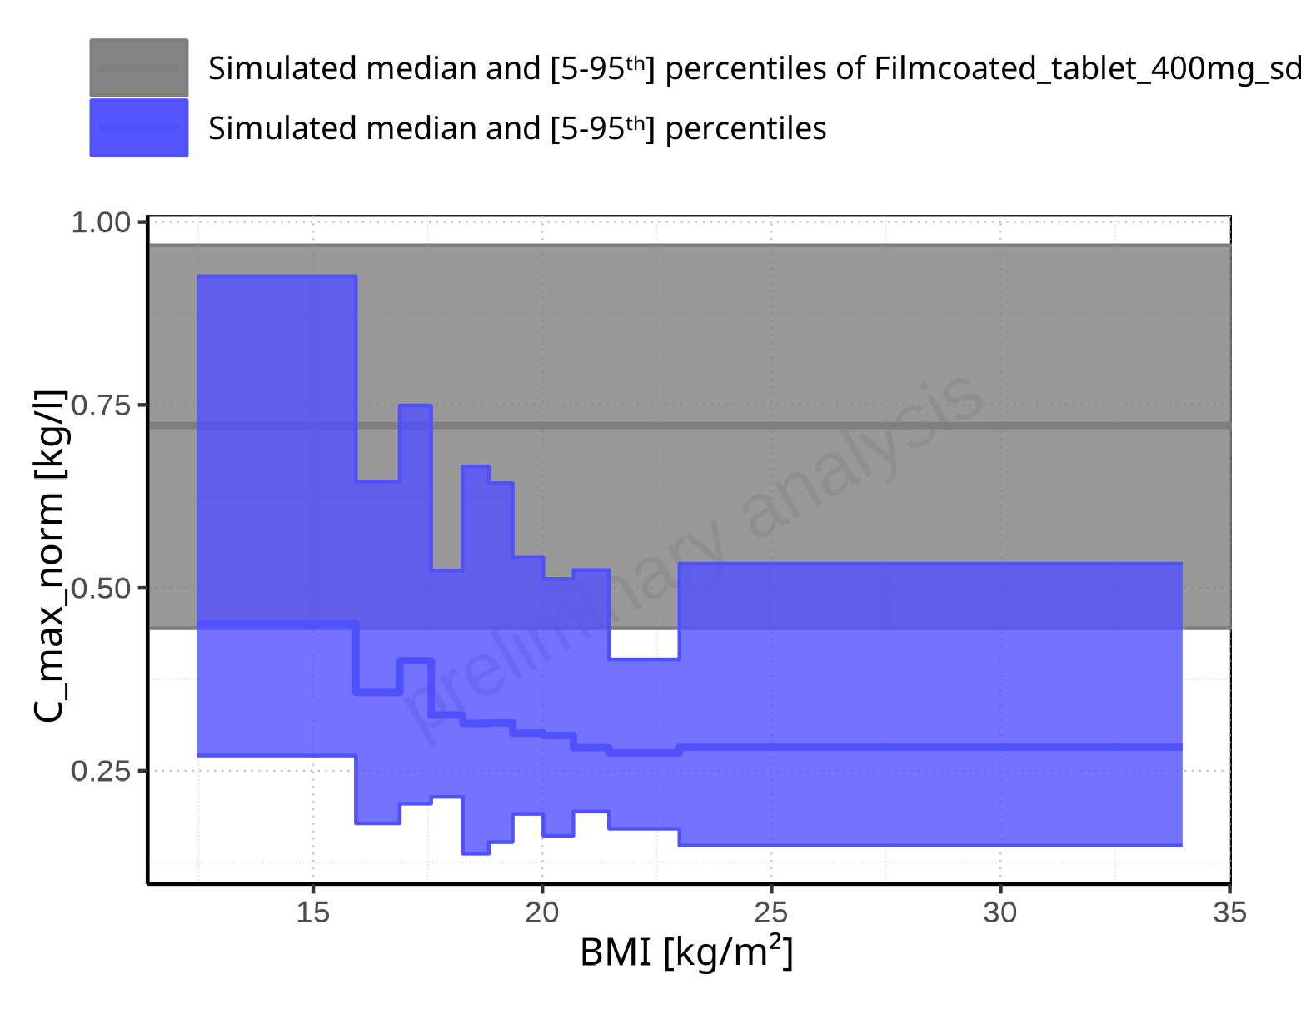

**Figure 2-50: BMI-dependence of C_max_norm for Larson 2013 8y-18y 400mg FCT meal in comparison to Filmcoated_tablet_400mg_sd. Profiles are plotted in a linear scale.**

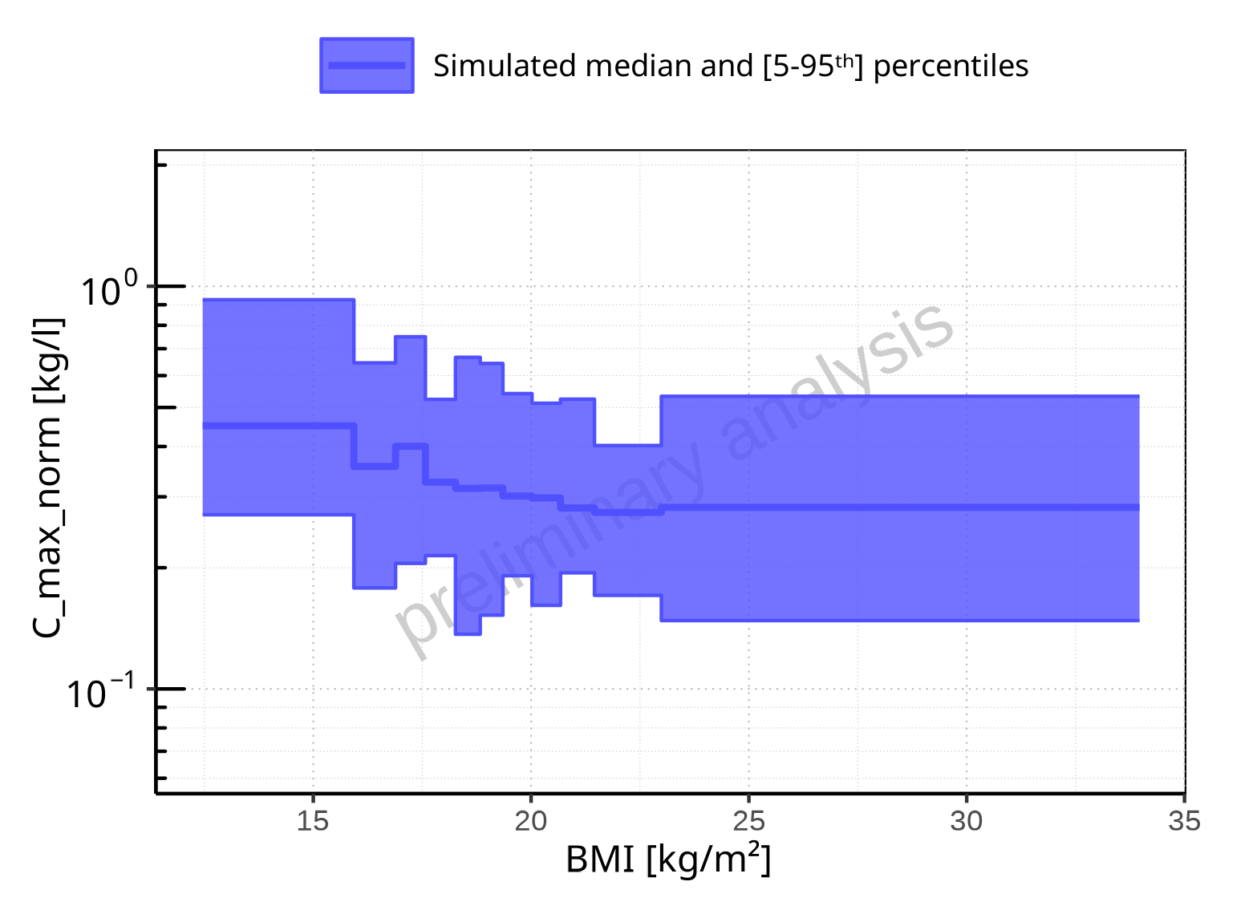

**Figure 2-51: BMI-dependence of C_max_norm for Larson 2013 8y-18y 400mg FCT meal. Profiles are plotted in a logarithmic scale.**

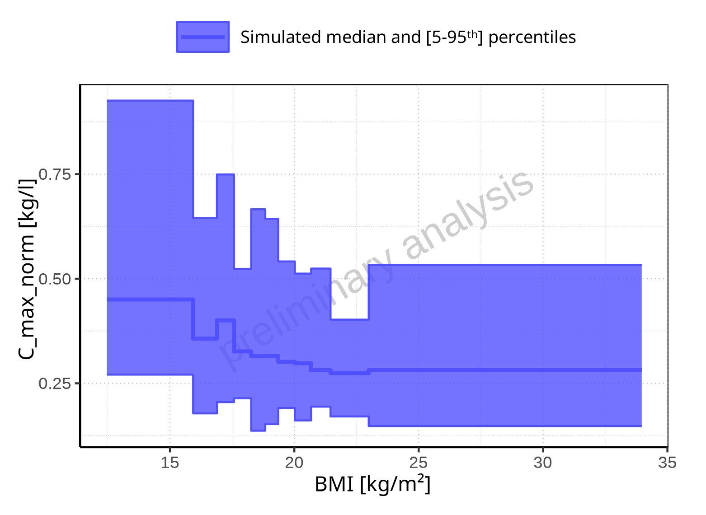

**Figure 2-52: BMI-dependence of C_max_norm for Larson 2013 8y-18y 400mg FCT meal. Profiles are plotted in a linear scale.**

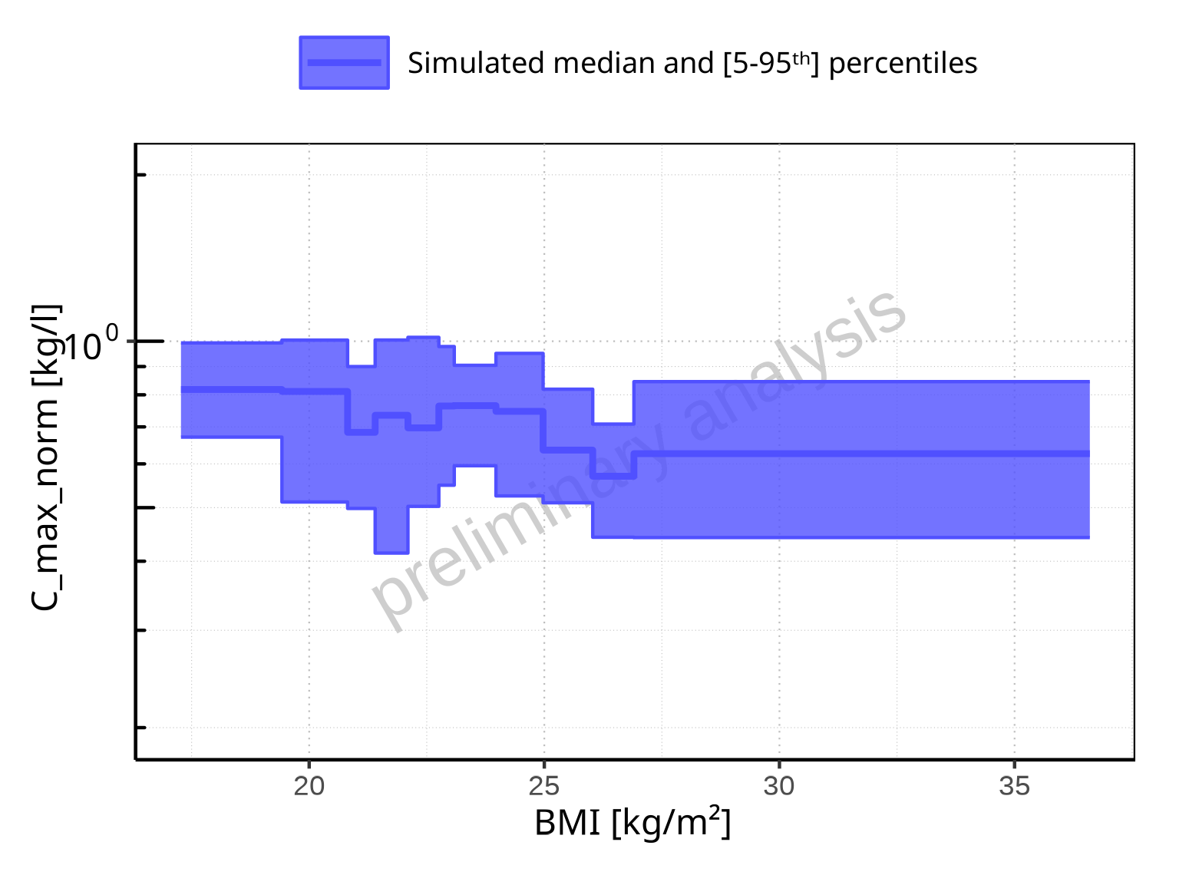

**Figure 2-53: BMI-dependence of C_max_norm for Filmcoated_tablet_400mg_sd. Profiles are plotted in a logarithmic scale.**

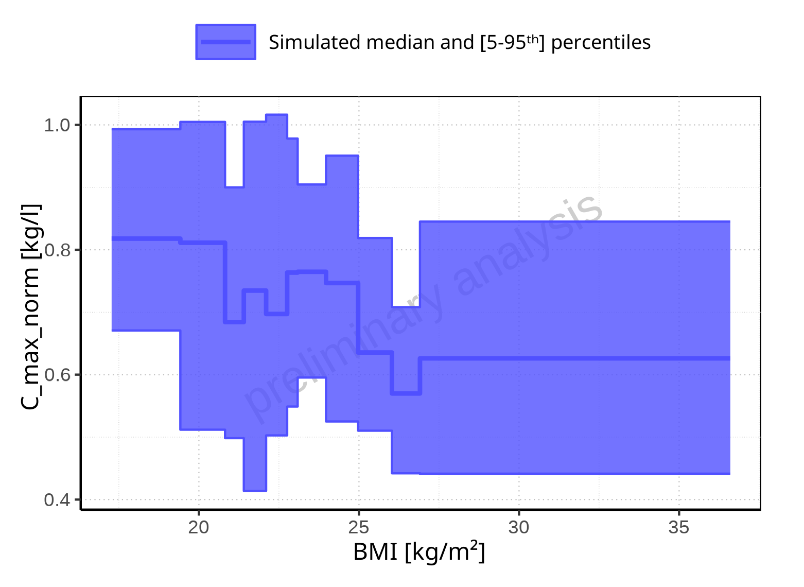

**Figure 2-54: BMI-dependence of C_max_norm for Filmcoated_tablet_400mg_sd. Profiles are plotted in a linear scale.**

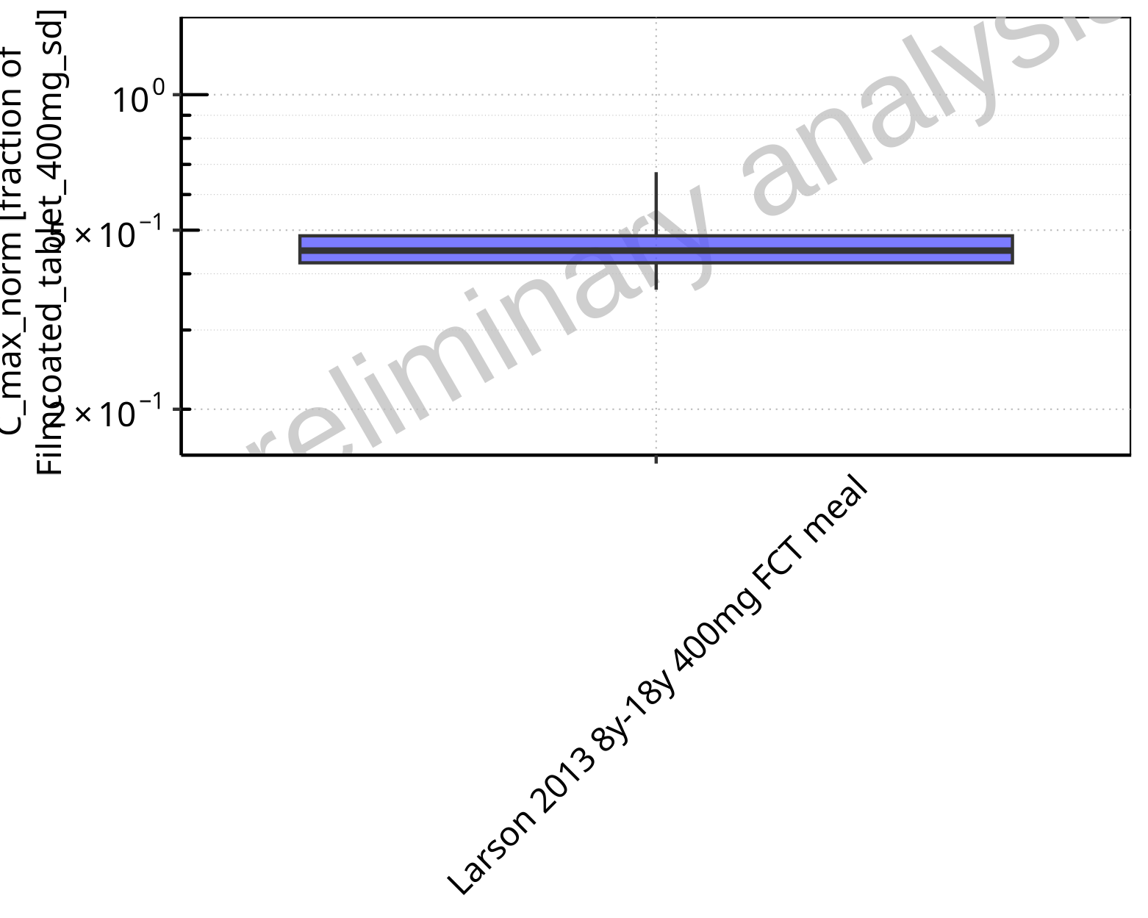

**Figure 2-55: Ratio of population summary statistics of C_max_norm of Raltegravir for Larson 2013 8y-18y 400mg FCT meal in comparison to Filmcoated_tablet_400mg_sd shown as box-whisker plot, which indicates ratios of the 5th, 25th, 50th, 75th, 95th percentiles in logarithmic scale.**

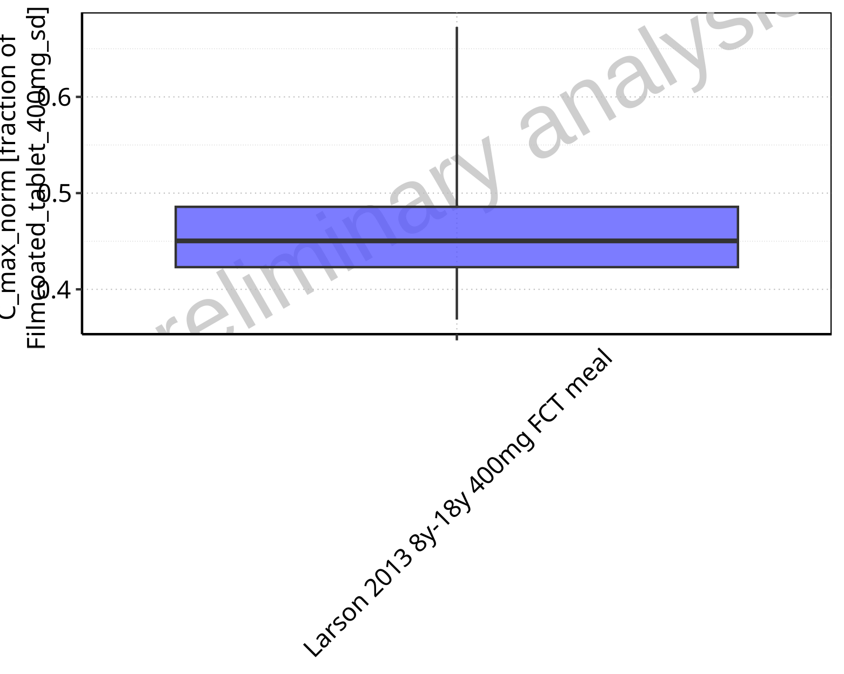

**Figure 2-56: Ratio of population summary statistics of C_max_norm of Raltegravir for Larson 2013 8y-18y 400mg FCT meal in comparison to Filmcoated_tablet_400mg_sd shown as box-whisker plot, which indicates ratios of the 5th, 25th, 50th, 75th, 95th percentiles in linear scale.**

**Table 2-4: Ratio of population summary statistics of C_max_norm of Raltegravir for Larson 2013 8y-18y 400mg FCT meal in comparison to Filmcoated_tablet_400mg_sd**

| Population | N | 5th pctl | 25th pctl | 50th pctl | 75th pctl | 95th pctl | Mean | SD | Geo Mean | Geo SD |
| --- | --- | --- | --- | --- | --- | --- | --- | --- | --- | --- |
| Larson 2013 8y-18y 400mg FCT meal | 500 | 0.37 | 0.42 | 0.45 | 0.49 | 0.67 | 0.50 | 1.02 | 0.47 | 1.20 |

### t_max

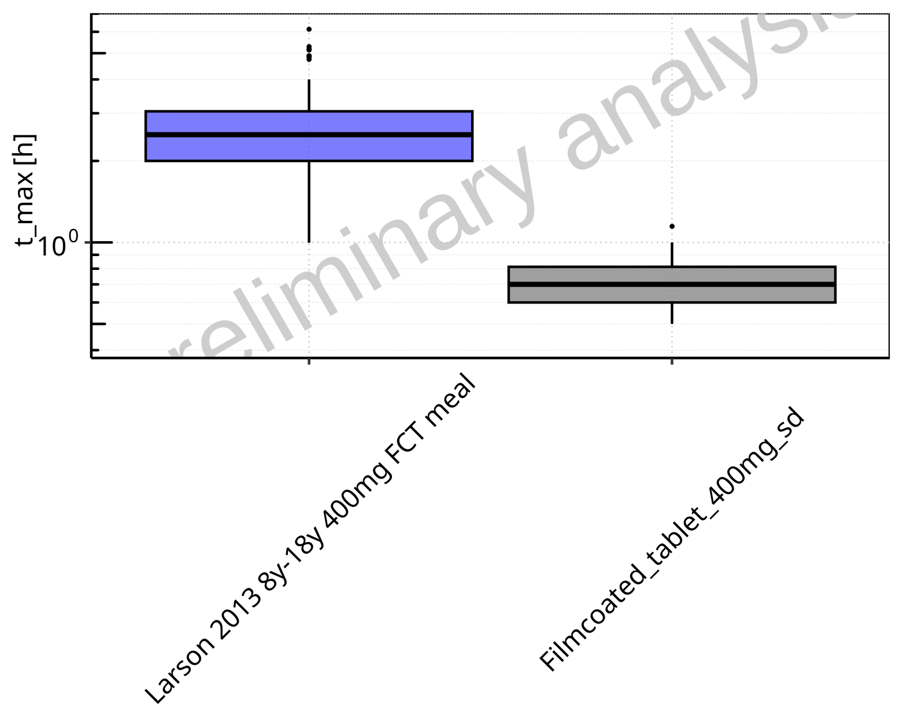

**Figure 2-57: t_max of Raltegravir for Larson 2013 8y-18y 400mg FCT meal, Filmcoated_tablet_400mg_sd shown as box-whisker plot, which indicates the 5th, 25th, 50th, 75th, 95th percentiles in logarithmic scale.**

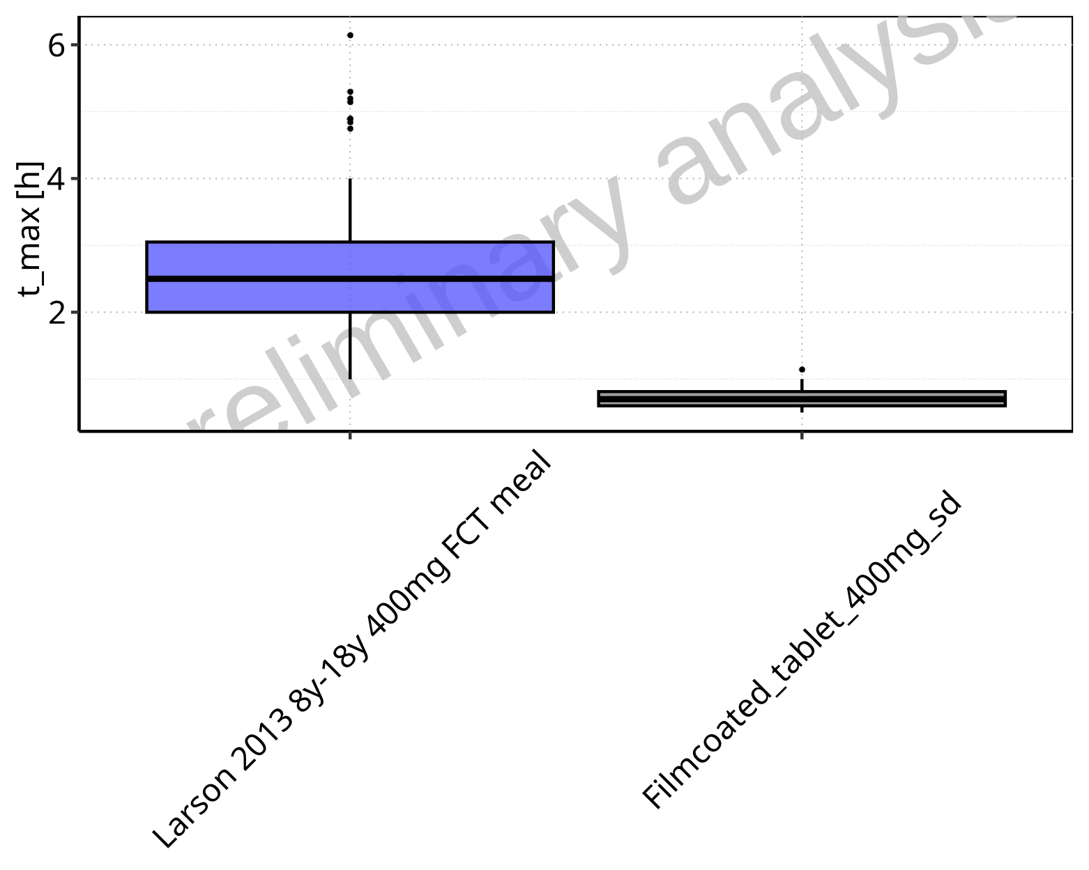

**Figure 2-58: t_max of Raltegravir for Larson 2013 8y-18y 400mg FCT meal, Filmcoated_tablet_400mg_sd shown as box-whisker plot, which indicates the 5th, 25th, 50th, 75th, 95th percentiles in linear scale.**

**Table 2-5: Population statistics summarizing t_max of Raltegravir for Larson 2013 8y-18y 400mg FCT meal, Filmcoated_tablet_400mg_sd reported in [h]**

| Population | N | 5th pctl | 25th pctl | 50th pctl | 75th pctl | 95th pctl | Mean | SD | Geo Mean | Geo SD |
| --- | --- | --- | --- | --- | --- | --- | --- | --- | --- | --- |
| Larson 2013 8y-18y 400mg FCT meal | 500 | 1.00 | 2.00 | 2.50 | 3.05 | 4 | 2.54 | 0.88 | 2.37 | 1.49 |
| Filmcoated_tablet_400mg_sd | 100 | 0.50 | 0.60 | 0.70 | 0.81 | 1 | 0.73 | 0.15 | 0.71 | 1.23 |

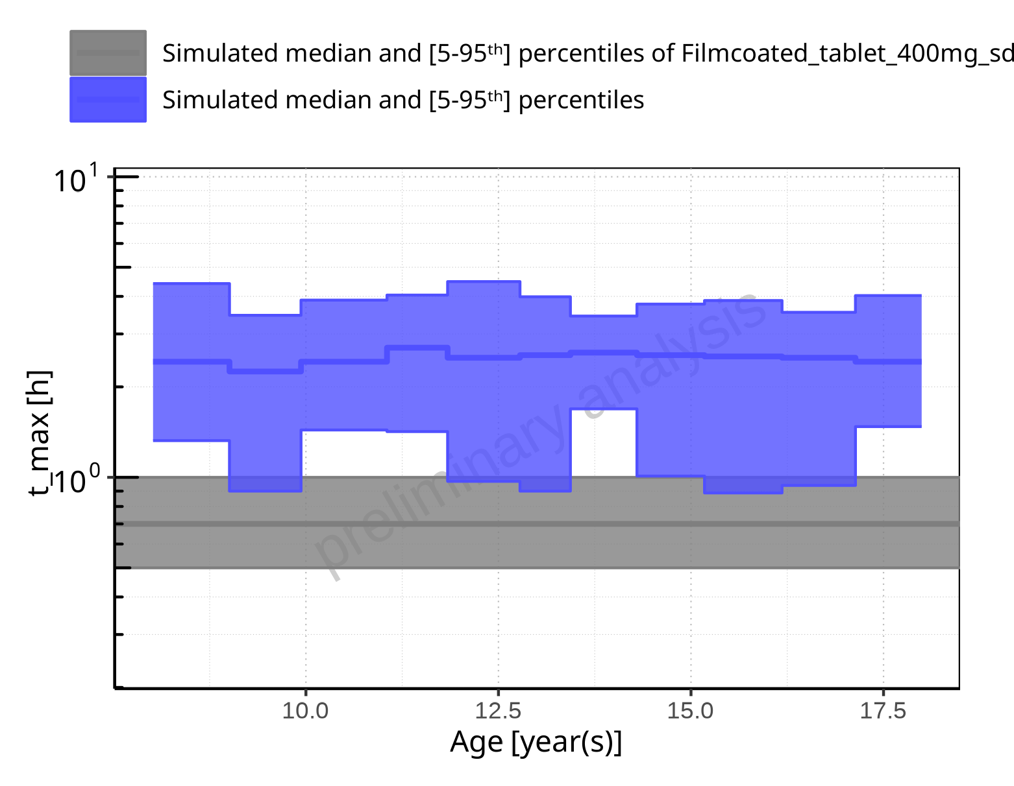

**Figure 2-59: Age-dependence of t_max for Larson 2013 8y-18y 400mg FCT meal in comparison to Filmcoated_tablet_400mg_sd. Profiles are plotted in a logarithmic scale.**

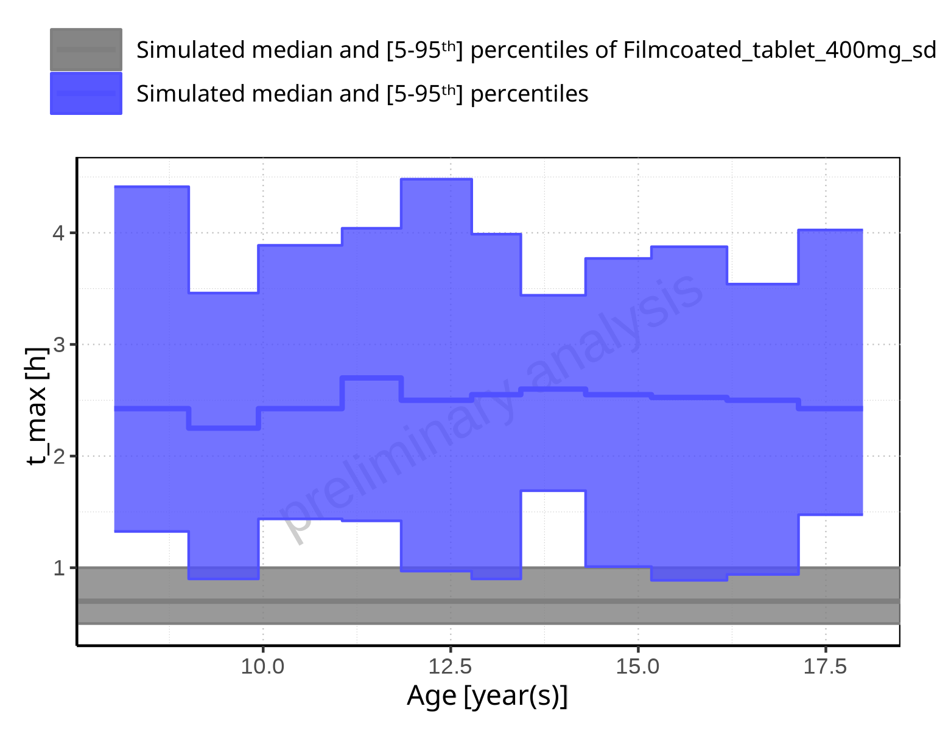

**Figure 2-60: Age-dependence of t_max for Larson 2013 8y-18y 400mg FCT meal in comparison to Filmcoated_tablet_400mg_sd. Profiles are plotted in a linear scale.**

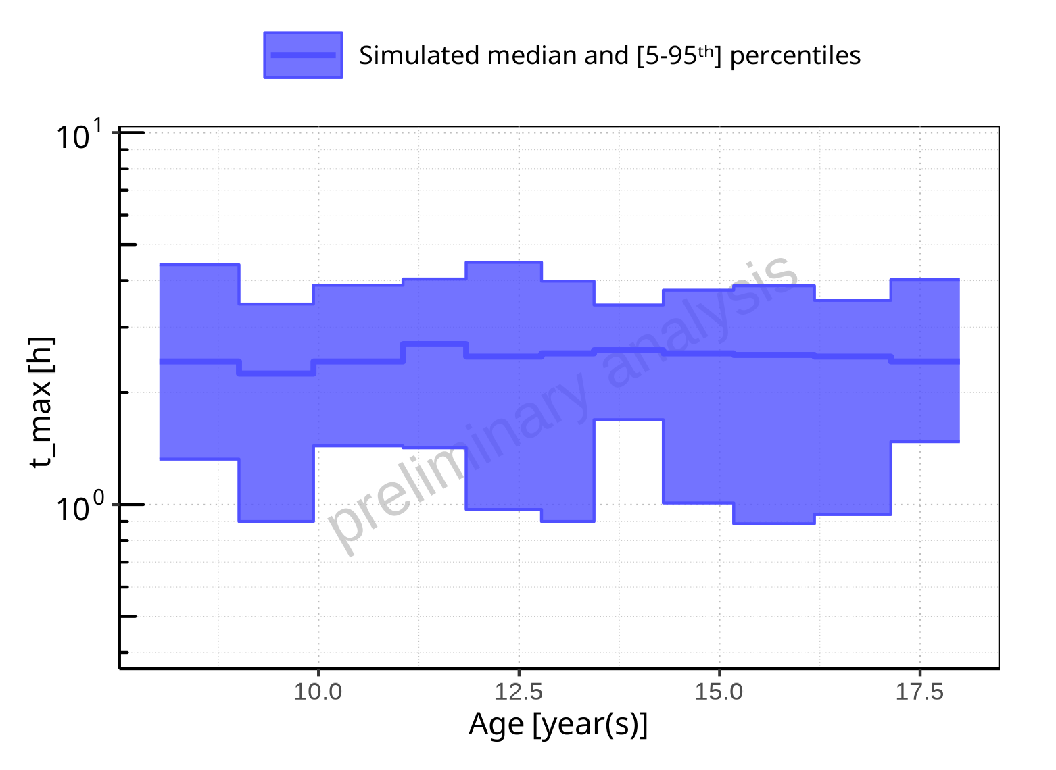

**Figure 2-61: Age-dependence of t_max for Larson 2013 8y-18y 400mg FCT meal. Profiles are plotted in a logarithmic scale.**

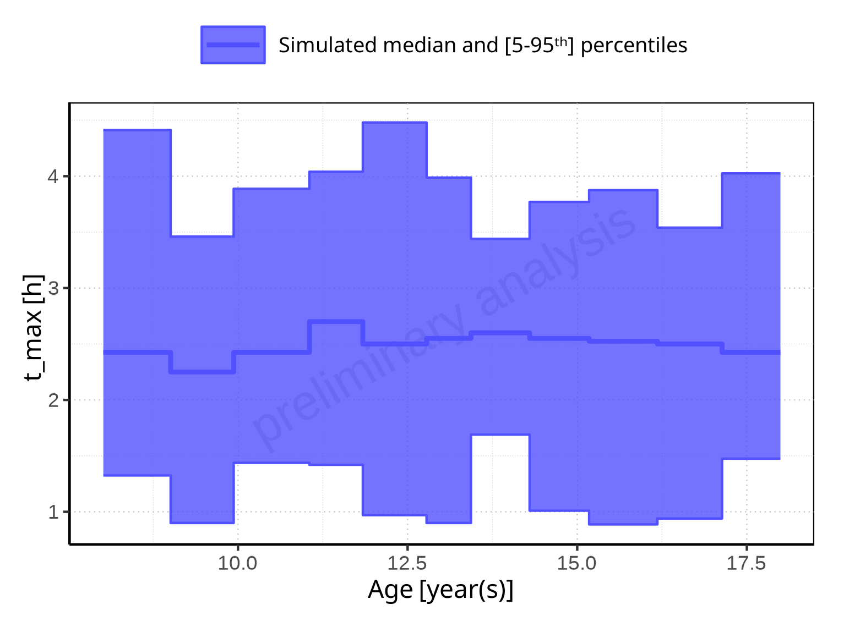

**Figure 2-62: Age-dependence of t_max for Larson 2013 8y-18y 400mg FCT meal. Profiles are plotted in a linear scale.**

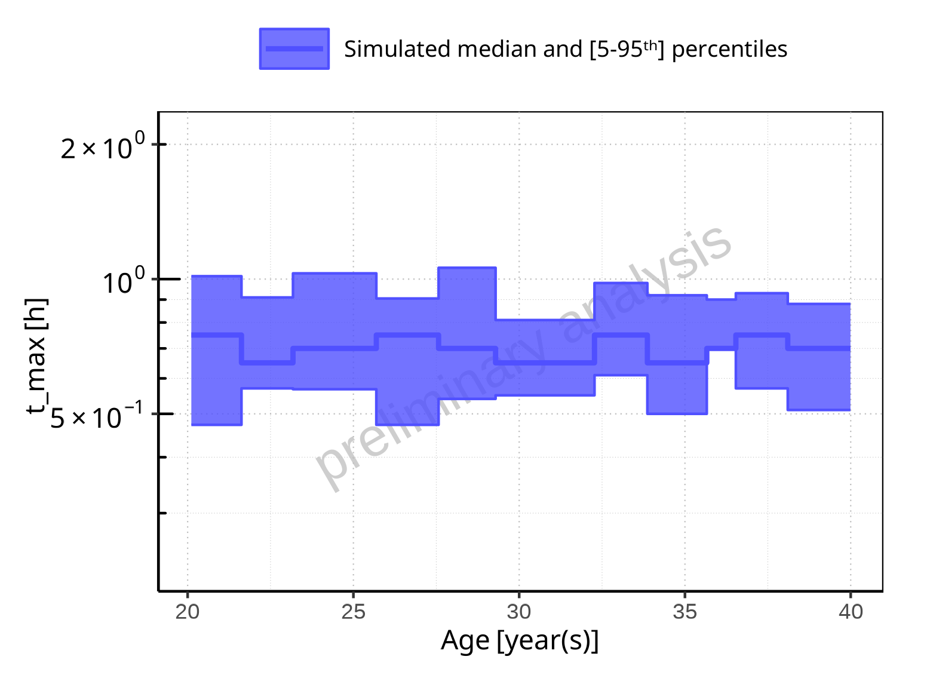

**Figure 2-63: Age-dependence of t_max for Filmcoated_tablet_400mg_sd. Profiles are plotted in a logarithmic scale.**

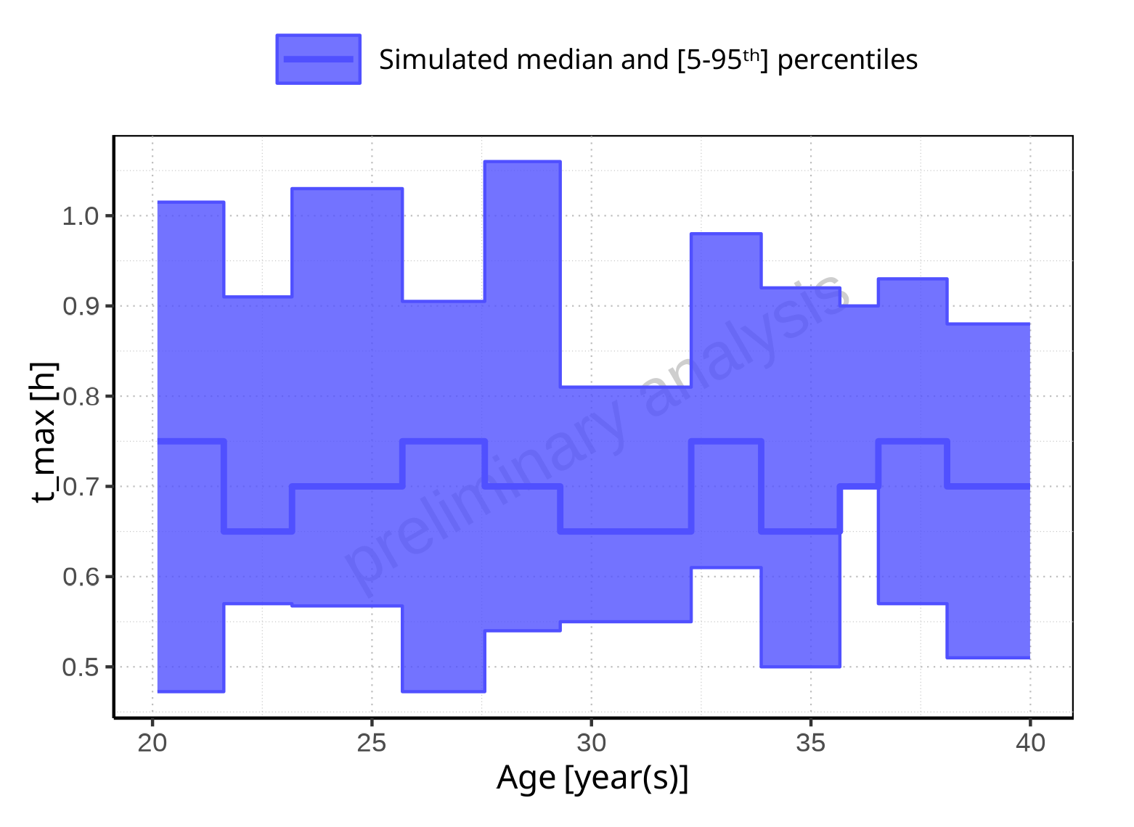

**Figure 2-64: Age-dependence of t_max for Filmcoated_tablet_400mg_sd. Profiles are plotted in a linear scale.**

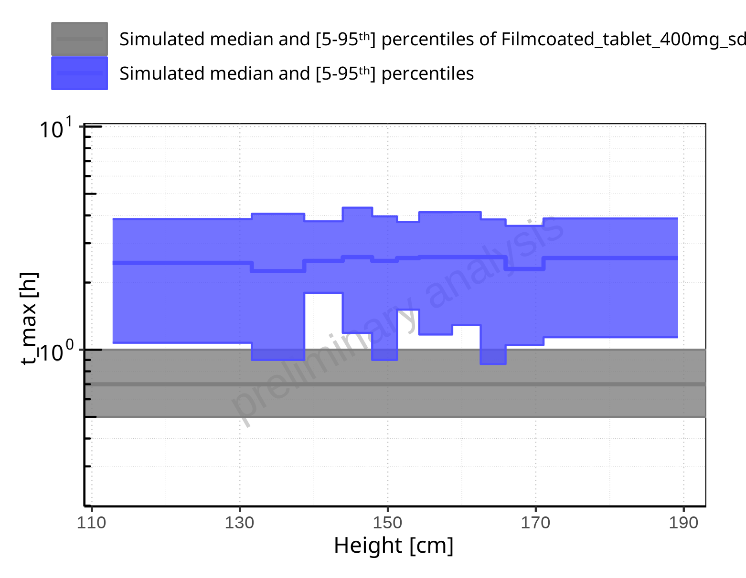

**Figure 2-65: Height-dependence of t_max for Larson 2013 8y-18y 400mg FCT meal in comparison to Filmcoated_tablet_400mg_sd. Profiles are plotted in a logarithmic scale.**

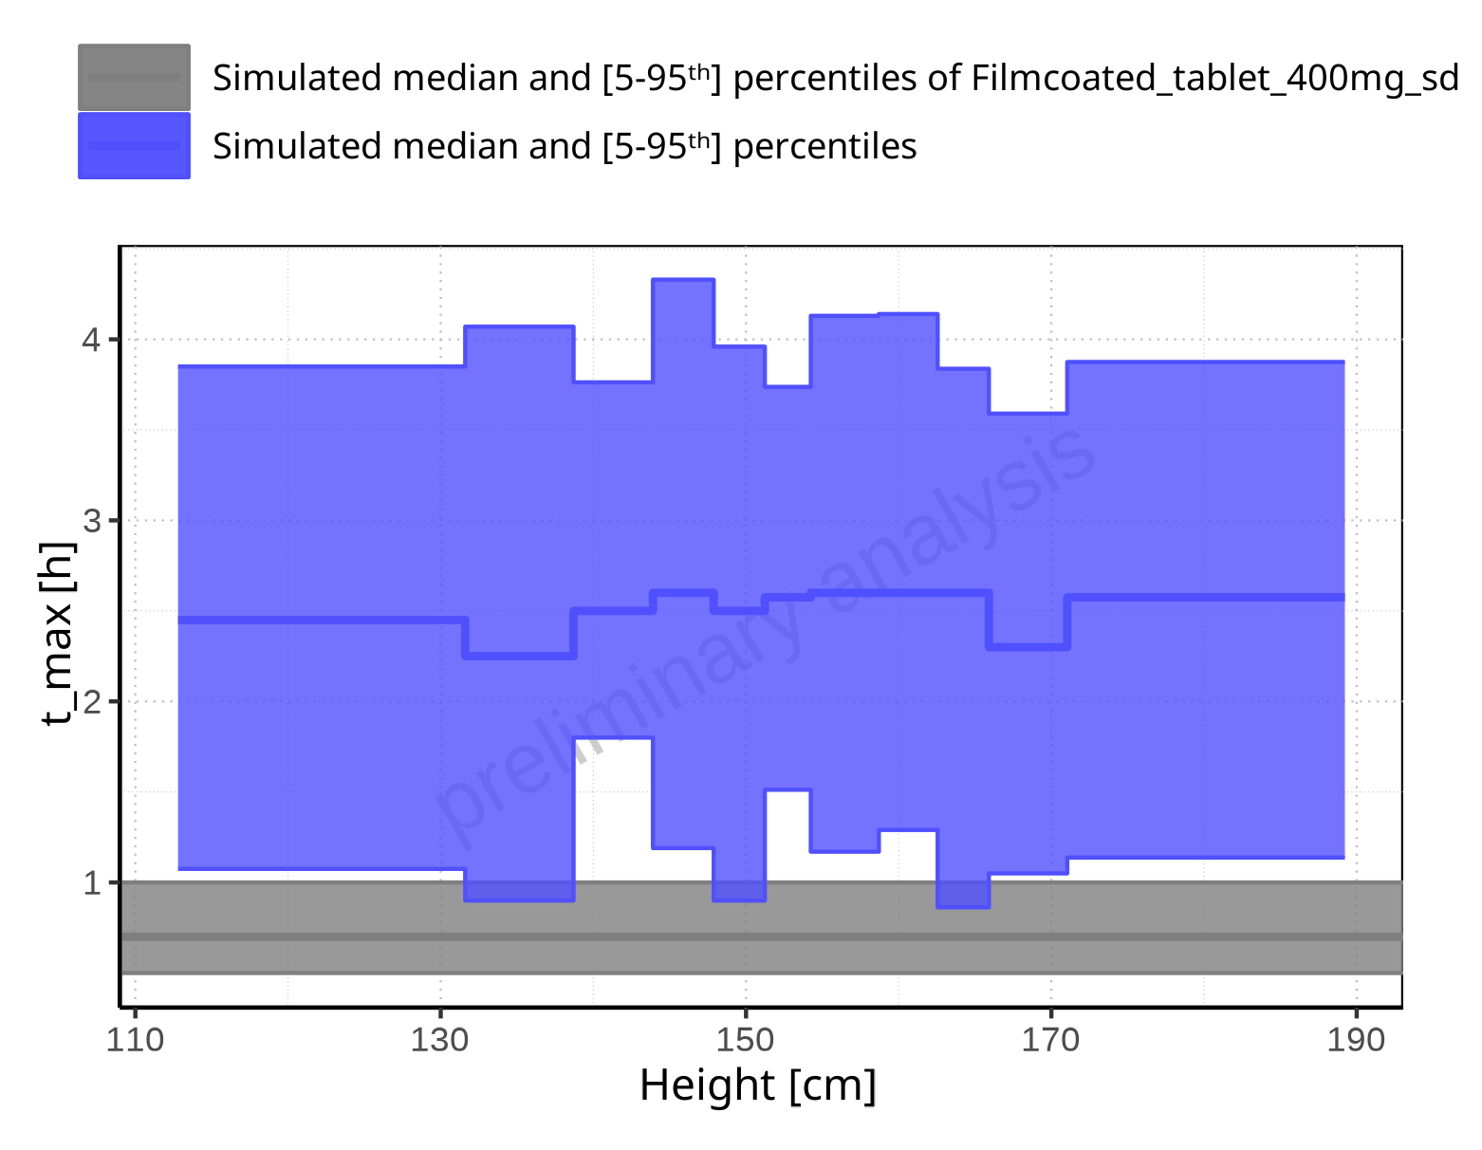

**Figure 2-66: Height-dependence of t_max for Larson 2013 8y-18y 400mg FCT meal in comparison to Filmcoated_tablet_400mg_sd. Profiles are plotted in a linear scale.**

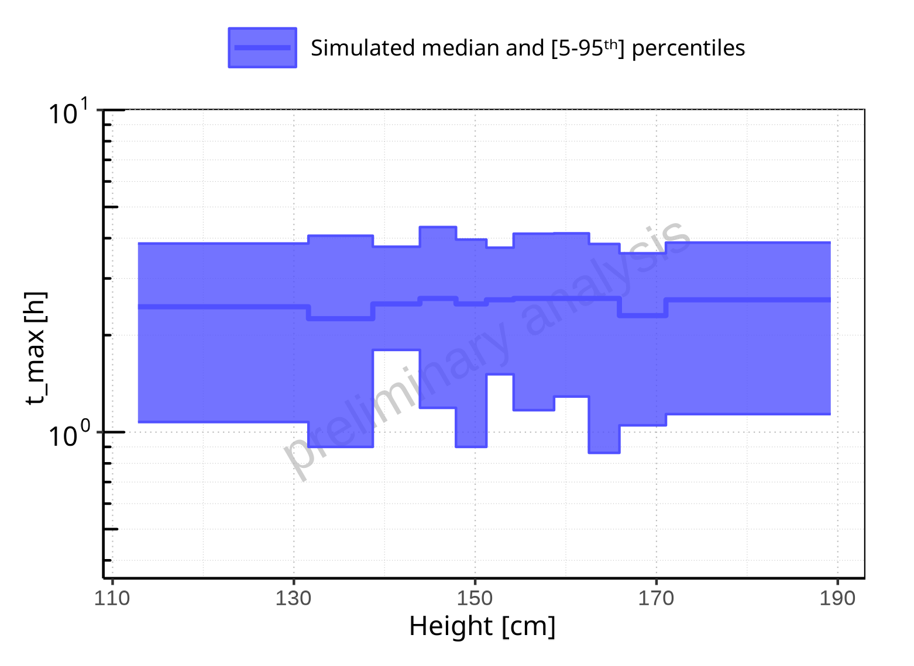

**Figure 2-67: Height-dependence of t_max for Larson 2013 8y-18y 400mg FCT meal. Profiles are plotted in a logarithmic scale.**

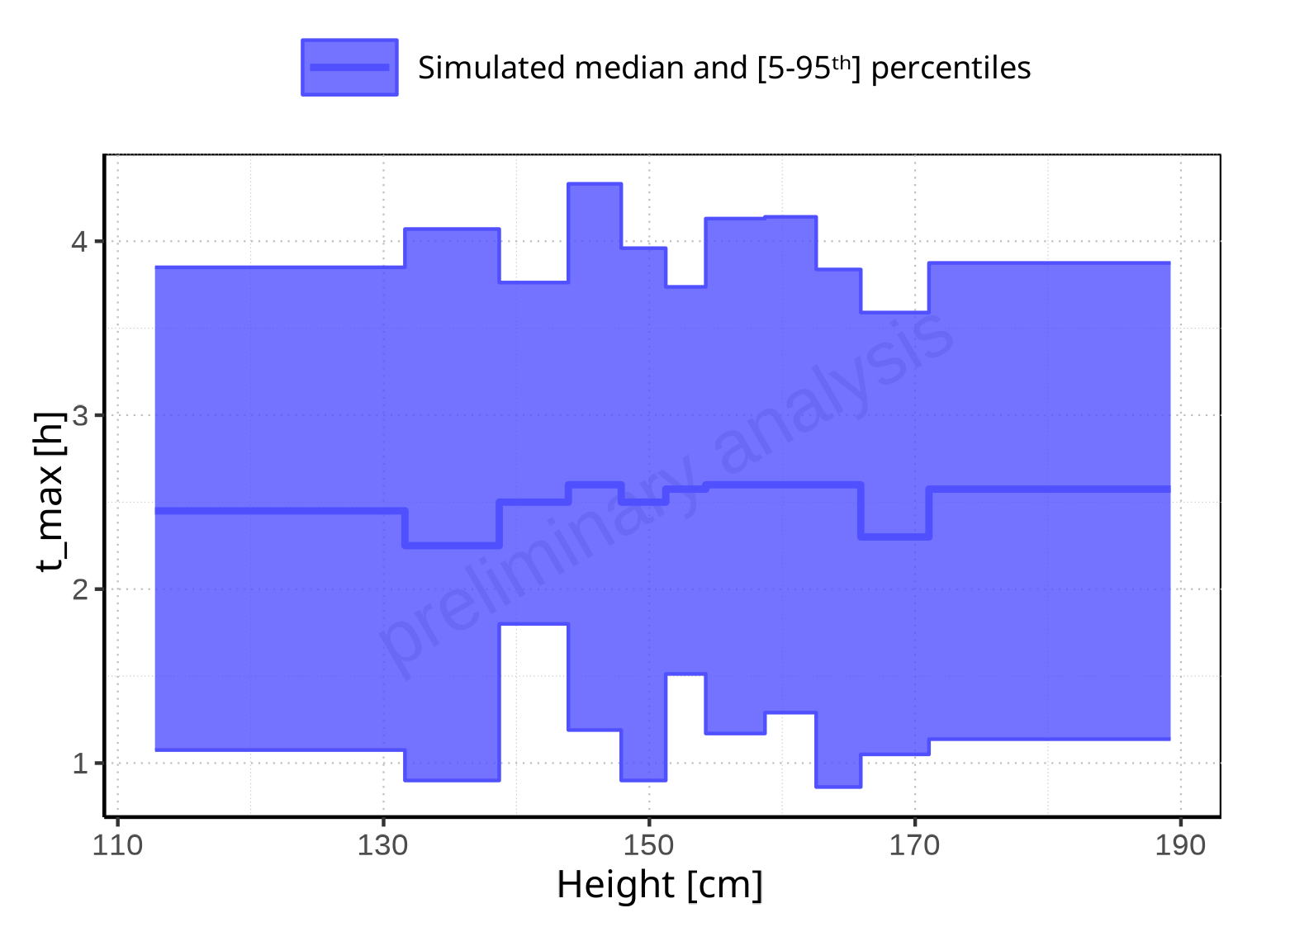

**Figure 2-68: Height-dependence of t_max for Larson 2013 8y-18y 400mg FCT meal. Profiles are plotted in a linear scale.**

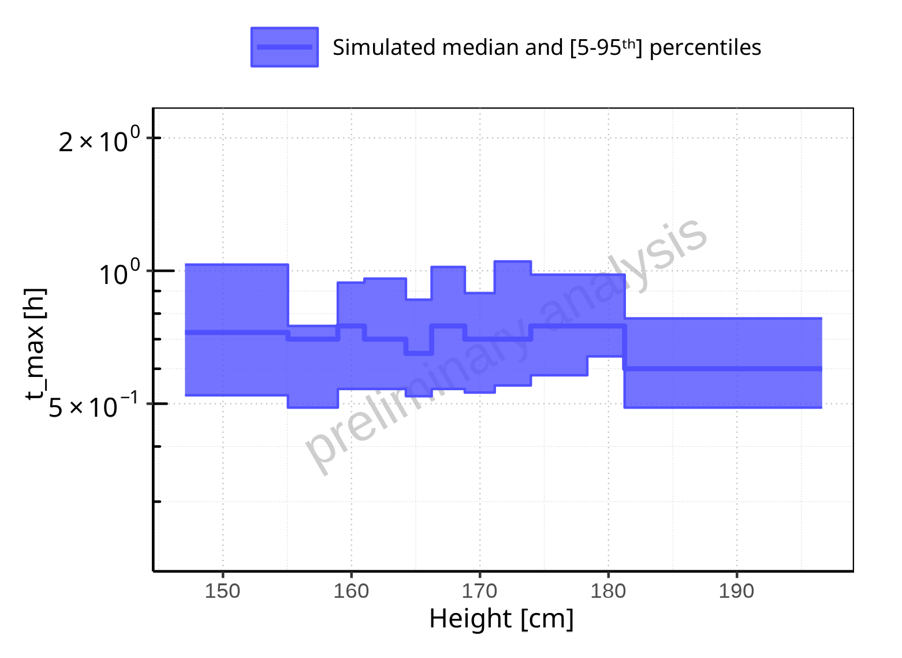

**Figure 2-69: Height-dependence of t_max for Filmcoated_tablet_400mg_sd. Profiles are plotted in a logarithmic scale.**

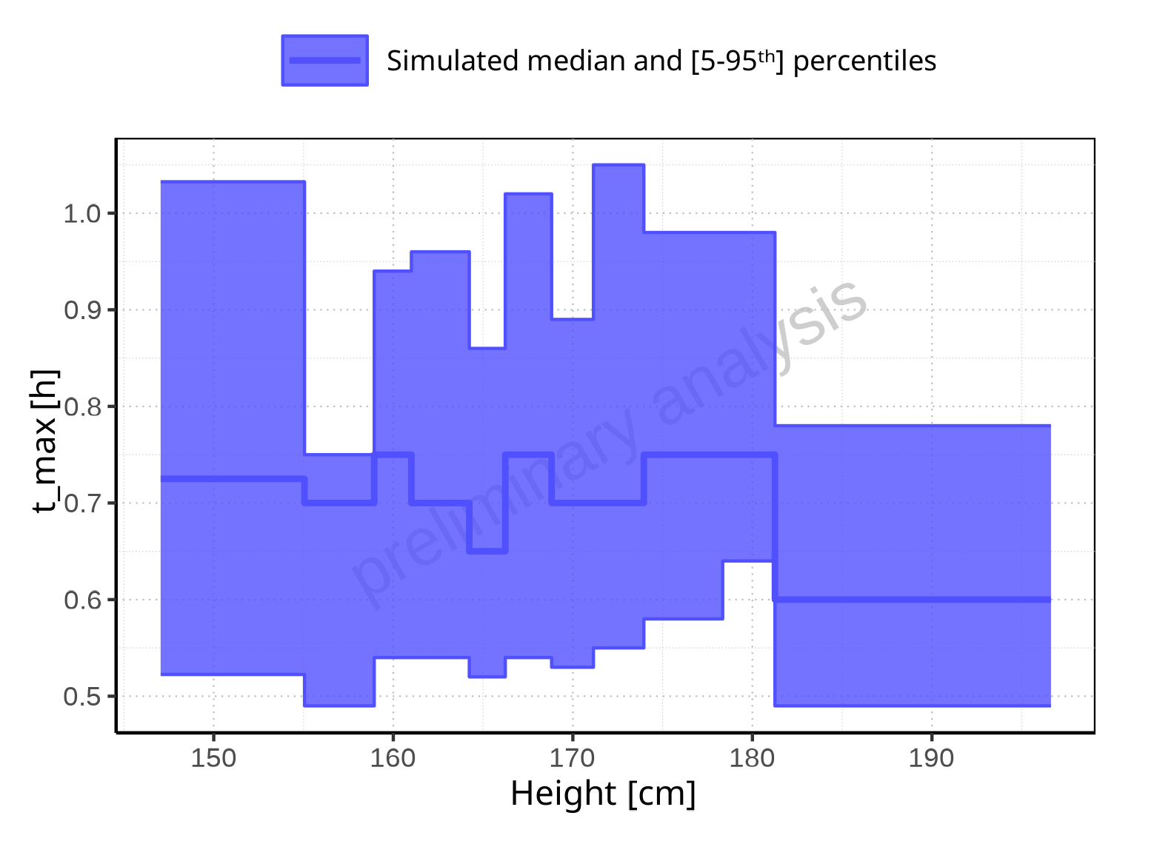

**Figure 2-70: Height-dependence of t_max for Filmcoated_tablet_400mg_sd. Profiles are plotted in a linear scale.**

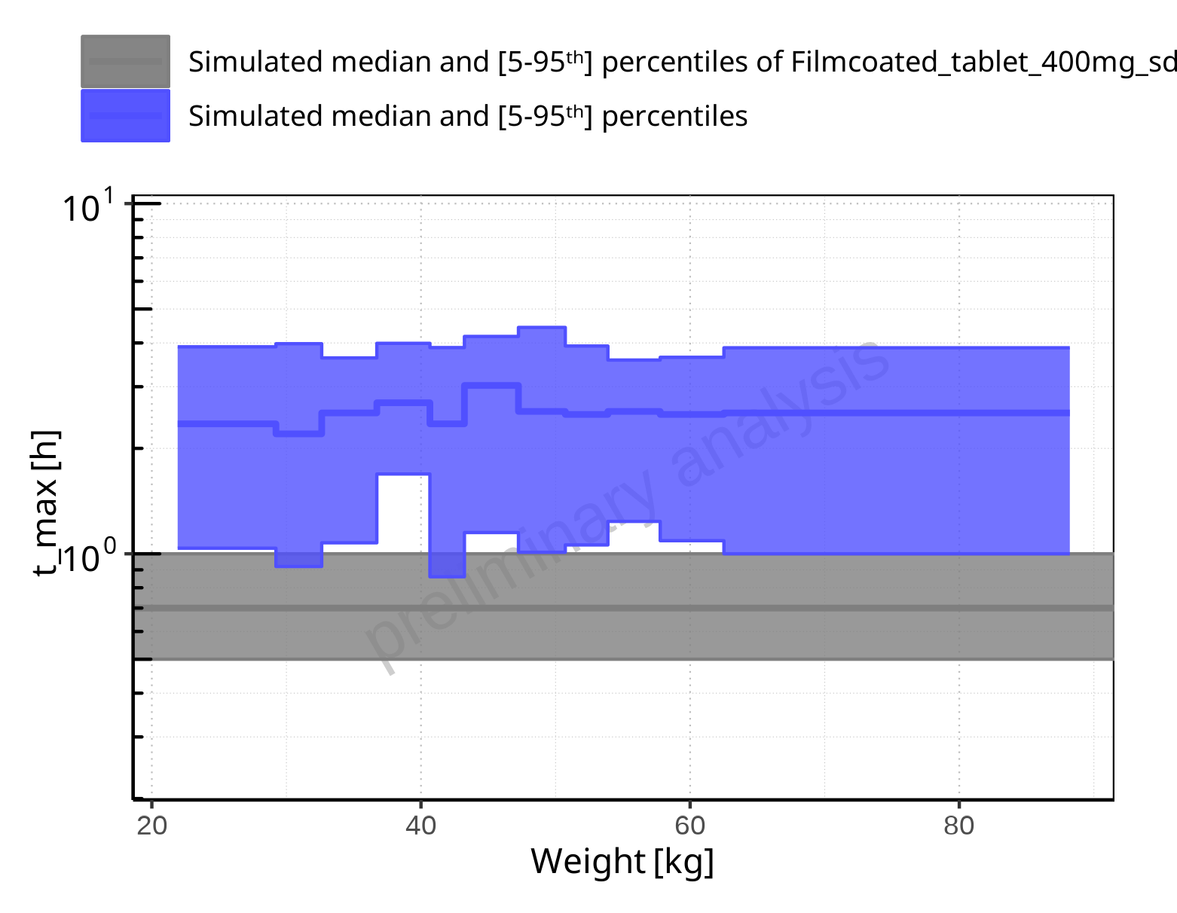

**Figure 2-71: Weight-dependence of t_max for Larson 2013 8y-18y 400mg FCT meal in comparison to Filmcoated_tablet_400mg_sd. Profiles are plotted in a logarithmic scale.**

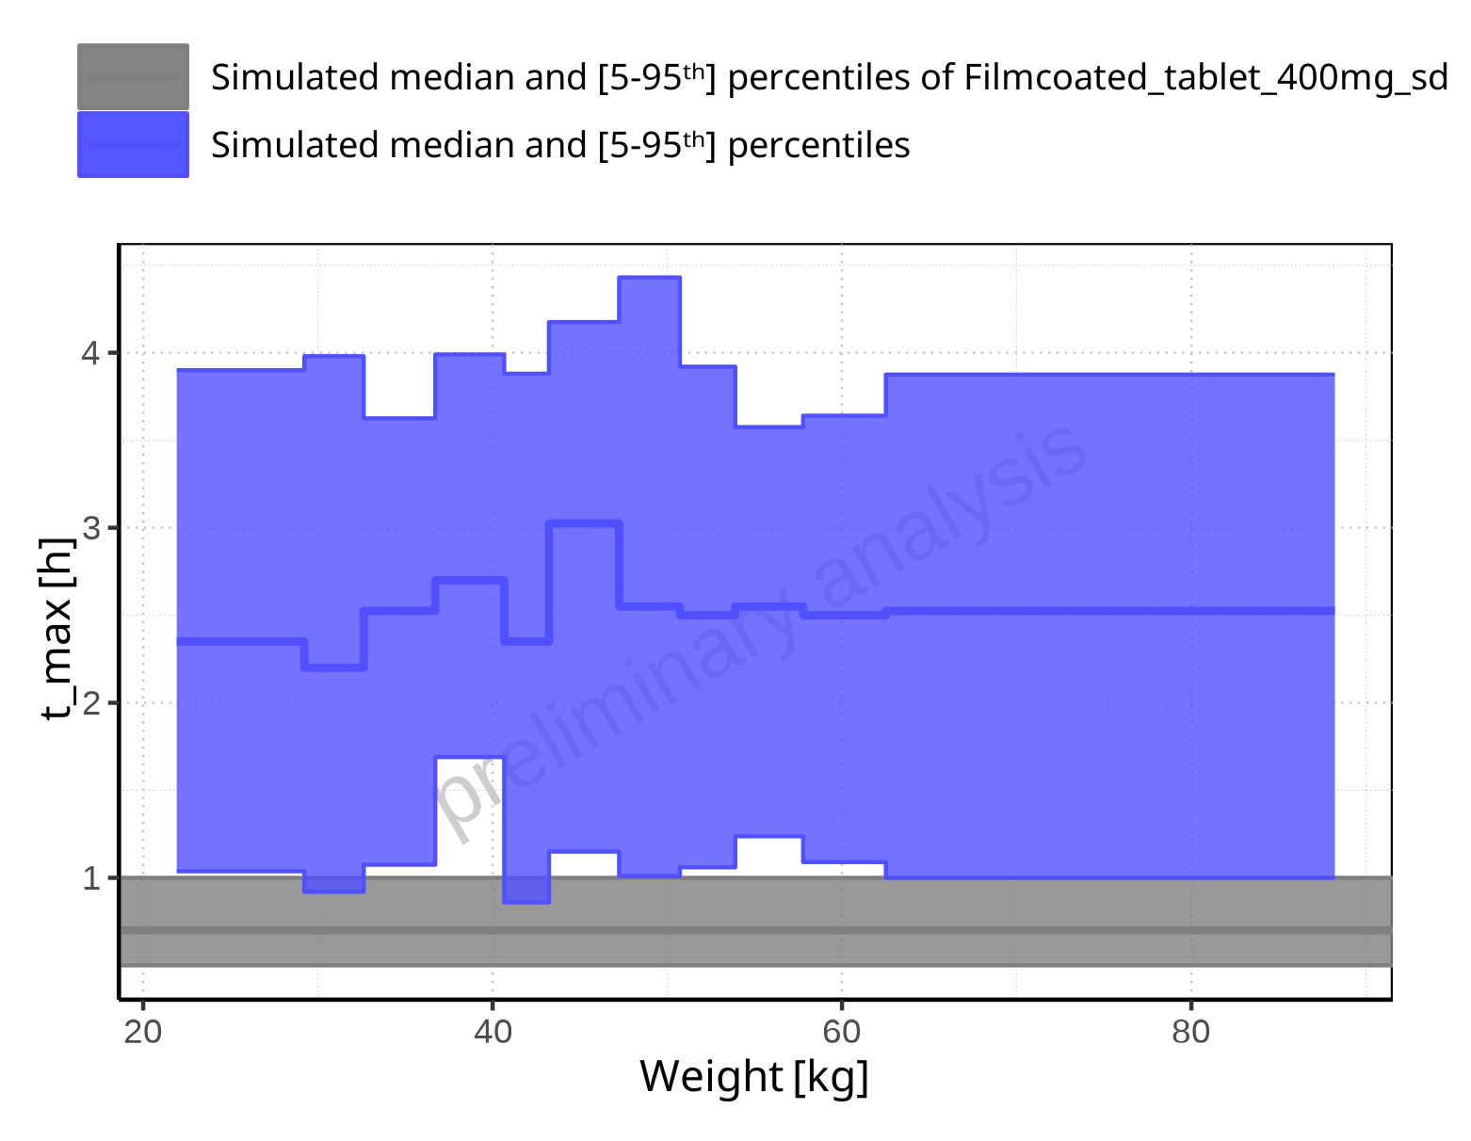

**Figure 2-72: Weight-dependence of t_max for Larson 2013 8y-18y 400mg FCT meal in comparison to Filmcoated_tablet_400mg_sd. Profiles are plotted in a linear scale.**

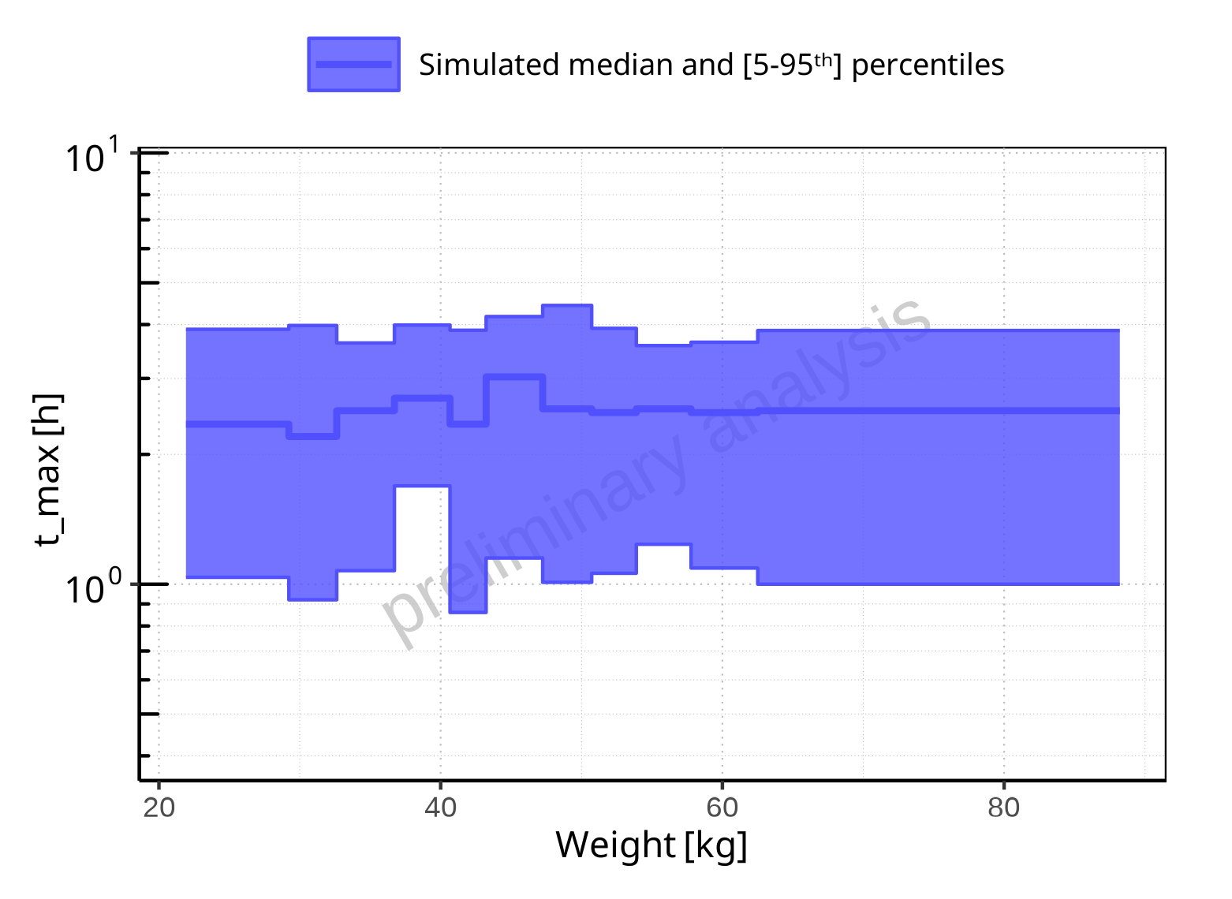

**Figure 2-73: Weight-dependence of t_max for Larson 2013 8y-18y 400mg FCT meal. Profiles are plotted in a logarithmic scale.**

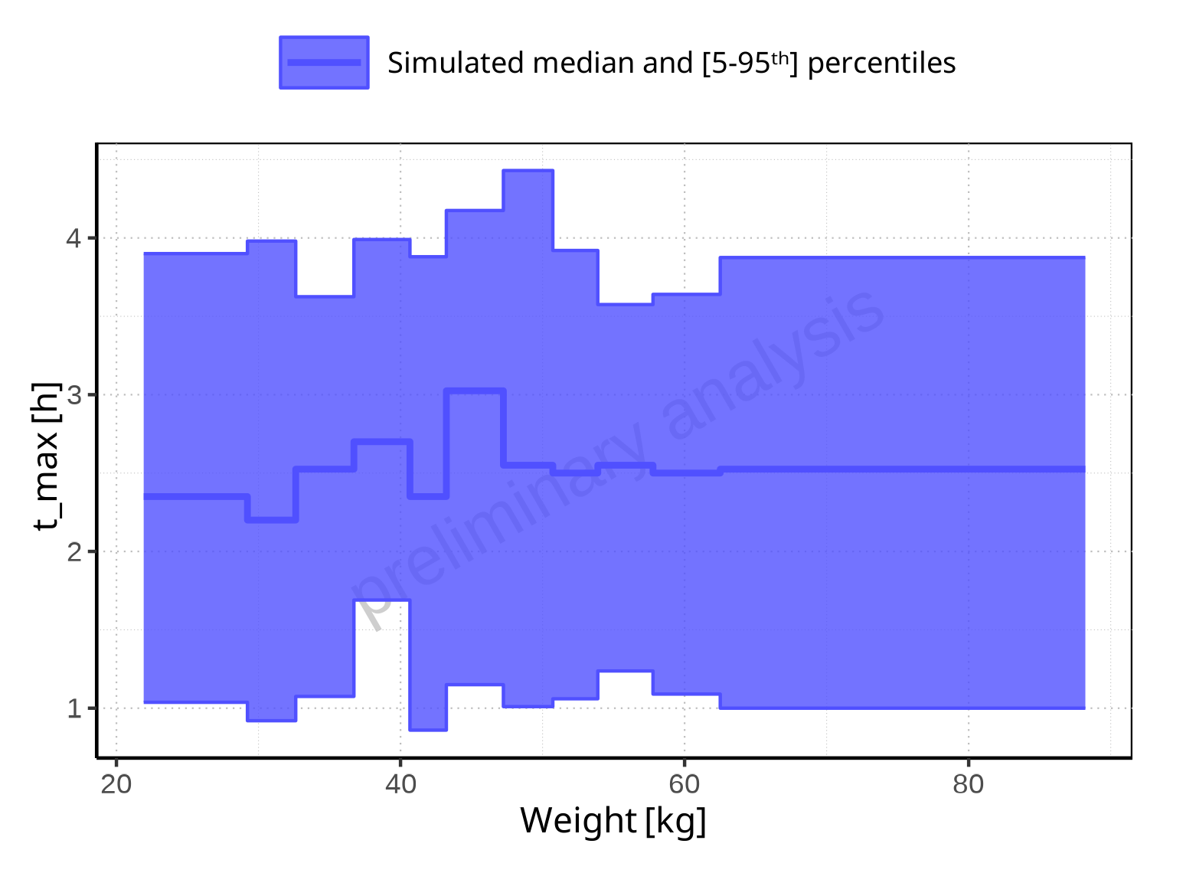

**Figure 2-74: Weight-dependence of t_max for Larson 2013 8y-18y 400mg FCT meal. Profiles are plotted in a linear scale.**

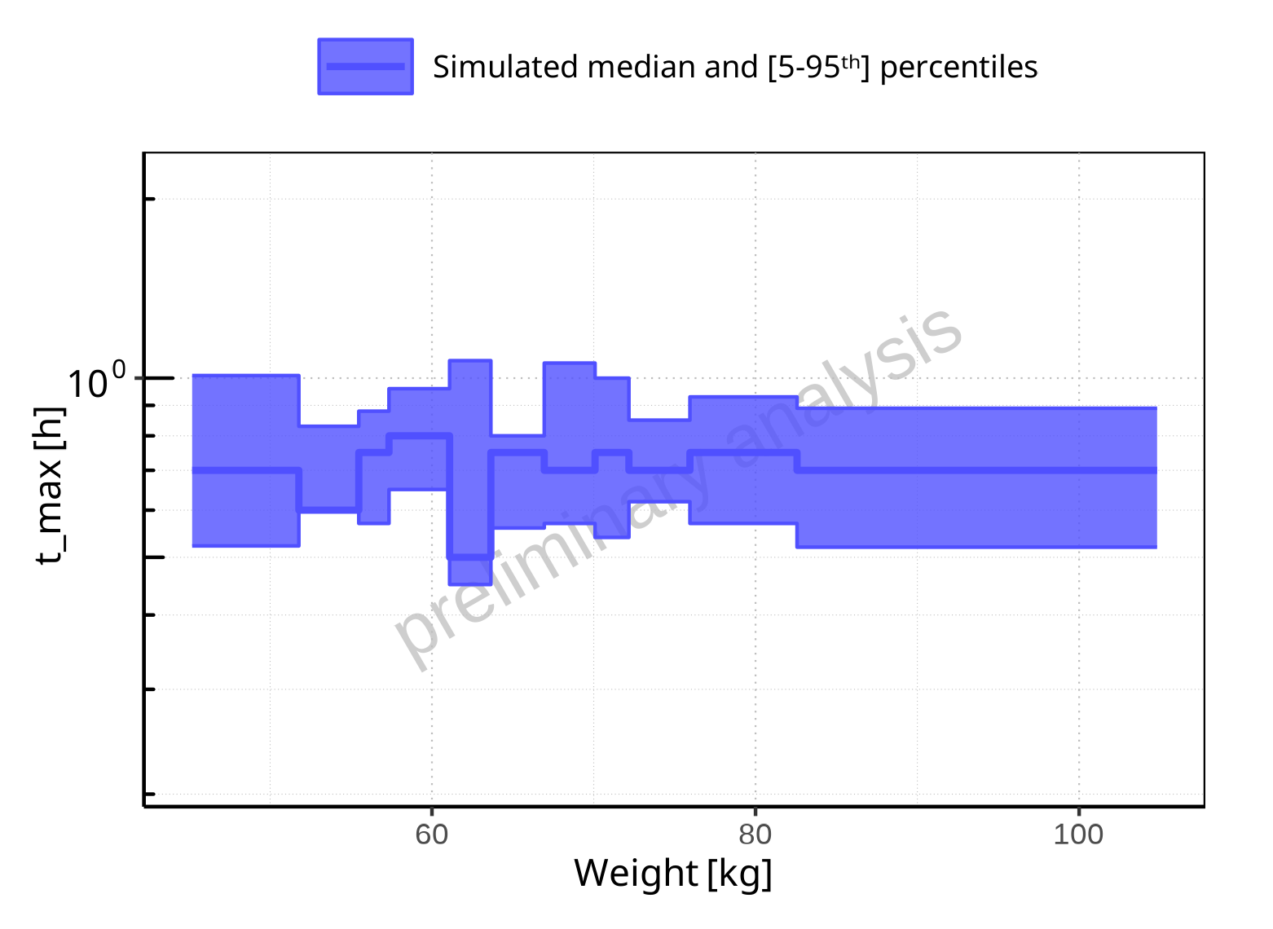

**Figure 2-75: Weight-dependence of t_max for Filmcoated_tablet_400mg_sd. Profiles are plotted in a logarithmic scale.**

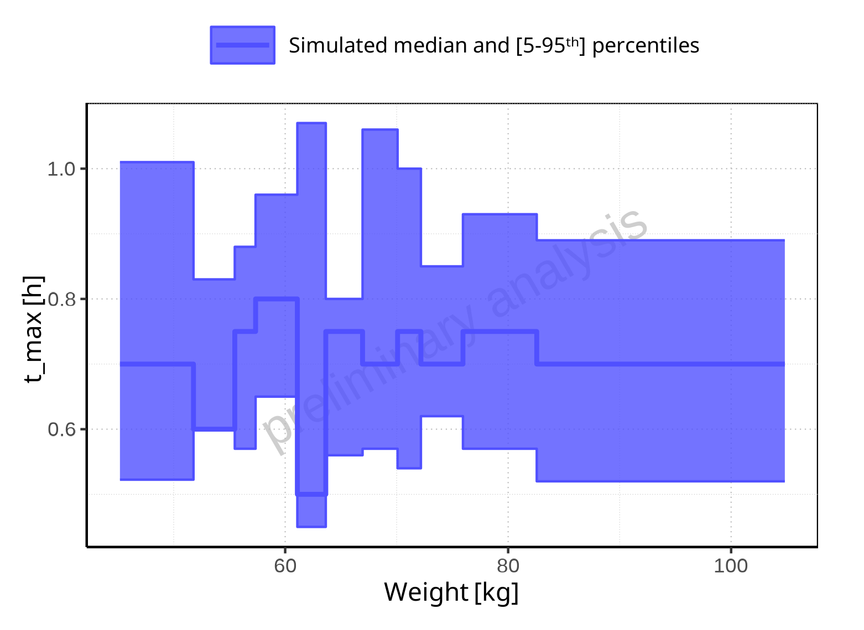

**Figure 2-76: Weight-dependence of t_max for Filmcoated_tablet_400mg_sd. Profiles are plotted in a linear scale.**

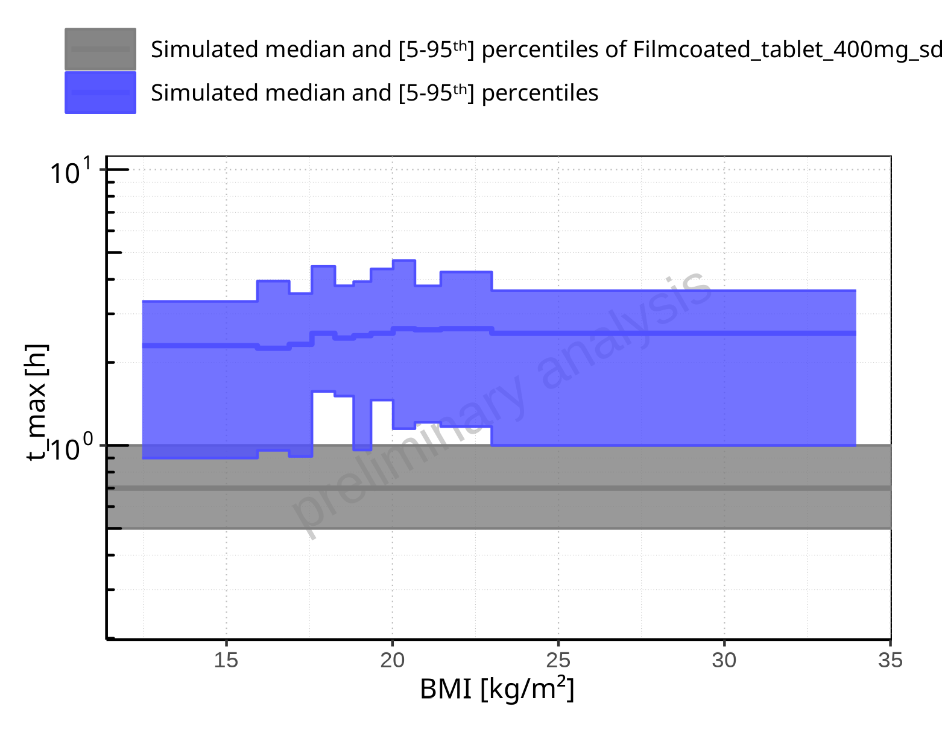

**Figure 2-77: BMI-dependence of t_max for Larson 2013 8y-18y 400mg FCT meal in comparison to Filmcoated_tablet_400mg_sd. Profiles are plotted in a logarithmic scale.**

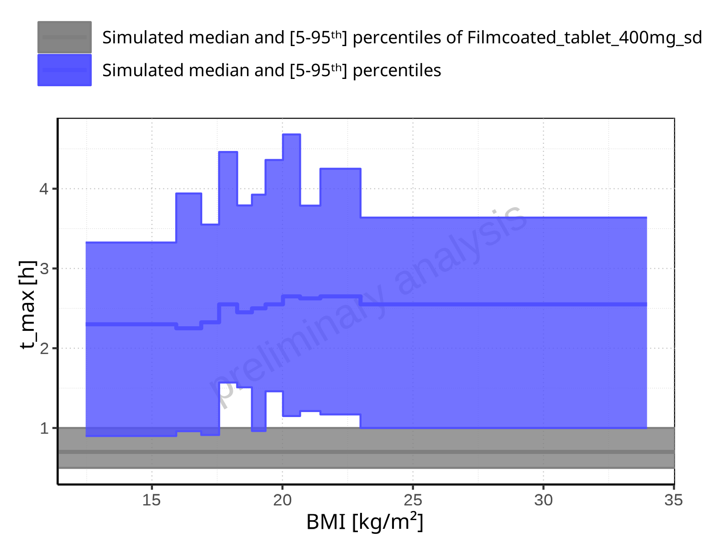

**Figure 2-78: BMI-dependence of t_max for Larson 2013 8y-18y 400mg FCT meal in comparison to Filmcoated_tablet_400mg_sd. Profiles are plotted in a linear scale.**

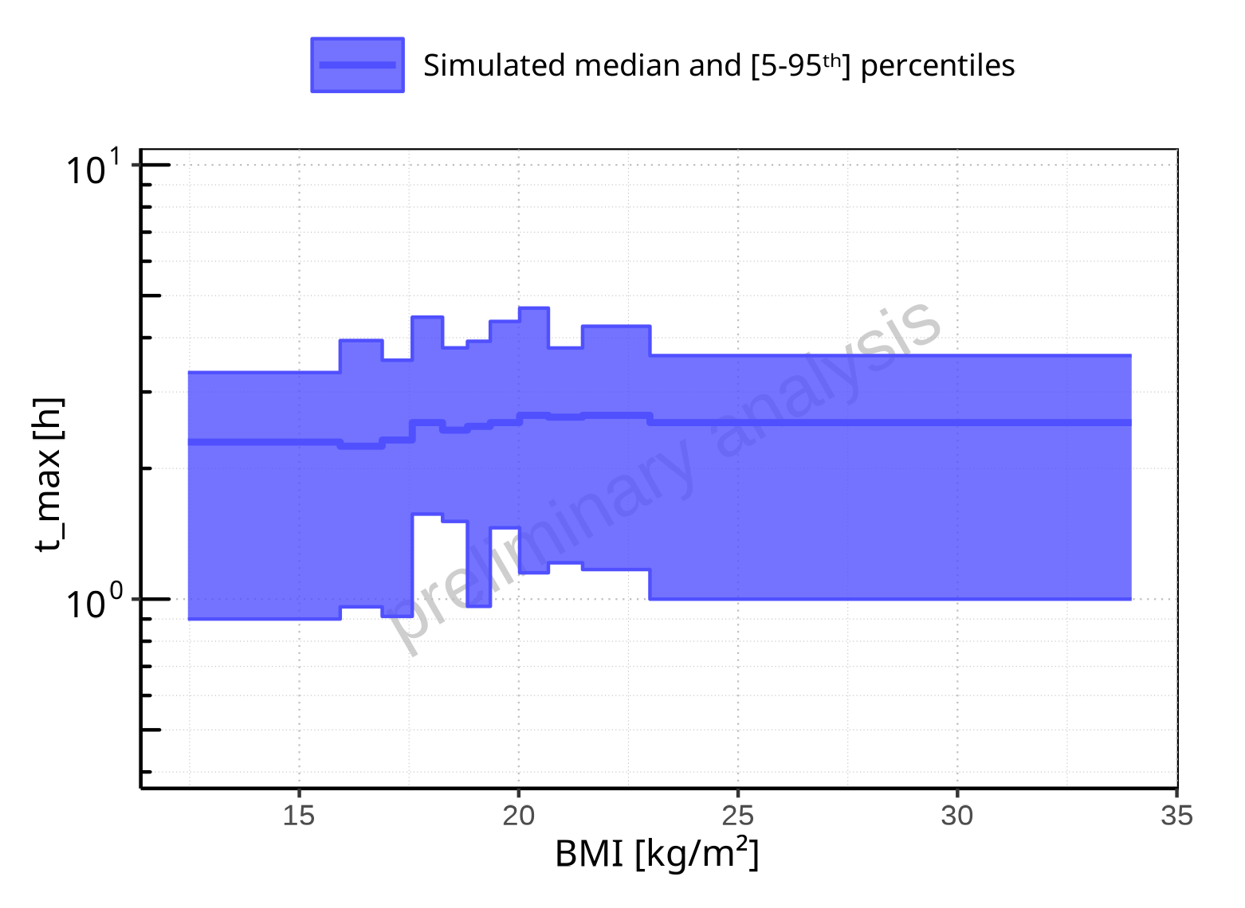

**Figure 2-79: BMI-dependence of t_max for Larson 2013 8y-18y 400mg FCT meal. Profiles are plotted in a logarithmic scale.**

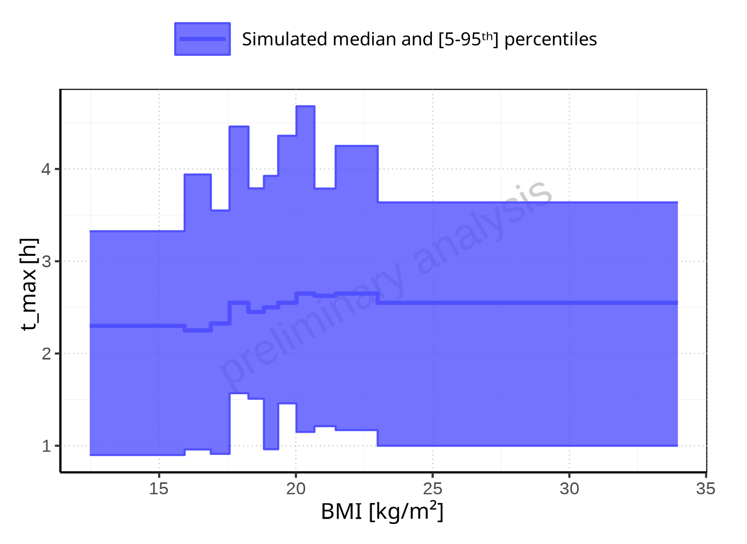

**Figure 2-80: BMI-dependence of t_max for Larson 2013 8y-18y 400mg FCT meal. Profiles are plotted in a linear scale.**

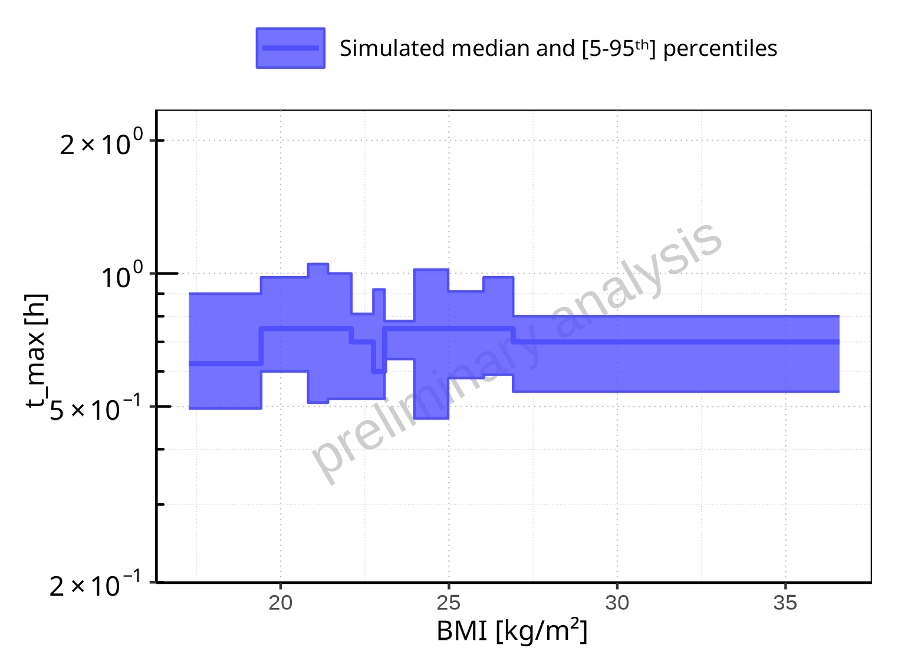

**Figure 2-81: BMI-dependence of t_max for Filmcoated_tablet_400mg_sd. Profiles are plotted in a logarithmic scale.**

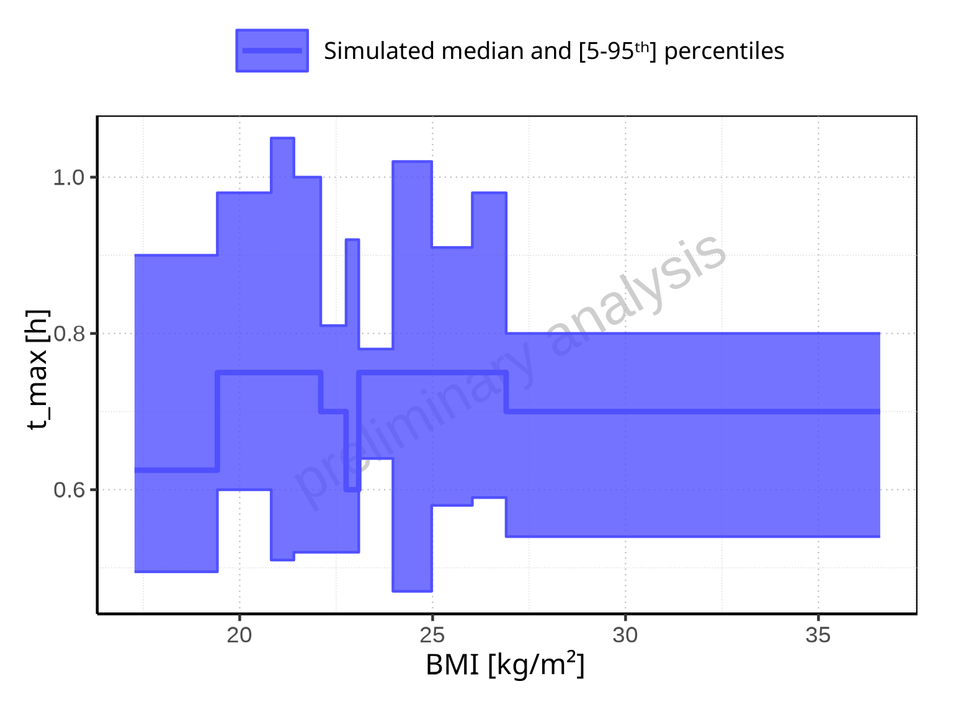

**Figure 2-82: BMI-dependence of t_max for Filmcoated_tablet_400mg_sd. Profiles are plotted in a linear scale.**

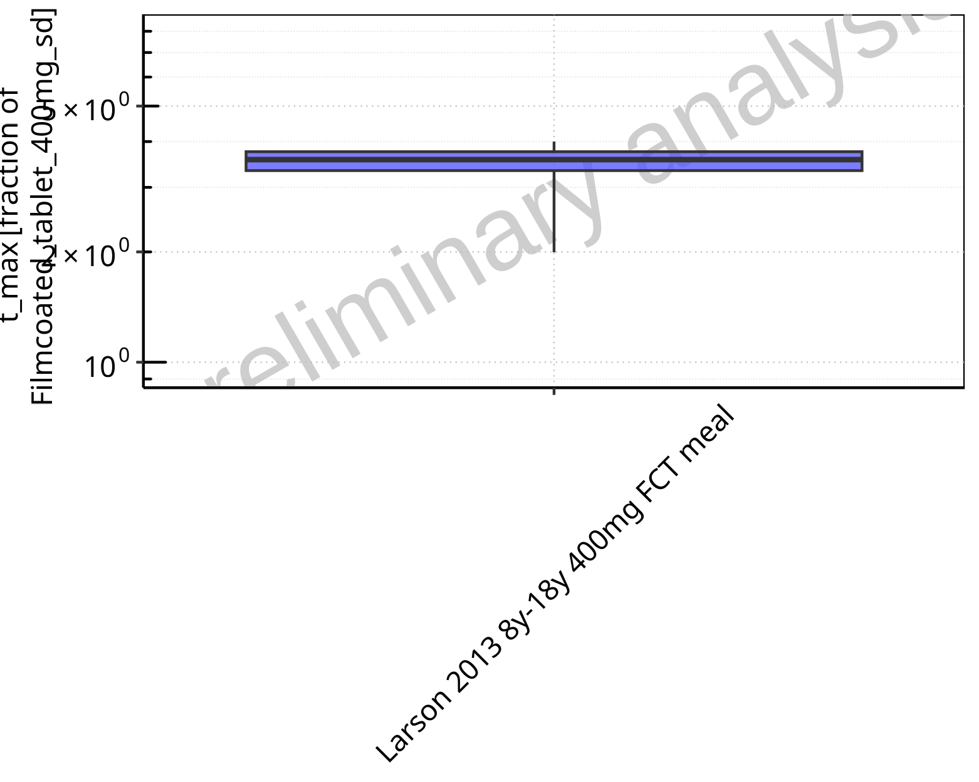

**Figure 2-83: Ratio of population summary statistics of t_max of Raltegravir for Larson 2013 8y-18y 400mg FCT meal in comparison to Filmcoated_tablet_400mg_sd shown as box-whisker plot, which indicates ratios of the 5th, 25th, 50th, 75th, 95th percentiles in logarithmic scale.**

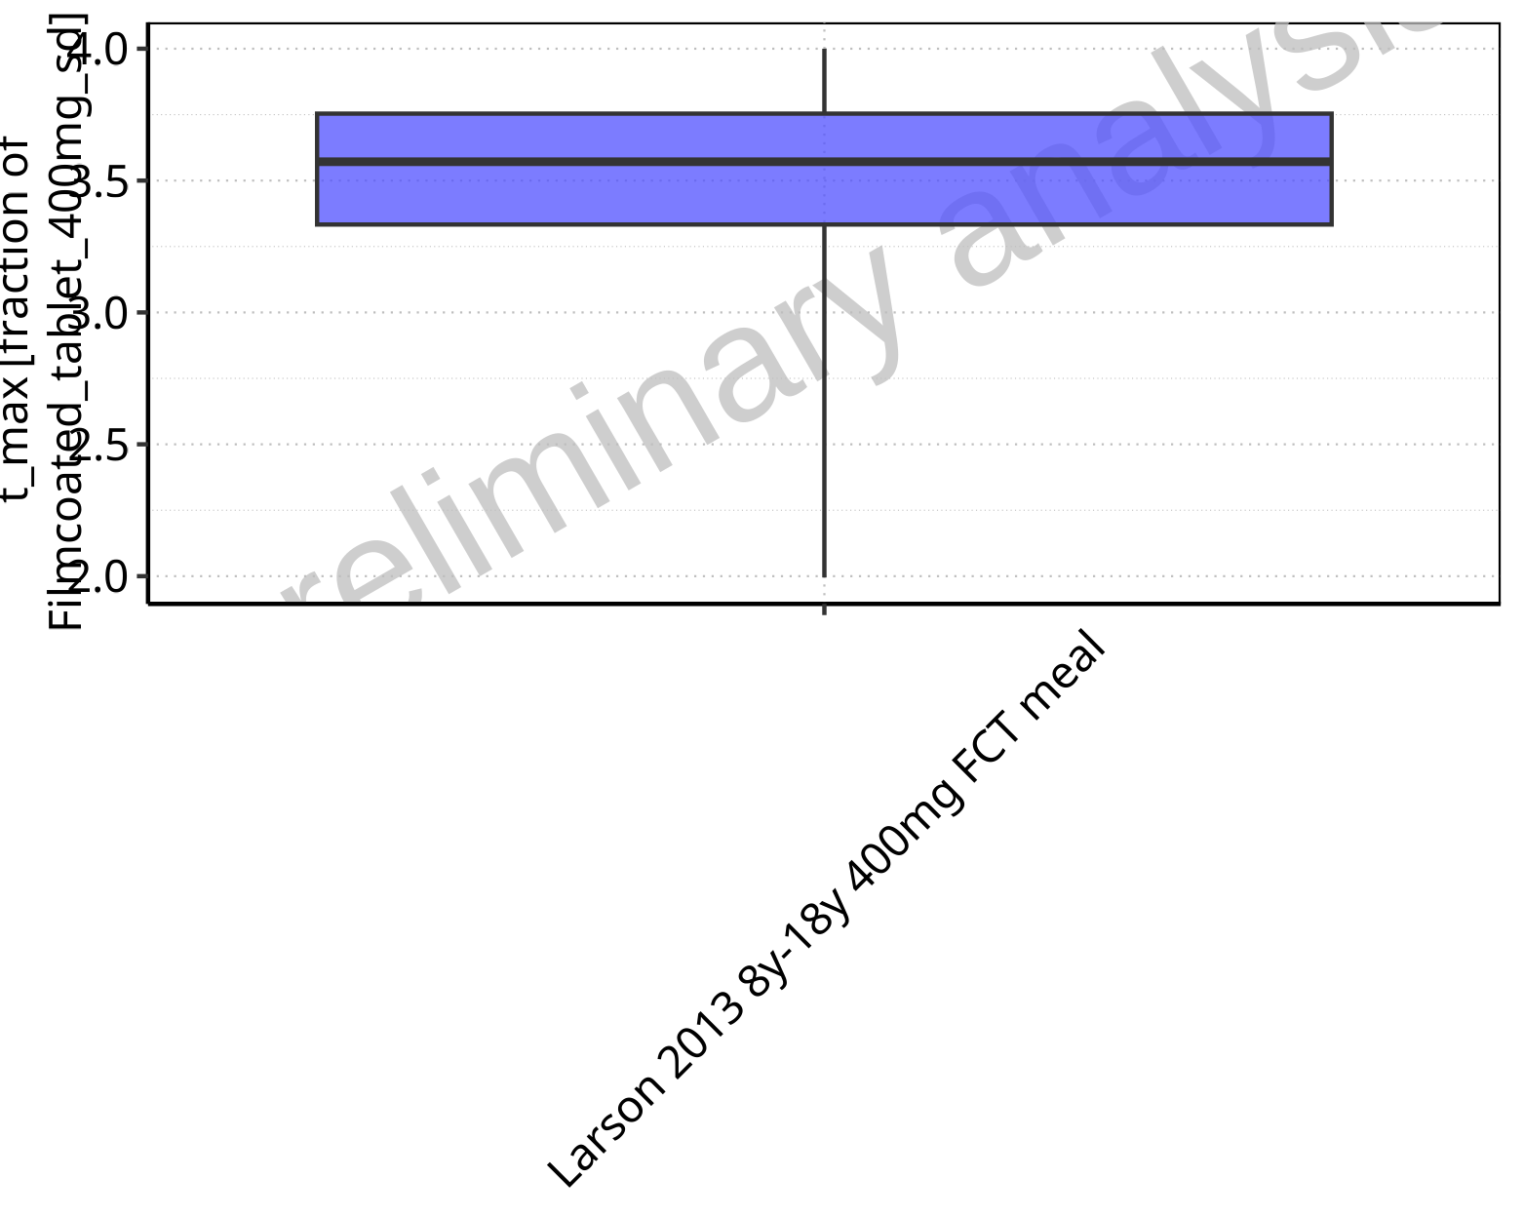

**Figure 2-84: Ratio of population summary statistics of t_max of Raltegravir for Larson 2013 8y-18y 400mg FCT meal in comparison to Filmcoated_tablet_400mg_sd shown as box-whisker plot, which indicates ratios of the 5th, 25th, 50th, 75th, 95th percentiles in linear scale.**

**Table 2-6: Ratio of population summary statistics of t_max of Raltegravir for Larson 2013 8y-18y 400mg FCT meal in comparison to Filmcoated_tablet_400mg_sd**

| Population | N | 5th pctl | 25th pctl | 50th pctl | 75th pctl | 95th pctl | Mean | SD | Geo Mean | Geo SD |
| --- | --- | --- | --- | --- | --- | --- | --- | --- | --- | --- |
| Larson 2013 8y-18y 400mg FCT meal | 500 | 2.00 | 3.33 | 3.57 | 3.75 | 4 | 3.49 | 5.79 | 3.32 | 1.20 |

### C_tEnd

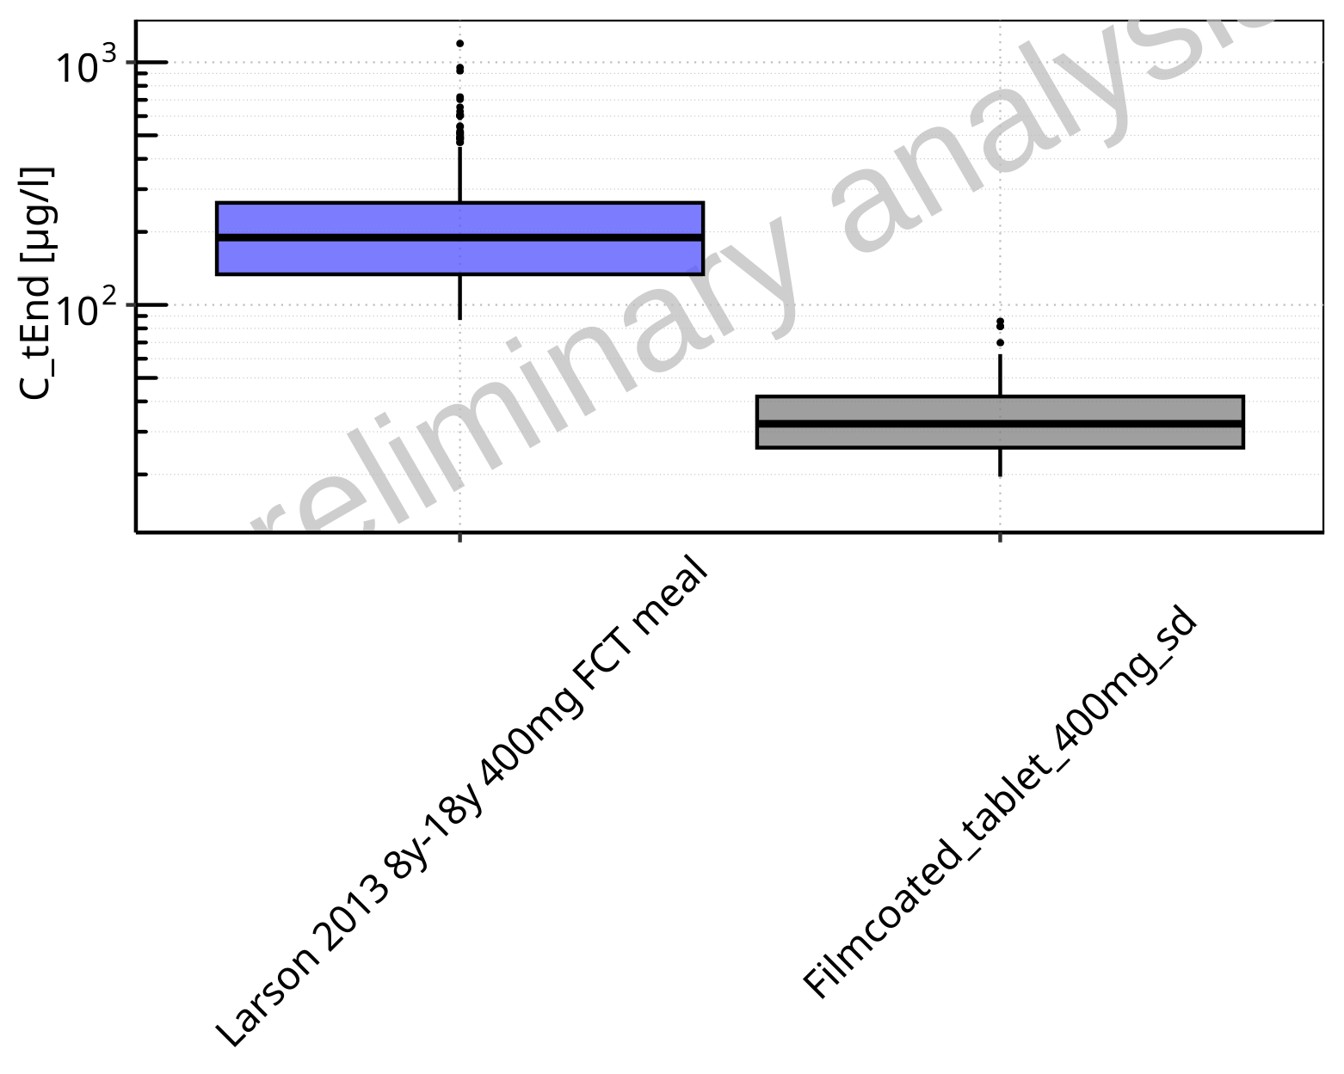

**Figure 2-85: C_tEnd of Raltegravir for Larson 2013 8y-18y 400mg FCT meal, Filmcoated_tablet_400mg_sd shown as box-whisker plot, which indicates the 5th, 25th, 50th, 75th, 95th percentiles in logarithmic scale.**

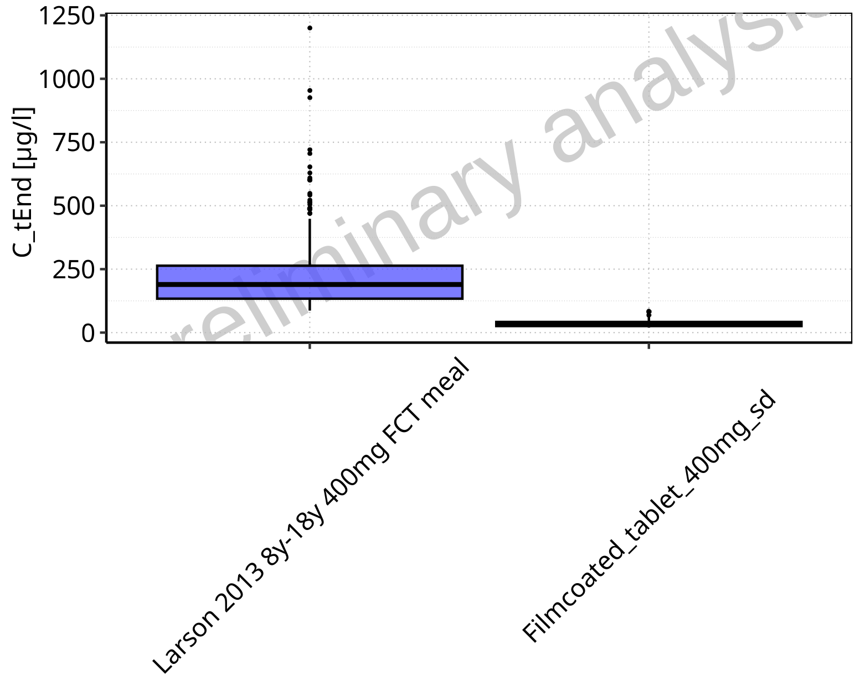

**Figure 2-86: C_tEnd of Raltegravir for Larson 2013 8y-18y 400mg FCT meal, Filmcoated_tablet_400mg_sd shown as box-whisker plot, which indicates the 5th, 25th, 50th, 75th, 95th percentiles in linear scale.**

**Table 2-7: Population statistics summarizing C_tEnd of Raltegravir for Larson 2013 8y-18y 400mg FCT meal, Filmcoated_tablet_400mg_sd reported in [µg/l]**

| Population | N | 5th pctl | 25th pctl | 50th pctl | 75th pctl | 95th pctl | Mean | SD | Geo Mean | Geo SD |
| --- | --- | --- | --- | --- | --- | --- | --- | --- | --- | --- |
| Larson 2013 8y-18y 400mg FCT meal | 500 | 86.63 | 133.65 | 189.56 | 263.51 | 448.02 | 218.90 | 129.12 | 191.12 | 1.67 |
| Filmcoated_tablet_400mg_sd | 100 | 19.57 | 25.80 | 32.35 | 41.91 | 62.68 | 35.39 | 14.21 | 33.01 | 1.44 |

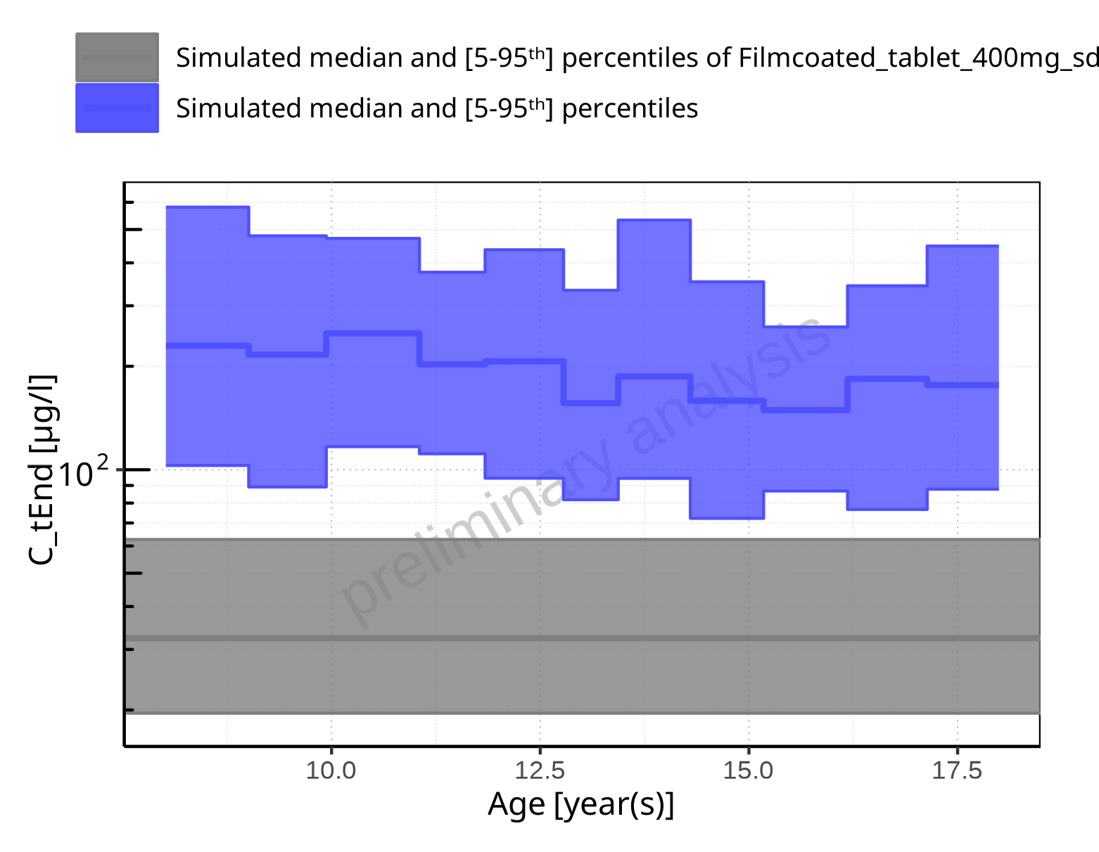

**Figure 2-87: Age-dependence of C_tEnd for Larson 2013 8y-18y 400mg FCT meal in comparison to Filmcoated_tablet_400mg_sd. Profiles are plotted in a logarithmic scale.**

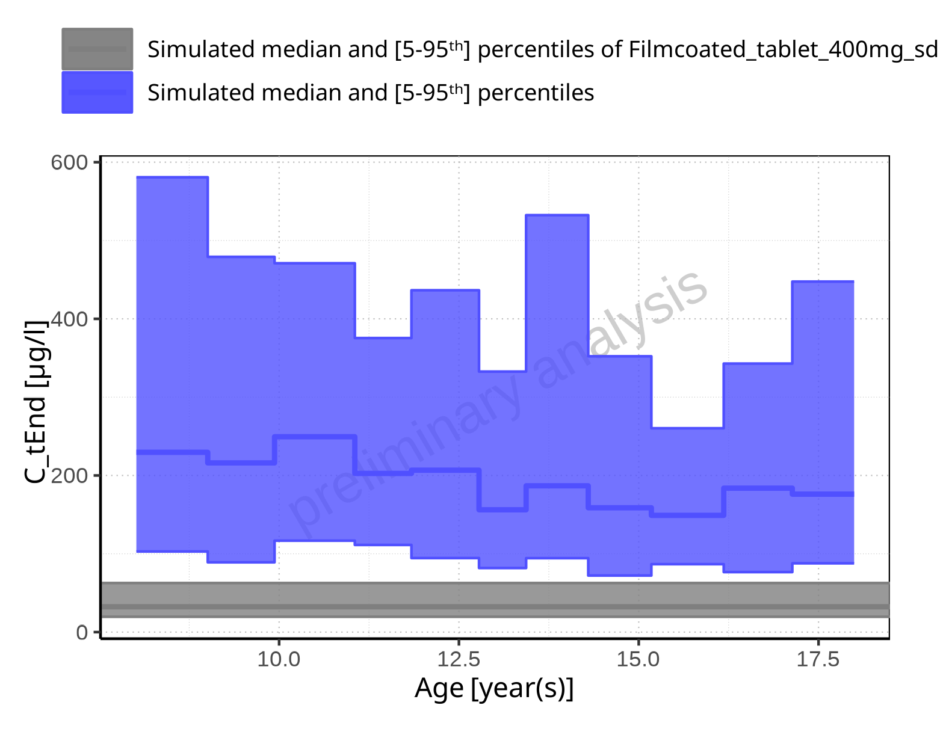

**Figure 2-88: Age-dependence of C_tEnd for Larson 2013 8y-18y 400mg FCT meal in comparison to Filmcoated_tablet_400mg_sd. Profiles are plotted in a linear scale.**

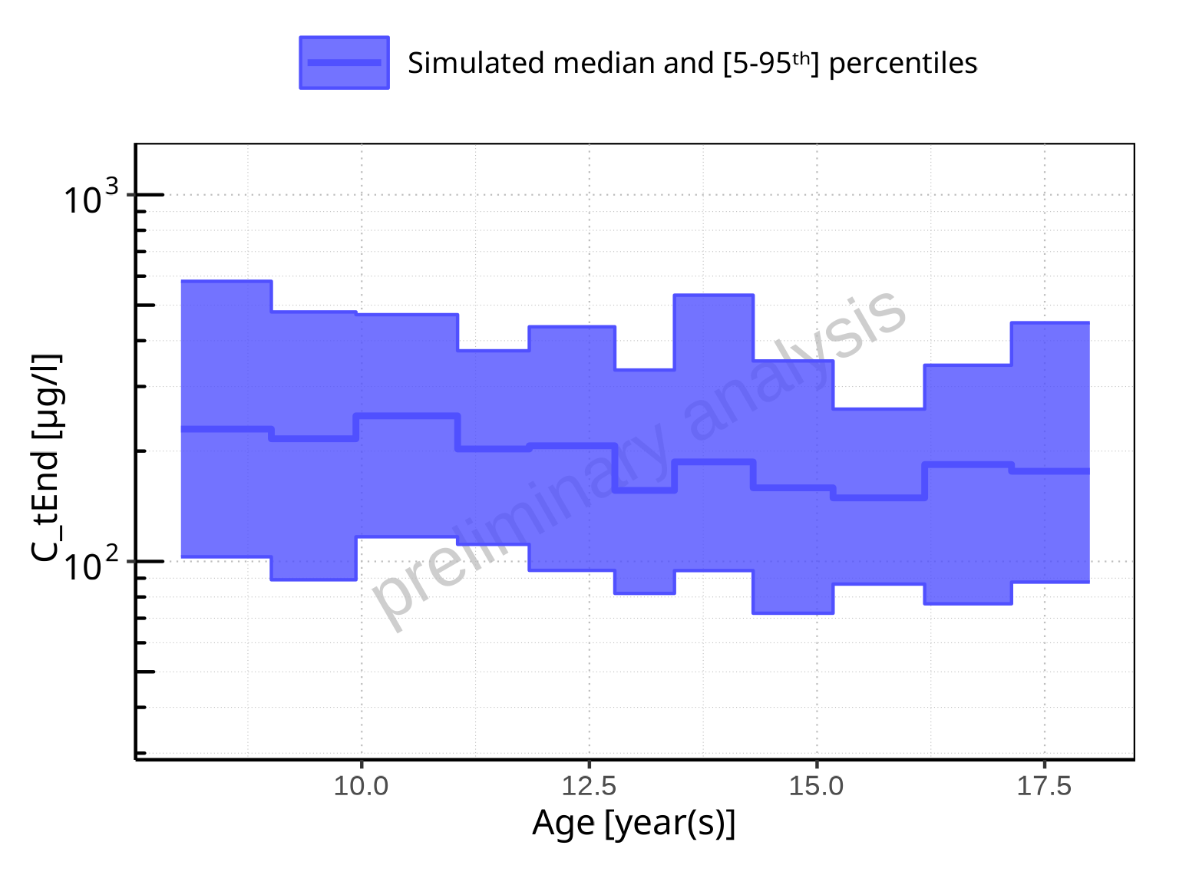

**Figure 2-89: Age-dependence of C_tEnd for Larson 2013 8y-18y 400mg FCT meal. Profiles are plotted in a logarithmic scale.**

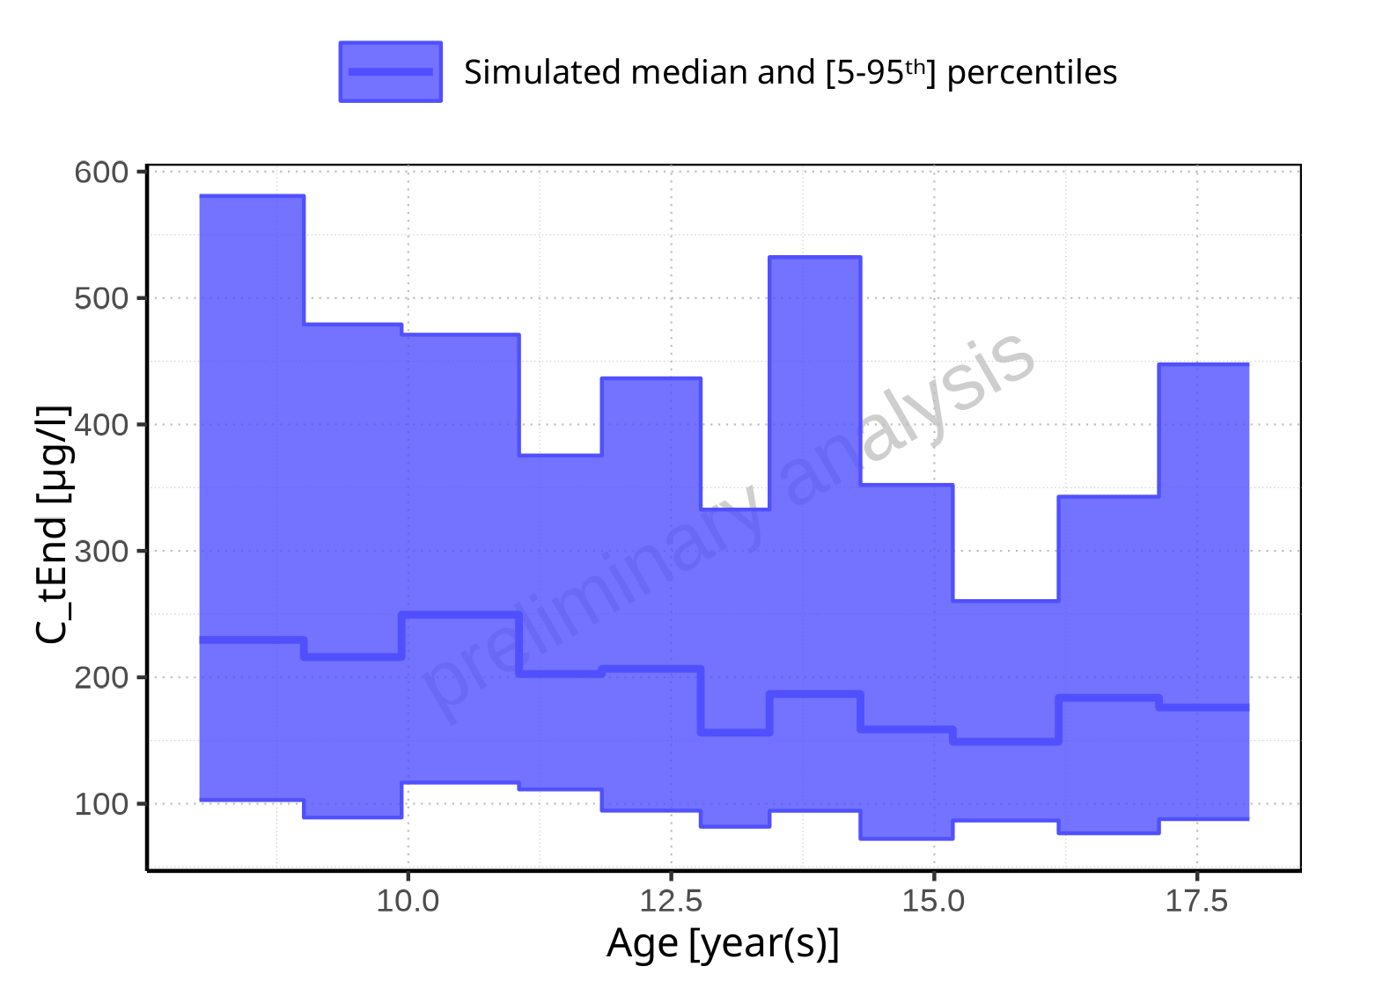

**Figure 2-90: Age-dependence of C_tEnd for Larson 2013 8y-18y 400mg FCT meal. Profiles are plotted in a linear scale.**

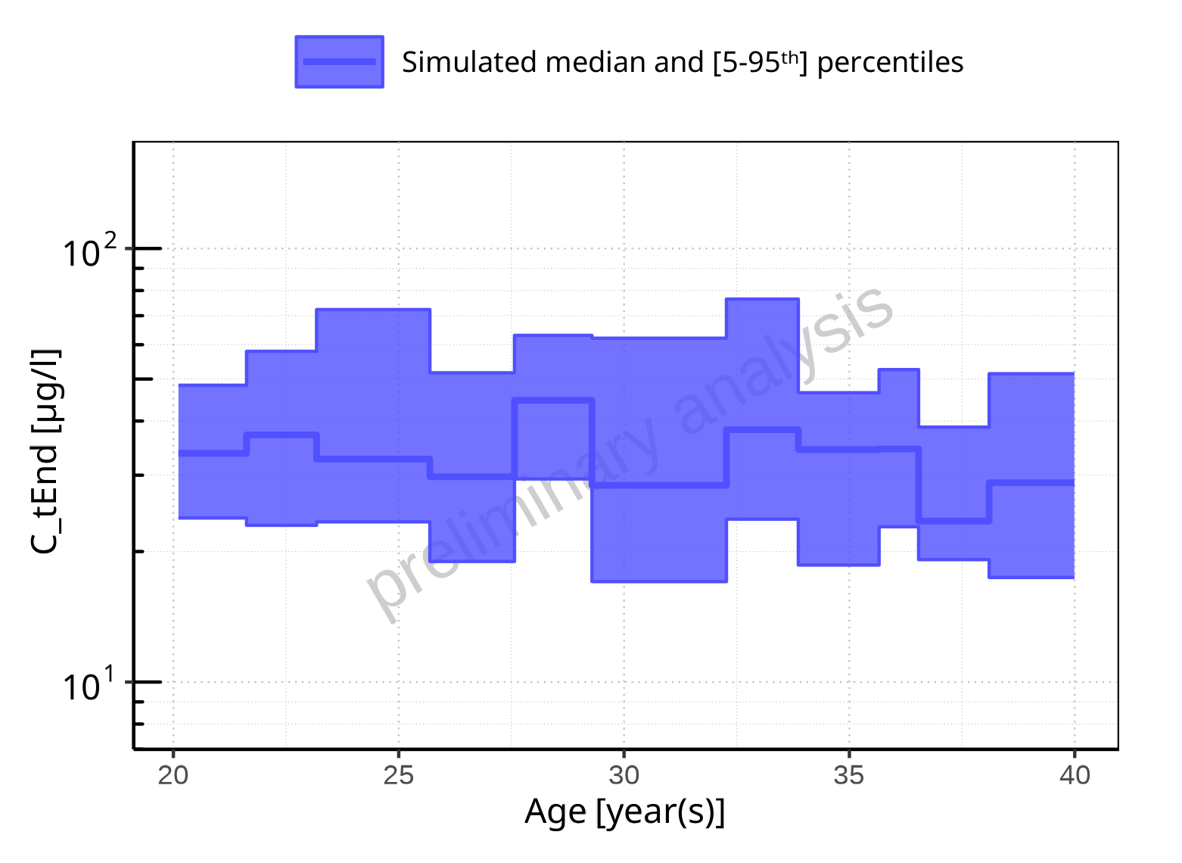

**Figure 2-91: Age-dependence of C_tEnd for Filmcoated_tablet_400mg_sd. Profiles are plotted in a logarithmic scale.**

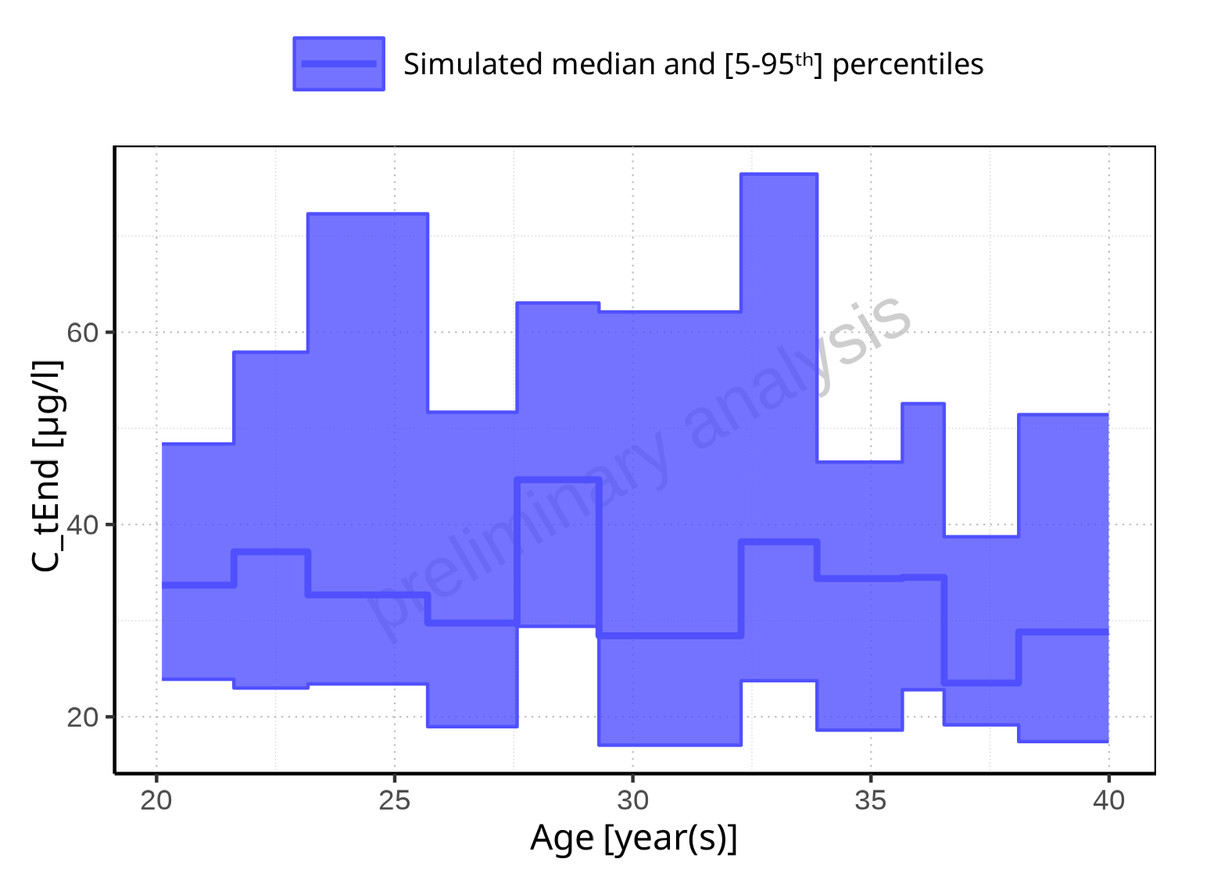

**Figure 2-92: Age-dependence of C_tEnd for Filmcoated_tablet_400mg_sd. Profiles are plotted in a linear scale.**

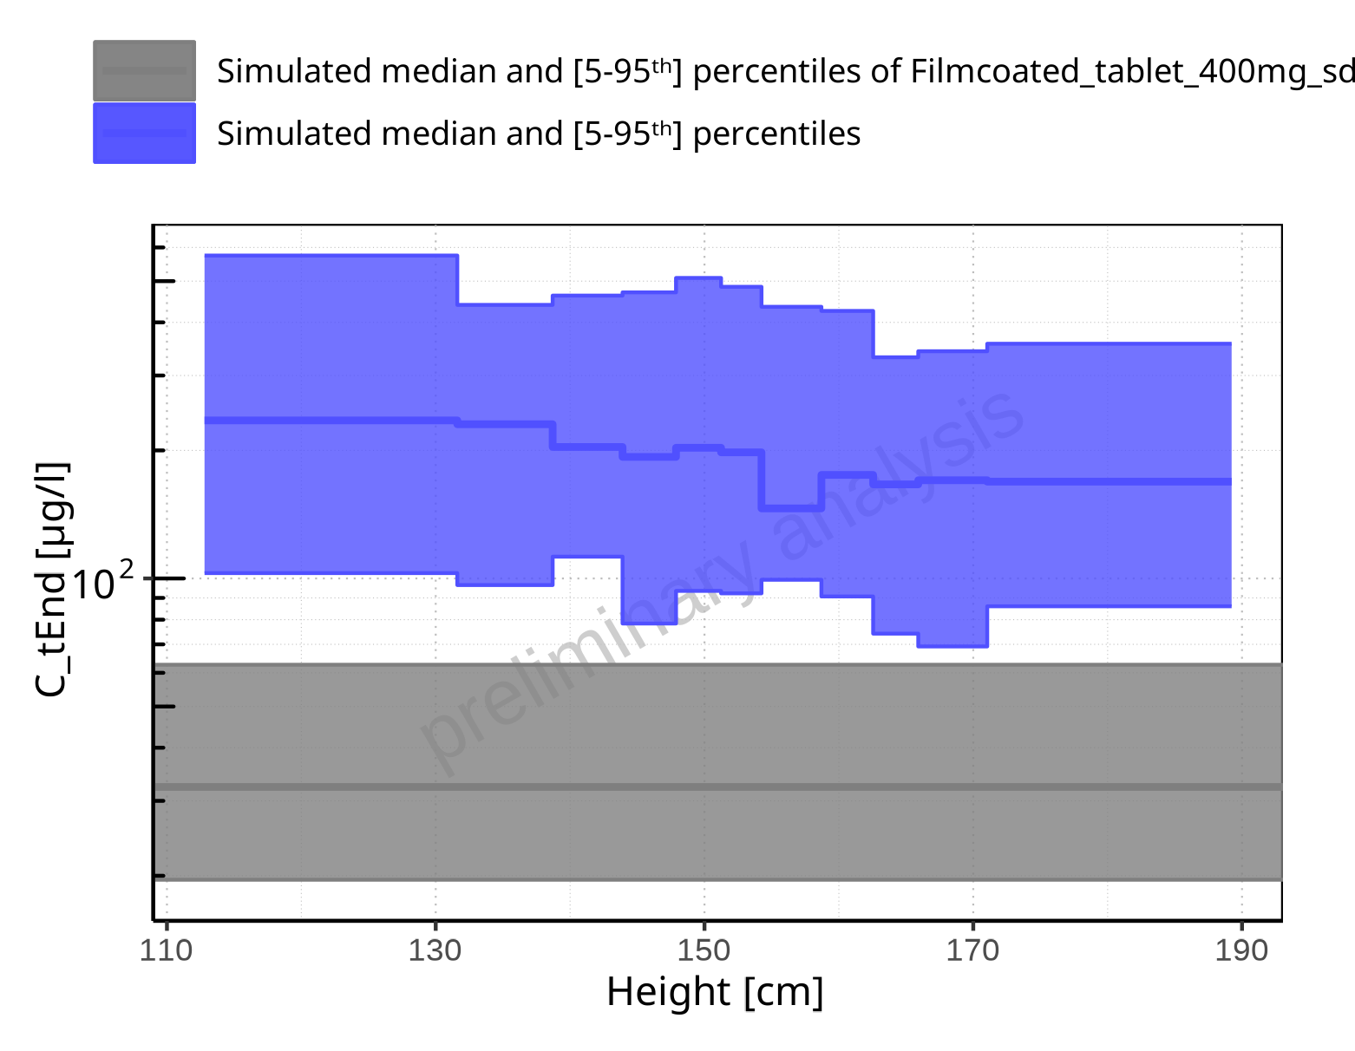

**Figure 2-93: Height-dependence of C_tEnd for Larson 2013 8y-18y 400mg FCT meal in comparison to Filmcoated_tablet_400mg_sd. Profiles are plotted in a logarithmic scale.**

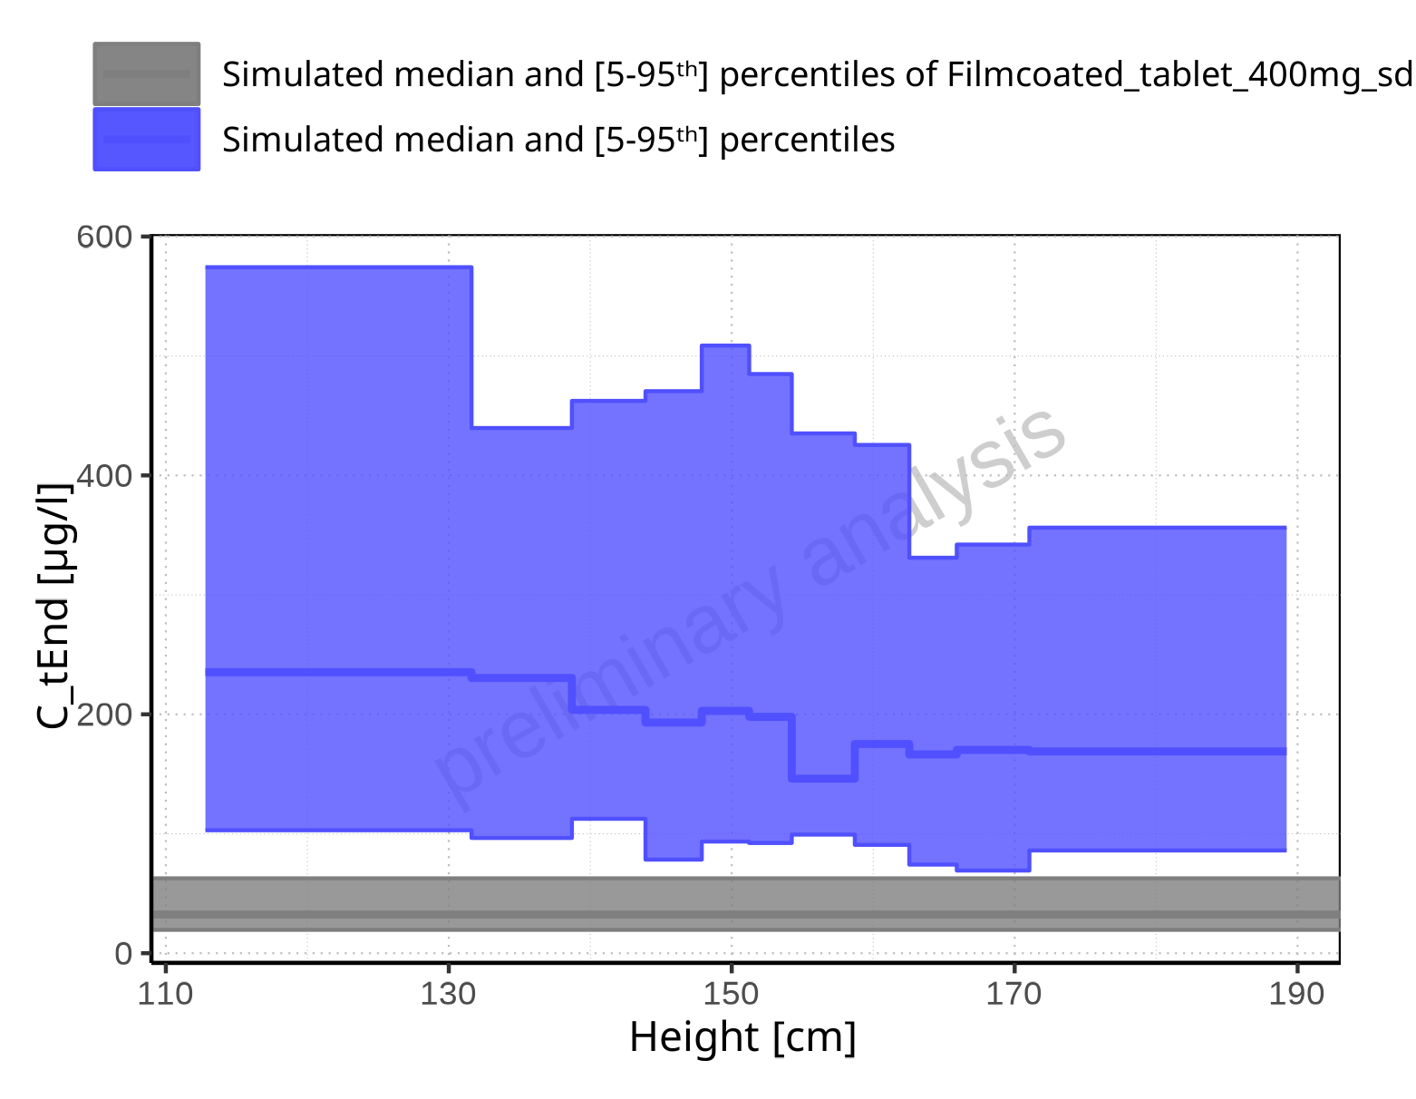

**Figure 2-94: Height-dependence of C_tEnd for Larson 2013 8y-18y 400mg FCT meal in comparison to Filmcoated_tablet_400mg_sd. Profiles are plotted in a linear scale.**

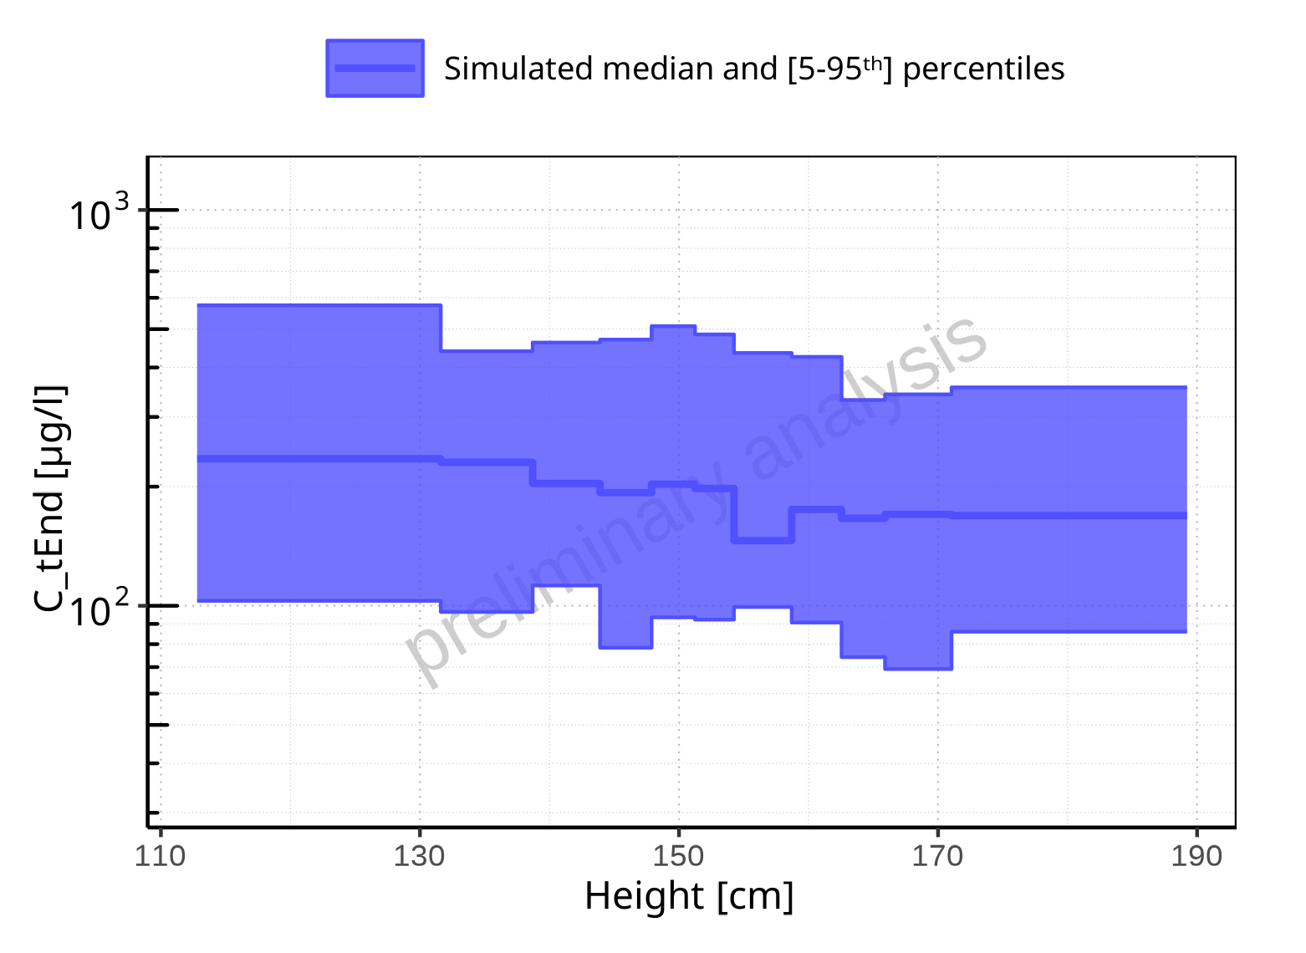

**Figure 2-95: Height-dependence of C_tEnd for Larson 2013 8y-18y 400mg FCT meal. Profiles are plotted in a logarithmic scale.**

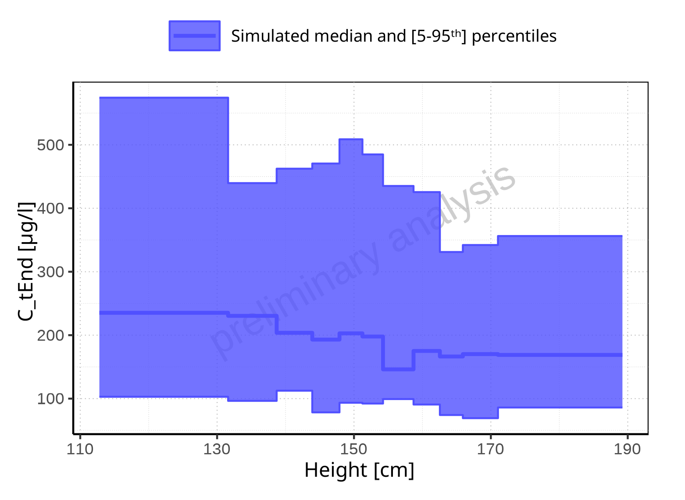

**Figure 2-96: Height-dependence of C_tEnd for Larson 2013 8y-18y 400mg FCT meal. Profiles are plotted in a linear scale.**

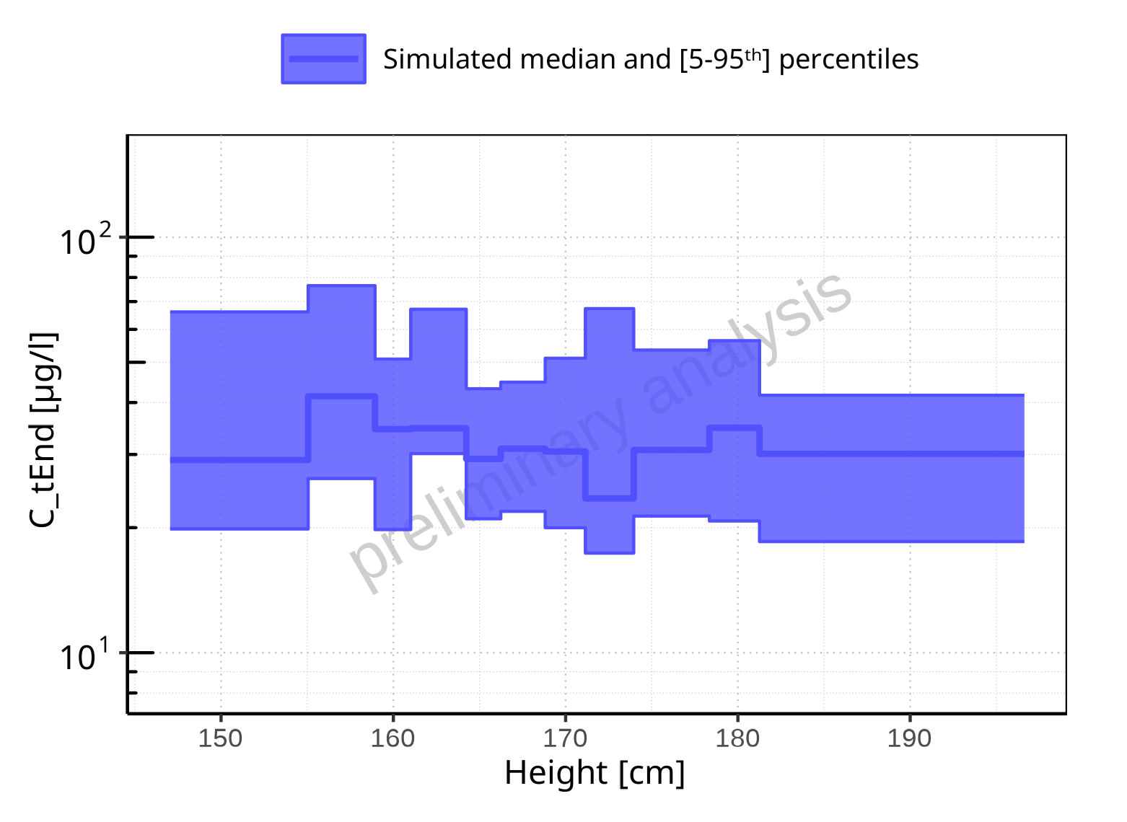

**Figure 2-97: Height-dependence of C_tEnd for Filmcoated_tablet_400mg_sd. Profiles are plotted in a logarithmic scale.**

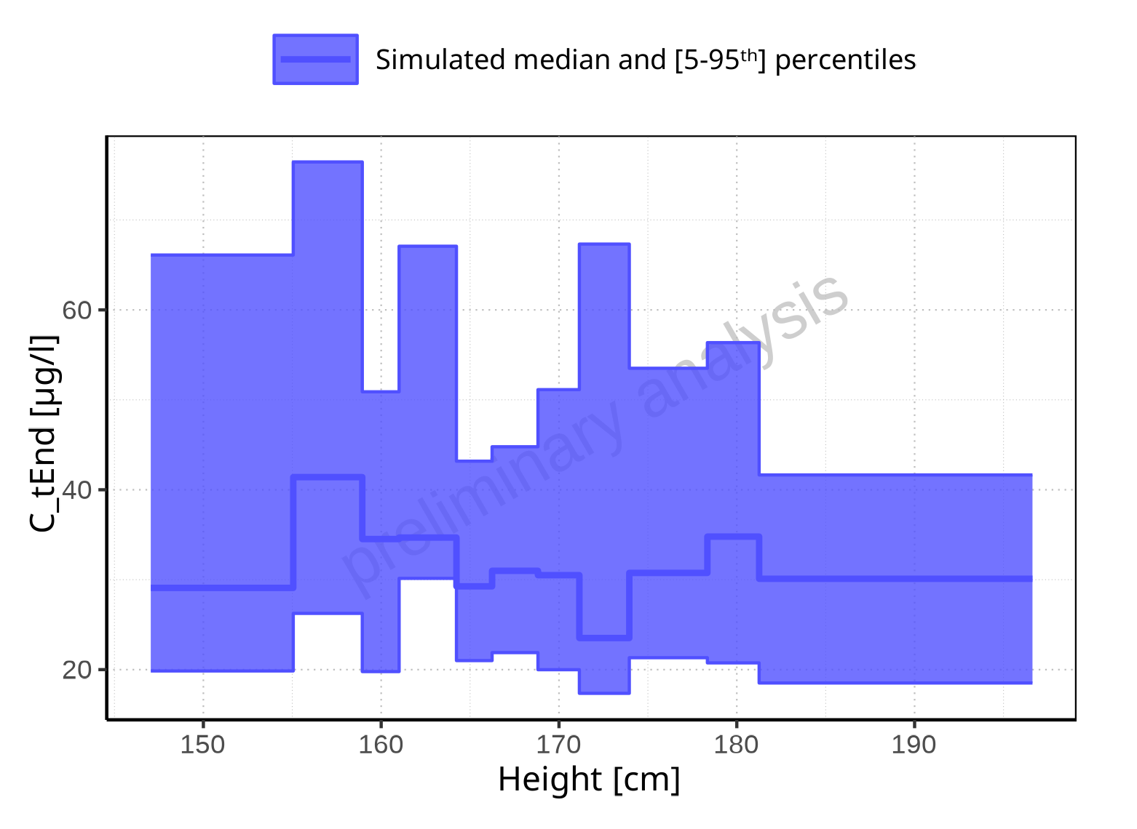

**Figure 2-98: Height-dependence of C_tEnd for Filmcoated_tablet_400mg_sd. Profiles are plotted in a linear scale.**

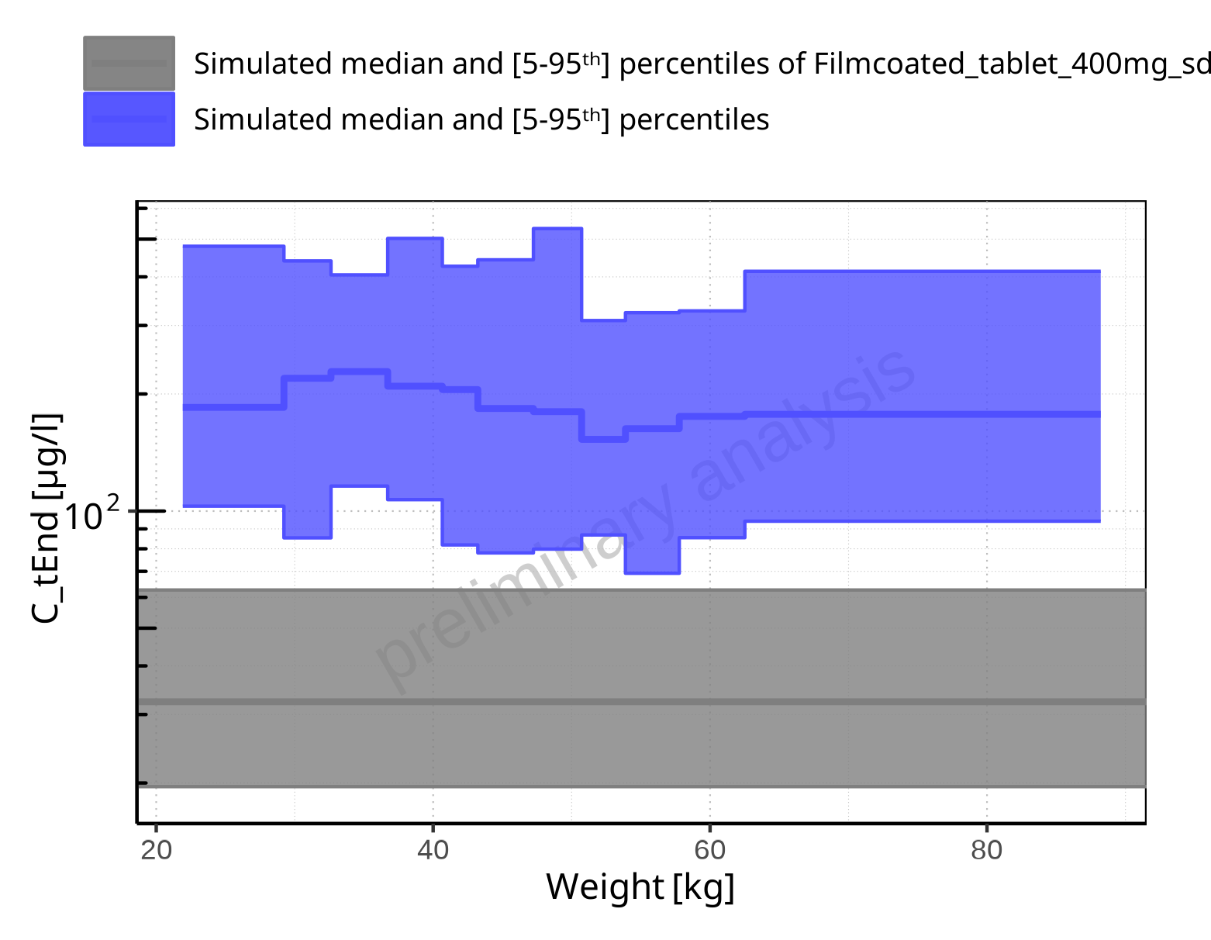

**Figure 2-99: Weight-dependence of C_tEnd for Larson 2013 8y-18y 400mg FCT meal in comparison to Filmcoated_tablet_400mg_sd. Profiles are plotted in a logarithmic scale.**

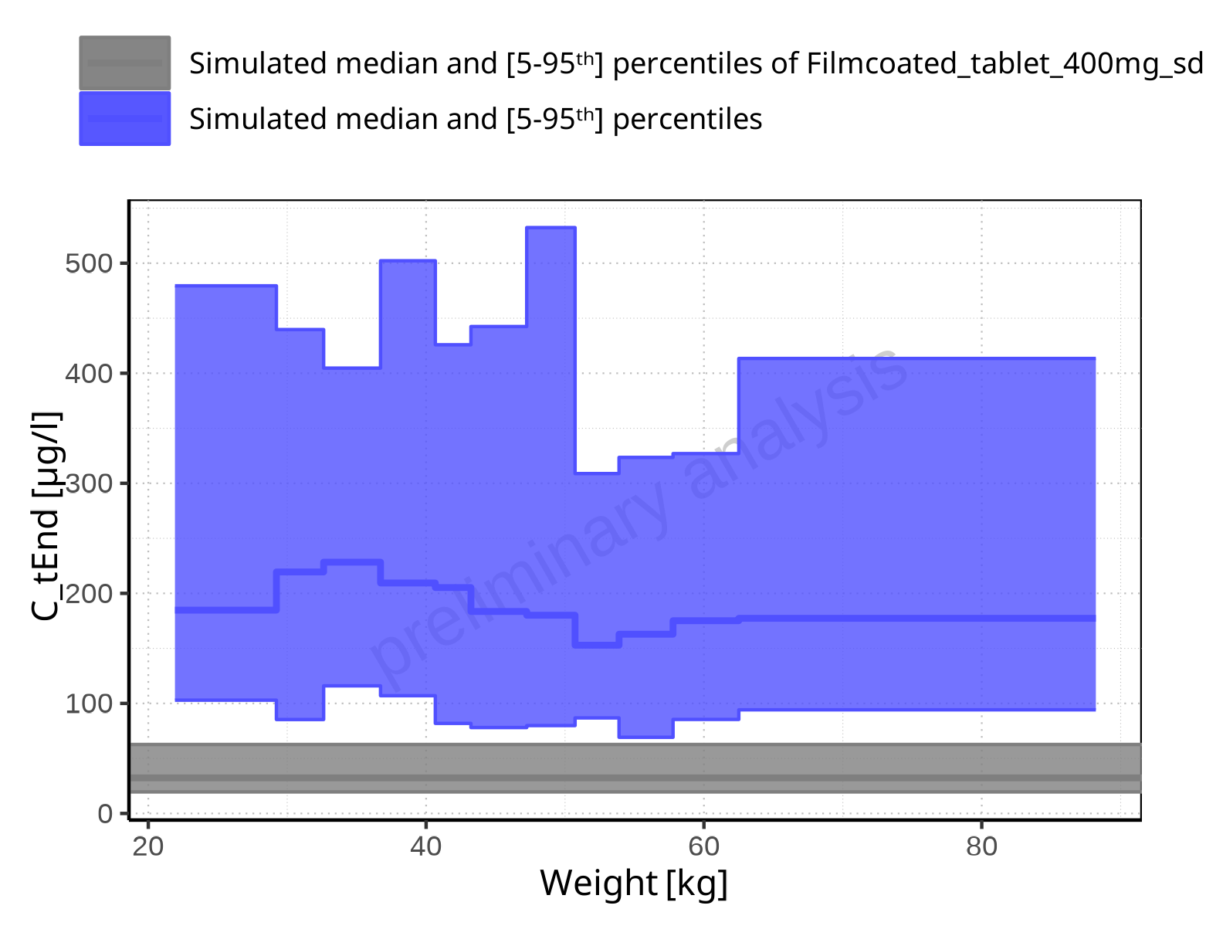

**Figure 2-100: Weight-dependence of C_tEnd for Larson 2013 8y-18y 400mg FCT meal in comparison to Filmcoated_tablet_400mg_sd. Profiles are plotted in a linear scale.**

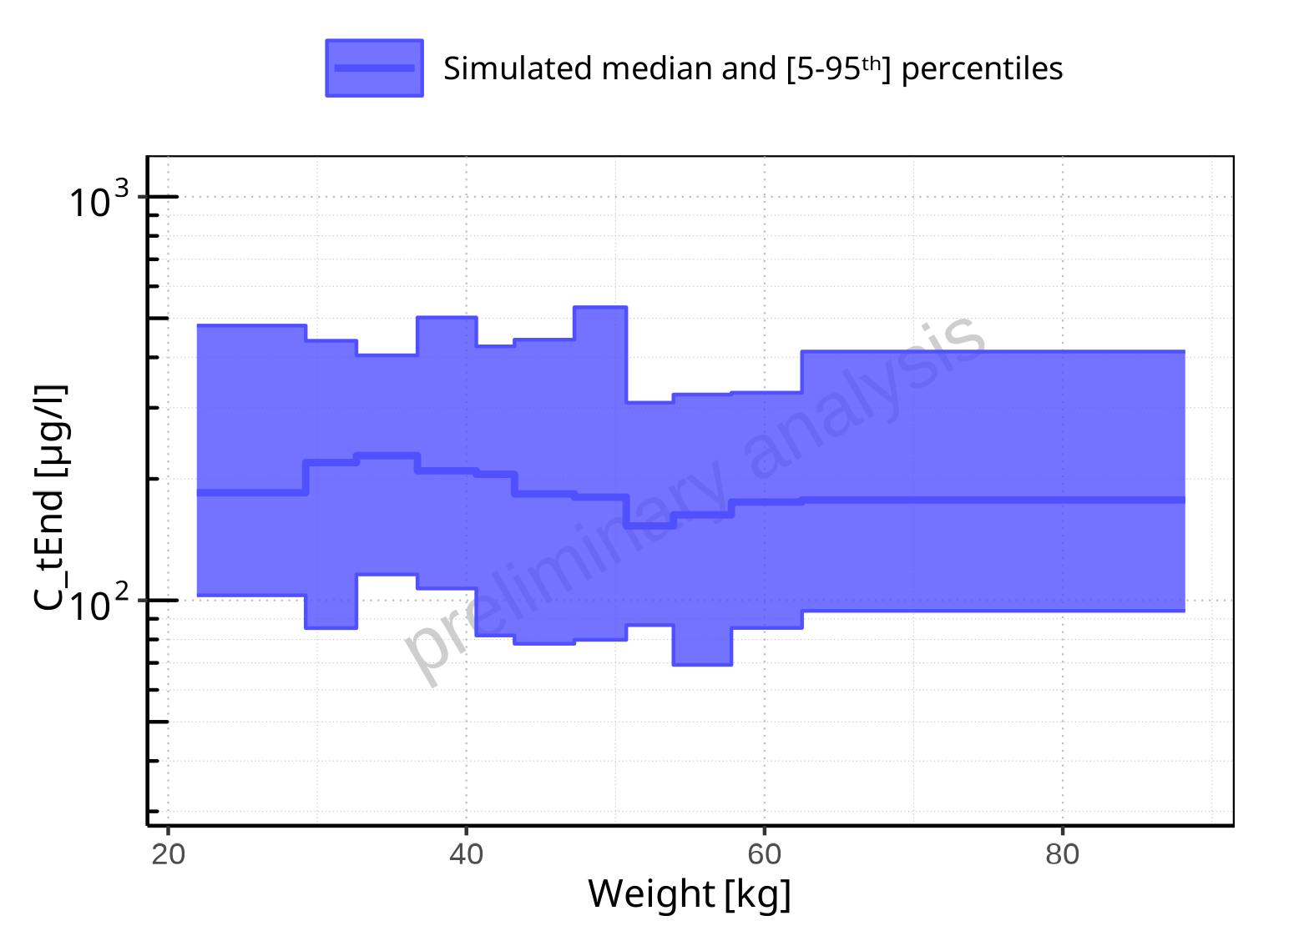

**Figure 2-101: Weight-dependence of C_tEnd for Larson 2013 8y-18y 400mg FCT meal. Profiles are plotted in a logarithmic scale.**

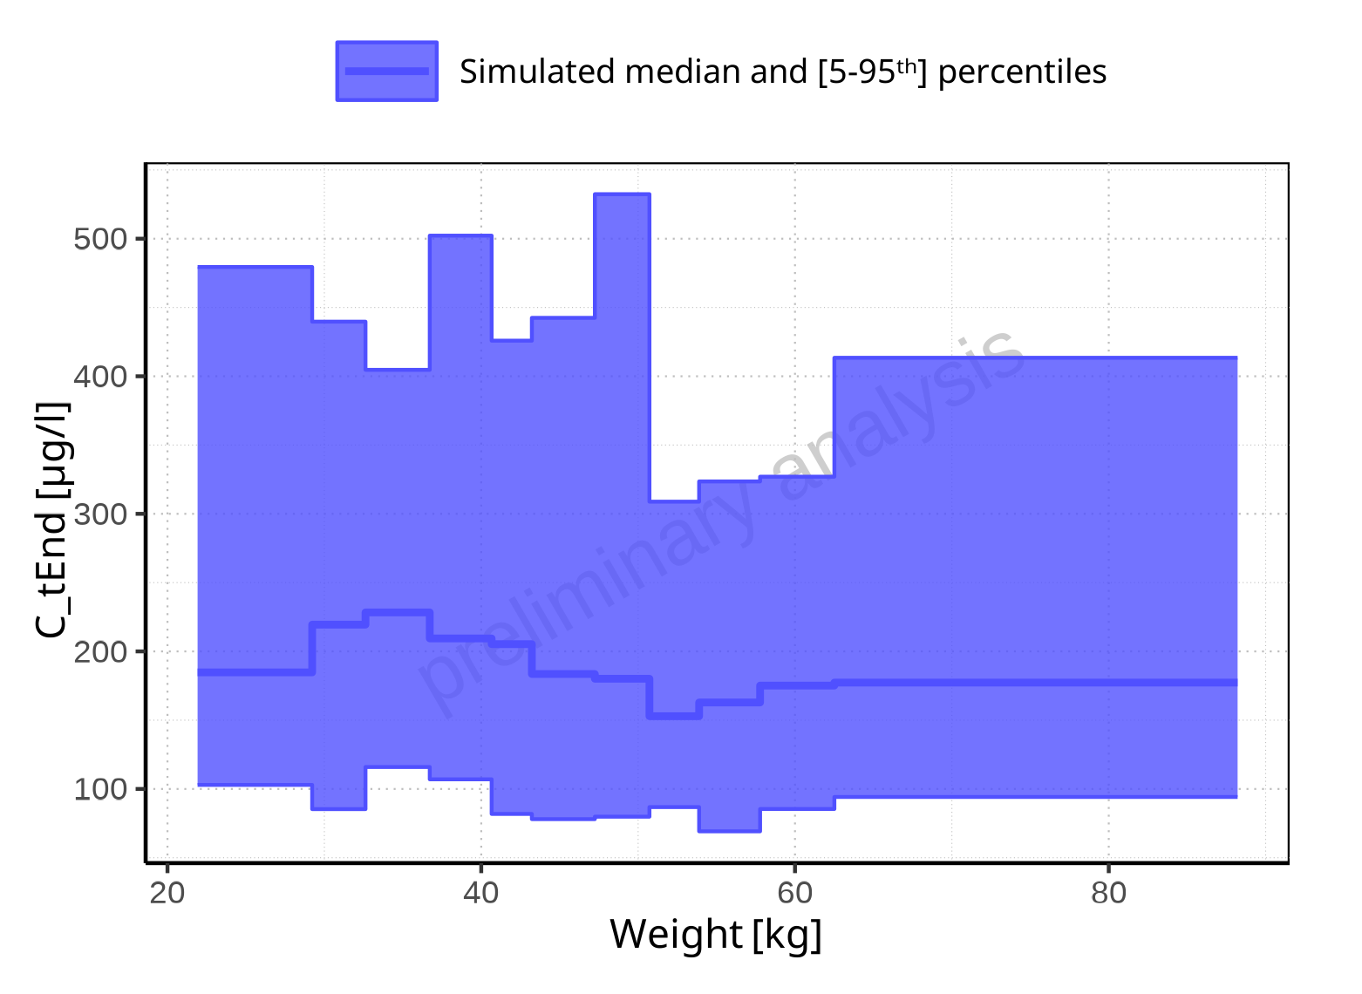

**Figure 2-102: Weight-dependence of C_tEnd for Larson 2013 8y-18y 400mg FCT meal. Profiles are plotted in a linear scale.**

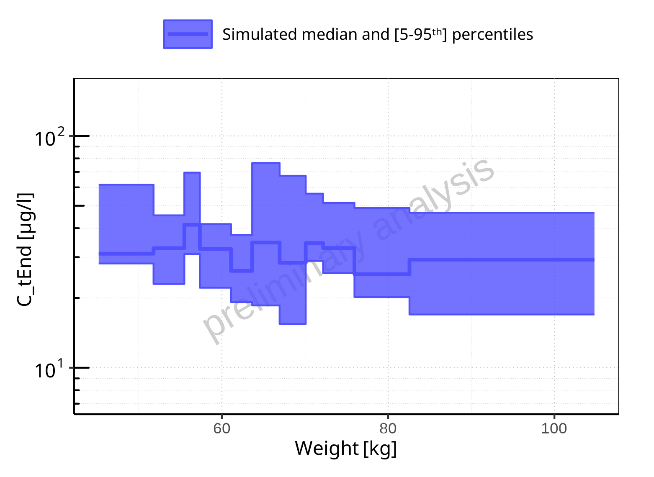

**Figure 2-103: Weight-dependence of C_tEnd for Filmcoated_tablet_400mg_sd. Profiles are plotted in a logarithmic scale.**

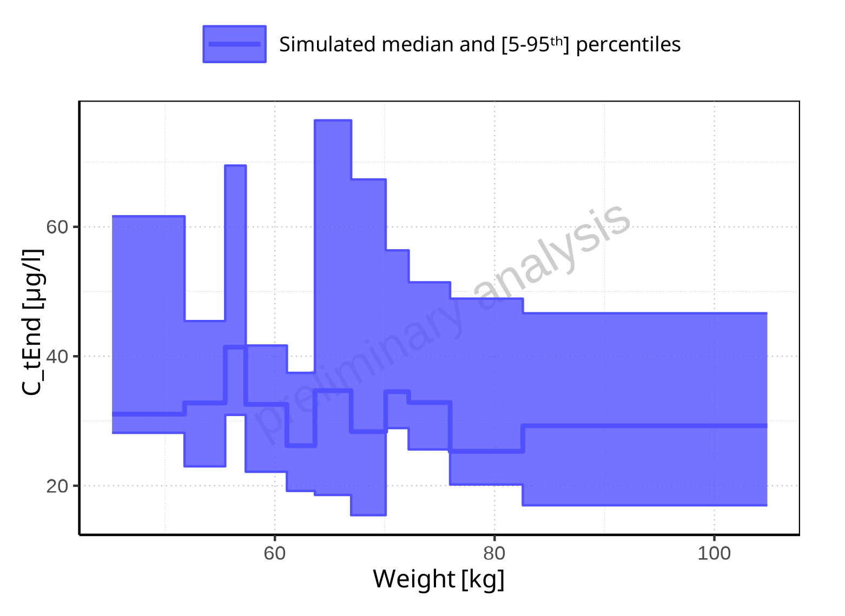

**Figure 2-104: Weight-dependence of C_tEnd for Filmcoated_tablet_400mg_sd. Profiles are plotted in a linear scale.**

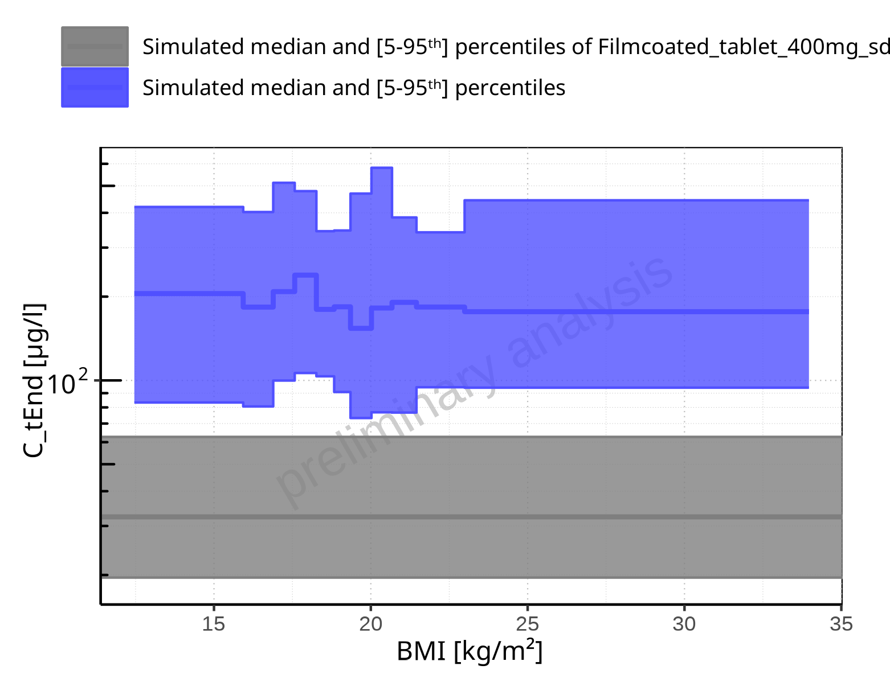

**Figure 2-105: BMI-dependence of C_tEnd for Larson 2013 8y-18y 400mg FCT meal in comparison to Filmcoated_tablet_400mg_sd. Profiles are plotted in a logarithmic scale.**

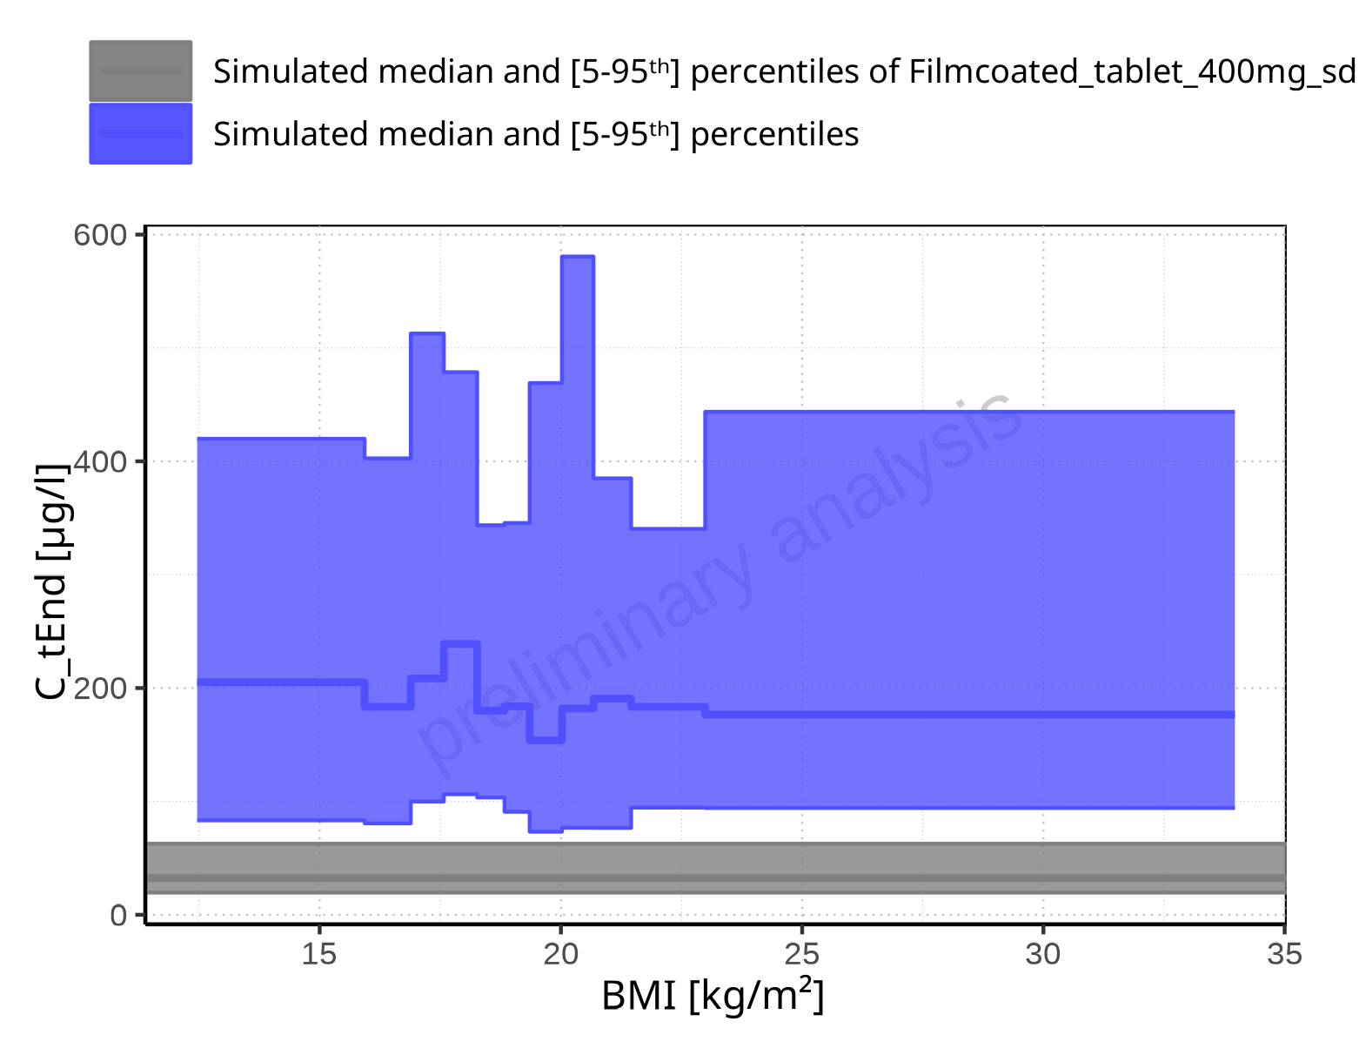

**Figure 2-106: BMI-dependence of C_tEnd for Larson 2013 8y-18y 400mg FCT meal in comparison to Filmcoated_tablet_400mg_sd. Profiles are plotted in a linear scale.**

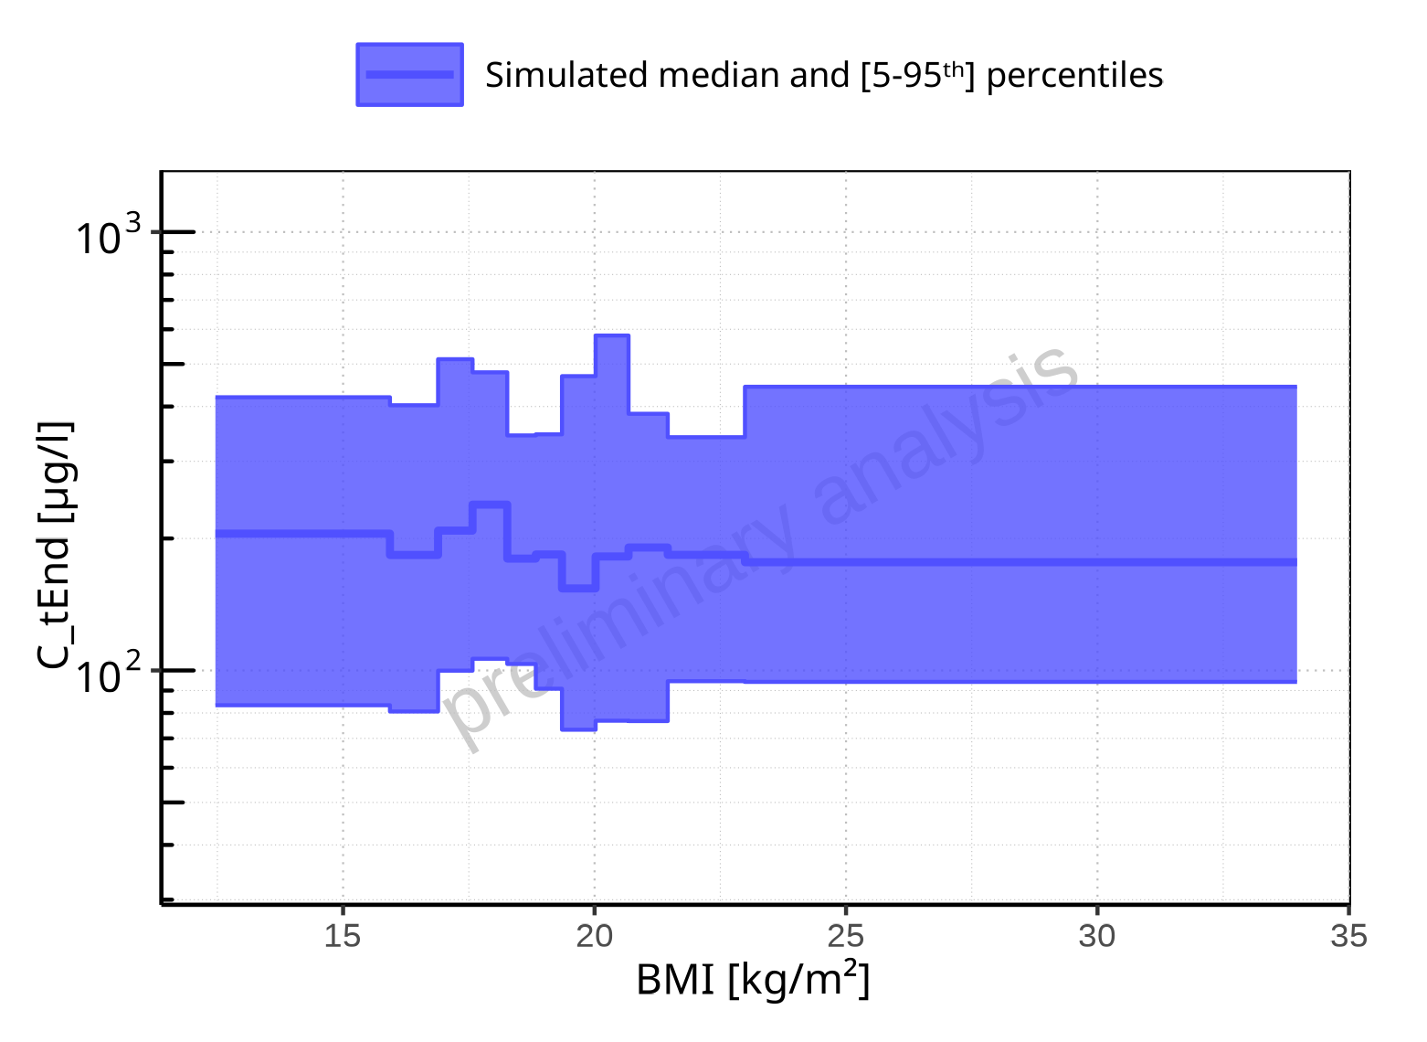

**Figure 2-107: BMI-dependence of C_tEnd for Larson 2013 8y-18y 400mg FCT meal. Profiles are plotted in a logarithmic scale.**

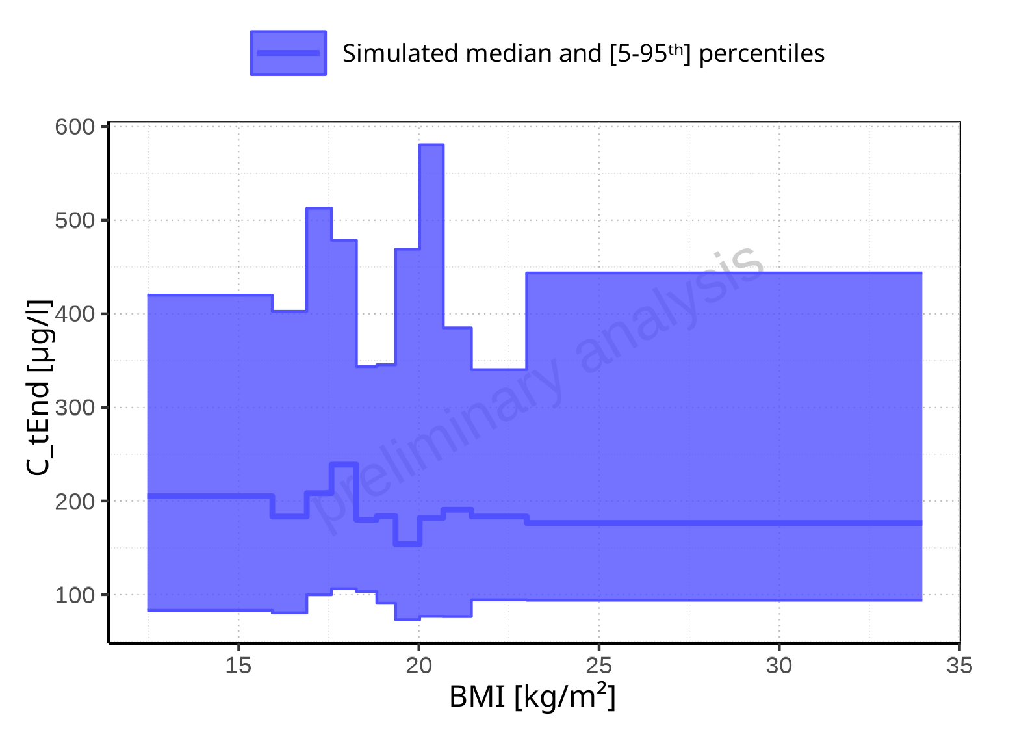

**Figure 2-108: BMI-dependence of C_tEnd for Larson 2013 8y-18y 400mg FCT meal. Profiles are plotted in a linear scale.**

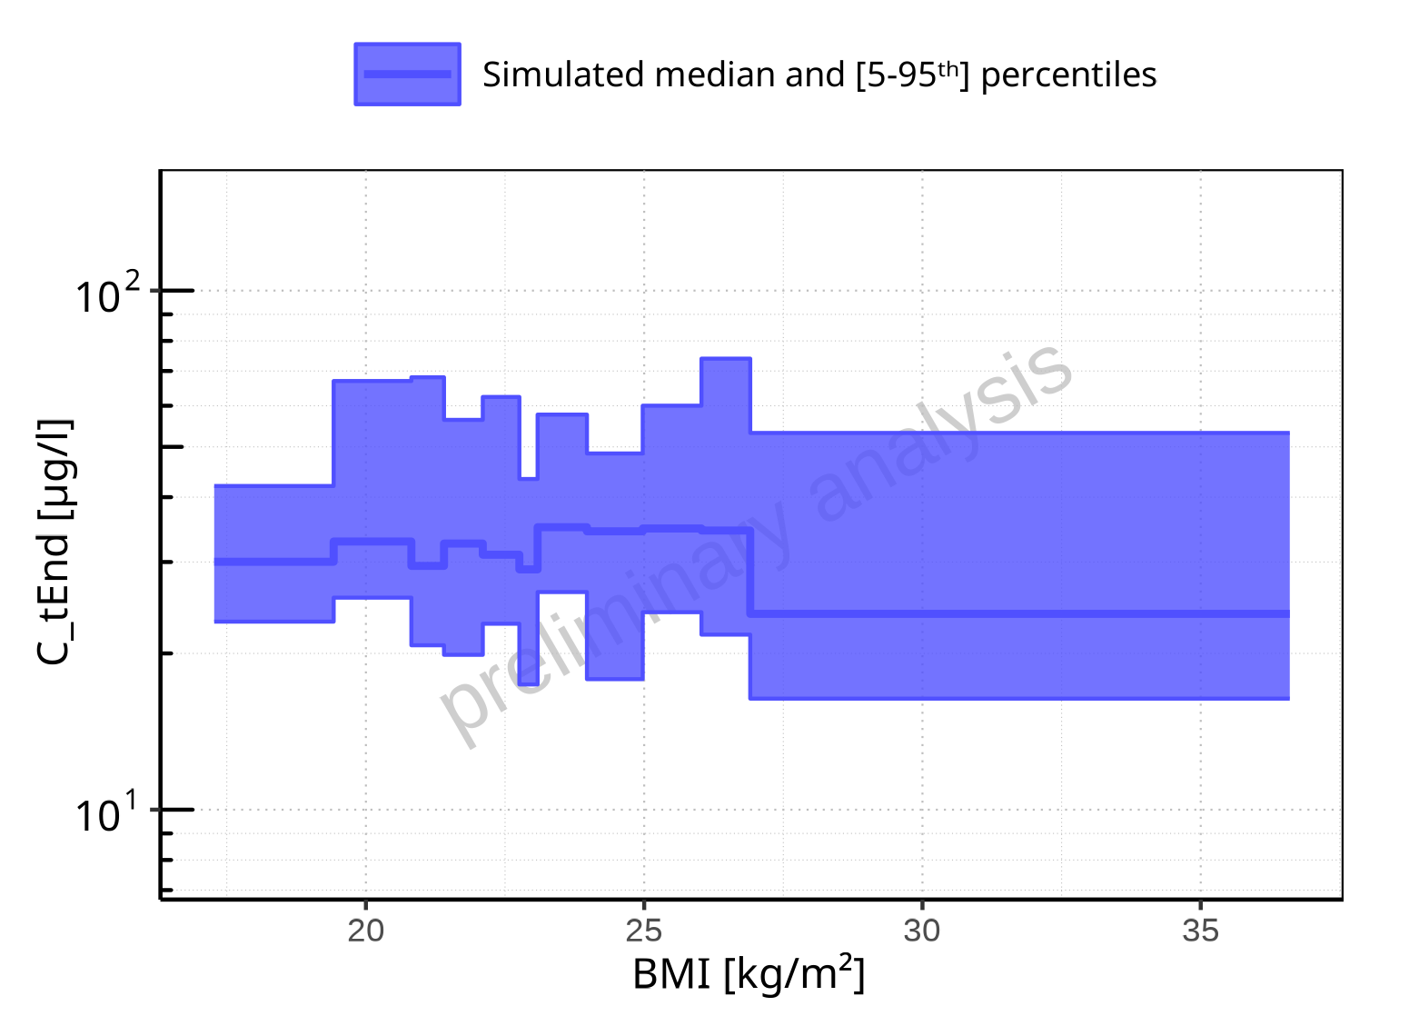

**Figure 2-109: BMI-dependence of C_tEnd for Filmcoated_tablet_400mg_sd. Profiles are plotted in a logarithmic scale.**

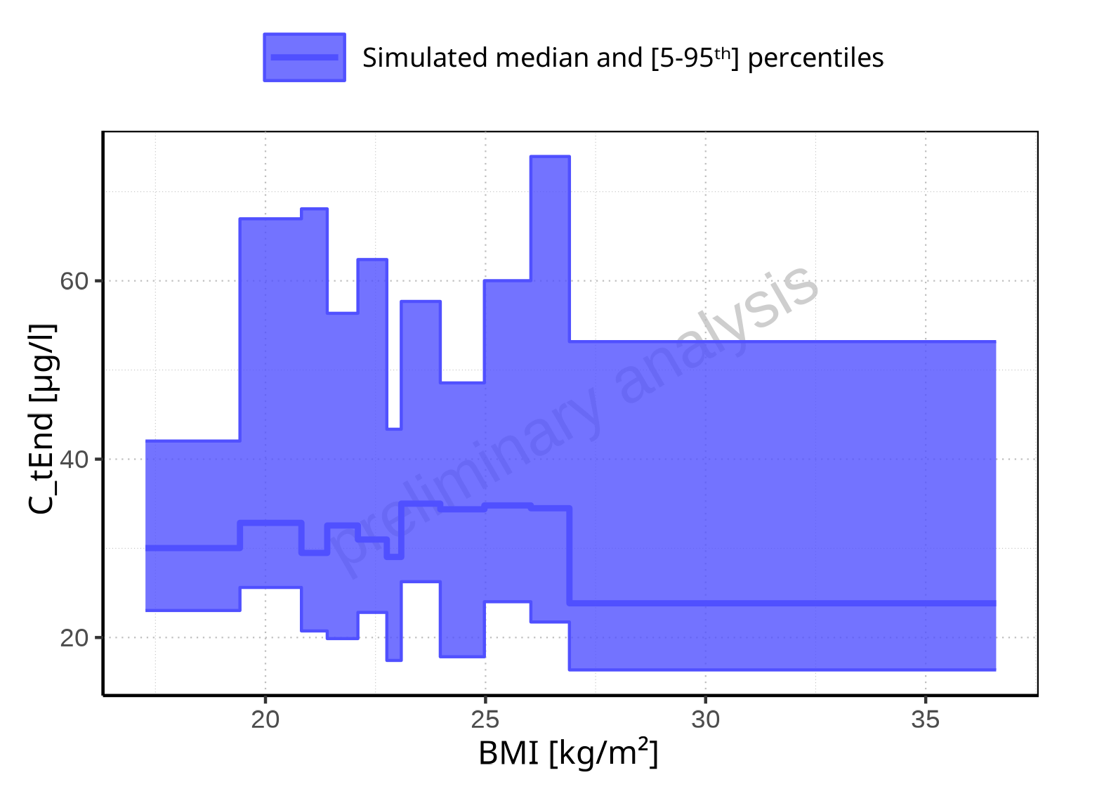

**Figure 2-110: BMI-dependence of C_tEnd for Filmcoated_tablet_400mg_sd. Profiles are plotted in a linear scale.**

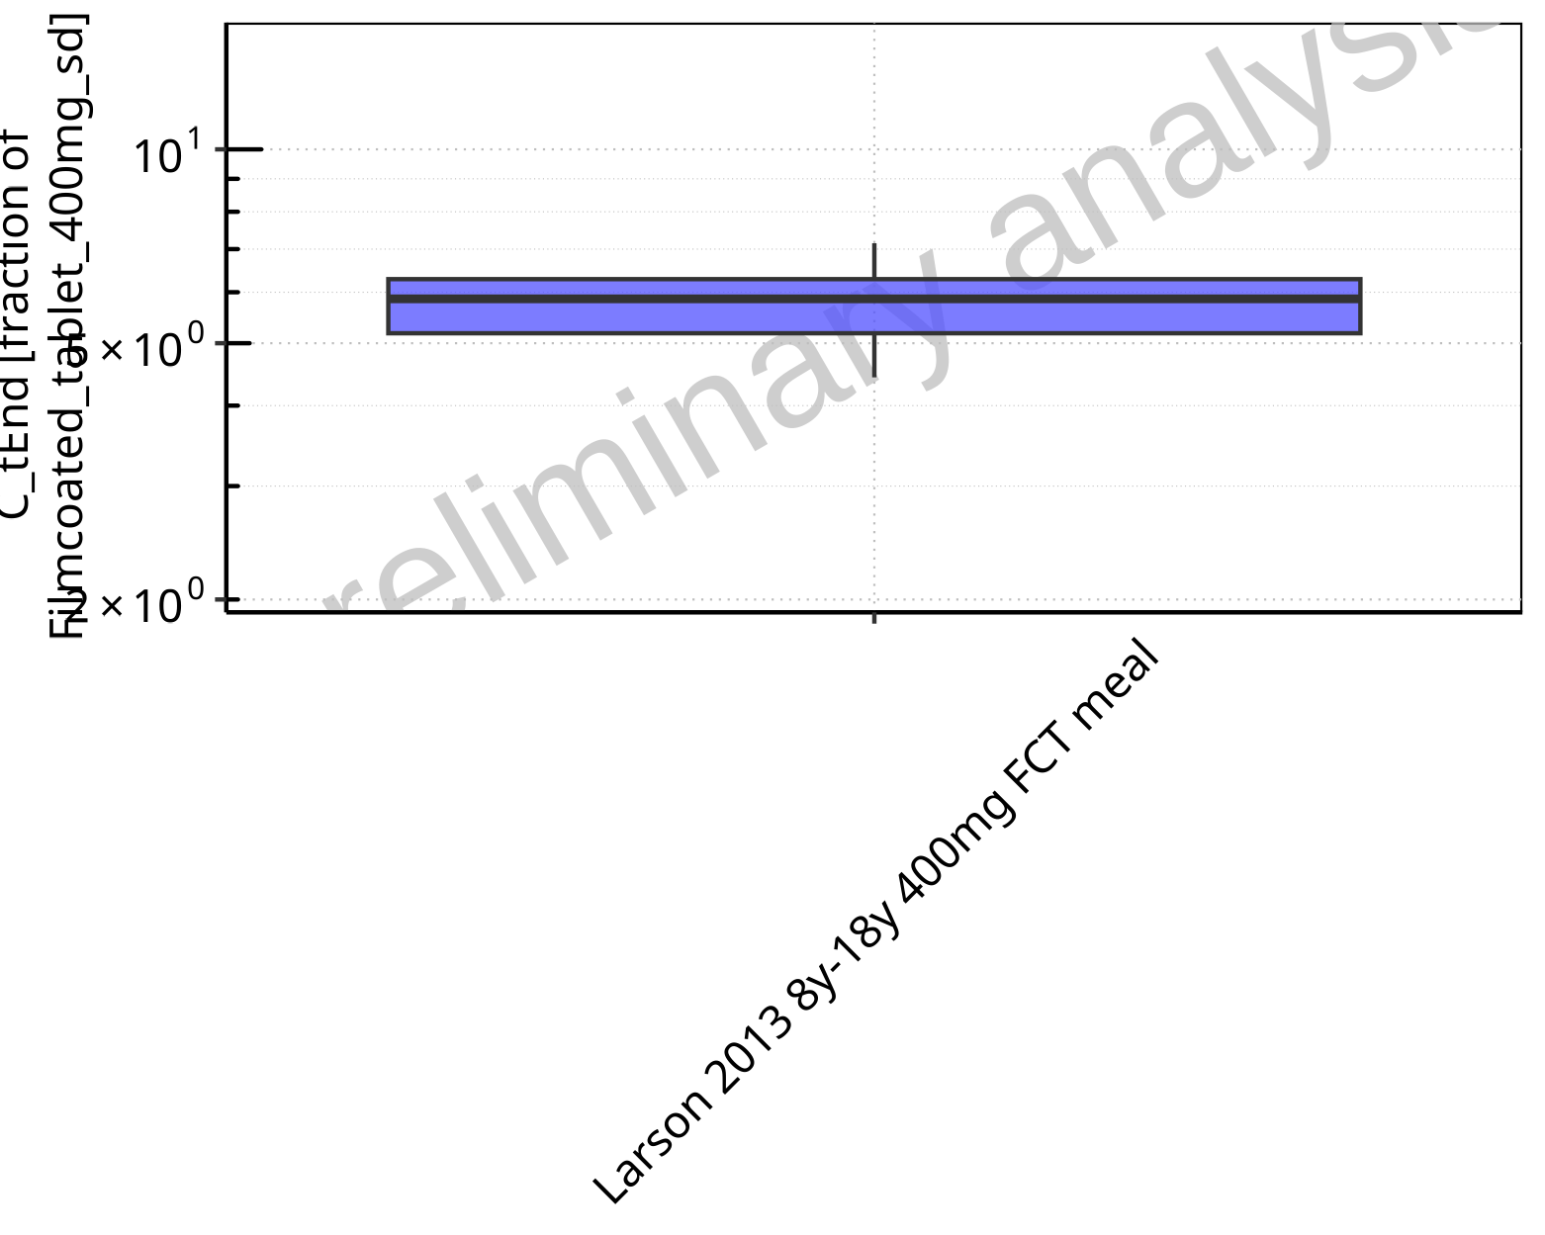

**Figure 2-111: Ratio of population summary statistics of C_tEnd of Raltegravir for Larson 2013 8y-18y 400mg FCT meal in comparison to Filmcoated_tablet_400mg_sd shown as box-whisker plot, which indicates ratios of the 5th, 25th, 50th, 75th, 95th percentiles in logarithmic scale.**

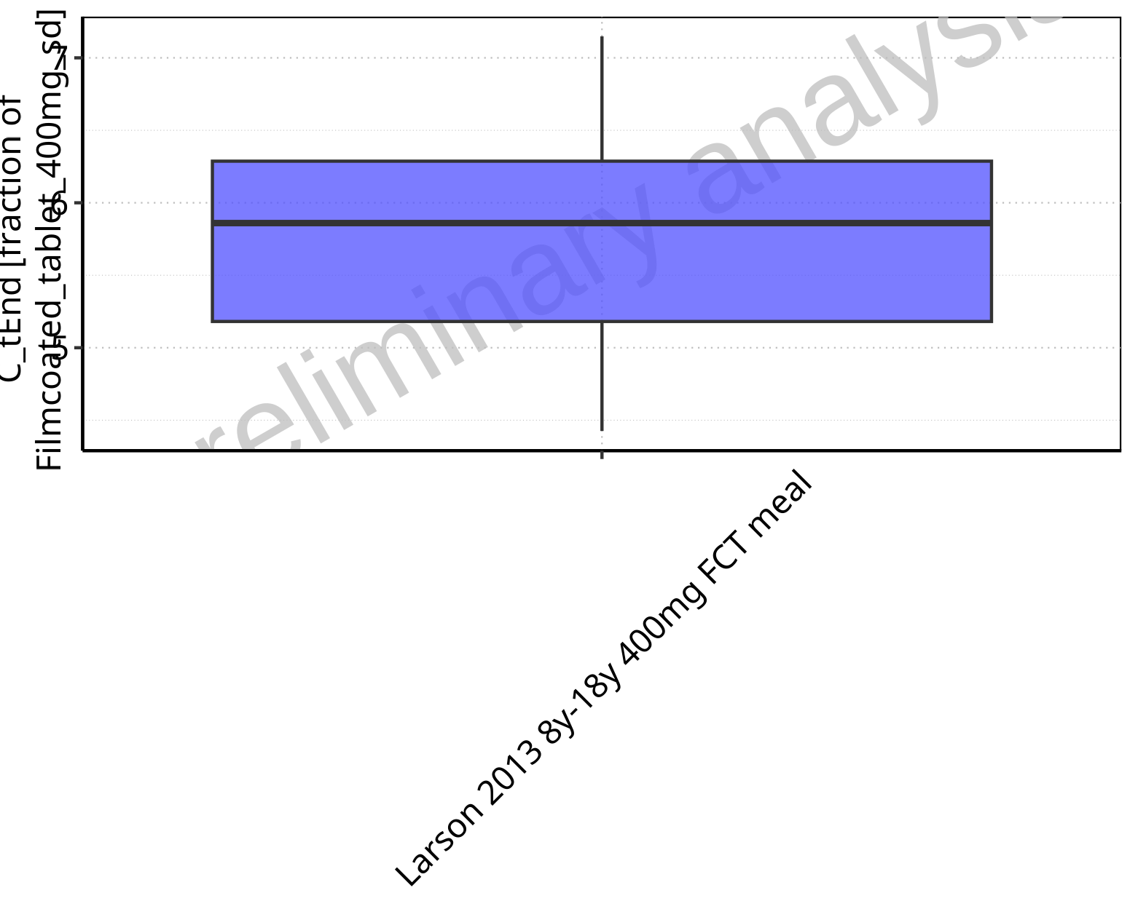

**Figure 2-112: Ratio of population summary statistics of C_tEnd of Raltegravir for Larson 2013 8y-18y 400mg FCT meal in comparison to Filmcoated_tablet_400mg_sd shown as box-whisker plot, which indicates ratios of the 5th, 25th, 50th, 75th, 95th percentiles in linear scale.**

**Table 2-8: Ratio of population summary statistics of C_tEnd of Raltegravir for Larson 2013 8y-18y 400mg FCT meal in comparison to Filmcoated_tablet_400mg_sd**

| Population | N | 5th pctl | 25th pctl | 50th pctl | 75th pctl | 95th pctl | Mean | SD | Geo Mean | Geo SD |
| --- | --- | --- | --- | --- | --- | --- | --- | --- | --- | --- |
| Larson 2013 8y-18y 400mg FCT meal | 500 | 4.43 | 5.18 | 5.86 | 6.29 | 7.15 | 6.19 | 9.09 | 5.79 | 1.15 |

### AUC

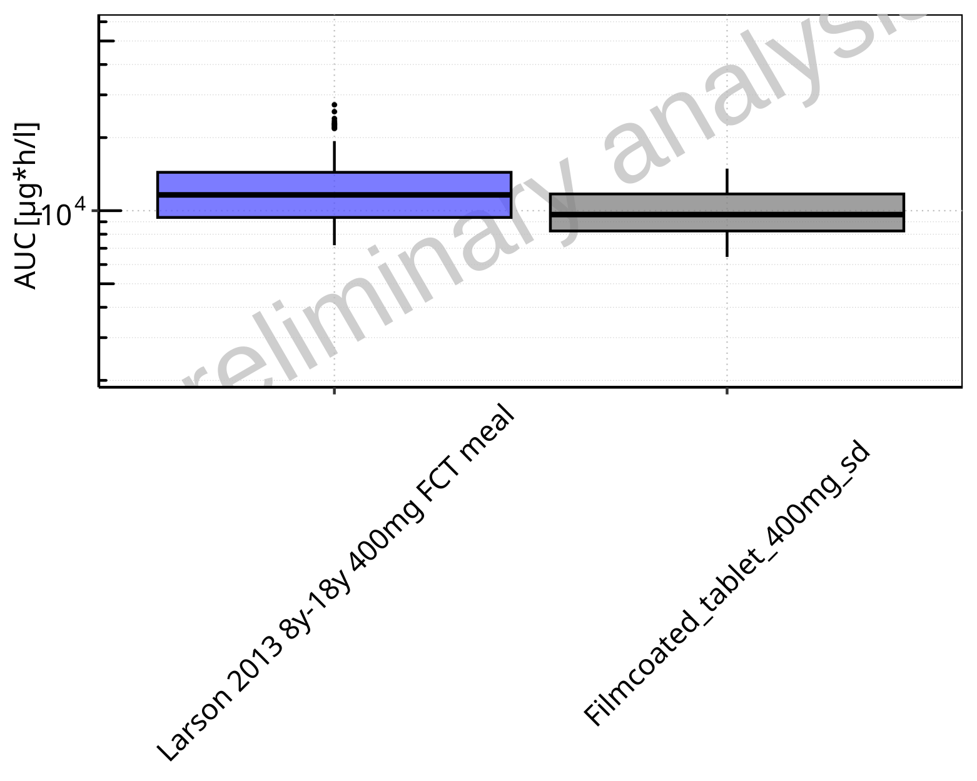

**Figure 2-113: AUC of Raltegravir for Larson 2013 8y-18y 400mg FCT meal, Filmcoated_tablet_400mg_sd shown as box-whisker plot, which indicates the 5th, 25th, 50th, 75th, 95th percentiles in logarithmic scale.**

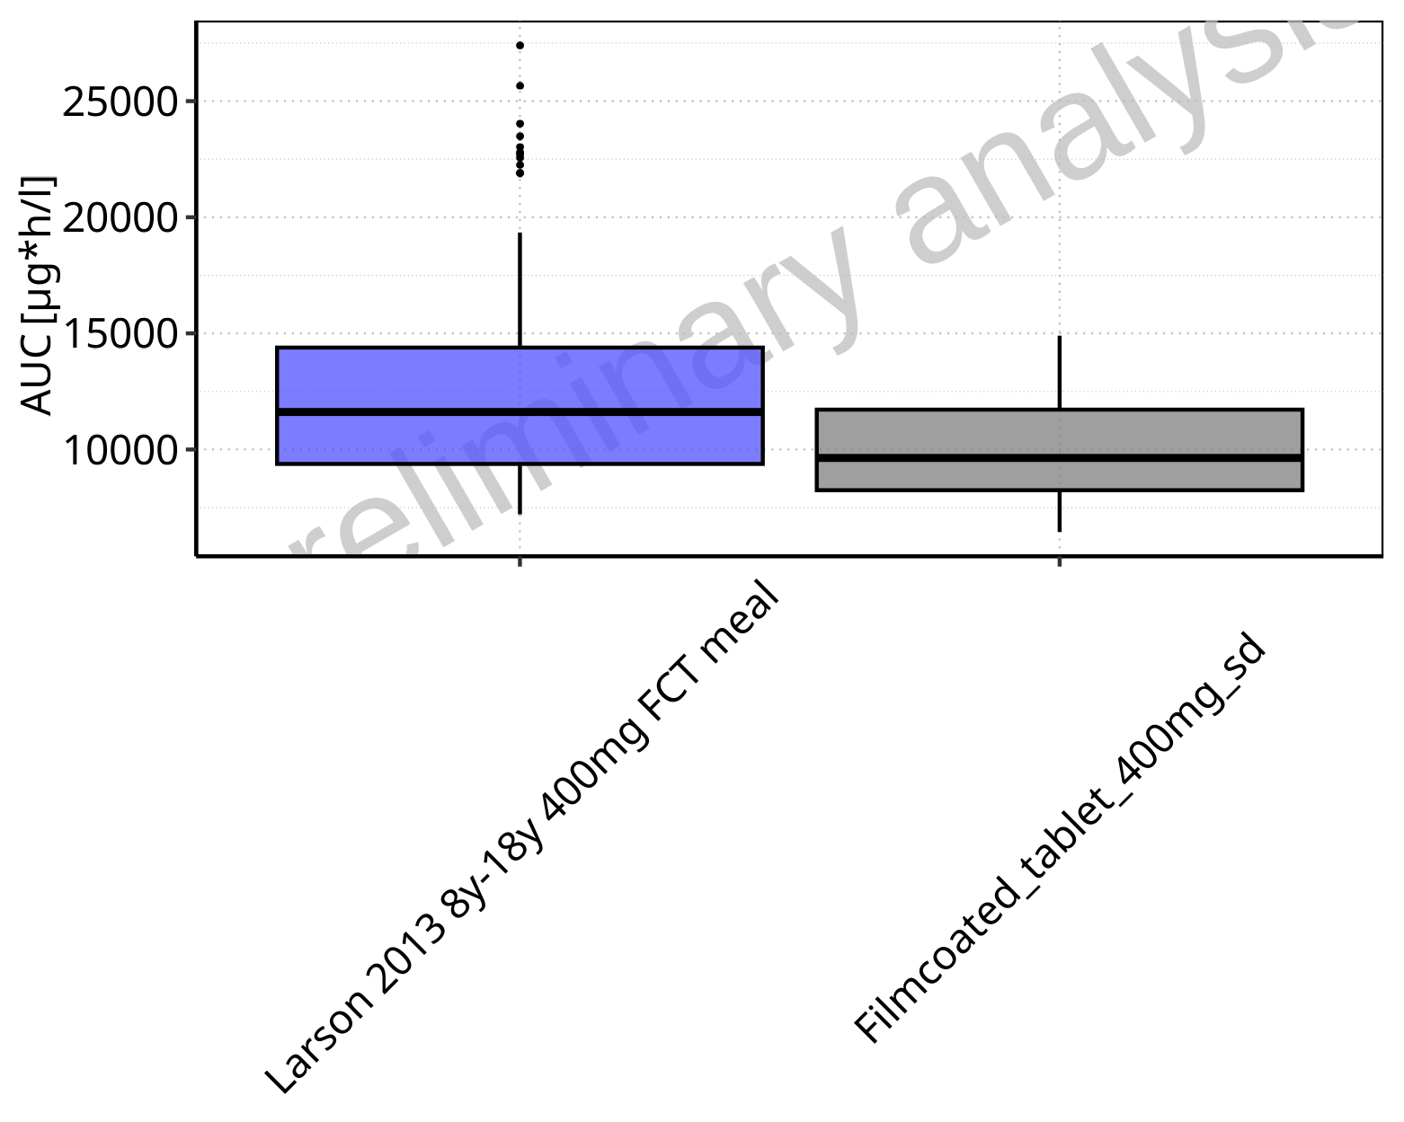

**Figure 2-114: AUC of Raltegravir for Larson 2013 8y-18y 400mg FCT meal, Filmcoated_tablet_400mg_sd shown as box-whisker plot, which indicates the 5th, 25th, 50th, 75th, 95th percentiles in linear scale.**

**Table 2-9: Population statistics summarizing AUC of Raltegravir for Larson 2013 8y-18y 400mg FCT meal, Filmcoated_tablet_400mg_sd reported in [µg*h/l]**

| Population | N | 5th pctl | 25th pctl | 50th pctl | 75th pctl | 95th pctl | Mean | SD | Geo Mean | Geo SD |
| --- | --- | --- | --- | --- | --- | --- | --- | --- | --- | --- |
| Larson 2013 8y-18y 400mg FCT meal | 500 | 7207.27 | 9378.92 | 11615.20 | 14388.94 | 19343.22 | 12199.86 | 3756.55 | 11656.08 | 1.35 |
| Filmcoated_tablet_400mg_sd | 100 | 6449.27 | 8248.74 | 9637.50 | 11717.00 | 14901.10 | 10129.70 | 2672.29 | 9784.56 | 1.31 |

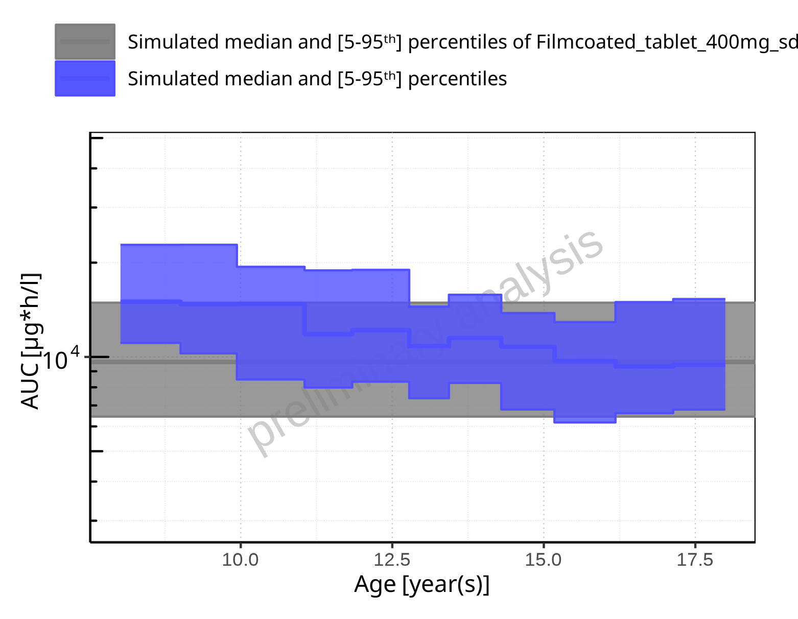

**Figure 2-115: Age-dependence of AUC for Larson 2013 8y-18y 400mg FCT meal in comparison to Filmcoated_tablet_400mg_sd. Profiles are plotted in a logarithmic scale.**

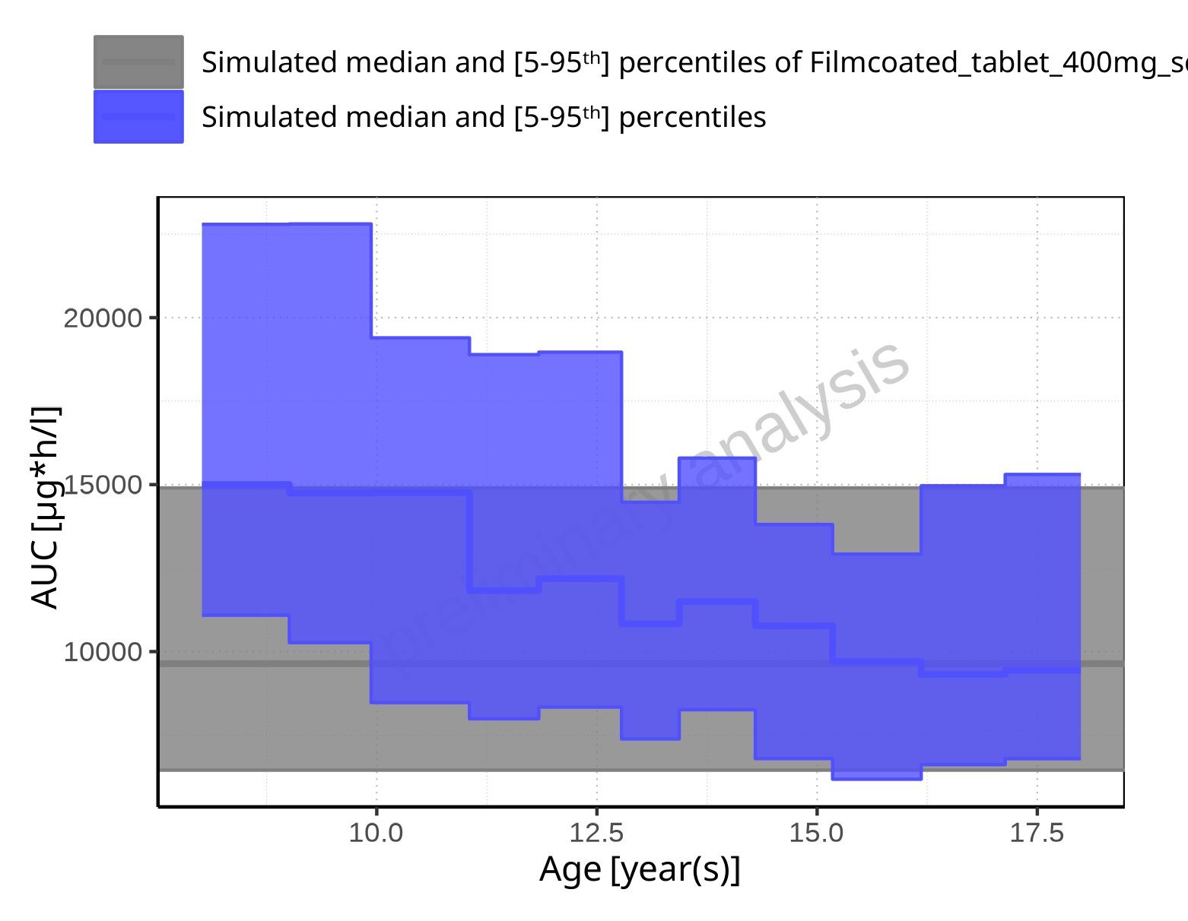

**Figure 2-116: Age-dependence of AUC for Larson 2013 8y-18y 400mg FCT meal in comparison to Filmcoated_tablet_400mg_sd. Profiles are plotted in a linear scale.**

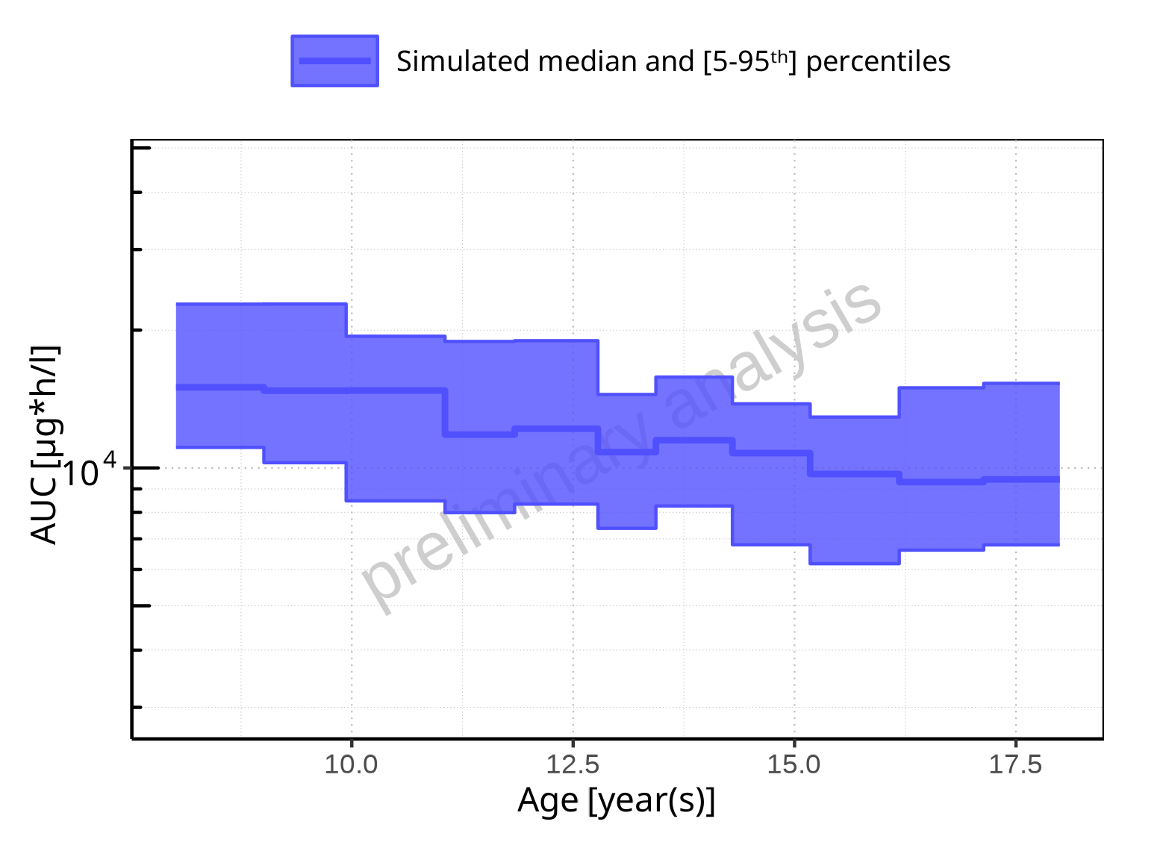

**Figure 2-117: Age-dependence of AUC for Larson 2013 8y-18y 400mg FCT meal. Profiles are plotted in a logarithmic scale.**

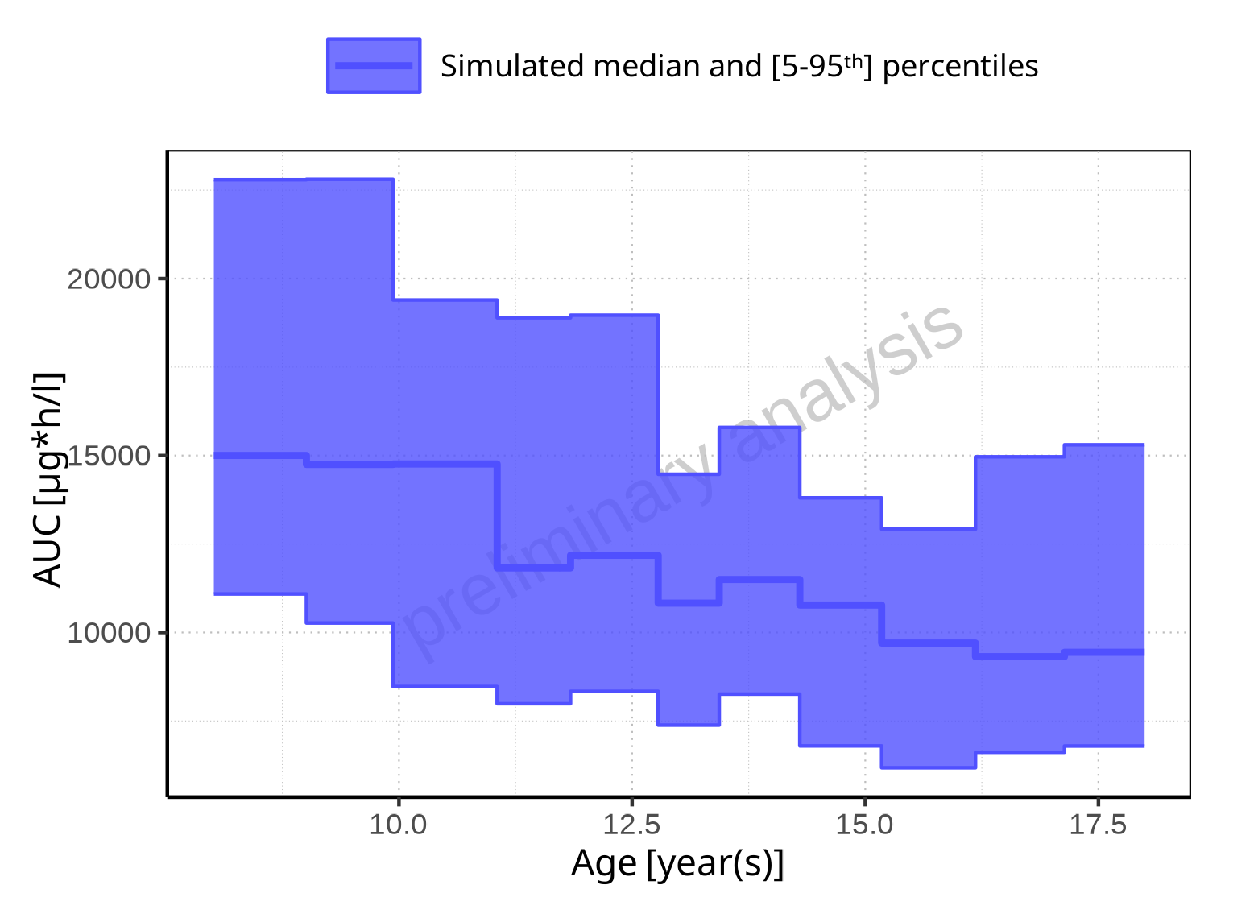

**Figure 2-118: Age-dependence of AUC for Larson 2013 8y-18y 400mg FCT meal. Profiles are plotted in a linear scale.**

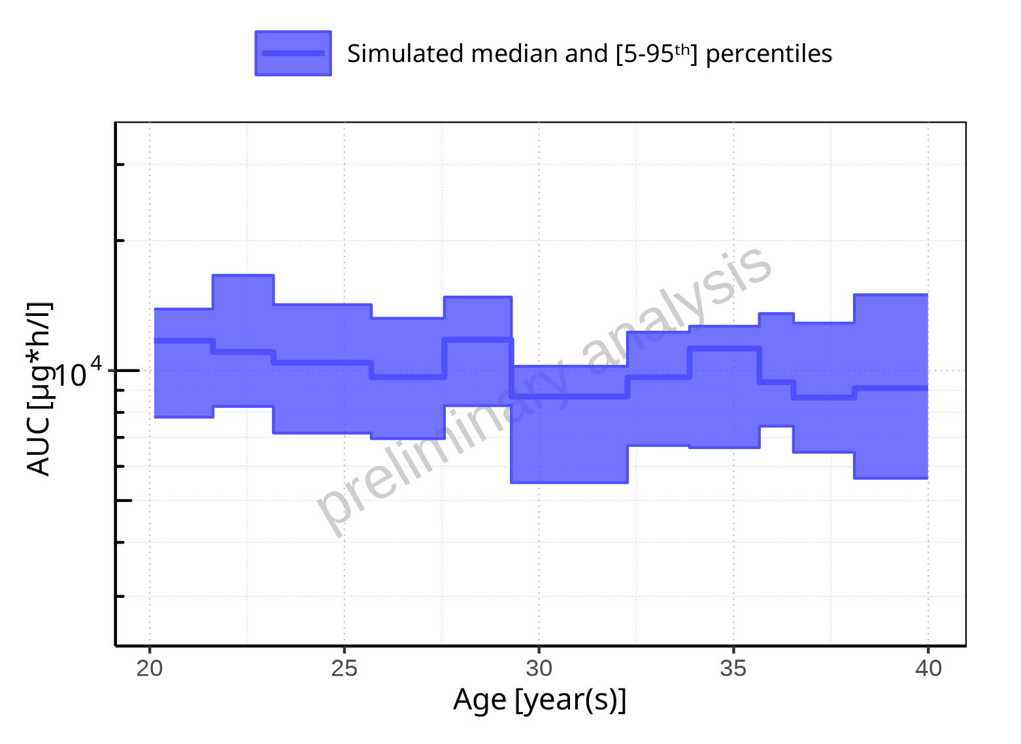

**Figure 2-119: Age-dependence of AUC for Filmcoated_tablet_400mg_sd. Profiles are plotted in a logarithmic scale.**

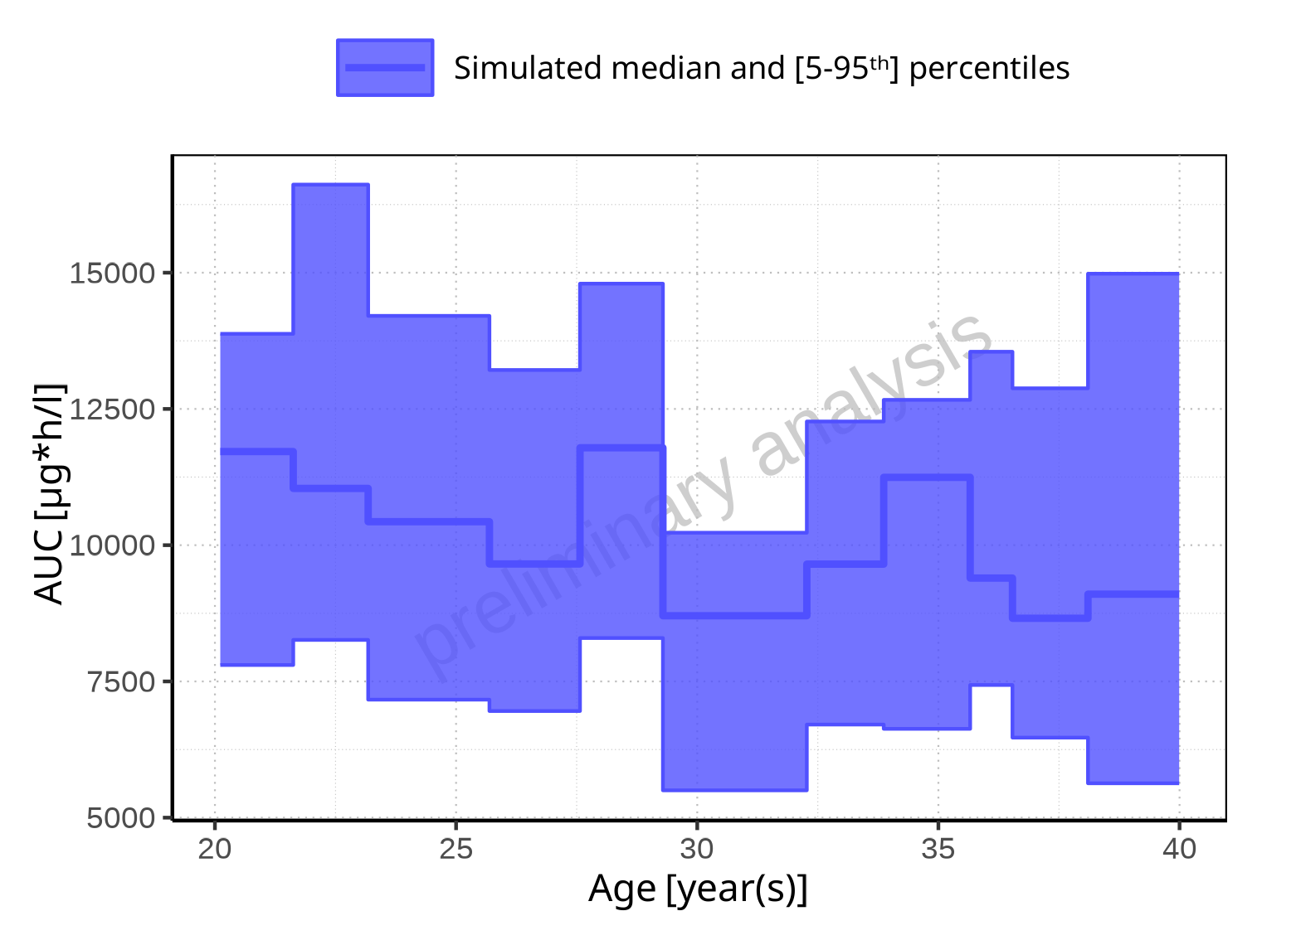

**Figure 2-120: Age-dependence of AUC for Filmcoated_tablet_400mg_sd. Profiles are plotted in a linear scale.**

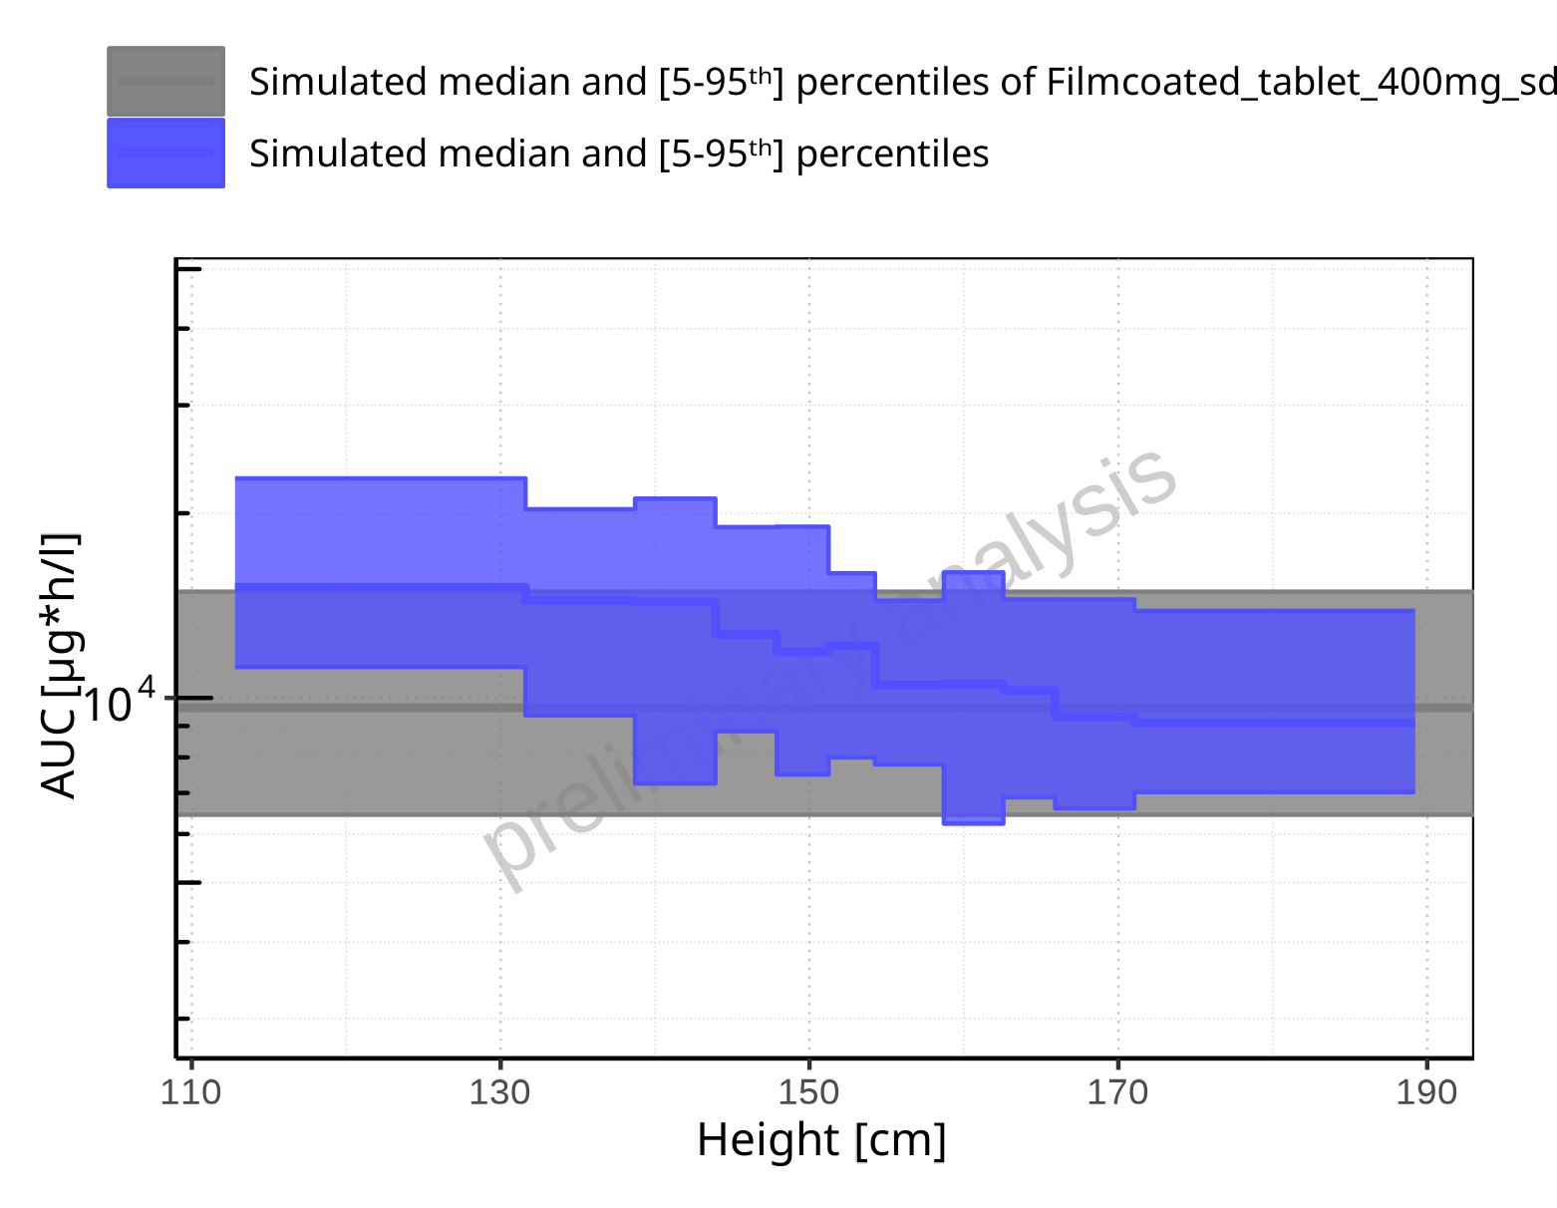

**Figure 2-121: Height-dependence of AUC for Larson 2013 8y-18y 400mg FCT meal in comparison to Filmcoated_tablet_400mg_sd. Profiles are plotted in a logarithmic scale.**

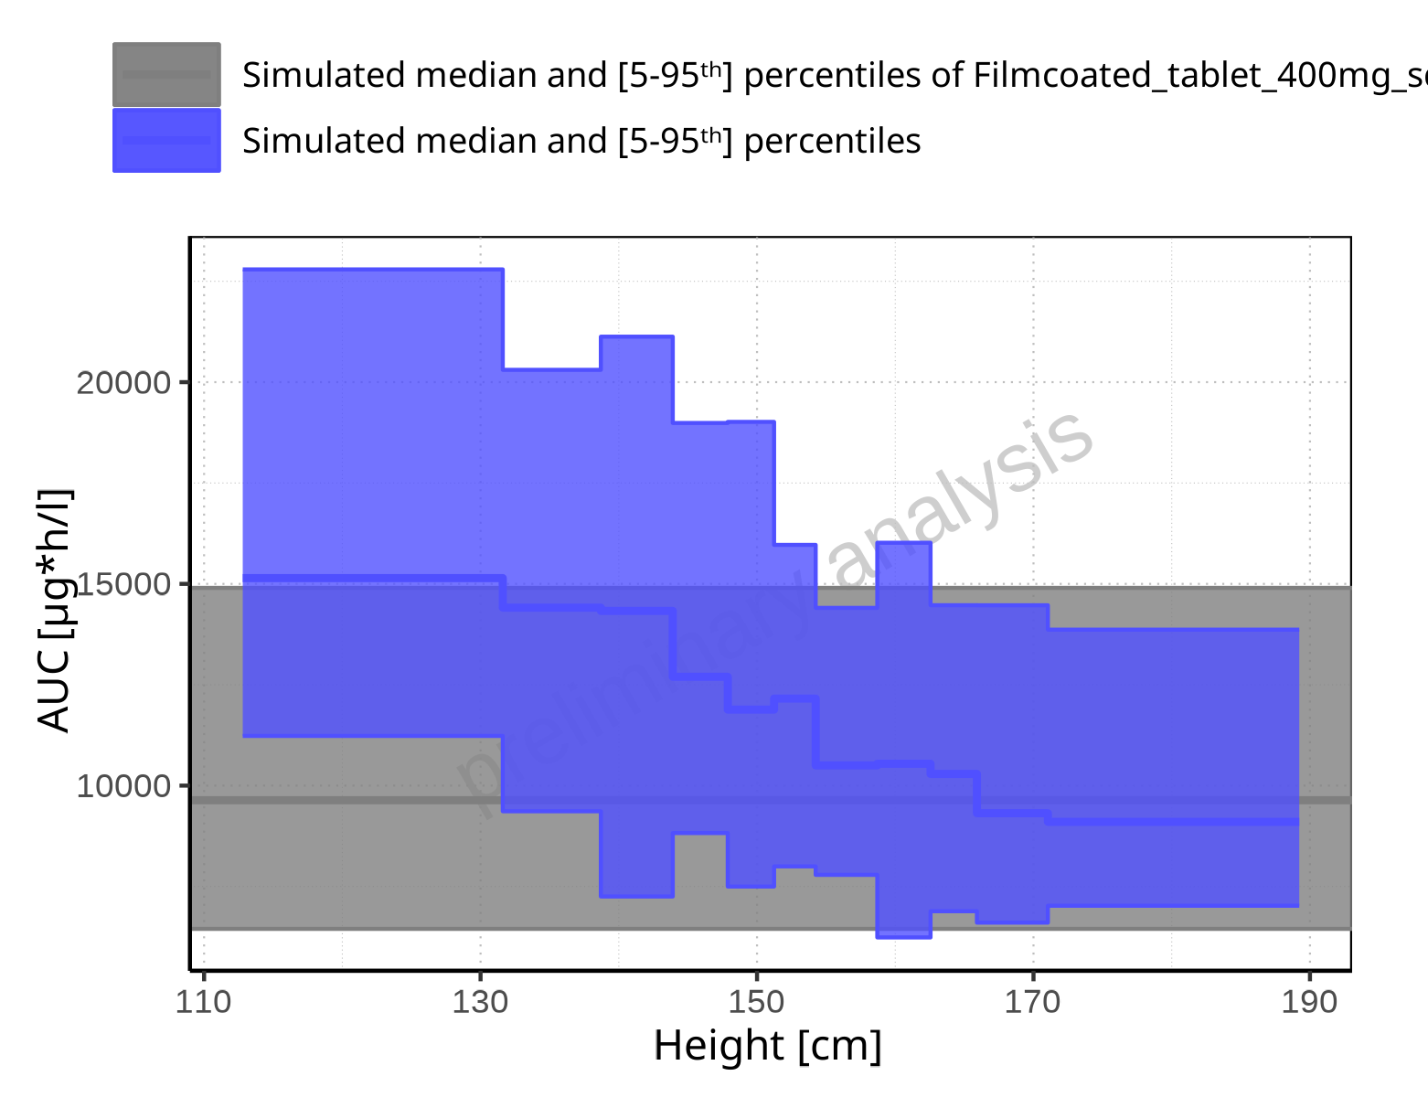

**Figure 2-122: Height-dependence of AUC for Larson 2013 8y-18y 400mg FCT meal in comparison to Filmcoated_tablet_400mg_sd. Profiles are plotted in a linear scale.**

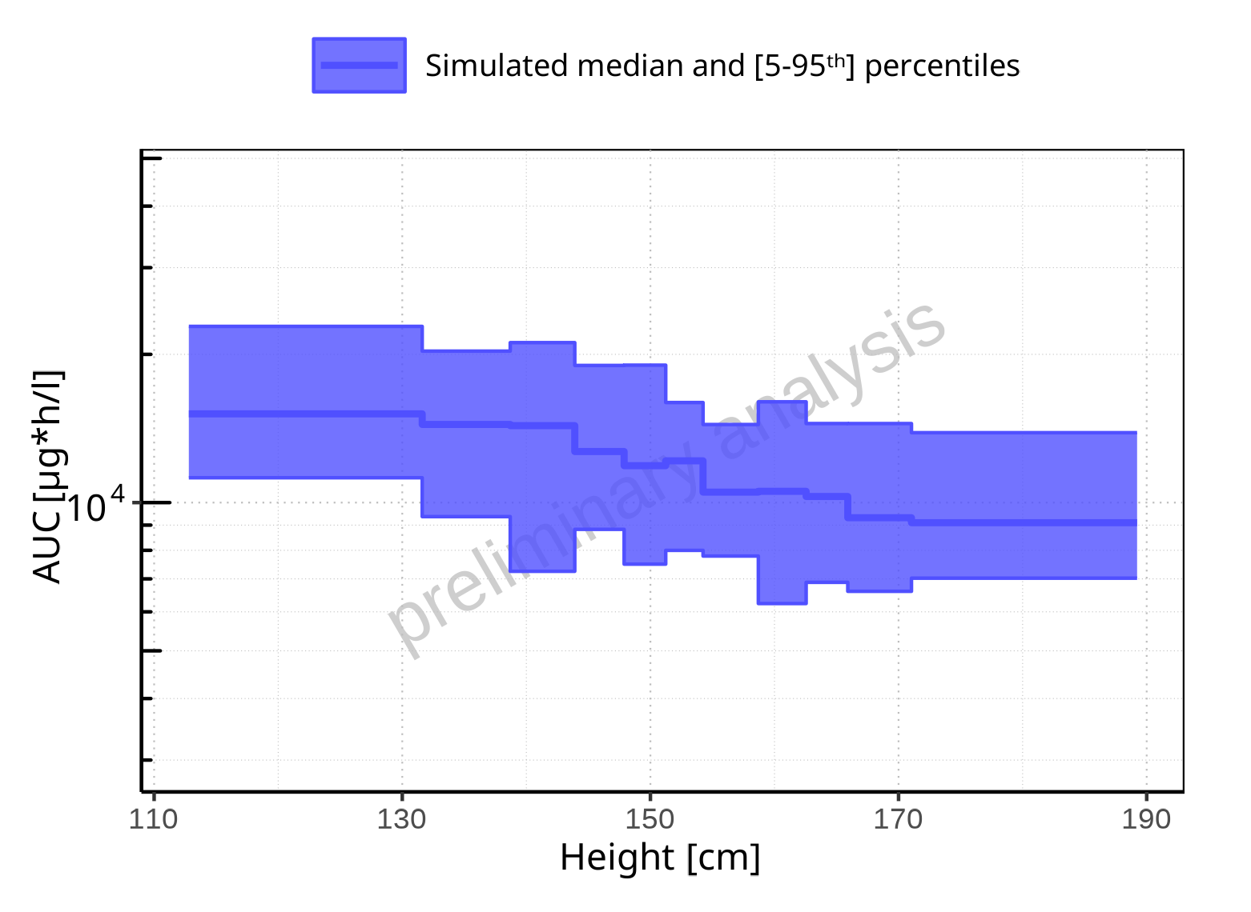

**Figure 2-123: Height-dependence of AUC for Larson 2013 8y-18y 400mg FCT meal. Profiles are plotted in a logarithmic scale.**

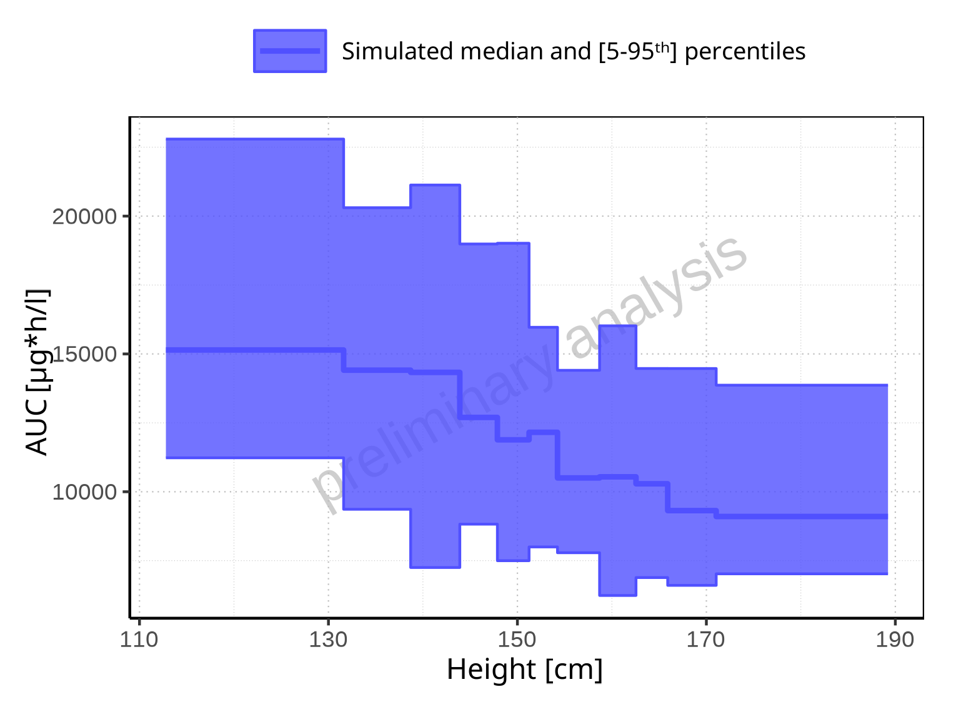

**Figure 2-124: Height-dependence of AUC for Larson 2013 8y-18y 400mg FCT meal. Profiles are plotted in a linear scale.**

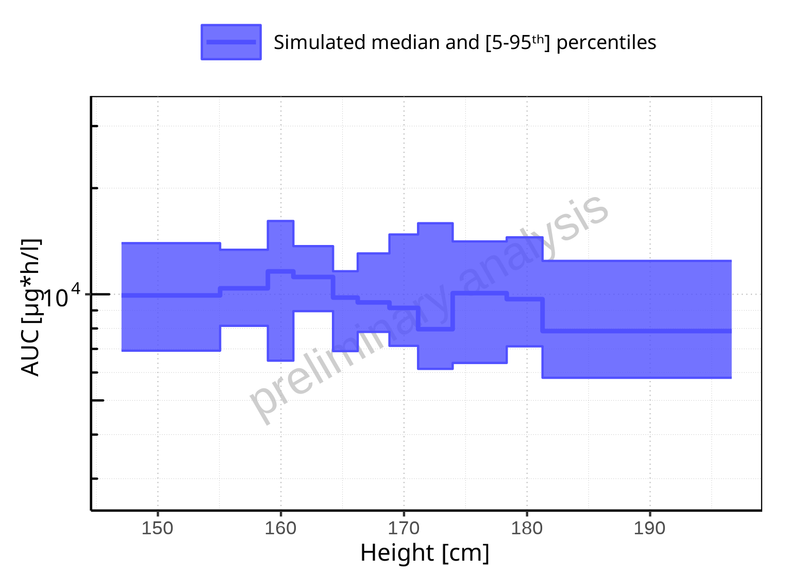

**Figure 2-125: Height-dependence of AUC for Filmcoated_tablet_400mg_sd. Profiles are plotted in a logarithmic scale.**

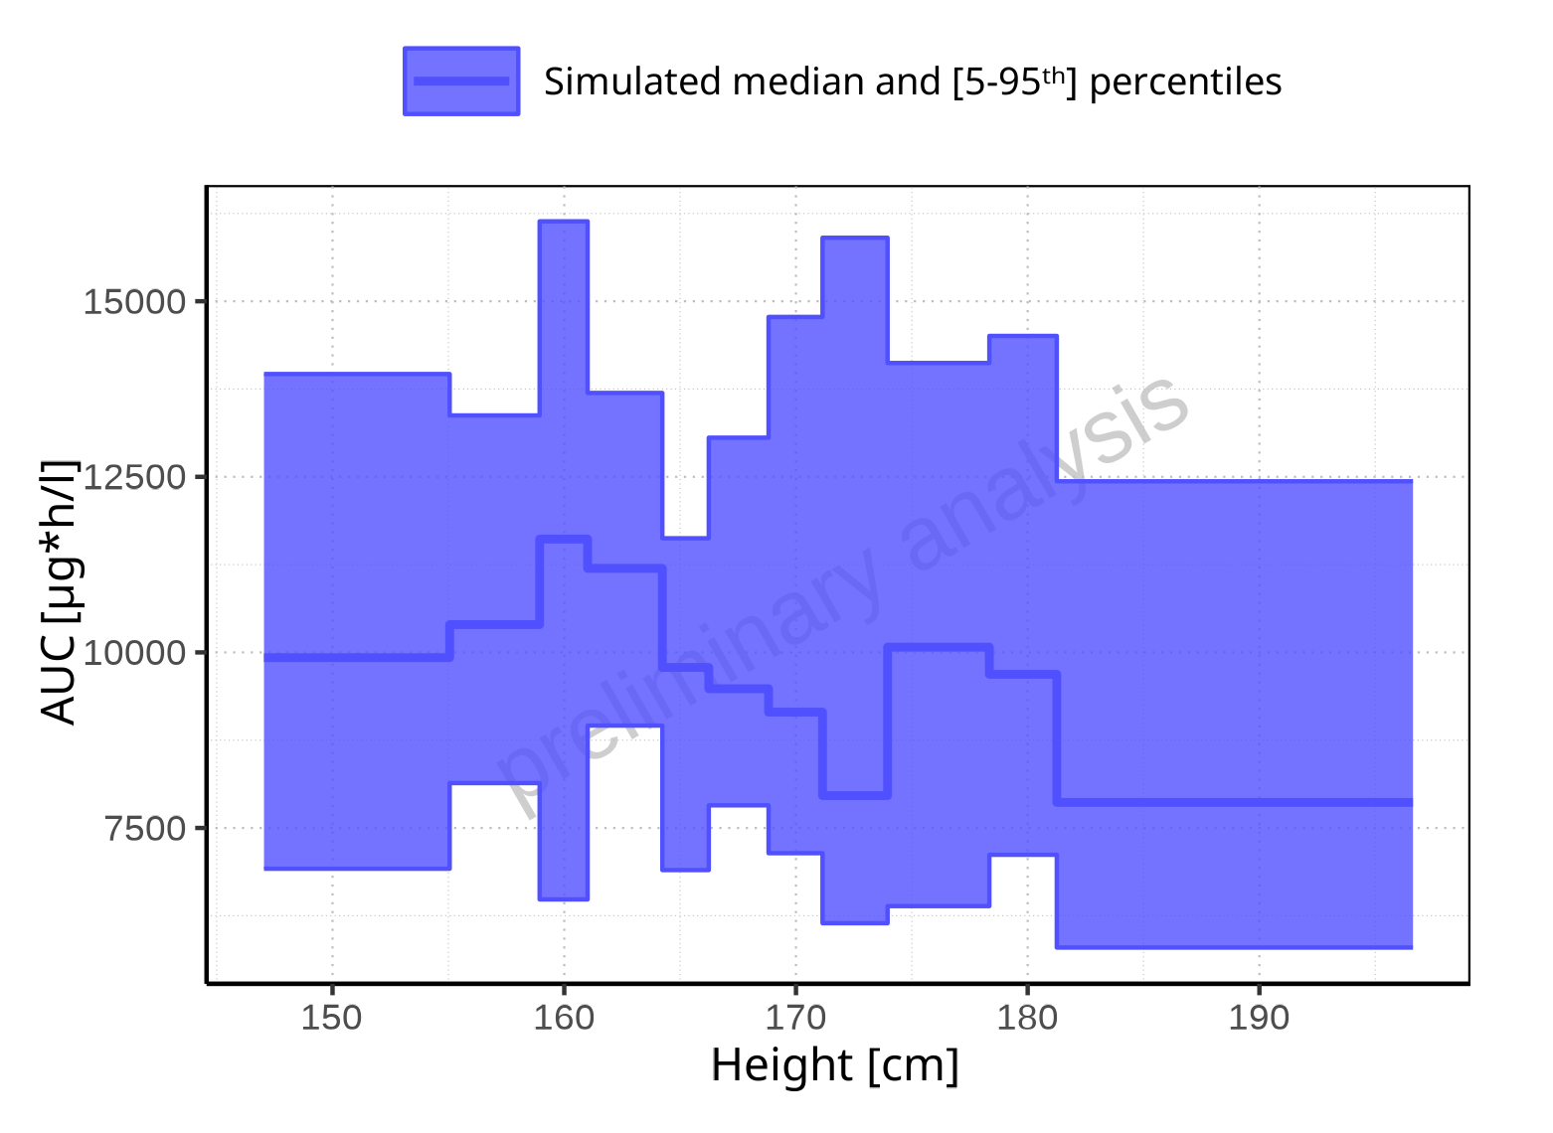

**Figure 2-126: Height-dependence of AUC for Filmcoated_tablet_400mg_sd. Profiles are plotted in a linear scale.**

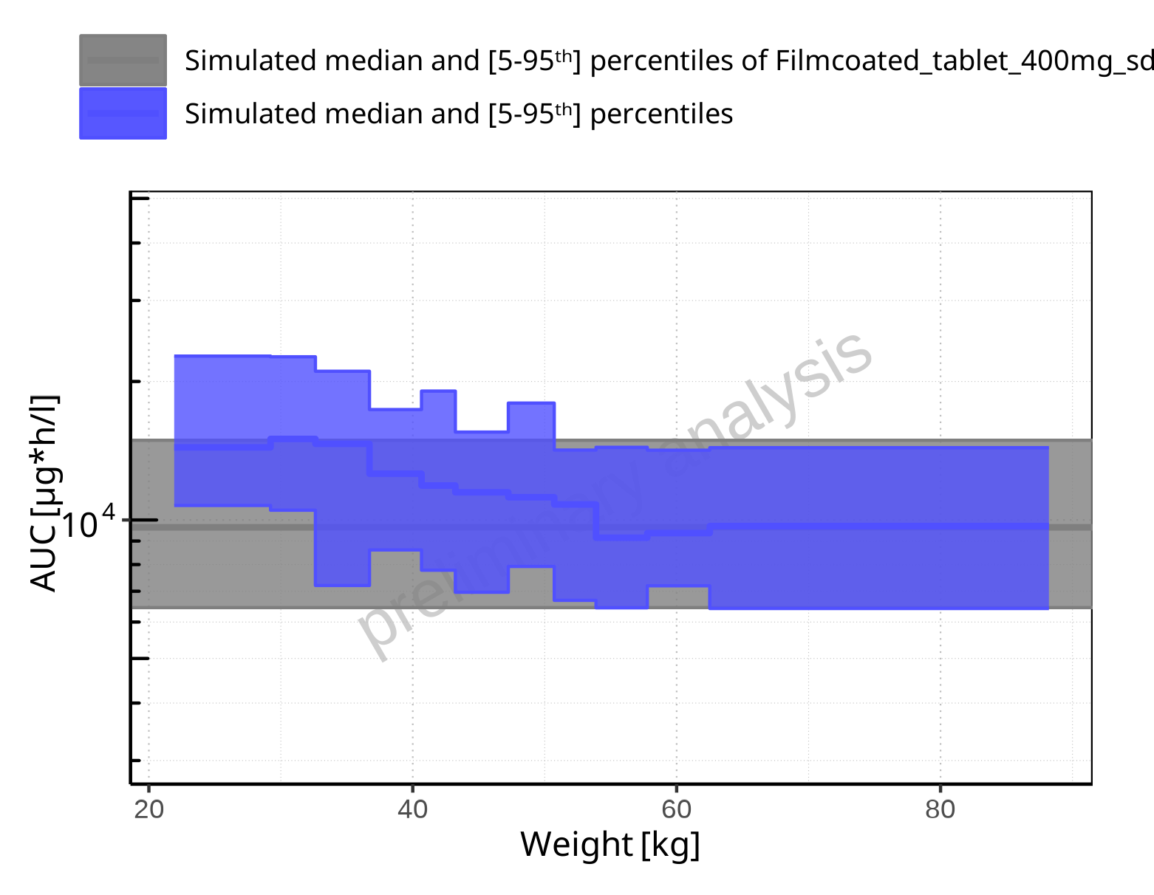

**Figure 2-127: Weight-dependence of AUC for Larson 2013 8y-18y 400mg FCT meal in comparison to Filmcoated_tablet_400mg_sd. Profiles are plotted in a logarithmic scale.**

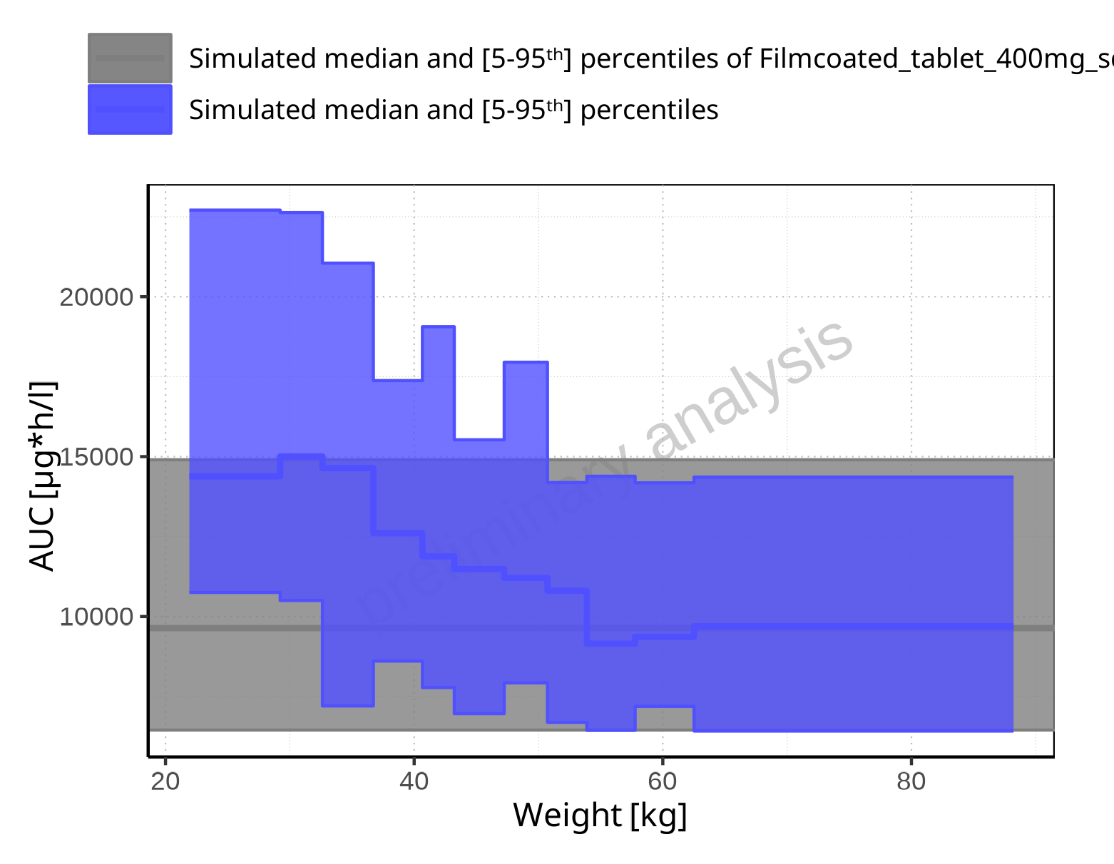

**Figure 2-128: Weight-dependence of AUC for Larson 2013 8y-18y 400mg FCT meal in comparison to Filmcoated_tablet_400mg_sd. Profiles are plotted in a linear scale.**

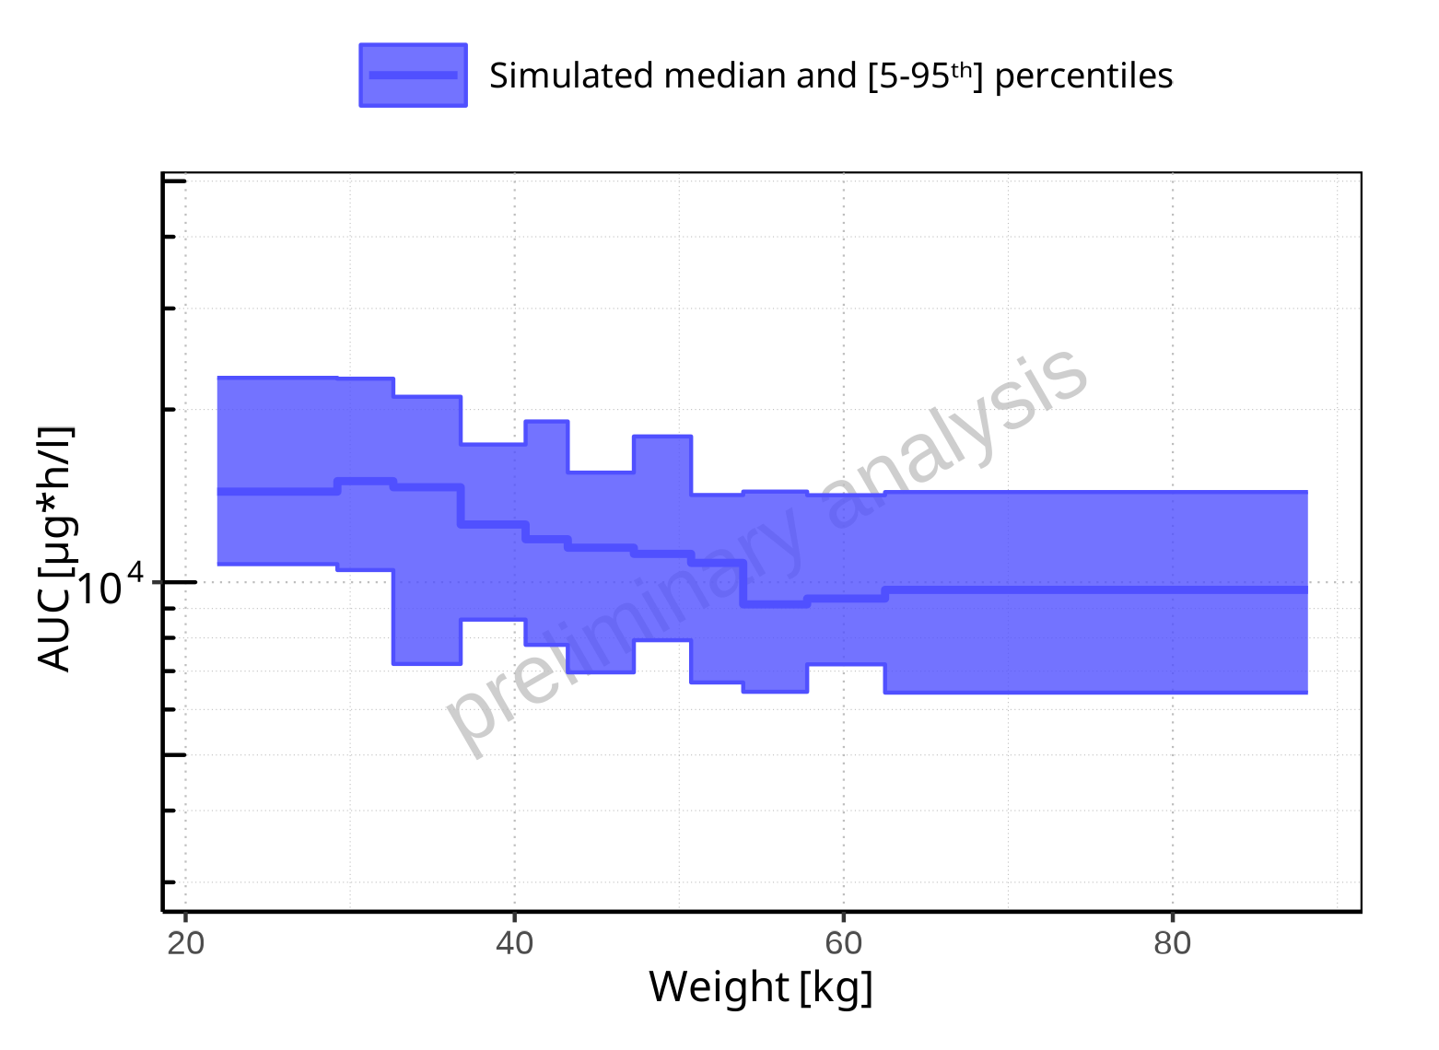

**Figure 2-129: Weight-dependence of AUC for Larson 2013 8y-18y 400mg FCT meal. Profiles are plotted in a logarithmic scale.**

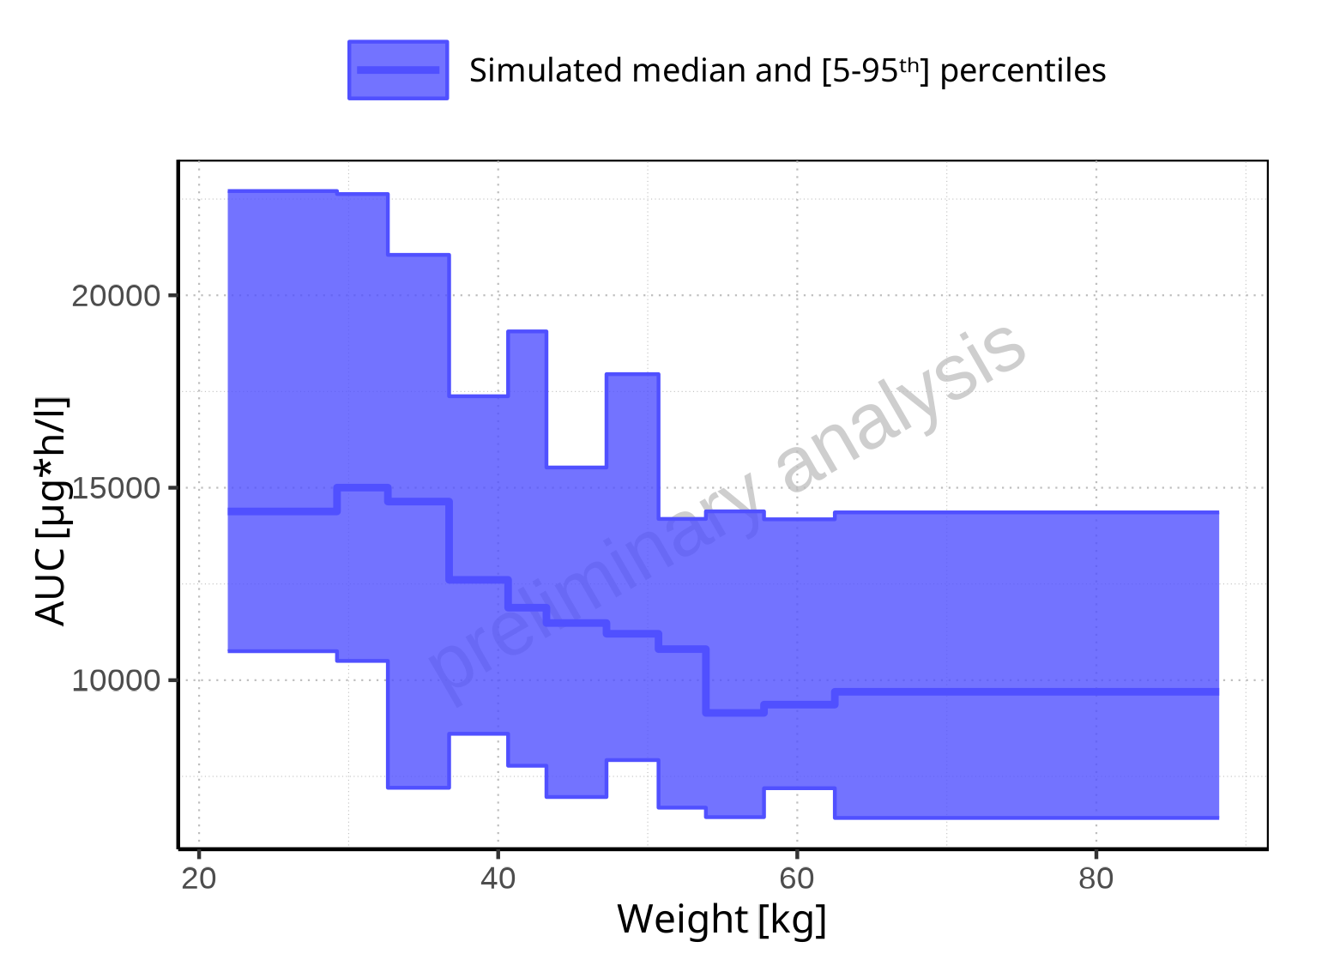

**Figure 2-130: Weight-dependence of AUC for Larson 2013 8y-18y 400mg FCT meal. Profiles are plotted in a linear scale.**

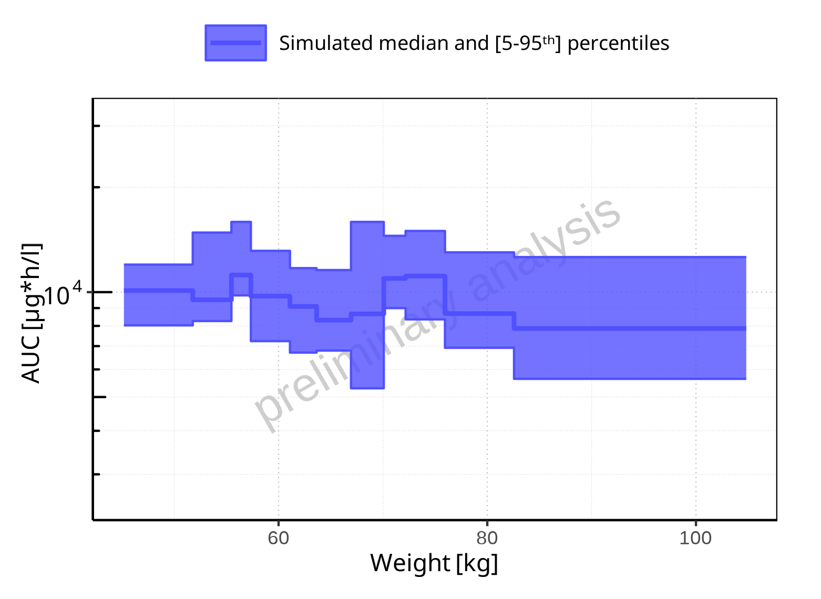

**Figure 2-131: Weight-dependence of AUC for Filmcoated_tablet_400mg_sd. Profiles are plotted in a logarithmic scale.**

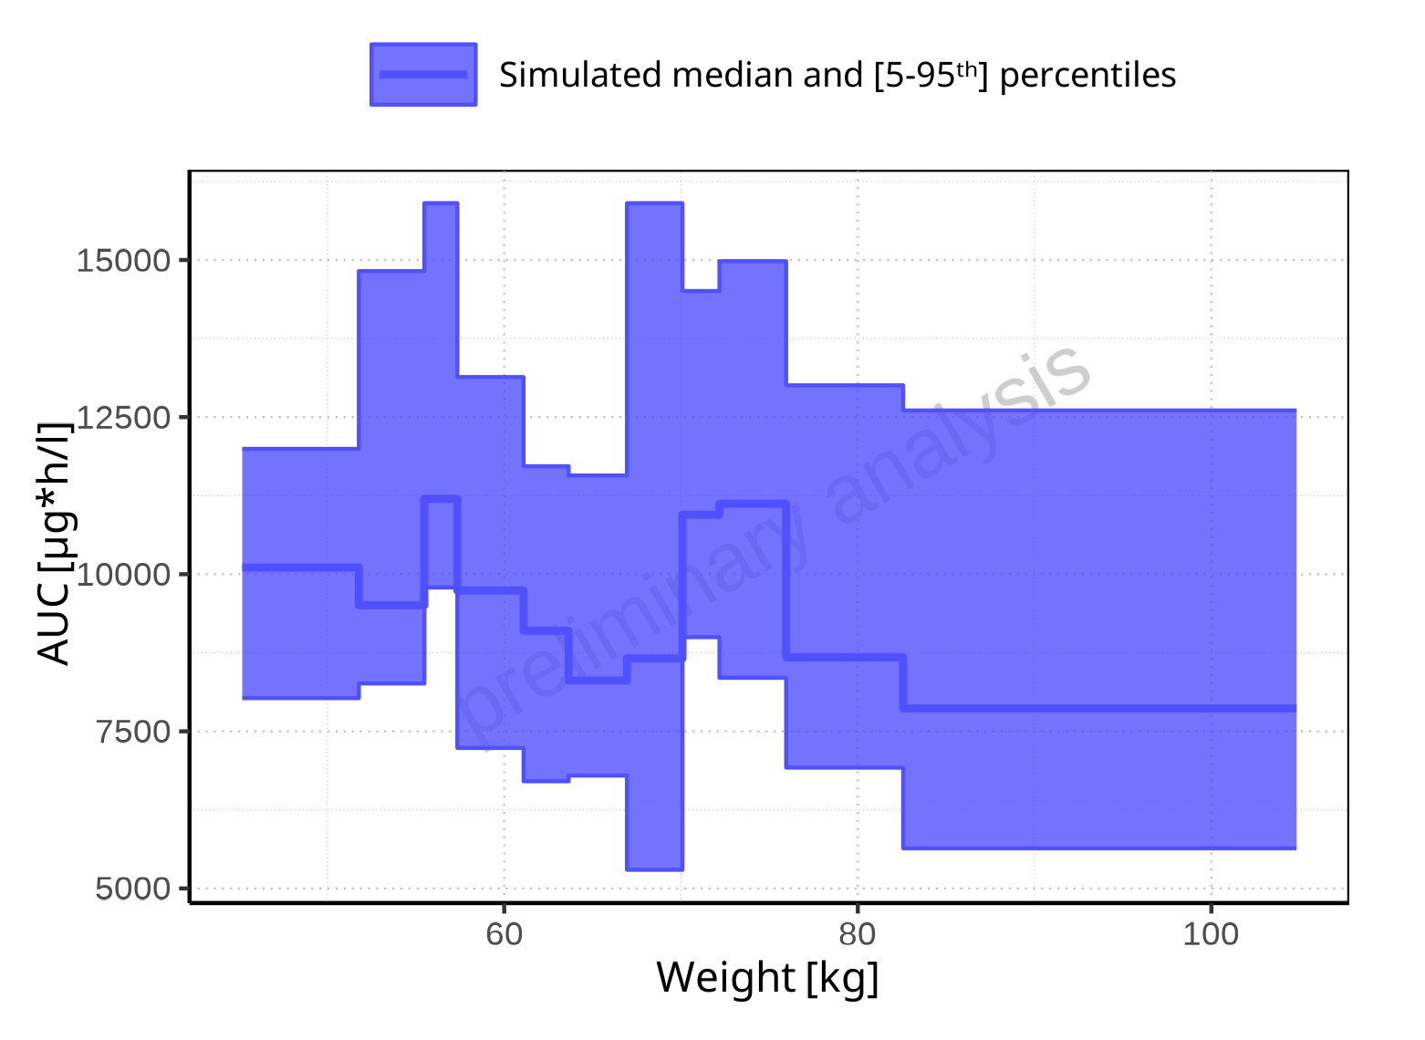

**Figure 2-132: Weight-dependence of AUC for Filmcoated_tablet_400mg_sd. Profiles are plotted in a linear scale.**

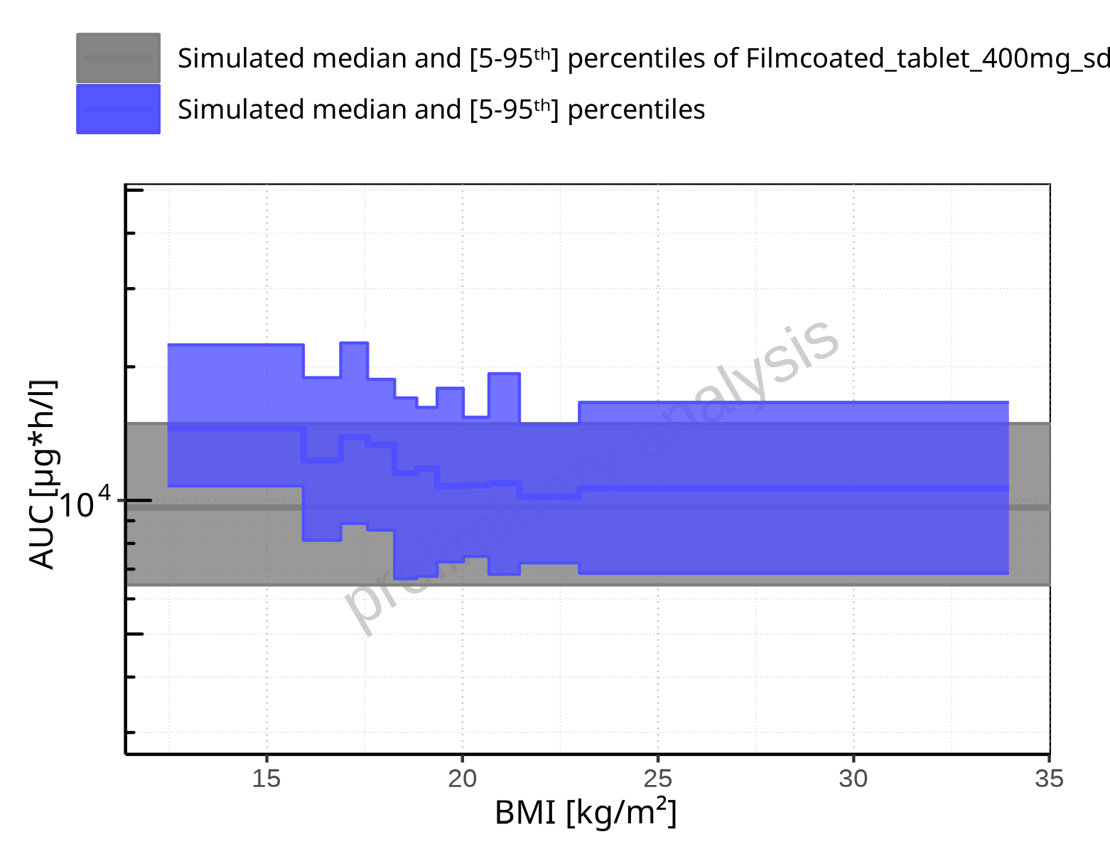

**Figure 2-133: BMI-dependence of AUC for Larson 2013 8y-18y 400mg FCT meal in comparison to Filmcoated_tablet_400mg_sd. Profiles are plotted in a logarithmic scale.**

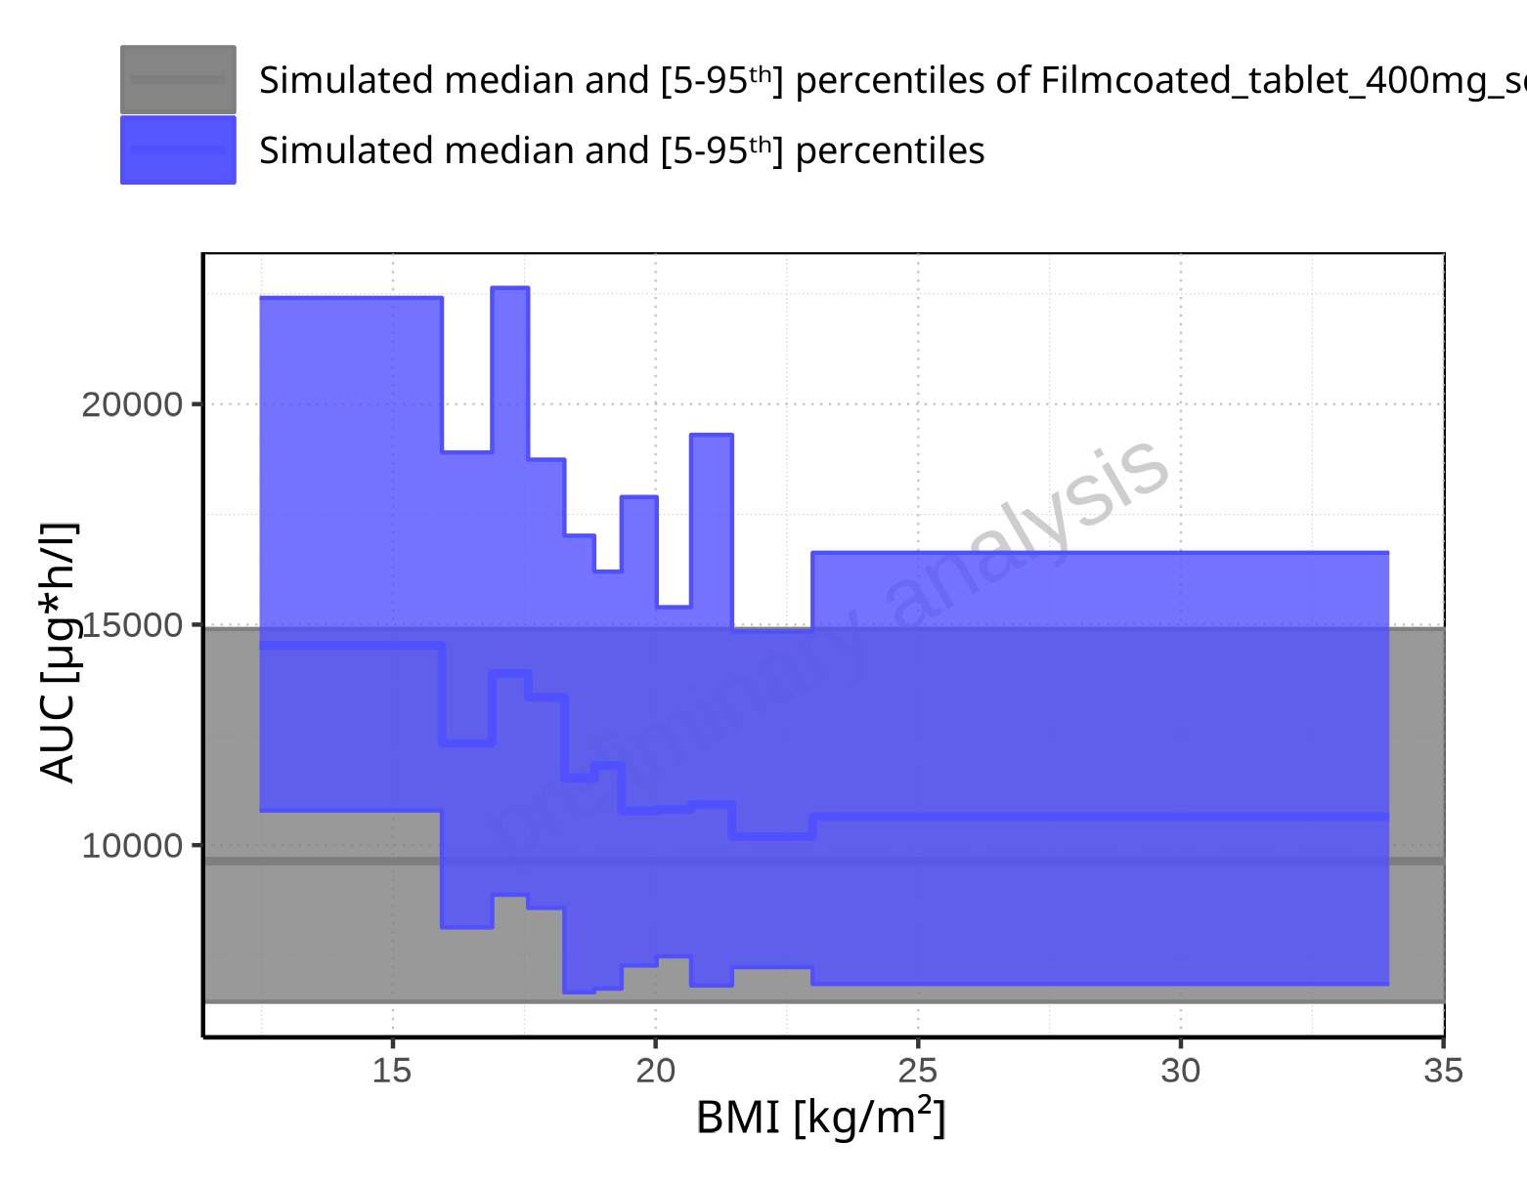

**Figure 2-134: BMI-dependence of AUC for Larson 2013 8y-18y 400mg FCT meal in comparison to Filmcoated_tablet_400mg_sd. Profiles are plotted in a linear scale.**

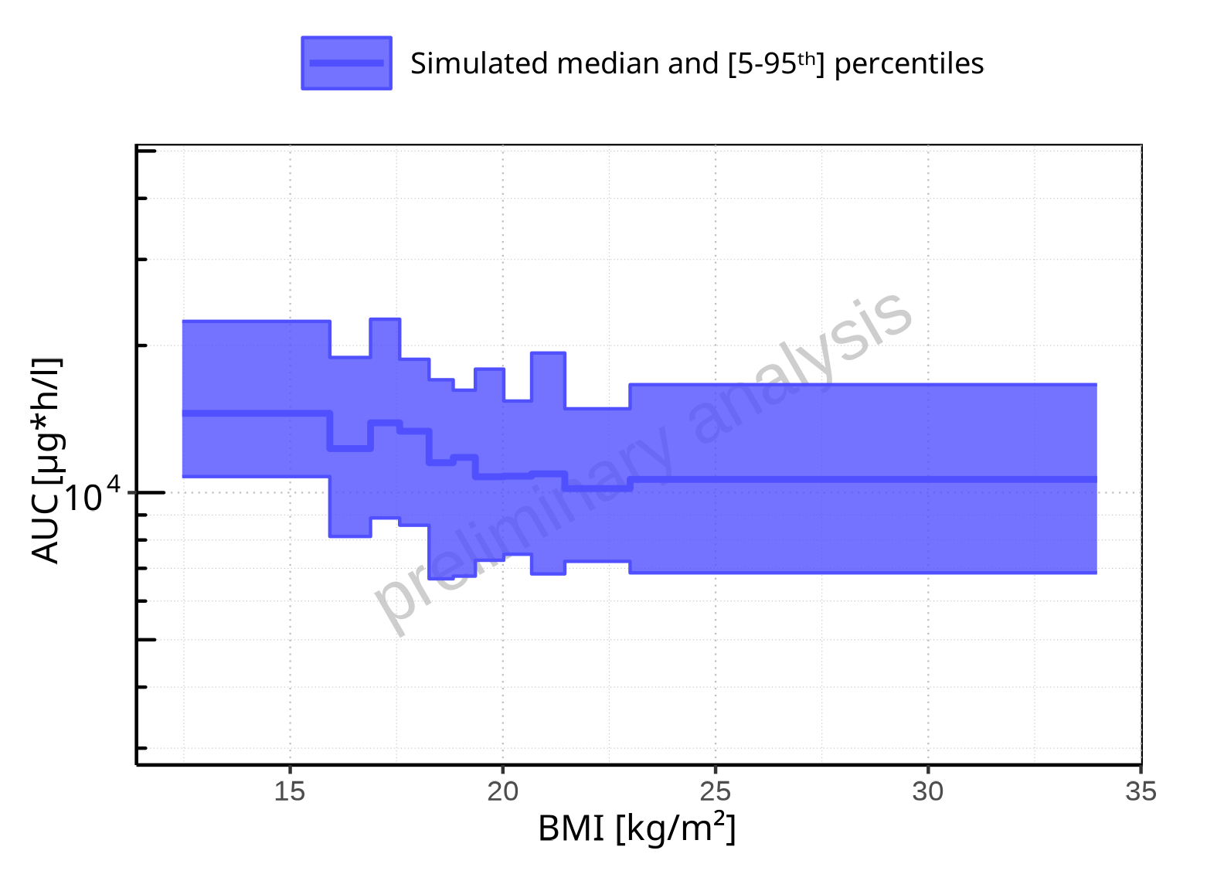

**Figure 2-135: BMI-dependence of AUC for Larson 2013 8y-18y 400mg FCT meal. Profiles are plotted in a logarithmic scale.**

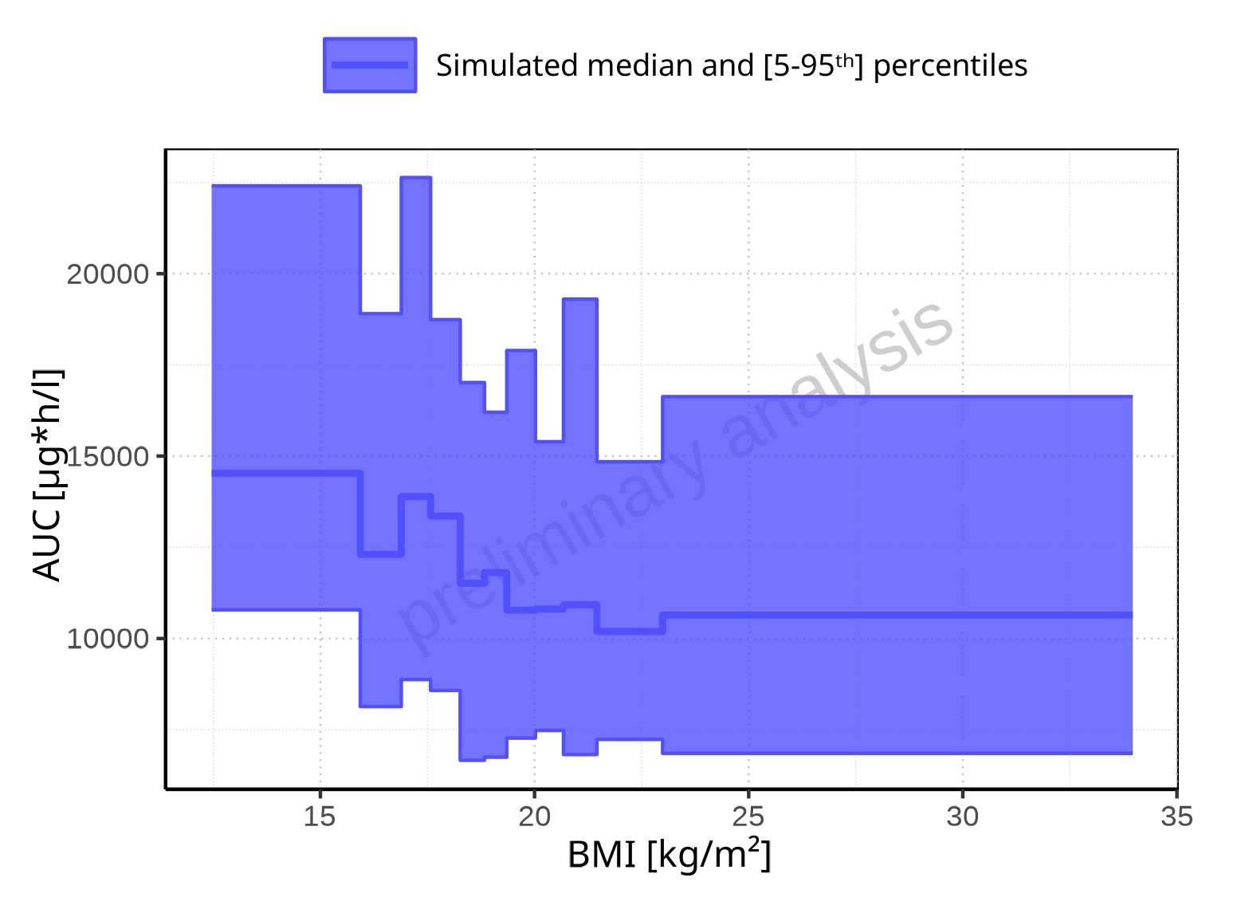

**Figure 2-136: BMI-dependence of AUC for Larson 2013 8y-18y 400mg FCT meal. Profiles are plotted in a linear scale.**

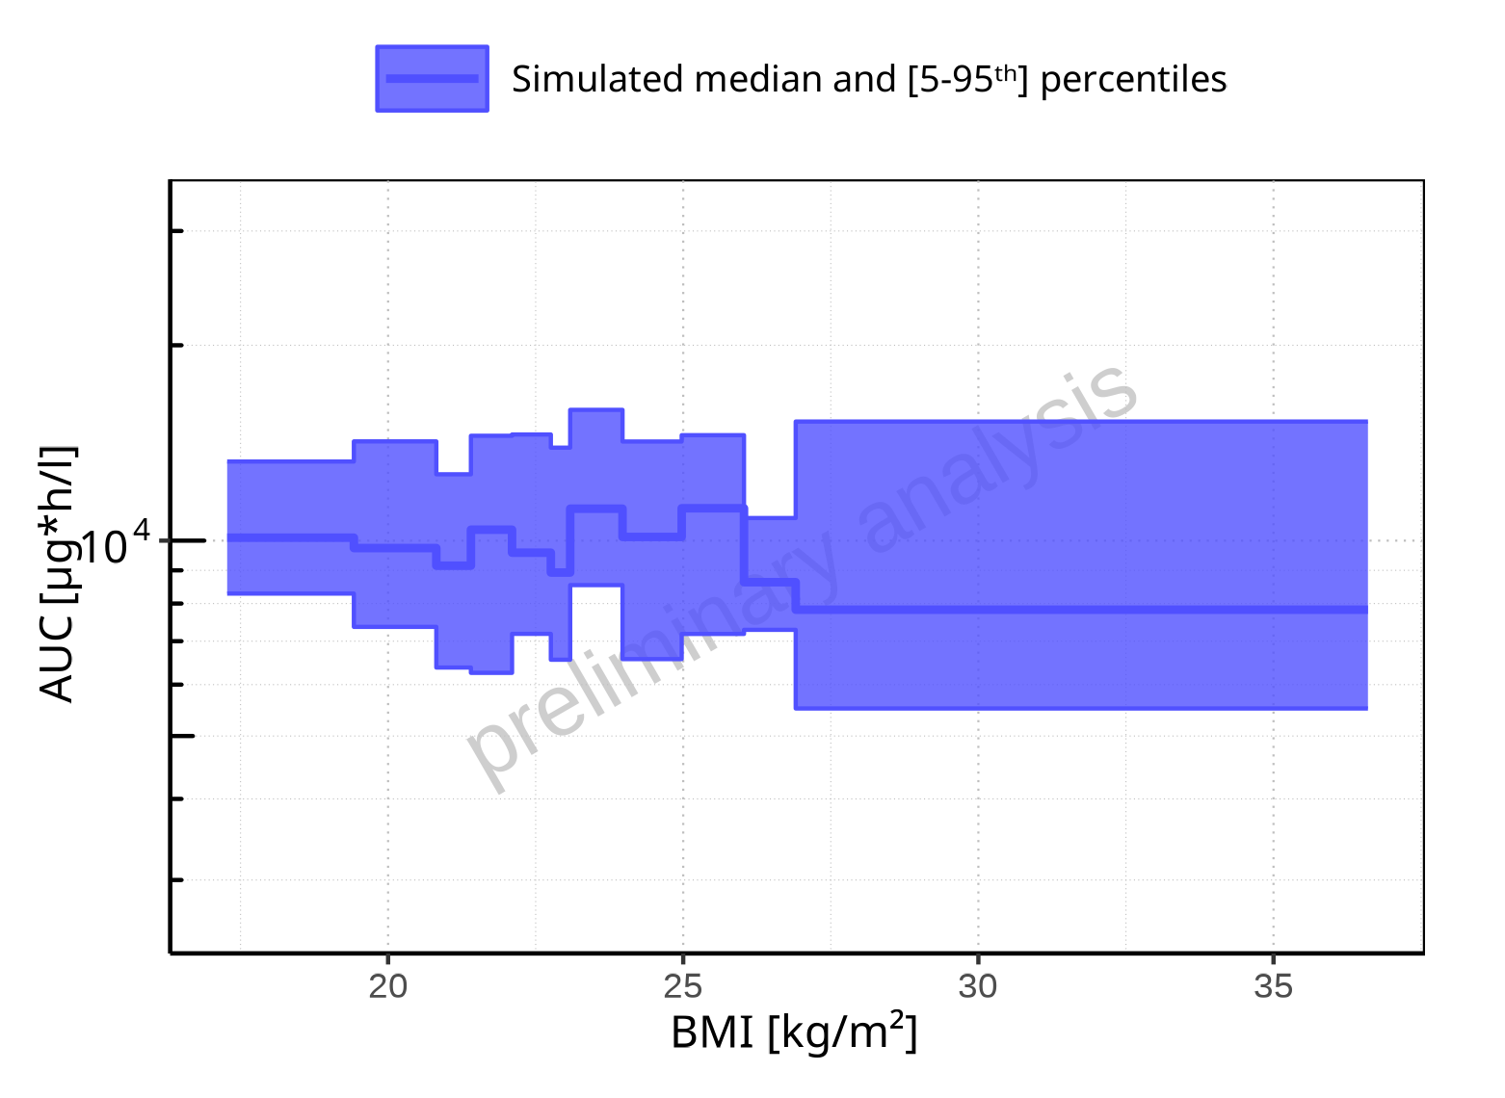

**Figure 2-137: BMI-dependence of AUC for Filmcoated_tablet_400mg_sd. Profiles are plotted in a logarithmic scale.**

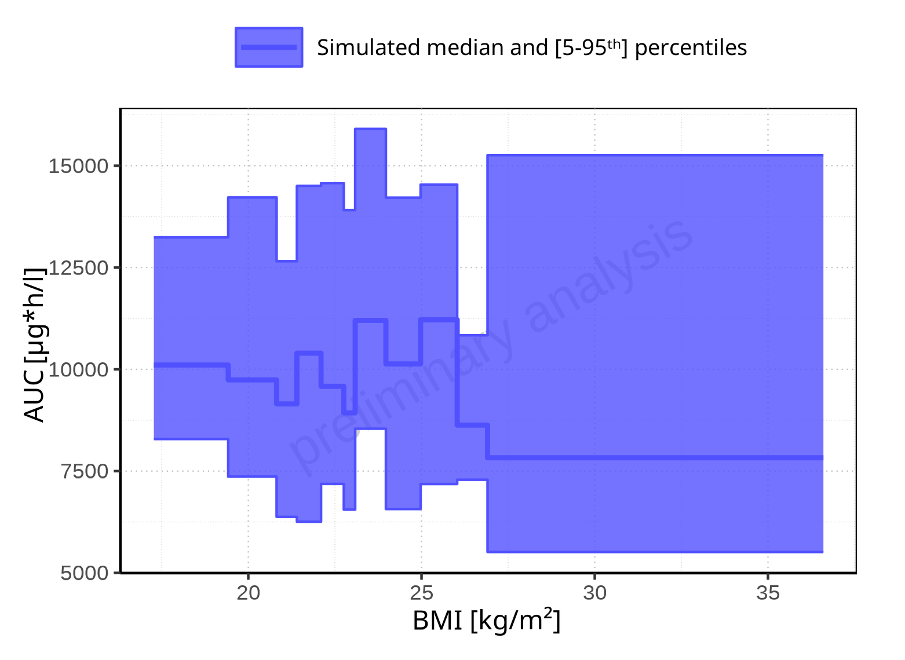

**Figure 2-138: BMI-dependence of AUC for Filmcoated_tablet_400mg_sd. Profiles are plotted in a linear scale.**

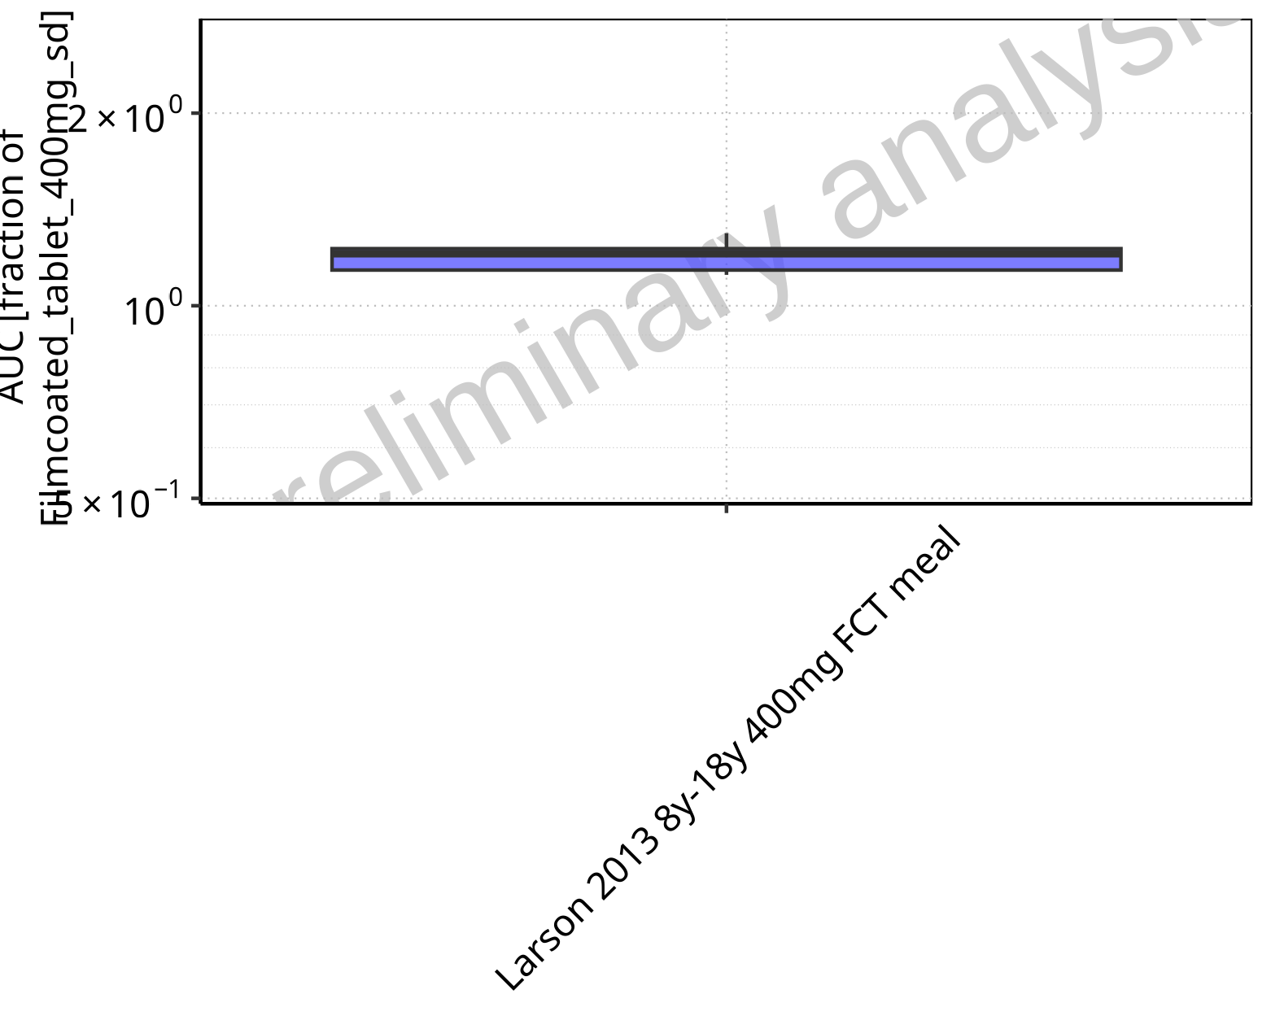

**Figure 2-139: Ratio of population summary statistics of AUC of Raltegravir for Larson 2013 8y-18y 400mg FCT meal in comparison to Filmcoated_tablet_400mg_sd shown as box-whisker plot, which indicates ratios of the 5th, 25th, 50th, 75th, 95th percentiles in logarithmic scale.**

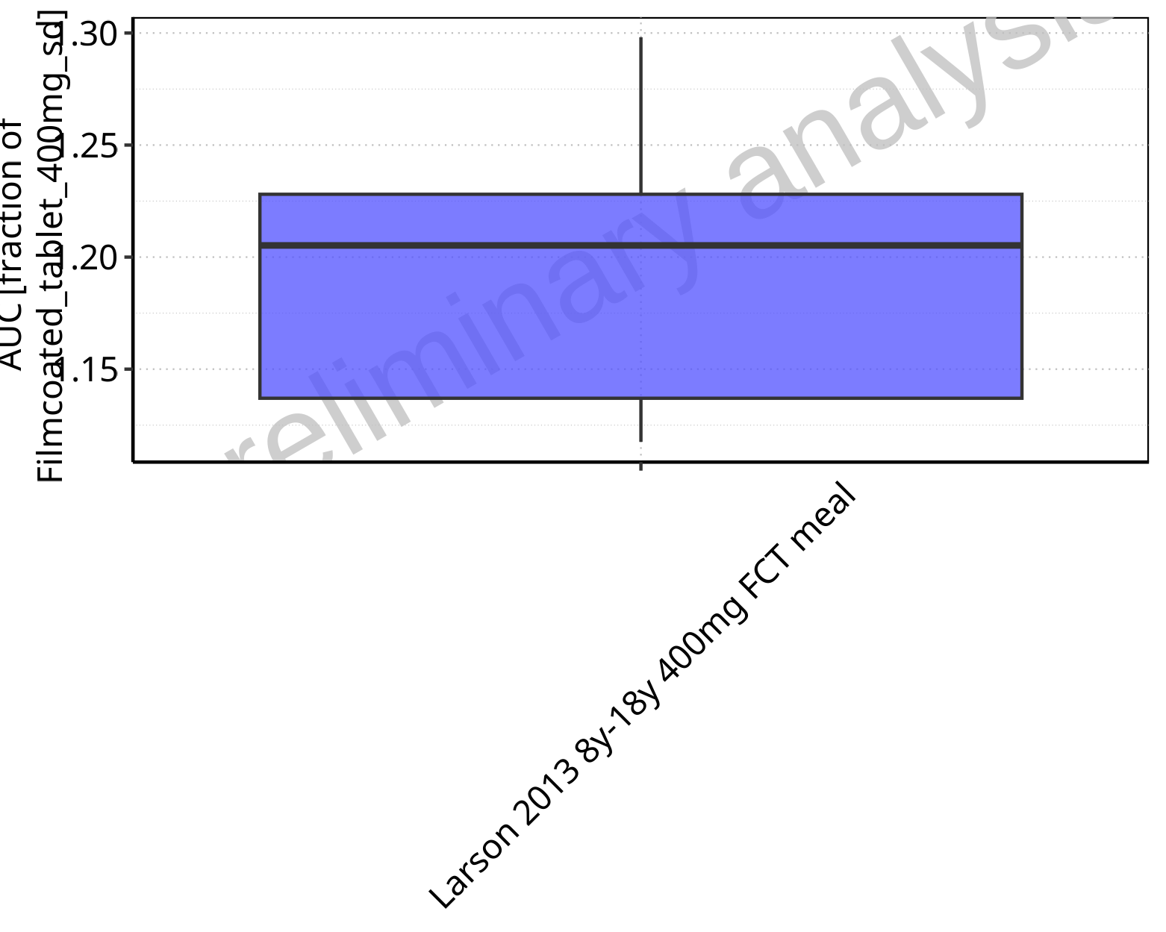

**Figure 2-140: Ratio of population summary statistics of AUC of Raltegravir for Larson 2013 8y-18y 400mg FCT meal in comparison to Filmcoated_tablet_400mg_sd shown as box-whisker plot, which indicates ratios of the 5th, 25th, 50th, 75th, 95th percentiles in linear scale.**

**Table 2-10: Ratio of population summary statistics of AUC of Raltegravir for Larson 2013 8y-18y 400mg FCT meal in comparison to Filmcoated_tablet_400mg_sd**

| Population | N | 5th pctl | 25th pctl | 50th pctl | 75th pctl | 95th pctl | Mean | SD | Geo Mean | Geo SD |
| --- | --- | --- | --- | --- | --- | --- | --- | --- | --- | --- |
| Larson 2013 8y-18y 400mg FCT meal | 500 | 1.12 | 1.14 | 1.21 | 1.23 | 1.30 | 1.20 | 1.41 | 1.19 | 1.04 |

### AUC_norm

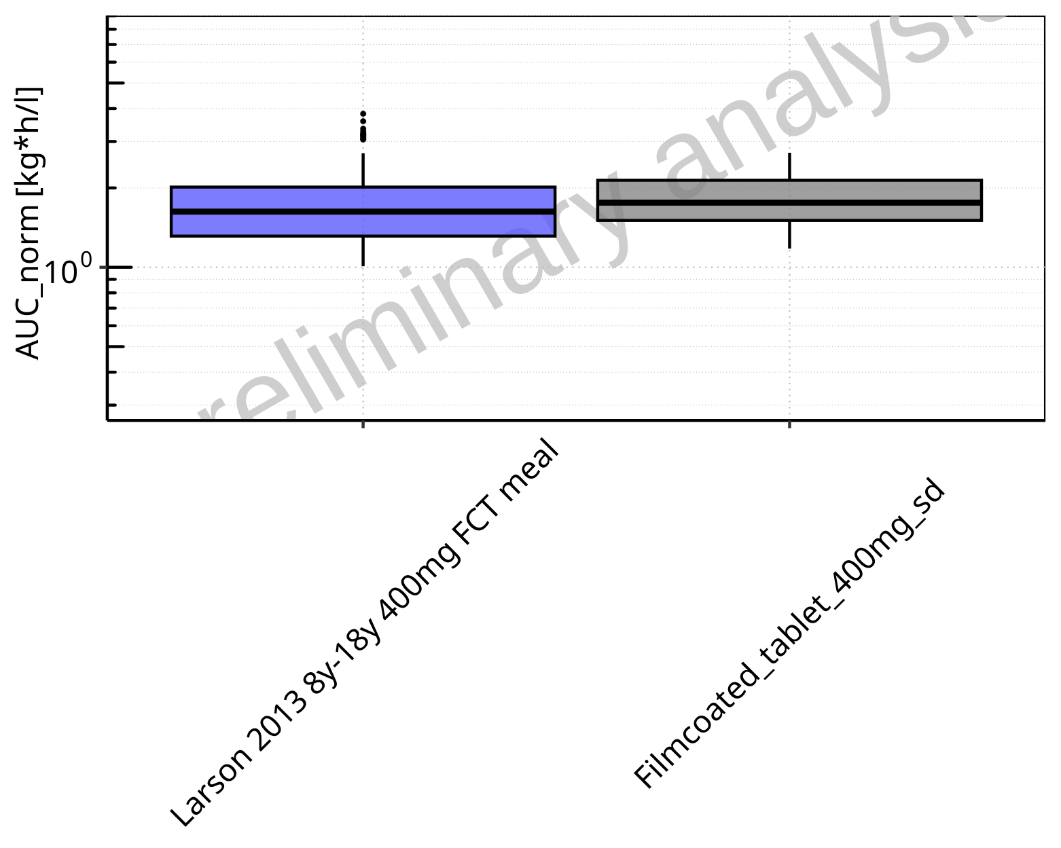

**Figure 2-141: AUC_norm of Raltegravir for Larson 2013 8y-18y 400mg FCT meal, Filmcoated_tablet_400mg_sd shown as box-whisker plot, which indicates the 5th, 25th, 50th, 75th, 95th percentiles in logarithmic scale.**

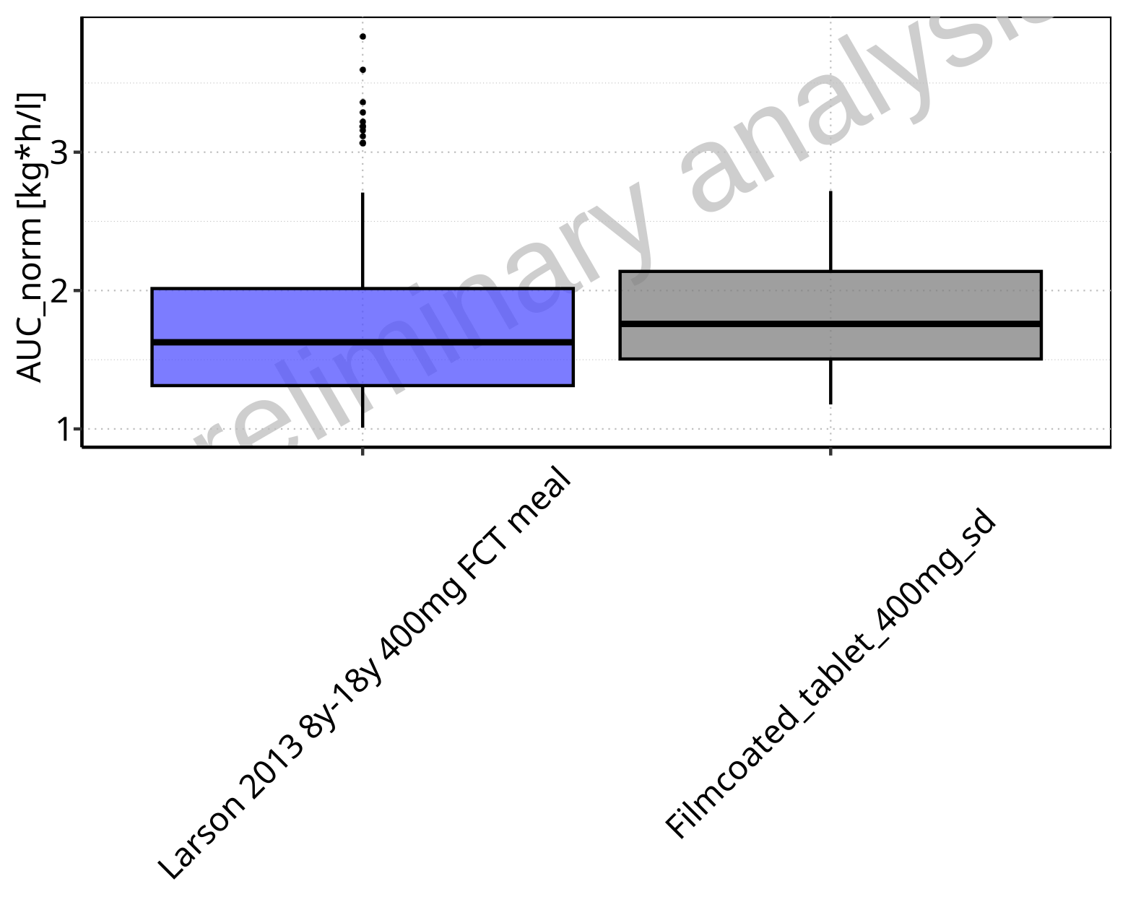

**Figure 2-142: AUC_norm of Raltegravir for Larson 2013 8y-18y 400mg FCT meal, Filmcoated_tablet_400mg_sd shown as box-whisker plot, which indicates the 5th, 25th, 50th, 75th, 95th percentiles in linear scale.**

**Table 2-11: Population statistics summarizing AUC_norm of Raltegravir for Larson 2013 8y-18y 400mg FCT meal, Filmcoated_tablet_400mg_sd reported in [kg*h/l]**

| Population | N | 5th pctl | 25th pctl | 50th pctl | 75th pctl | 95th pctl | Mean | SD | Geo Mean | Geo SD |
| --- | --- | --- | --- | --- | --- | --- | --- | --- | --- | --- |
| Larson 2013 8y-18y 400mg FCT meal | 500 | 1.01 | 1.31 | 1.63 | 2.01 | 2.71 | 1.71 | 0.53 | 1.63 | 1.35 |
| Filmcoated_tablet_400mg_sd | 100 | 1.18 | 1.51 | 1.76 | 2.14 | 2.72 | 1.85 | 0.49 | 1.79 | 1.31 |

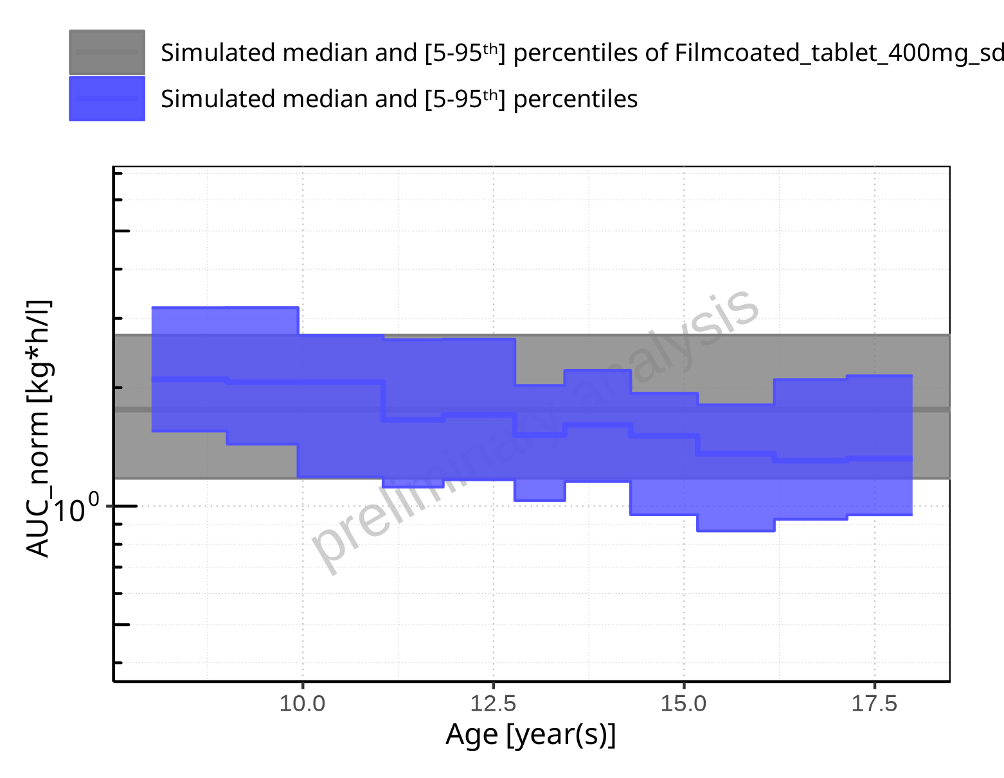

**Figure 2-143: Age-dependence of AUC_norm for Larson 2013 8y-18y 400mg FCT meal in comparison to Filmcoated_tablet_400mg_sd. Profiles are plotted in a logarithmic scale.**

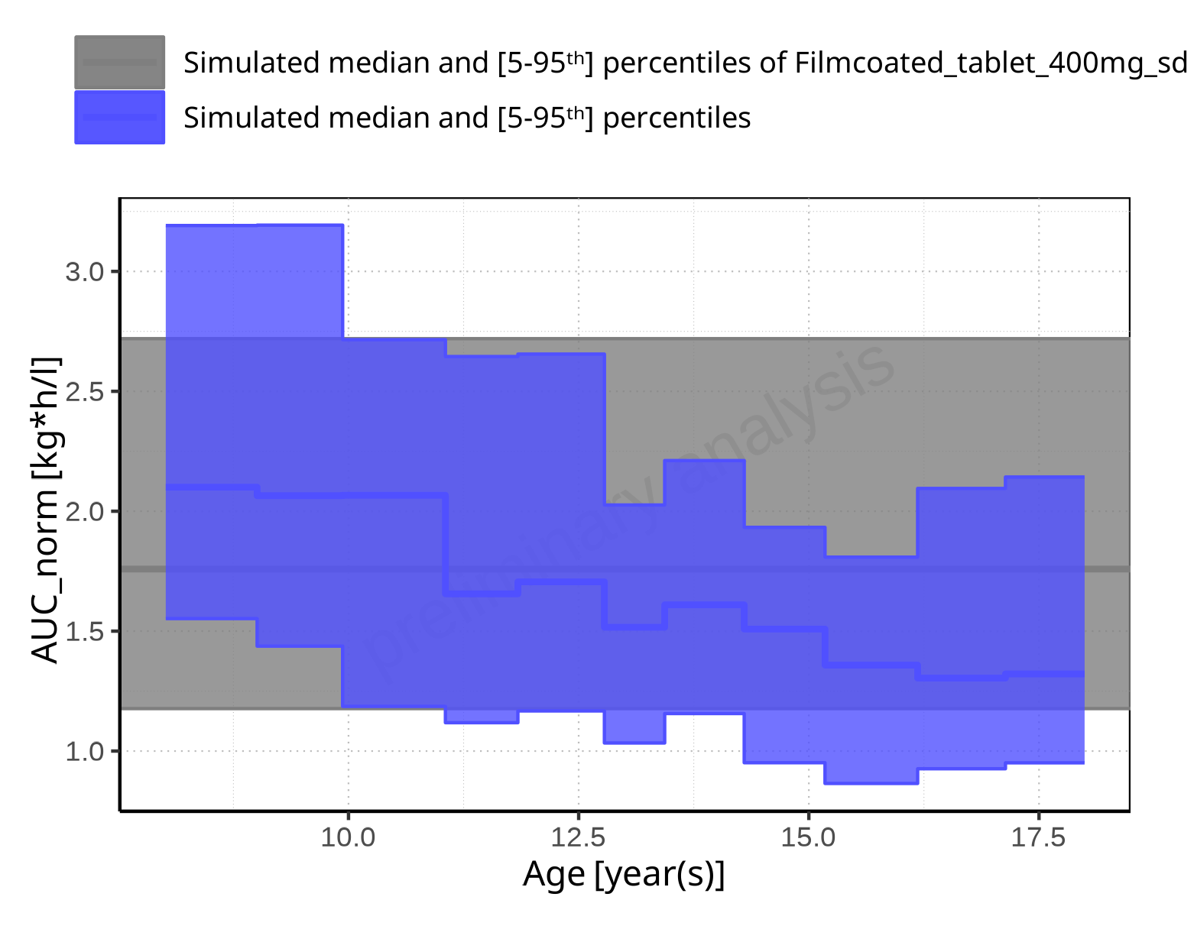

**Figure 2-144: Age-dependence of AUC_norm for Larson 2013 8y-18y 400mg FCT meal in comparison to Filmcoated_tablet_400mg_sd. Profiles are plotted in a linear scale.**

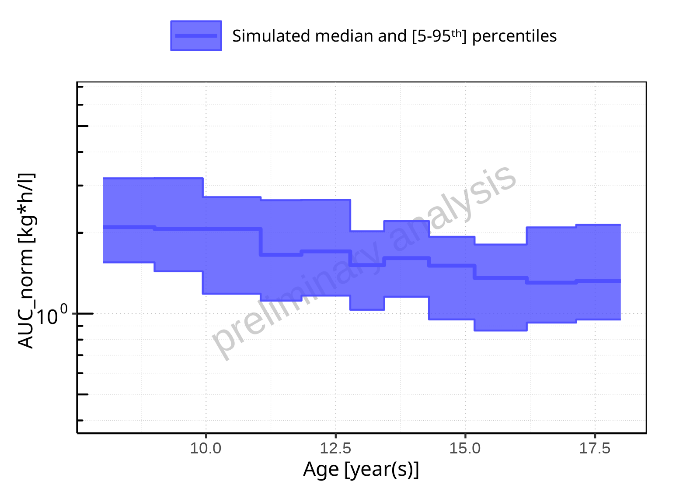

**Figure 2-145: Age-dependence of AUC_norm for Larson 2013 8y-18y 400mg FCT meal. Profiles are plotted in a logarithmic scale.**

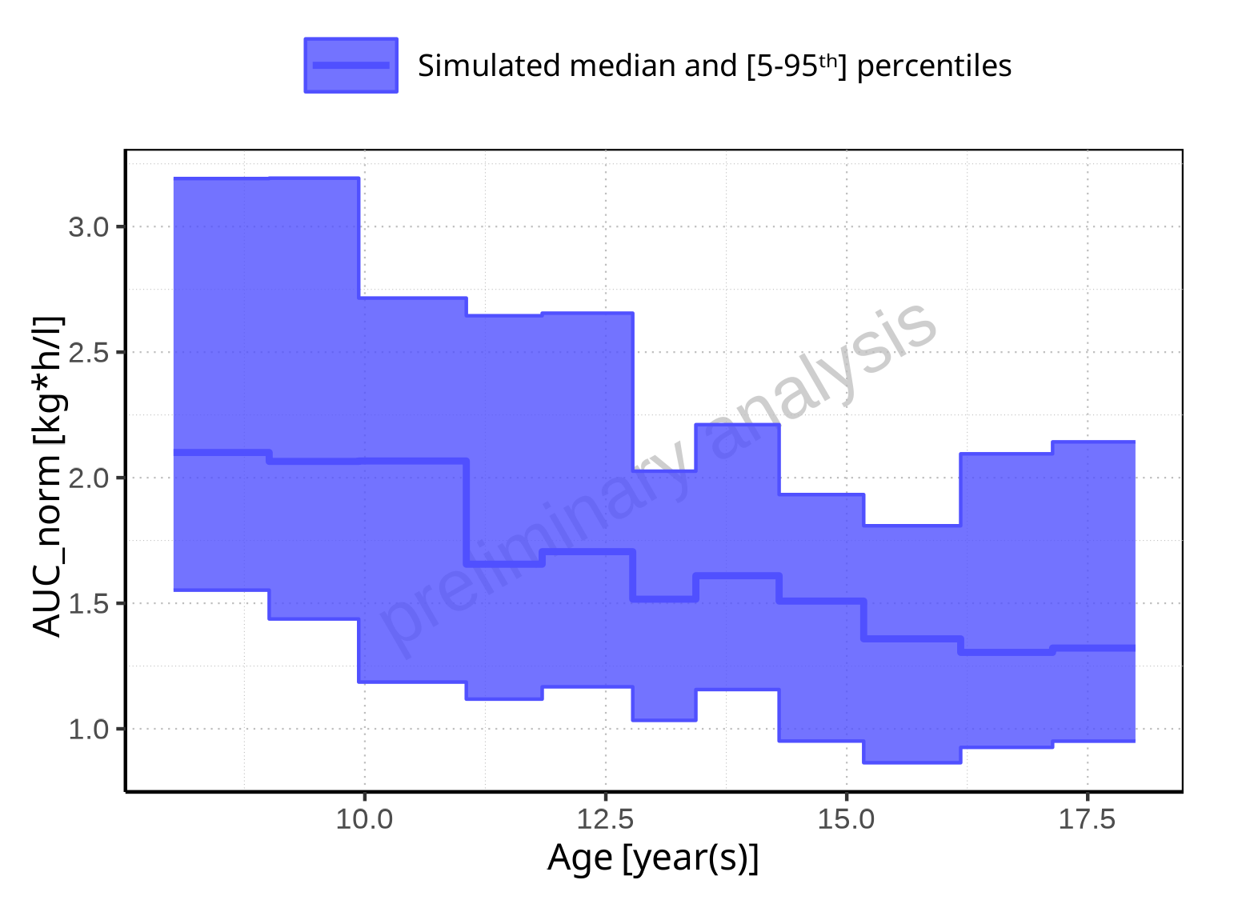

**Figure 2-146: Age-dependence of AUC_norm for Larson 2013 8y-18y 400mg FCT meal. Profiles are plotted in a linear scale.**

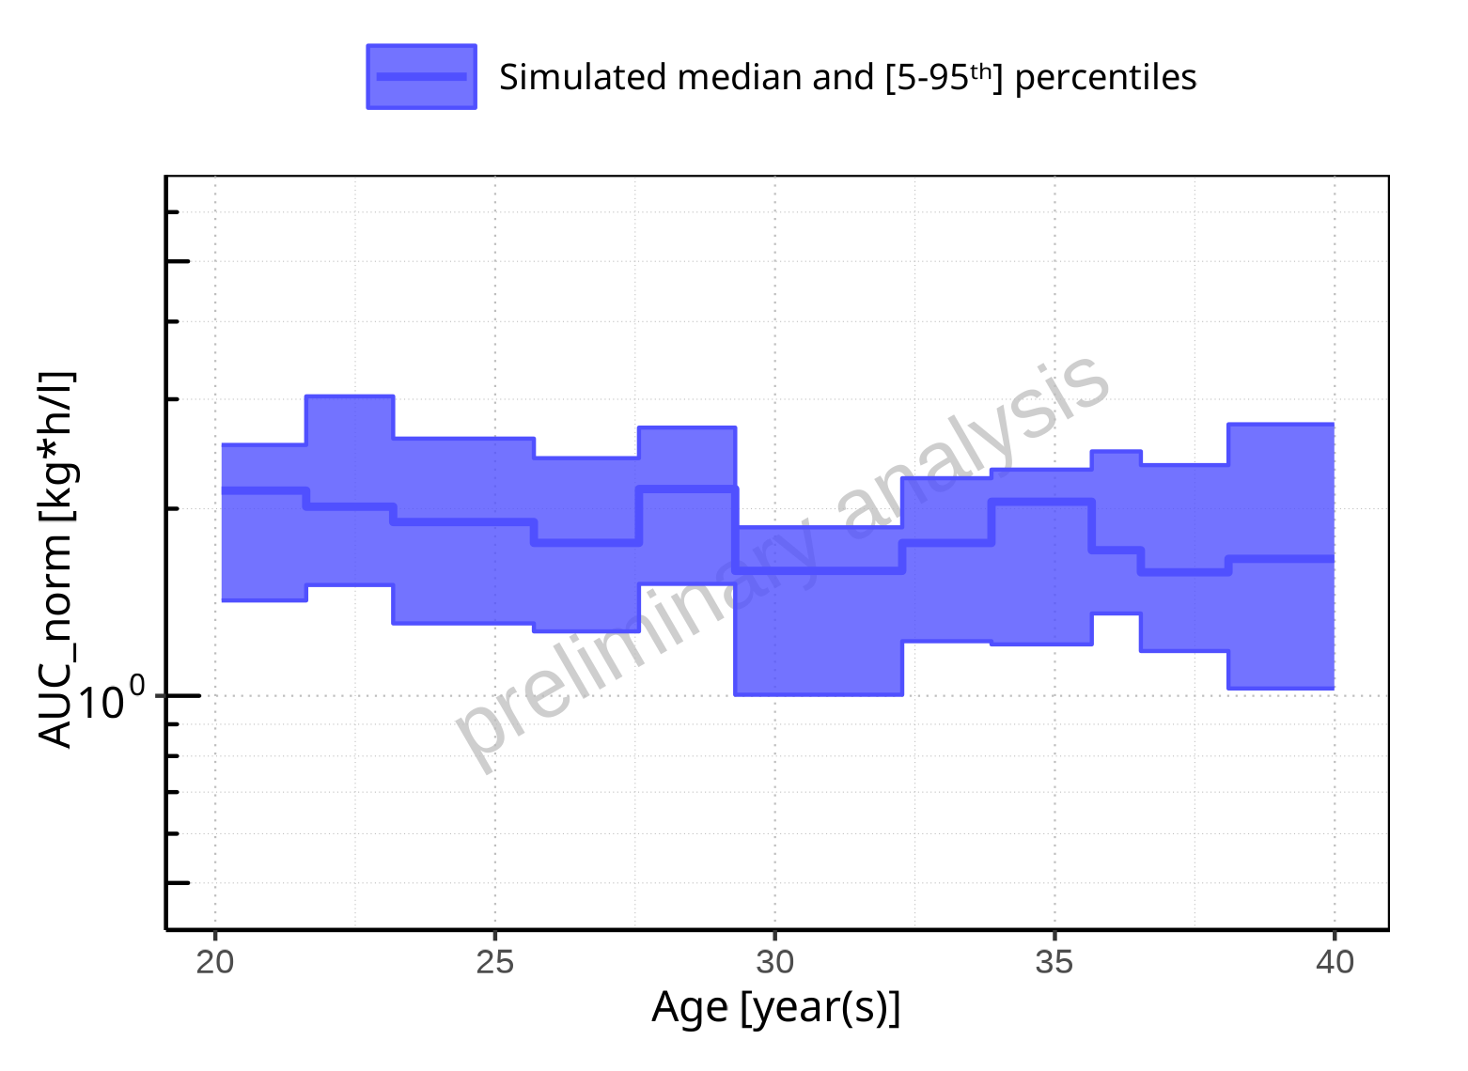

**Figure 2-147: Age-dependence of AUC_norm for Filmcoated_tablet_400mg_sd. Profiles are plotted in a logarithmic scale.**

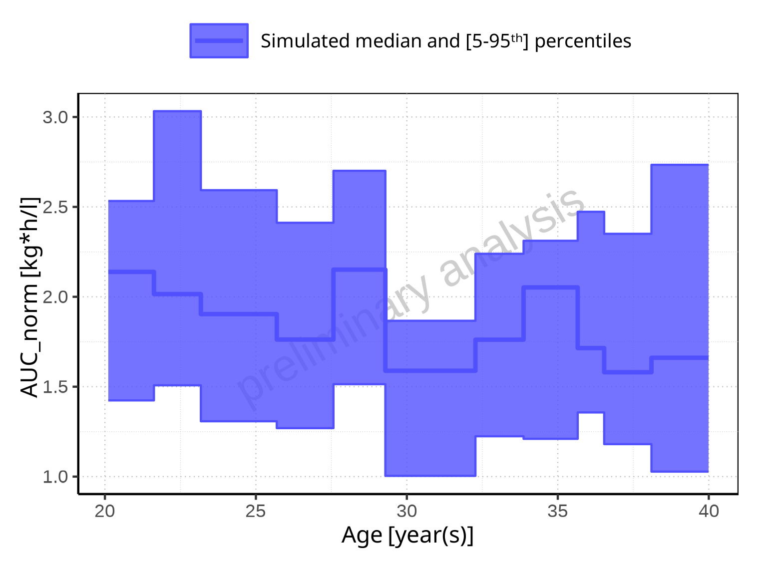

**Figure 2-148: Age-dependence of AUC_norm for Filmcoated_tablet_400mg_sd. Profiles are plotted in a linear scale.**

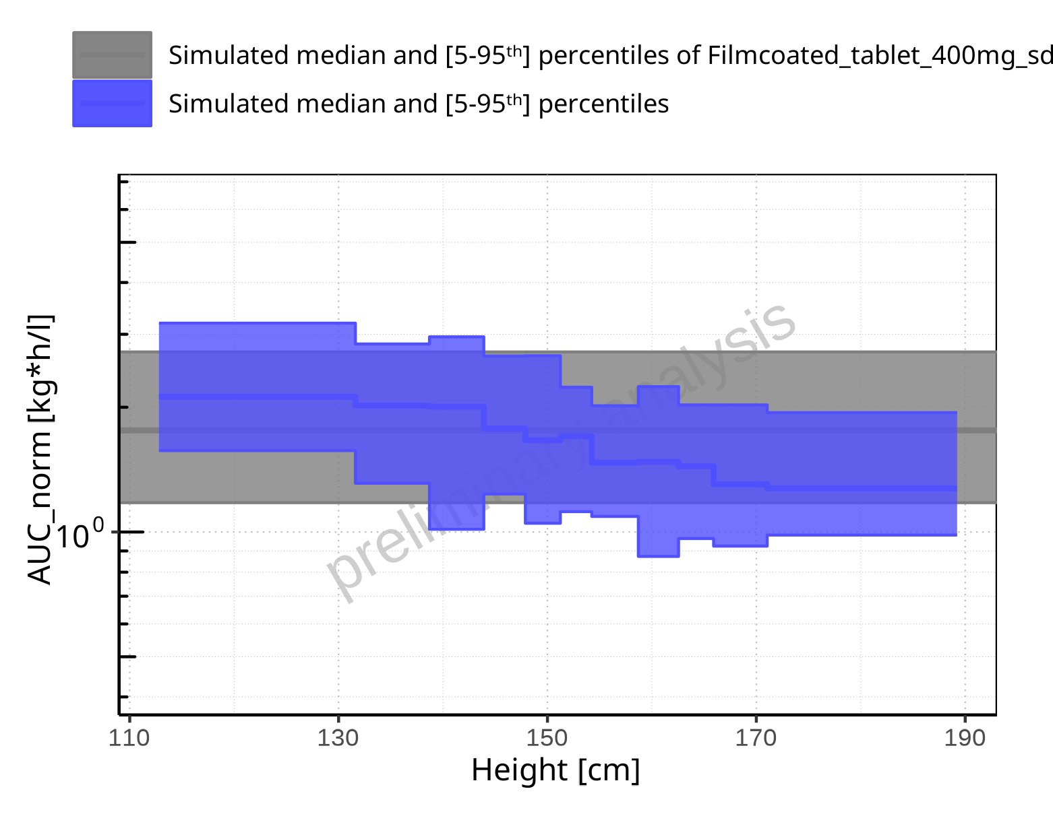

**Figure 2-149: Height-dependence of AUC_norm for Larson 2013 8y-18y 400mg FCT meal in comparison to Filmcoated_tablet_400mg_sd. Profiles are plotted in a logarithmic scale.**

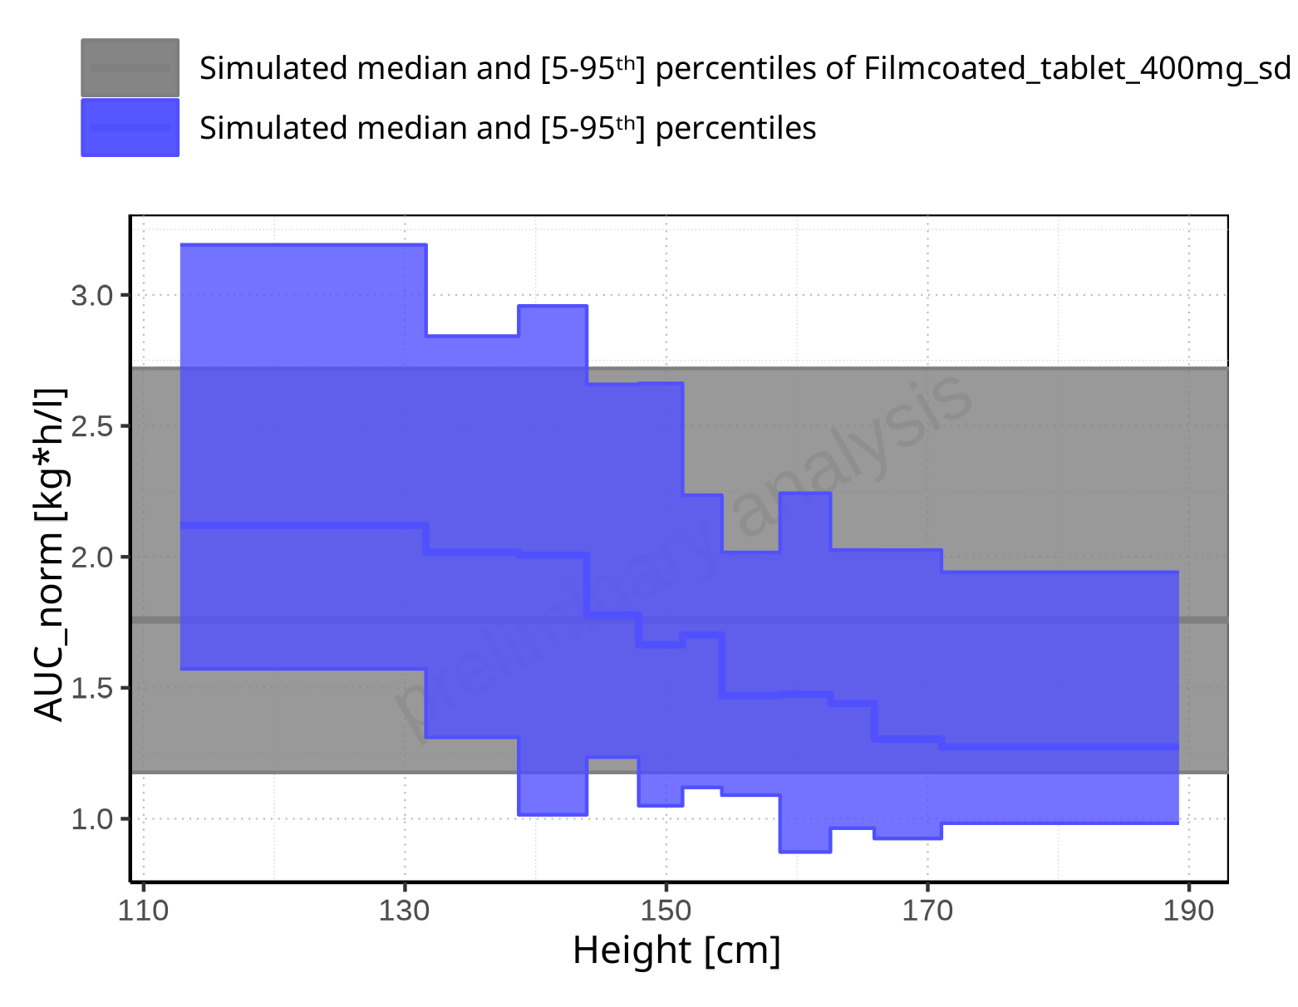

**Figure 2-150: Height-dependence of AUC_norm for Larson 2013 8y-18y 400mg FCT meal in comparison to Filmcoated_tablet_400mg_sd. Profiles are plotted in a linear scale.**

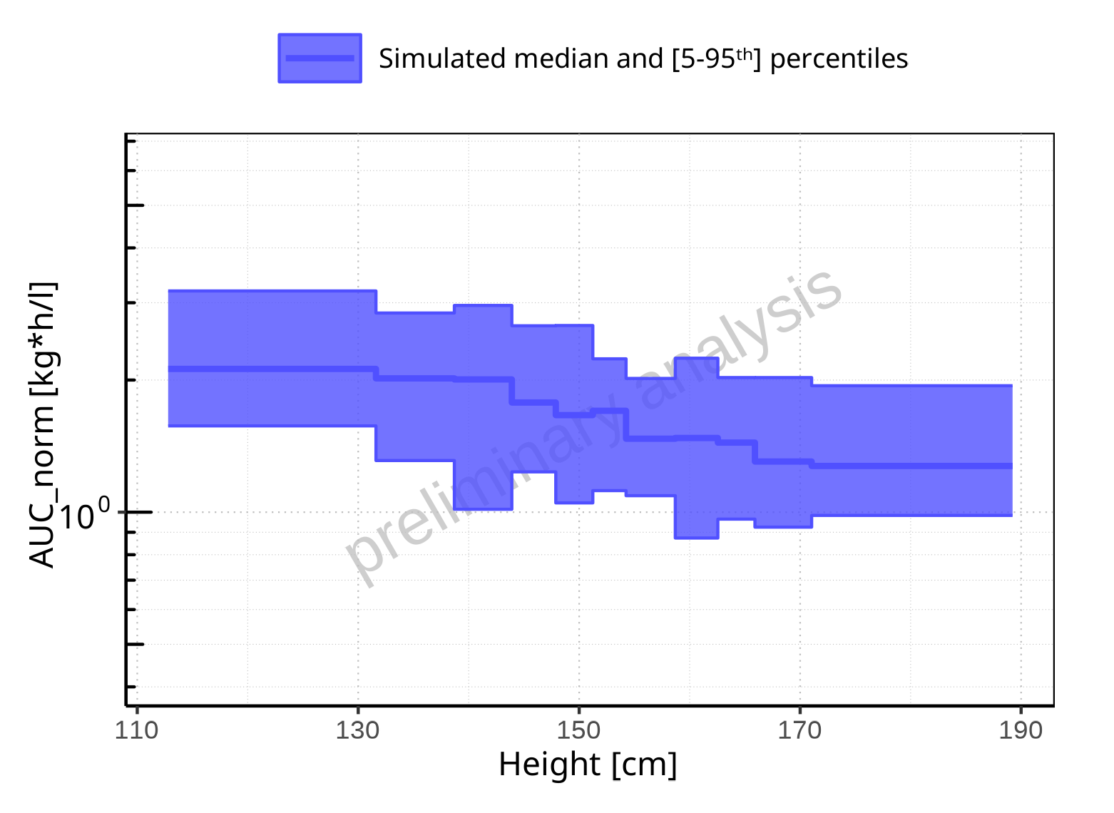

**Figure 2-151: Height-dependence of AUC_norm for Larson 2013 8y-18y 400mg FCT meal. Profiles are plotted in a logarithmic scale.**

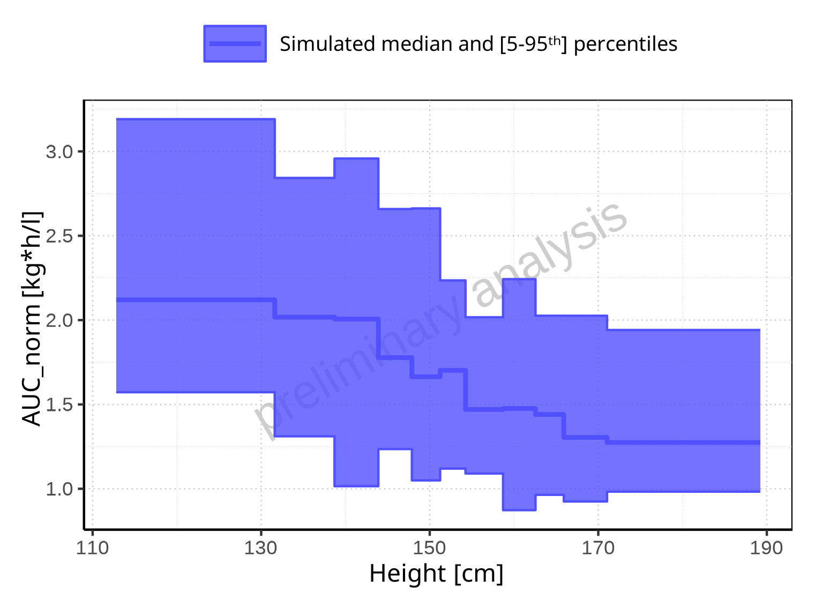

**Figure 2-152: Height-dependence of AUC_norm for Larson 2013 8y-18y 400mg FCT meal. Profiles are plotted in a linear scale.**

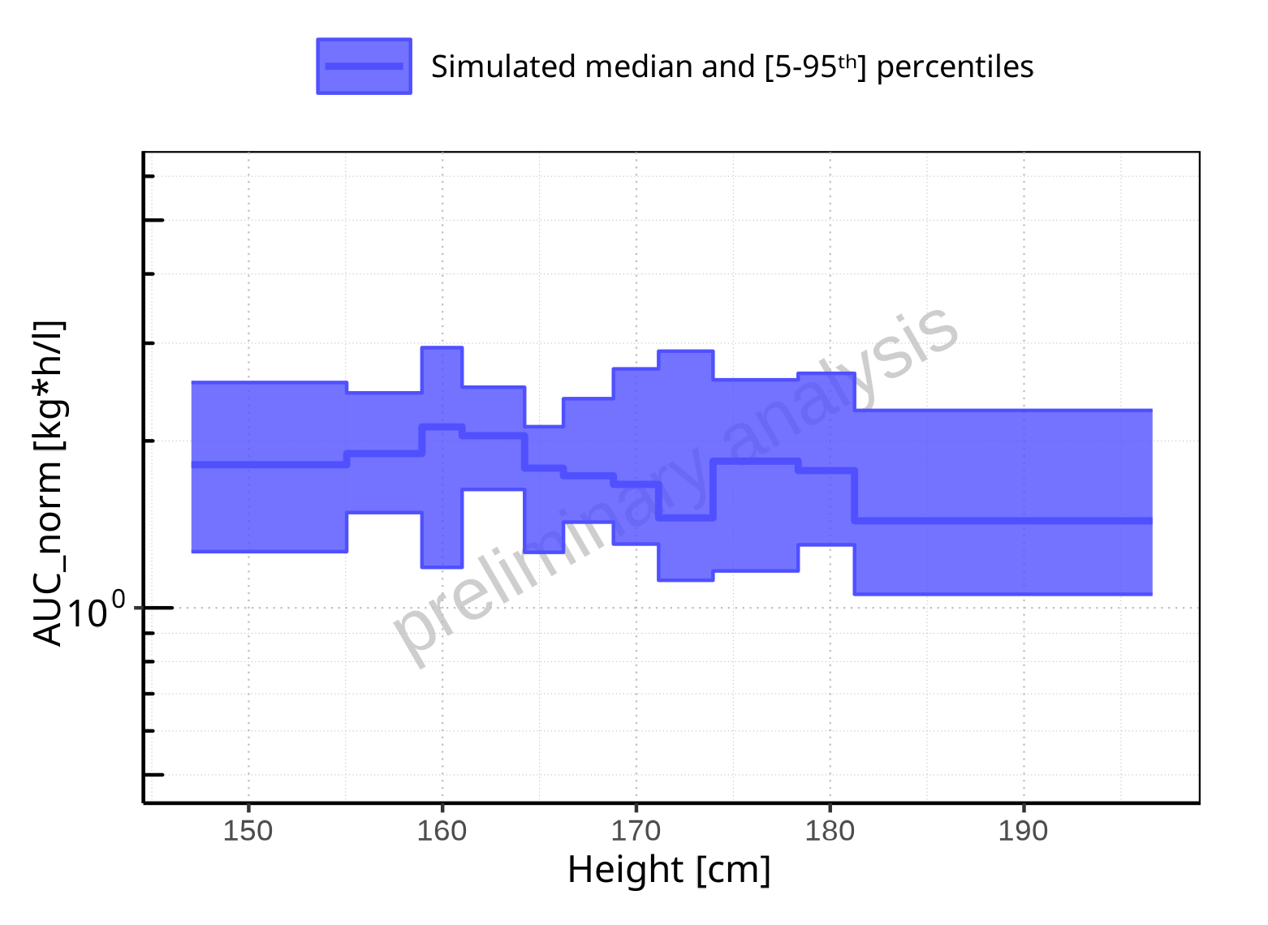

**Figure 2-153: Height-dependence of AUC_norm for Filmcoated_tablet_400mg_sd. Profiles are plotted in a logarithmic scale.**

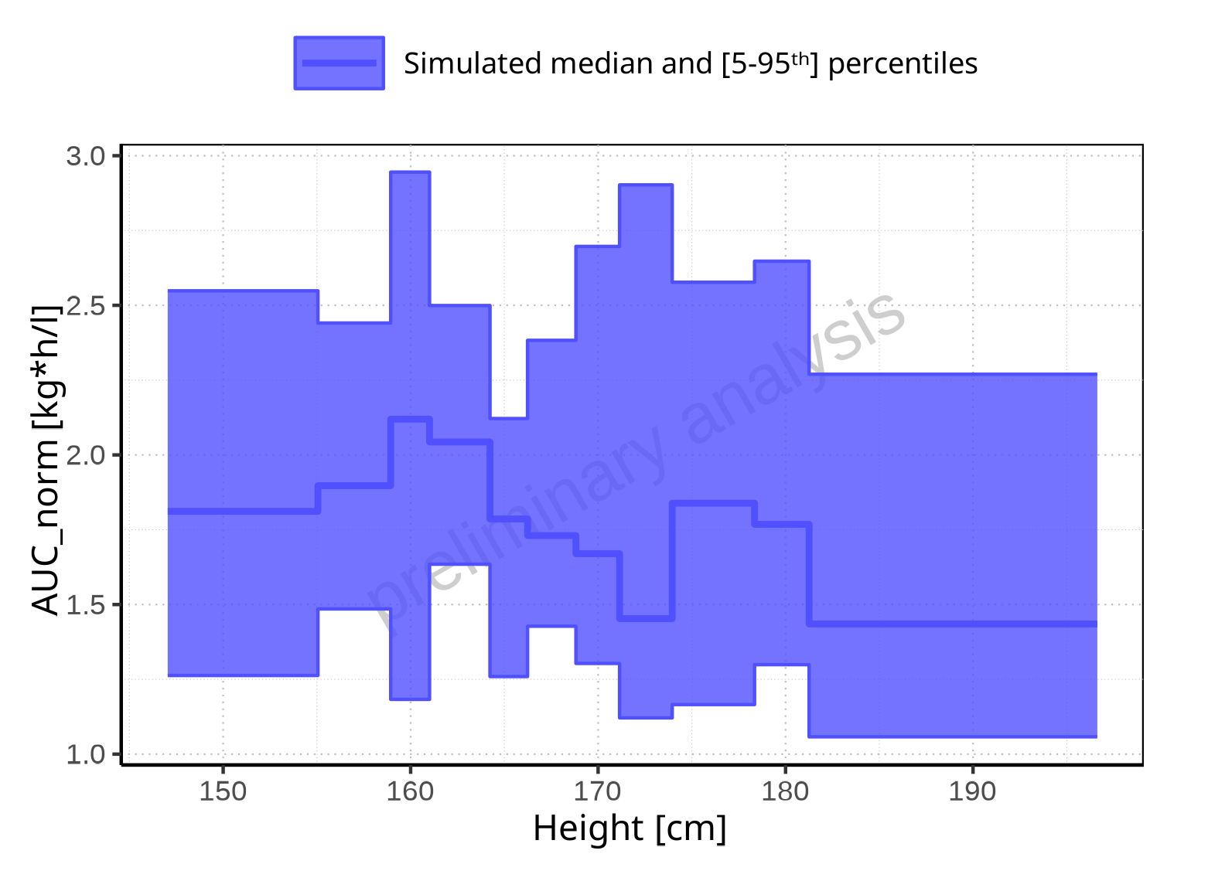

**Figure 2-154: Height-dependence of AUC_norm for Filmcoated_tablet_400mg_sd. Profiles are plotted in a linear scale.**

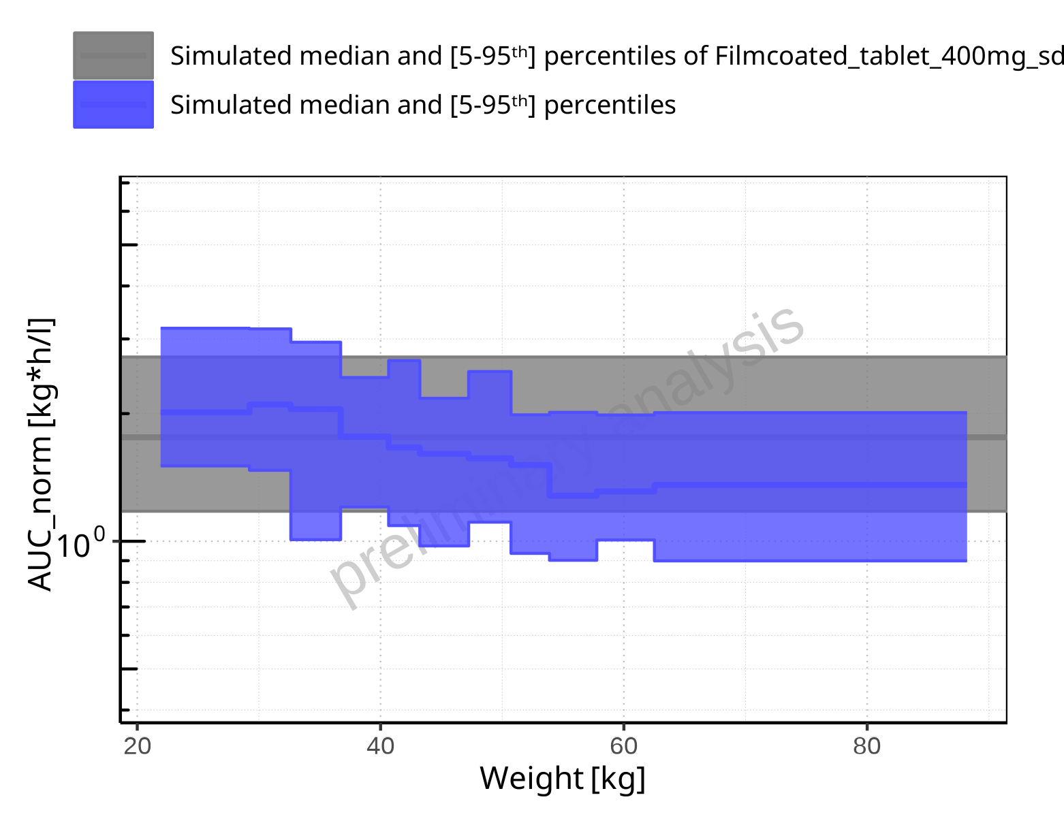

**Figure 2-155: Weight-dependence of AUC_norm for Larson 2013 8y-18y 400mg FCT meal in comparison to Filmcoated_tablet_400mg_sd. Profiles are plotted in a logarithmic scale.**

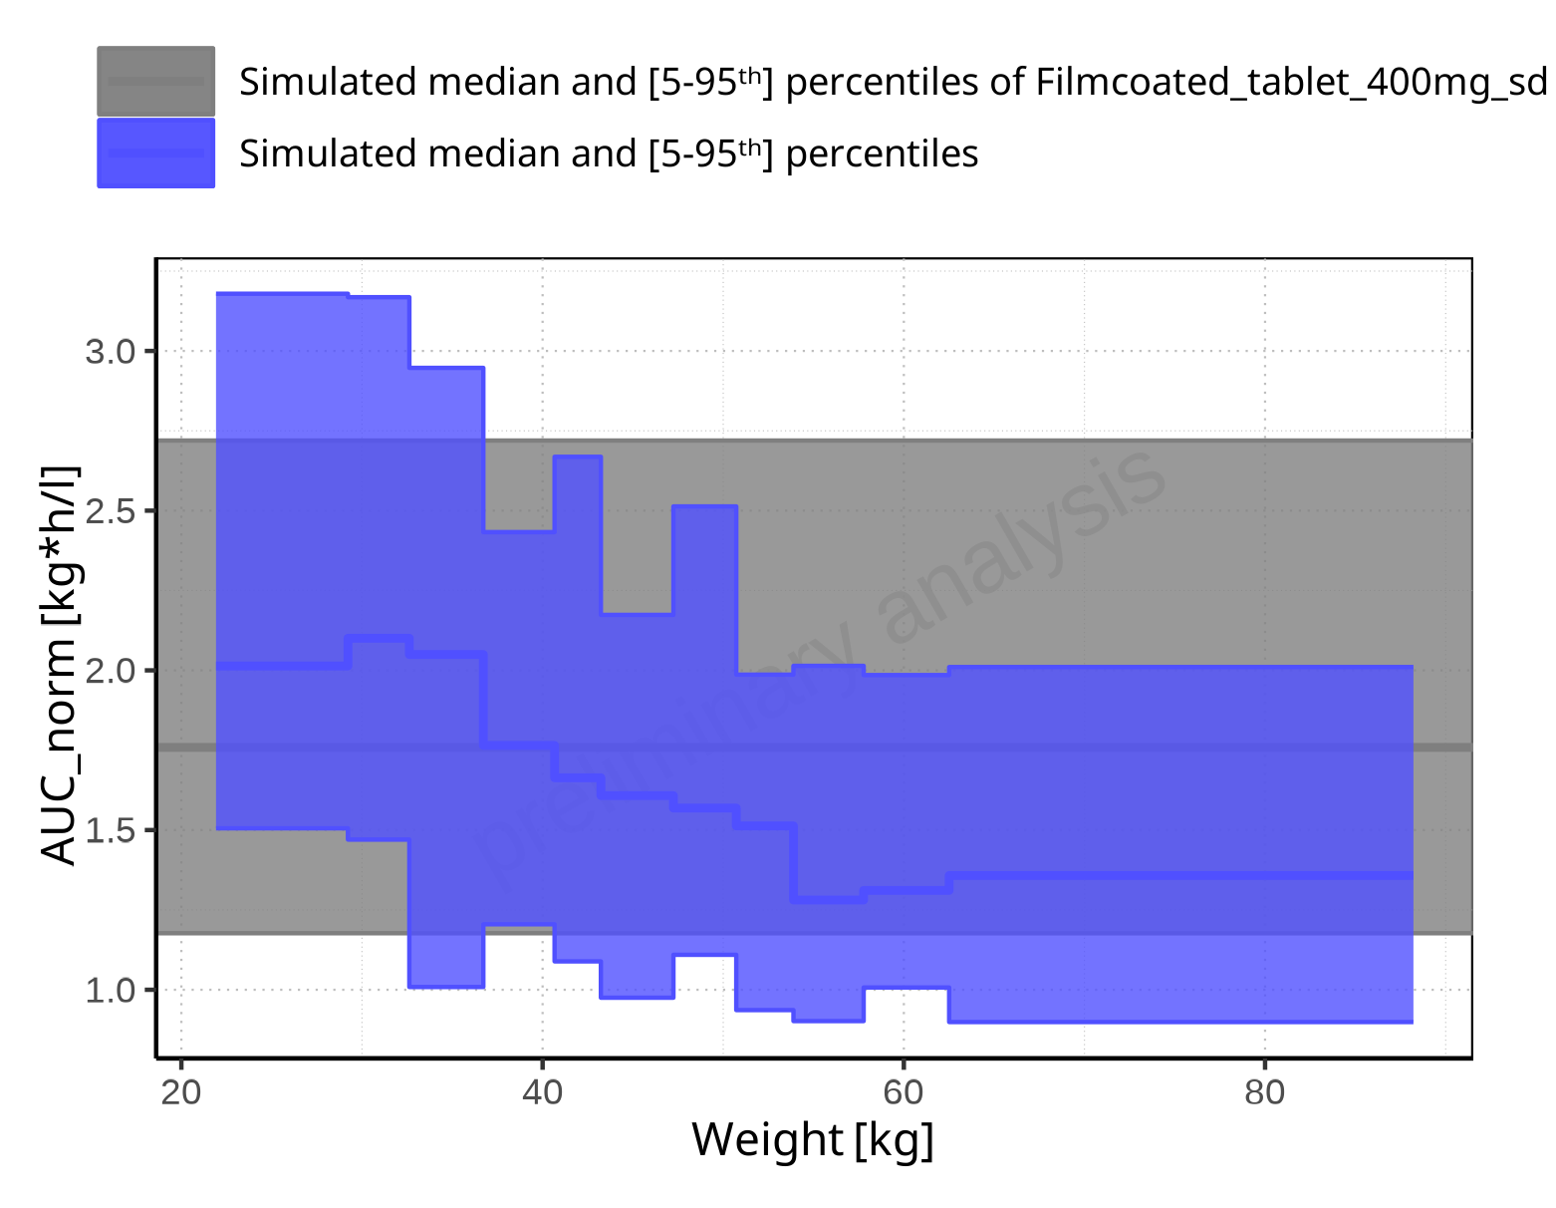

**Figure 2-156: Weight-dependence of AUC_norm for Larson 2013 8y-18y 400mg FCT meal in comparison to Filmcoated_tablet_400mg_sd. Profiles are plotted in a linear scale.**

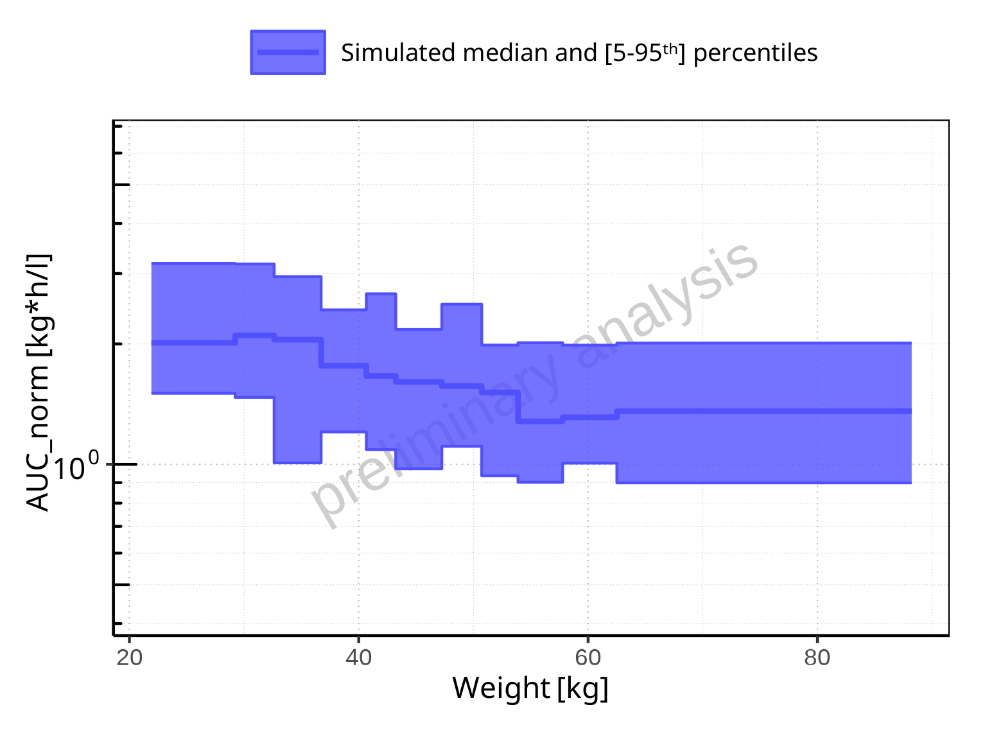

**Figure 2-157: Weight-dependence of AUC_norm for Larson 2013 8y-18y 400mg FCT meal. Profiles are plotted in a logarithmic scale.**

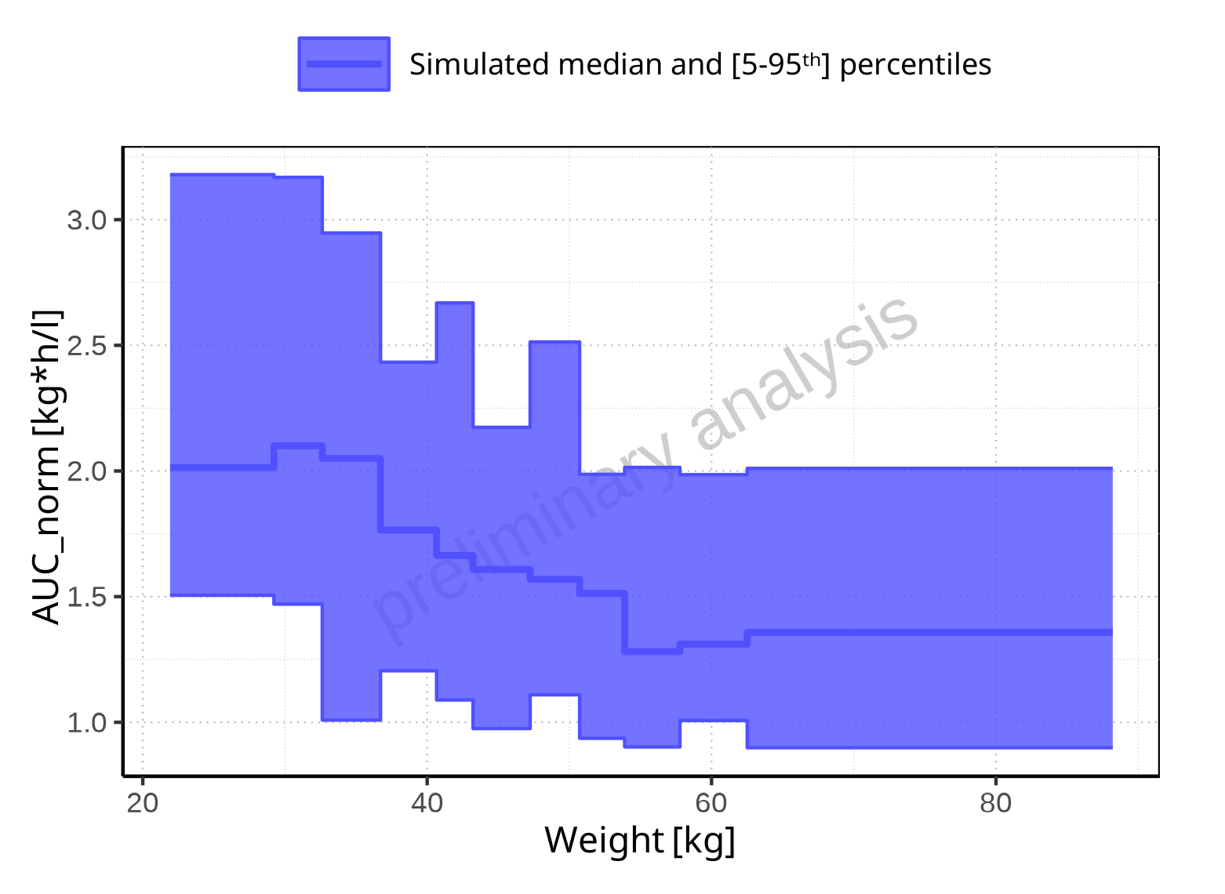

**Figure 2-158: Weight-dependence of AUC_norm for Larson 2013 8y-18y 400mg FCT meal. Profiles are plotted in a linear scale.**

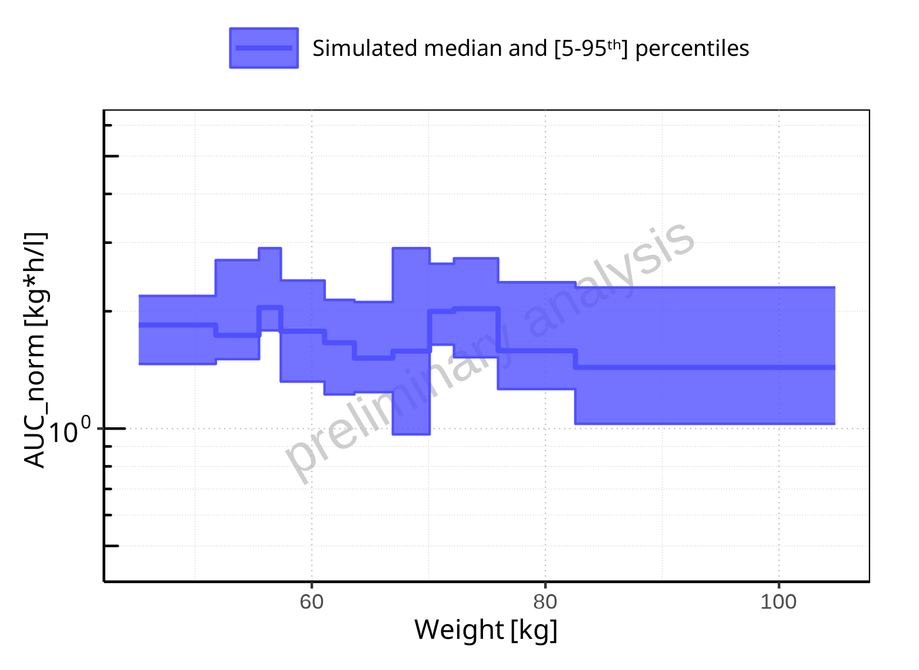

**Figure 2-159: Weight-dependence of AUC_norm for Filmcoated_tablet_400mg_sd. Profiles are plotted in a logarithmic scale.**

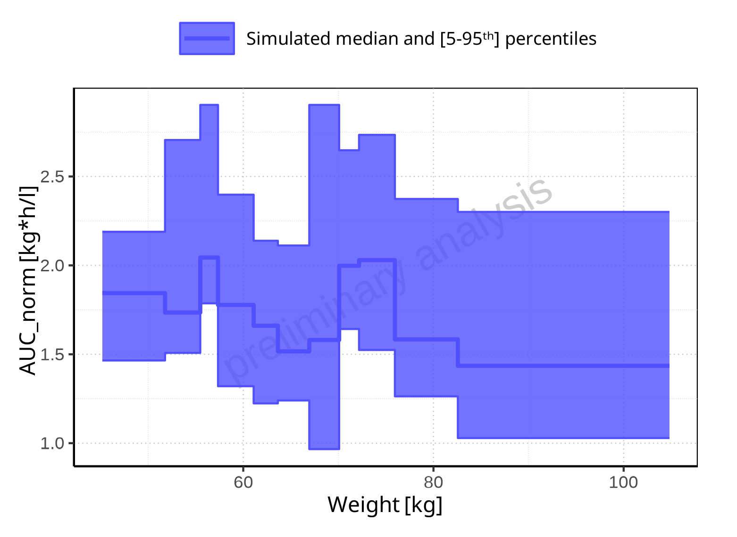

**Figure 2-160: Weight-dependence of AUC_norm for Filmcoated_tablet_400mg_sd. Profiles are plotted in a linear scale.**

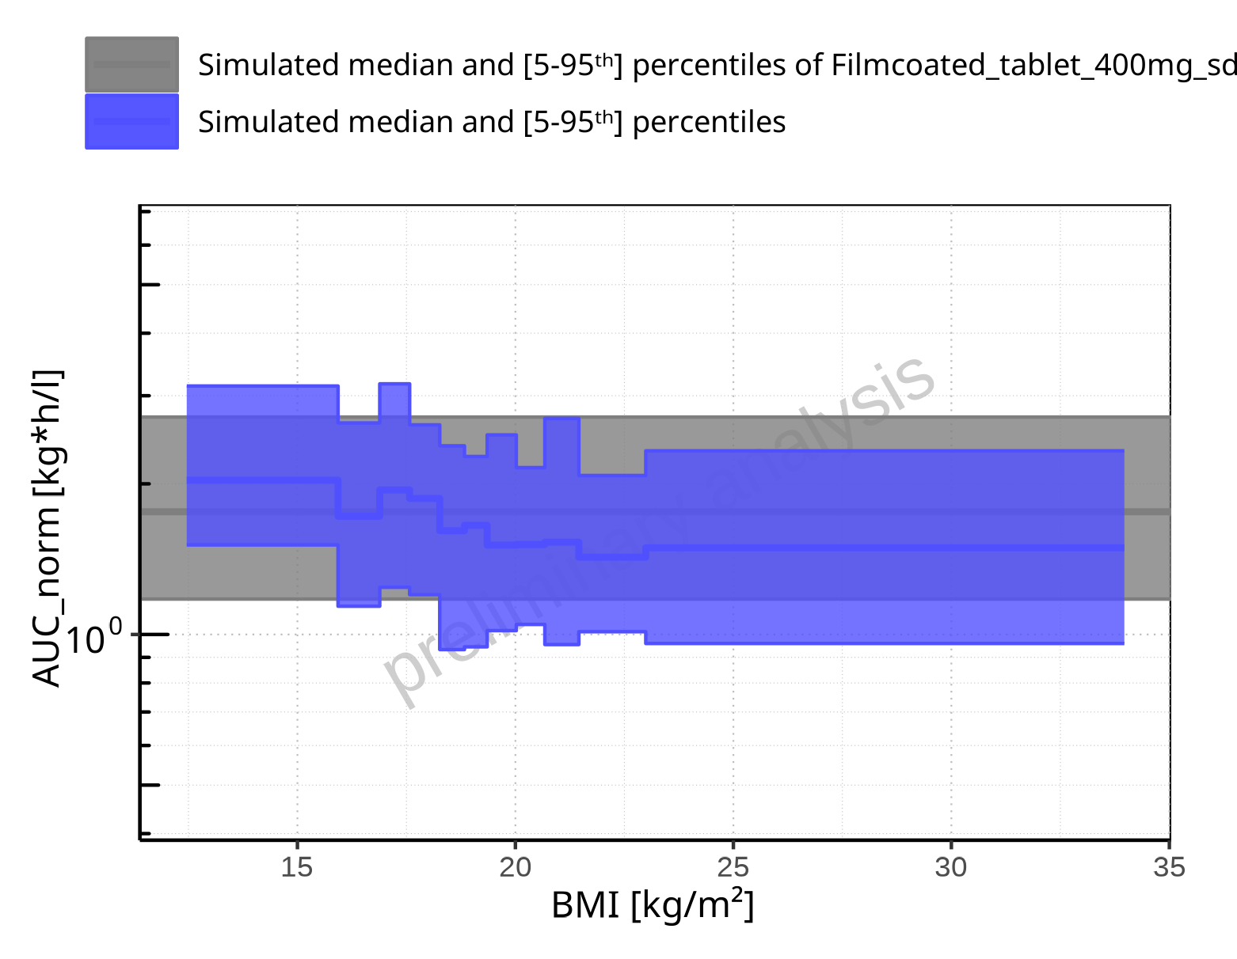

**Figure 2-161: BMI-dependence of AUC_norm for Larson 2013 8y-18y 400mg FCT meal in comparison to Filmcoated_tablet_400mg_sd. Profiles are plotted in a logarithmic scale.**

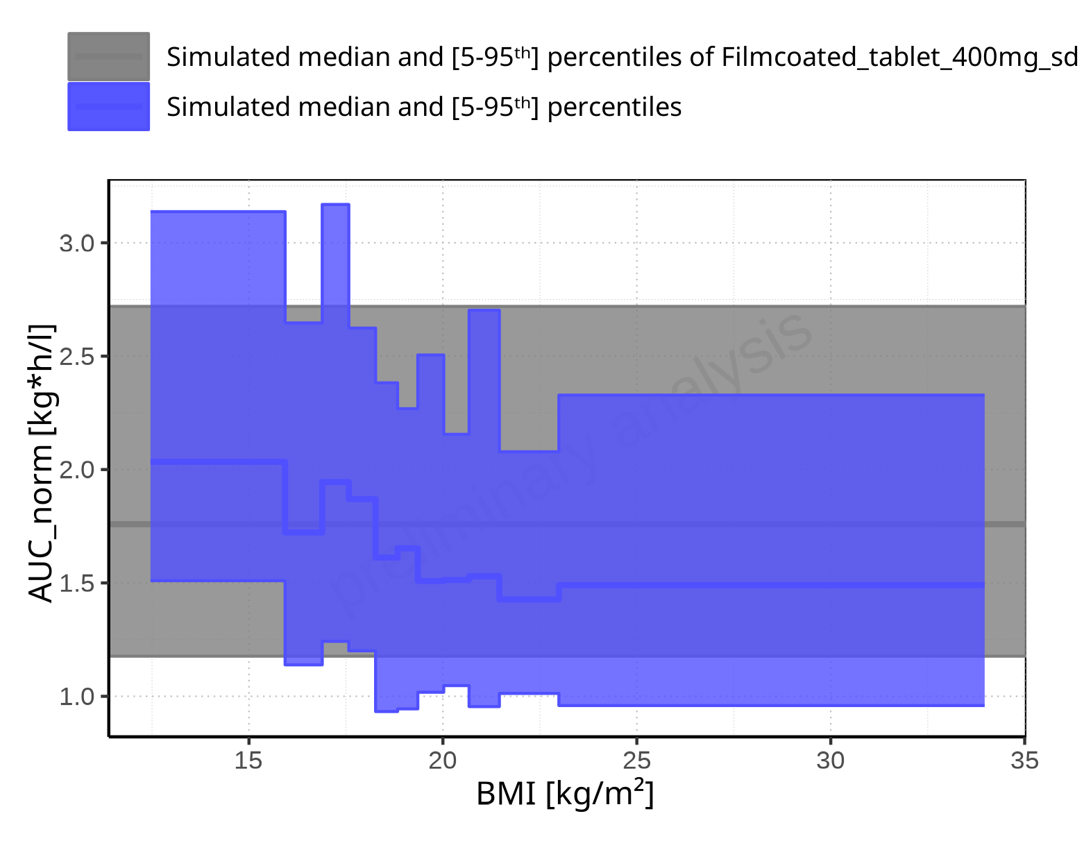

**Figure 2-162: BMI-dependence of AUC_norm for Larson 2013 8y-18y 400mg FCT meal in comparison to Filmcoated_tablet_400mg_sd. Profiles are plotted in a linear scale.**

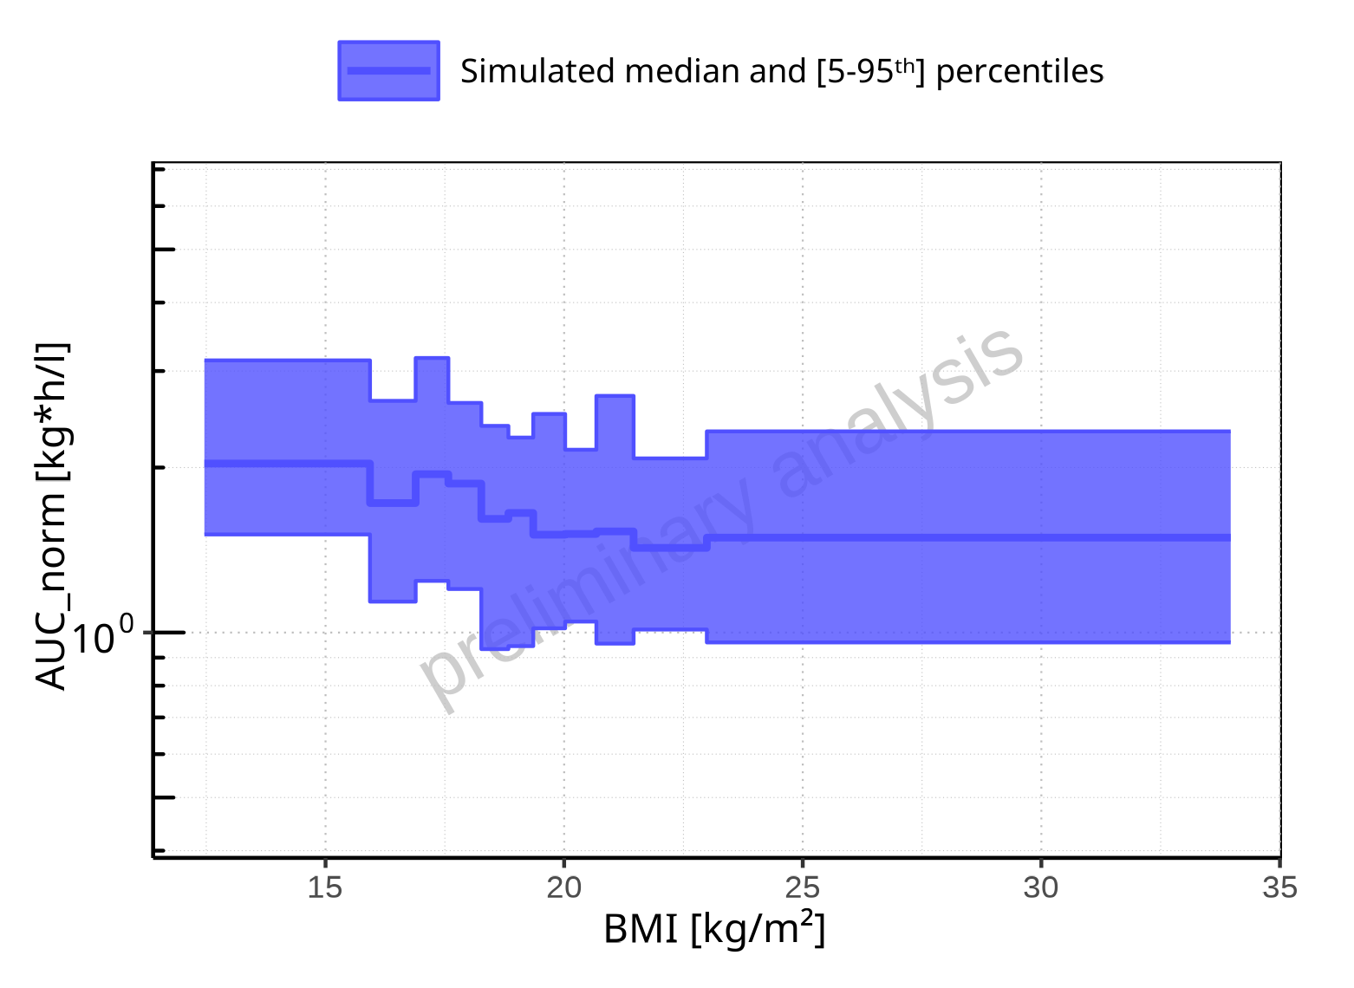

**Figure 2-163: BMI-dependence of AUC_norm for Larson 2013 8y-18y 400mg FCT meal. Profiles are plotted in a logarithmic scale.**

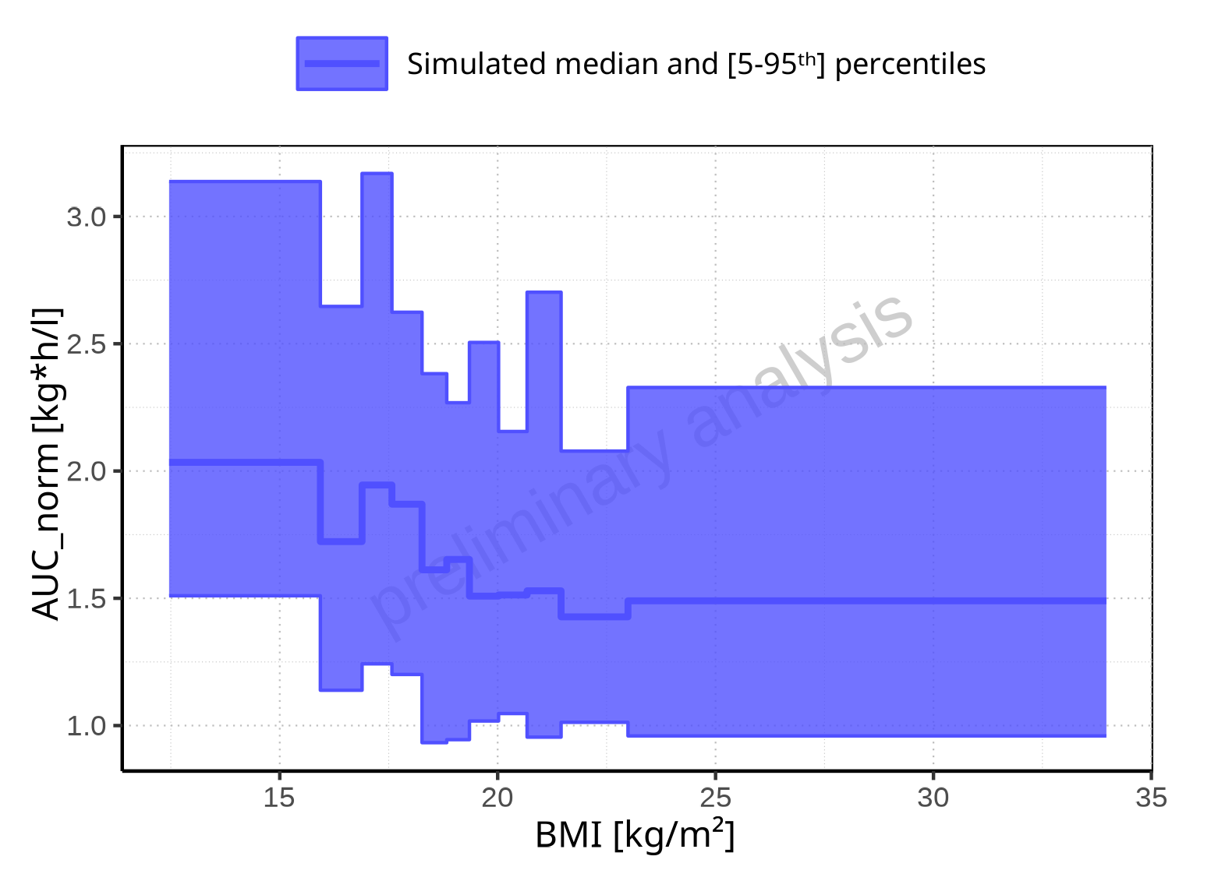

**Figure 2-164: BMI-dependence of AUC_norm for Larson 2013 8y-18y 400mg FCT meal. Profiles are plotted in a linear scale.**

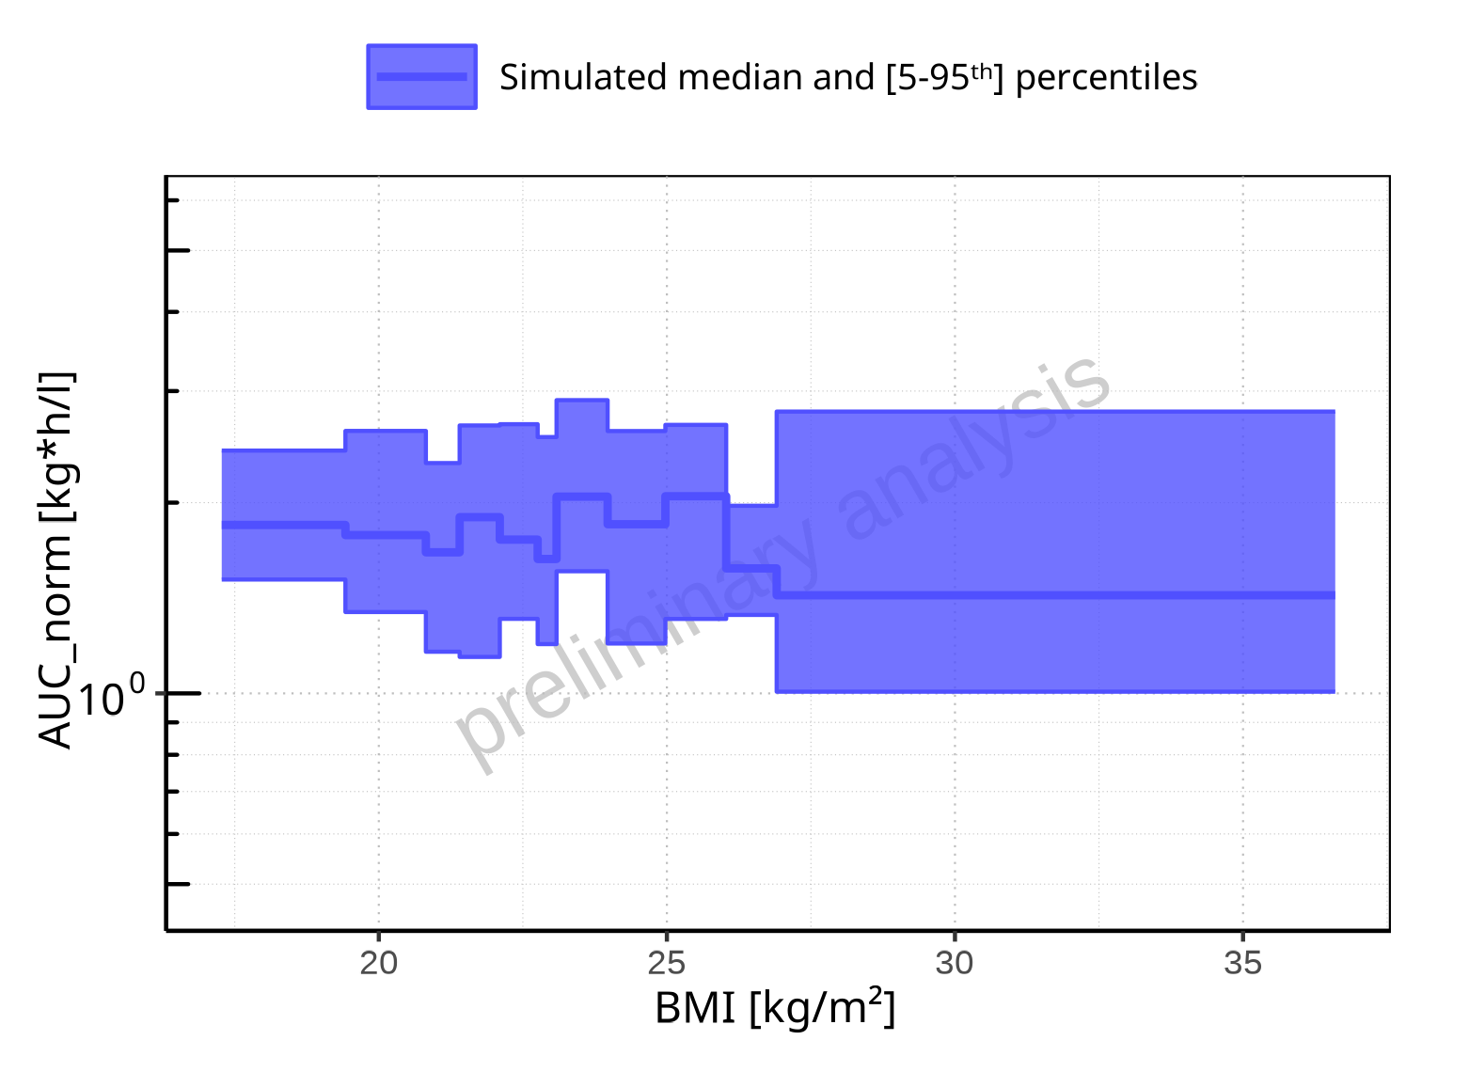

**Figure 2-165: BMI-dependence of AUC_norm for Filmcoated_tablet_400mg_sd. Profiles are plotted in a logarithmic scale.**

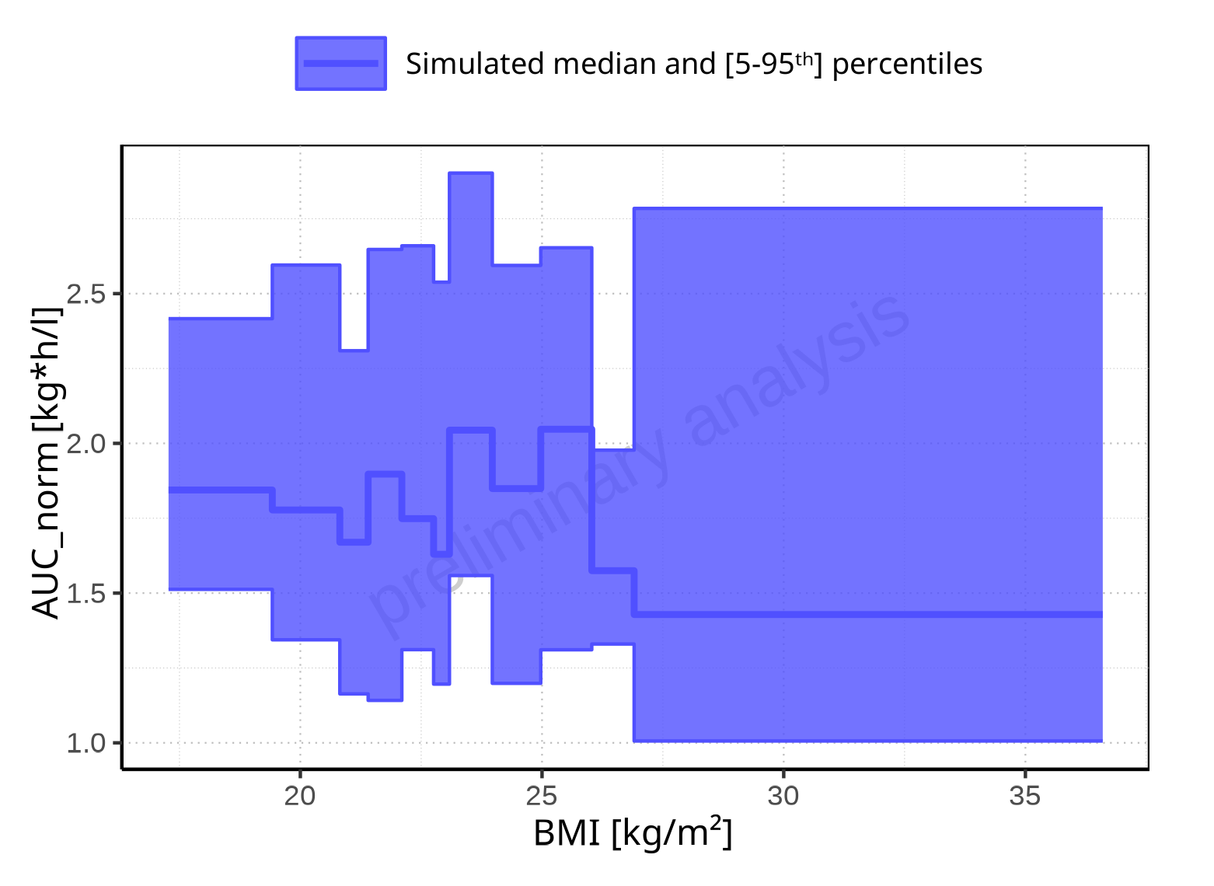

**Figure 2-166: BMI-dependence of AUC_norm for Filmcoated_tablet_400mg_sd. Profiles are plotted in a linear scale.**

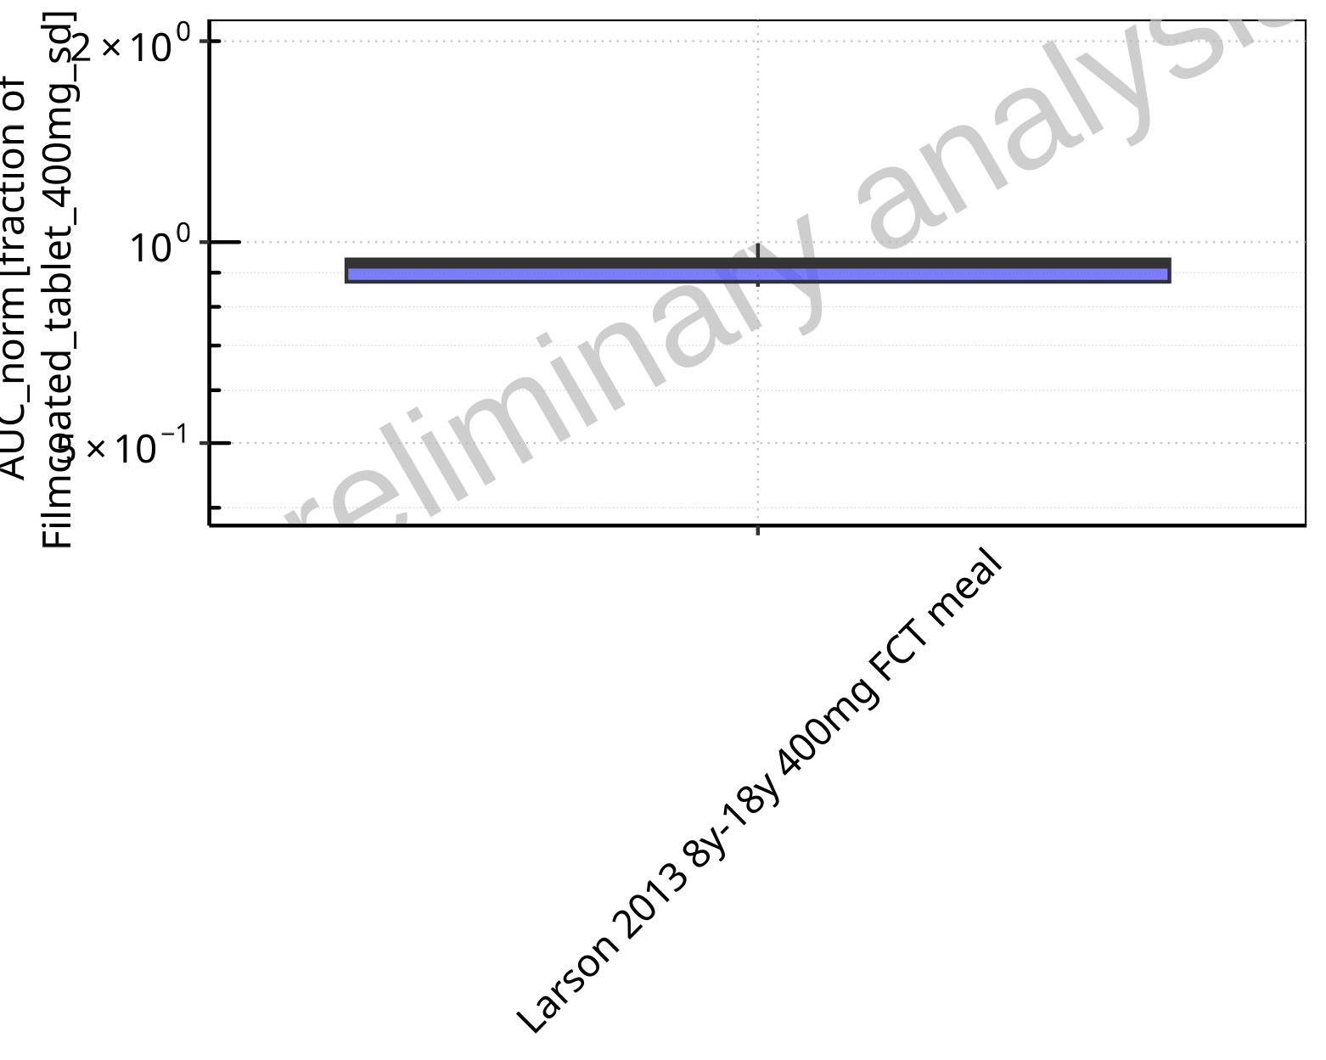

**Figure 2-167: Ratio of population summary statistics of AUC_norm of Raltegravir for Larson 2013 8y-18y 400mg FCT meal in comparison to Filmcoated_tablet_400mg_sd shown as box-whisker plot, which indicates ratios of the 5th, 25th, 50th, 75th, 95th percentiles in logarithmic scale.**

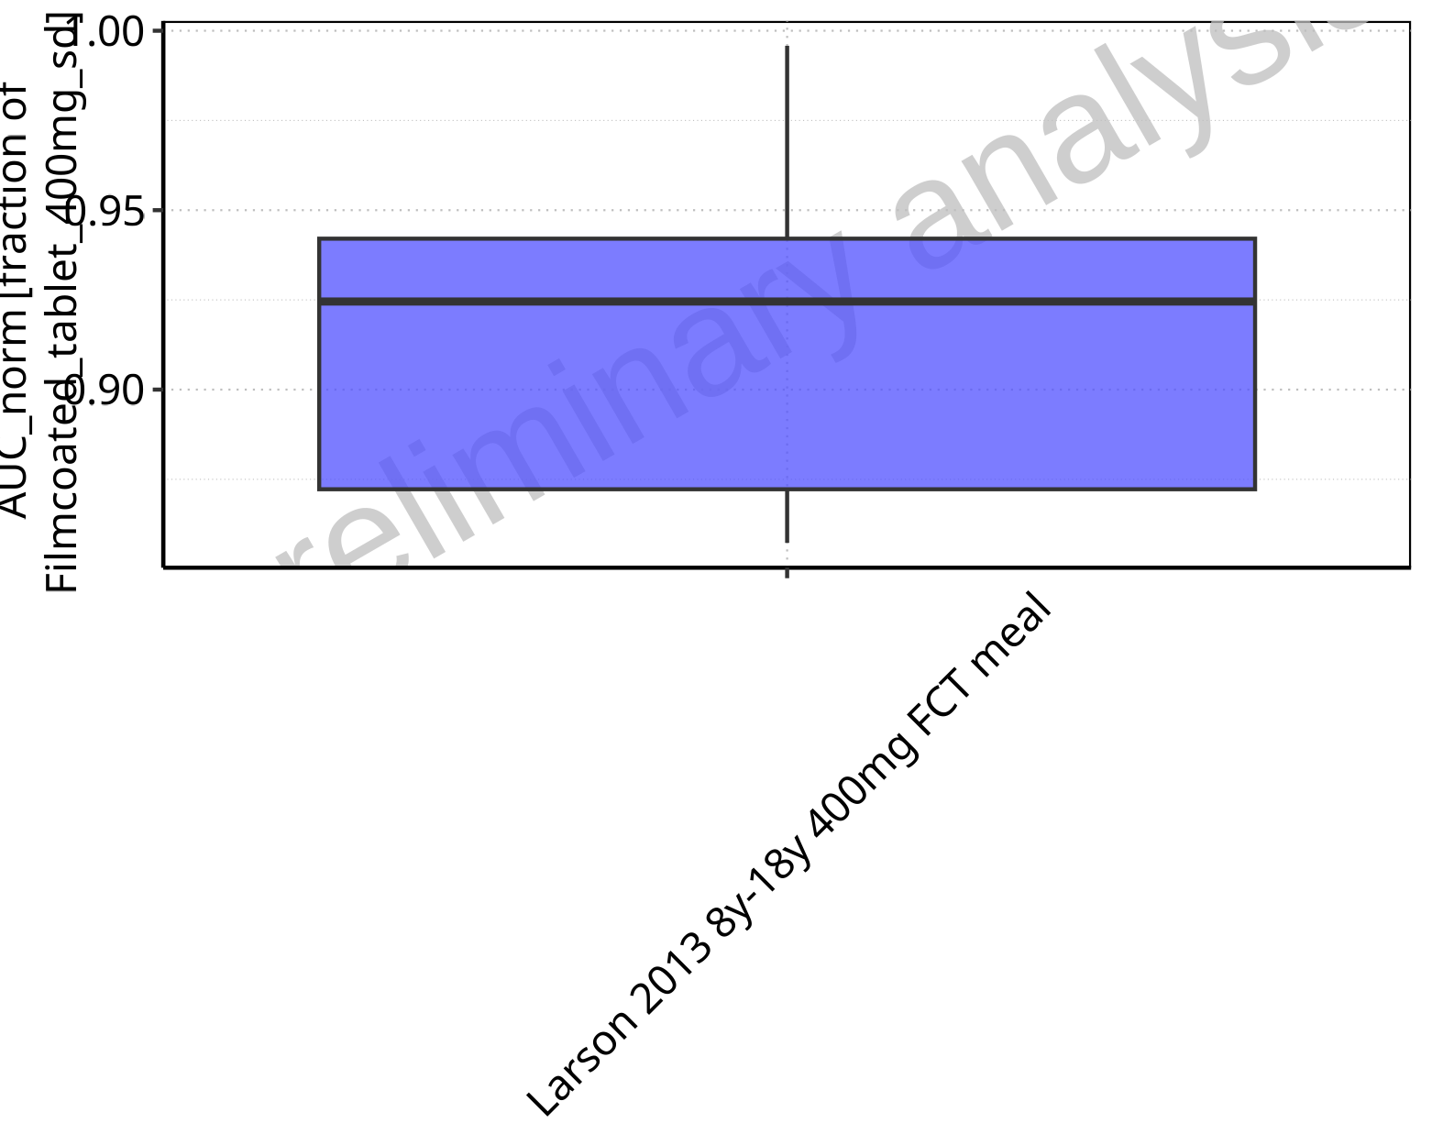

**Figure 2-168: Ratio of population summary statistics of AUC_norm of Raltegravir for Larson 2013 8y-18y 400mg FCT meal in comparison to Filmcoated_tablet_400mg_sd shown as box-whisker plot, which indicates ratios of the 5th, 25th, 50th, 75th, 95th percentiles in linear scale.**

**Table 2-12: Ratio of population summary statistics of AUC_norm of Raltegravir for Larson 2013 8y-18y 400mg FCT meal in comparison to Filmcoated_tablet_400mg_sd**

| Population | N | 5th pctl | 25th pctl | 50th pctl | 75th pctl | 95th pctl | Mean | SD | Geo Mean | Geo SD |
| --- | --- | --- | --- | --- | --- | --- | --- | --- | --- | --- |
| Larson 2013 8y-18y 400mg FCT meal | 500 | 0.86 | 0.87 | 0.92 | 0.94 | 1.00 | 0.92 | 1.08 | 0.91 | 1.04 |

### AUC_inf

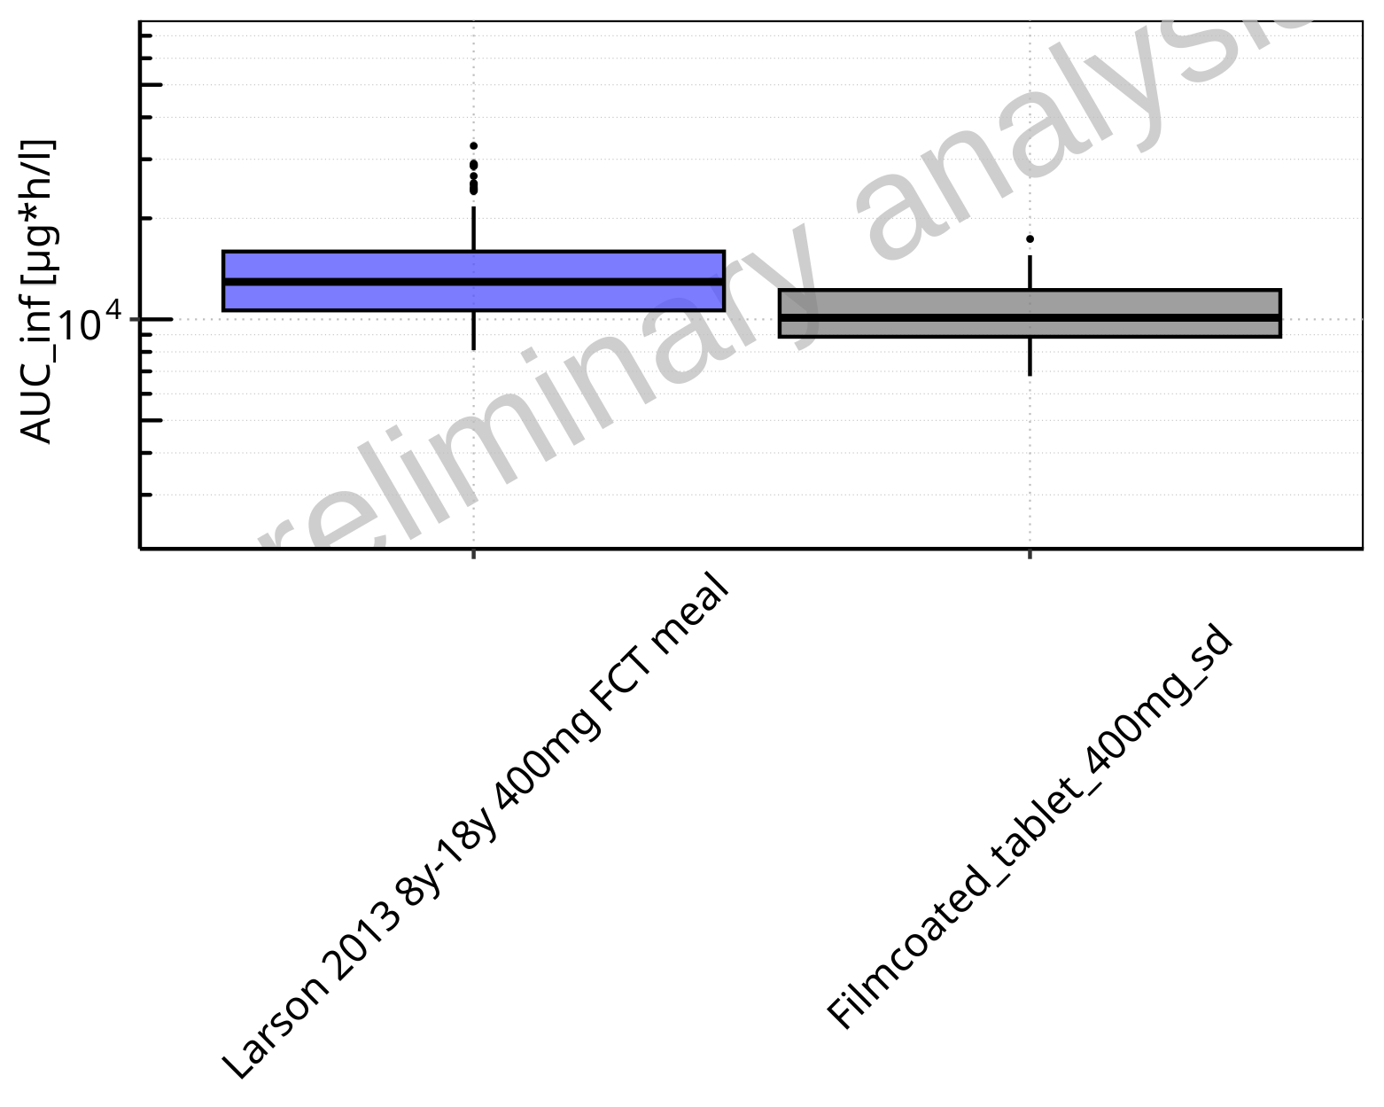

**Figure 2-169: AUC_inf of Raltegravir for Larson 2013 8y-18y 400mg FCT meal, Filmcoated_tablet_400mg_sd shown as box-whisker plot, which indicates the 5th, 25th, 50th, 75th, 95th percentiles in logarithmic scale.**

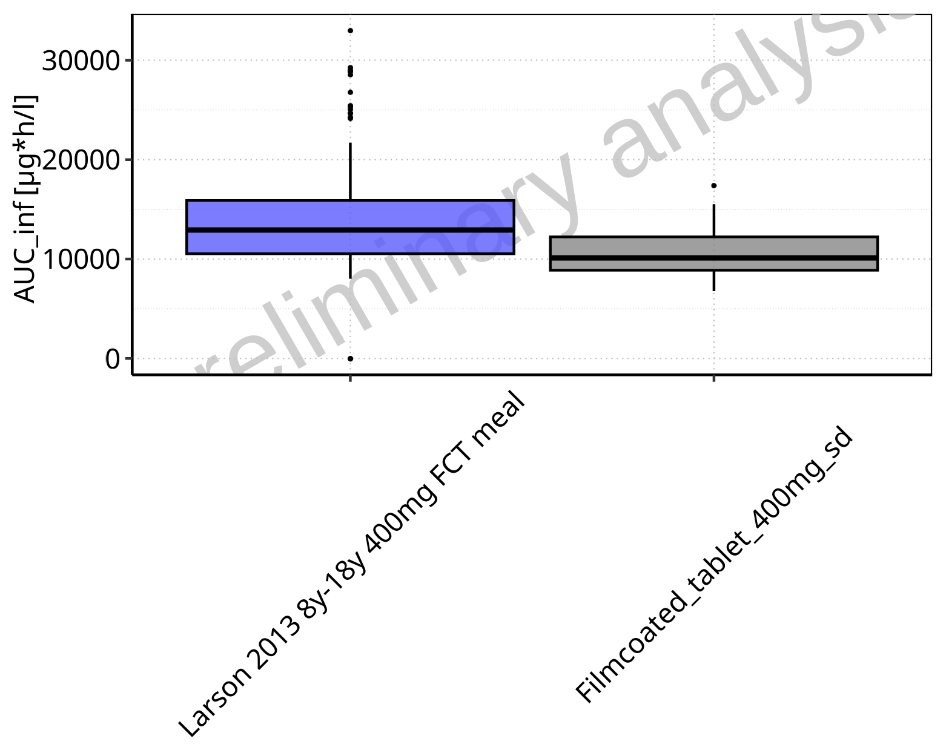

**Figure 2-170: AUC_inf of Raltegravir for Larson 2013 8y-18y 400mg FCT meal, Filmcoated_tablet_400mg_sd shown as box-whisker plot, which indicates the 5th, 25th, 50th, 75th, 95th percentiles in linear scale.**

**Table 2-13: Population statistics summarizing AUC_inf of Raltegravir for Larson 2013 8y-18y 400mg FCT meal, Filmcoated_tablet_400mg_sd reported in [µg*h/l]**

| Population | N | 5th pctl | 25th pctl | 50th pctl | 75th pctl | 95th pctl | Mean | SD | Geo Mean | Geo SD |
| --- | --- | --- | --- | --- | --- | --- | --- | --- | --- | --- |
| Larson 2013 8y-18y 400mg FCT meal | 500 | 8017.56 | 10533.54 | 12921.05 | 15892.61 | 21707.95 | 13652.19 | 4460.23 | 0.00 | - |
| Filmcoated_tablet_400mg_sd | 100 | 6771.99 | 8875.70 | 10112.32 | 12229.14 | 15523.15 | 10626.71 | 2757.61 | 10275.45 | 1.30 |

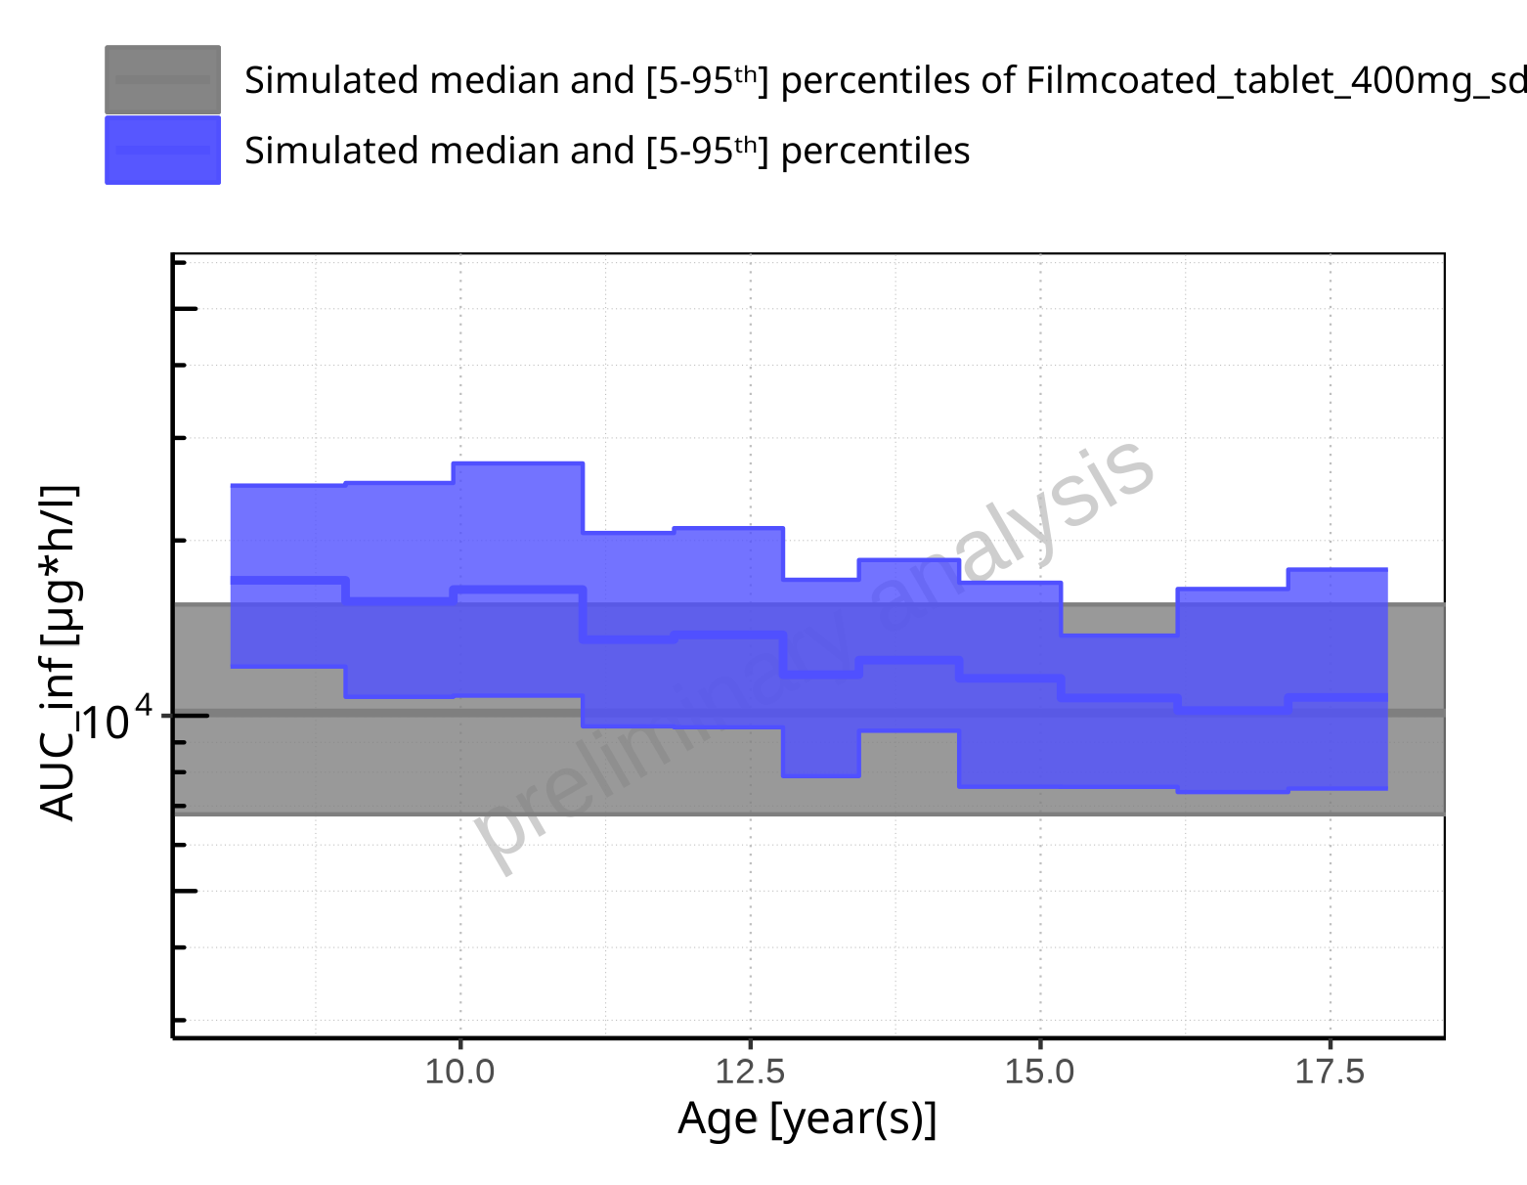

**Figure 2-171: Age-dependence of AUC_inf for Larson 2013 8y-18y 400mg FCT meal in comparison to Filmcoated_tablet_400mg_sd. Profiles are plotted in a logarithmic scale.**

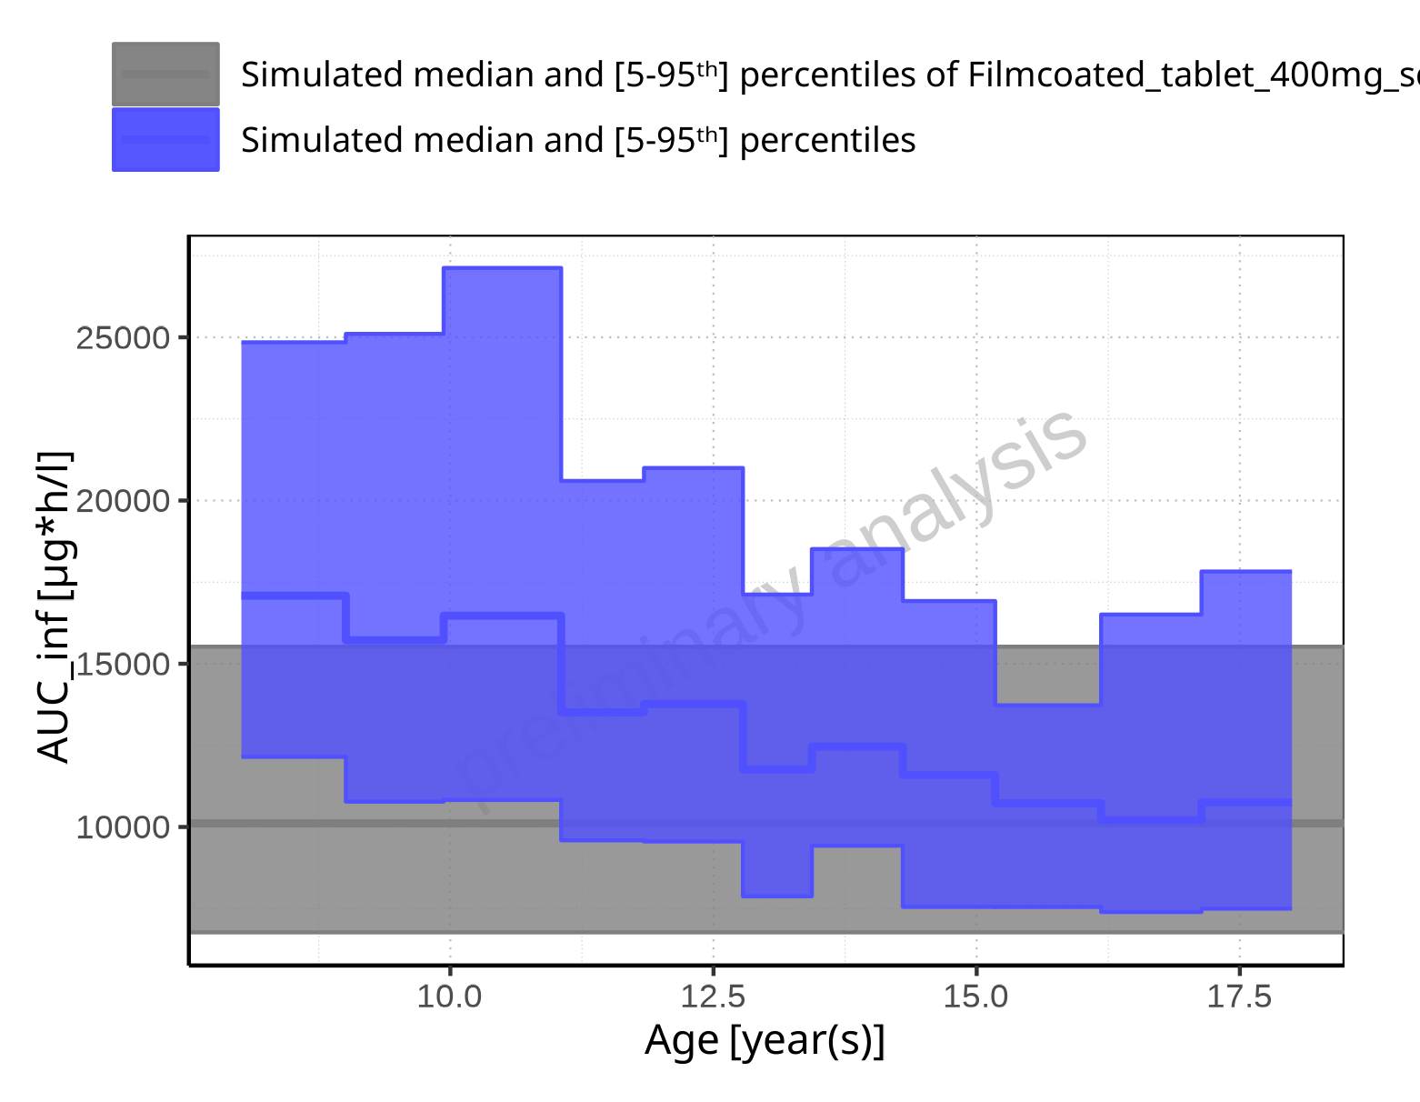

**Figure 2-172: Age-dependence of AUC_inf for Larson 2013 8y-18y 400mg FCT meal in comparison to Filmcoated_tablet_400mg_sd. Profiles are plotted in a linear scale.**

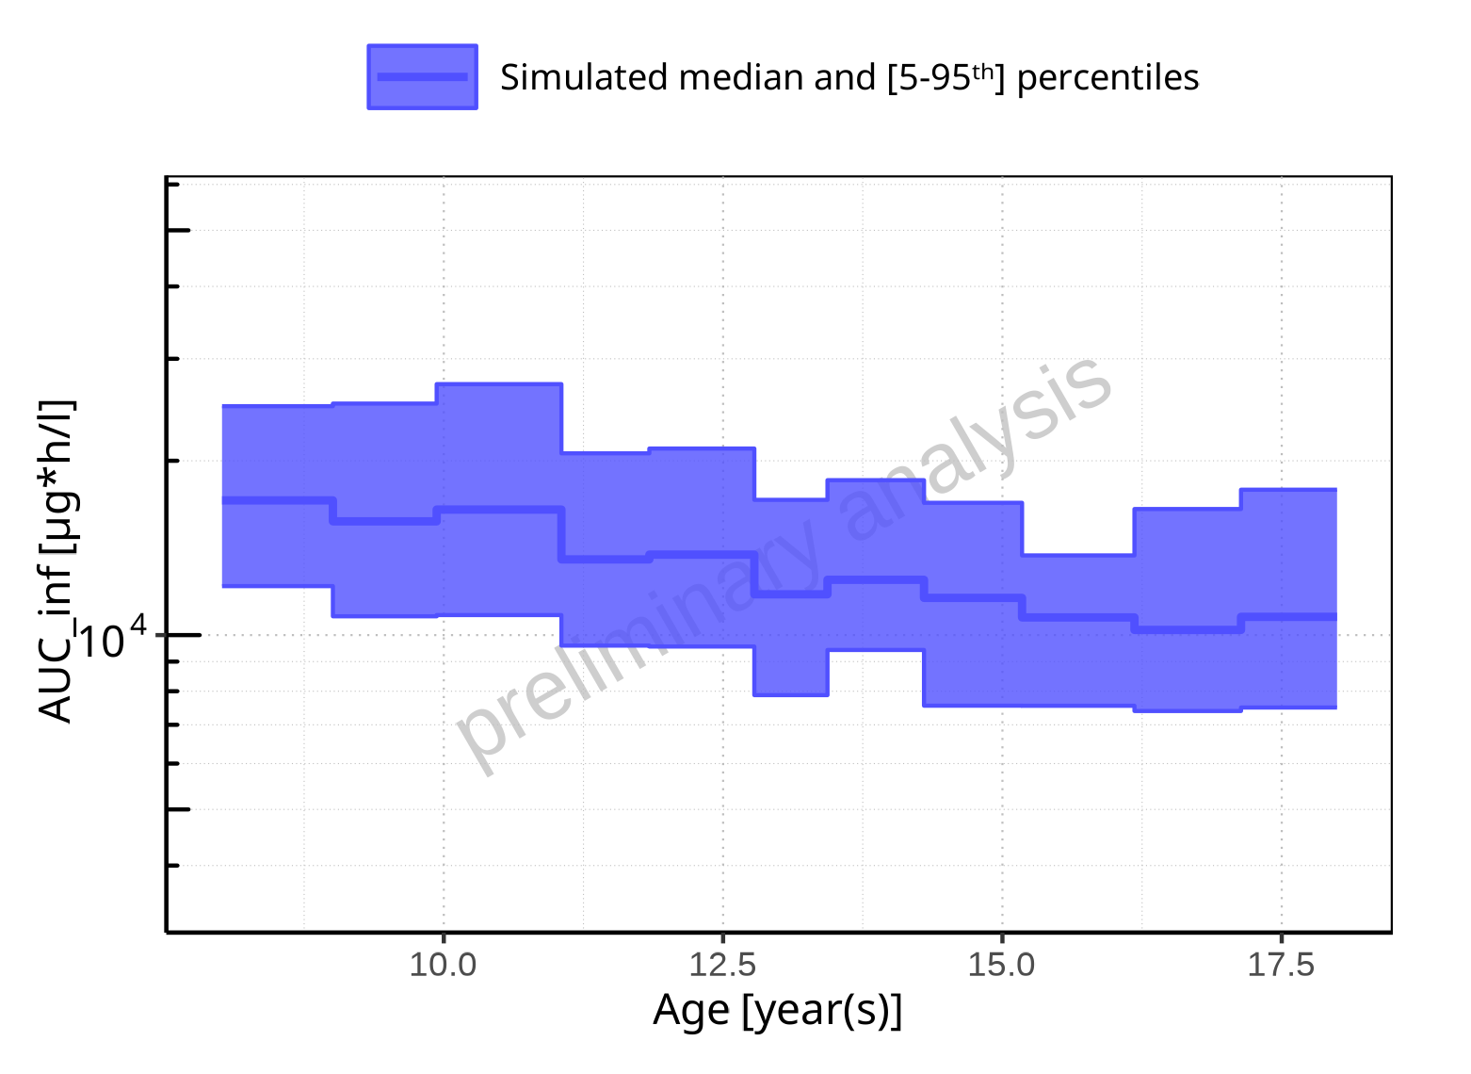

**Figure 2-173: Age-dependence of AUC_inf for Larson 2013 8y-18y 400mg FCT meal. Profiles are plotted in a logarithmic scale.**

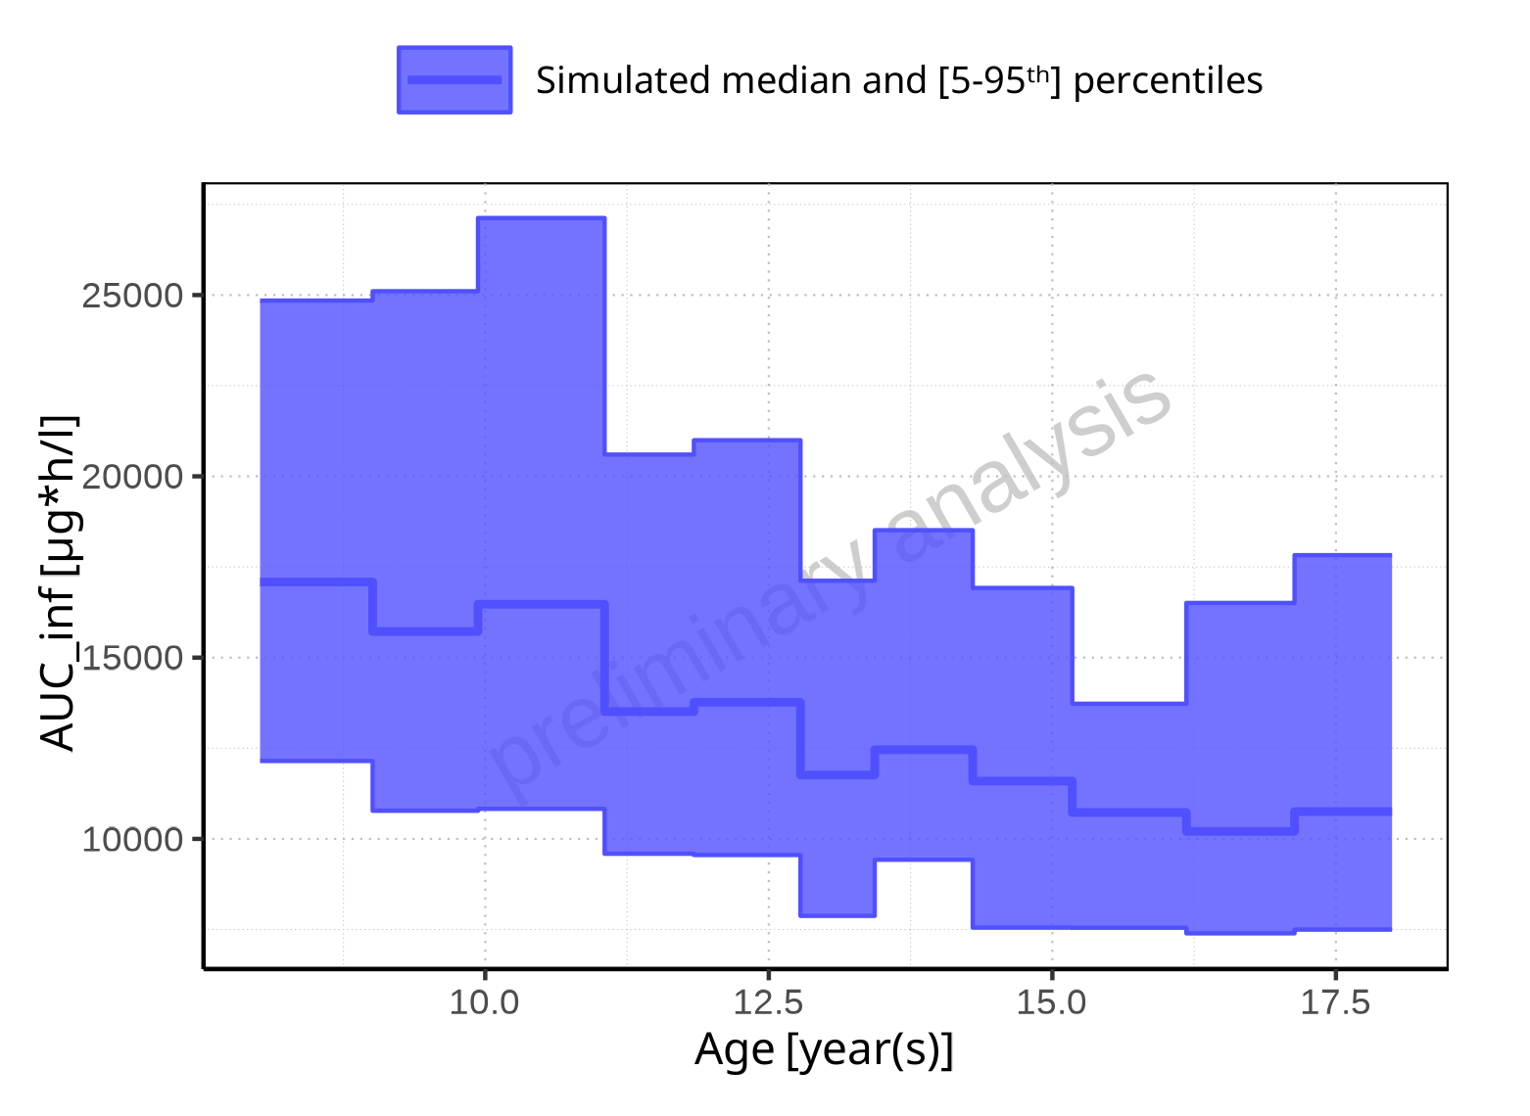

**Figure 2-174: Age-dependence of AUC_inf for Larson 2013 8y-18y 400mg FCT meal. Profiles are plotted in a linear scale.**

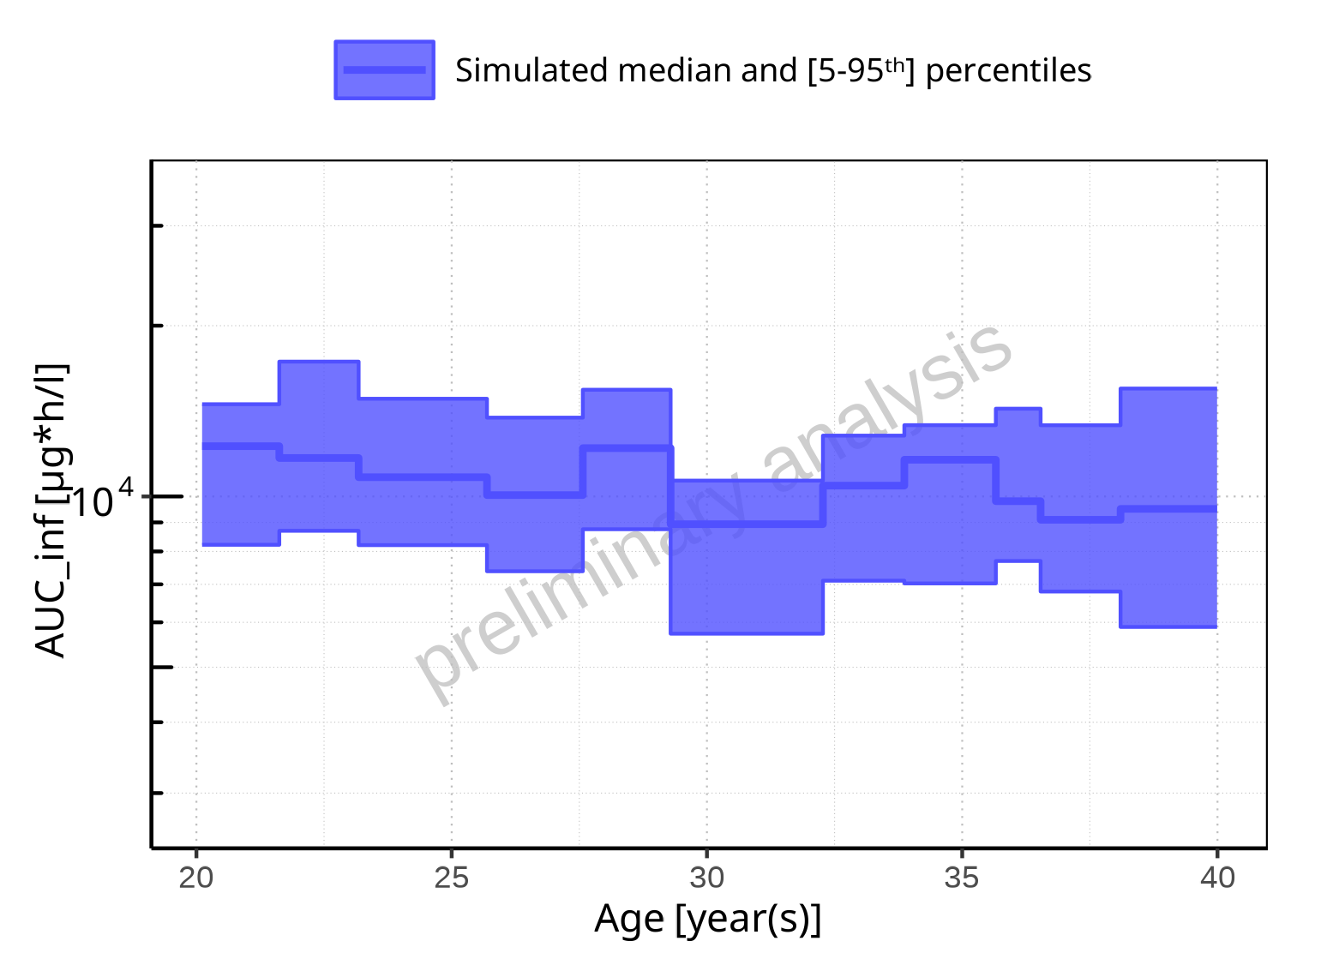

**Figure 2-175: Age-dependence of AUC_inf for Filmcoated_tablet_400mg_sd. Profiles are plotted in a logarithmic scale.**

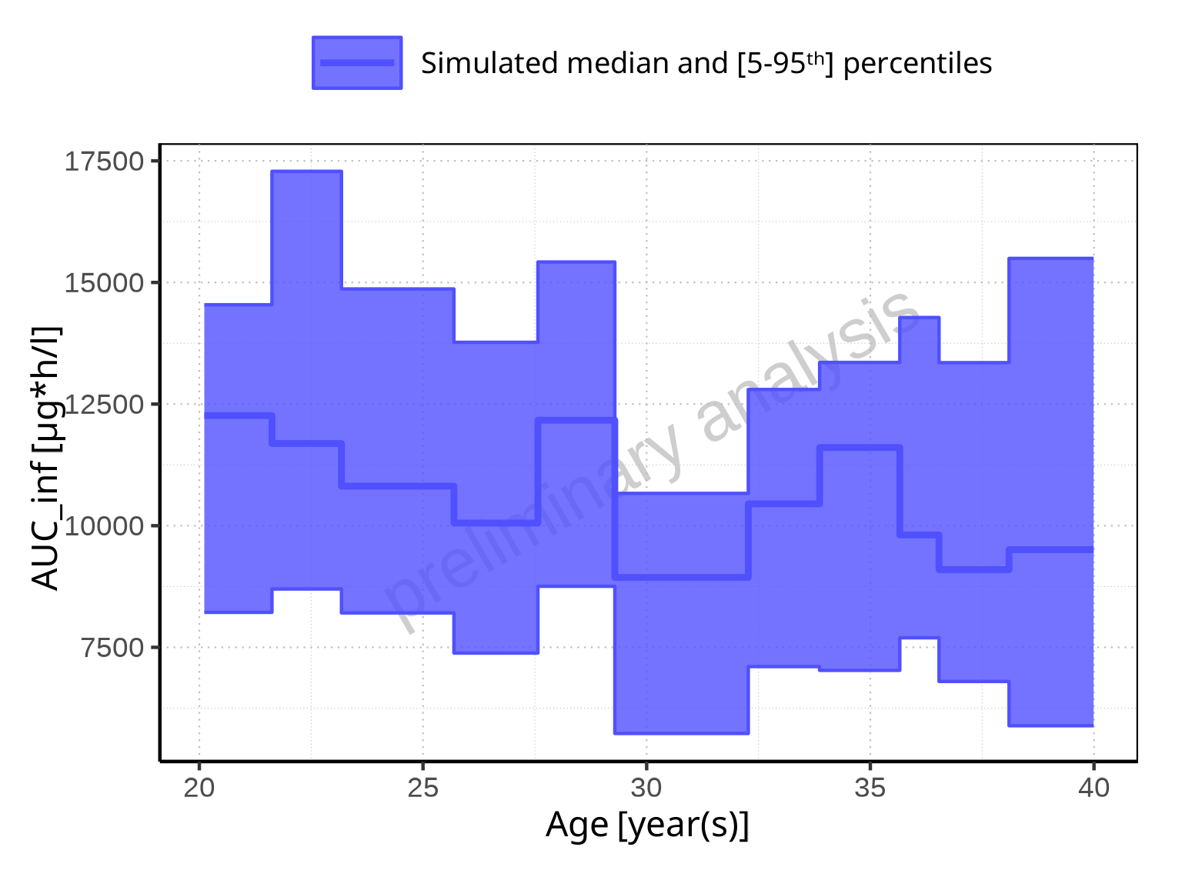

**Figure 2-176: Age-dependence of AUC_inf for Filmcoated_tablet_400mg_sd. Profiles are plotted in a linear scale.**

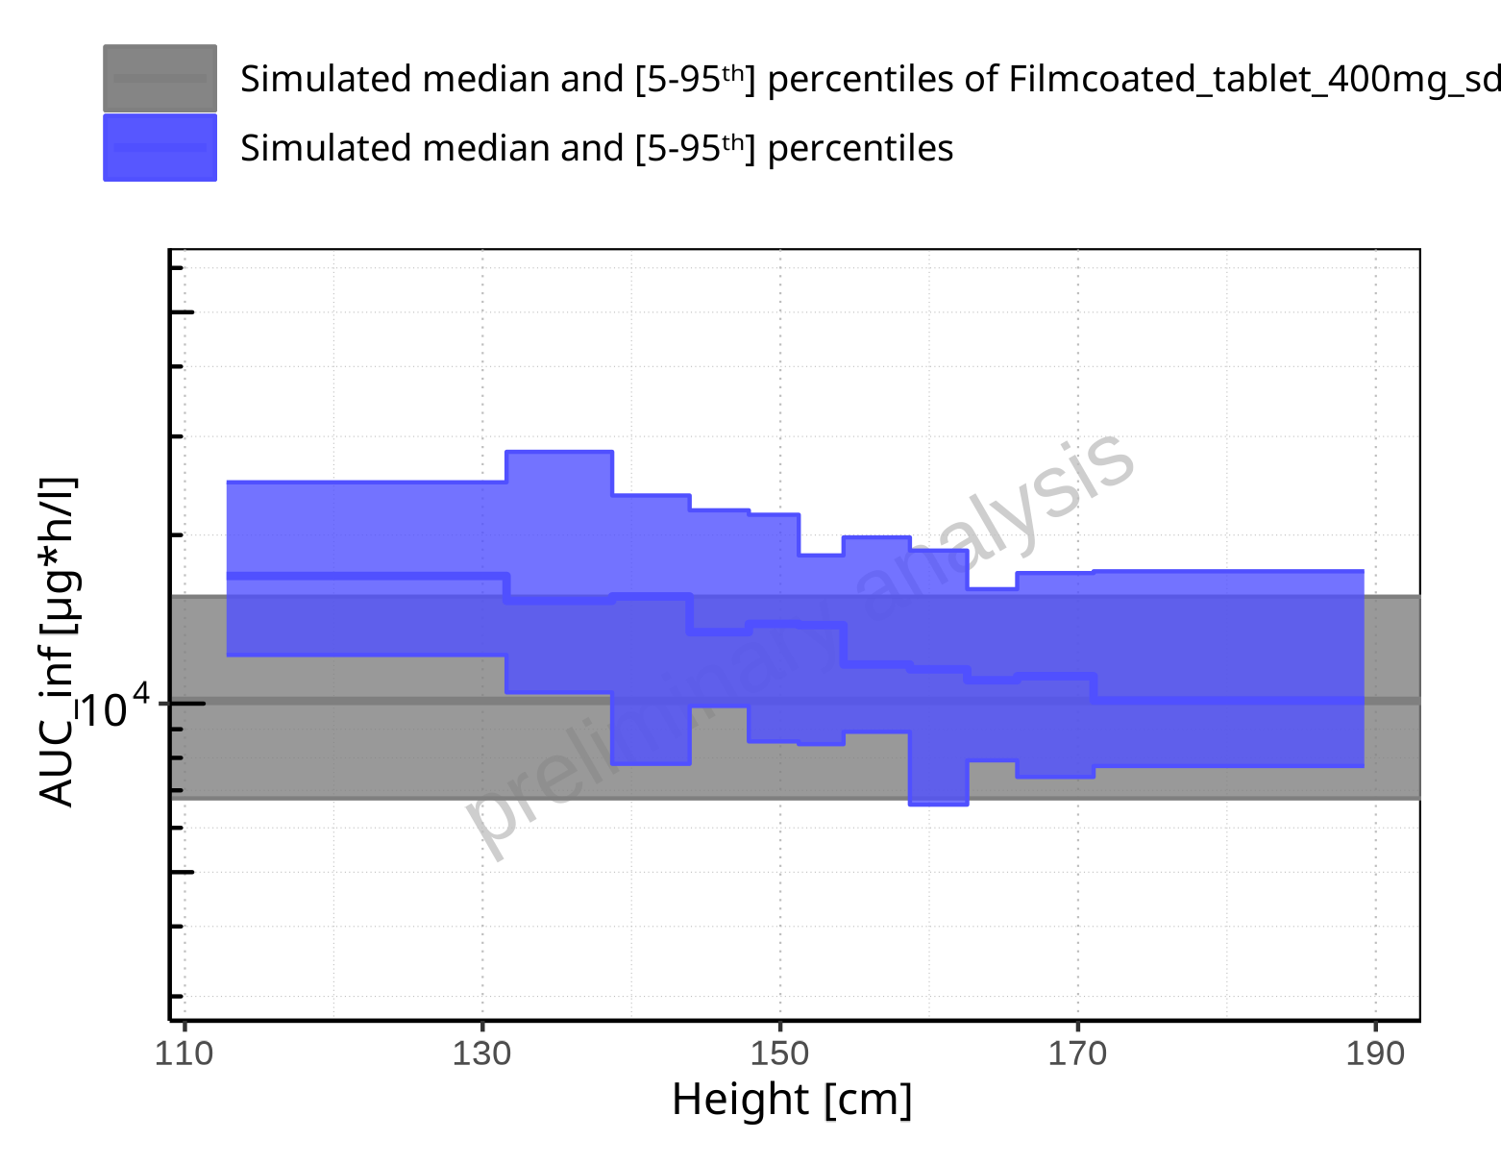

**Figure 2-177: Height-dependence of AUC_inf for Larson 2013 8y-18y 400mg FCT meal in comparison to Filmcoated_tablet_400mg_sd. Profiles are plotted in a logarithmic scale.**

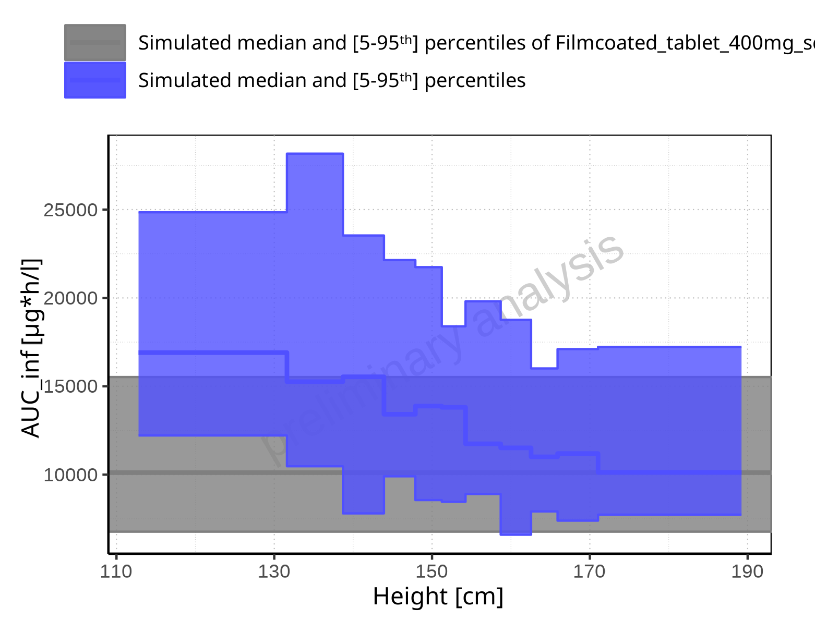

**Figure 2-178: Height-dependence of AUC_inf for Larson 2013 8y-18y 400mg FCT meal in comparison to Filmcoated_tablet_400mg_sd. Profiles are plotted in a linear scale.**

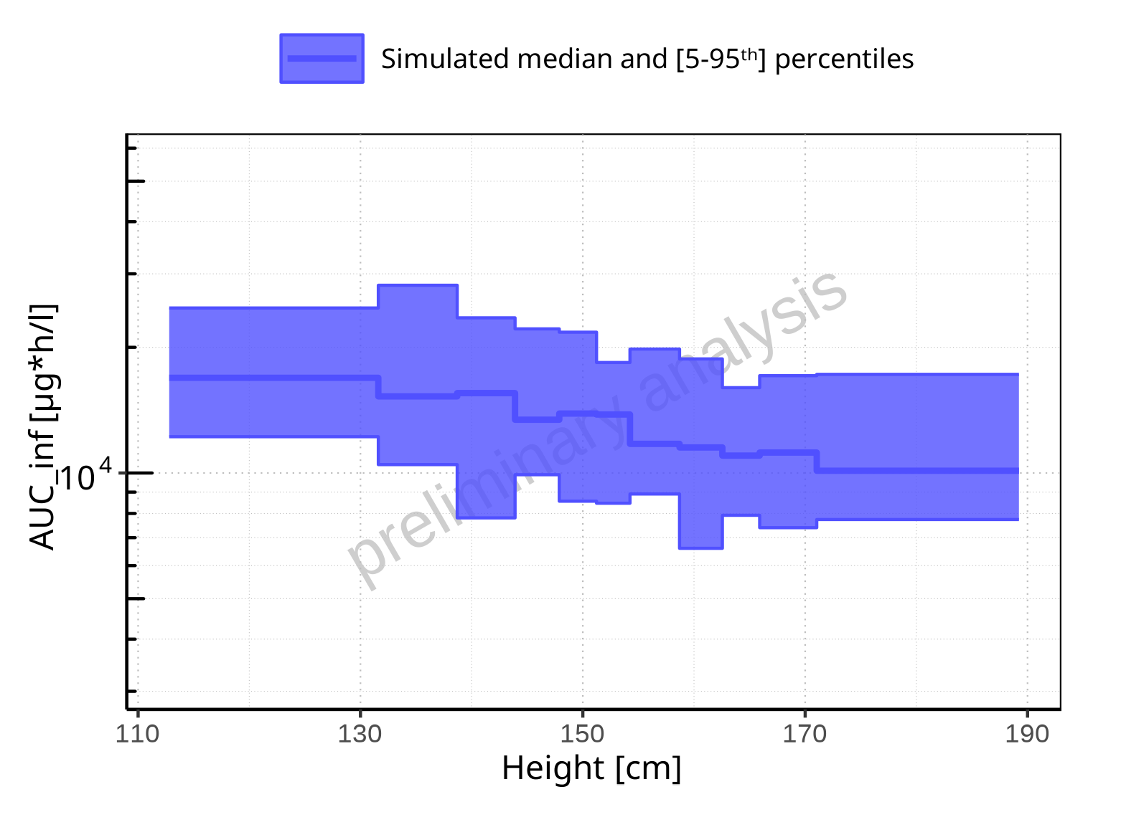

**Figure 2-179: Height-dependence of AUC_inf for Larson 2013 8y-18y 400mg FCT meal. Profiles are plotted in a logarithmic scale.**

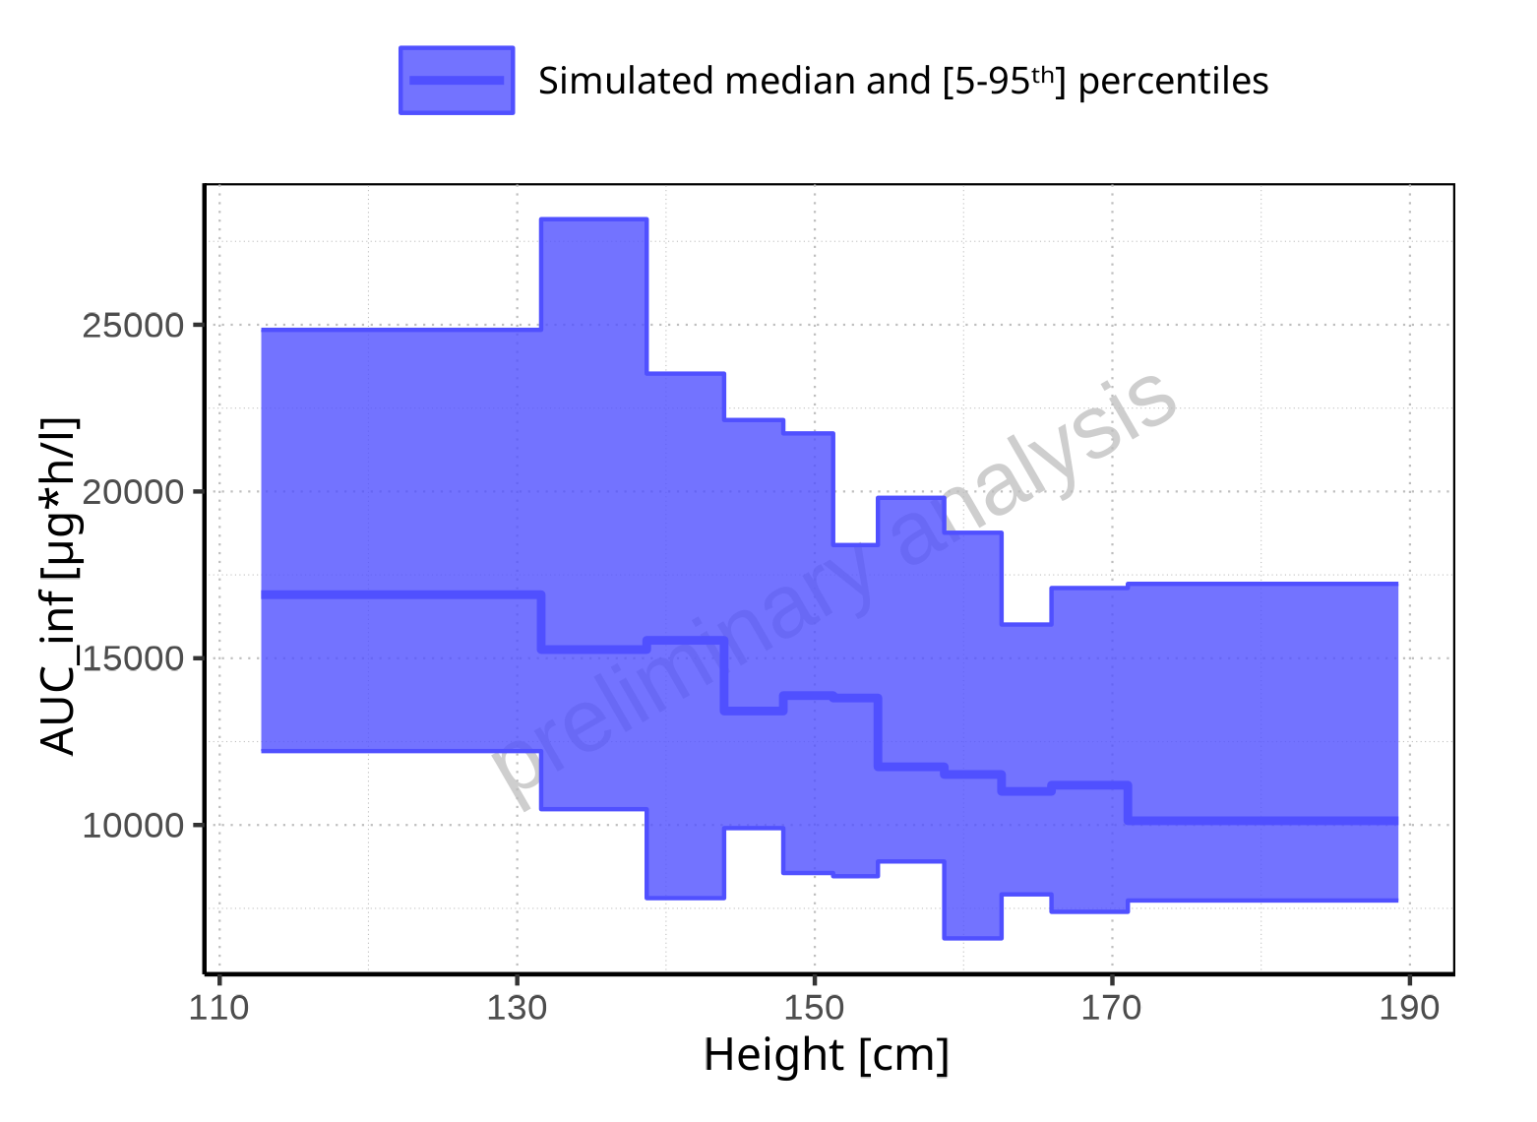

**Figure 2-180: Height-dependence of AUC_inf for Larson 2013 8y-18y 400mg FCT meal. Profiles are plotted in a linear scale.**

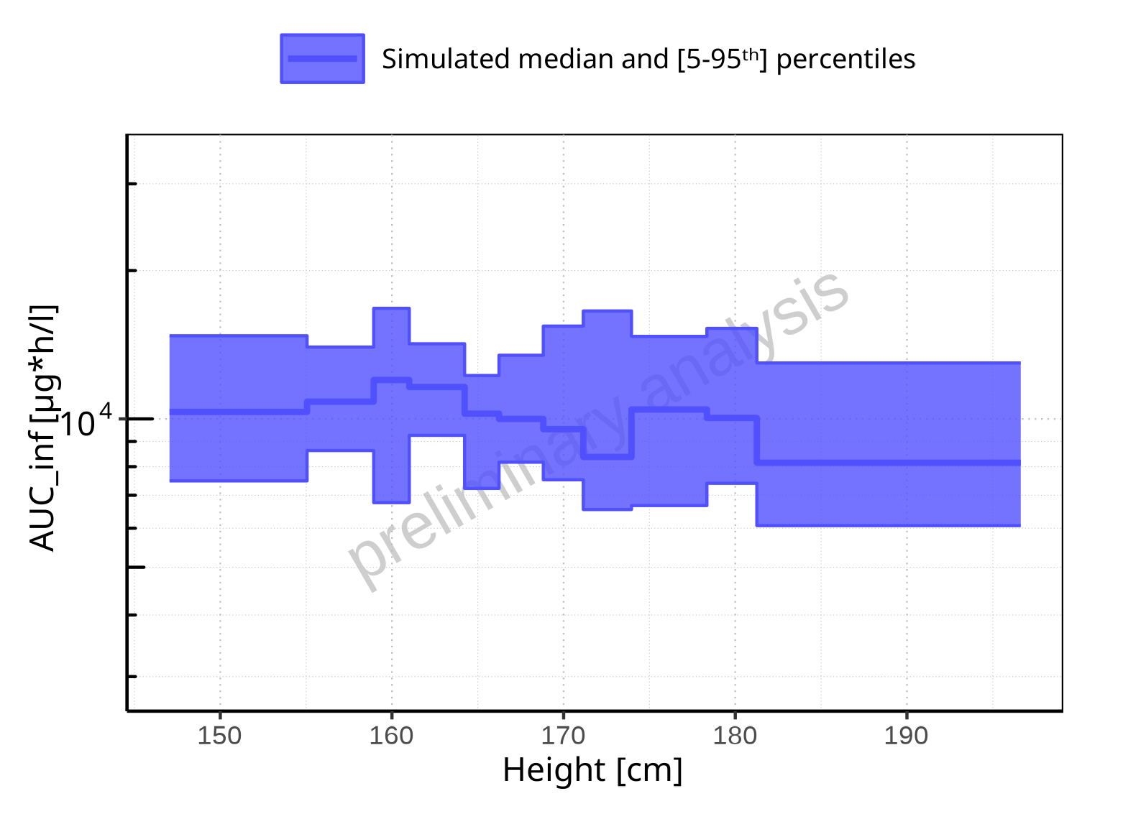

**Figure 2-181: Height-dependence of AUC_inf for Filmcoated_tablet_400mg_sd. Profiles are plotted in a logarithmic scale.**

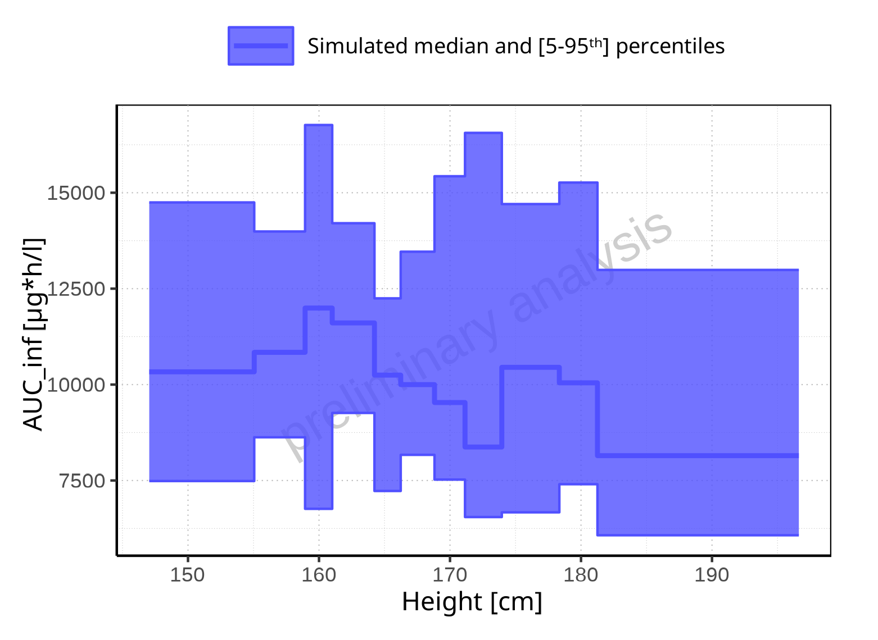

**Figure 2-182: Height-dependence of AUC_inf for Filmcoated_tablet_400mg_sd. Profiles are plotted in a linear scale.**

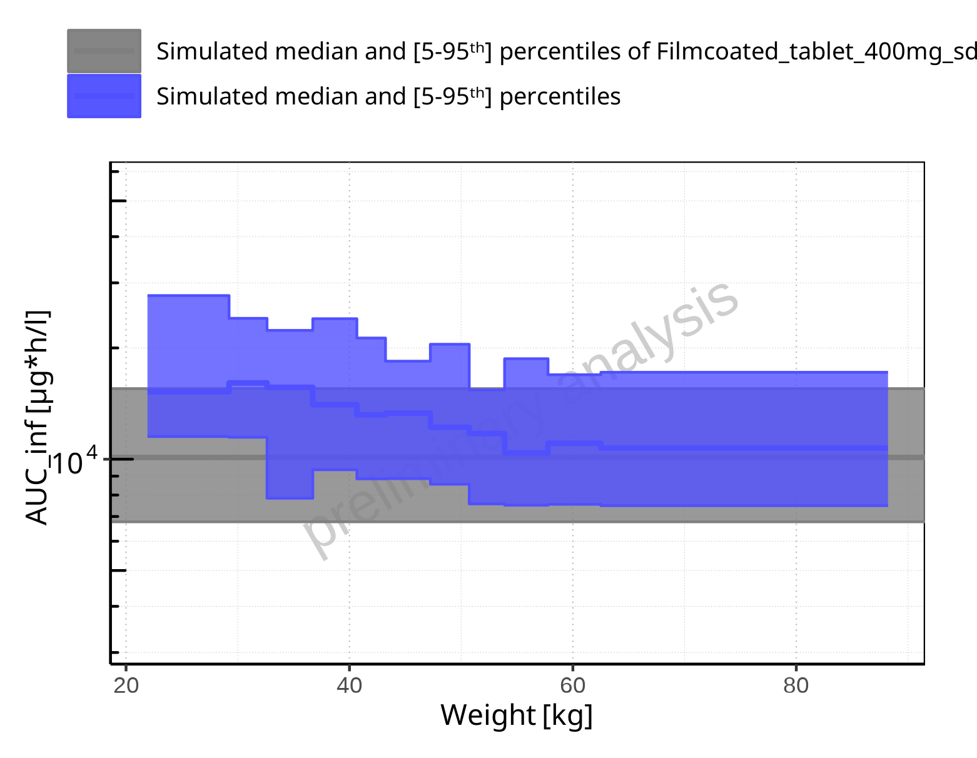

**Figure 2-183: Weight-dependence of AUC_inf for Larson 2013 8y-18y 400mg FCT meal in comparison to Filmcoated_tablet_400mg_sd. Profiles are plotted in a logarithmic scale.**

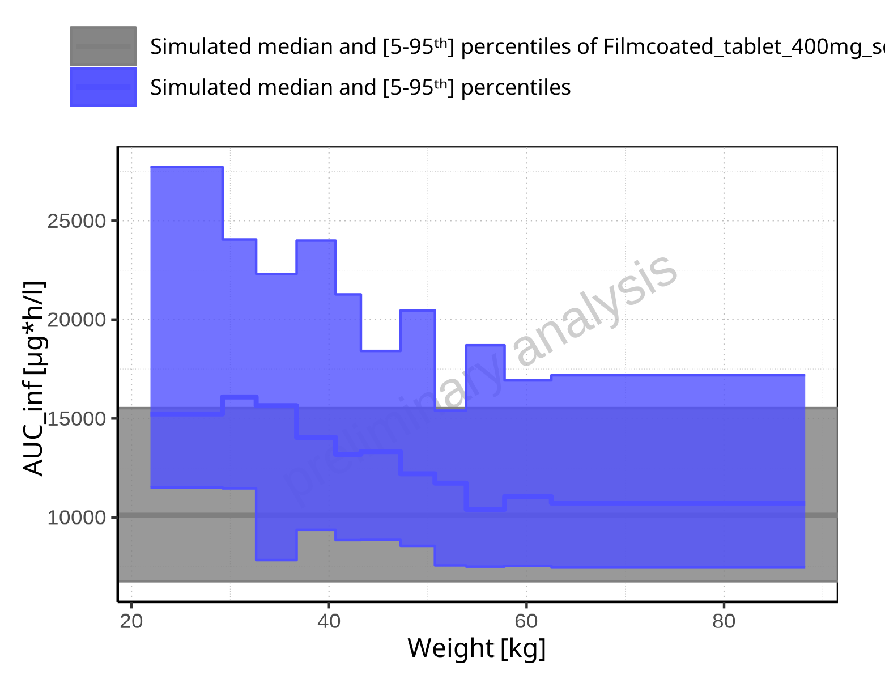

**Figure 2-184: Weight-dependence of AUC_inf for Larson 2013 8y-18y 400mg FCT meal in comparison to Filmcoated_tablet_400mg_sd. Profiles are plotted in a linear scale.**

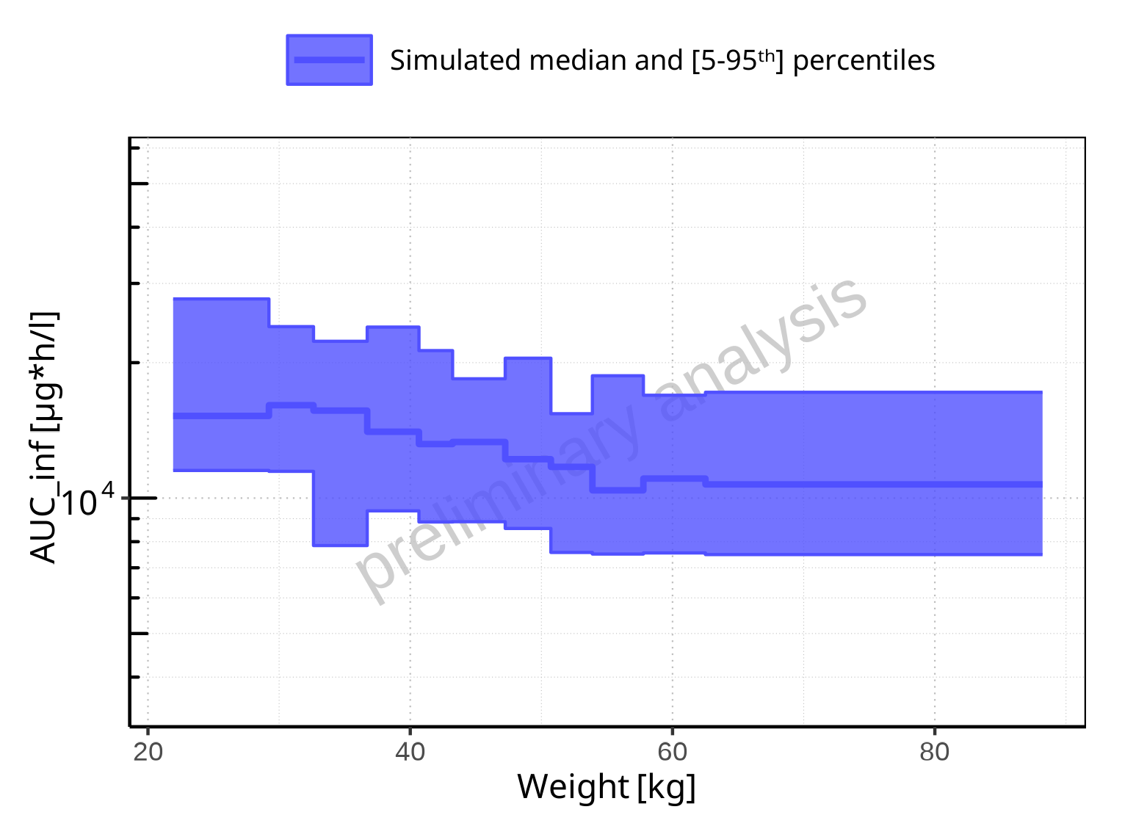

**Figure 2-185: Weight-dependence of AUC_inf for Larson 2013 8y-18y 400mg FCT meal. Profiles are plotted in a logarithmic scale.**

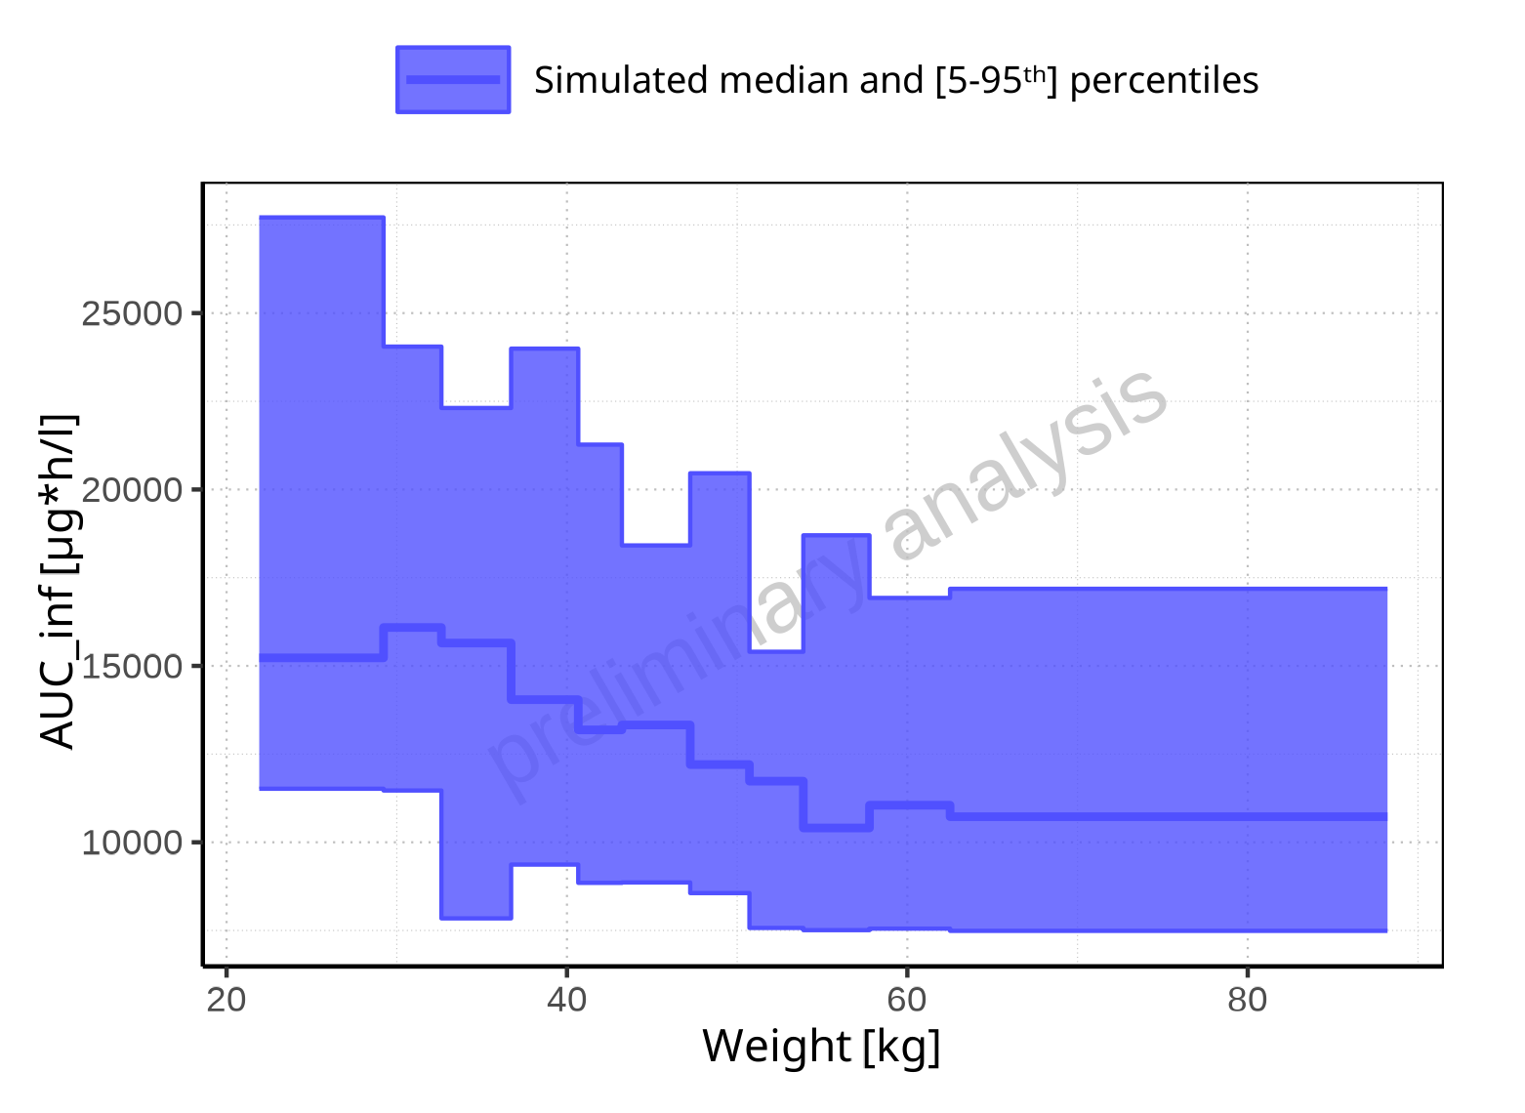

**Figure 2-186: Weight-dependence of AUC_inf for Larson 2013 8y-18y 400mg FCT meal. Profiles are plotted in a linear scale.**

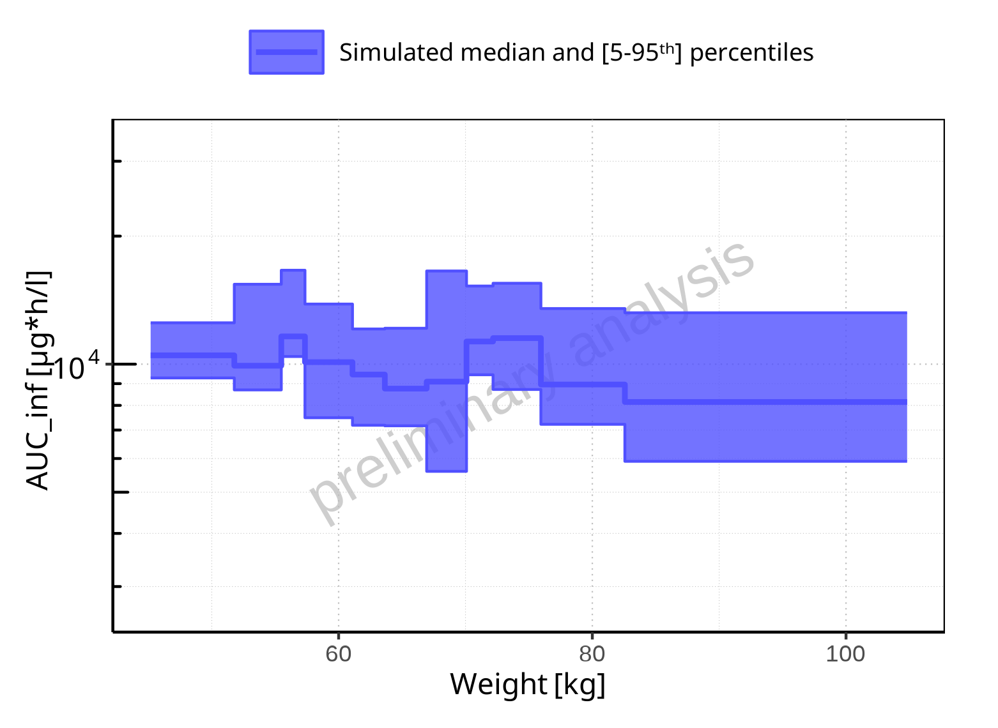

**Figure 2-187: Weight-dependence of AUC_inf for Filmcoated_tablet_400mg_sd. Profiles are plotted in a logarithmic scale.**

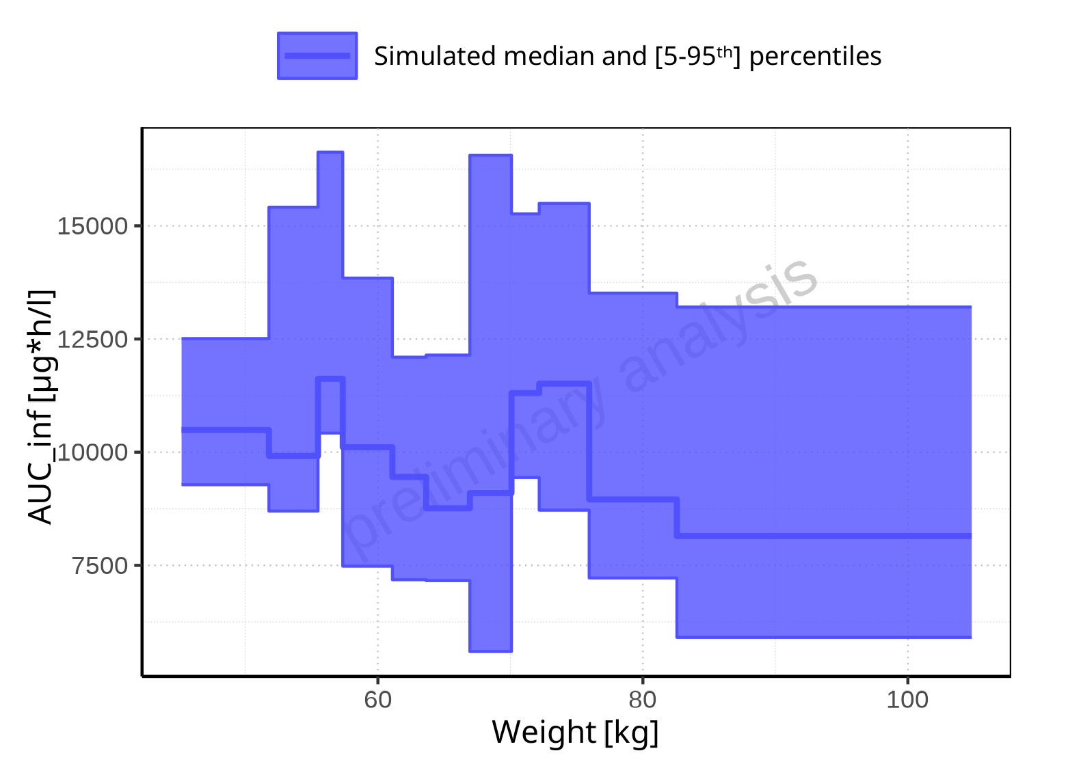

**Figure 2-188: Weight-dependence of AUC_inf for Filmcoated_tablet_400mg_sd. Profiles are plotted in a linear scale.**

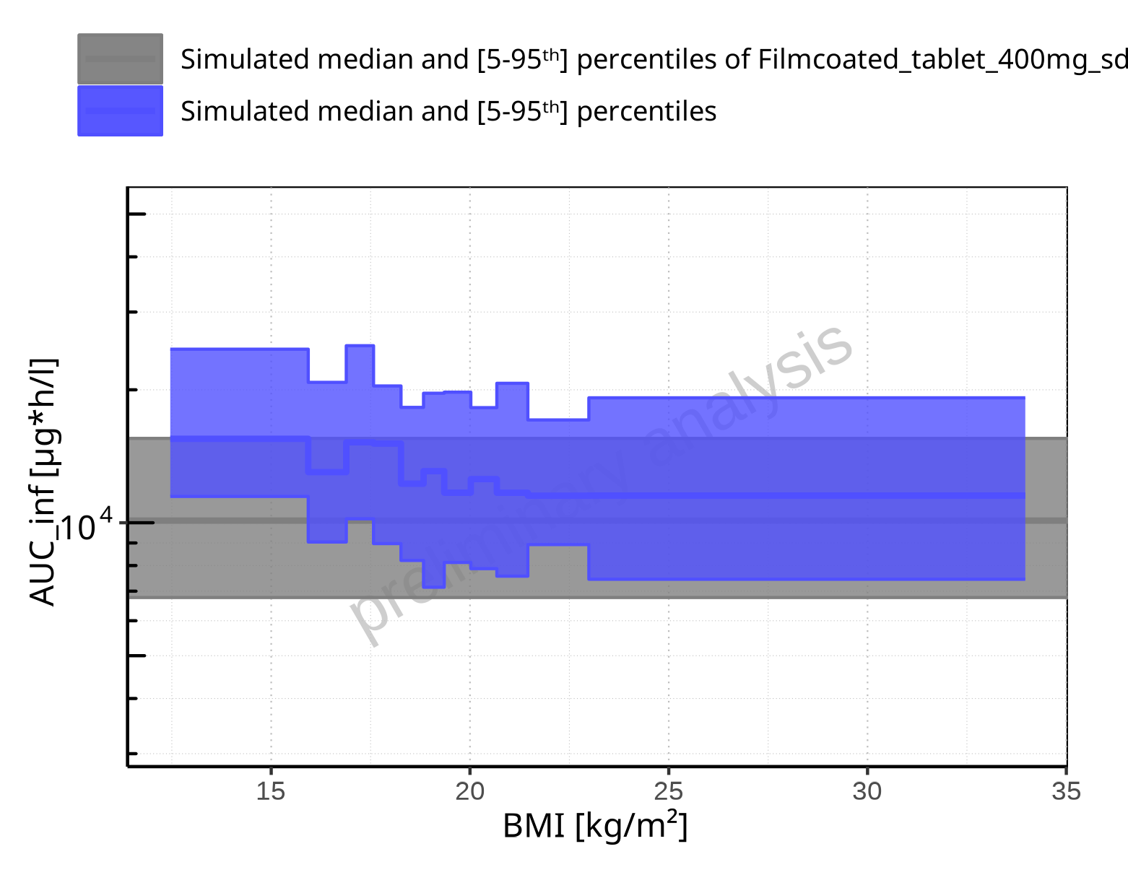

**Figure 2-189: BMI-dependence of AUC_inf for Larson 2013 8y-18y 400mg FCT meal in comparison to Filmcoated_tablet_400mg_sd. Profiles are plotted in a logarithmic scale.**

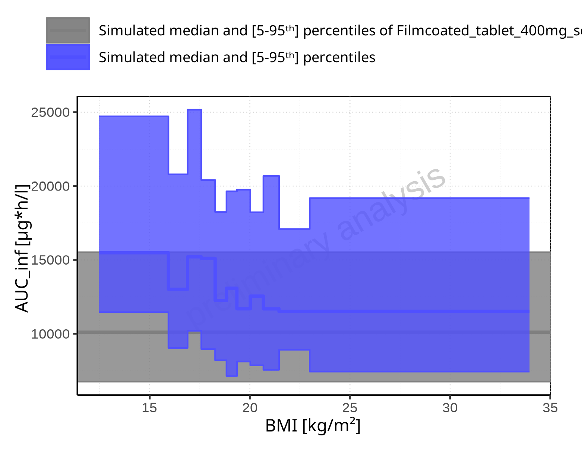

**Figure 2-190: BMI-dependence of AUC_inf for Larson 2013 8y-18y 400mg FCT meal in comparison to Filmcoated_tablet_400mg_sd. Profiles are plotted in a linear scale.**

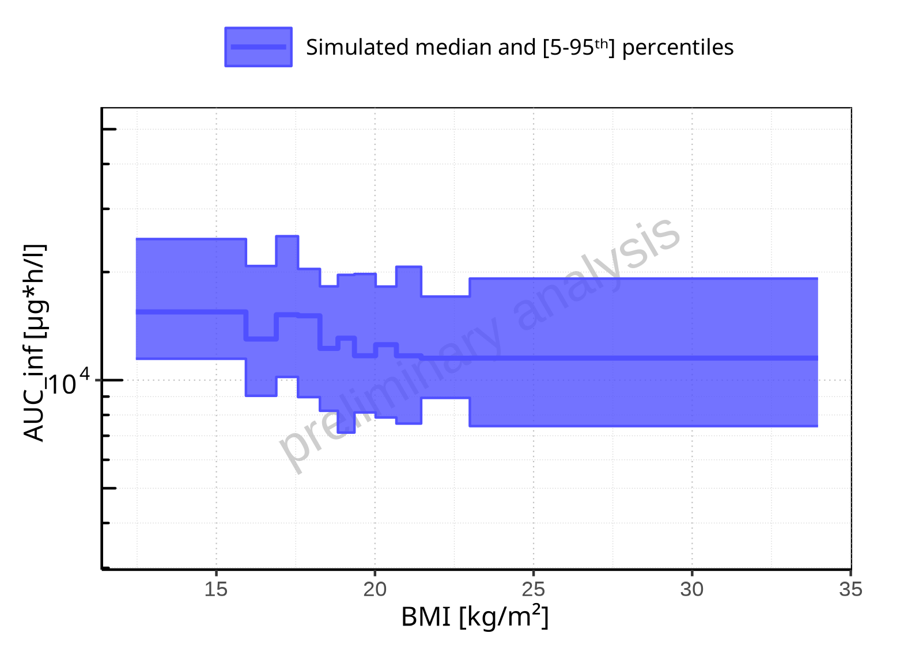

**Figure 2-191: BMI-dependence of AUC_inf for Larson 2013 8y-18y 400mg FCT meal. Profiles are plotted in a logarithmic scale.**

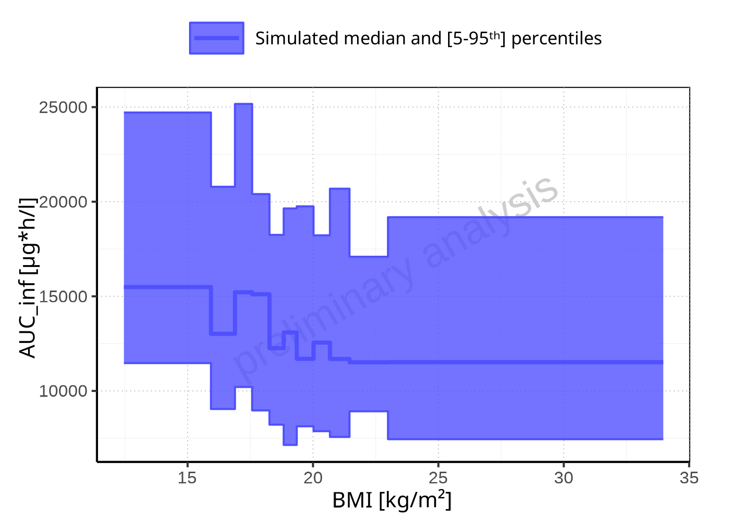

**Figure 2-192: BMI-dependence of AUC_inf for Larson 2013 8y-18y 400mg FCT meal. Profiles are plotted in a linear scale.**

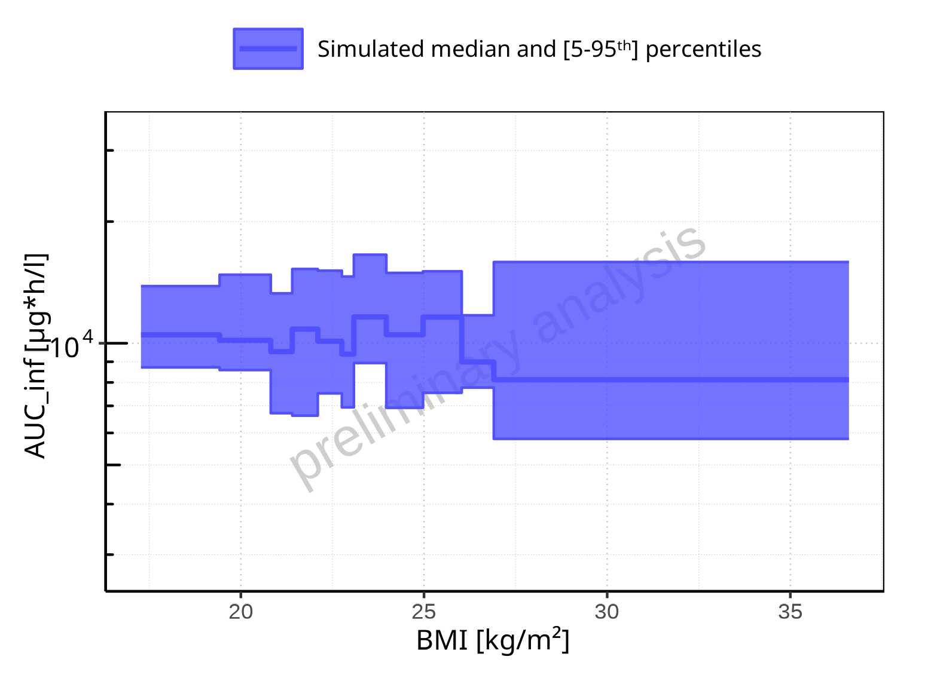

**Figure 2-193: BMI-dependence of AUC_inf for Filmcoated_tablet_400mg_sd. Profiles are plotted in a logarithmic scale.**

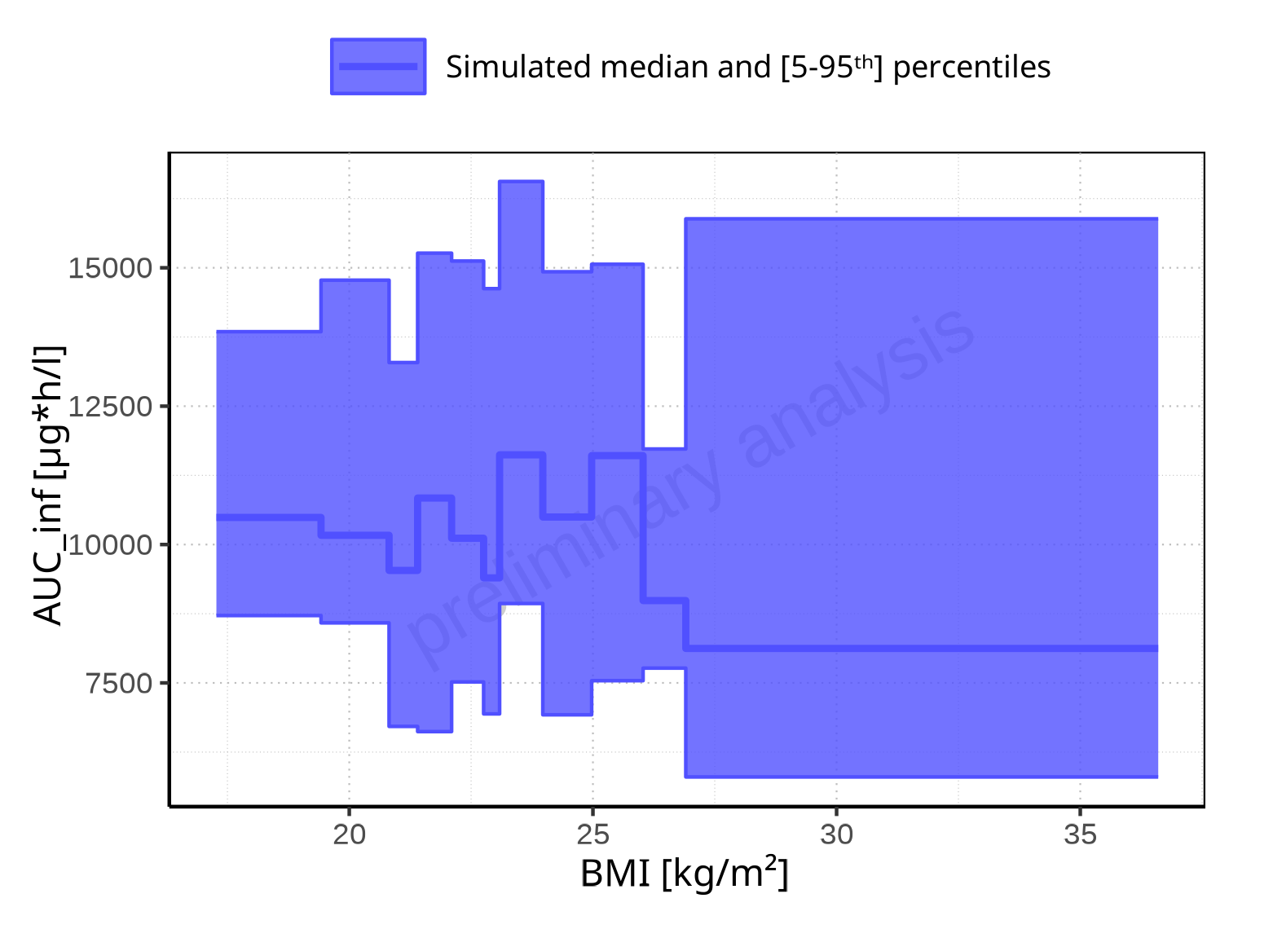

**Figure 2-194: BMI-dependence of AUC_inf for Filmcoated_tablet_400mg_sd. Profiles are plotted in a linear scale.**

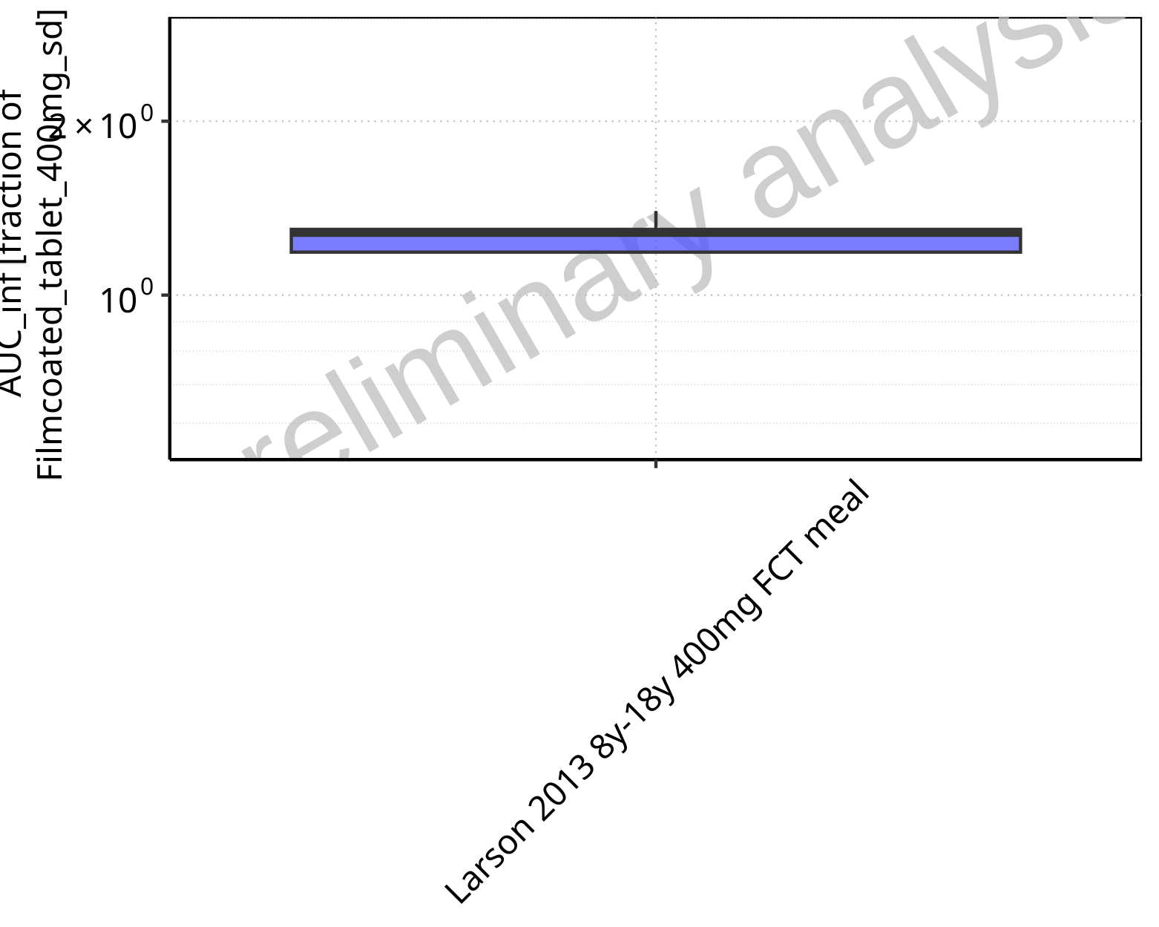

**Figure 2-195: Ratio of population summary statistics of AUC_inf of Raltegravir for Larson 2013 8y-18y 400mg FCT meal in comparison to Filmcoated_tablet_400mg_sd shown as box-whisker plot, which indicates ratios of the 5th, 25th, 50th, 75th, 95th percentiles in logarithmic scale.**

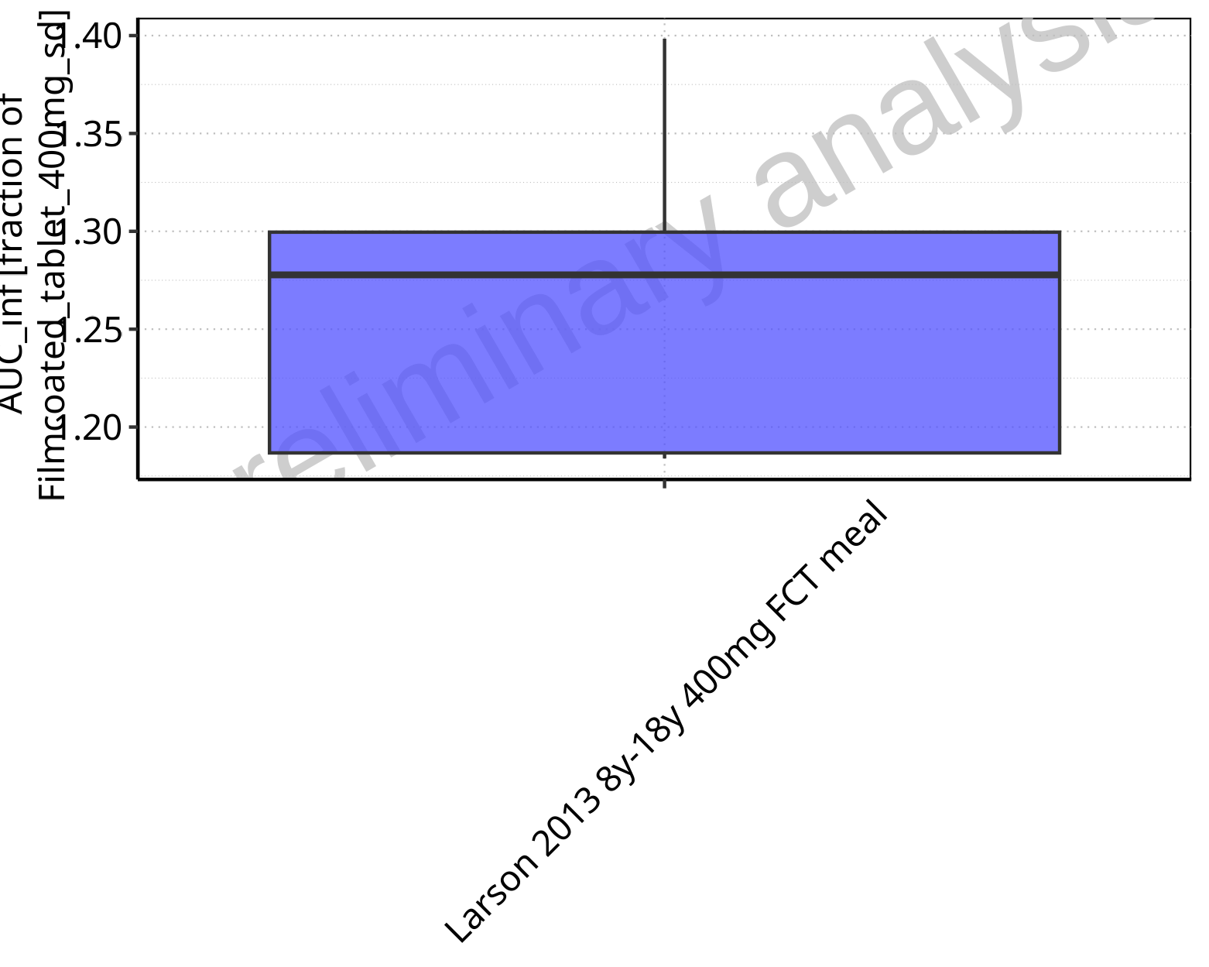

**Figure 2-196: Ratio of population summary statistics of AUC_inf of Raltegravir for Larson 2013 8y-18y 400mg FCT meal in comparison to Filmcoated_tablet_400mg_sd shown as box-whisker plot, which indicates ratios of the 5th, 25th, 50th, 75th, 95th percentiles in linear scale.**

**Table 2-14: Ratio of population summary statistics of AUC_inf of Raltegravir for Larson 2013 8y-18y 400mg FCT meal in comparison to Filmcoated_tablet_400mg_sd**

| Population | N | 5th pctl | 25th pctl | 50th pctl | 75th pctl | 95th pctl | Mean | SD | Geo Mean | Geo SD |
| --- | --- | --- | --- | --- | --- | --- | --- | --- | --- | --- |
| Larson 2013 8y-18y 400mg FCT meal | 500 | 1.18 | 1.19 | 1.28 | 1.30 | 1.40 | 1.28 | 1.62 | 0 | - |

### AUC_inf_norm

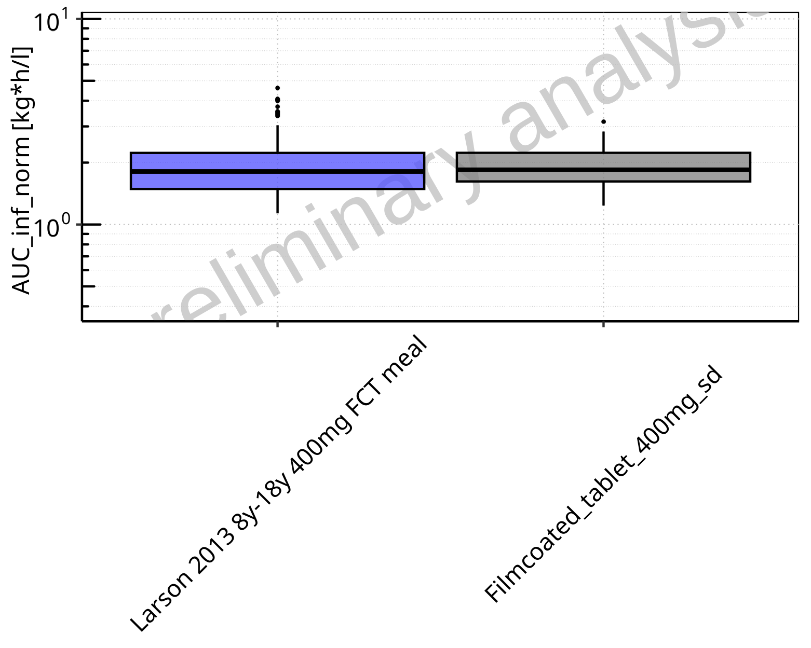

**Figure 2-197: AUC_inf_norm of Raltegravir for Larson 2013 8y-18y 400mg FCT meal, Filmcoated_tablet_400mg_sd shown as box-whisker plot, which indicates the 5th, 25th, 50th, 75th, 95th percentiles in logarithmic scale.**

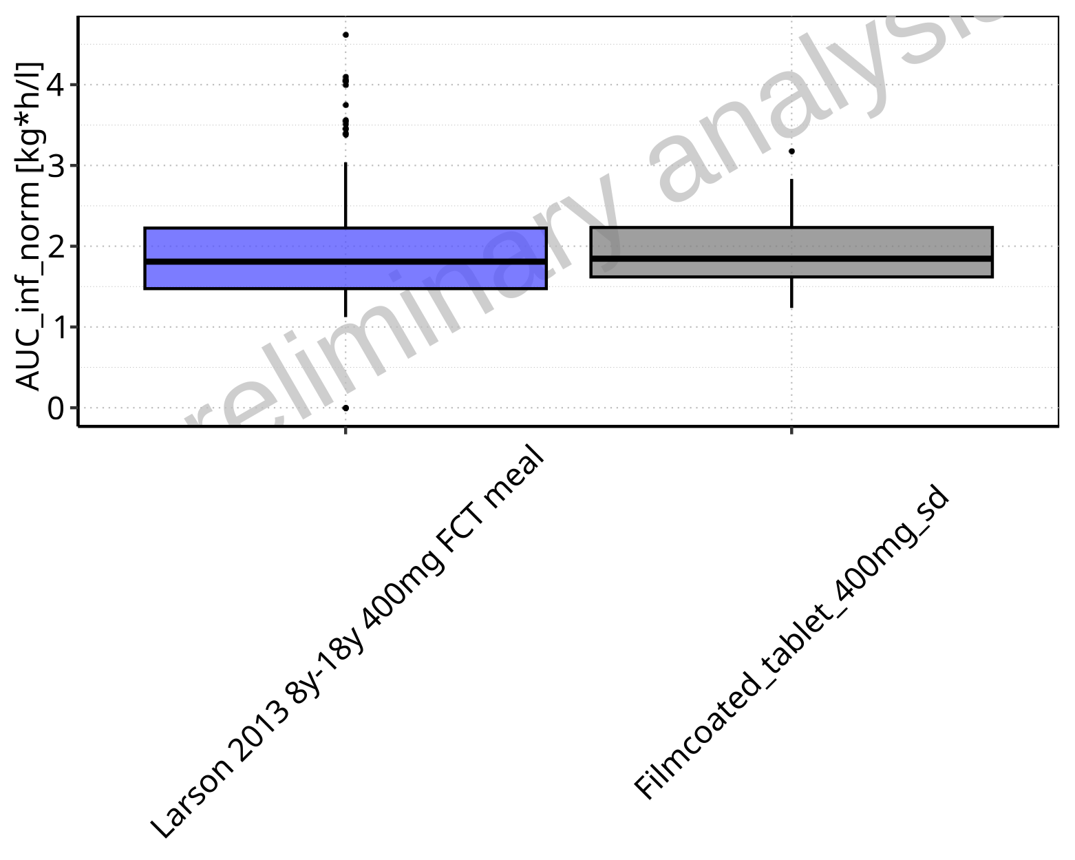

**Figure 2-198: AUC_inf_norm of Raltegravir for Larson 2013 8y-18y 400mg FCT meal, Filmcoated_tablet_400mg_sd shown as box-whisker plot, which indicates the 5th, 25th, 50th, 75th, 95th percentiles in linear scale.**

**Table 2-15: Population statistics summarizing AUC_inf_norm of Raltegravir for Larson 2013 8y-18y 400mg FCT meal, Filmcoated_tablet_400mg_sd reported in [kg*h/l]**

| Population | N | 5th pctl | 25th pctl | 50th pctl | 75th pctl | 95th pctl | Mean | SD | Geo Mean | Geo SD |
| --- | --- | --- | --- | --- | --- | --- | --- | --- | --- | --- |
| Larson 2013 8y-18y 400mg FCT meal | 500 | 1.12 | 1.47 | 1.81 | 2.22 | 3.04 | 1.91 | 0.62 | 0.00 | - |
| Filmcoated_tablet_400mg_sd | 100 | 1.24 | 1.62 | 1.85 | 2.23 | 2.83 | 1.94 | 0.50 | 1.88 | 1.30 |

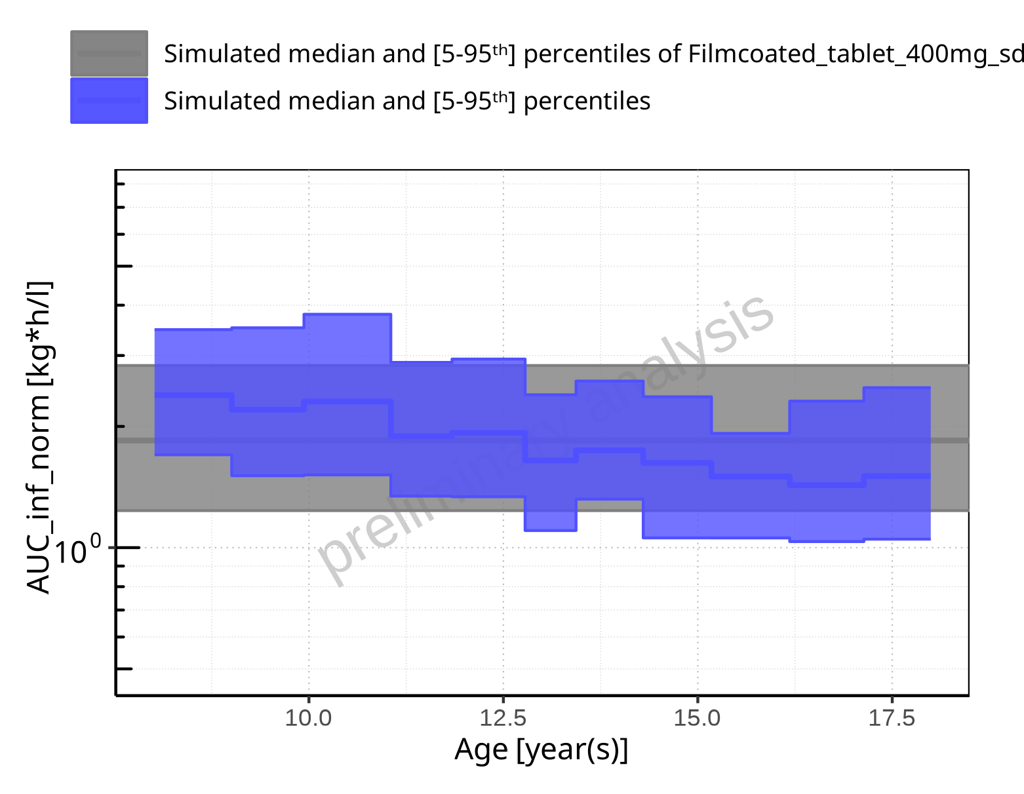

**Figure 2-199: Age-dependence of AUC_inf_norm for Larson 2013 8y-18y 400mg FCT meal in comparison to Filmcoated_tablet_400mg_sd. Profiles are plotted in a logarithmic scale.**

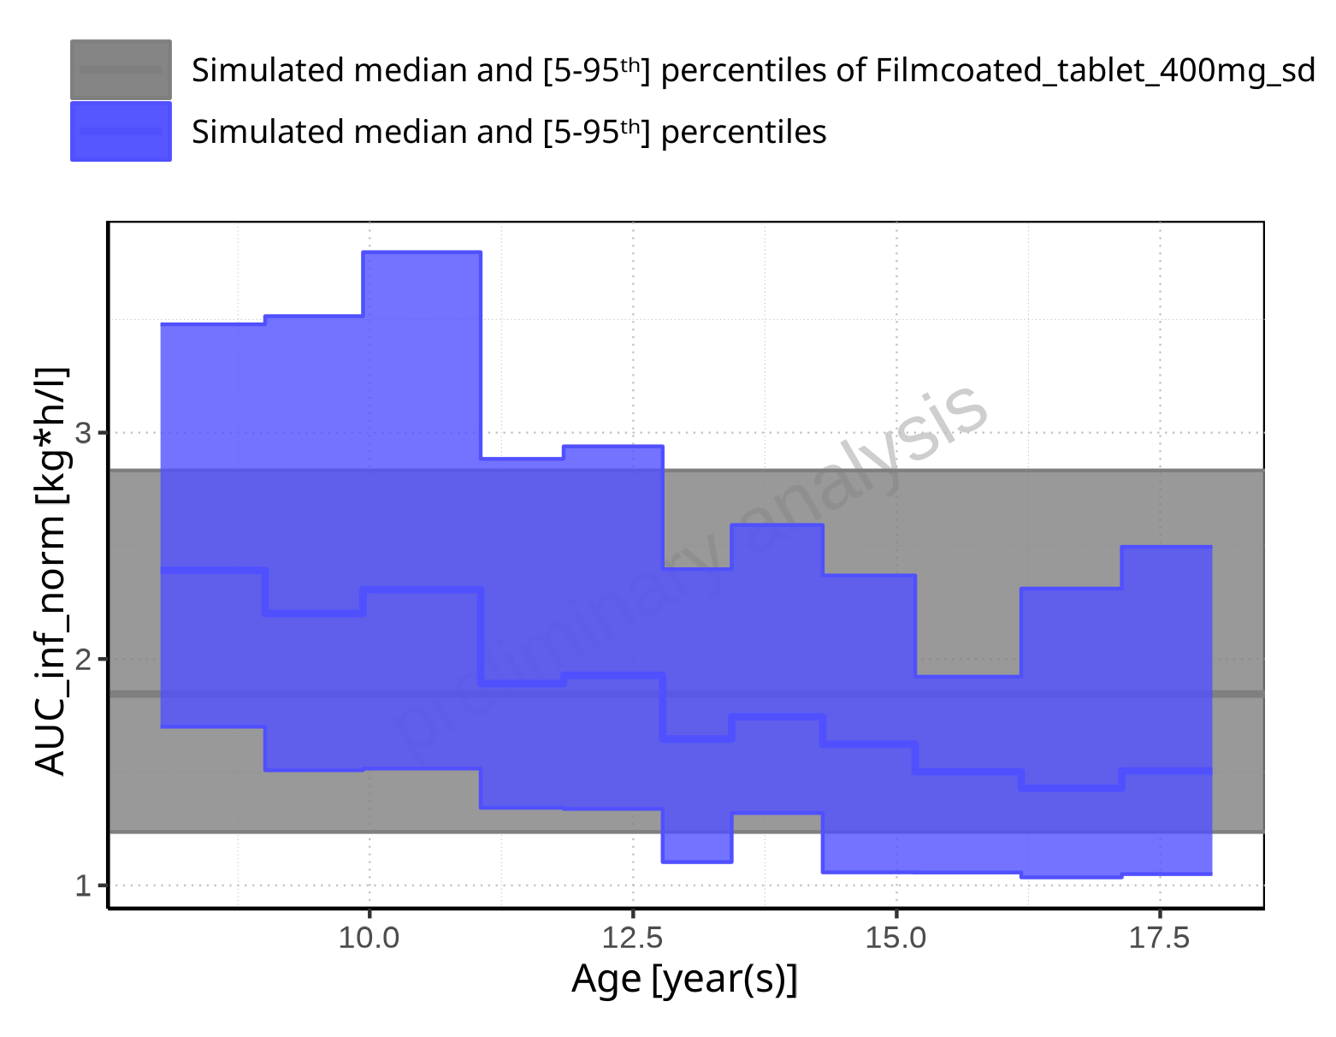

**Figure 2-200: Age-dependence of AUC_inf_norm for Larson 2013 8y-18y 400mg FCT meal in comparison to Filmcoated_tablet_400mg_sd. Profiles are plotted in a linear scale.**

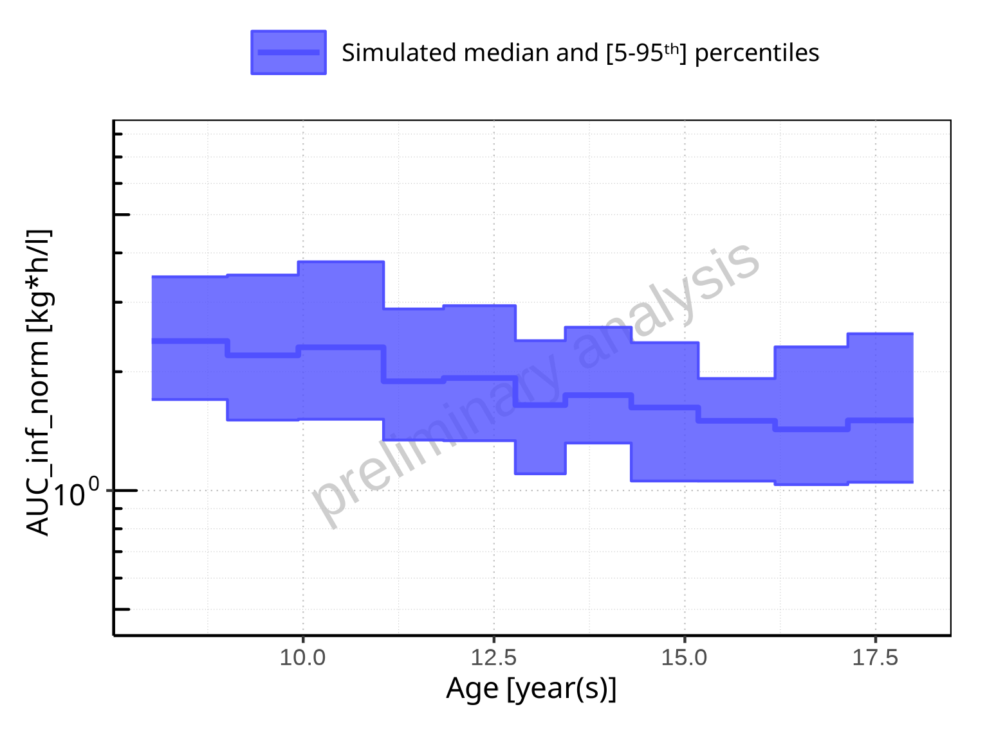

**Figure 2-201: Age-dependence of AUC_inf_norm for Larson 2013 8y-18y 400mg FCT meal. Profiles are plotted in a logarithmic scale.**

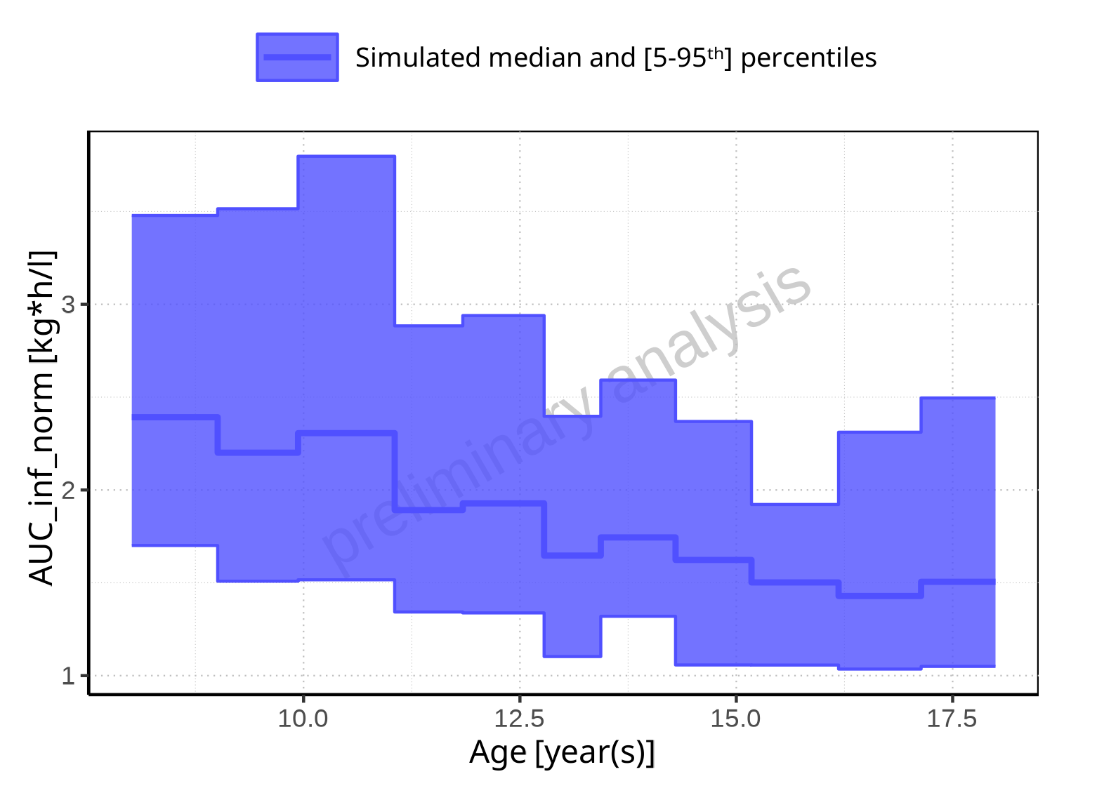

**Figure 2-202: Age-dependence of AUC_inf_norm for Larson 2013 8y-18y 400mg FCT meal. Profiles are plotted in a linear scale.**

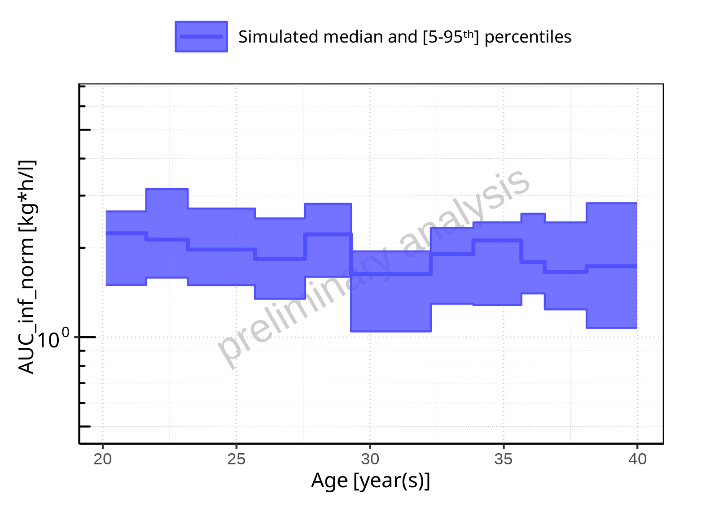

**Figure 2-203: Age-dependence of AUC_inf_norm for Filmcoated_tablet_400mg_sd. Profiles are plotted in a logarithmic scale.**

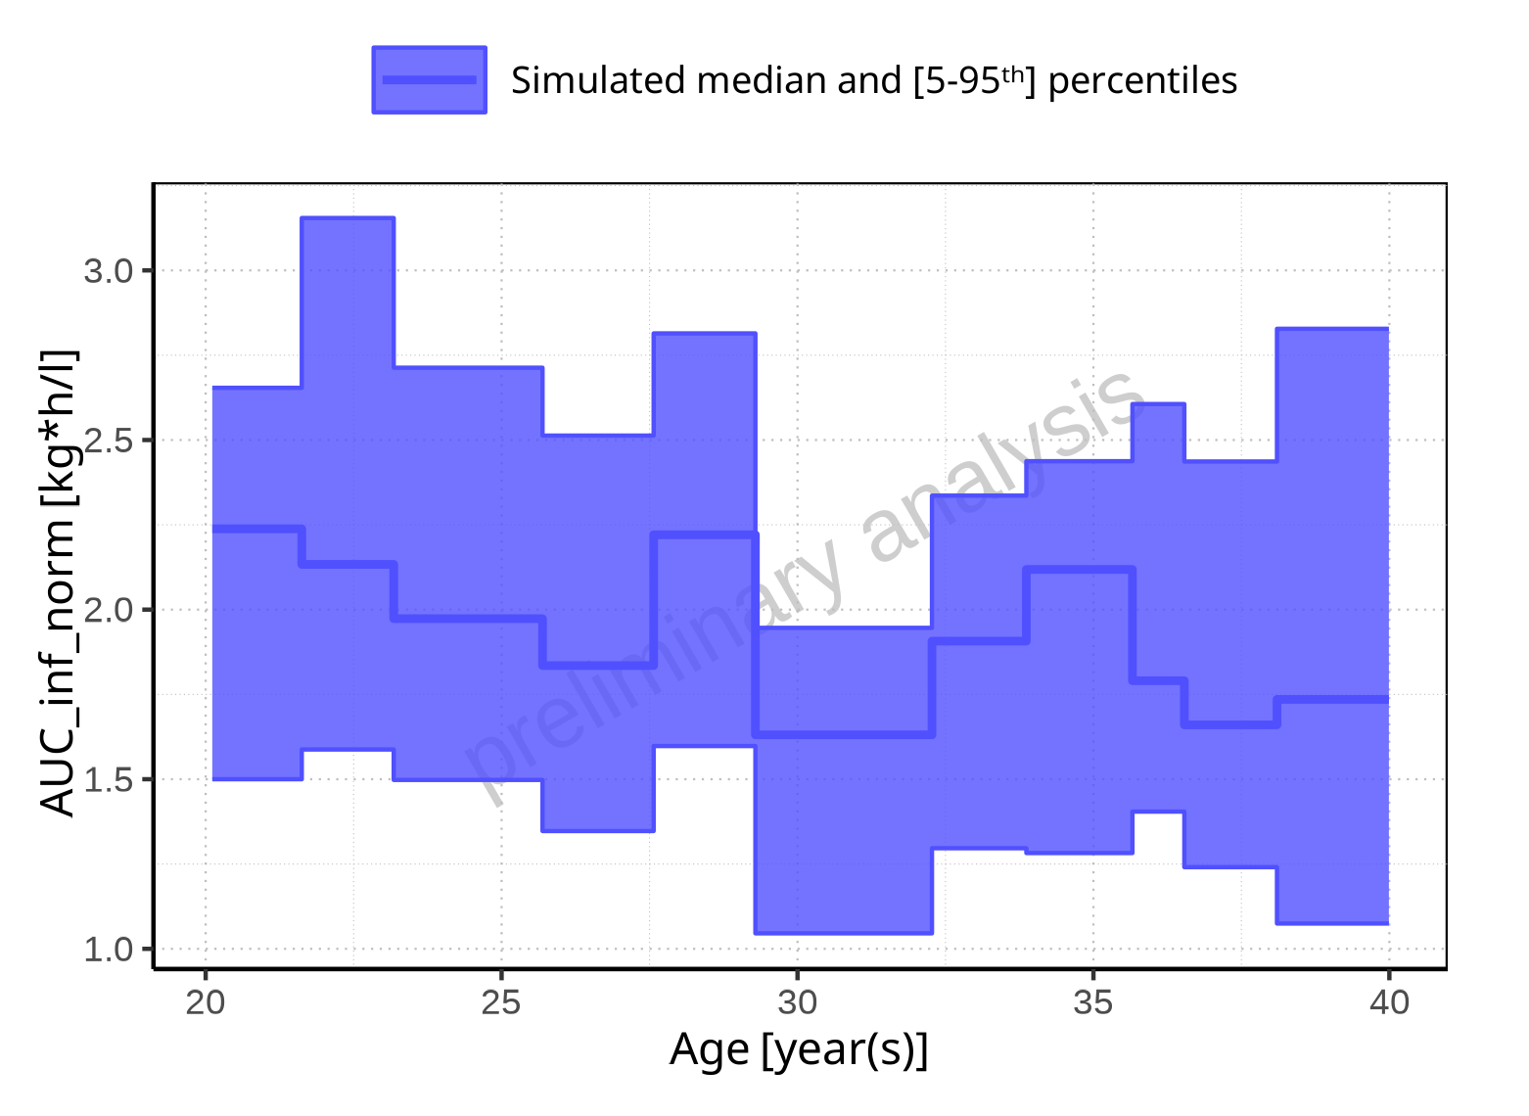

**Figure 2-204: Age-dependence of AUC_inf_norm for Filmcoated_tablet_400mg_sd. Profiles are plotted in a linear scale.**

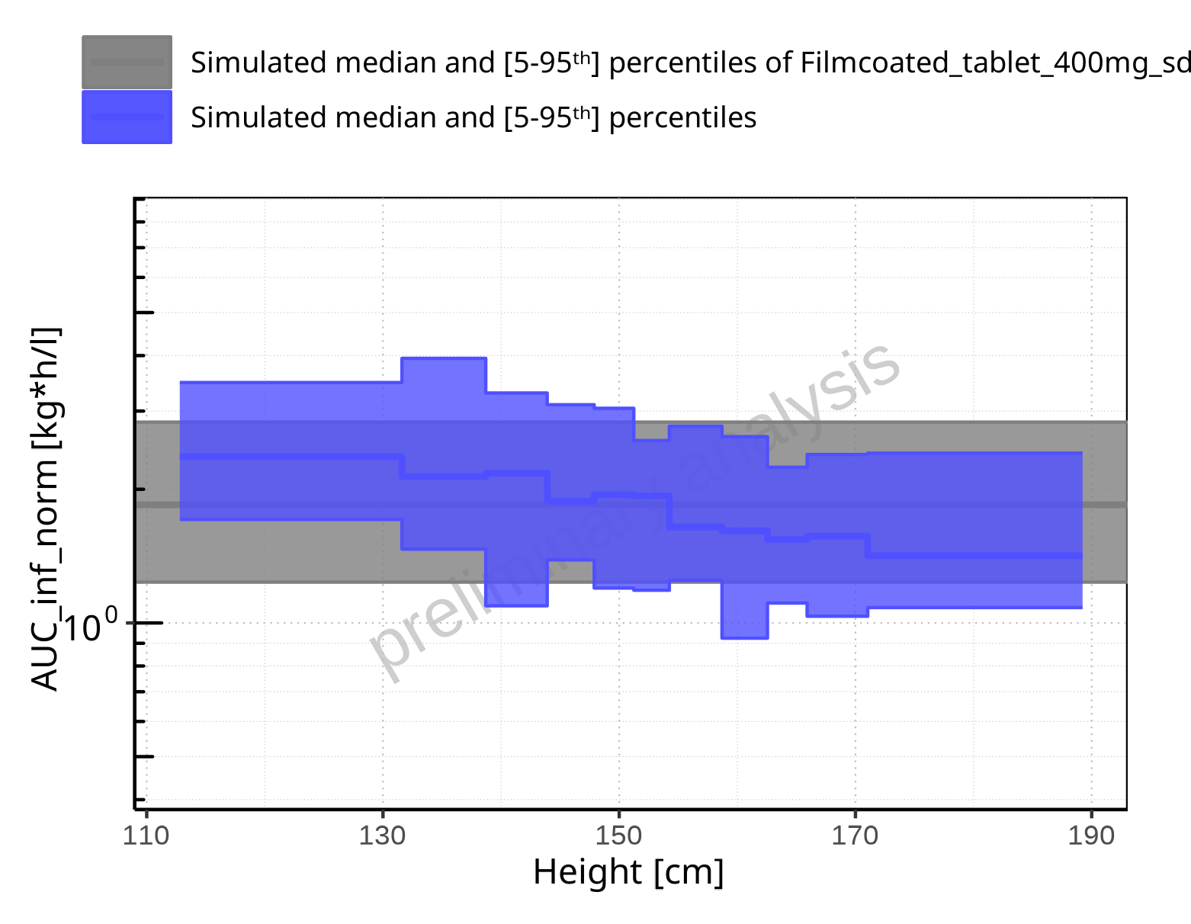

**Figure 2-205: Height-dependence of AUC_inf_norm for Larson 2013 8y-18y 400mg FCT meal in comparison to Filmcoated_tablet_400mg_sd. Profiles are plotted in a logarithmic scale.**

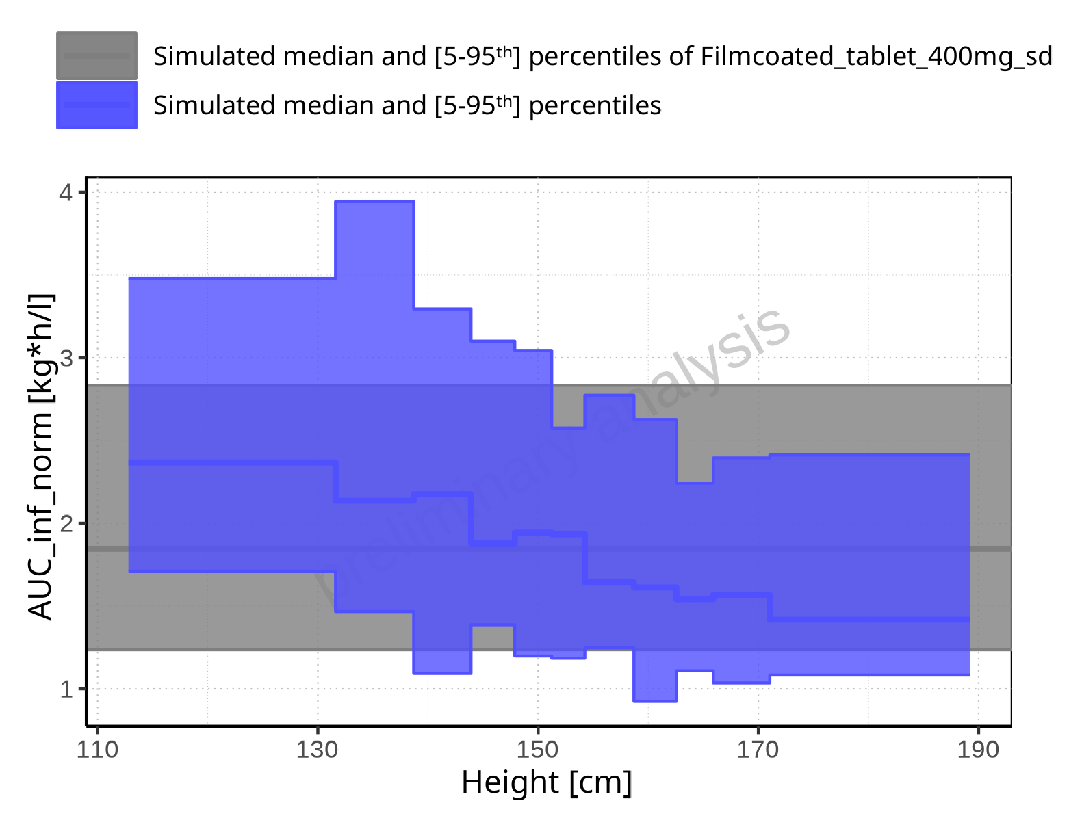

**Figure 2-206: Height-dependence of AUC_inf_norm for Larson 2013 8y-18y 400mg FCT meal in comparison to Filmcoated_tablet_400mg_sd. Profiles are plotted in a linear scale.**

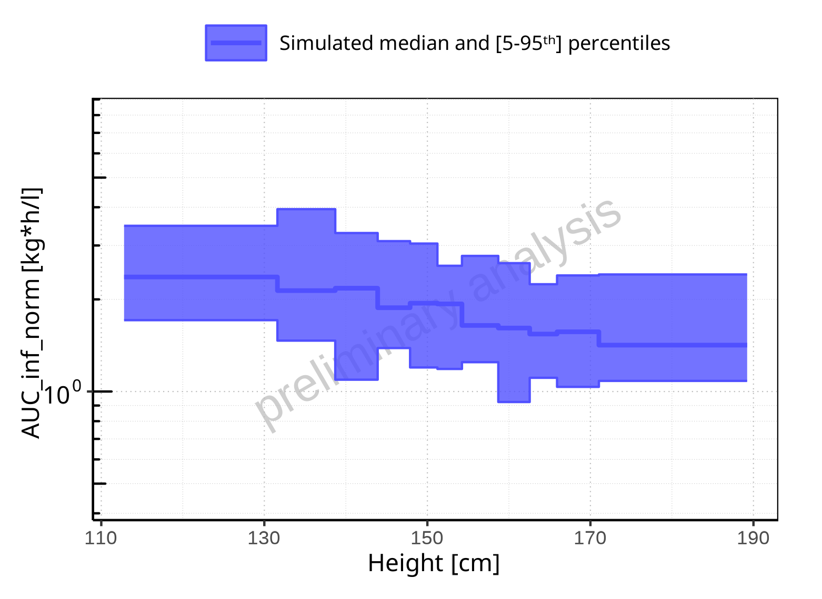

**Figure 2-207: Height-dependence of AUC_inf_norm for Larson 2013 8y-18y 400mg FCT meal. Profiles are plotted in a logarithmic scale.**

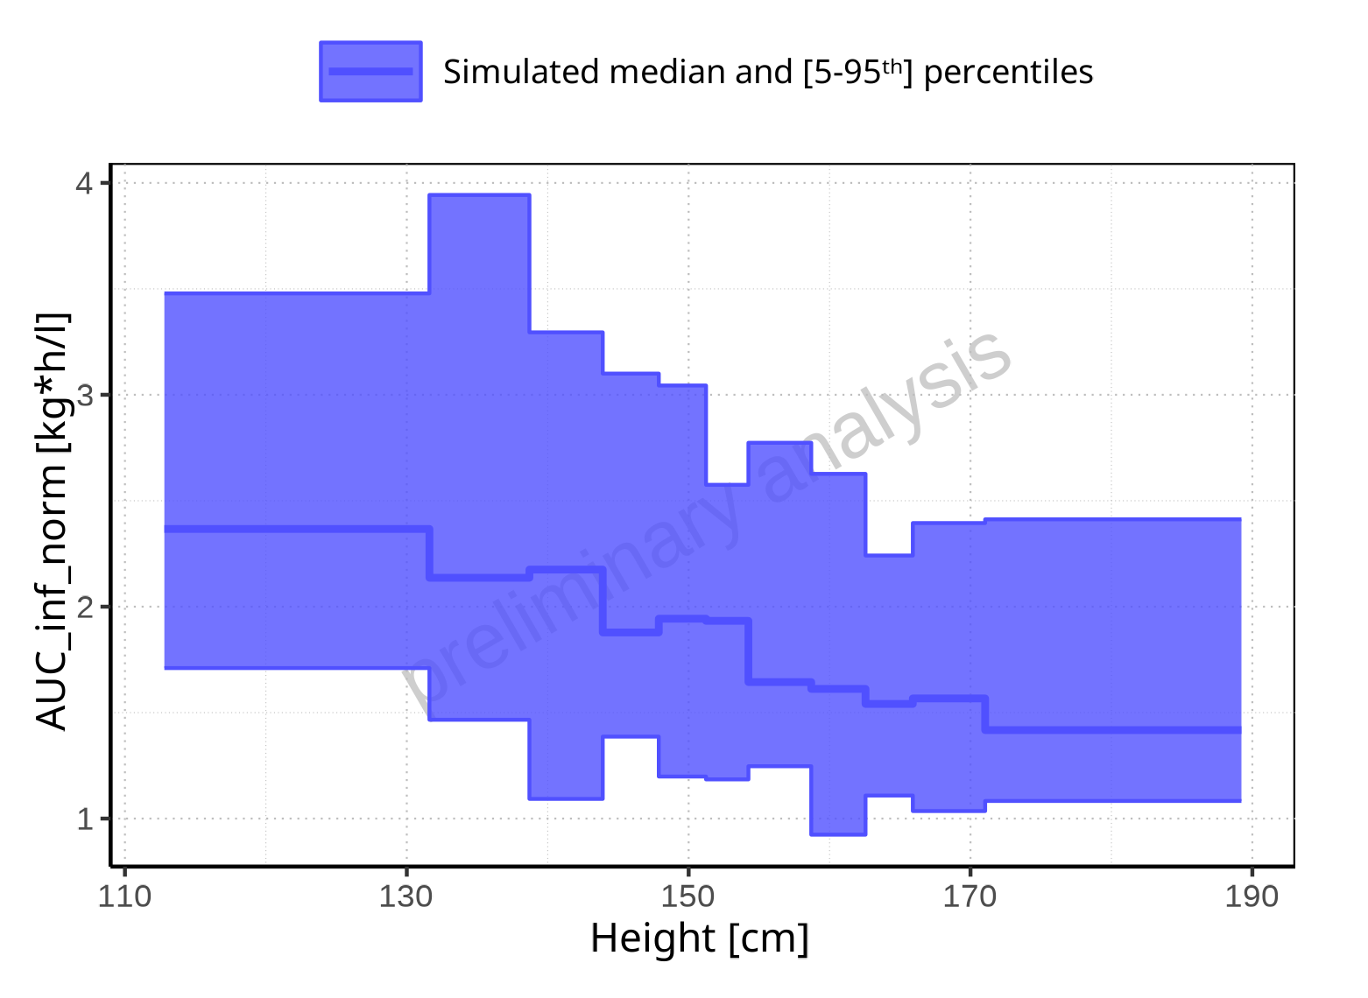

**Figure 2-208: Height-dependence of AUC_inf_norm for Larson 2013 8y-18y 400mg FCT meal. Profiles are plotted in a linear scale.**

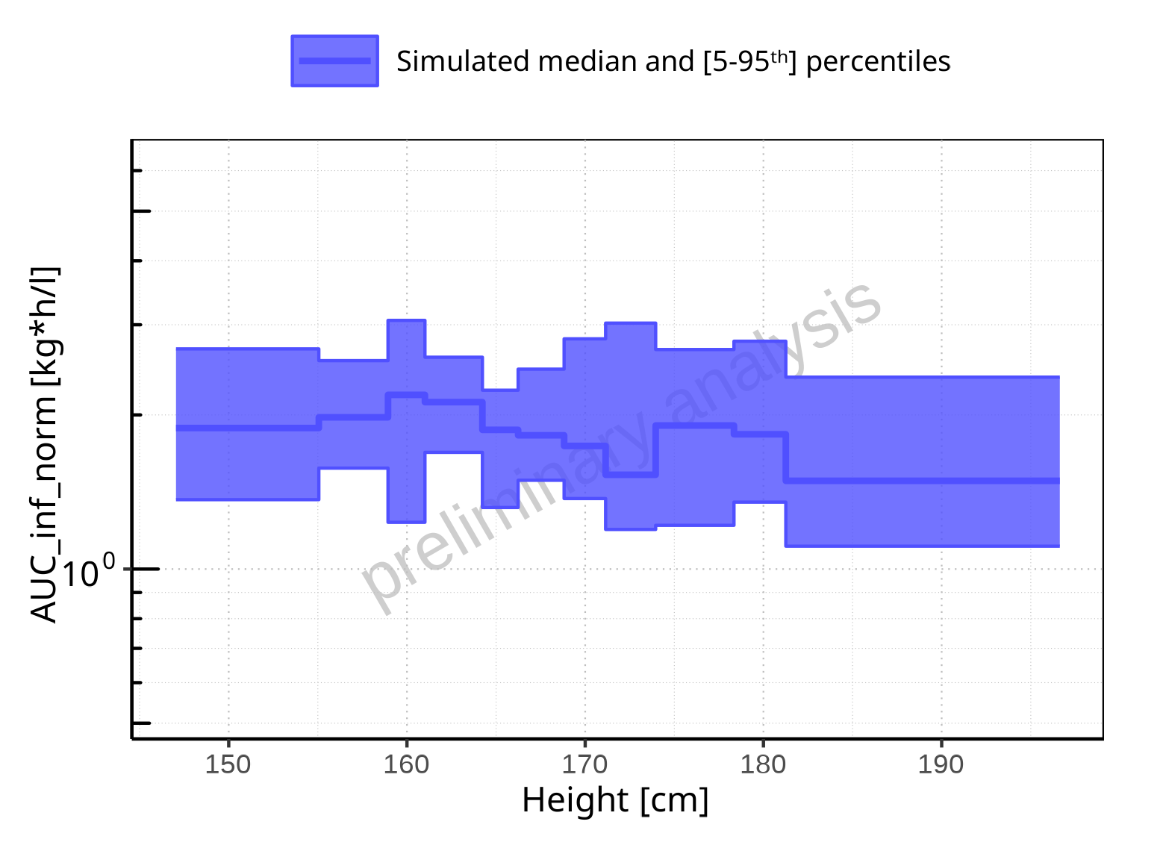

**Figure 2-209: Height-dependence of AUC_inf_norm for Filmcoated_tablet_400mg_sd. Profiles are plotted in a logarithmic scale.**

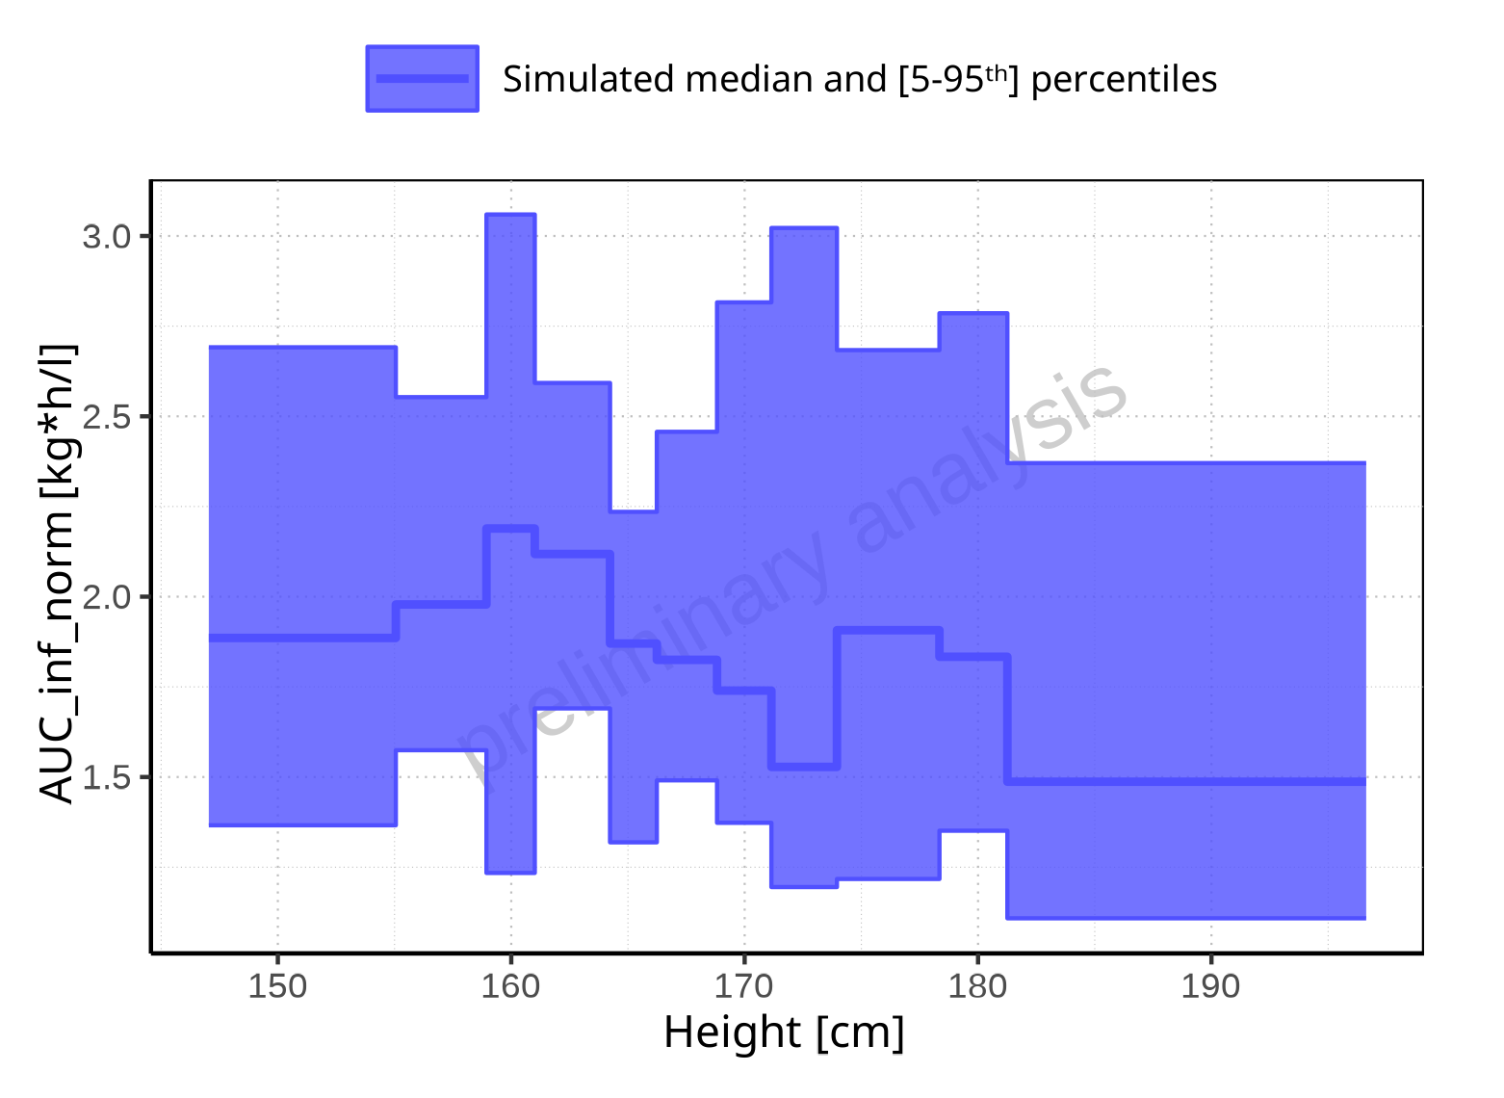

**Figure 2-210: Height-dependence of AUC_inf_norm for Filmcoated_tablet_400mg_sd. Profiles are plotted in a linear scale.**

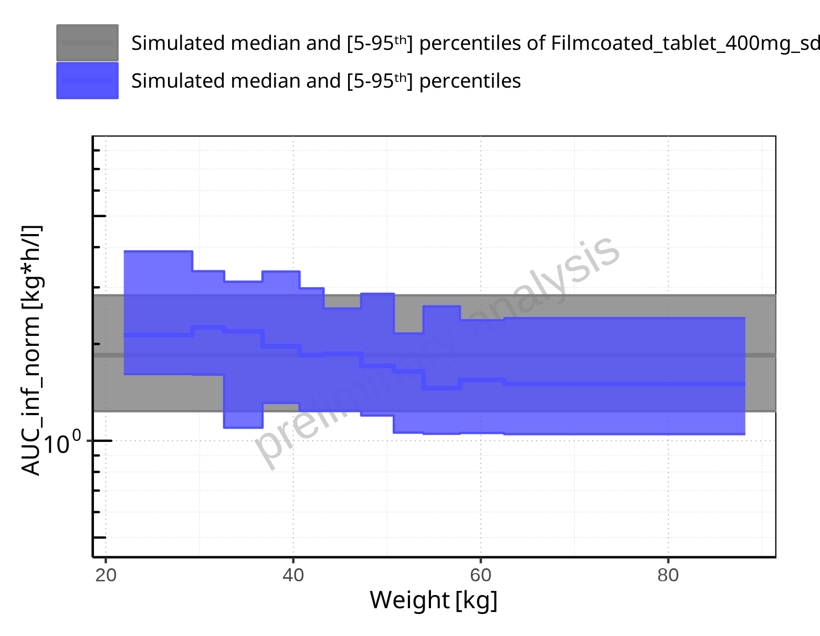

**Figure 2-211: Weight-dependence of AUC_inf_norm for Larson 2013 8y-18y 400mg FCT meal in comparison to Filmcoated_tablet_400mg_sd. Profiles are plotted in a logarithmic scale.**

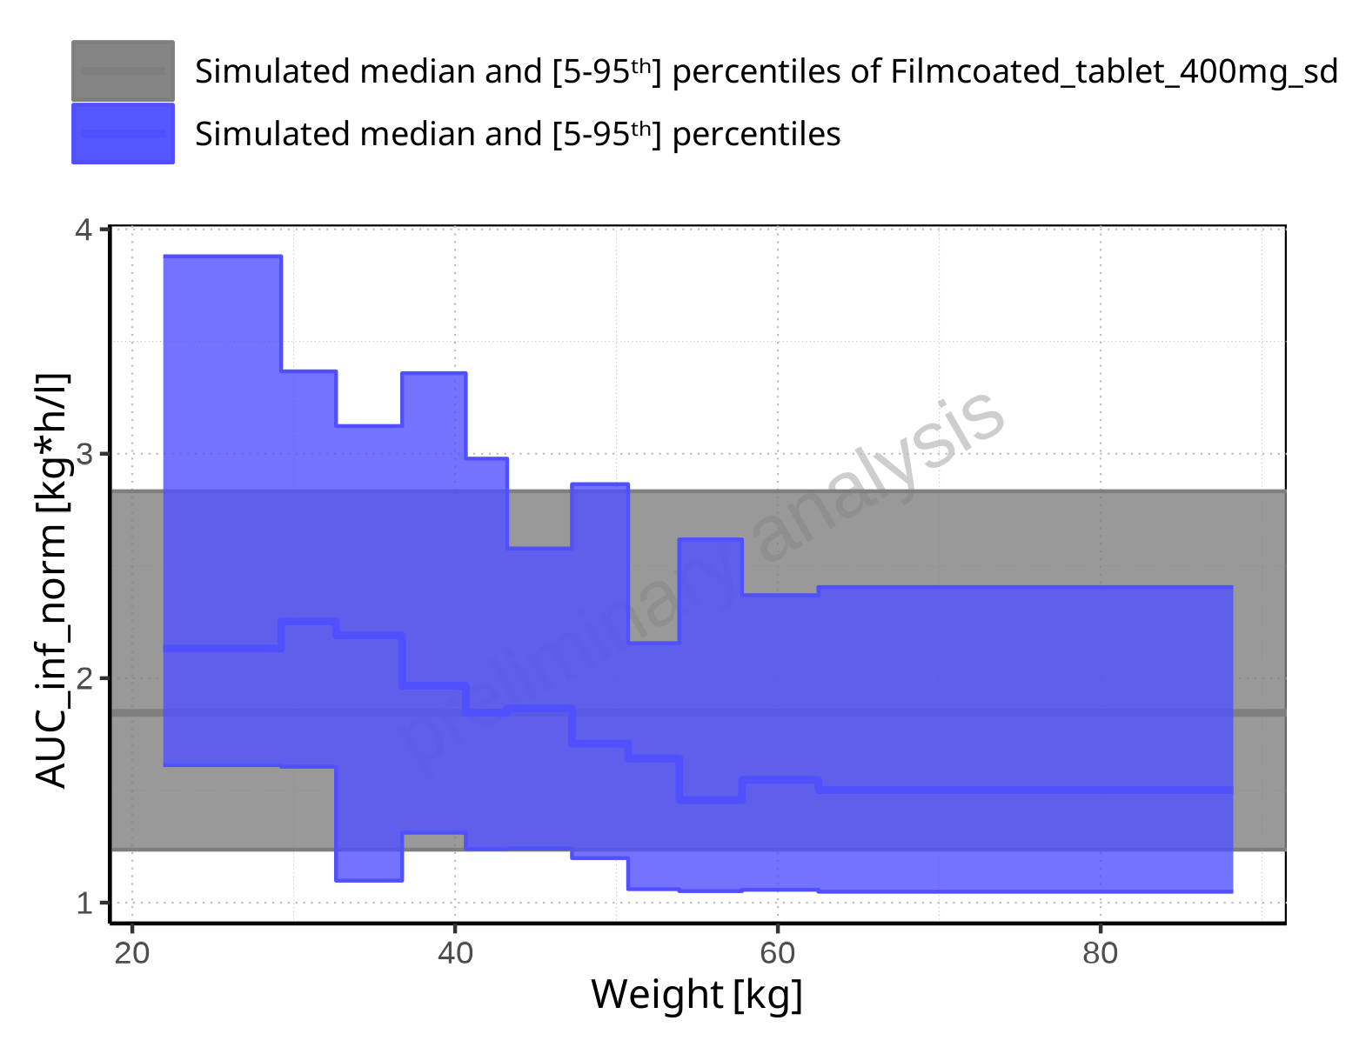

**Figure 2-212: Weight-dependence of AUC_inf_norm for Larson 2013 8y-18y 400mg FCT meal in comparison to Filmcoated_tablet_400mg_sd. Profiles are plotted in a linear scale.**

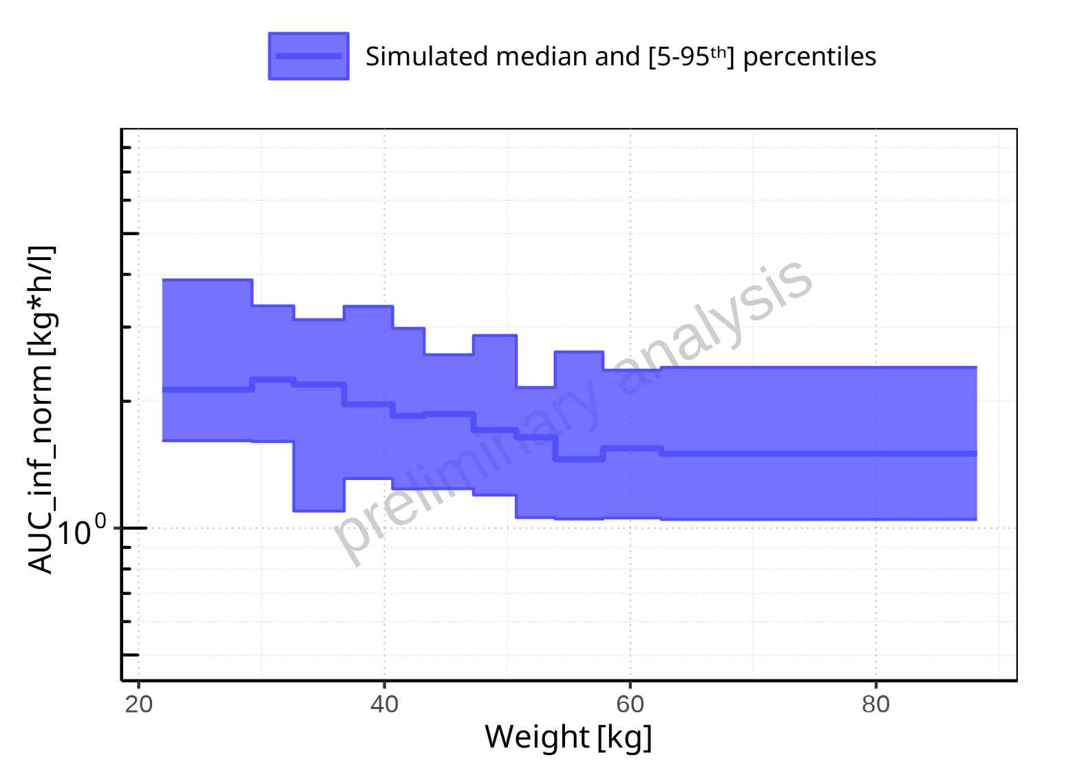

**Figure 2-213: Weight-dependence of AUC_inf_norm for Larson 2013 8y-18y 400mg FCT meal. Profiles are plotted in a logarithmic scale.**

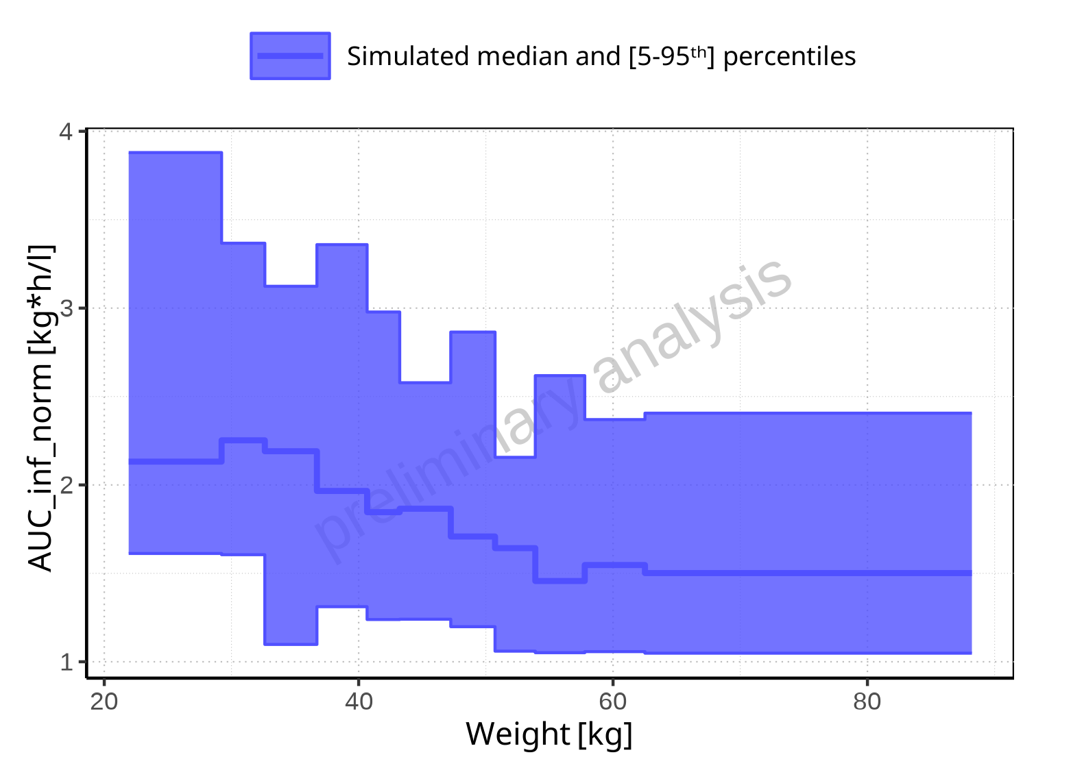

**Figure 2-214: Weight-dependence of AUC_inf_norm for Larson 2013 8y-18y 400mg FCT meal. Profiles are plotted in a linear scale.**

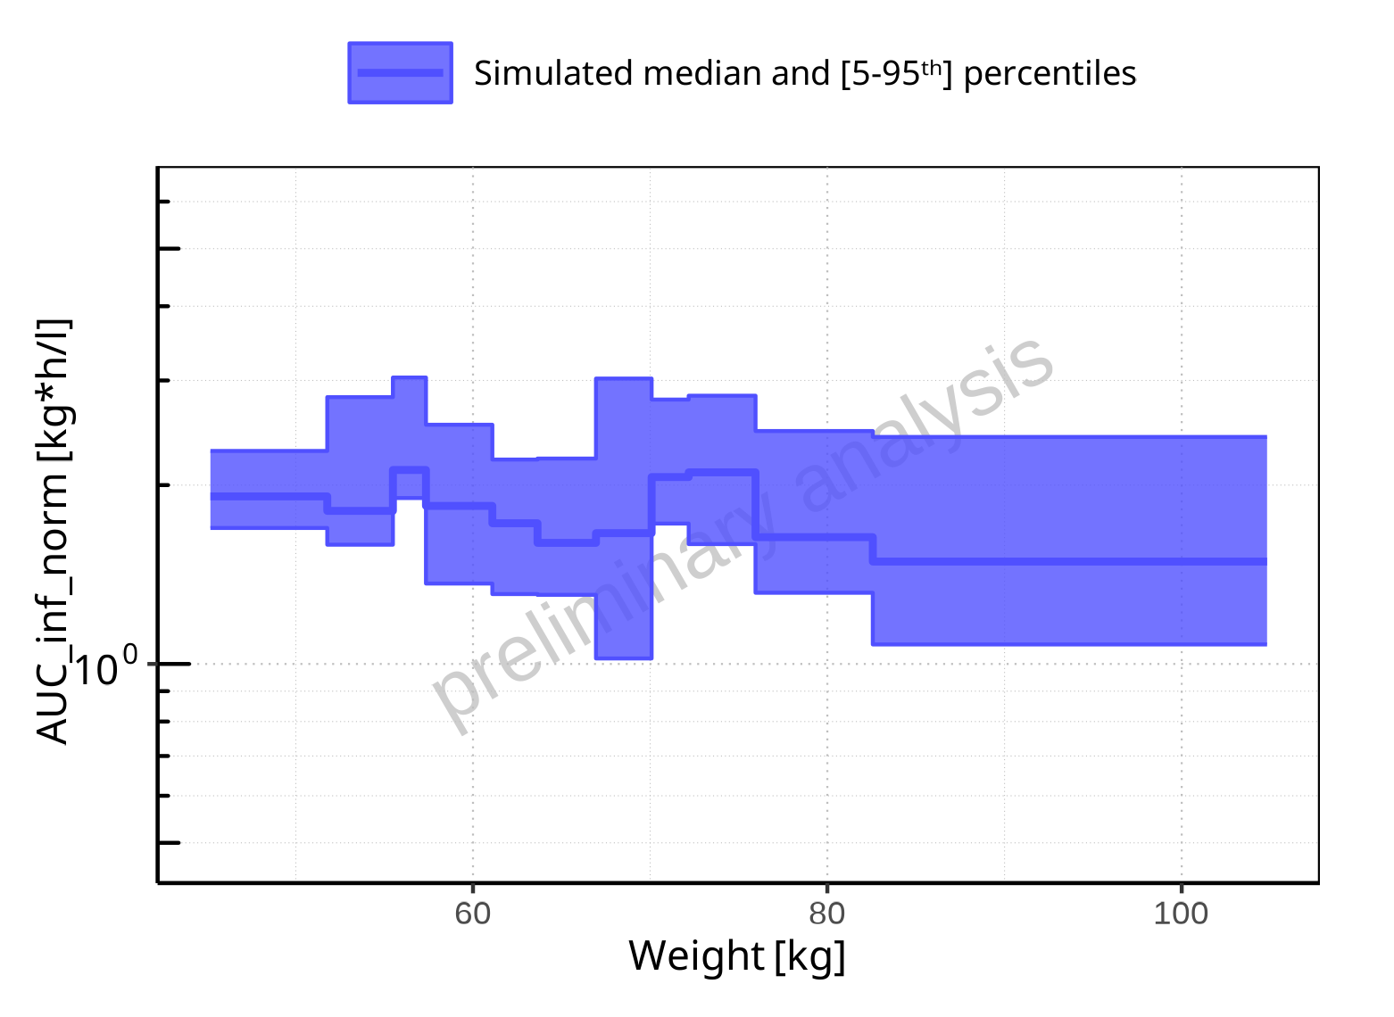

**Figure 2-215: Weight-dependence of AUC_inf_norm for Filmcoated_tablet_400mg_sd. Profiles are plotted in a logarithmic scale.**

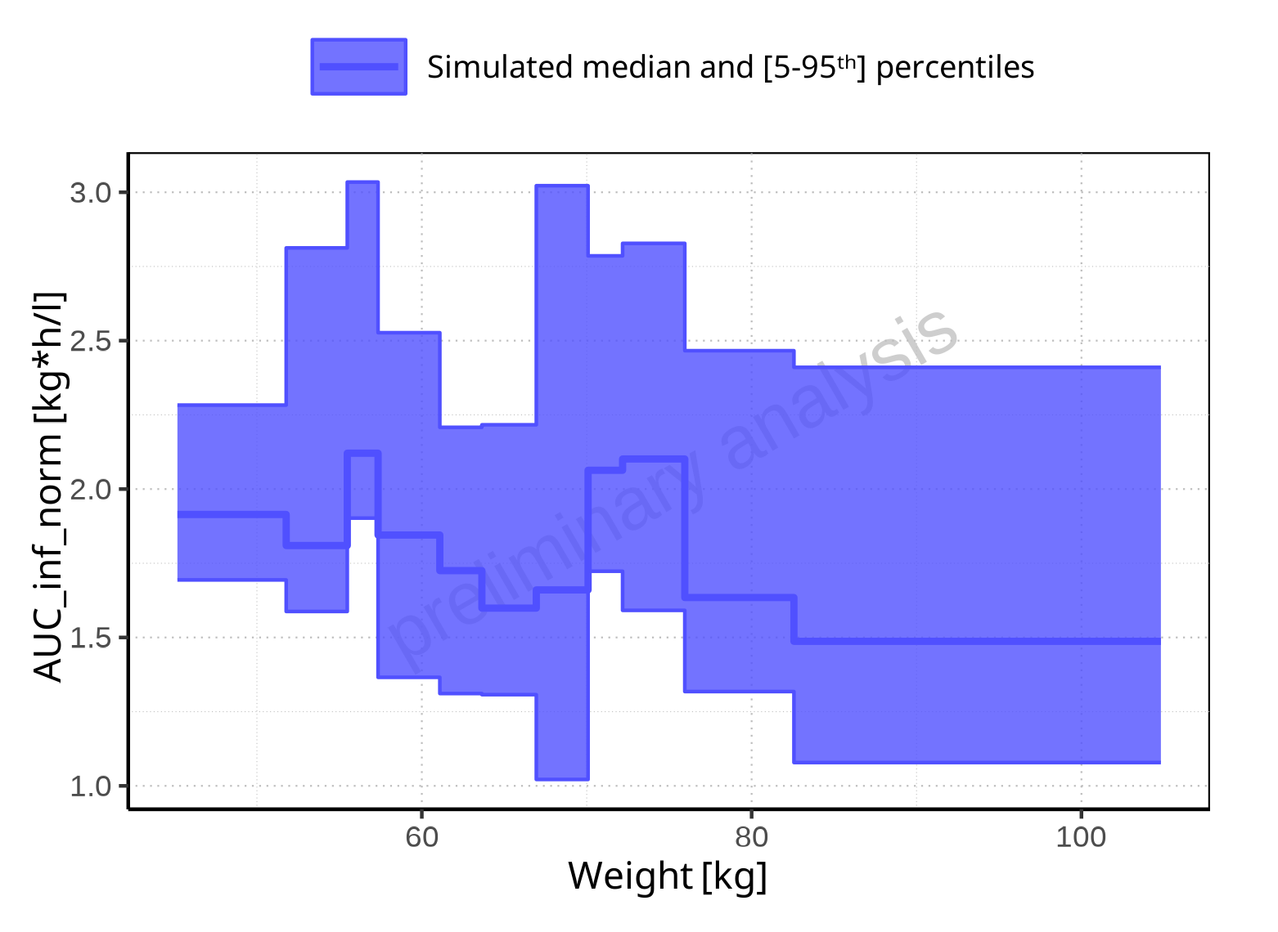

**Figure 2-216: Weight-dependence of AUC_inf_norm for Filmcoated_tablet_400mg_sd. Profiles are plotted in a linear scale.**

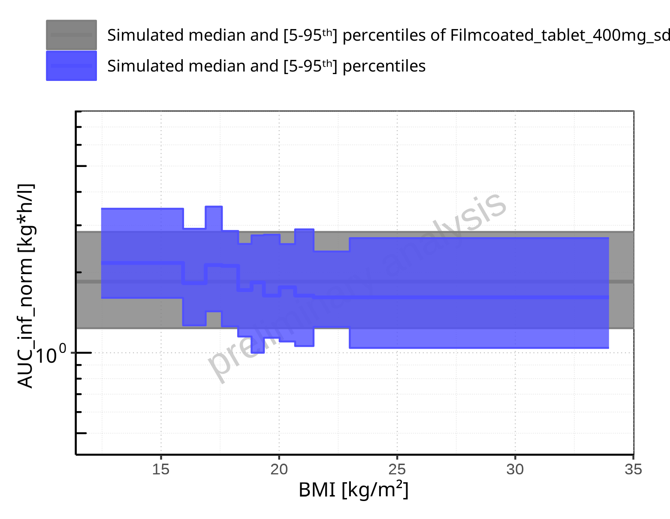

**Figure 2-217: BMI-dependence of AUC_inf_norm for Larson 2013 8y-18y 400mg FCT meal in comparison to Filmcoated_tablet_400mg_sd. Profiles are plotted in a logarithmic scale.**

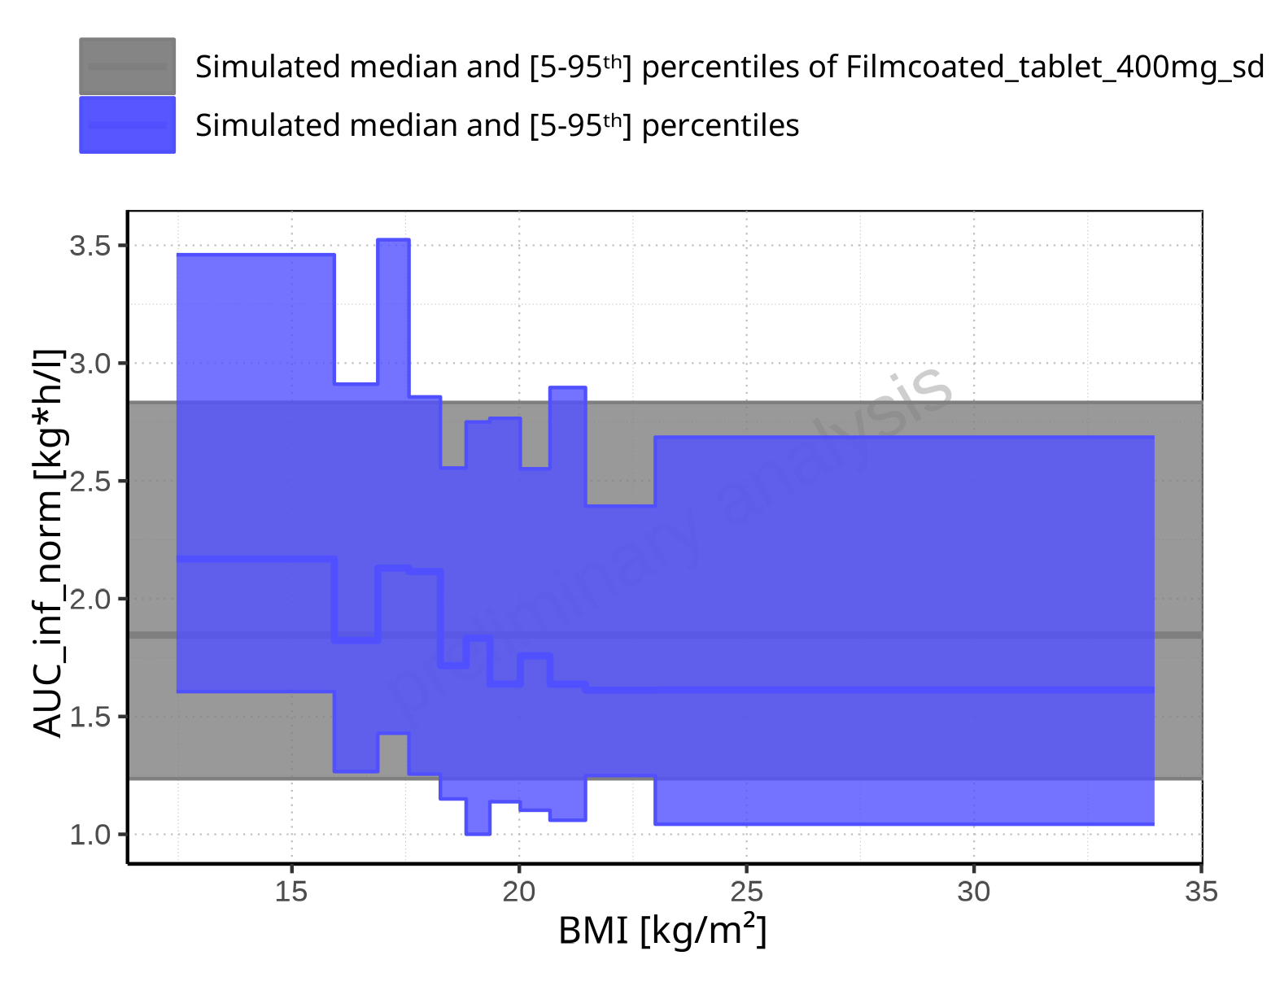

**Figure 2-218: BMI-dependence of AUC_inf_norm for Larson 2013 8y-18y 400mg FCT meal in comparison to Filmcoated_tablet_400mg_sd. Profiles are plotted in a linear scale.**

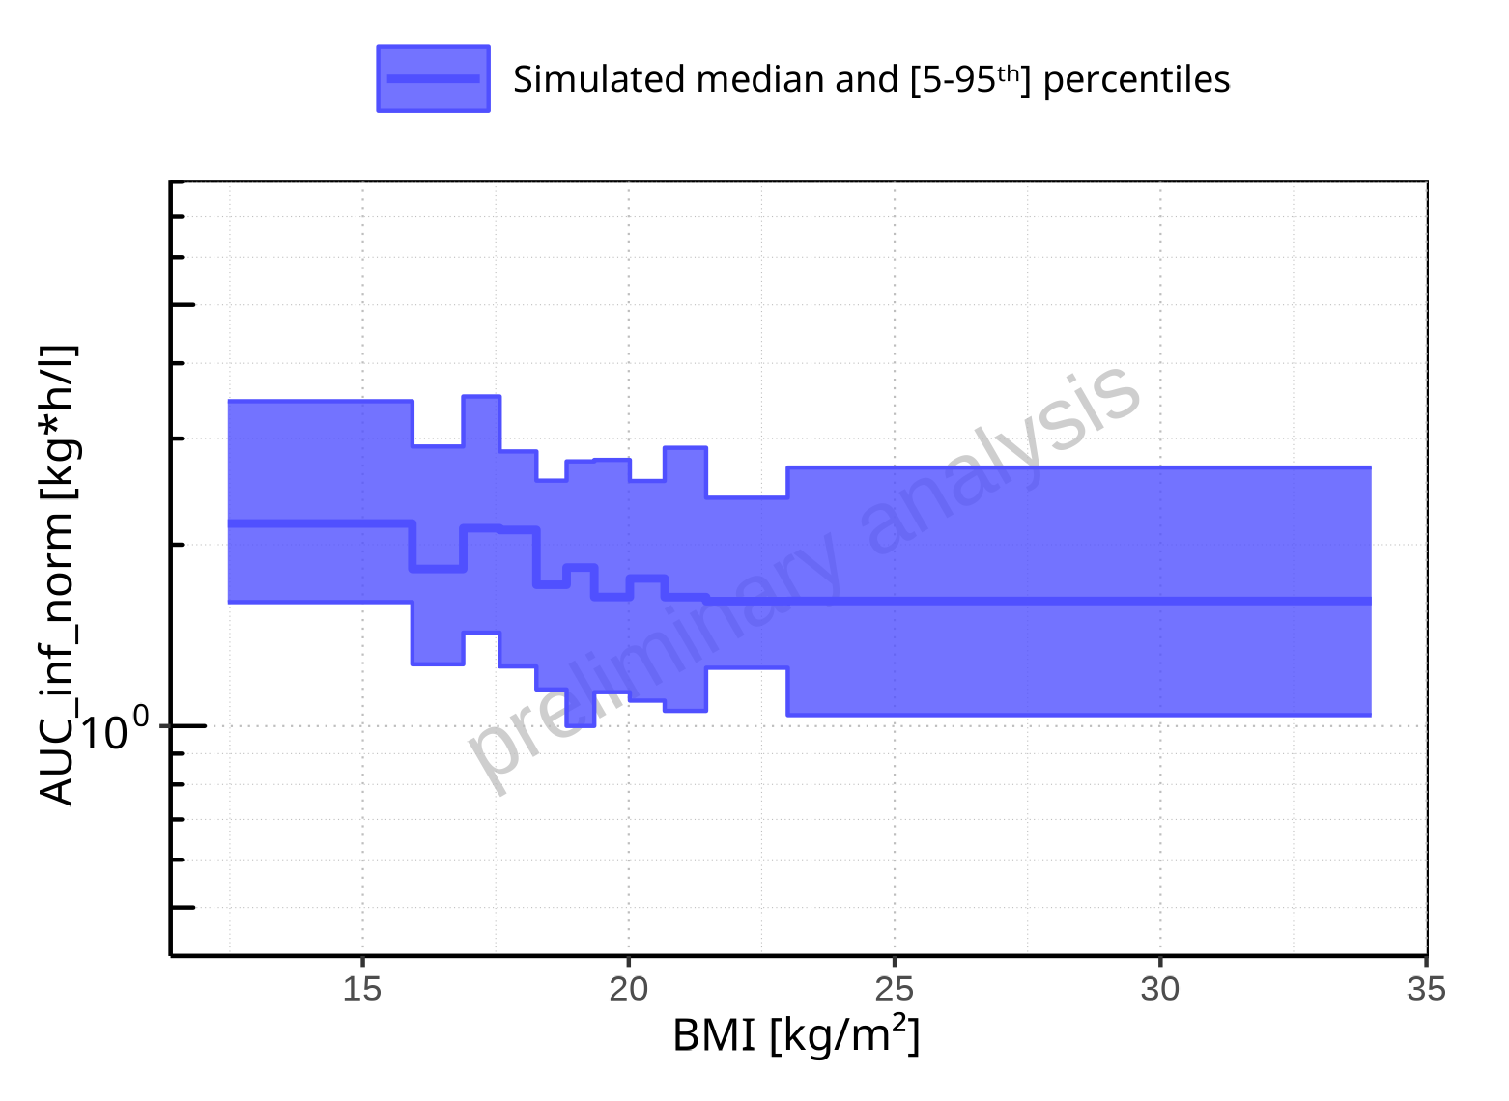

**Figure 2-219: BMI-dependence of AUC_inf_norm for Larson 2013 8y-18y 400mg FCT meal. Profiles are plotted in a logarithmic scale.**

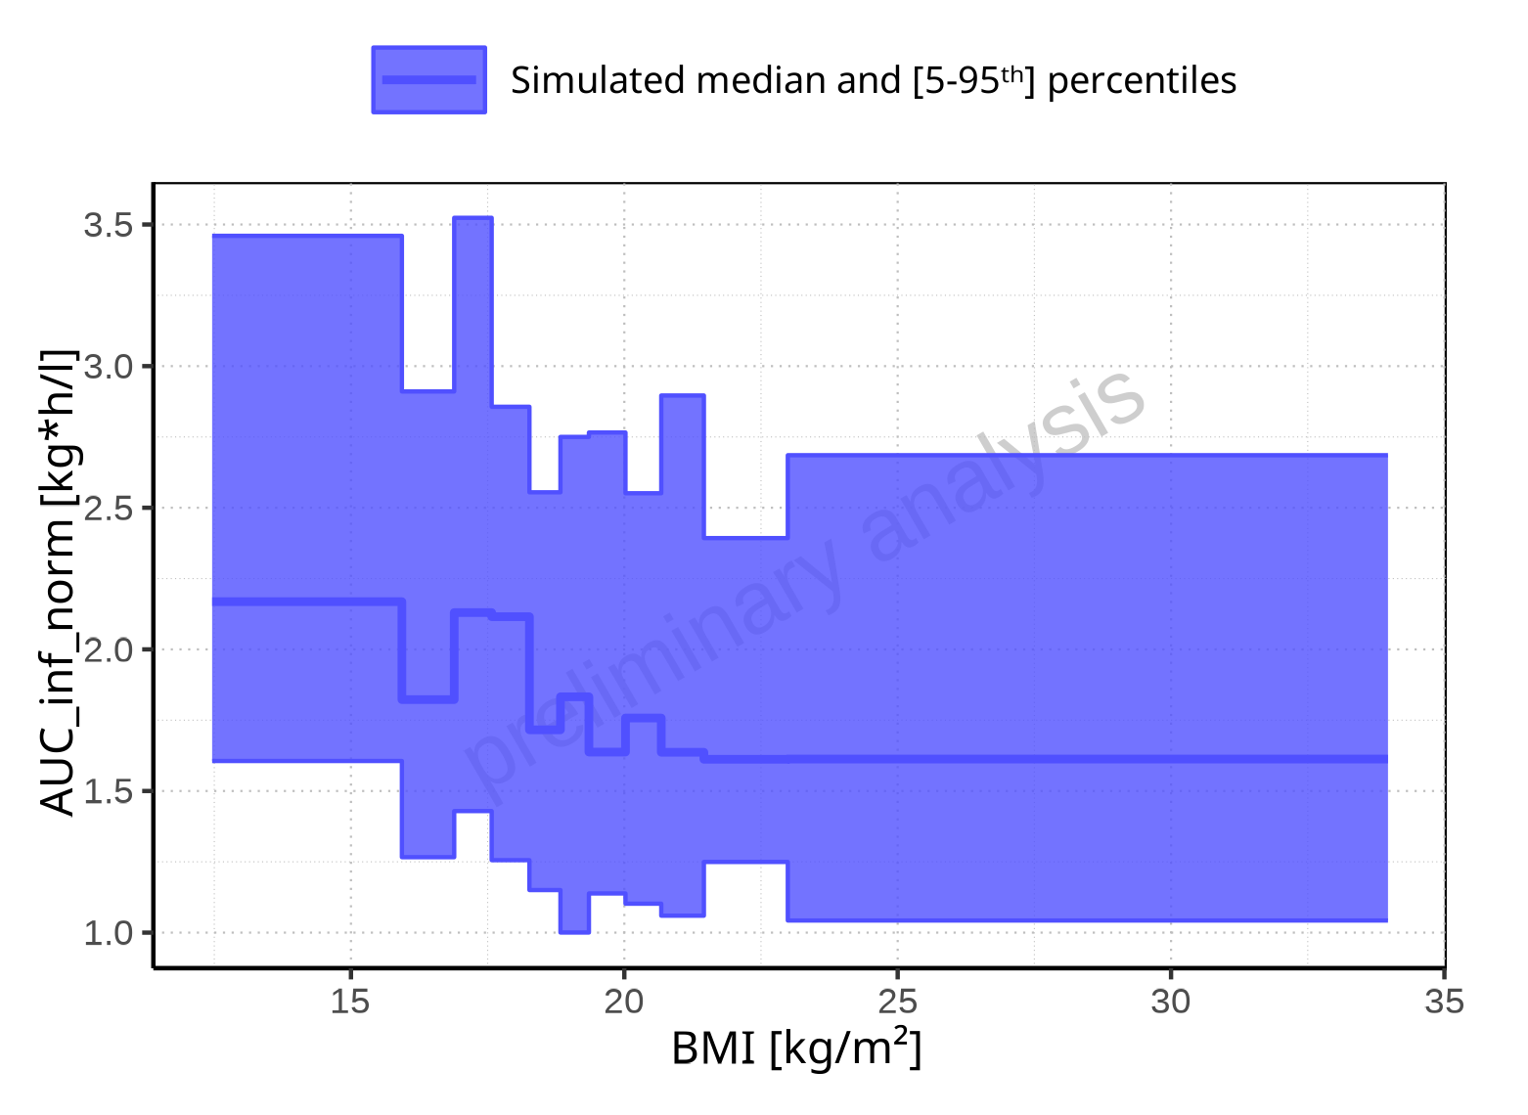

**Figure 2-220: BMI-dependence of AUC_inf_norm for Larson 2013 8y-18y 400mg FCT meal. Profiles are plotted in a linear scale.**

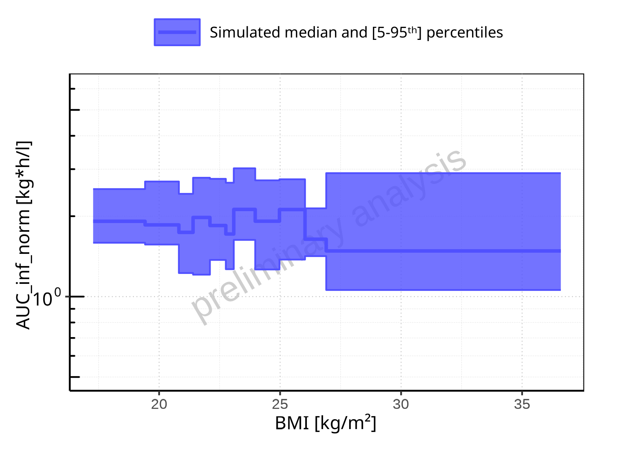

**Figure 2-221: BMI-dependence of AUC_inf_norm for Filmcoated_tablet_400mg_sd. Profiles are plotted in a logarithmic scale.**

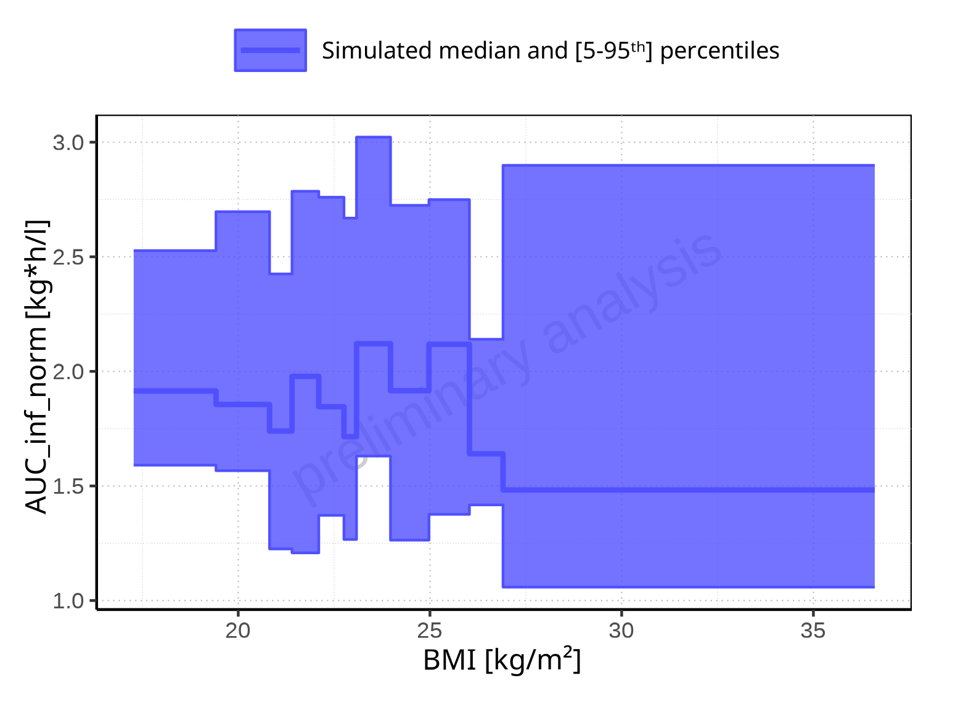

**Figure 2-222: BMI-dependence of AUC_inf_norm for Filmcoated_tablet_400mg_sd. Profiles are plotted in a linear scale.**

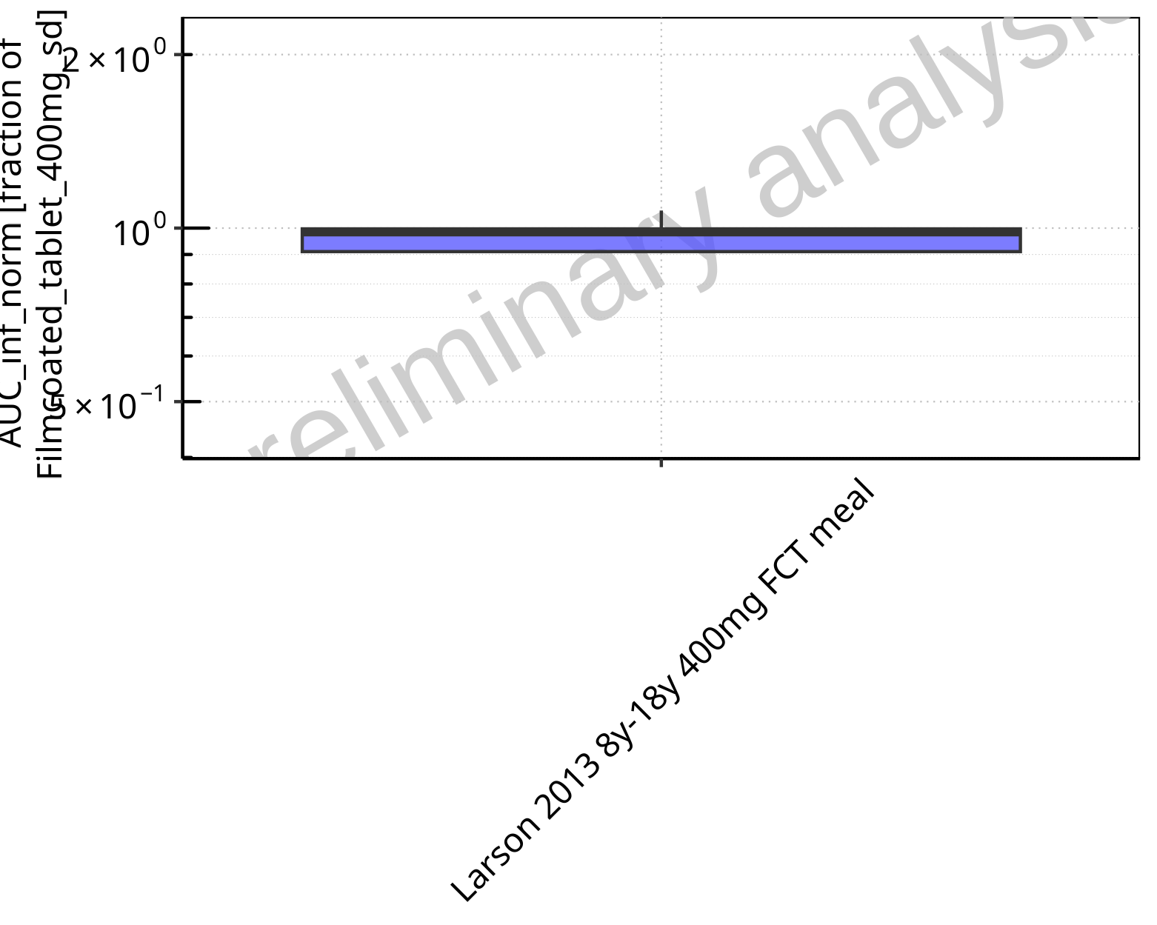

**Figure 2-223: Ratio of population summary statistics of AUC_inf_norm of Raltegravir for Larson 2013 8y-18y 400mg FCT meal in comparison to Filmcoated_tablet_400mg_sd shown as box-whisker plot, which indicates ratios of the 5th, 25th, 50th, 75th, 95th percentiles in logarithmic scale.**

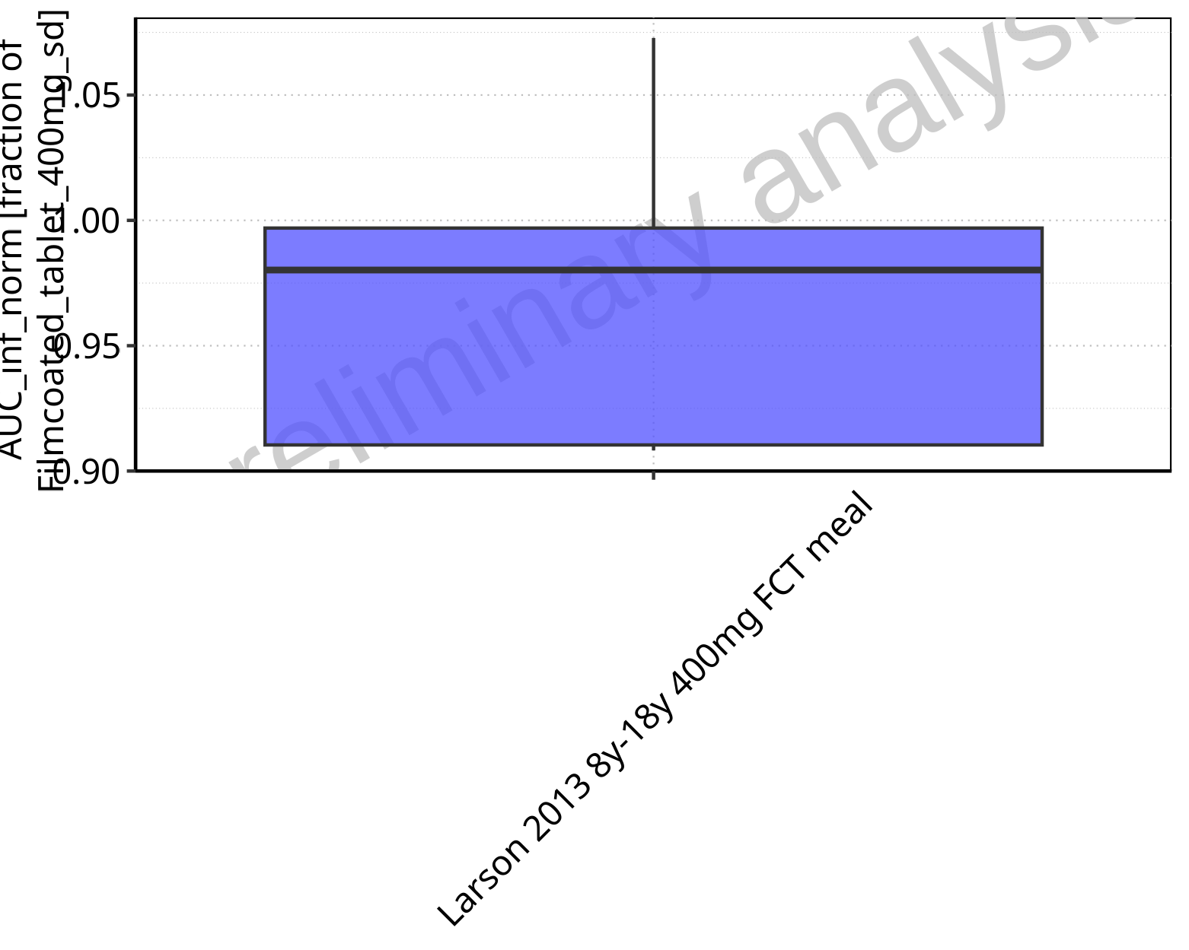

**Figure 2-224: Ratio of population summary statistics of AUC_inf_norm of Raltegravir for Larson 2013 8y-18y 400mg FCT meal in comparison to Filmcoated_tablet_400mg_sd shown as box-whisker plot, which indicates ratios of the 5th, 25th, 50th, 75th, 95th percentiles in linear scale.**

**Table 2-16: Ratio of population summary statistics of AUC_inf_norm of Raltegravir for Larson 2013 8y-18y 400mg FCT meal in comparison to Filmcoated_tablet_400mg_sd**

| Population | N | 5th pctl | 25th pctl | 50th pctl | 75th pctl | 95th pctl | Mean | SD | Geo Mean | Geo SD |
| --- | --- | --- | --- | --- | --- | --- | --- | --- | --- | --- |
| Larson 2013 8y-18y 400mg FCT meal | 500 | 0.91 | 0.91 | 0.98 | 1.00 | 1.07 | 0.99 | 1.24 | 0 | - |

### MRT

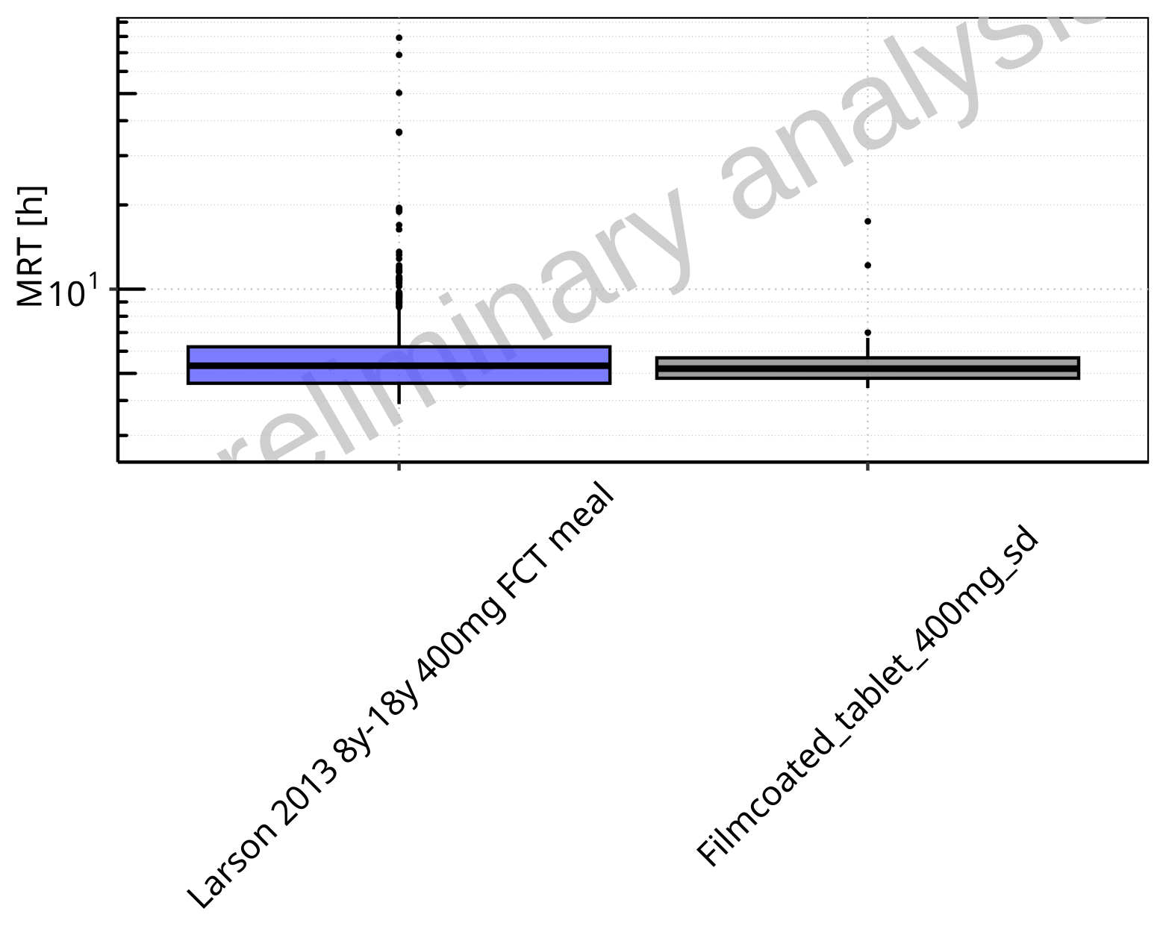

**Figure 2-225: MRT of Raltegravir for Larson 2013 8y-18y 400mg FCT meal, Filmcoated_tablet_400mg_sd shown as box-whisker plot, which indicates the 5th, 25th, 50th, 75th, 95th percentiles in logarithmic scale.**

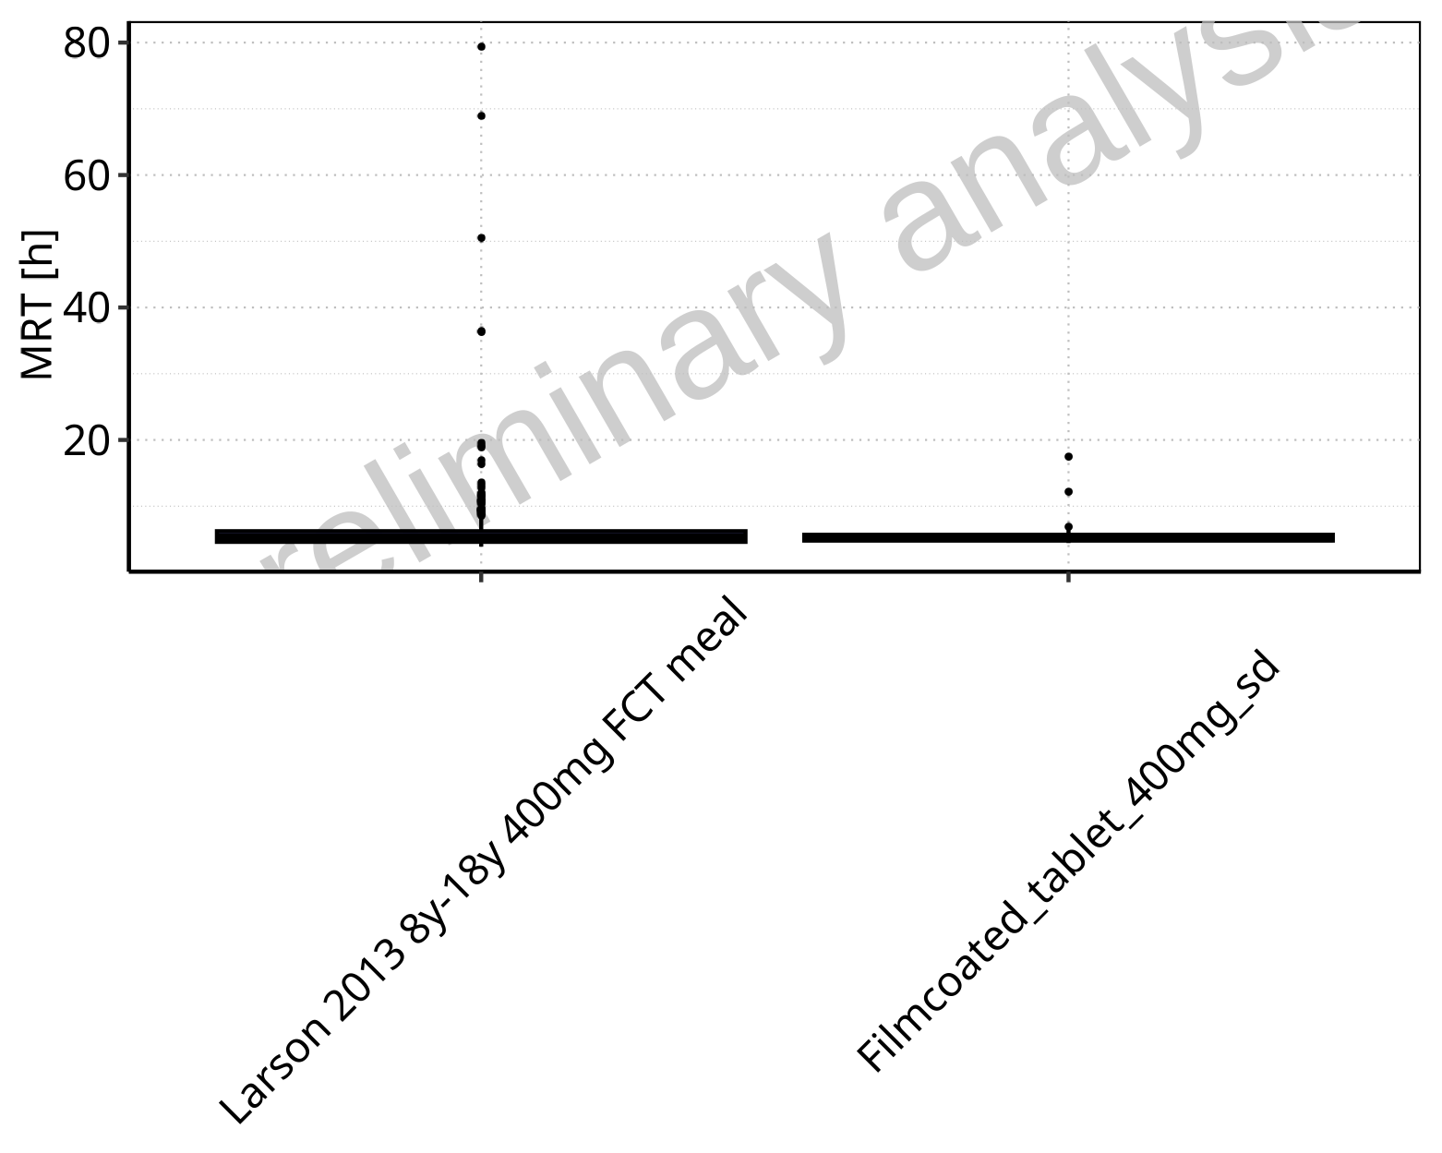

**Figure 2-226: MRT of Raltegravir for Larson 2013 8y-18y 400mg FCT meal, Filmcoated_tablet_400mg_sd shown as box-whisker plot, which indicates the 5th, 25th, 50th, 75th, 95th percentiles in linear scale.**

**Table 2-17: Population statistics summarizing MRT of Raltegravir for Larson 2013 8y-18y 400mg FCT meal, Filmcoated_tablet_400mg_sd reported in [h]**

| Population | N | 5th pctl | 25th pctl | 50th pctl | 75th pctl | 95th pctl | Mean | SD | Geo Mean | Geo SD |
| --- | --- | --- | --- | --- | --- | --- | --- | --- | --- | --- |
| Larson 2013 8y-18y 400mg FCT meal | 497 | 3.88 | 4.61 | 5.32 | 6.22 | 10.31 | 6.26 | 5.56 | 5.64 | 1.44 |
| Filmcoated_tablet_400mg_sd | 100 | 4.43 | 4.80 | 5.20 | 5.68 | 6.70 | 5.44 | 1.54 | 5.32 | 1.21 |

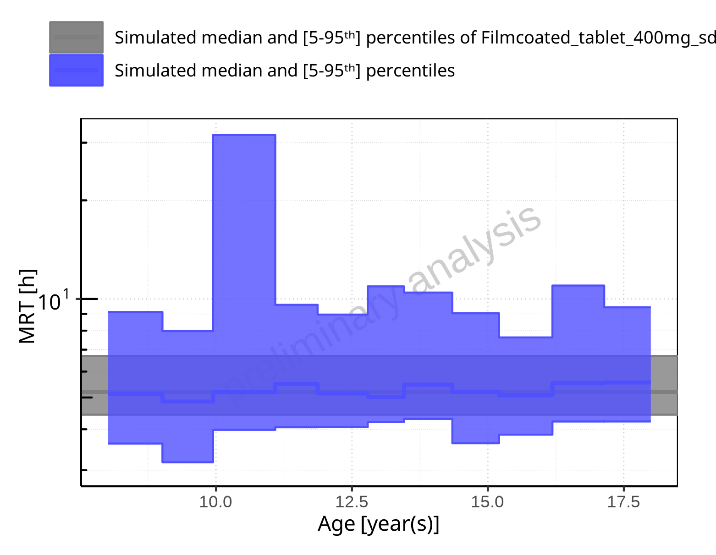

**Figure 2-227: Age-dependence of MRT for Larson 2013 8y-18y 400mg FCT meal in comparison to Filmcoated_tablet_400mg_sd. Profiles are plotted in a logarithmic scale.**

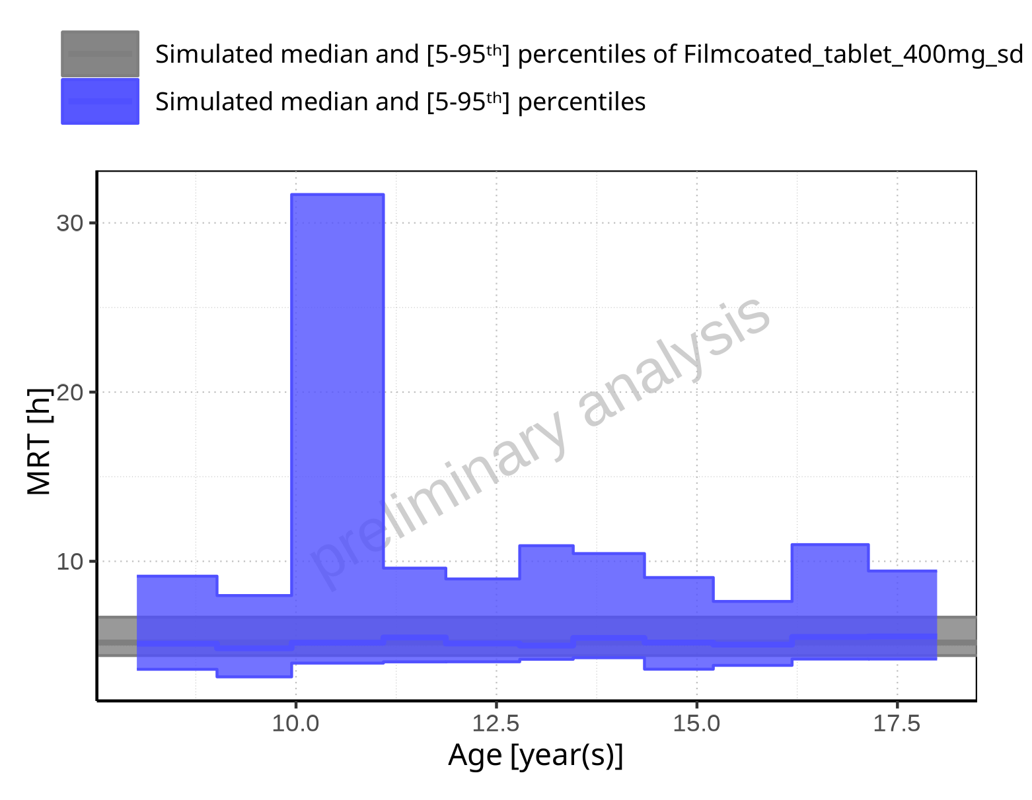

**Figure 2-228: Age-dependence of MRT for Larson 2013 8y-18y 400mg FCT meal in comparison to Filmcoated_tablet_400mg_sd. Profiles are plotted in a linear scale.**

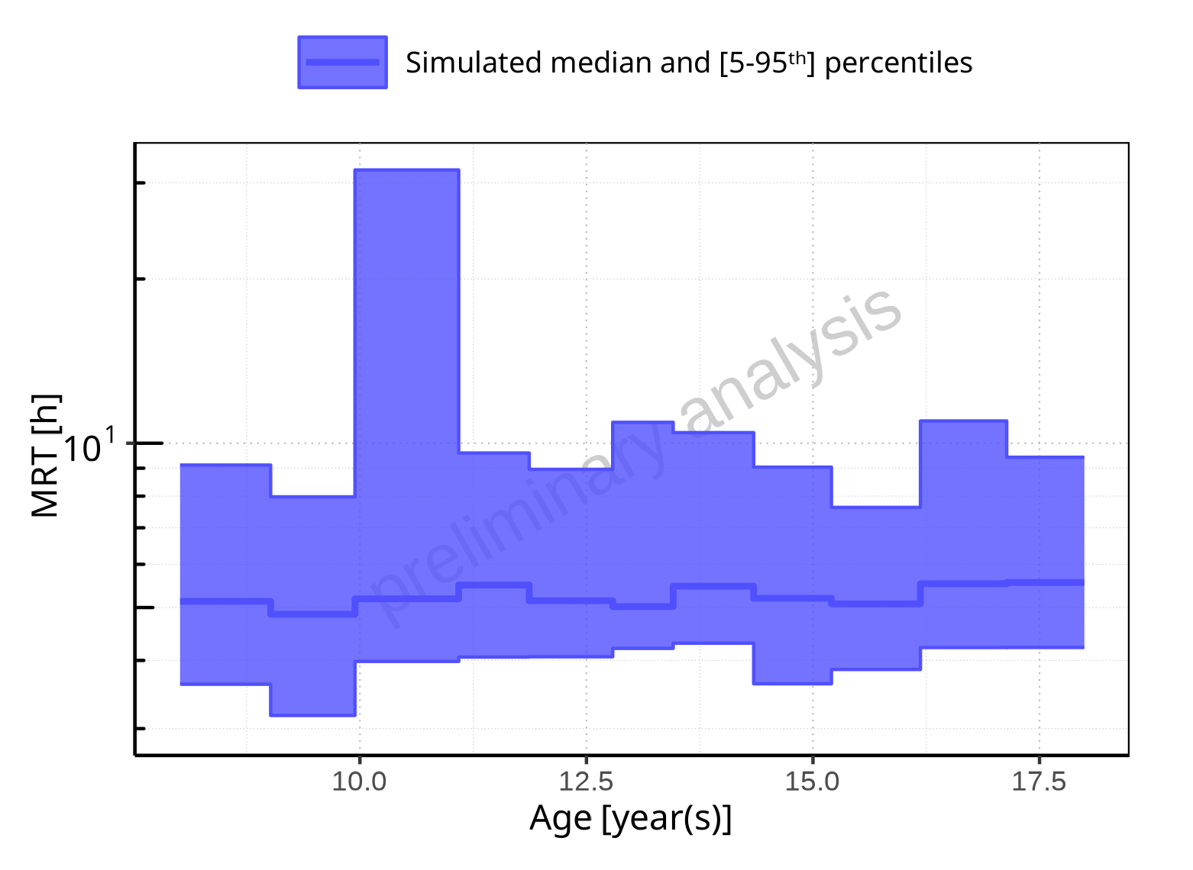

**Figure 2-229: Age-dependence of MRT for Larson 2013 8y-18y 400mg FCT meal. Profiles are plotted in a logarithmic scale.**

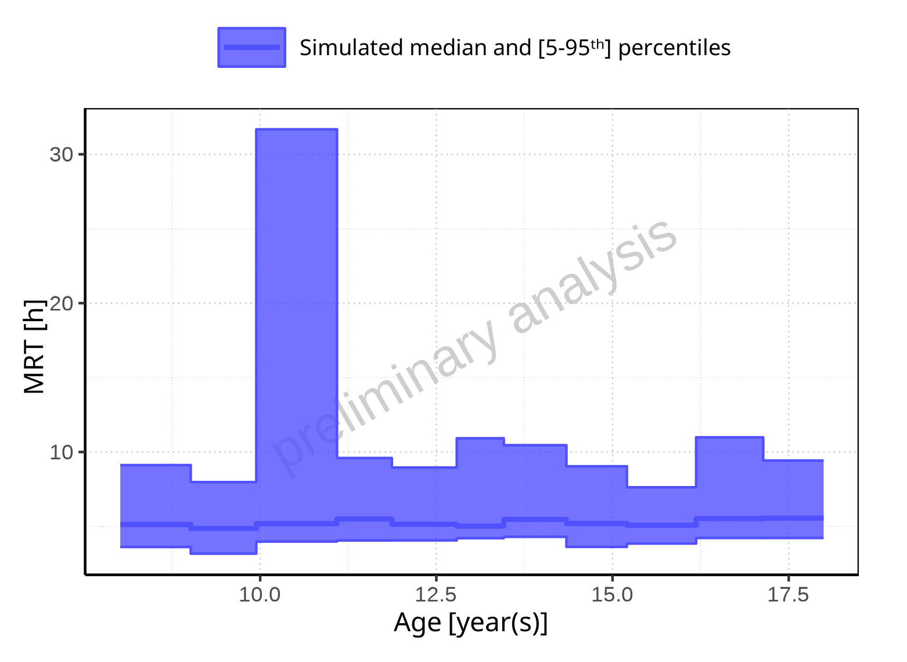

**Figure 2-230: Age-dependence of MRT for Larson 2013 8y-18y 400mg FCT meal. Profiles are plotted in a linear scale.**

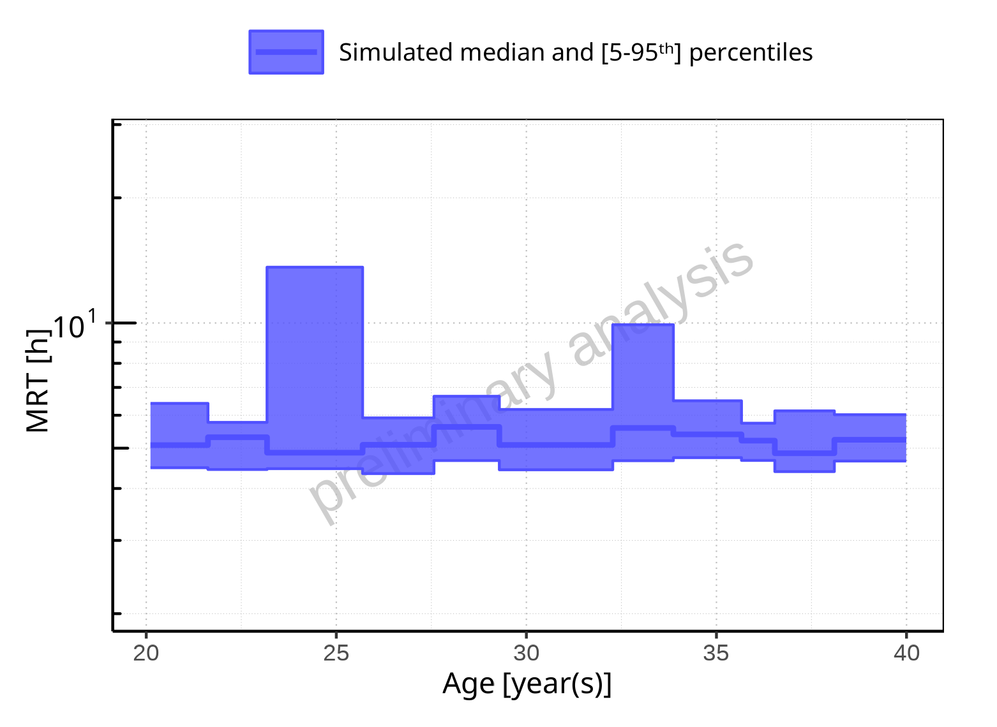

**Figure 2-231: Age-dependence of MRT for Filmcoated_tablet_400mg_sd. Profiles are plotted in a logarithmic scale.**

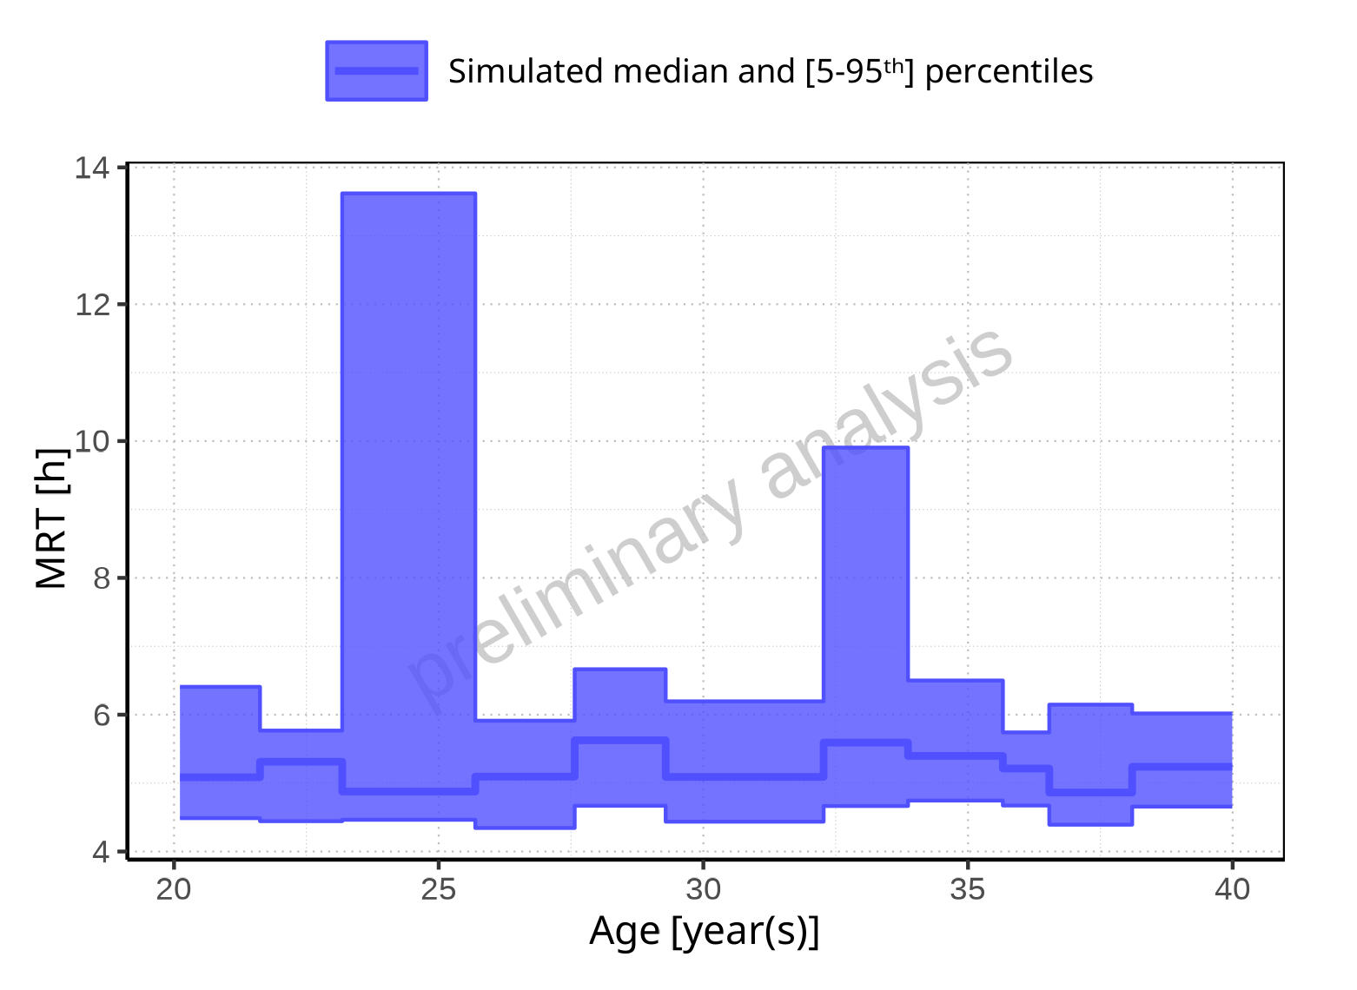

**Figure 2-232: Age-dependence of MRT for Filmcoated_tablet_400mg_sd. Profiles are plotted in a linear scale.**

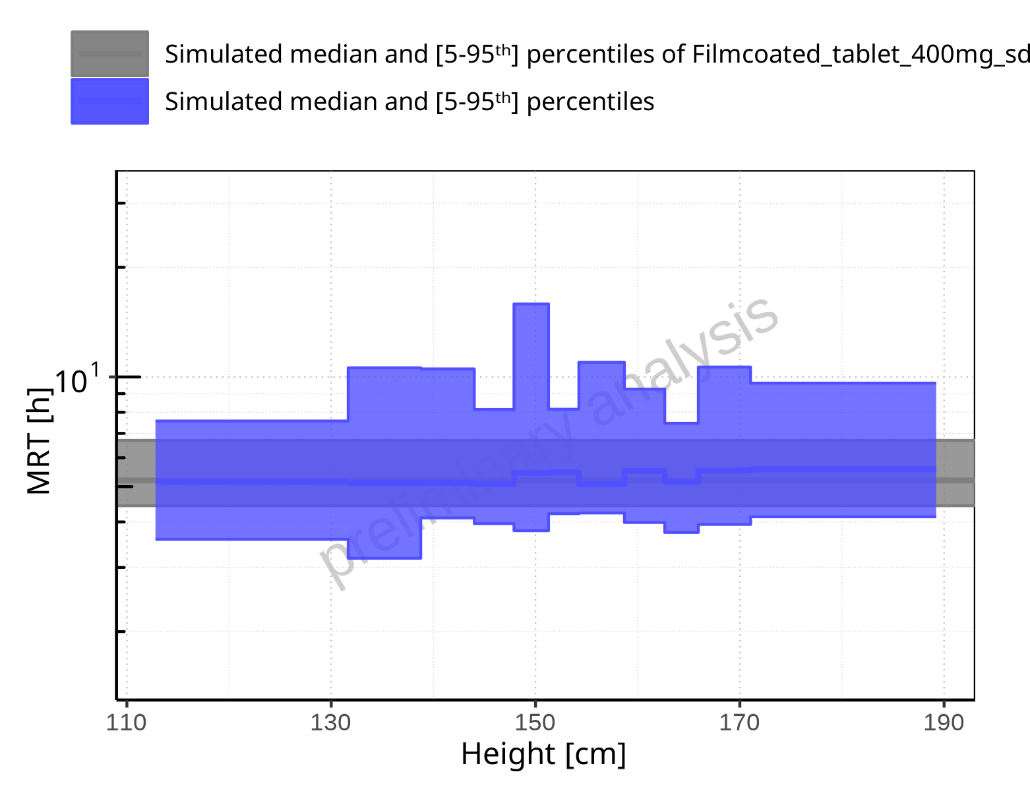

**Figure 2-233: Height-dependence of MRT for Larson 2013 8y-18y 400mg FCT meal in comparison to Filmcoated_tablet_400mg_sd. Profiles are plotted in a logarithmic scale.**

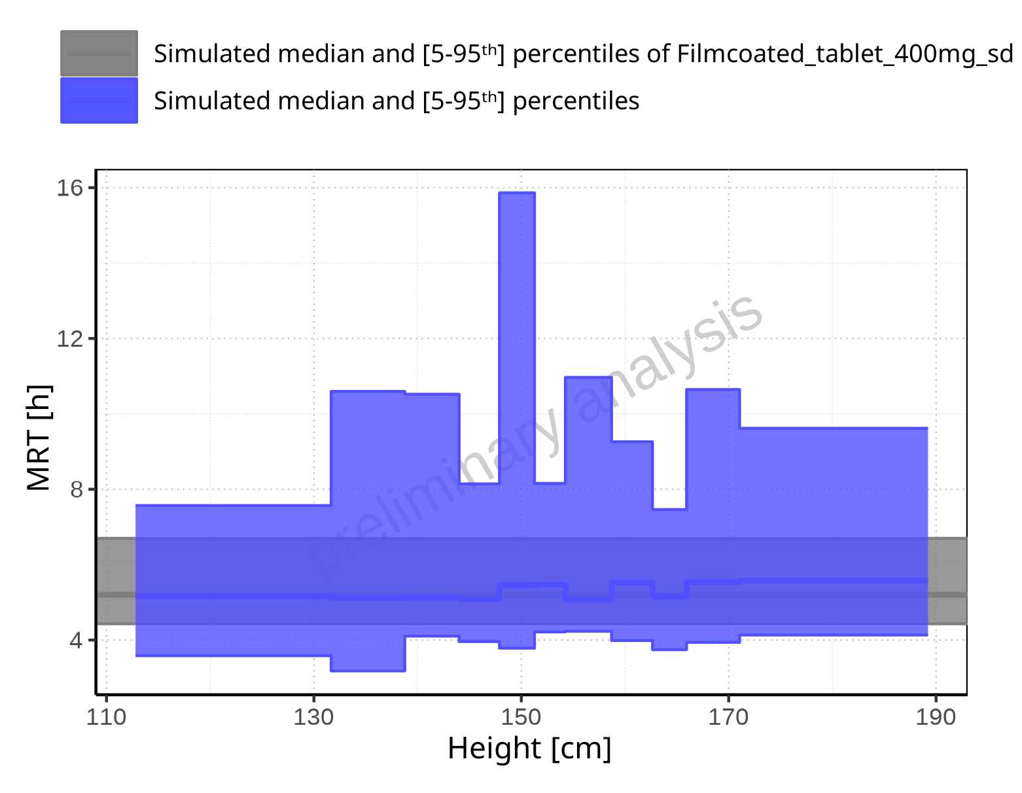

**Figure 2-234: Height-dependence of MRT for Larson 2013 8y-18y 400mg FCT meal in comparison to Filmcoated_tablet_400mg_sd. Profiles are plotted in a linear scale.**

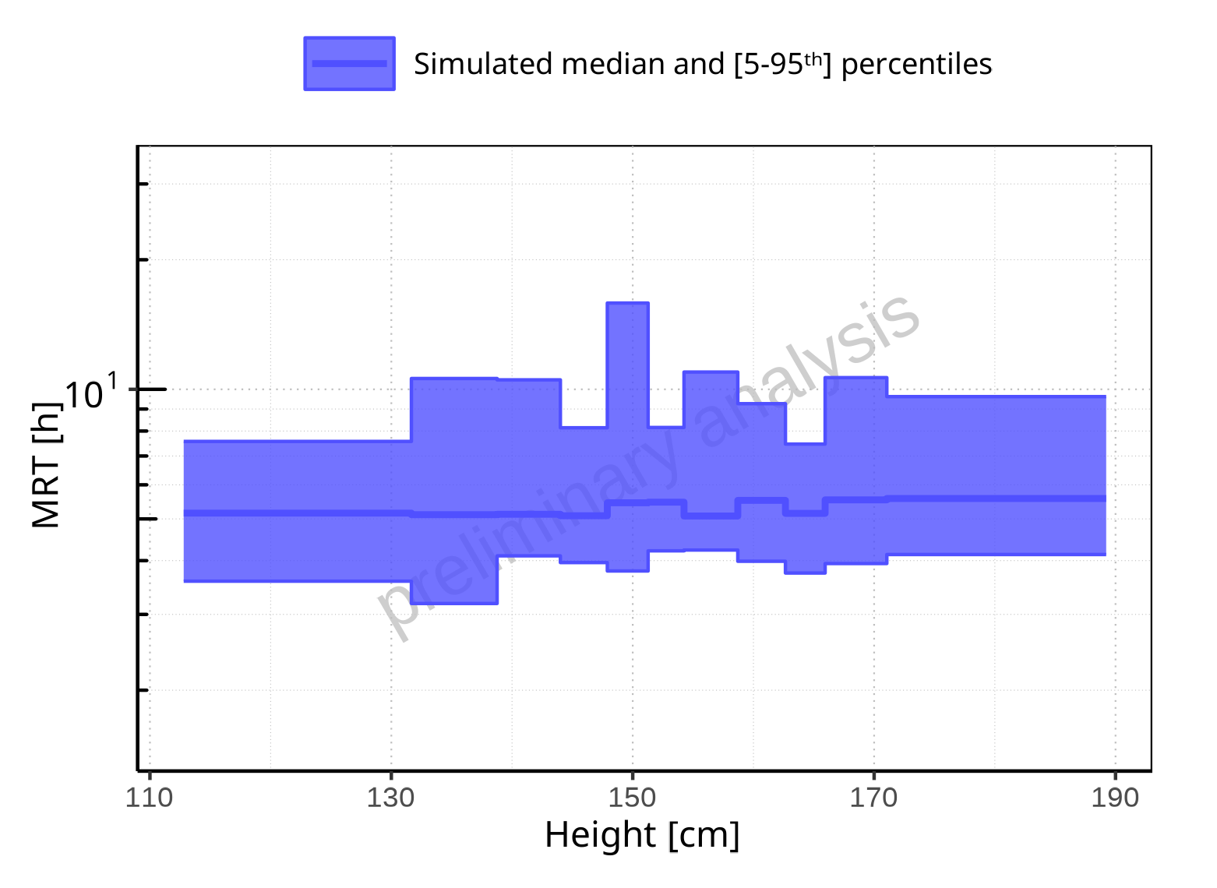

**Figure 2-235: Height-dependence of MRT for Larson 2013 8y-18y 400mg FCT meal. Profiles are plotted in a logarithmic scale.**

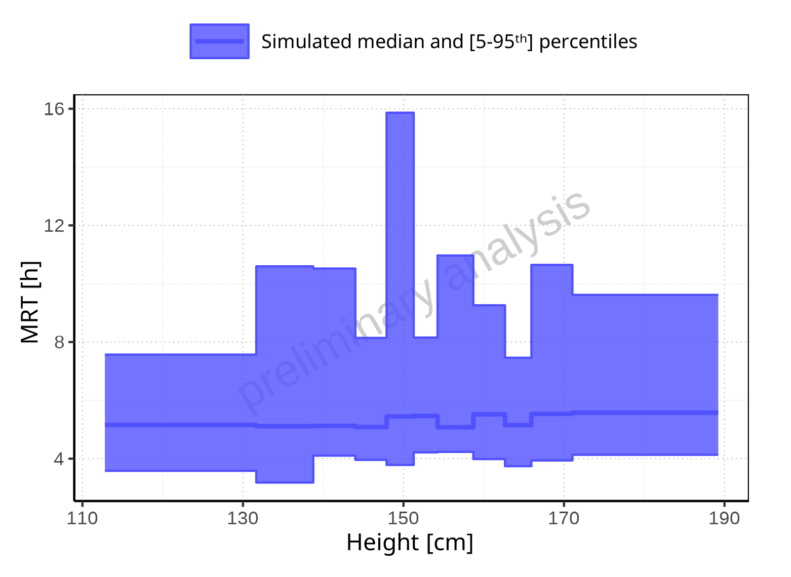

**Figure 2-236: Height-dependence of MRT for Larson 2013 8y-18y 400mg FCT meal. Profiles are plotted in a linear scale.**

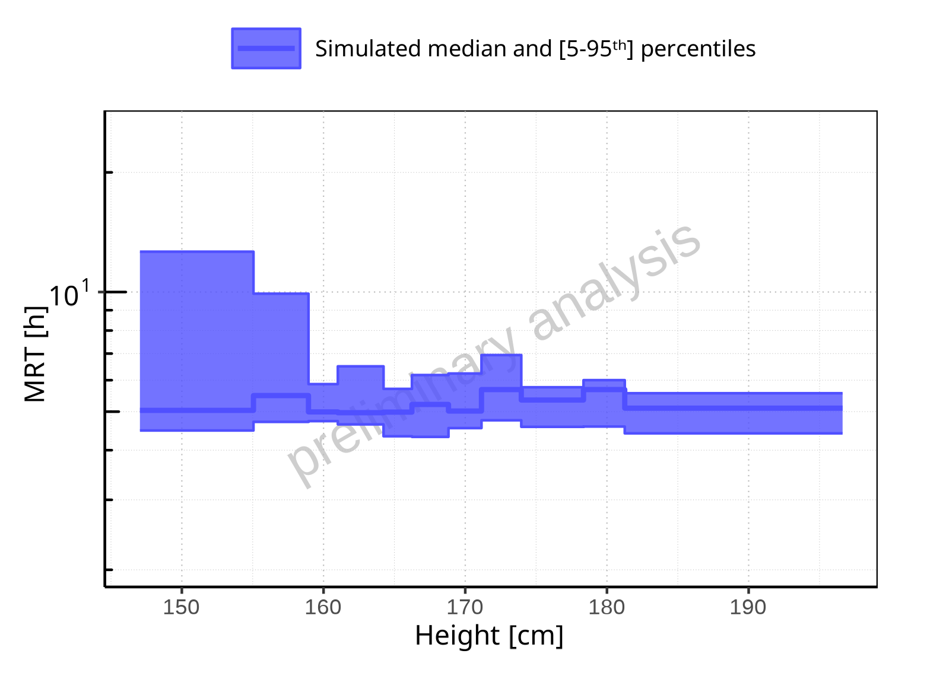

**Figure 2-237: Height-dependence of MRT for Filmcoated_tablet_400mg_sd. Profiles are plotted in a logarithmic scale.**

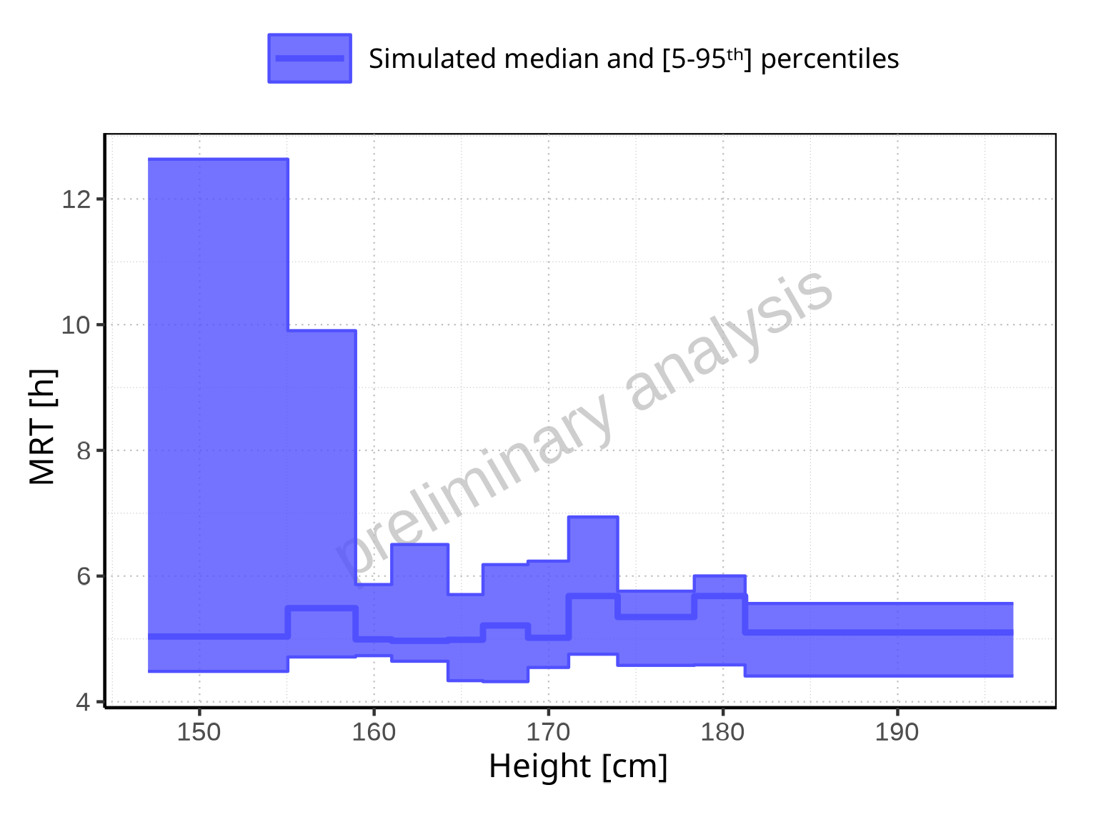

**Figure 2-238: Height-dependence of MRT for Filmcoated_tablet_400mg_sd. Profiles are plotted in a linear scale.**

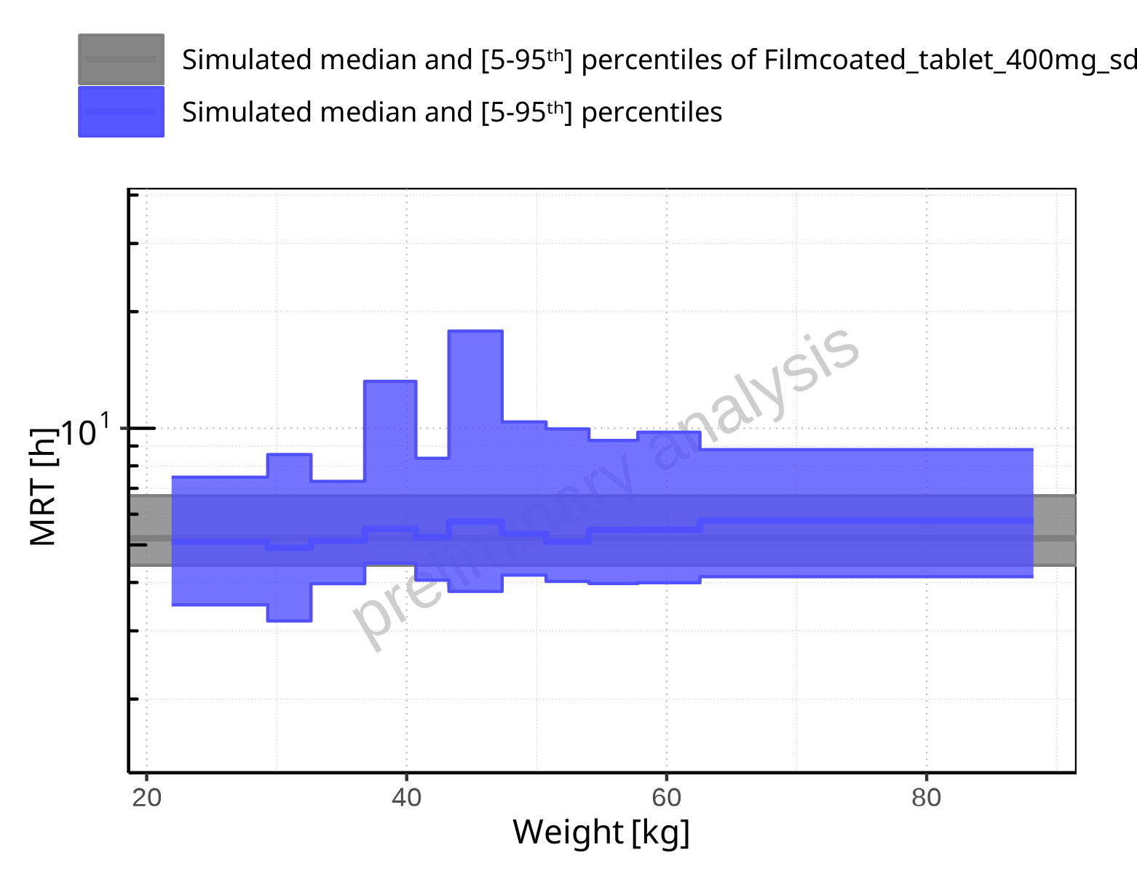

**Figure 2-239: Weight-dependence of MRT for Larson 2013 8y-18y 400mg FCT meal in comparison to Filmcoated_tablet_400mg_sd. Profiles are plotted in a logarithmic scale.**

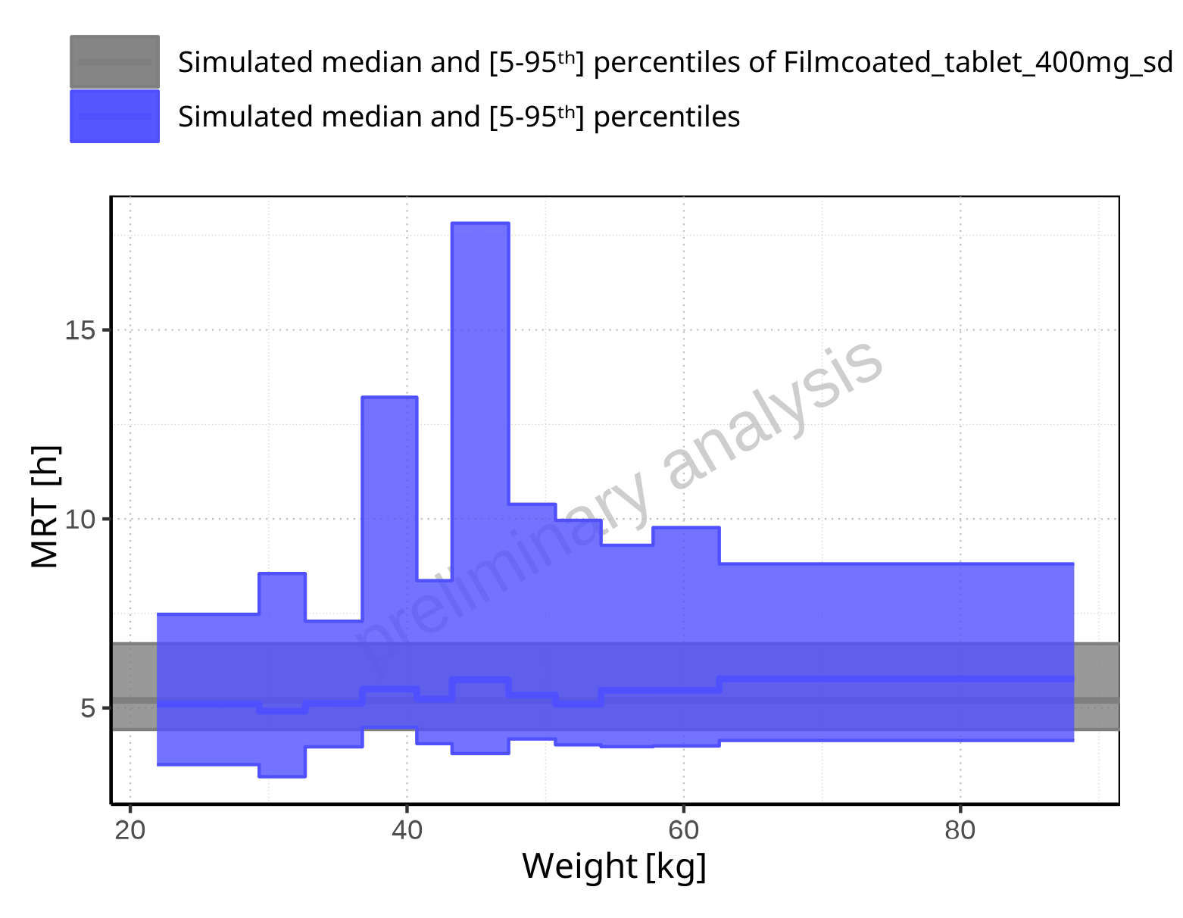

**Figure 2-240: Weight-dependence of MRT for Larson 2013 8y-18y 400mg FCT meal in comparison to Filmcoated_tablet_400mg_sd. Profiles are plotted in a linear scale.**

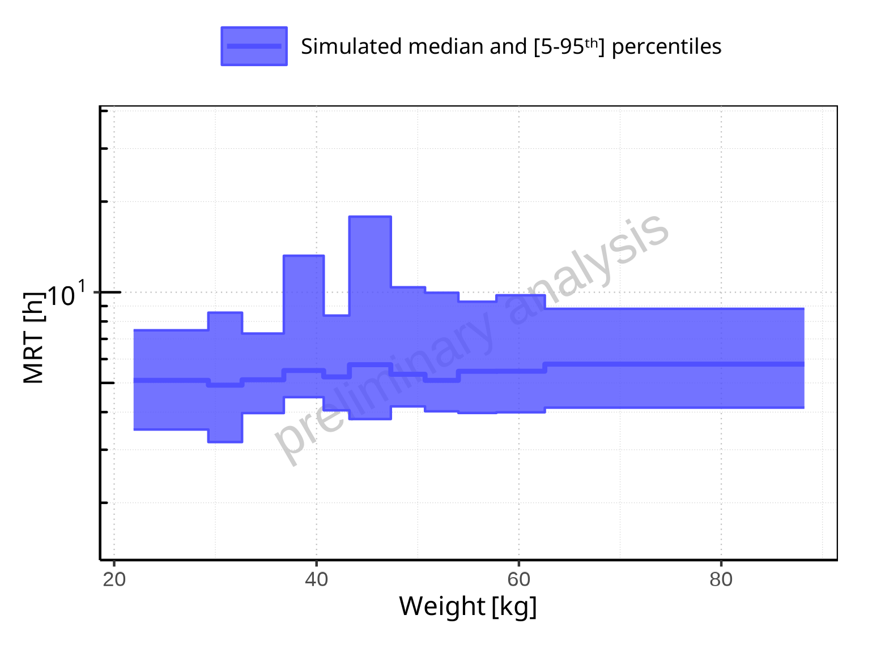

**Figure 2-241: Weight-dependence of MRT for Larson 2013 8y-18y 400mg FCT meal. Profiles are plotted in a logarithmic scale.**

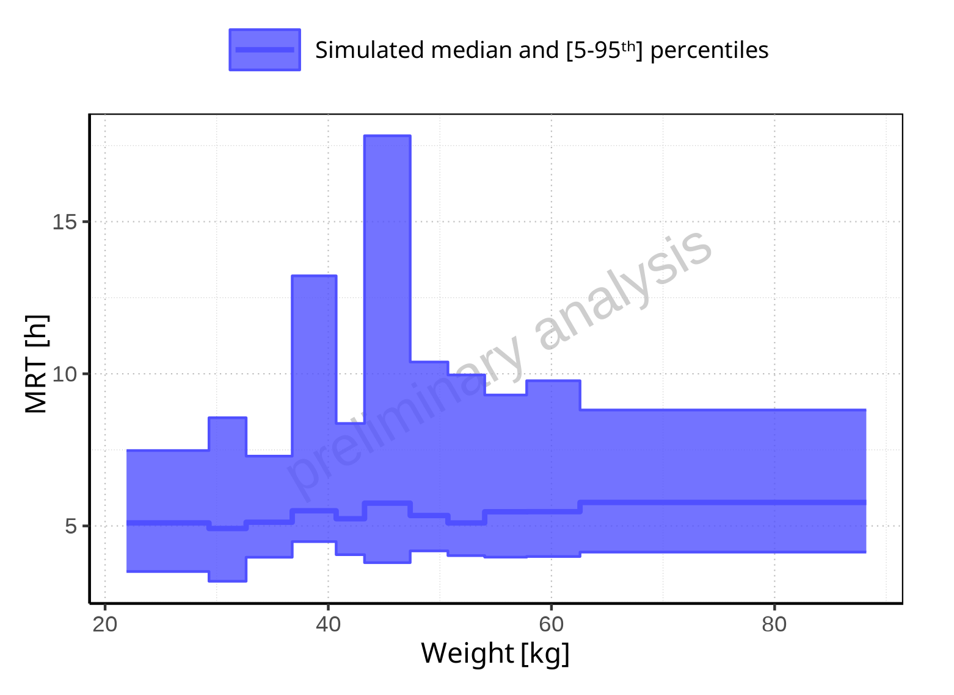

**Figure 2-242: Weight-dependence of MRT for Larson 2013 8y-18y 400mg FCT meal. Profiles are plotted in a linear scale.**

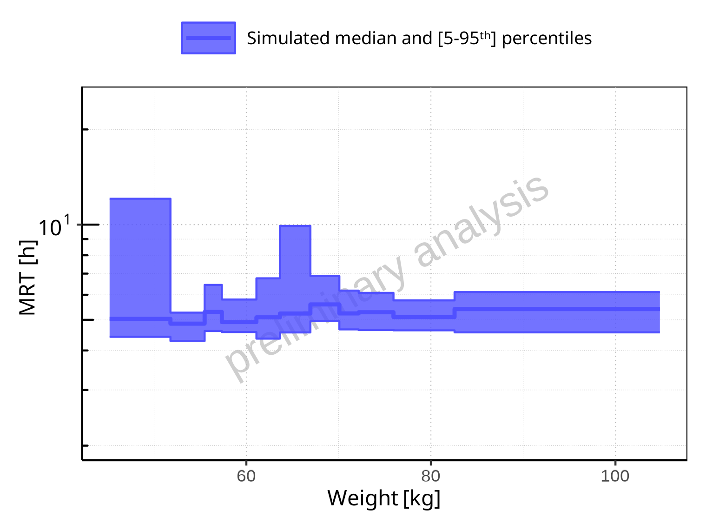

**Figure 2-243: Weight-dependence of MRT for Filmcoated_tablet_400mg_sd. Profiles are plotted in a logarithmic scale.**

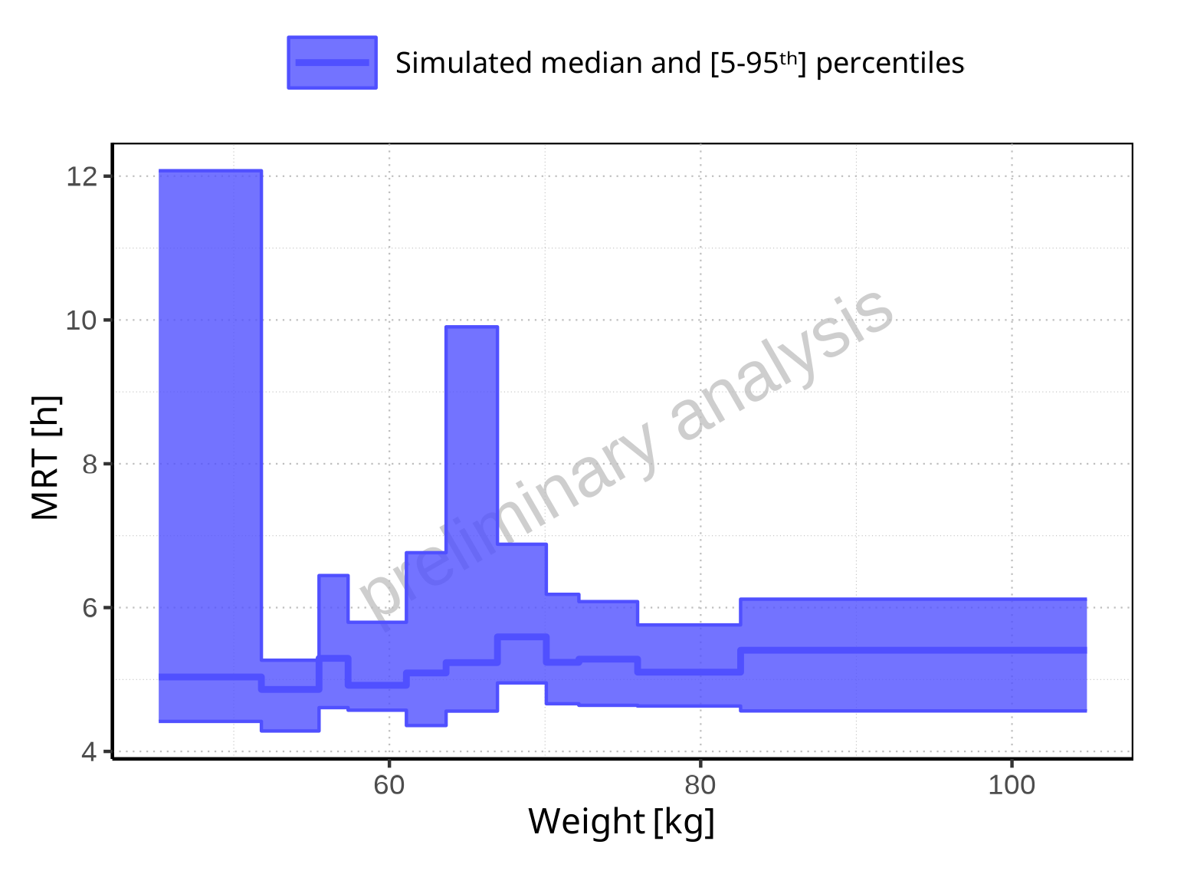

**Figure 2-244: Weight-dependence of MRT for Filmcoated_tablet_400mg_sd. Profiles are plotted in a linear scale.**

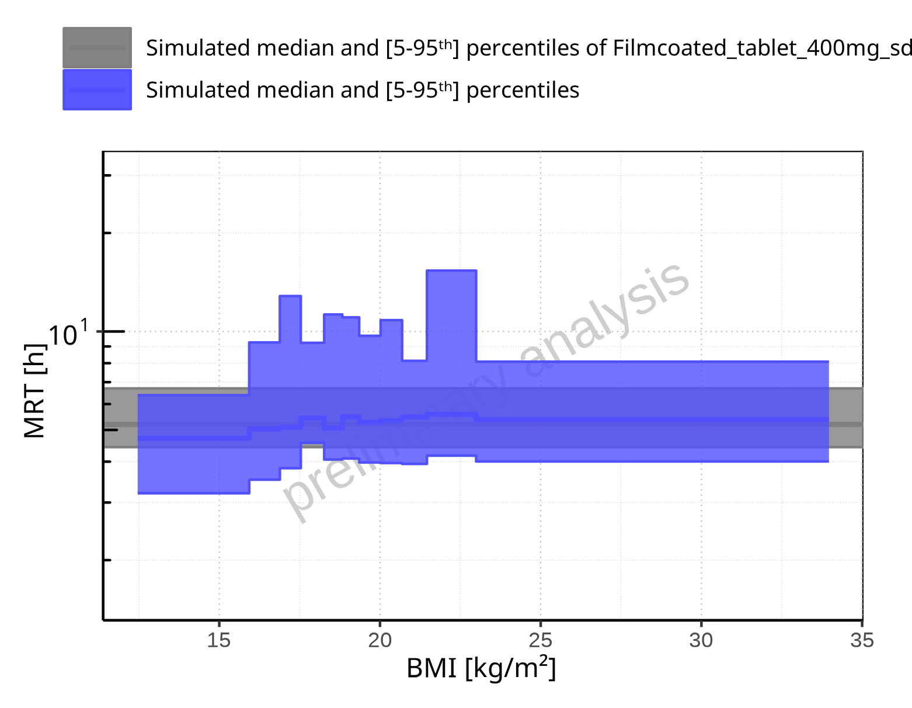

**Figure 2-245: BMI-dependence of MRT for Larson 2013 8y-18y 400mg FCT meal in comparison to Filmcoated_tablet_400mg_sd. Profiles are plotted in a logarithmic scale.**

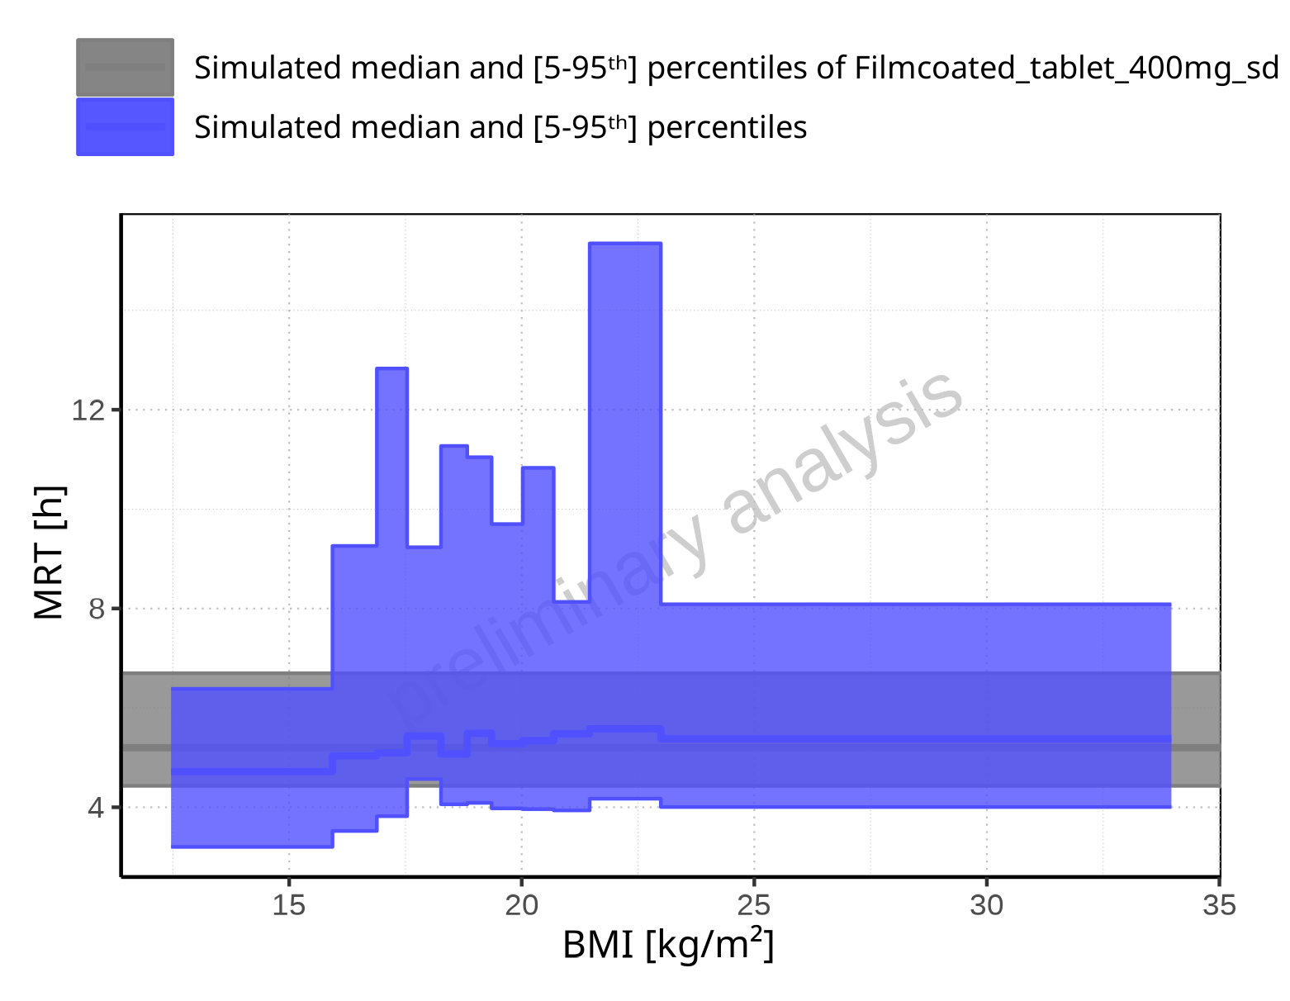

**Figure 2-246: BMI-dependence of MRT for Larson 2013 8y-18y 400mg FCT meal in comparison to Filmcoated_tablet_400mg_sd. Profiles are plotted in a linear scale.**

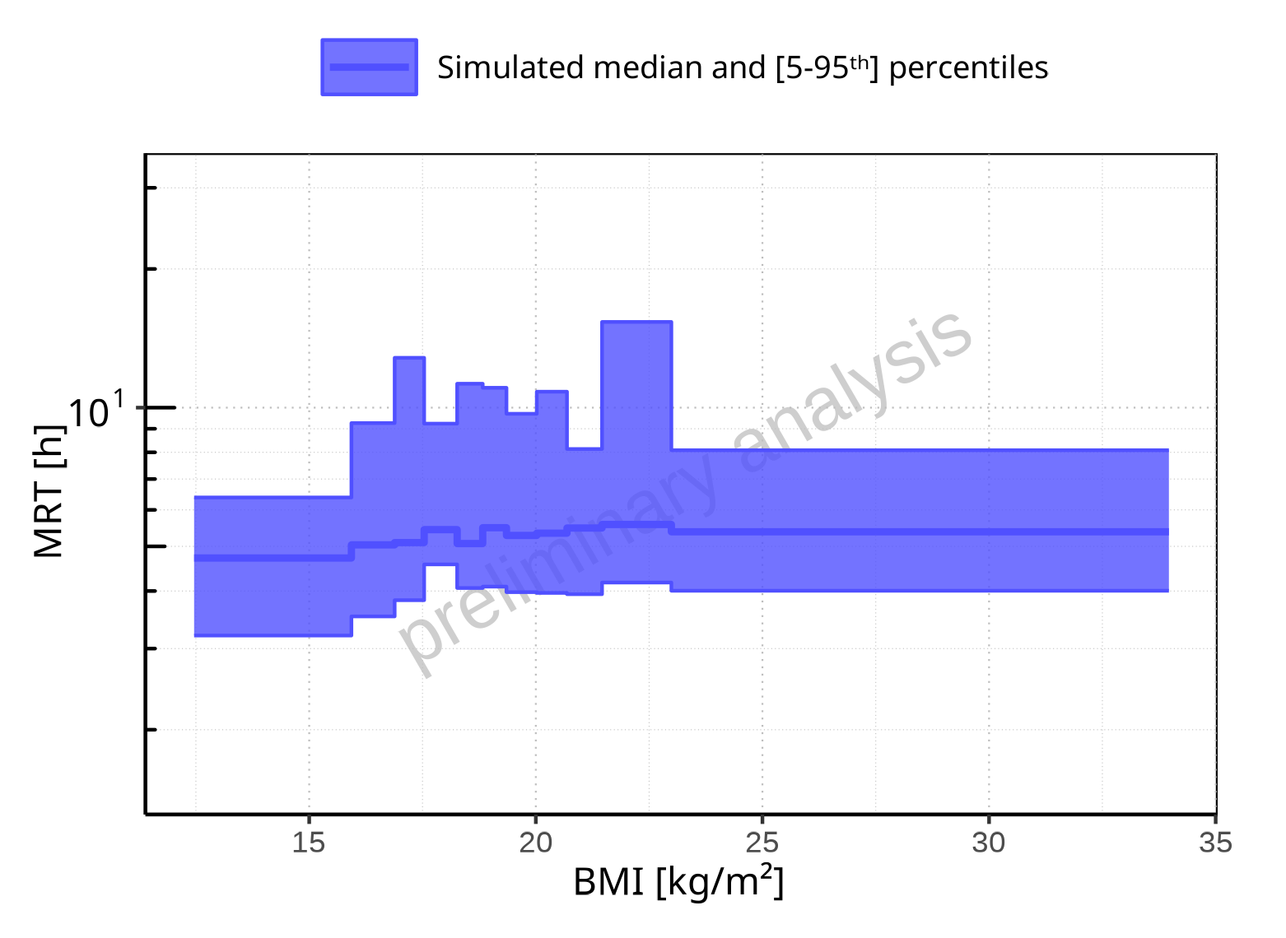

**Figure 2-247: BMI-dependence of MRT for Larson 2013 8y-18y 400mg FCT meal. Profiles are plotted in a logarithmic scale.**

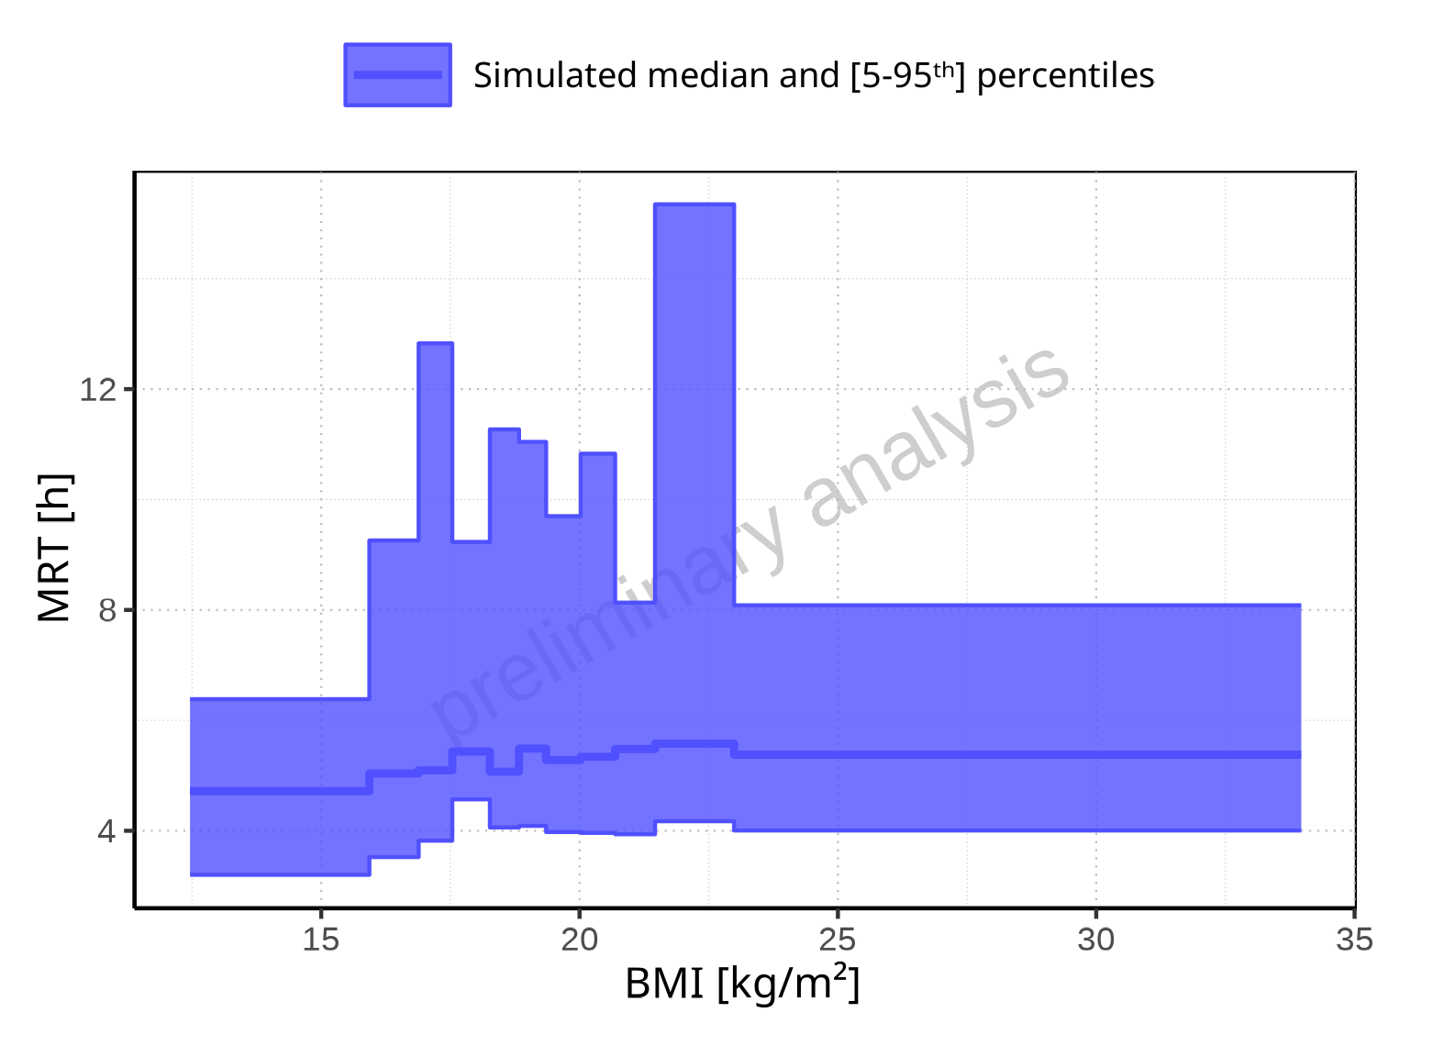

**Figure 2-248: BMI-dependence of MRT for Larson 2013 8y-18y 400mg FCT meal. Profiles are plotted in a linear scale.**

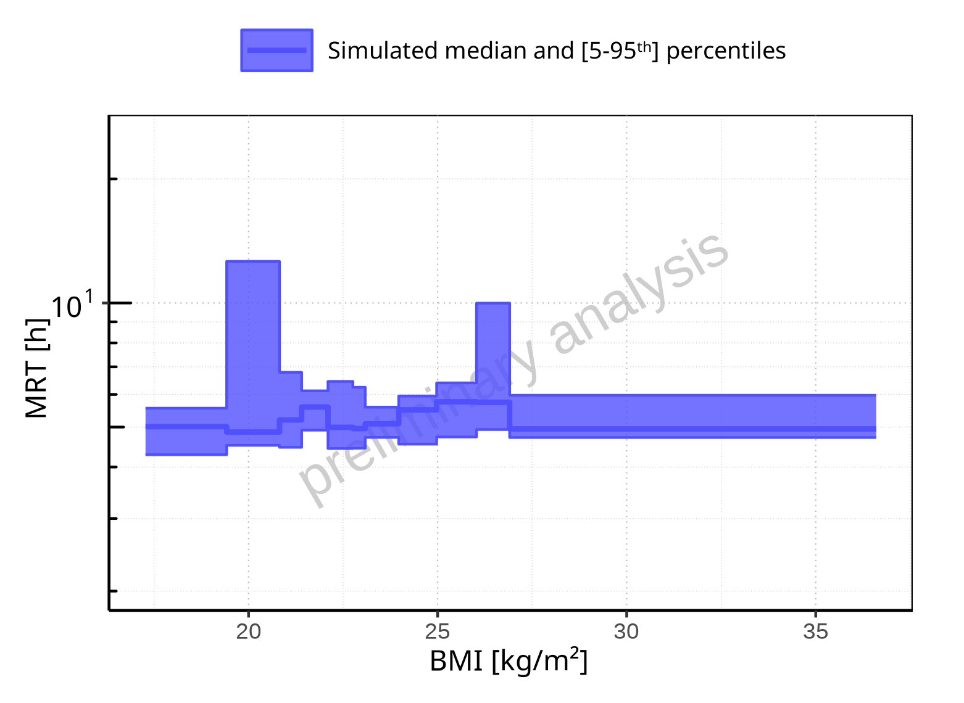

**Figure 2-249: BMI-dependence of MRT for Filmcoated_tablet_400mg_sd. Profiles are plotted in a logarithmic scale.**

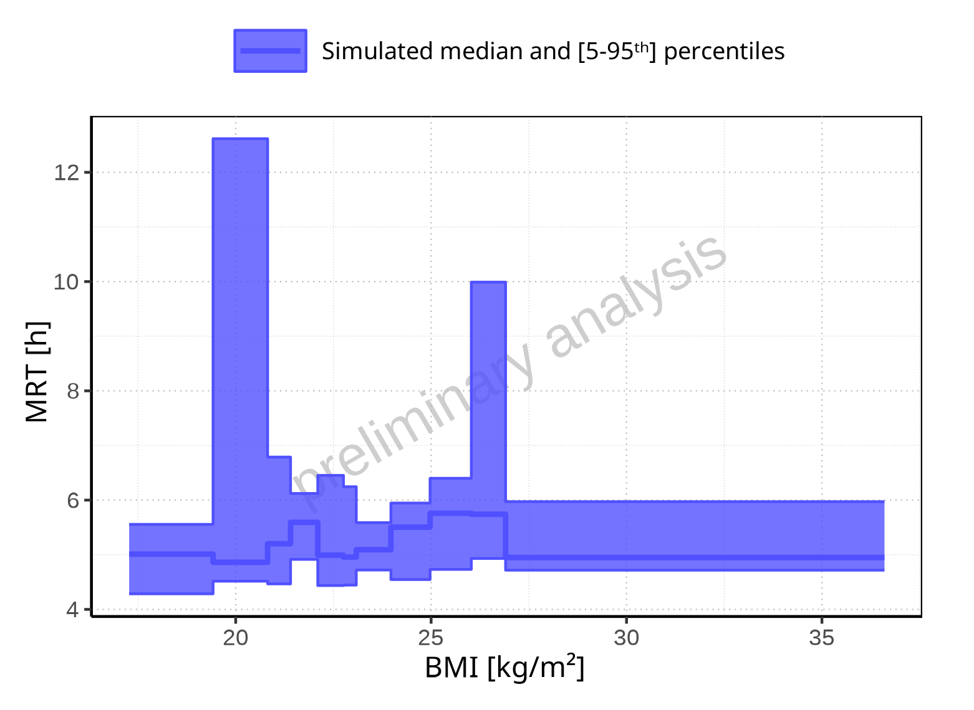

**Figure 2-250: BMI-dependence of MRT for Filmcoated_tablet_400mg_sd. Profiles are plotted in a linear scale.**

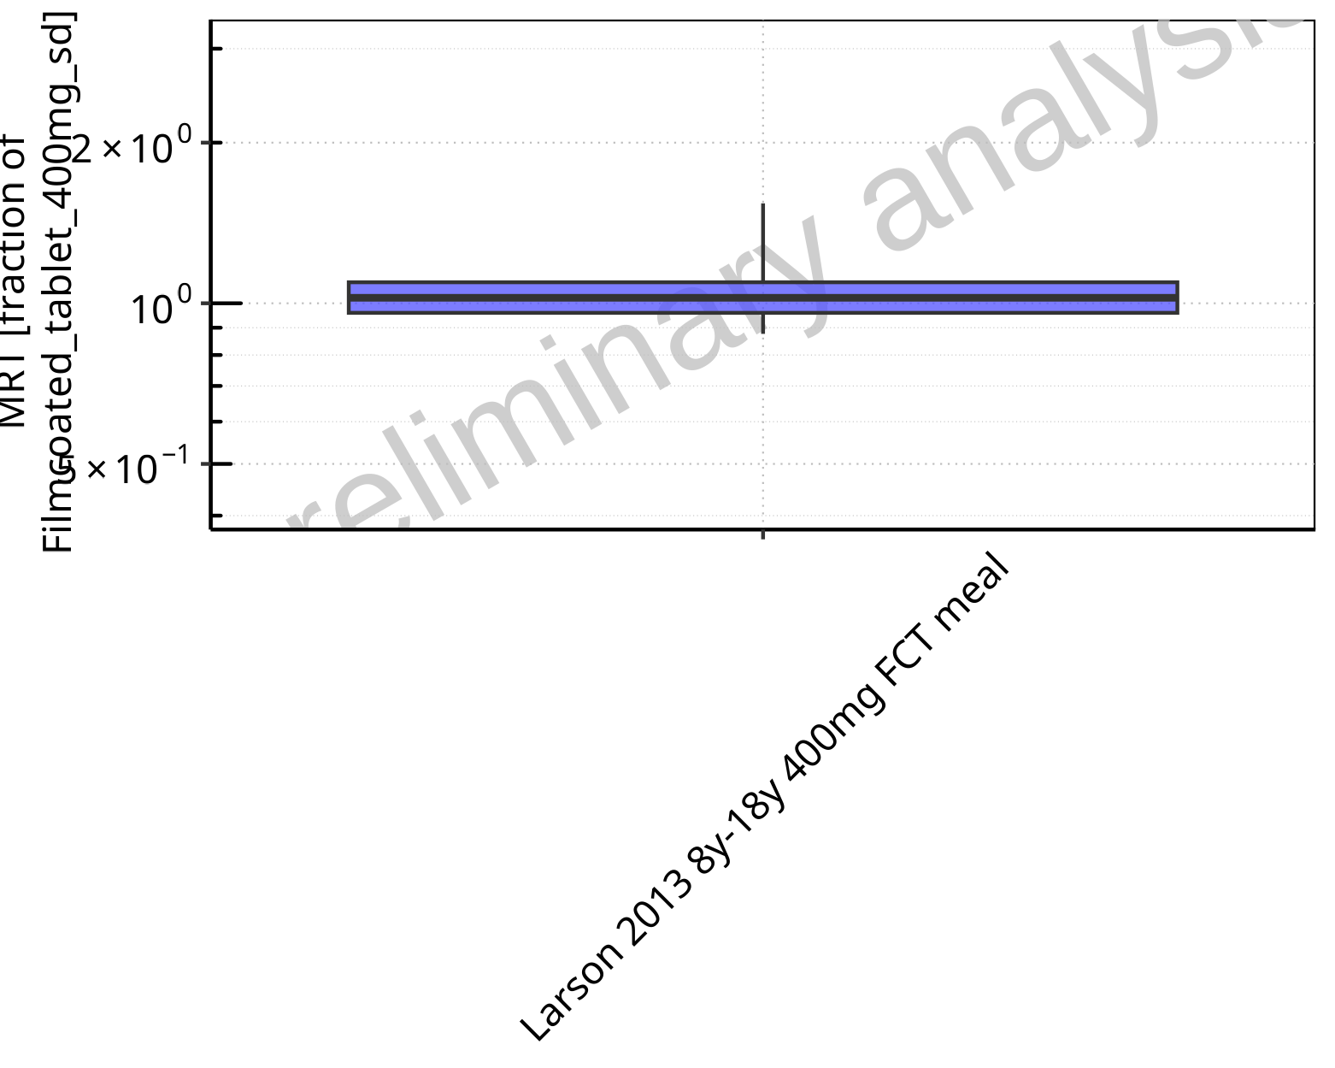

**Figure 2-251: Ratio of population summary statistics of MRT of Raltegravir for Larson 2013 8y-18y 400mg FCT meal in comparison to Filmcoated_tablet_400mg_sd shown as box-whisker plot, which indicates ratios of the 5th, 25th, 50th, 75th, 95th percentiles in logarithmic scale.**

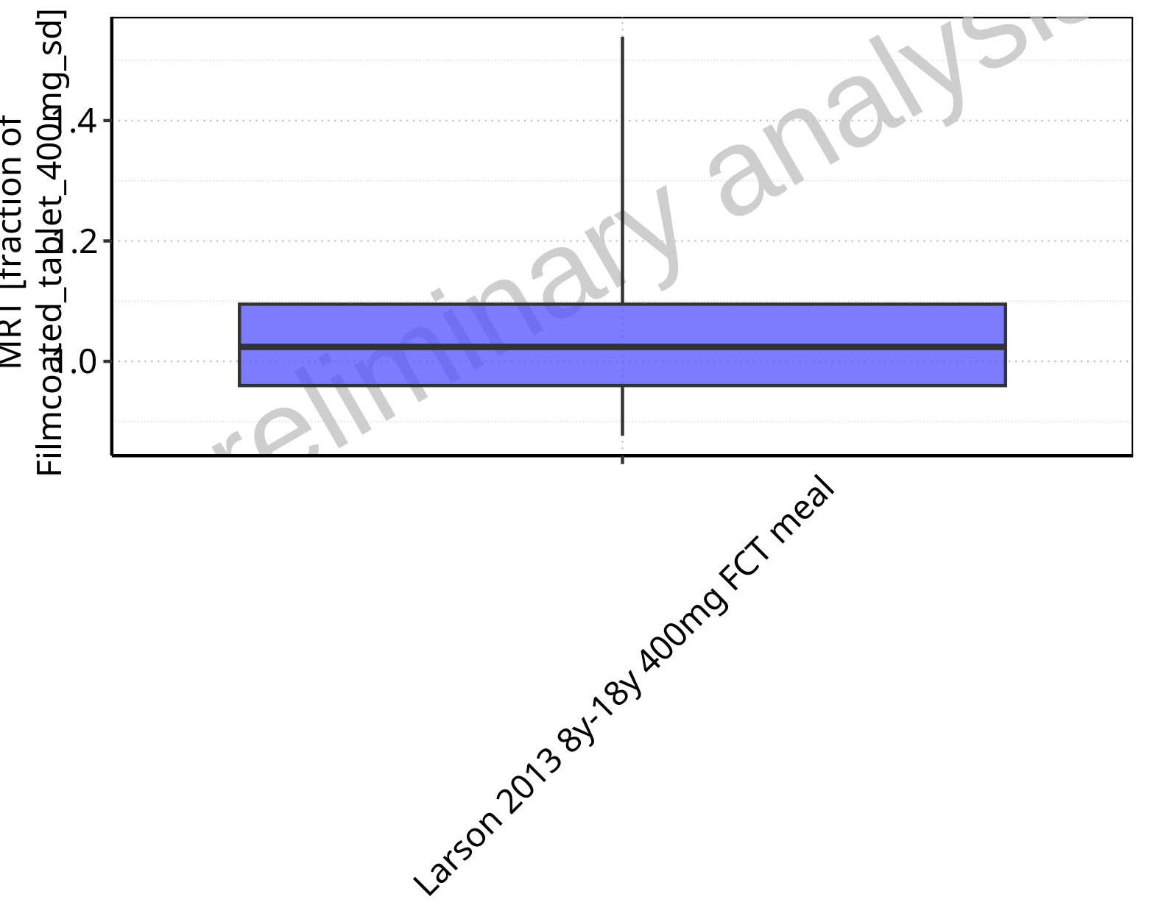

**Figure 2-252: Ratio of population summary statistics of MRT of Raltegravir for Larson 2013 8y-18y 400mg FCT meal in comparison to Filmcoated_tablet_400mg_sd shown as box-whisker plot, which indicates ratios of the 5th, 25th, 50th, 75th, 95th percentiles in linear scale.**

**Table 2-18: Ratio of population summary statistics of MRT of Raltegravir for Larson 2013 8y-18y 400mg FCT meal in comparison to Filmcoated_tablet_400mg_sd**

| Population | N | 5th pctl | 25th pctl | 50th pctl | 75th pctl | 95th pctl | Mean | SD | Geo Mean | Geo SD |
| --- | --- | --- | --- | --- | --- | --- | --- | --- | --- | --- |
| Larson 2013 8y-18y 400mg FCT meal | 497 | 0.88 | 0.96 | 1.02 | 1.09 | 1.54 | 1.15 | 3.62 | 1.06 | 1.19 |

### Thalf

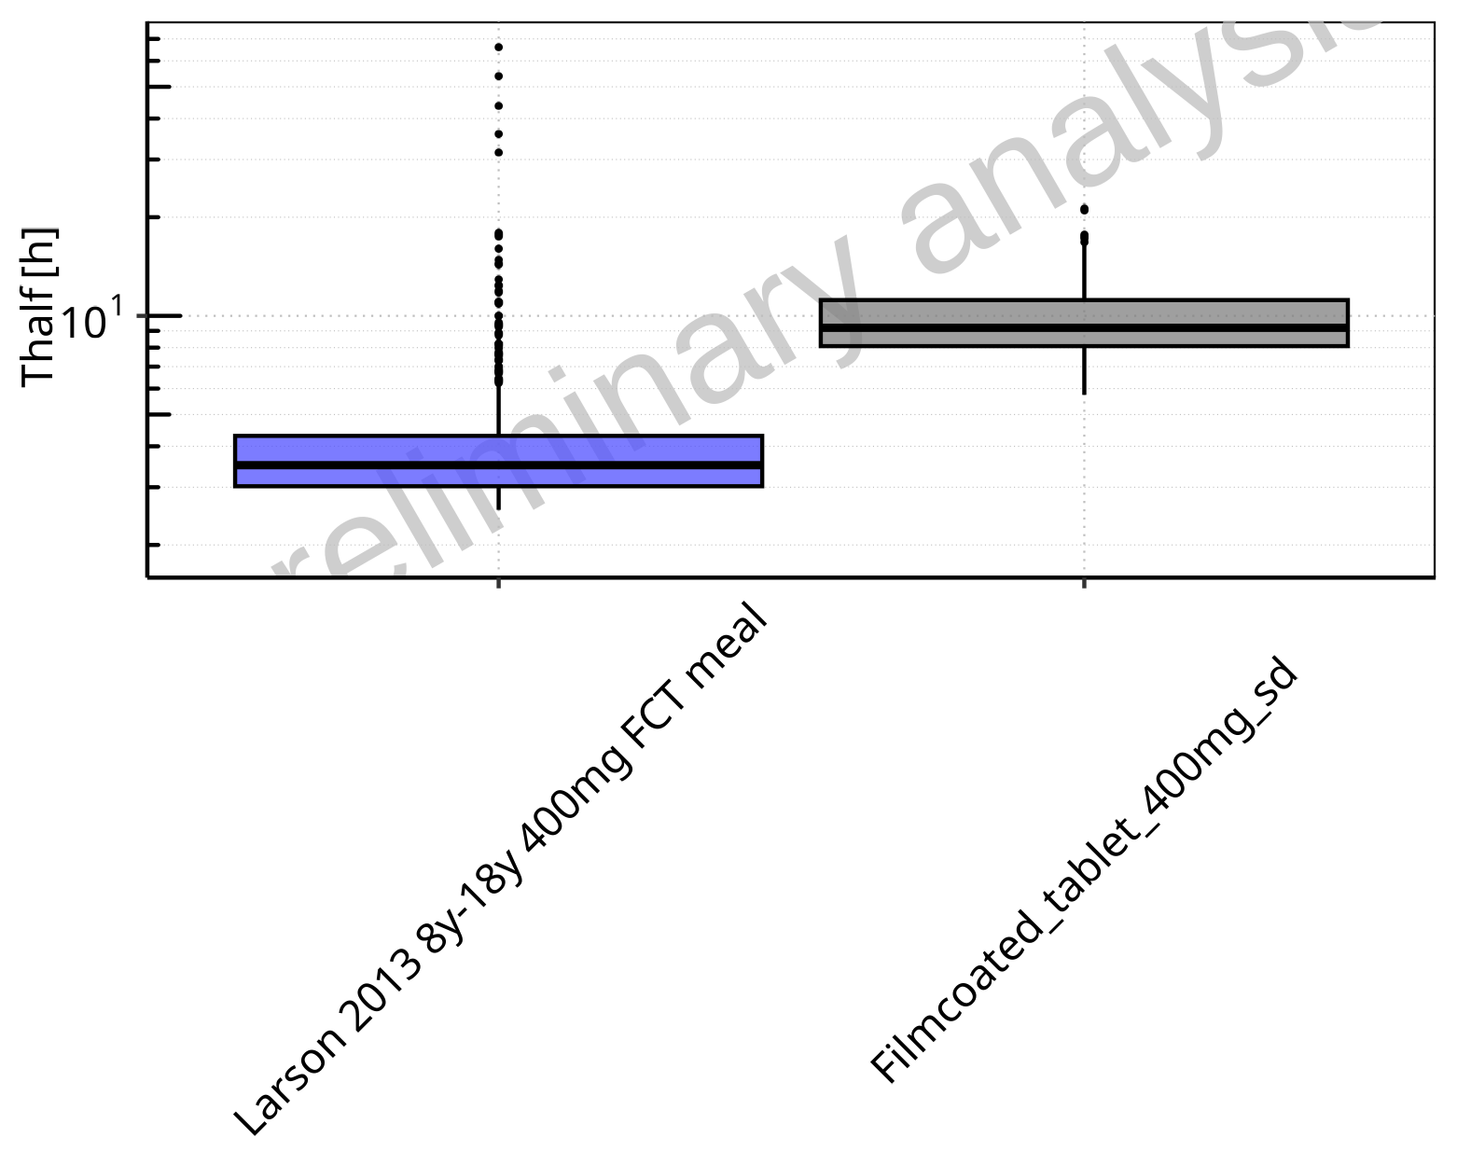

**Figure 2-253: Thalf of Raltegravir for Larson 2013 8y-18y 400mg FCT meal, Filmcoated_tablet_400mg_sd shown as box-whisker plot, which indicates the 5th, 25th, 50th, 75th, 95th percentiles in logarithmic scale.**

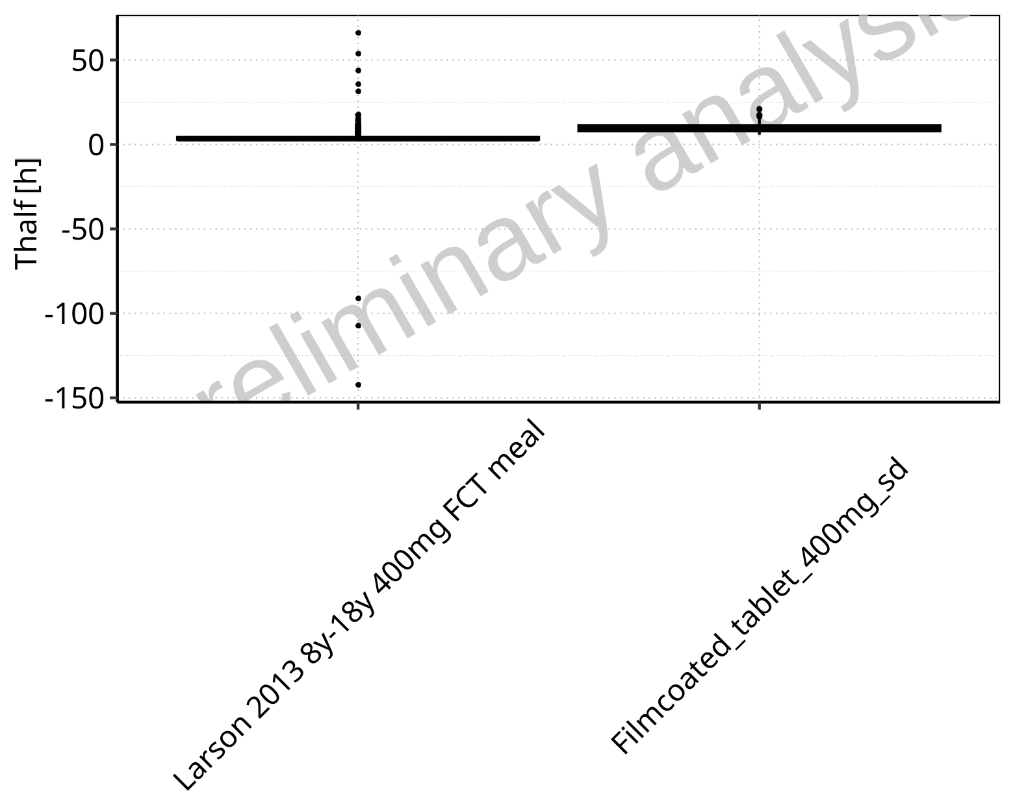

**Figure 2-254: Thalf of Raltegravir for Larson 2013 8y-18y 400mg FCT meal, Filmcoated_tablet_400mg_sd shown as box-whisker plot, which indicates the 5th, 25th, 50th, 75th, 95th percentiles in linear scale.**

**Table 2-19: Population statistics summarizing Thalf of Raltegravir for Larson 2013 8y-18y 400mg FCT meal, Filmcoated_tablet_400mg_sd reported in [h]**

| Population | N | 5th pctl | 25th pctl | 50th pctl | 75th pctl | 95th pctl | Mean | SD | Geo Mean | Geo SD |
| --- | --- | --- | --- | --- | --- | --- | --- | --- | --- | --- |
| Larson 2013 8y-18y 400mg FCT meal | 500 | 2.55 | 3.01 | 3.49 | 4.30 | 9.43 | 3.90 | 10.49 | - | - |
| Filmcoated_tablet_400mg_sd | 100 | 5.74 | 8.08 | 9.20 | 11.18 | 16.81 | 9.99 | 3.18 | 9.55 | 1.35 |

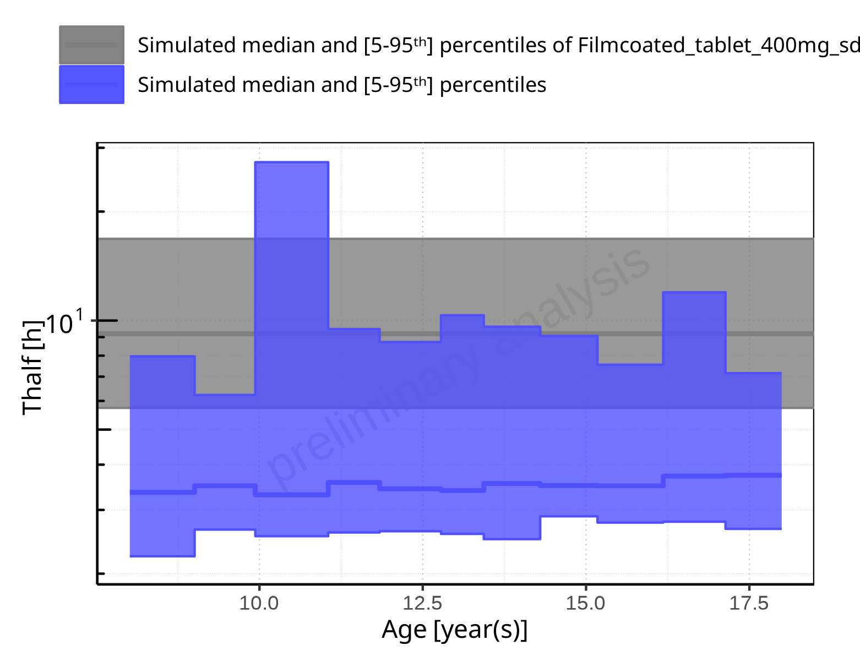

**Figure 2-255: Age-dependence of Thalf for Larson 2013 8y-18y 400mg FCT meal in comparison to Filmcoated_tablet_400mg_sd. Profiles are plotted in a logarithmic scale.**

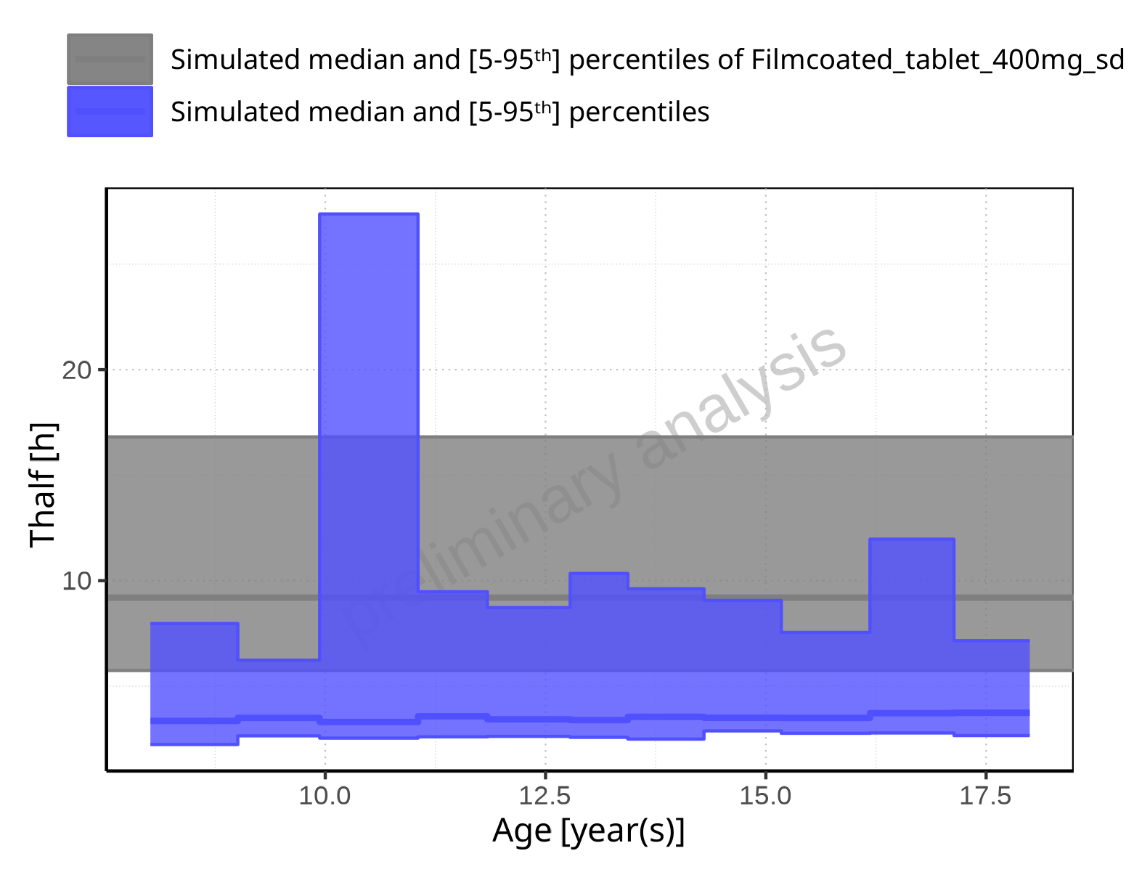

**Figure 2-256: Age-dependence of Thalf for Larson 2013 8y-18y 400mg FCT meal in comparison to Filmcoated_tablet_400mg_sd. Profiles are plotted in a linear scale.**

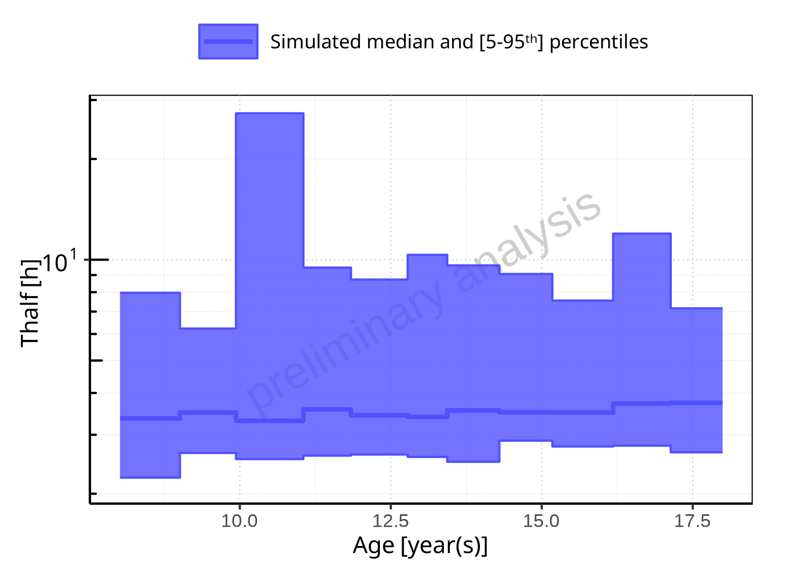

**Figure 2-257: Age-dependence of Thalf for Larson 2013 8y-18y 400mg FCT meal. Profiles are plotted in a logarithmic scale.**

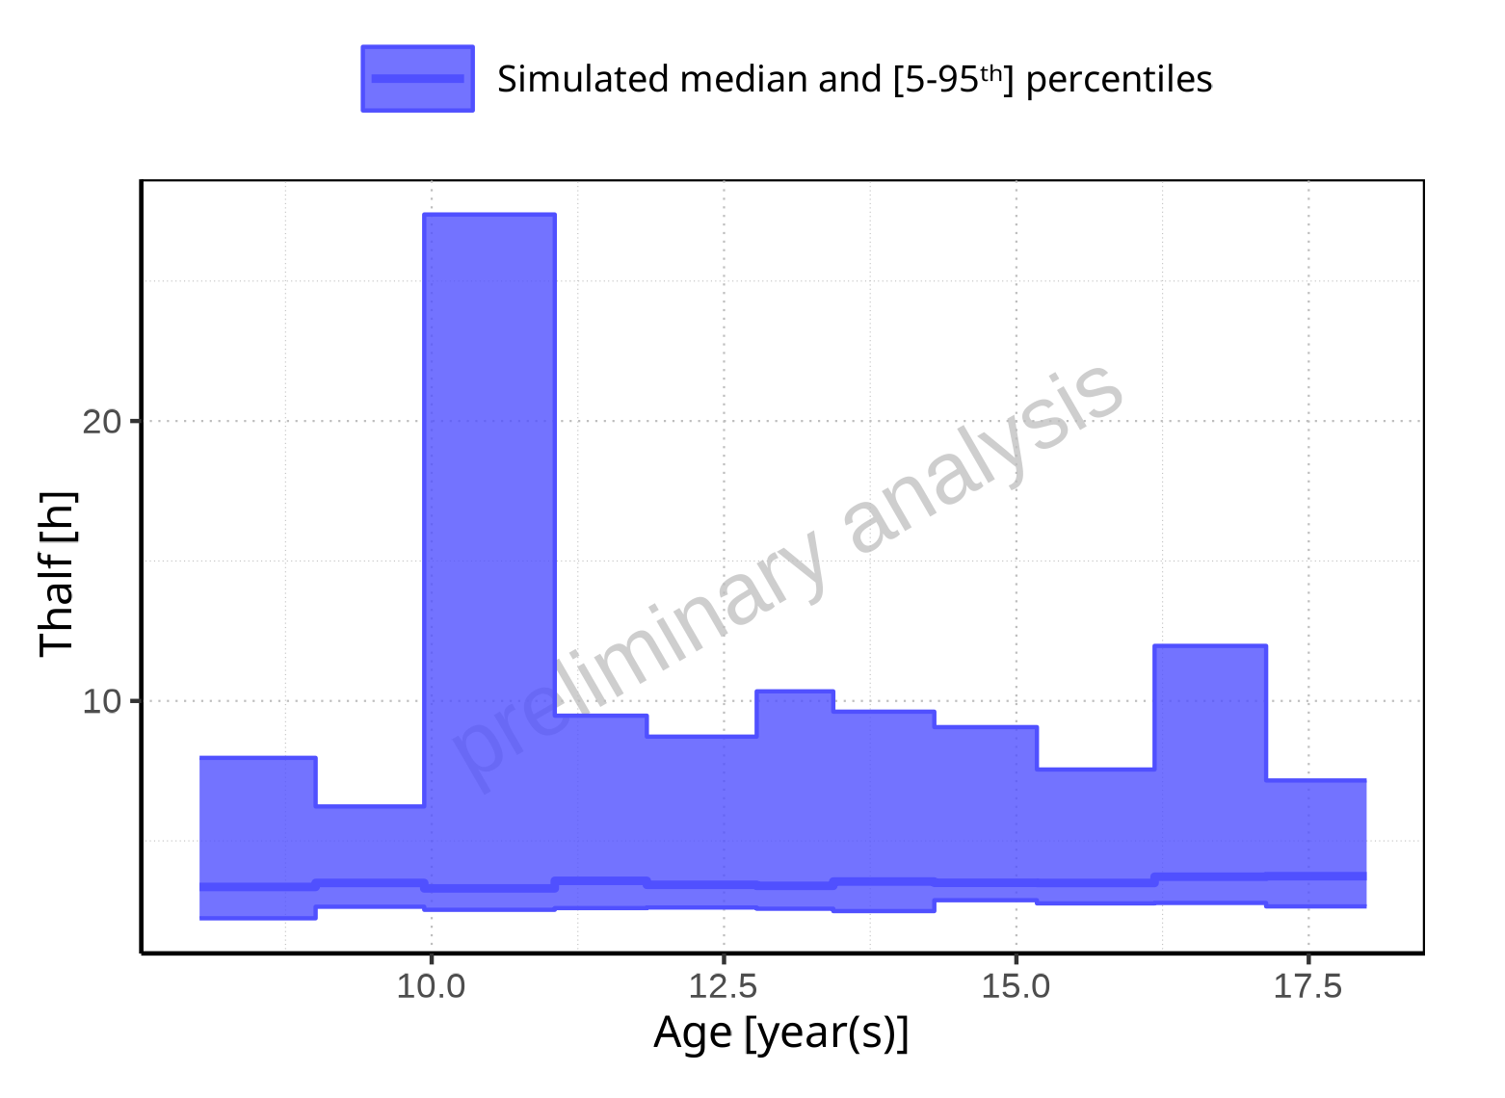

**Figure 2-258: Age-dependence of Thalf for Larson 2013 8y-18y 400mg FCT meal. Profiles are plotted in a linear scale.**

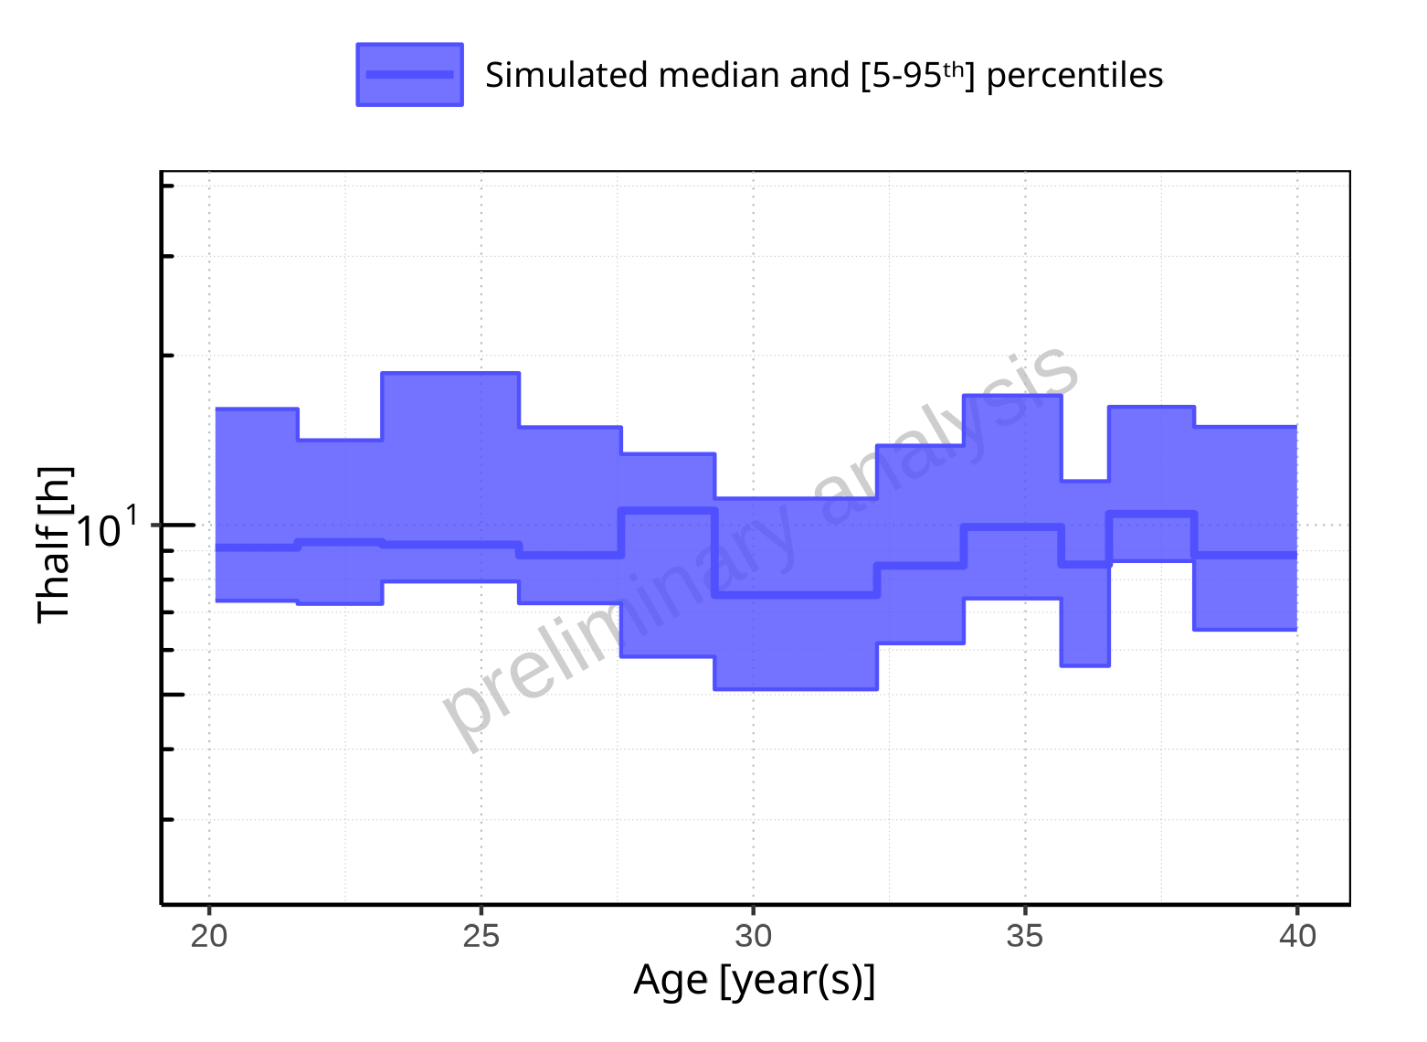

**Figure 2-259: Age-dependence of Thalf for Filmcoated_tablet_400mg_sd. Profiles are plotted in a logarithmic scale.**

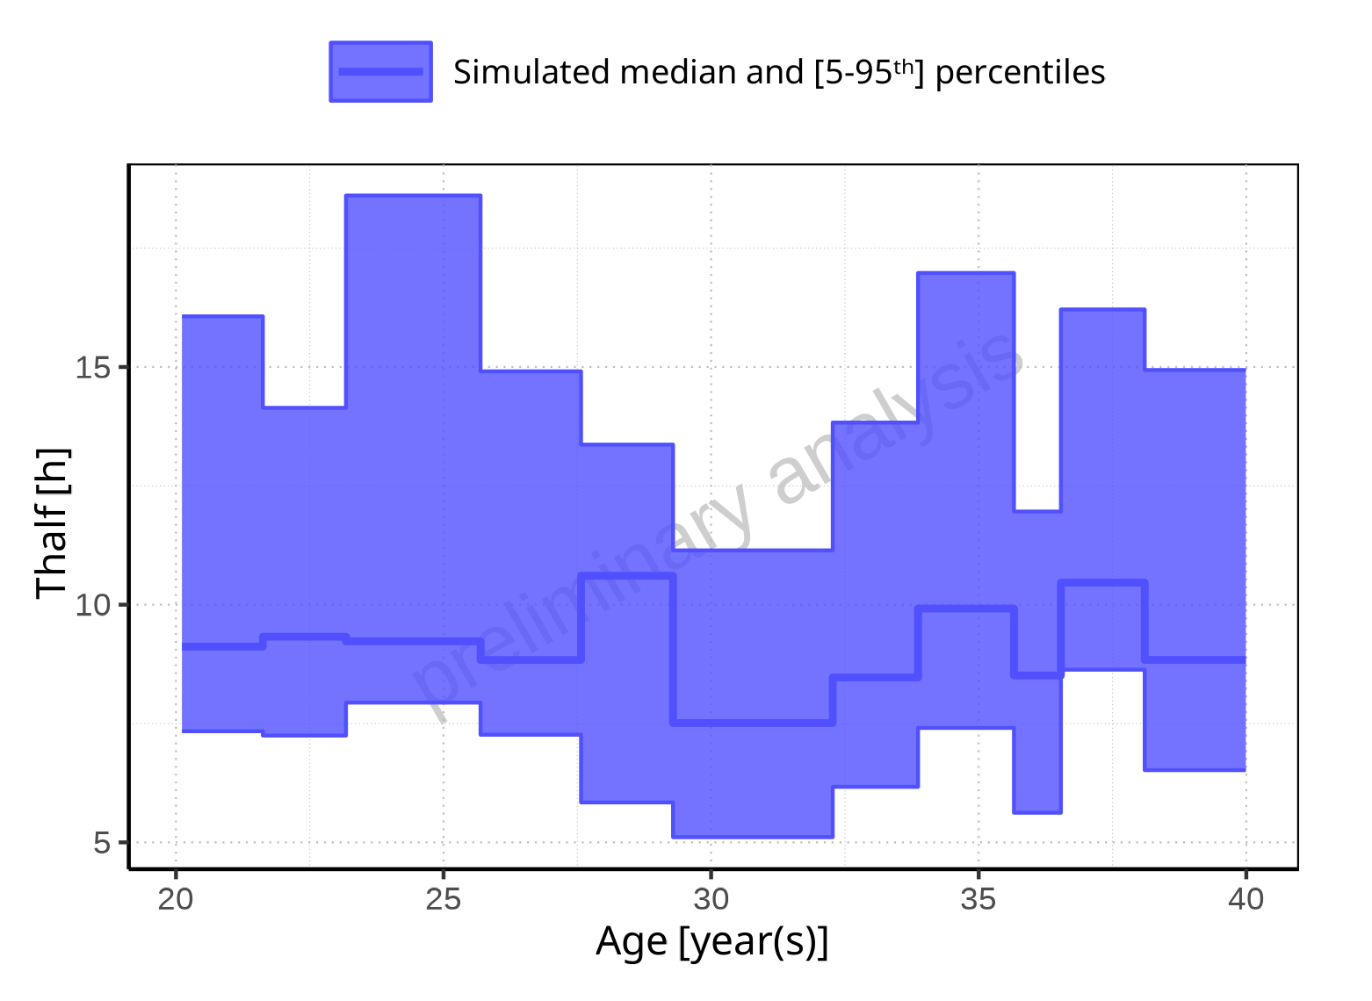

**Figure 2-260: Age-dependence of Thalf for Filmcoated_tablet_400mg_sd. Profiles are plotted in a linear scale.**

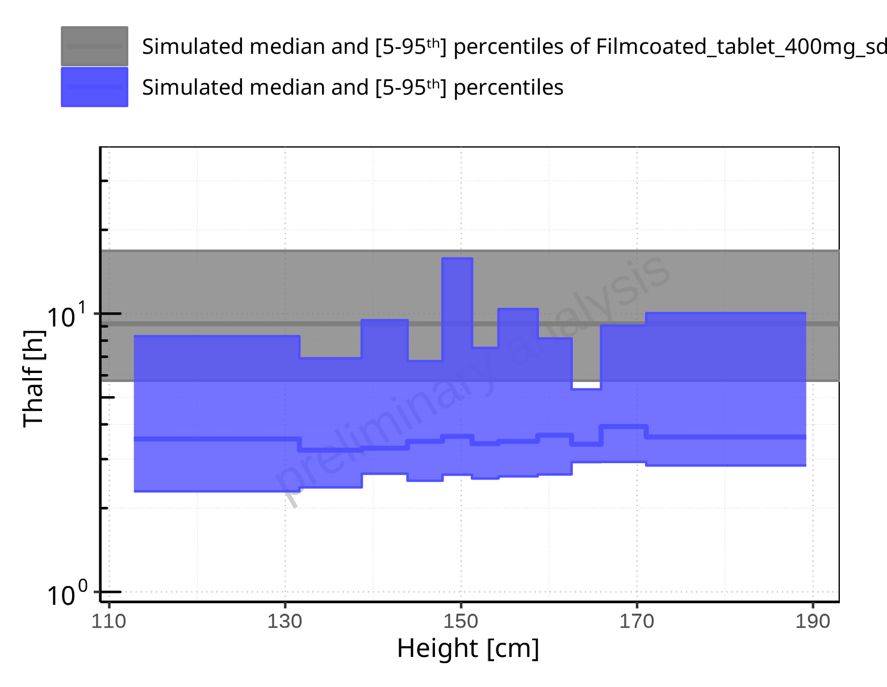

**Figure 2-261: Height-dependence of Thalf for Larson 2013 8y-18y 400mg FCT meal in comparison to Filmcoated_tablet_400mg_sd. Profiles are plotted in a logarithmic scale.**

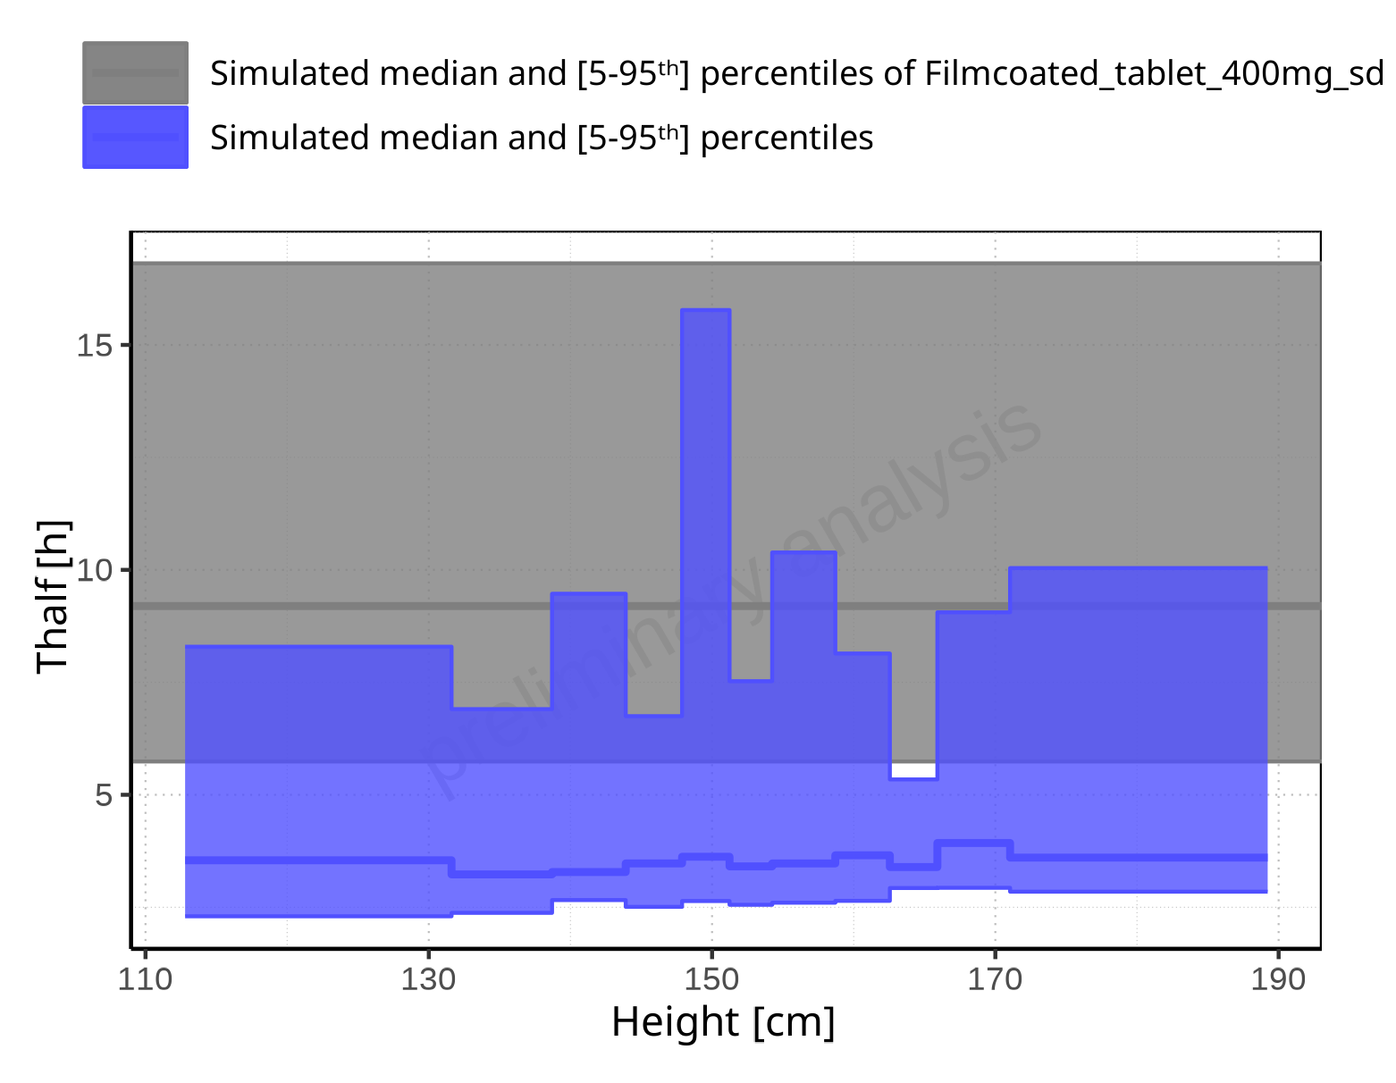

**Figure 2-262: Height-dependence of Thalf for Larson 2013 8y-18y 400mg FCT meal in comparison to Filmcoated_tablet_400mg_sd. Profiles are plotted in a linear scale.**

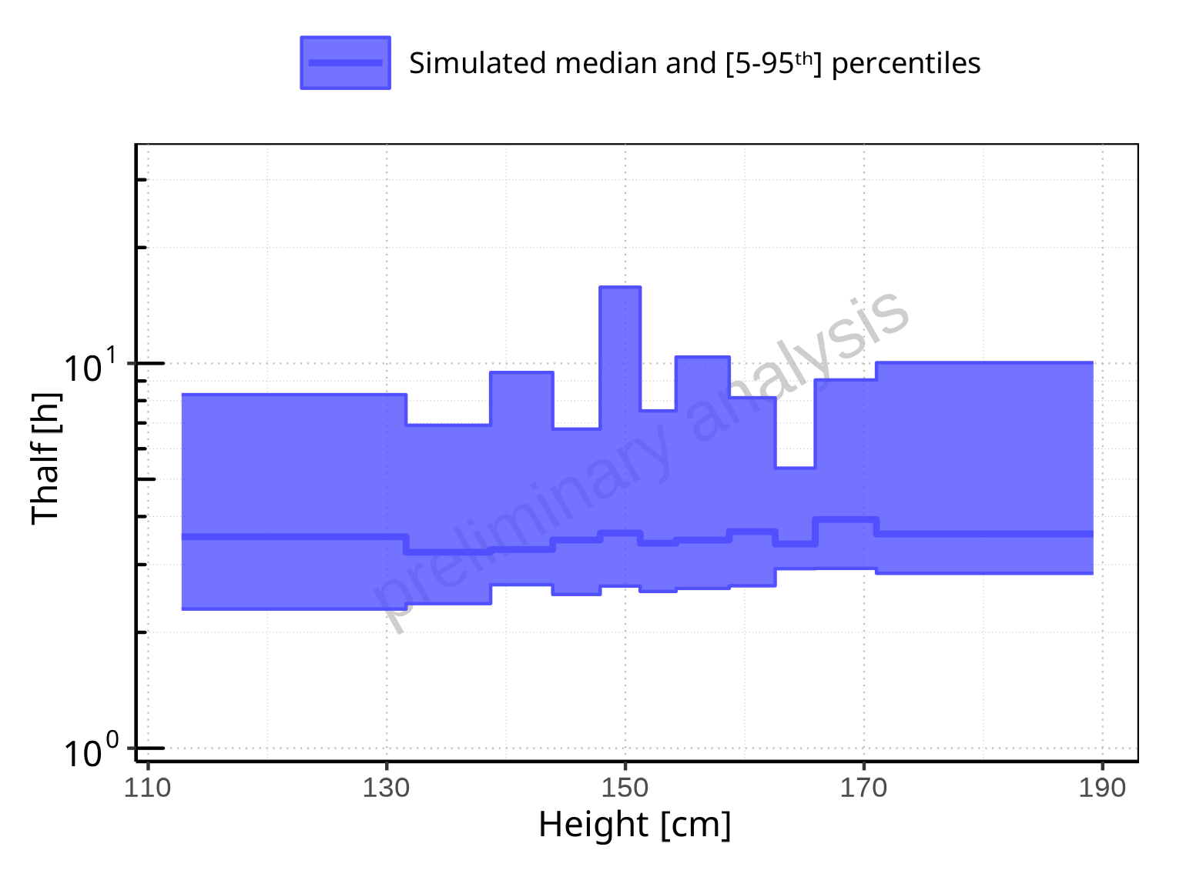

**Figure 2-263: Height-dependence of Thalf for Larson 2013 8y-18y 400mg FCT meal. Profiles are plotted in a logarithmic scale.**

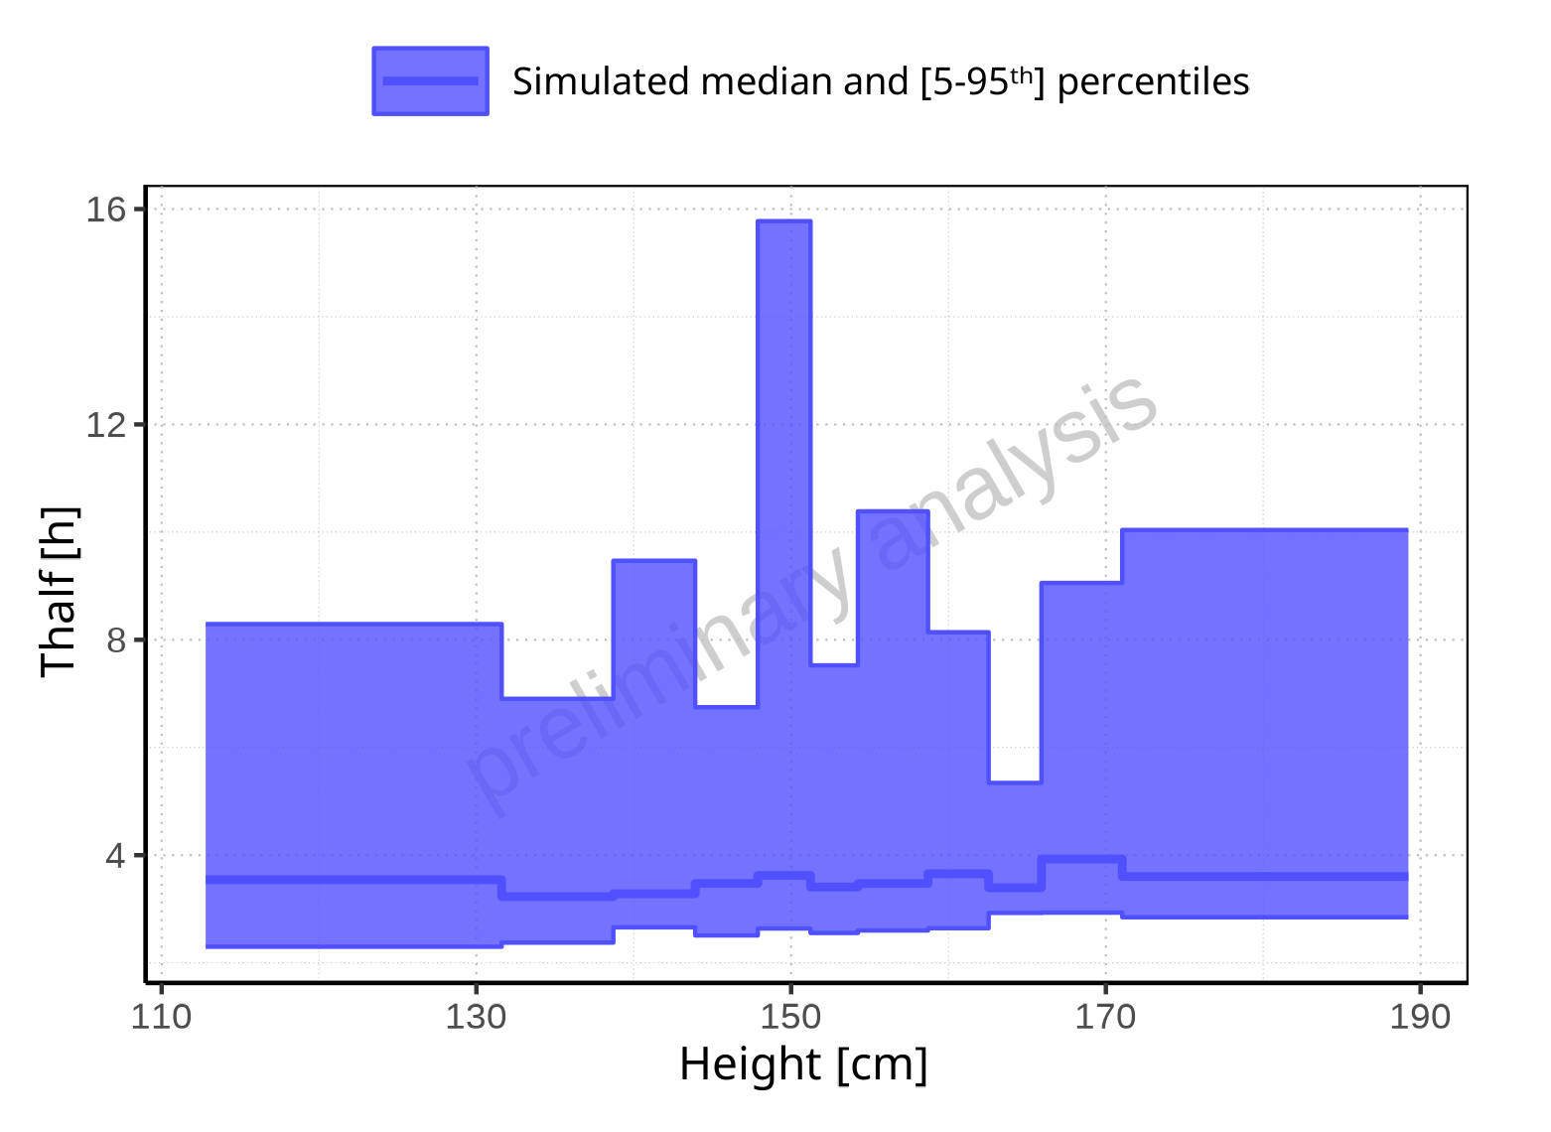

**Figure 2-264: Height-dependence of Thalf for Larson 2013 8y-18y 400mg FCT meal. Profiles are plotted in a linear scale.**

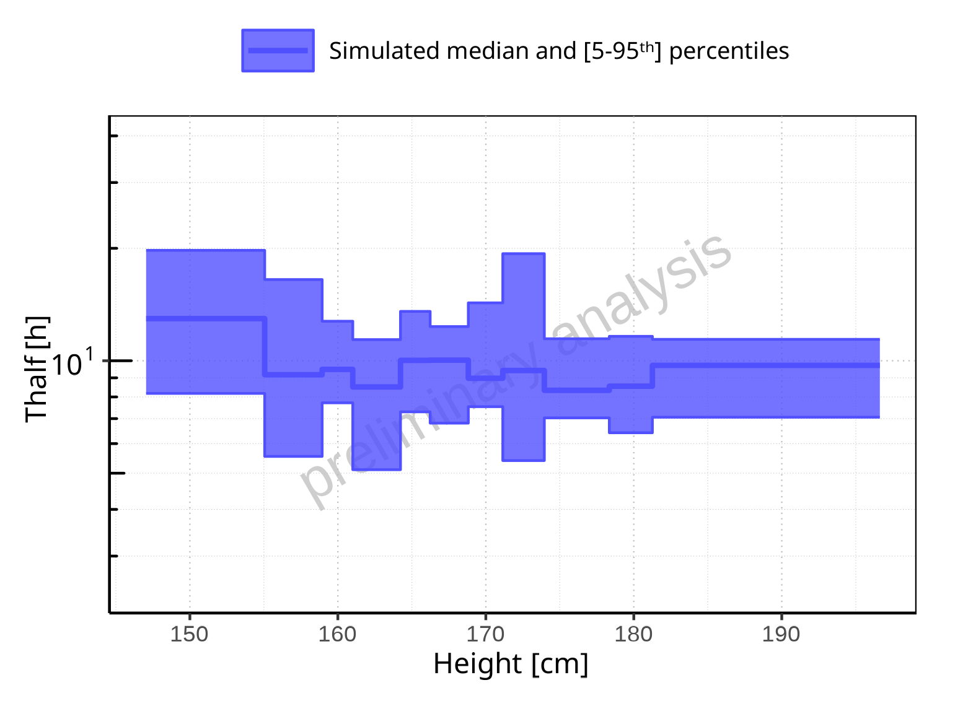

**Figure 2-265: Height-dependence of Thalf for Filmcoated_tablet_400mg_sd. Profiles are plotted in a logarithmic scale.**

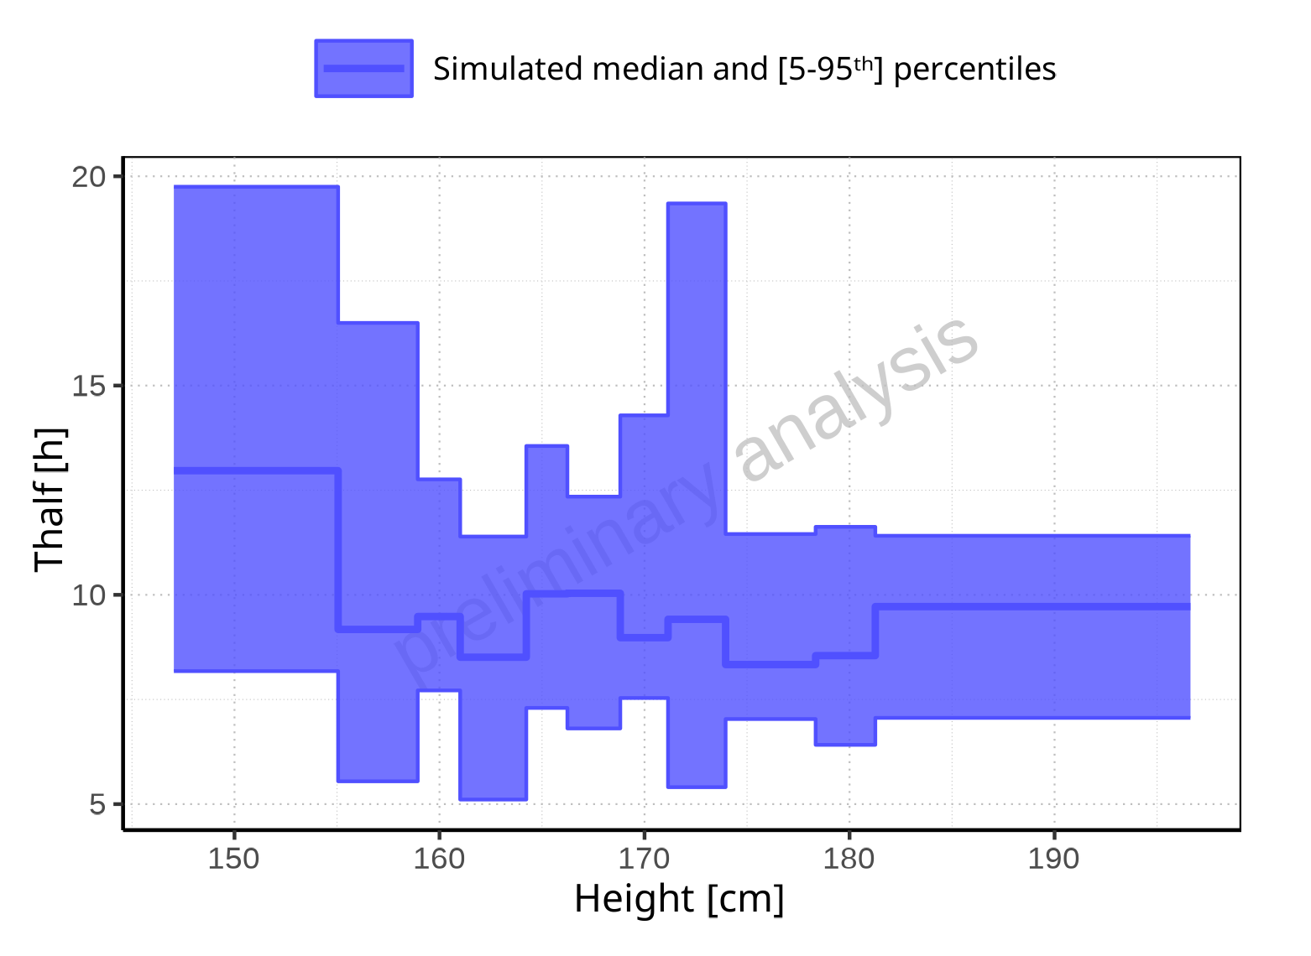

**Figure 2-266: Height-dependence of Thalf for Filmcoated_tablet_400mg_sd. Profiles are plotted in a linear scale.**

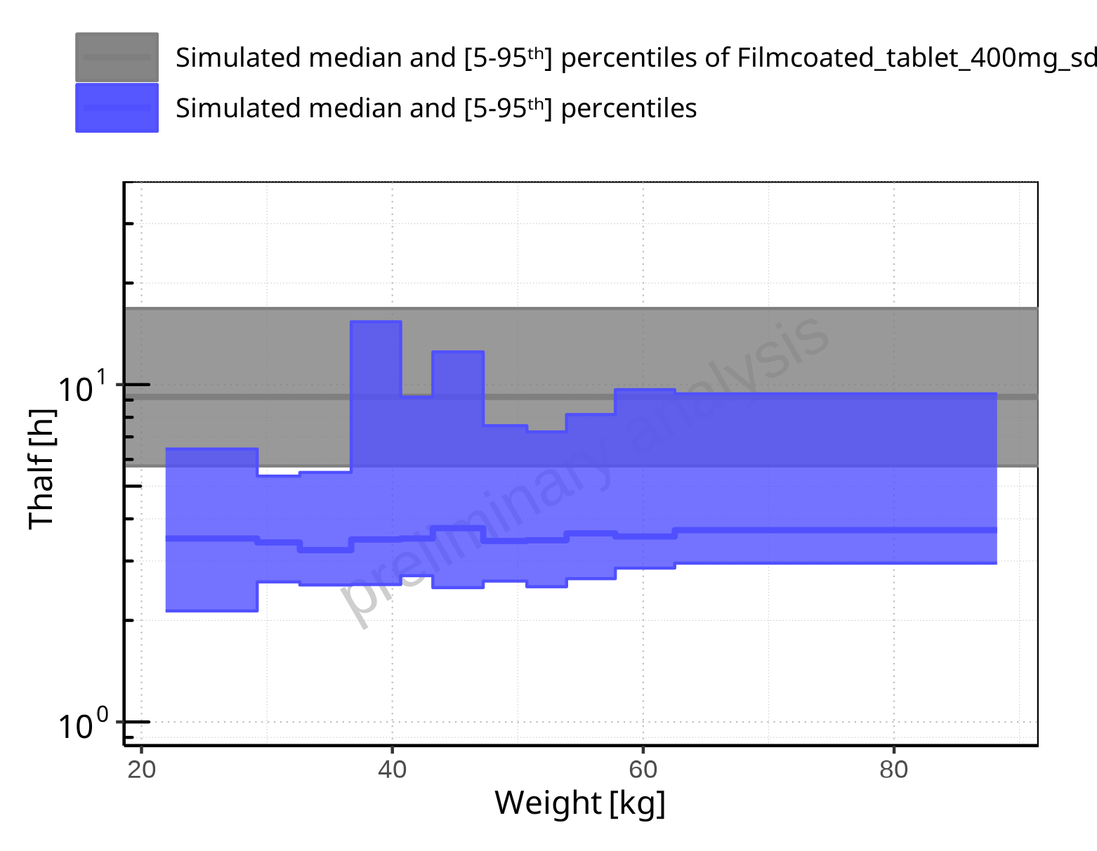

**Figure 2-267: Weight-dependence of Thalf for Larson 2013 8y-18y 400mg FCT meal in comparison to Filmcoated_tablet_400mg_sd. Profiles are plotted in a logarithmic scale.**

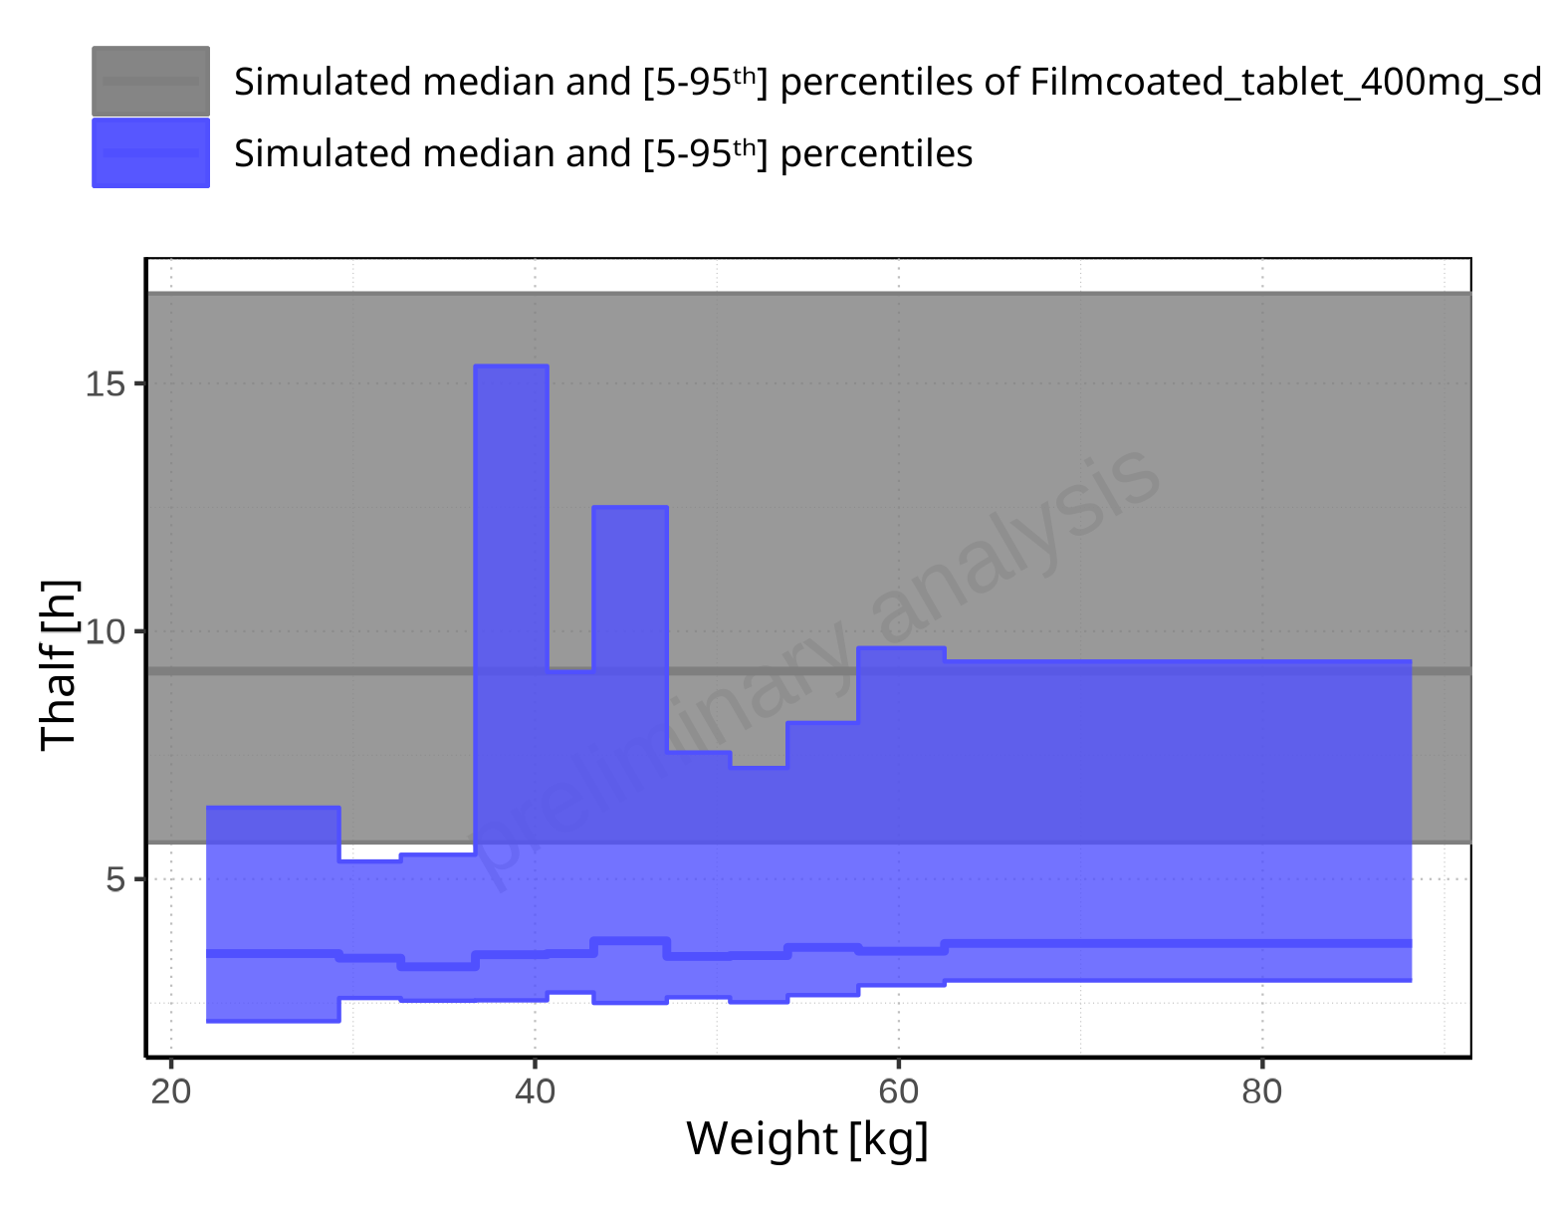

**Figure 2-268: Weight-dependence of Thalf for Larson 2013 8y-18y 400mg FCT meal in comparison to Filmcoated_tablet_400mg_sd. Profiles are plotted in a linear scale.**

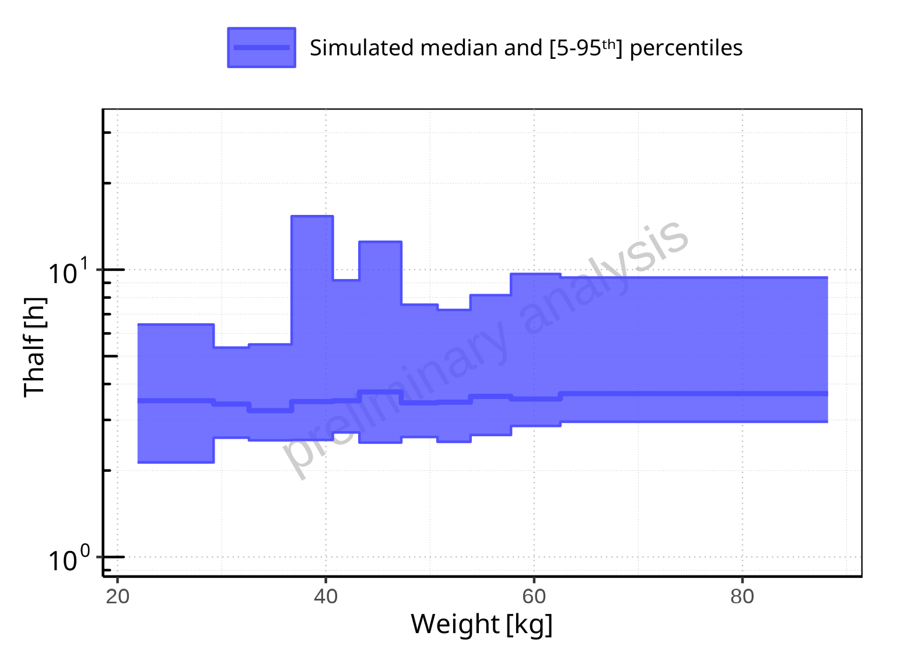

**Figure 2-269: Weight-dependence of Thalf for Larson 2013 8y-18y 400mg FCT meal. Profiles are plotted in a logarithmic scale.**

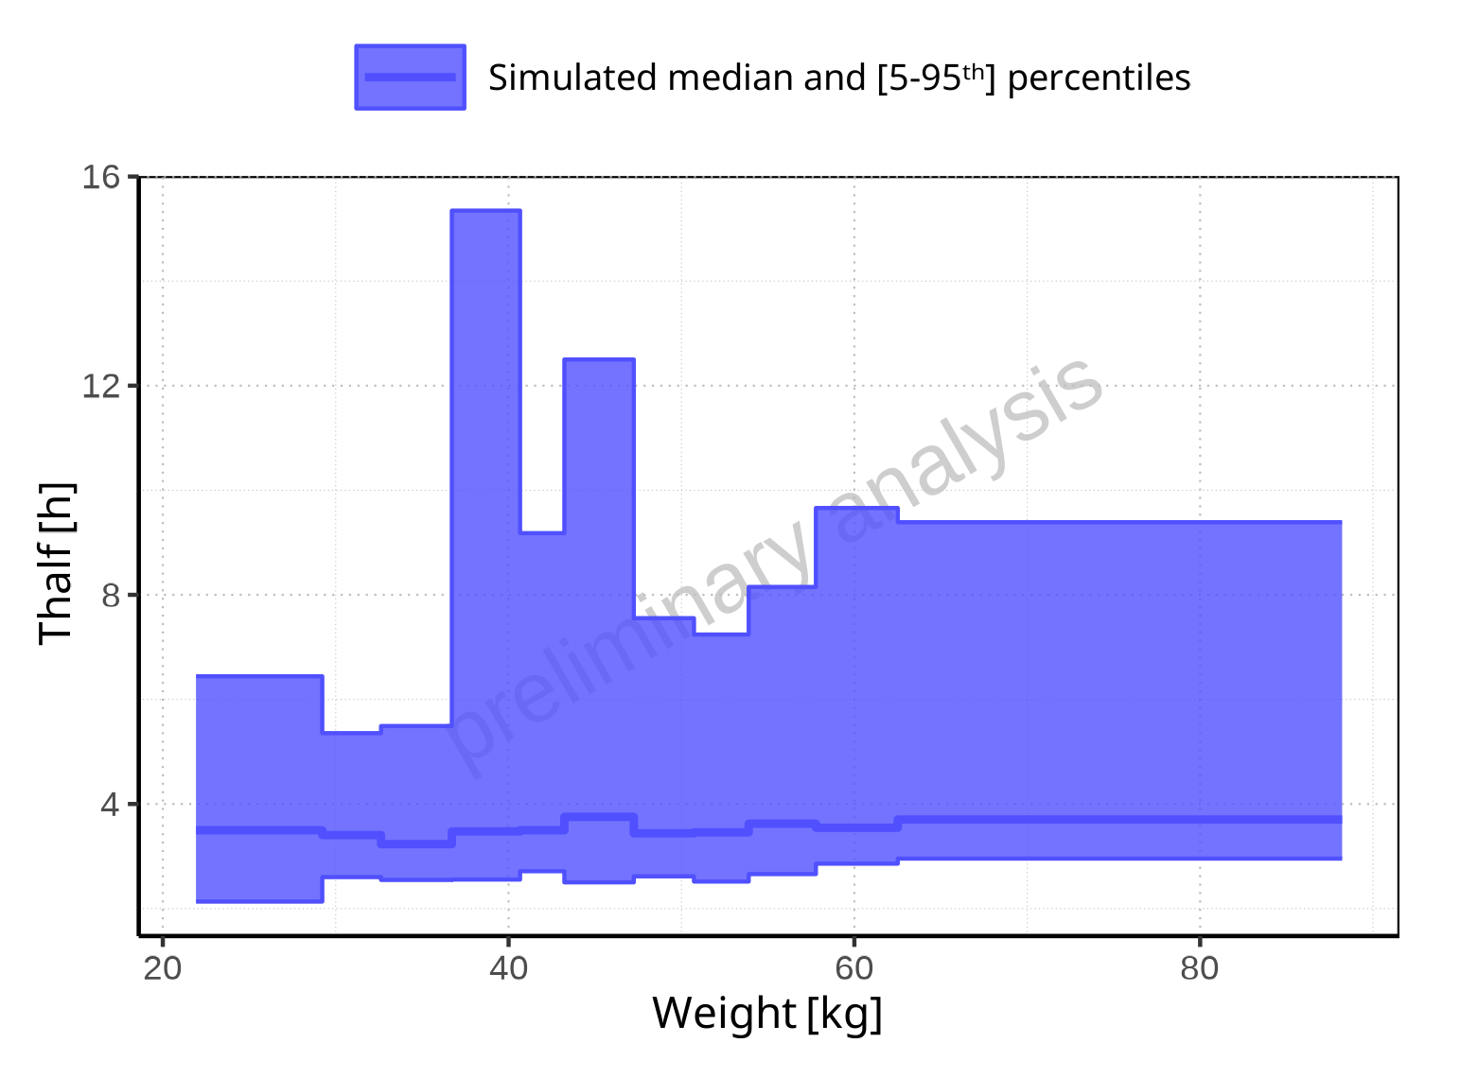

**Figure 2-270: Weight-dependence of Thalf for Larson 2013 8y-18y 400mg FCT meal. Profiles are plotted in a linear scale.**

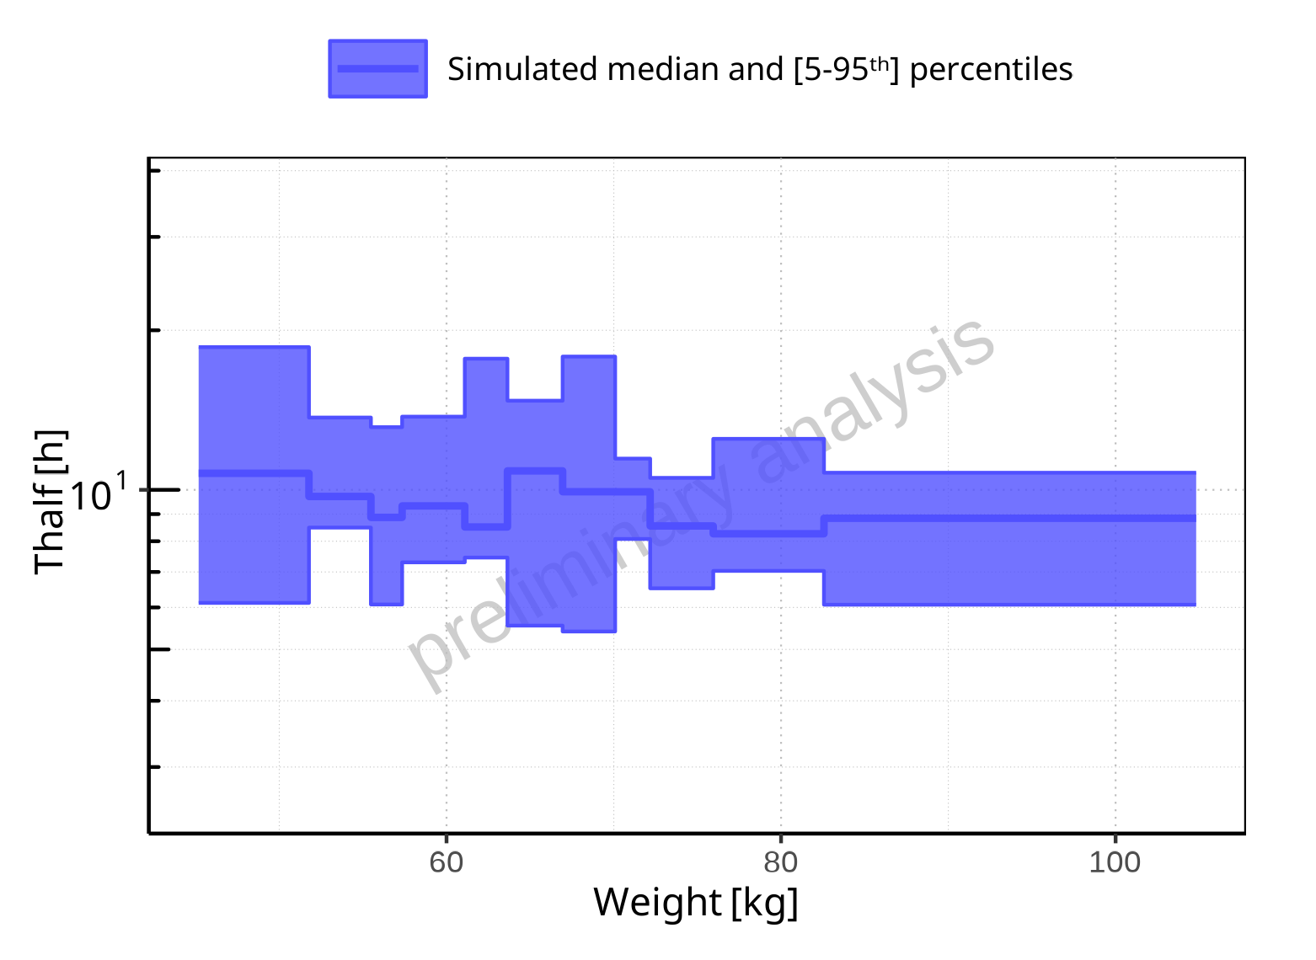

**Figure 2-271: Weight-dependence of Thalf for Filmcoated_tablet_400mg_sd. Profiles are plotted in a logarithmic scale.**

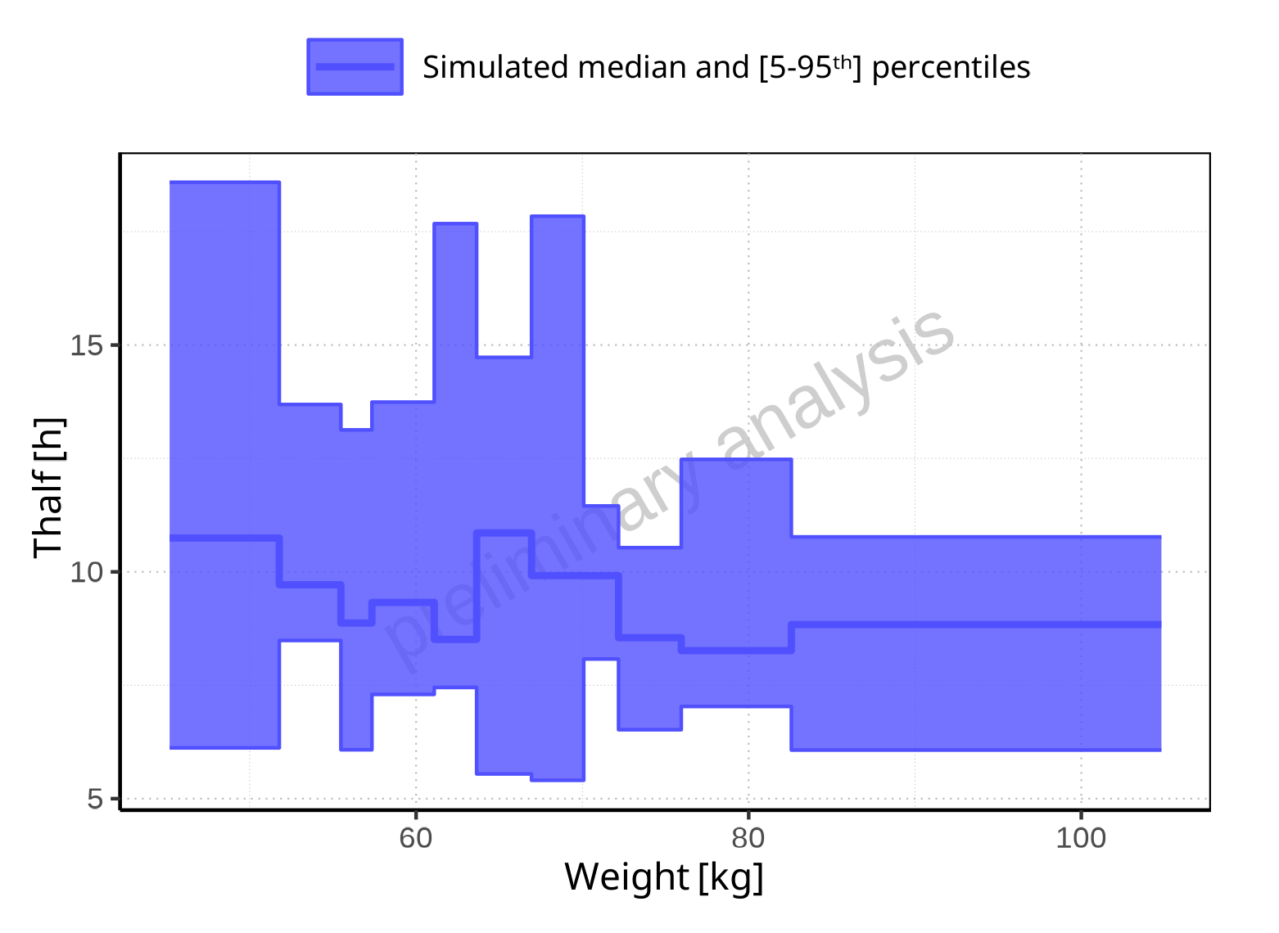

**Figure 2-272: Weight-dependence of Thalf for Filmcoated_tablet_400mg_sd. Profiles are plotted in a linear scale.**

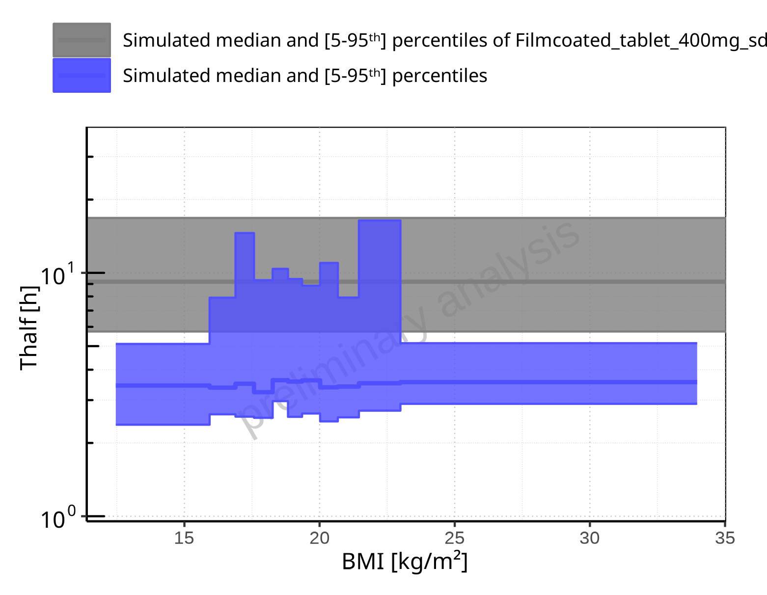

**Figure 2-273: BMI-dependence of Thalf for Larson 2013 8y-18y 400mg FCT meal in comparison to Filmcoated_tablet_400mg_sd. Profiles are plotted in a logarithmic scale.**

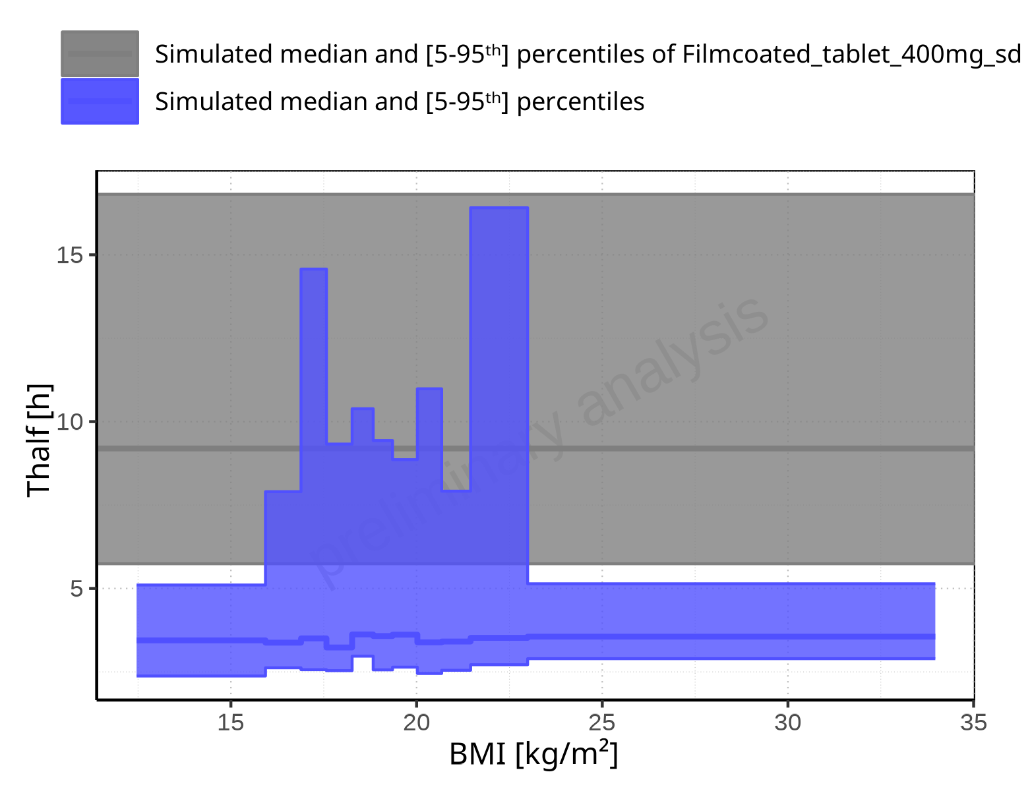

**Figure 2-274: BMI-dependence of Thalf for Larson 2013 8y-18y 400mg FCT meal in comparison to Filmcoated_tablet_400mg_sd. Profiles are plotted in a linear scale.**

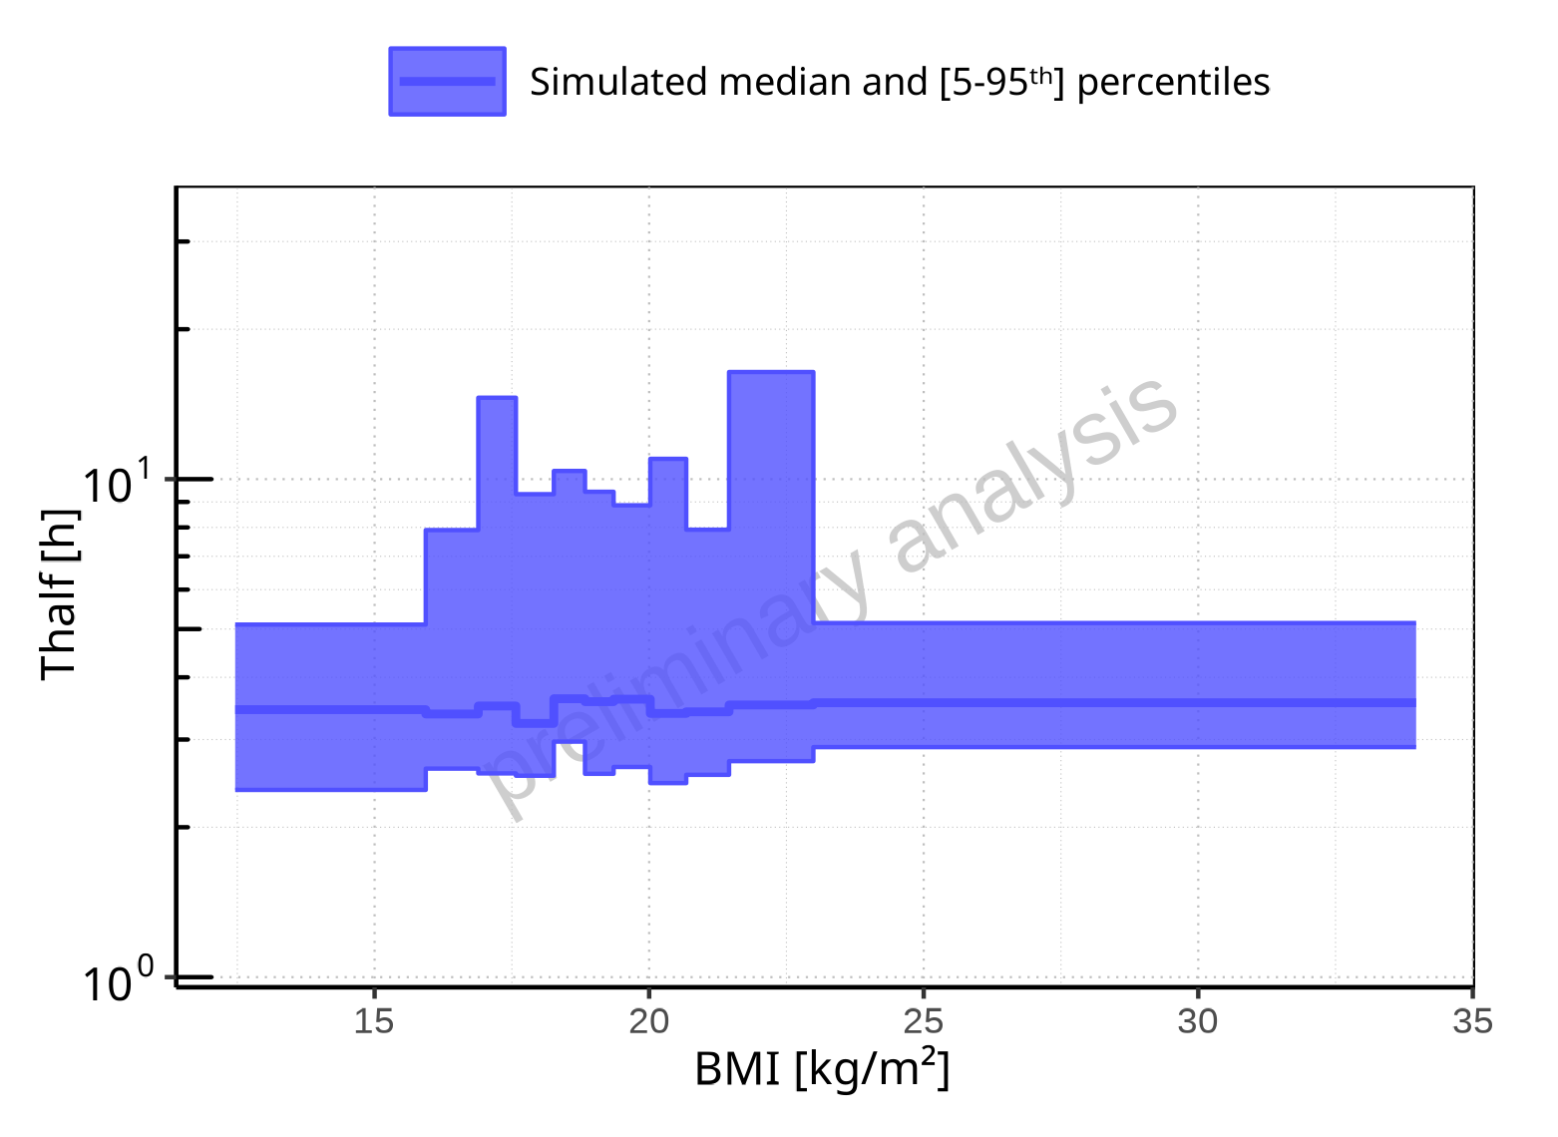

**Figure 2-275: BMI-dependence of Thalf for Larson 2013 8y-18y 400mg FCT meal. Profiles are plotted in a logarithmic scale.**

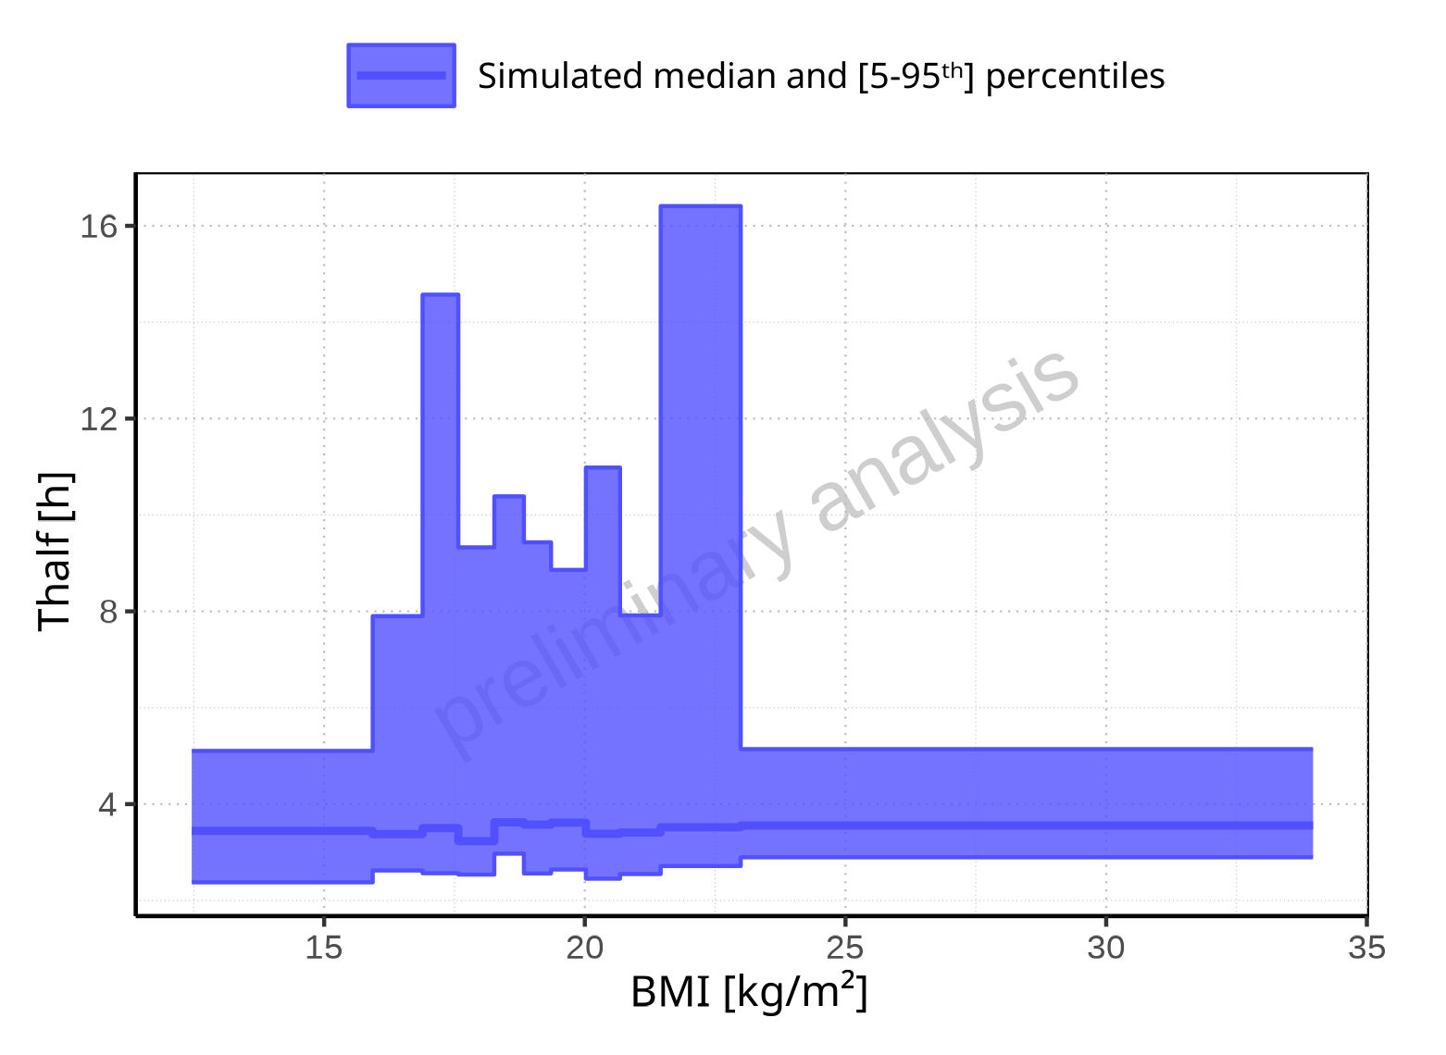

**Figure 2-276: BMI-dependence of Thalf for Larson 2013 8y-18y 400mg FCT meal. Profiles are plotted in a linear scale.**

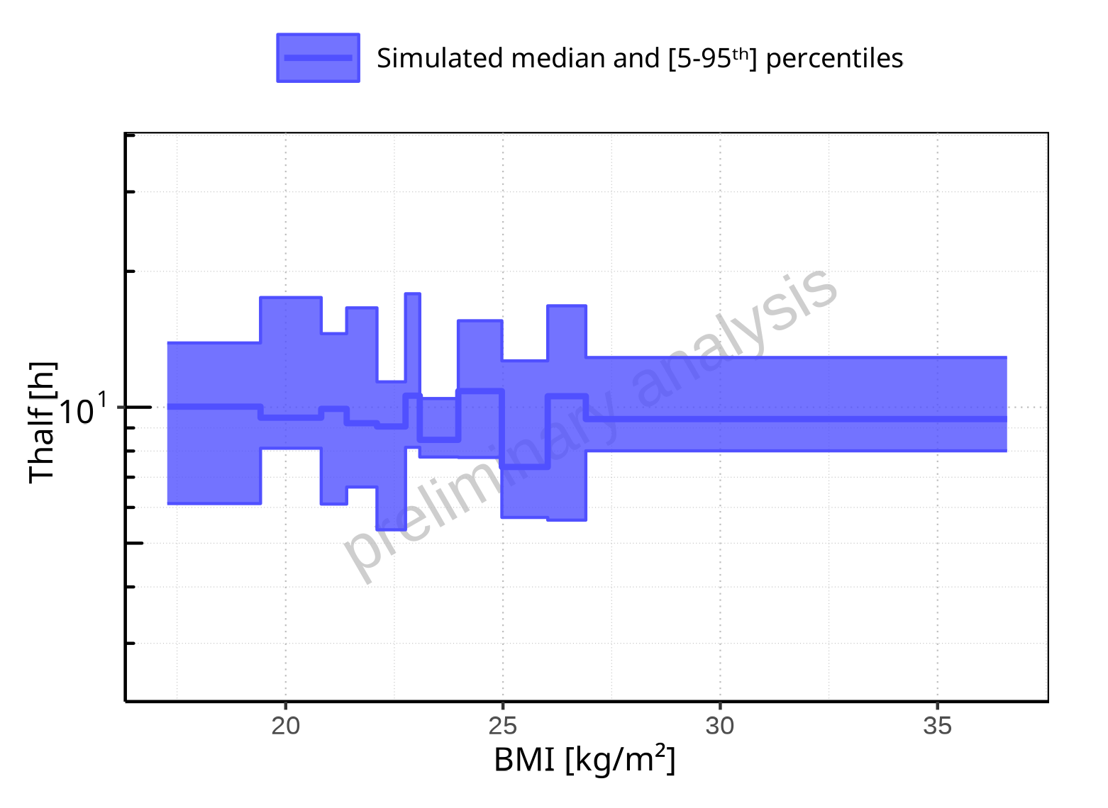

**Figure 2-277: BMI-dependence of Thalf for Filmcoated_tablet_400mg_sd. Profiles are plotted in a logarithmic scale.**

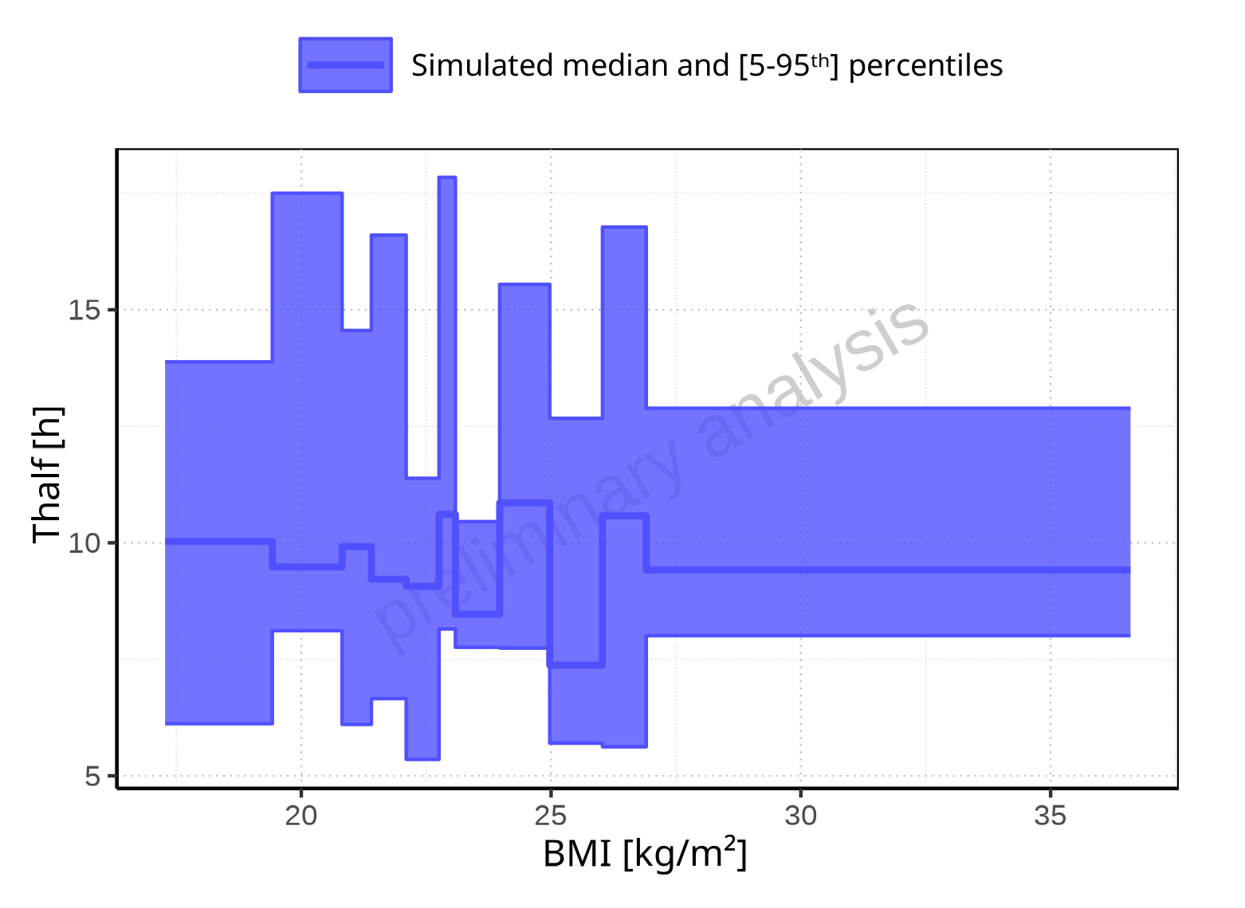

**Figure 2-278: BMI-dependence of Thalf for Filmcoated_tablet_400mg_sd. Profiles are plotted in a linear scale.**

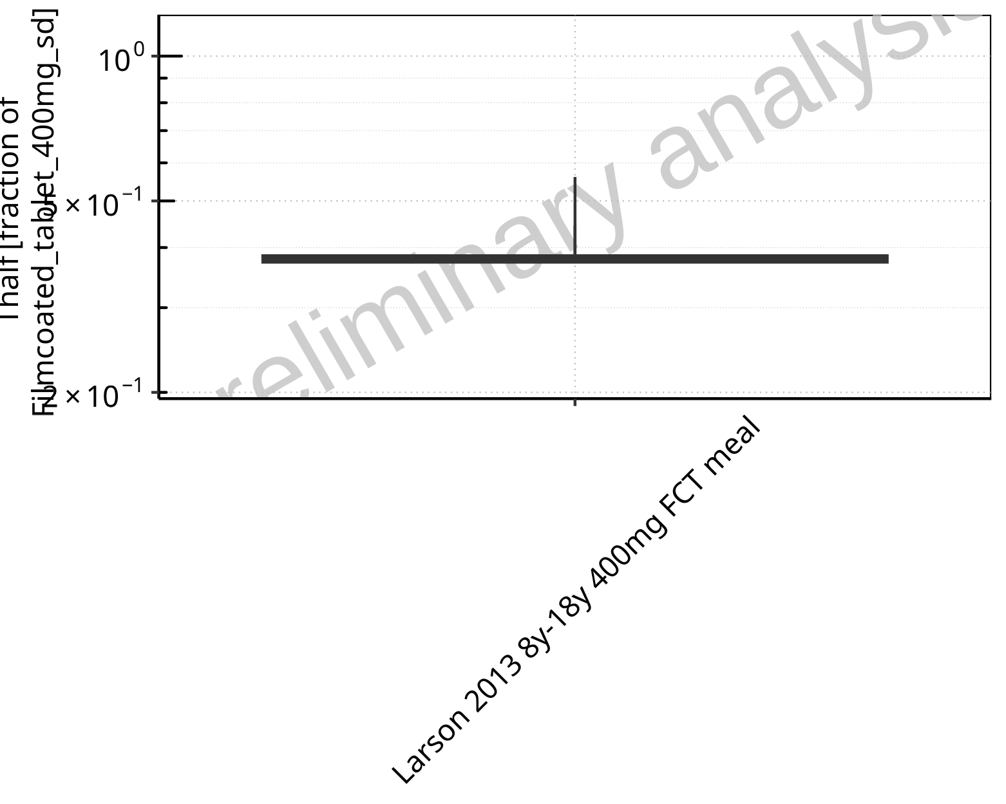

**Figure 2-279: Ratio of population summary statistics of Thalf of Raltegravir for Larson 2013 8y-18y 400mg FCT meal in comparison to Filmcoated_tablet_400mg_sd shown as box-whisker plot, which indicates ratios of the 5th, 25th, 50th, 75th, 95th percentiles in logarithmic scale.**

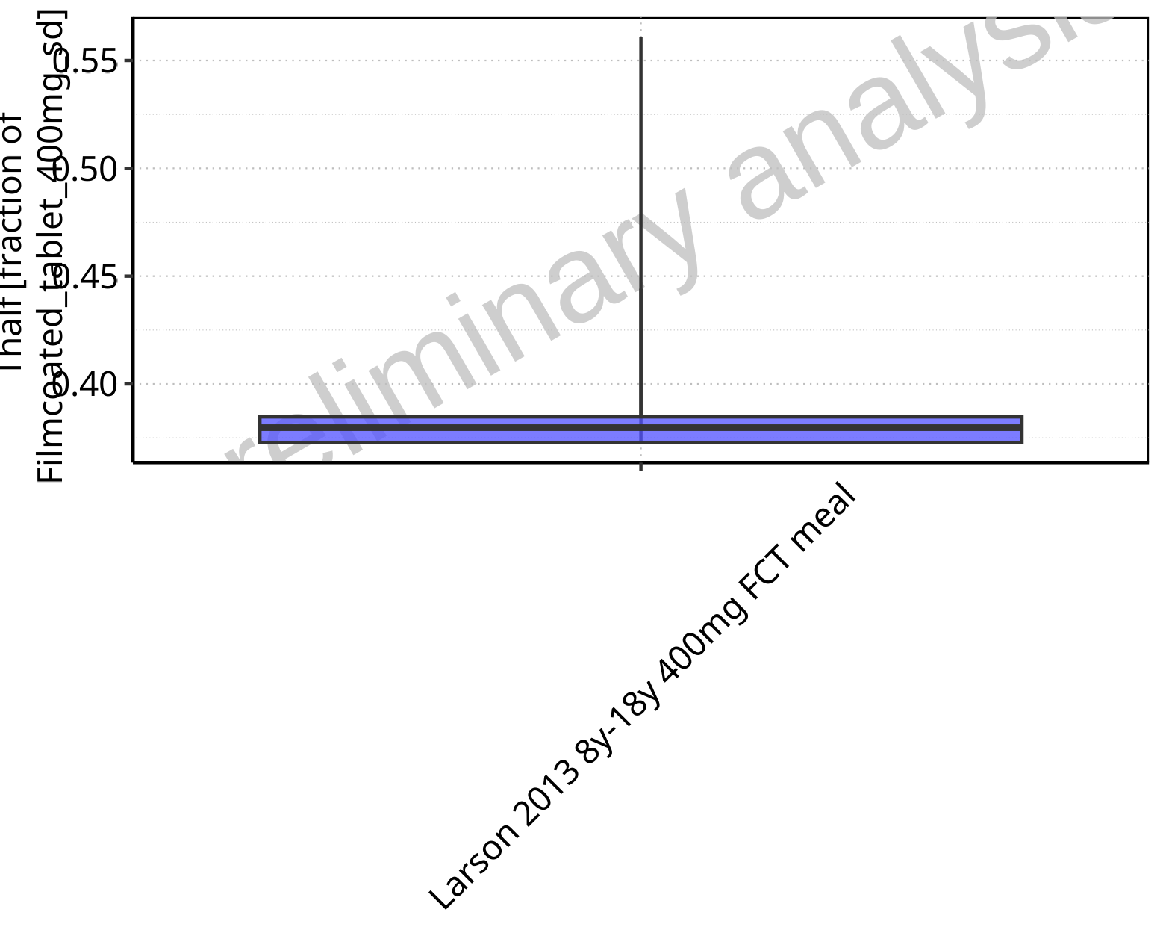

**Figure 2-280: Ratio of population summary statistics of Thalf of Raltegravir for Larson 2013 8y-18y 400mg FCT meal in comparison to Filmcoated_tablet_400mg_sd shown as box-whisker plot, which indicates ratios of the 5th, 25th, 50th, 75th, 95th percentiles in linear scale.**

**Table 2-20: Ratio of population summary statistics of Thalf of Raltegravir for Larson 2013 8y-18y 400mg FCT meal in comparison to Filmcoated_tablet_400mg_sd**

| Population | N | 5th pctl | 25th pctl | 50th pctl | 75th pctl | 95th pctl | Mean | SD | Geo Mean | Geo SD |
| --- | --- | --- | --- | --- | --- | --- | --- | --- | --- | --- |
| Larson 2013 8y-18y 400mg FCT meal | 500 | 0.44 | 0.37 | 0.38 | 0.38 | 0.56 | 0.39 | 3.30 | - | - |

### CL

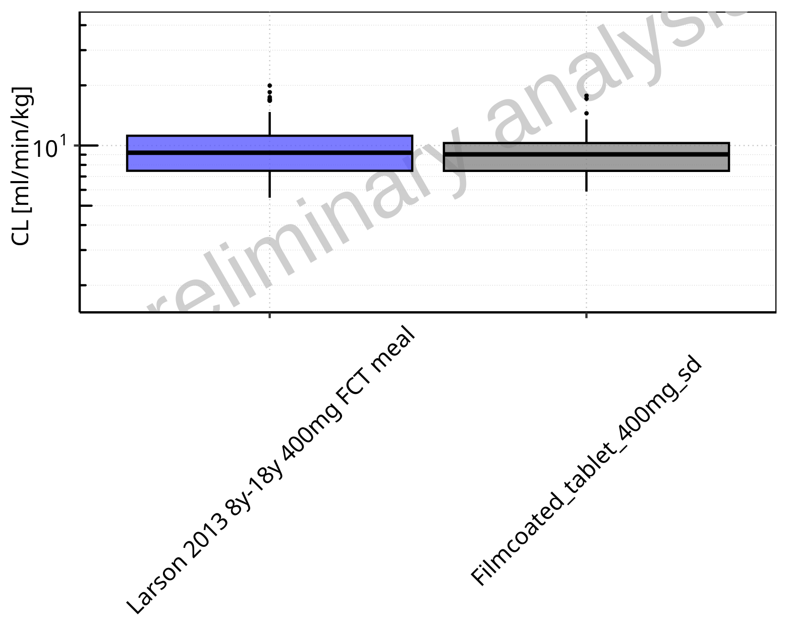

**Figure 2-281: CL of Raltegravir for Larson 2013 8y-18y 400mg FCT meal, Filmcoated_tablet_400mg_sd shown as box-whisker plot, which indicates the 5th, 25th, 50th, 75th, 95th percentiles in logarithmic scale.**

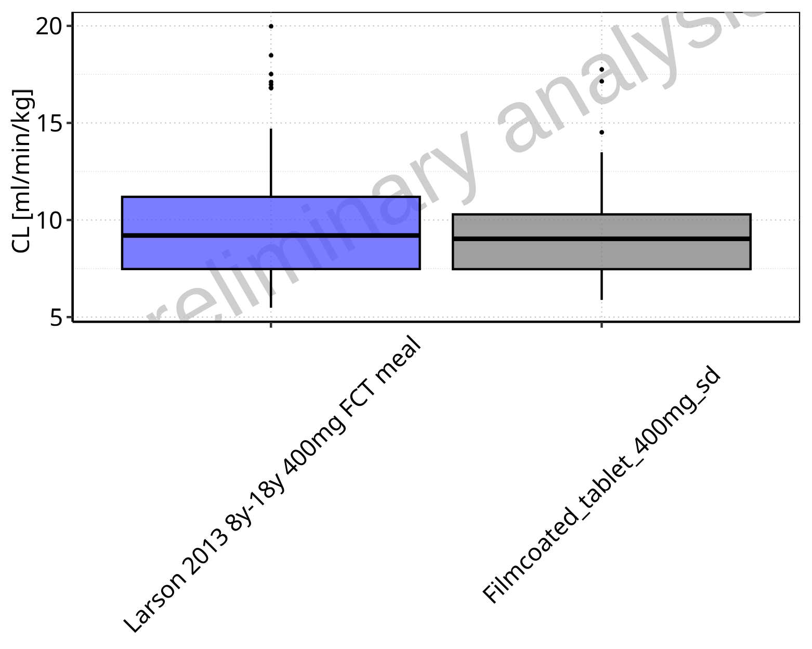

**Figure 2-282: CL of Raltegravir for Larson 2013 8y-18y 400mg FCT meal, Filmcoated_tablet_400mg_sd shown as box-whisker plot, which indicates the 5th, 25th, 50th, 75th, 95th percentiles in linear scale.**

**Table 2-21: Population statistics summarizing CL of Raltegravir for Larson 2013 8y-18y 400mg FCT meal, Filmcoated_tablet_400mg_sd reported in [ml/min/kg]**

| Population | N | 5th pctl | 25th pctl | 50th pctl | 75th pctl | 95th pctl | Mean | SD | Geo Mean | Geo SD |
| --- | --- | --- | --- | --- | --- | --- | --- | --- | --- | --- |
| Larson 2013 8y-18y 400mg FCT meal | 497 | 5.48 | 7.47 | 9.20 | 11.19 | 14.71 | 9.49 | 2.84 | 9.08 | 1.35 |
| Filmcoated_tablet_400mg_sd | 100 | 5.88 | 7.47 | 9.03 | 10.29 | 13.49 | 9.20 | 2.50 | 8.89 | 1.30 |

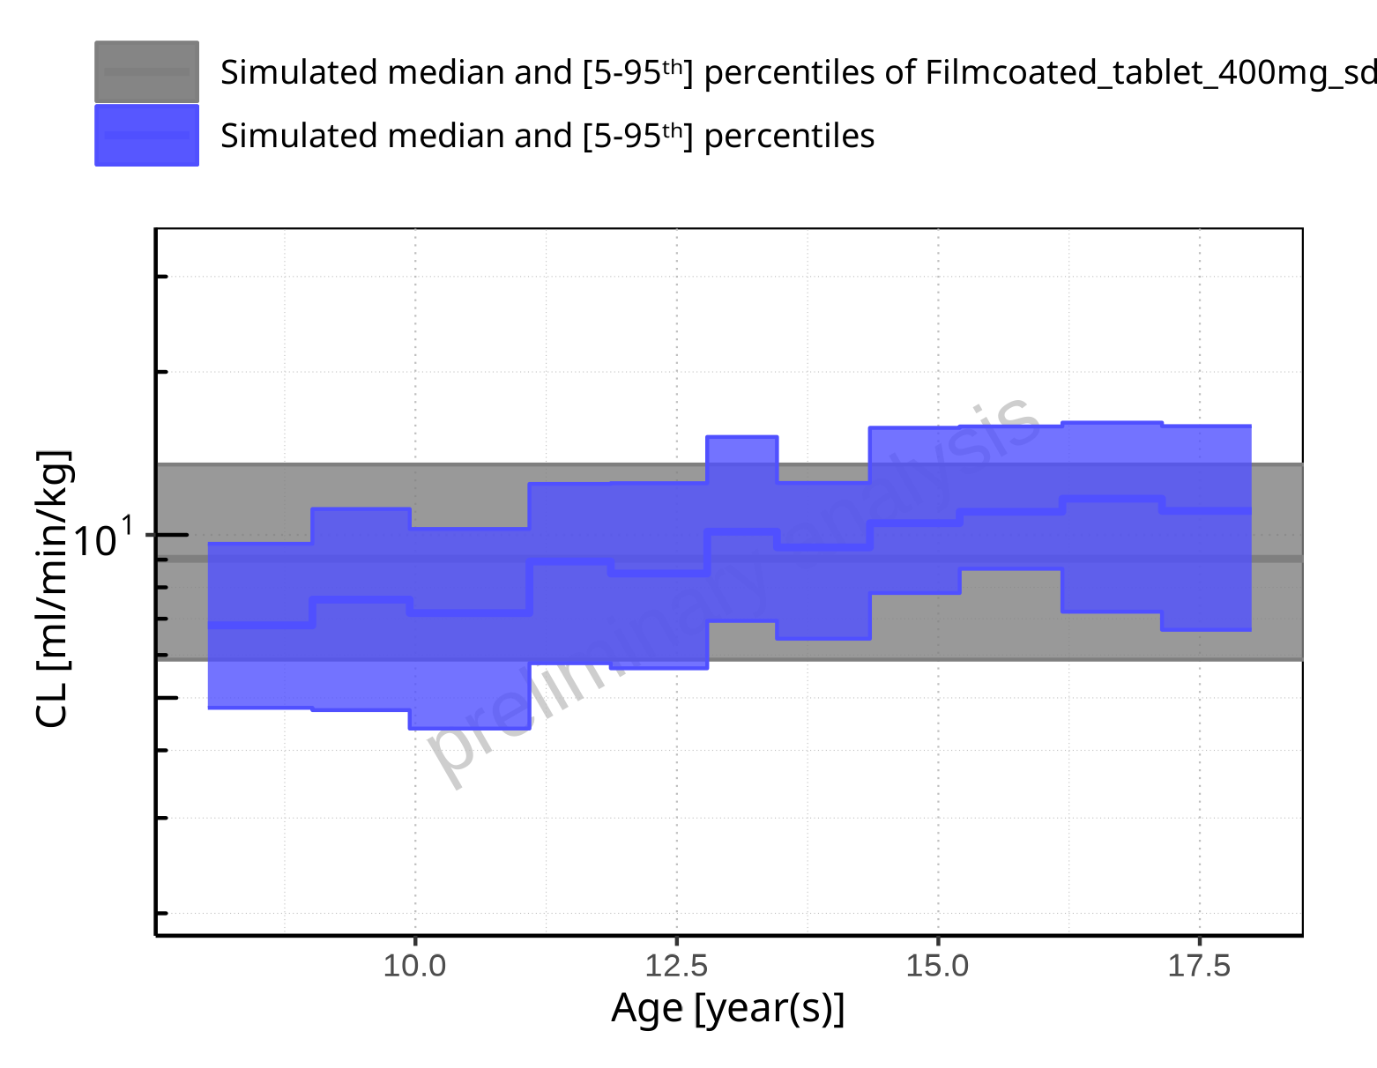

**Figure 2-283: Age-dependence of CL for Larson 2013 8y-18y 400mg FCT meal in comparison to Filmcoated_tablet_400mg_sd. Profiles are plotted in a logarithmic scale.**

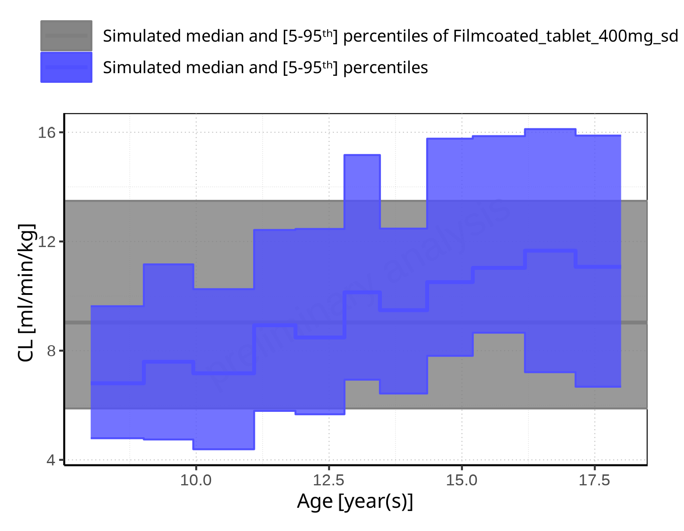

**Figure 2-284: Age-dependence of CL for Larson 2013 8y-18y 400mg FCT meal in comparison to Filmcoated_tablet_400mg_sd. Profiles are plotted in a linear scale.**

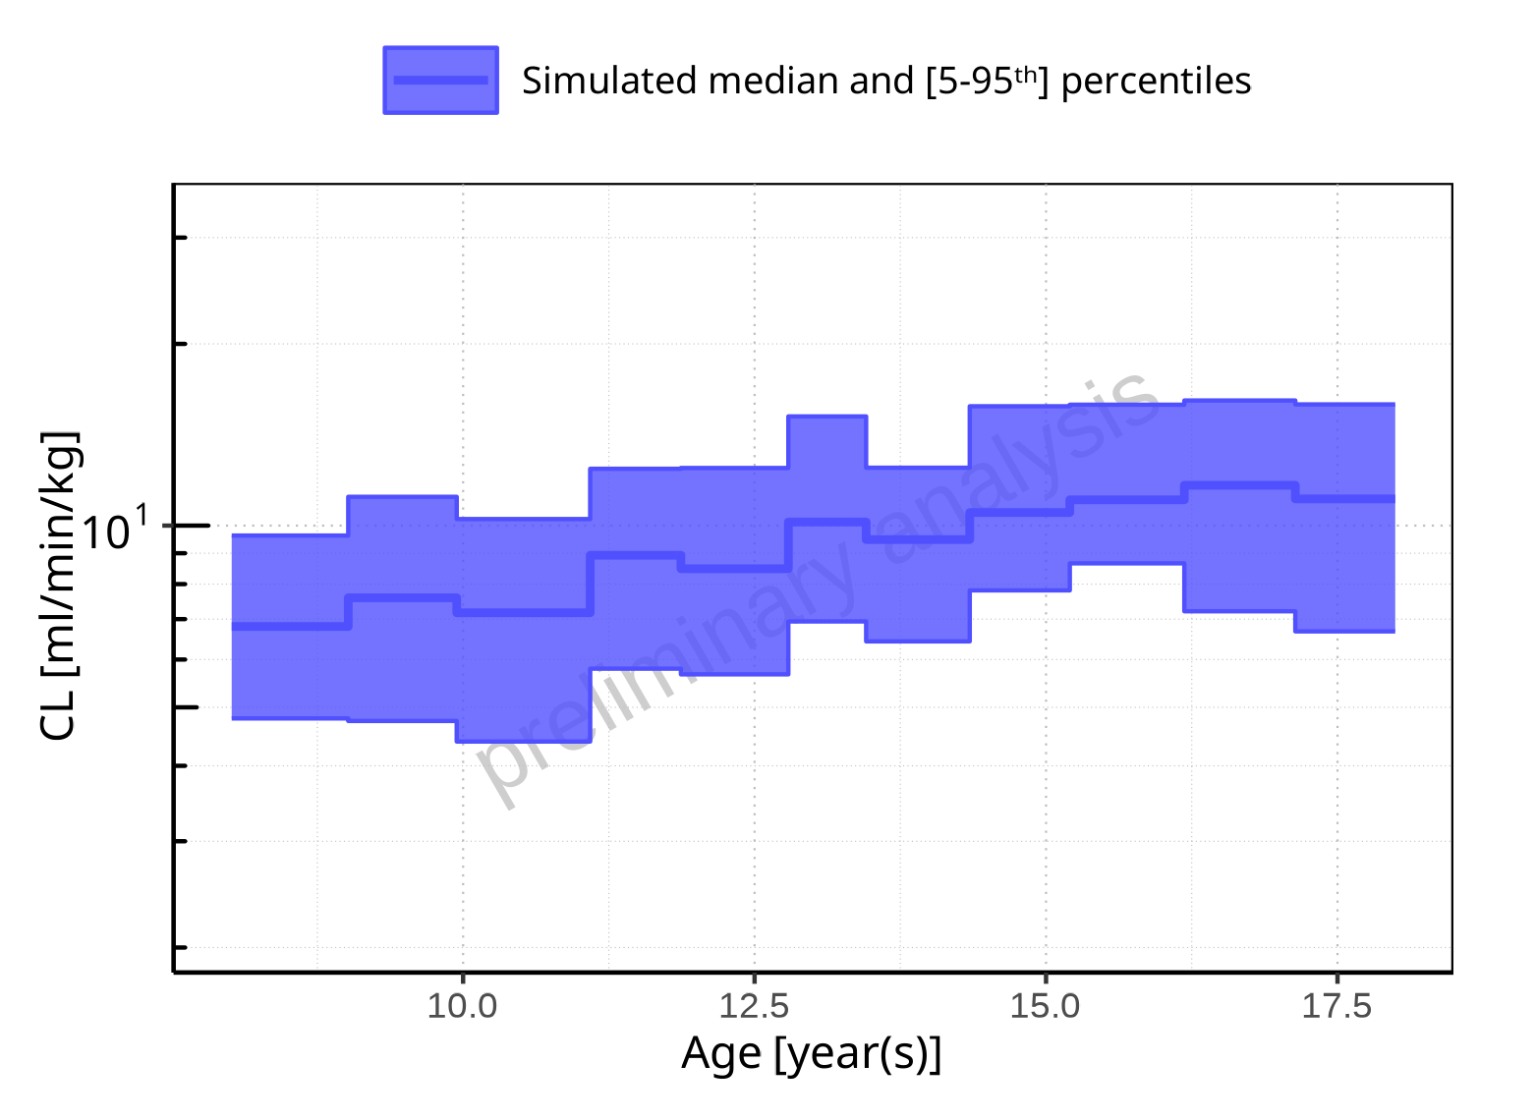

**Figure 2-285: Age-dependence of CL for Larson 2013 8y-18y 400mg FCT meal. Profiles are plotted in a logarithmic scale.**

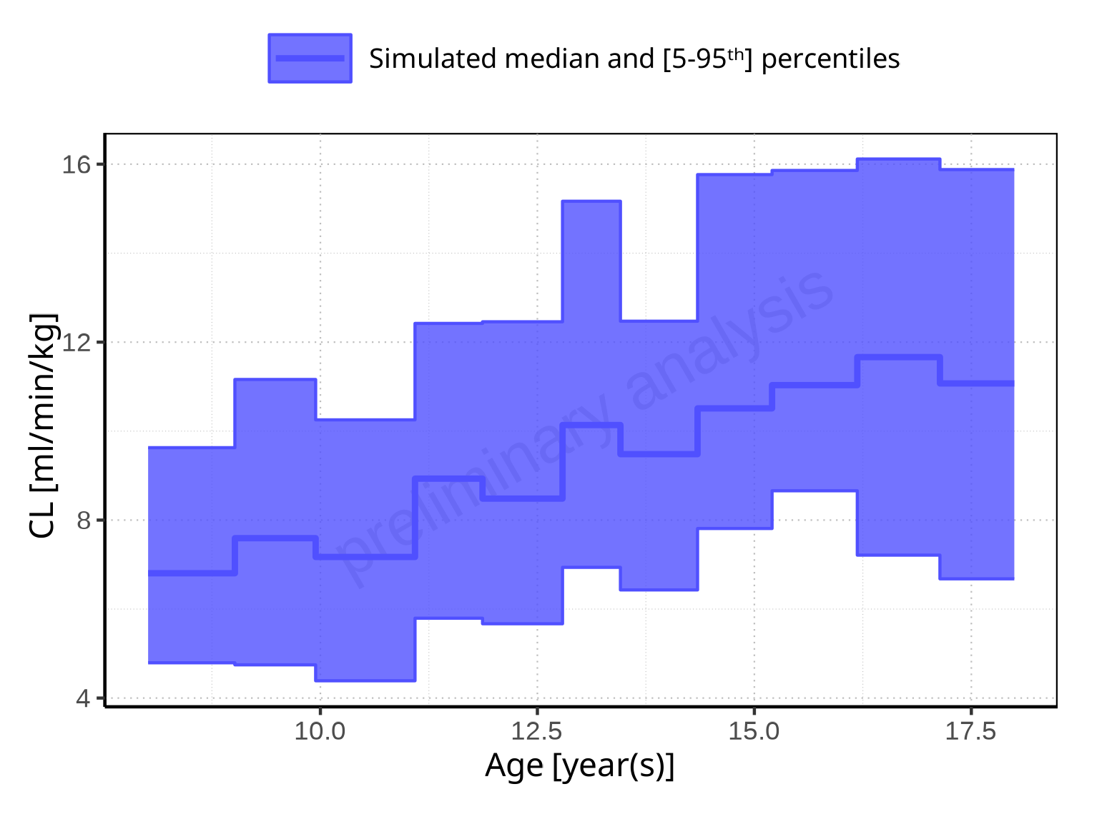

**Figure 2-286: Age-dependence of CL for Larson 2013 8y-18y 400mg FCT meal. Profiles are plotted in a linear scale.**

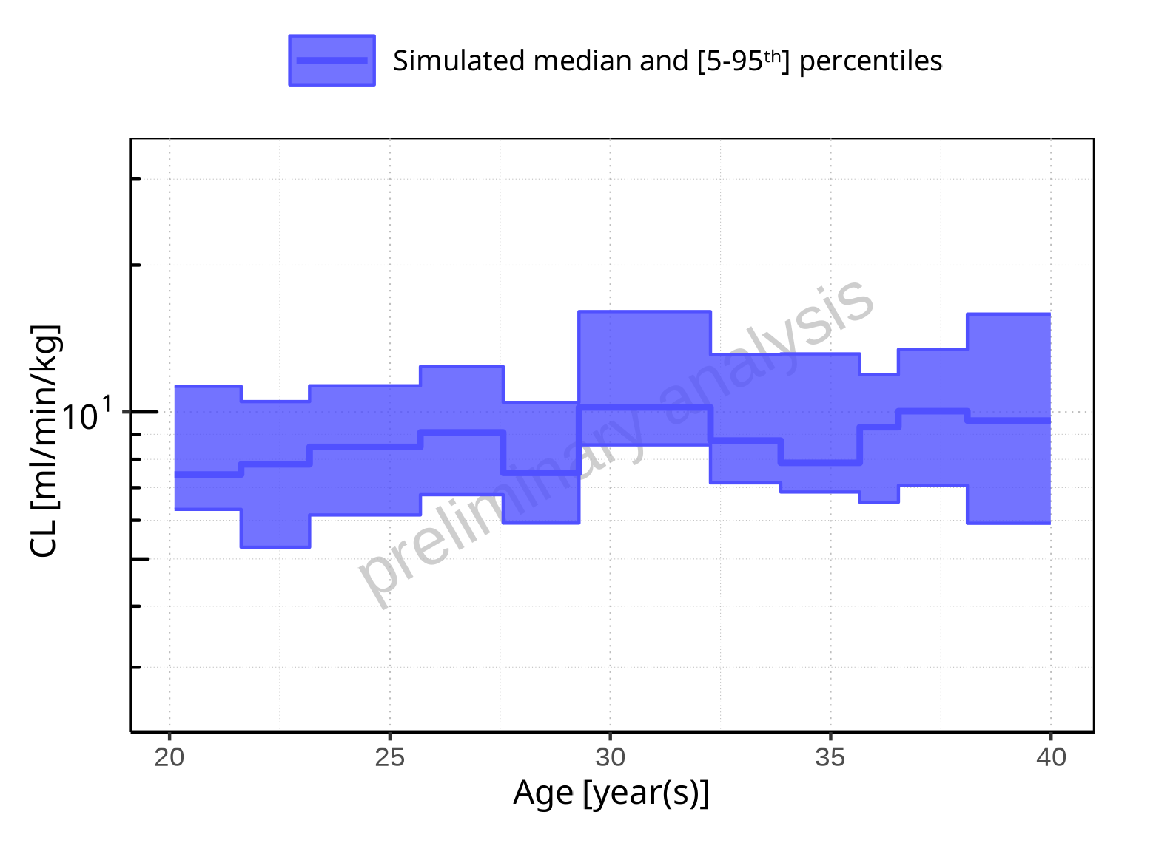

**Figure 2-287: Age-dependence of CL for Filmcoated_tablet_400mg_sd. Profiles are plotted in a logarithmic scale.**

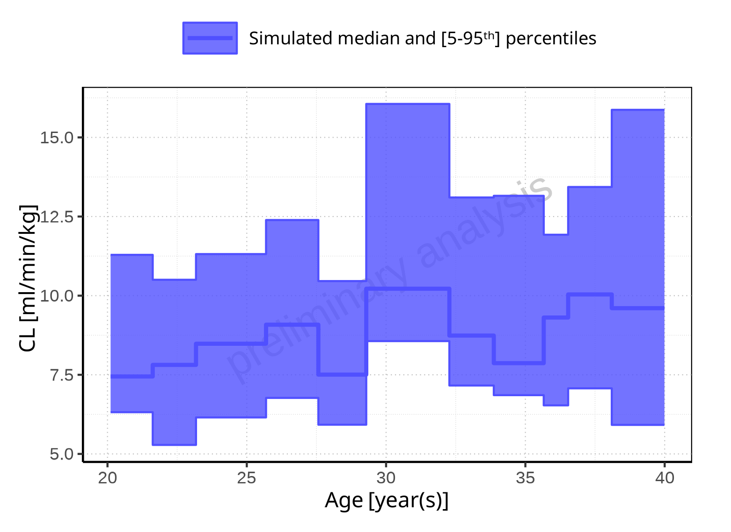

**Figure 2-288: Age-dependence of CL for Filmcoated_tablet_400mg_sd. Profiles are plotted in a linear scale.**

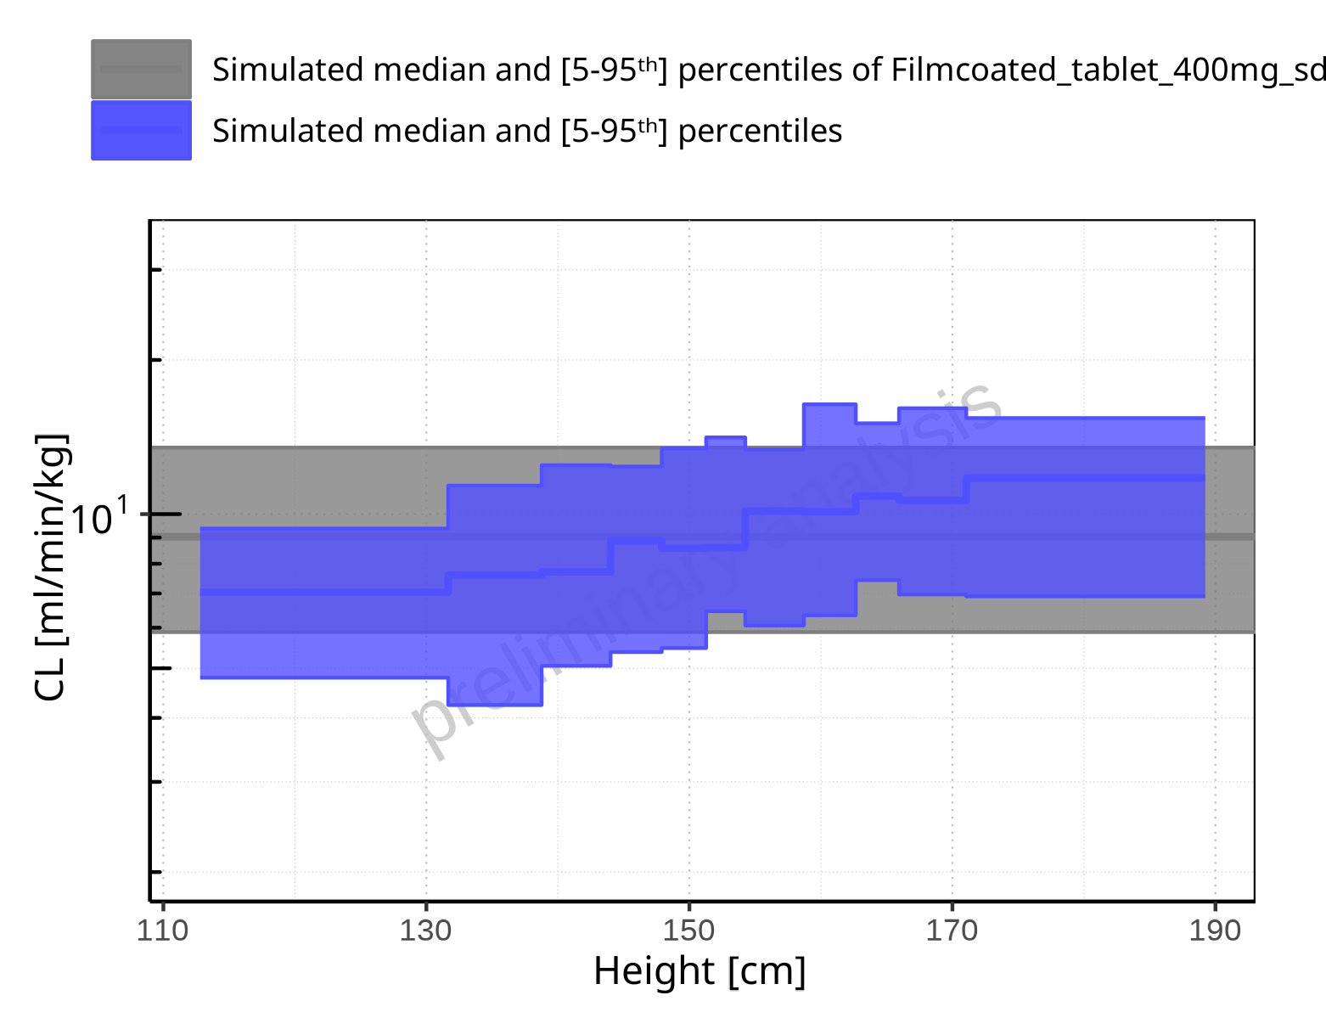

**Figure 2-289: Height-dependence of CL for Larson 2013 8y-18y 400mg FCT meal in comparison to Filmcoated_tablet_400mg_sd. Profiles are plotted in a logarithmic scale.**

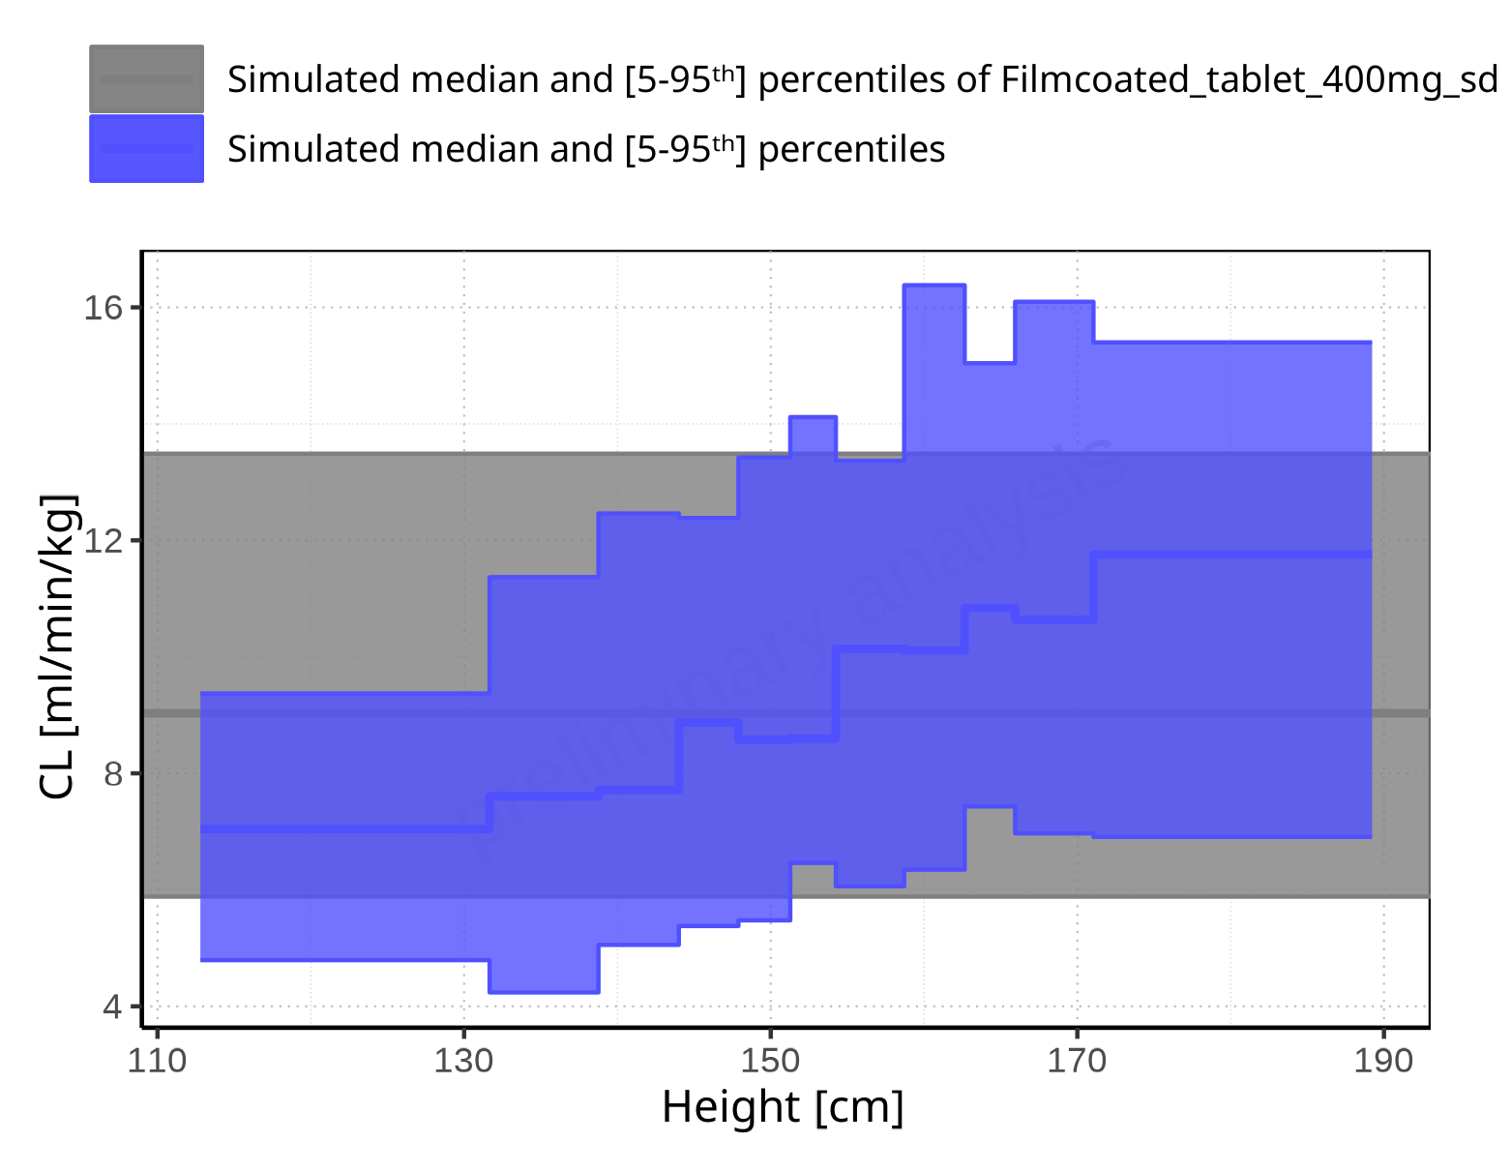

**Figure 2-290: Height-dependence of CL for Larson 2013 8y-18y 400mg FCT meal in comparison to Filmcoated_tablet_400mg_sd. Profiles are plotted in a linear scale.**

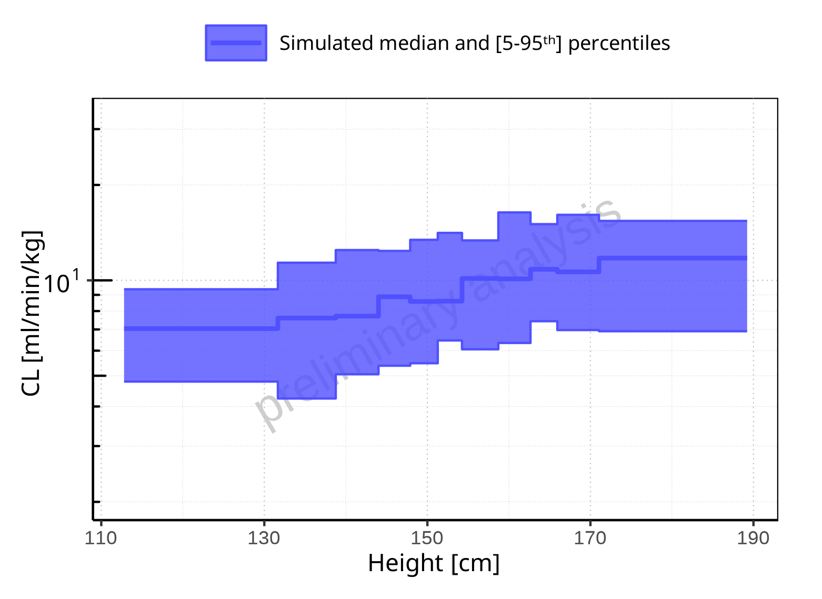

**Figure 2-291: Height-dependence of CL for Larson 2013 8y-18y 400mg FCT meal. Profiles are plotted in a logarithmic scale.**

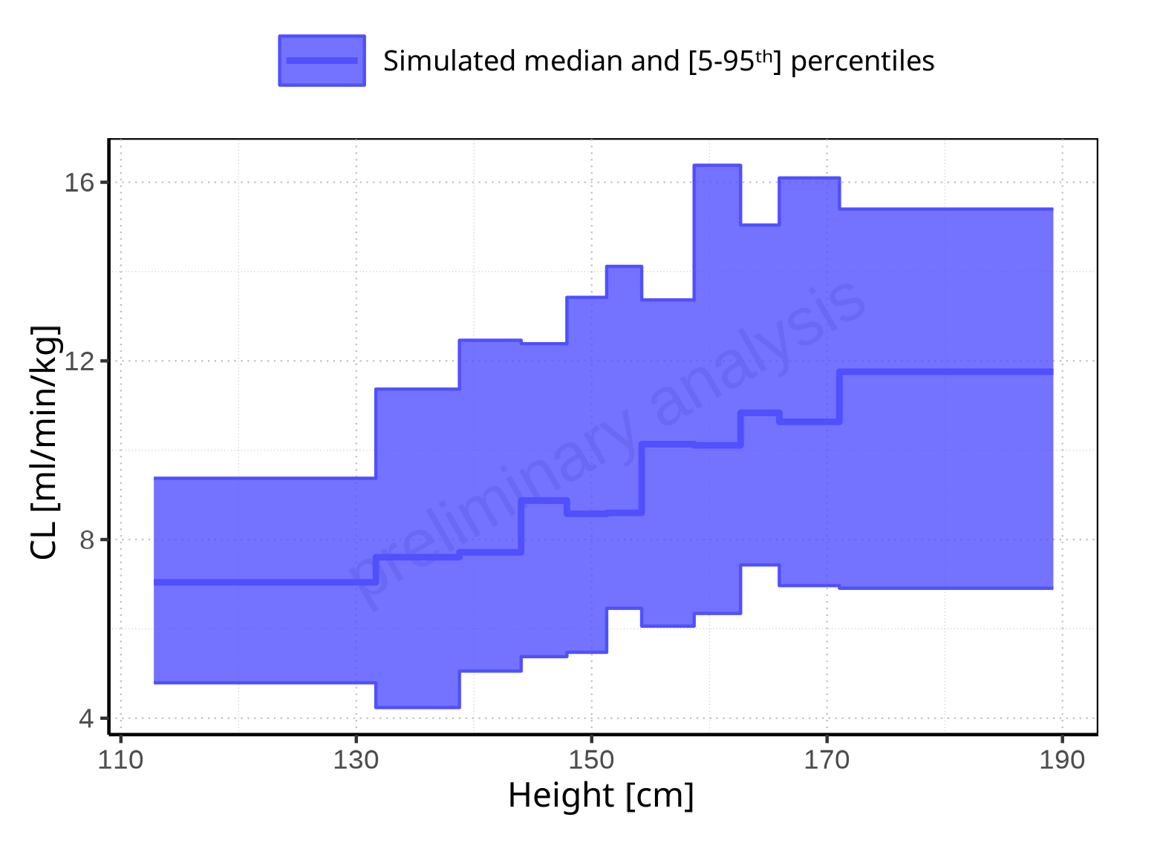

**Figure 2-292: Height-dependence of CL for Larson 2013 8y-18y 400mg FCT meal. Profiles are plotted in a linear scale.**

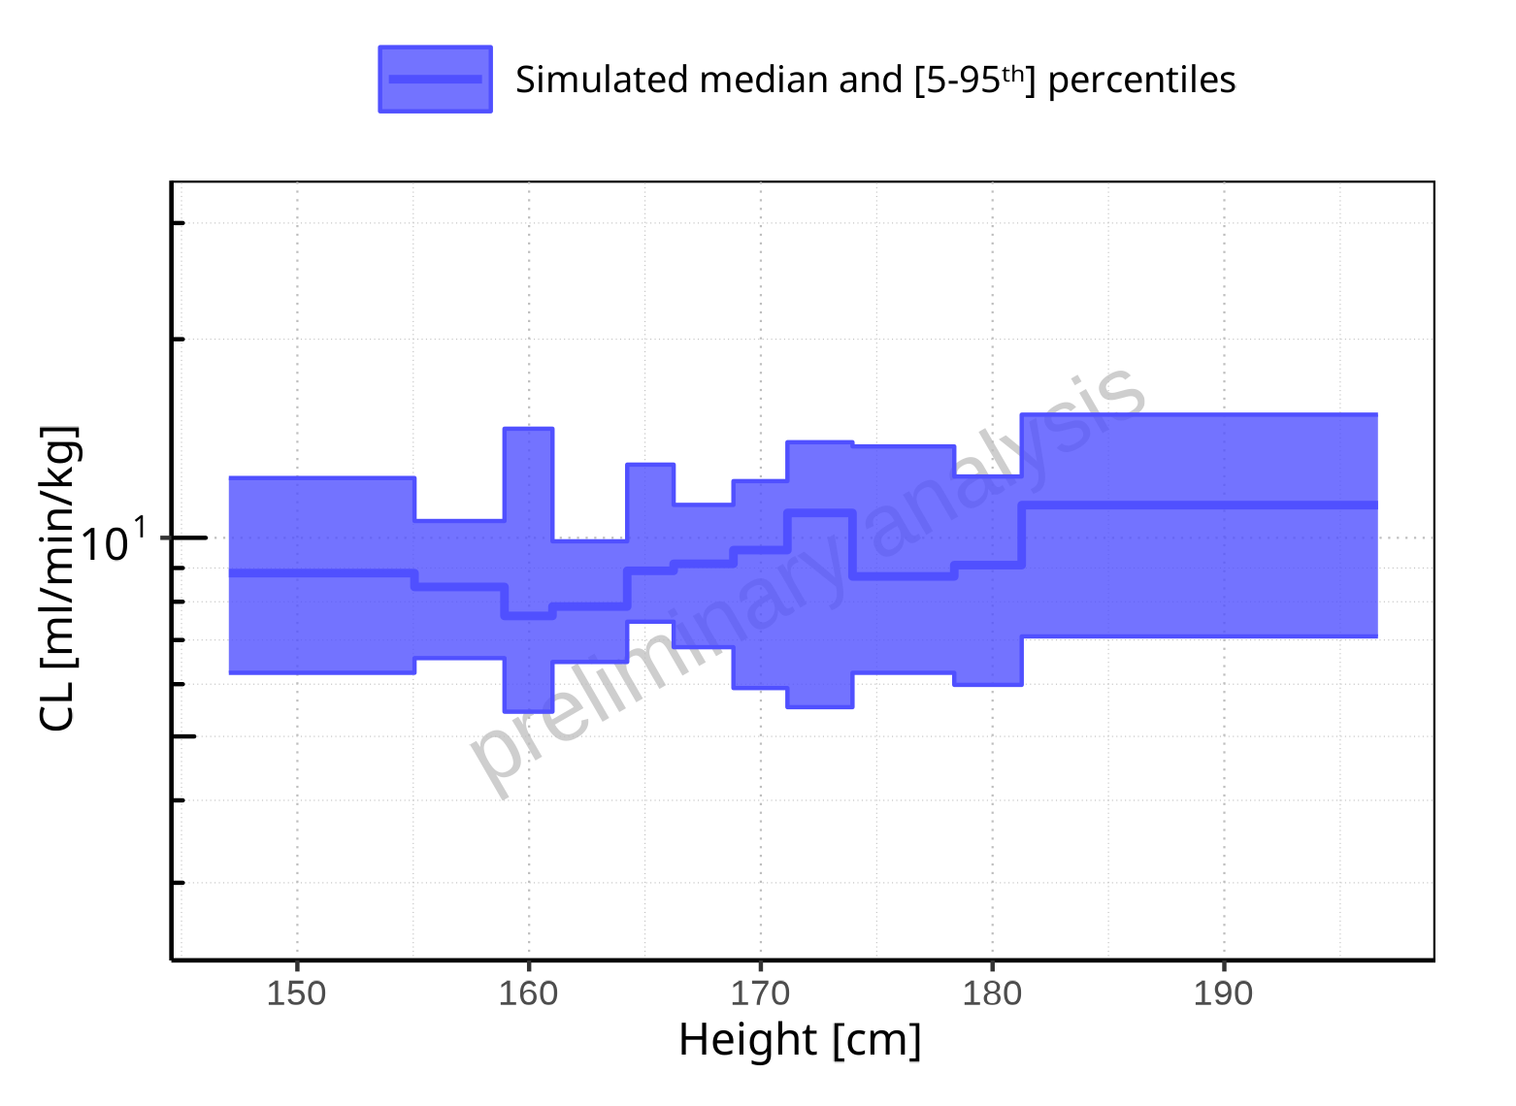

**Figure 2-293: Height-dependence of CL for Filmcoated_tablet_400mg_sd. Profiles are plotted in a logarithmic scale.**

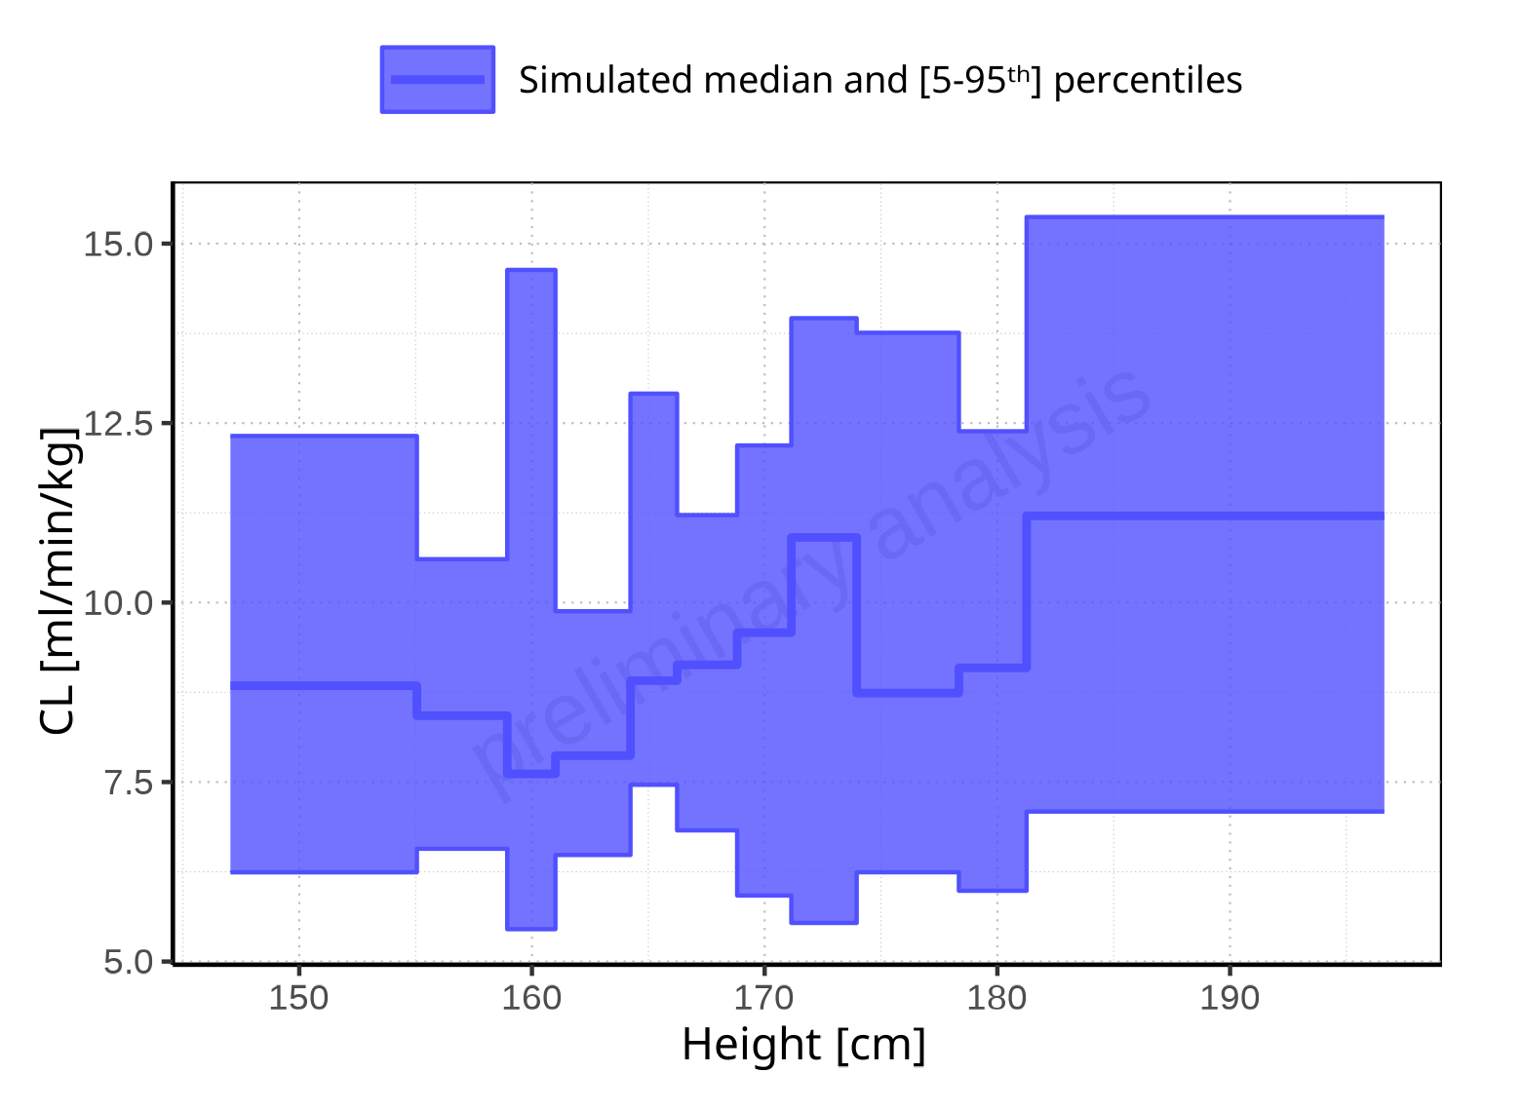

**Figure 2-294: Height-dependence of CL for Filmcoated_tablet_400mg_sd. Profiles are plotted in a linear scale.**

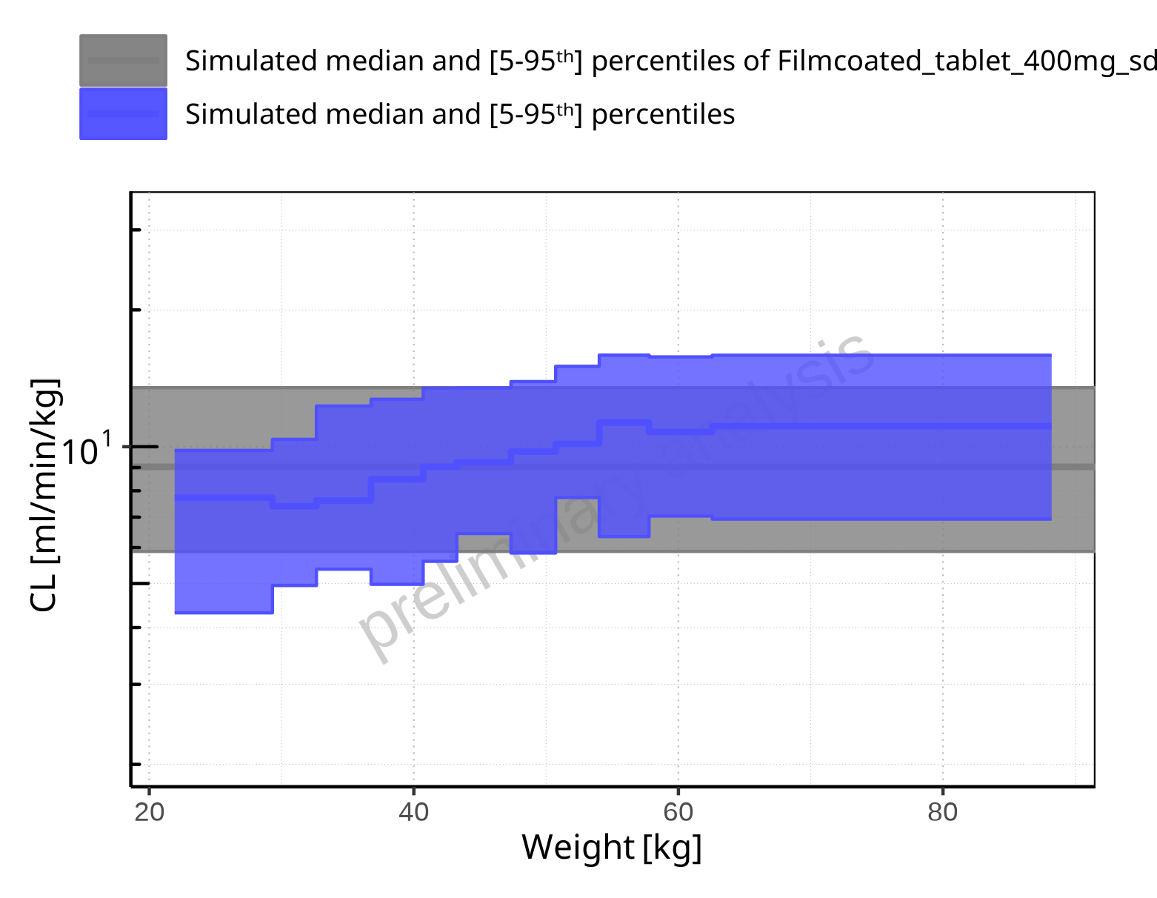

**Figure 2-295: Weight-dependence of CL for Larson 2013 8y-18y 400mg FCT meal in comparison to Filmcoated_tablet_400mg_sd. Profiles are plotted in a logarithmic scale.**

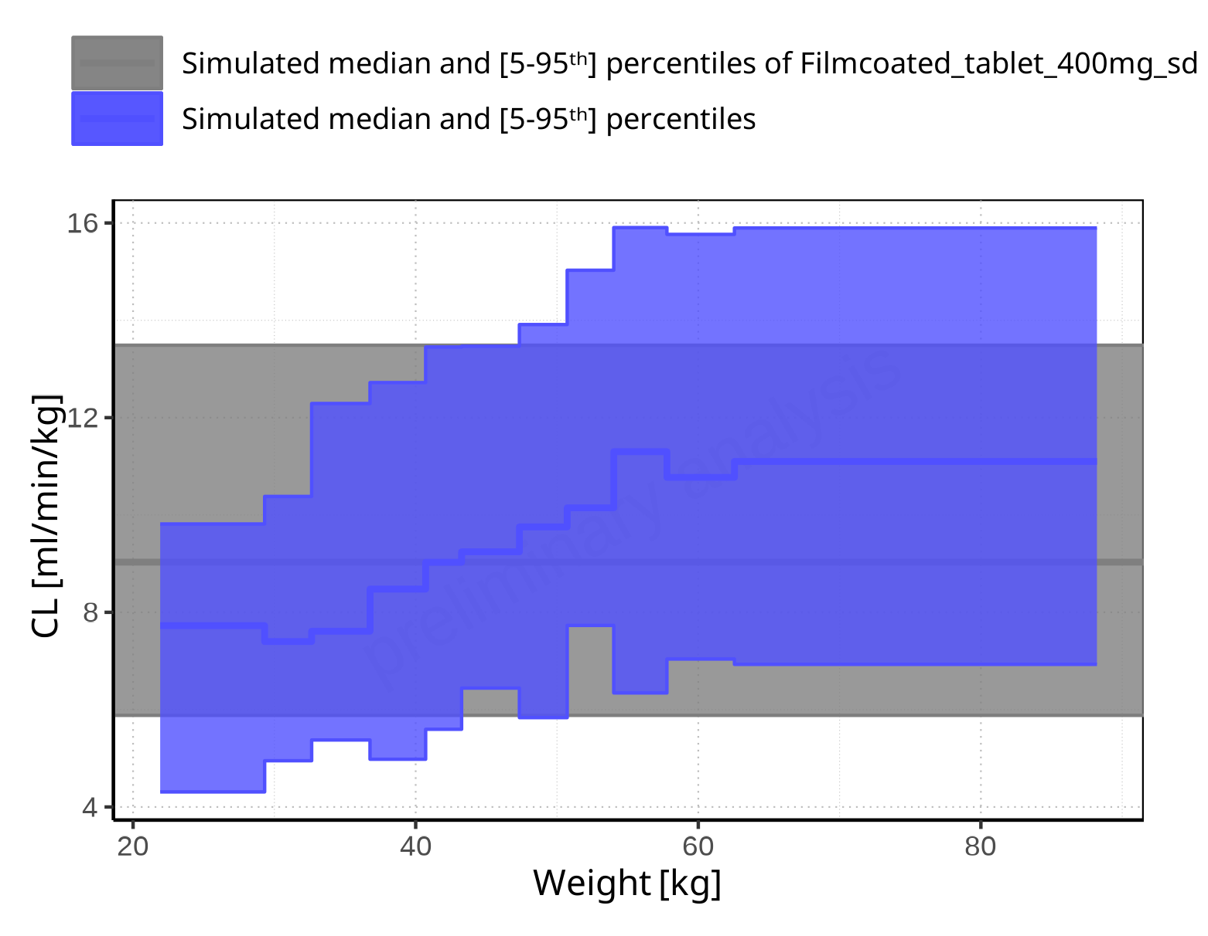

**Figure 2-296: Weight-dependence of CL for Larson 2013 8y-18y 400mg FCT meal in comparison to Filmcoated_tablet_400mg_sd. Profiles are plotted in a linear scale.**

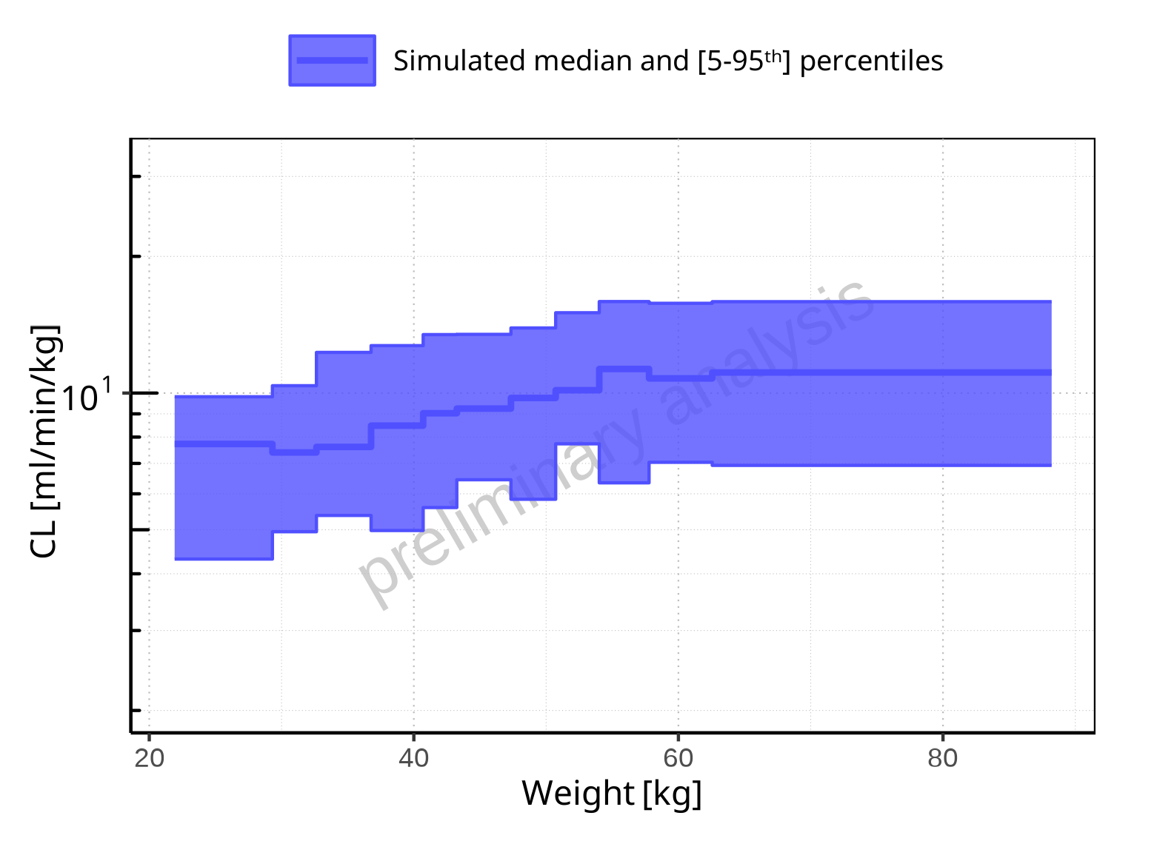

**Figure 2-297: Weight-dependence of CL for Larson 2013 8y-18y 400mg FCT meal. Profiles are plotted in a logarithmic scale.**

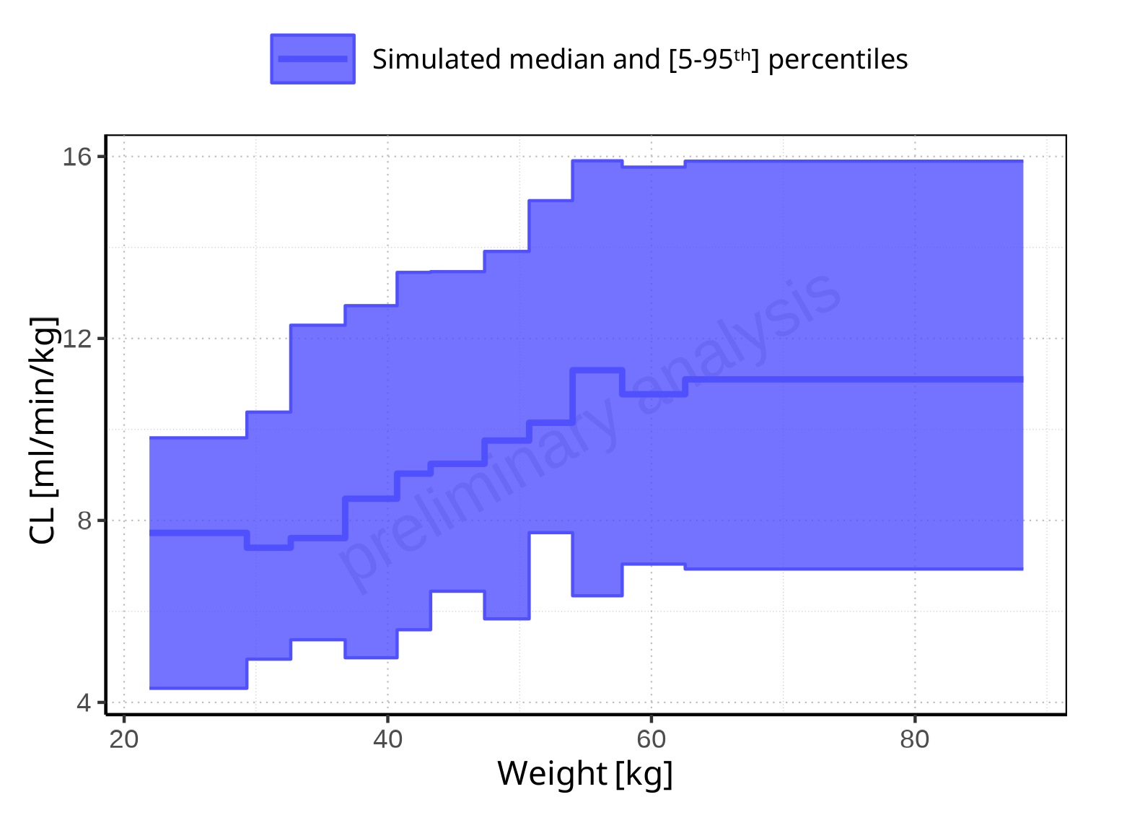

**Figure 2-298: Weight-dependence of CL for Larson 2013 8y-18y 400mg FCT meal. Profiles are plotted in a linear scale.**

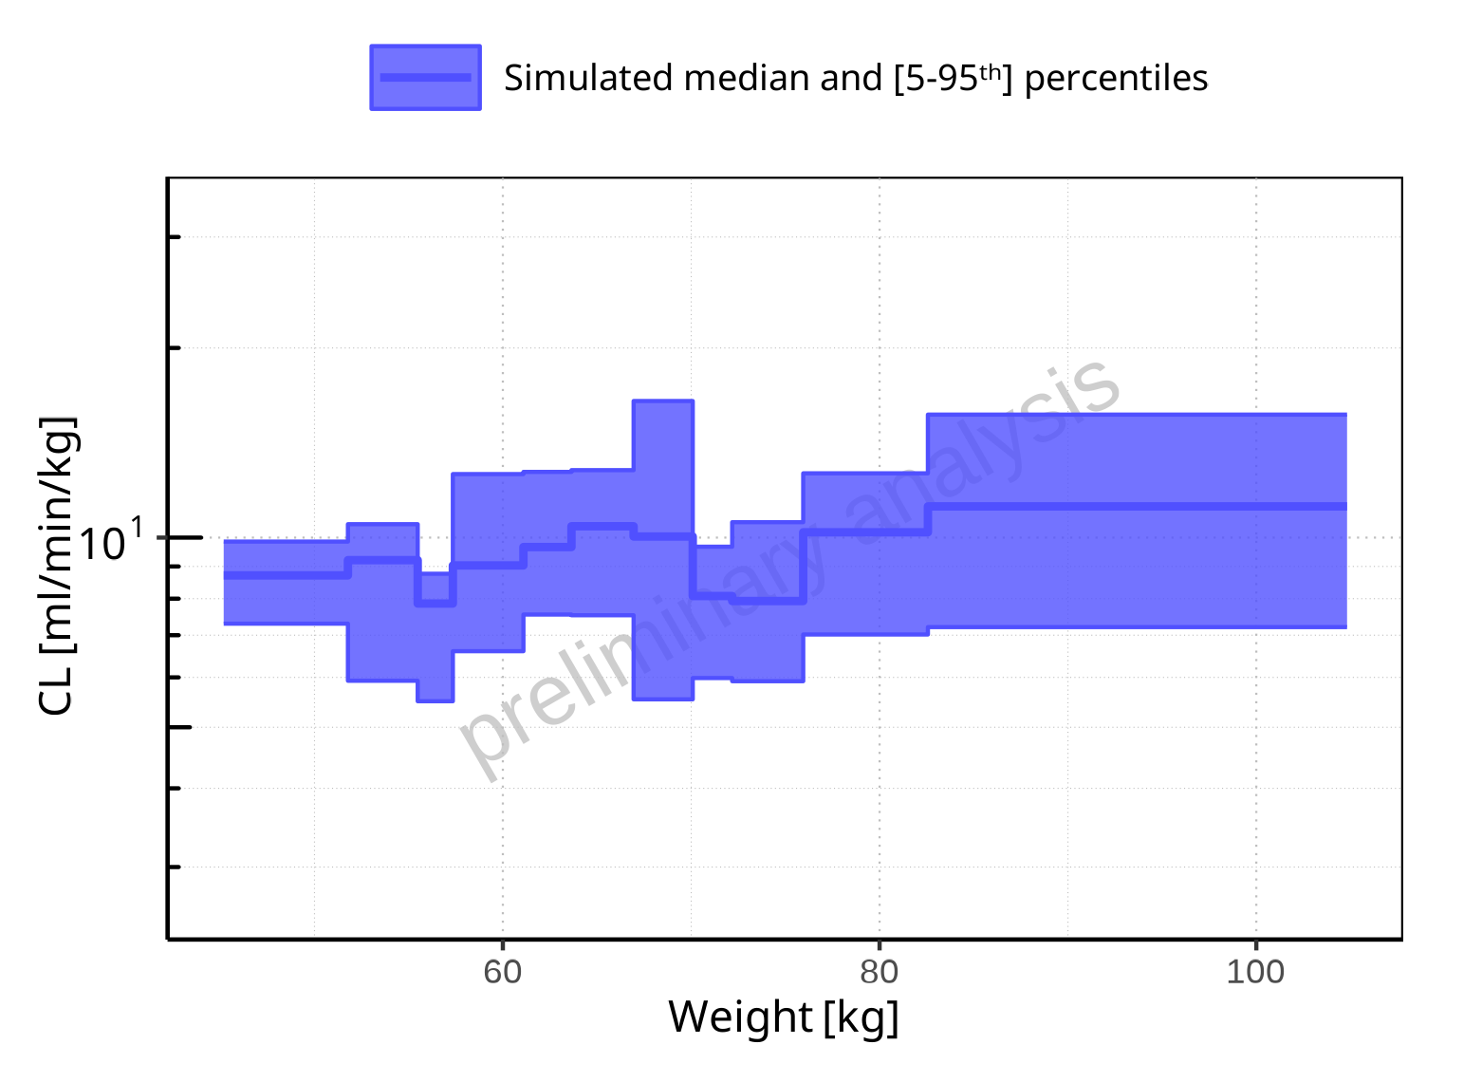

**Figure 2-299: Weight-dependence of CL for Filmcoated_tablet_400mg_sd. Profiles are plotted in a logarithmic scale.**

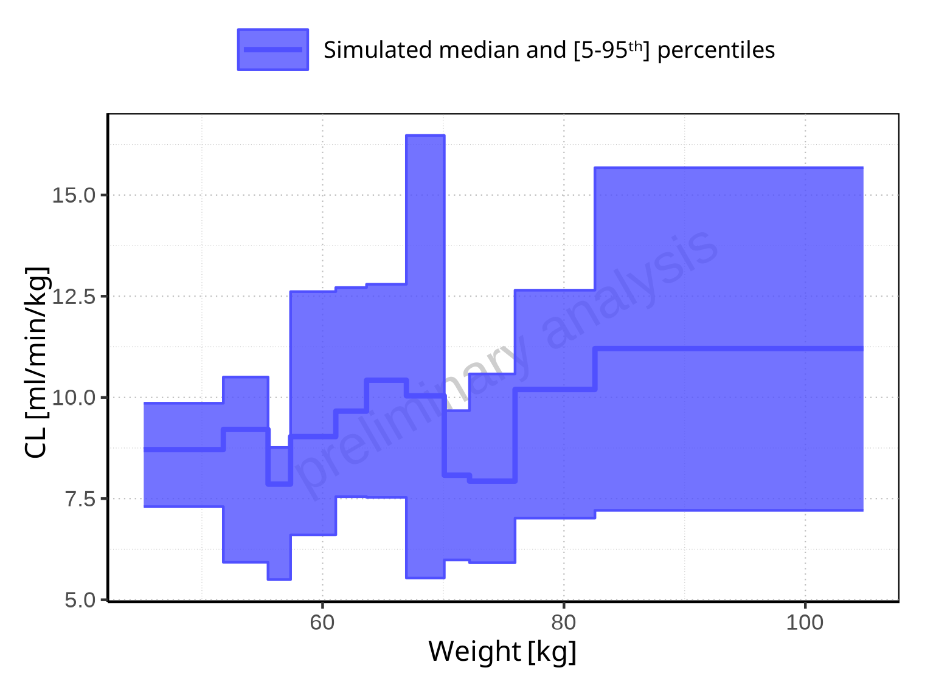

**Figure 2-300: Weight-dependence of CL for Filmcoated_tablet_400mg_sd. Profiles are plotted in a linear scale.**

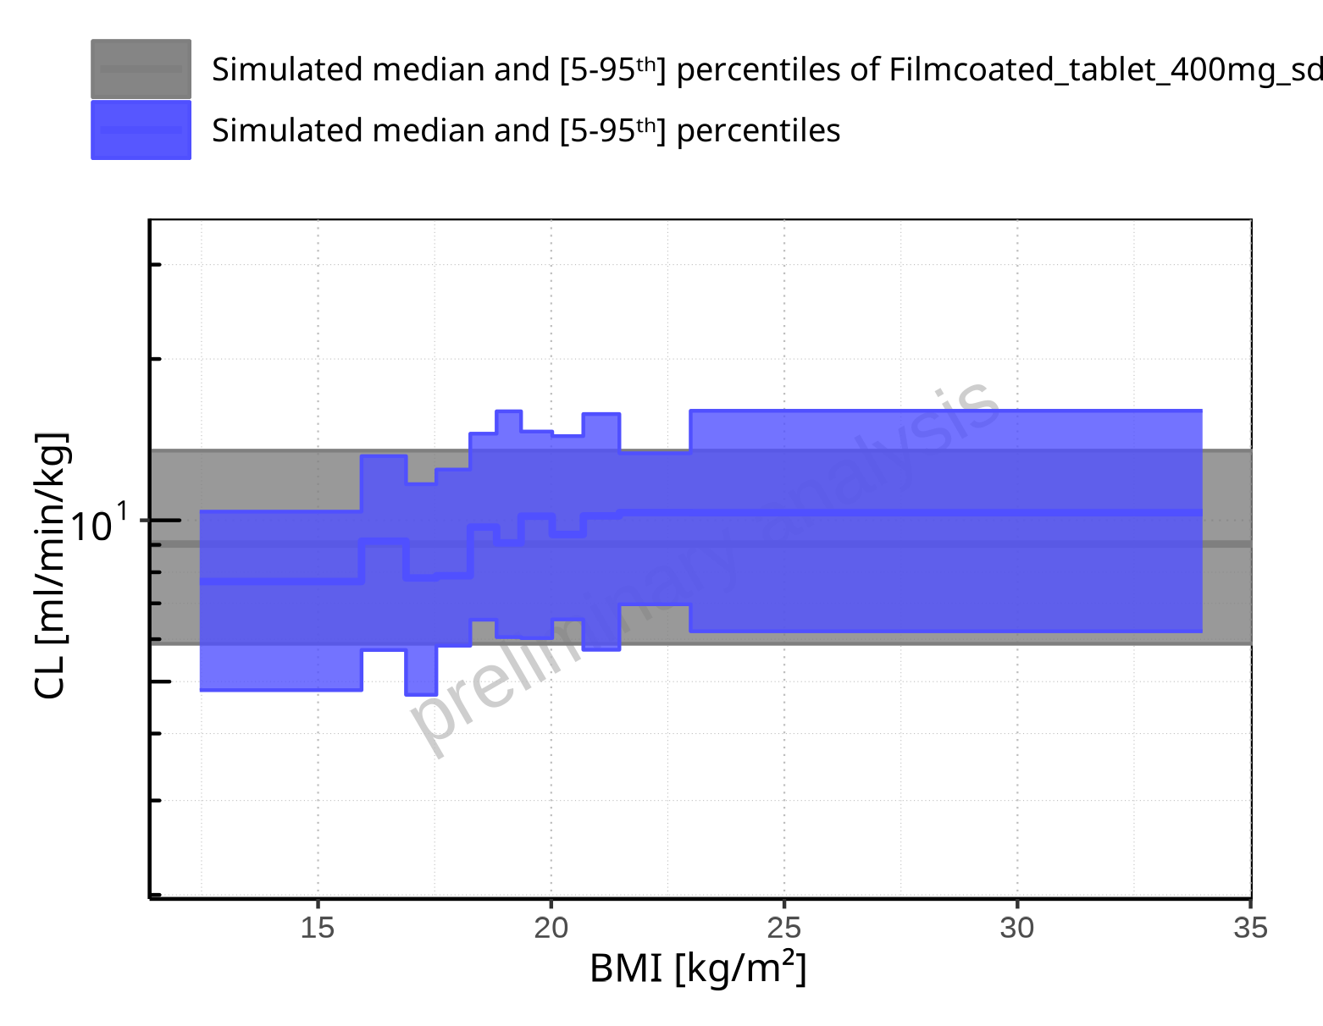

**Figure 2-301: BMI-dependence of CL for Larson 2013 8y-18y 400mg FCT meal in comparison to Filmcoated_tablet_400mg_sd. Profiles are plotted in a logarithmic scale.**

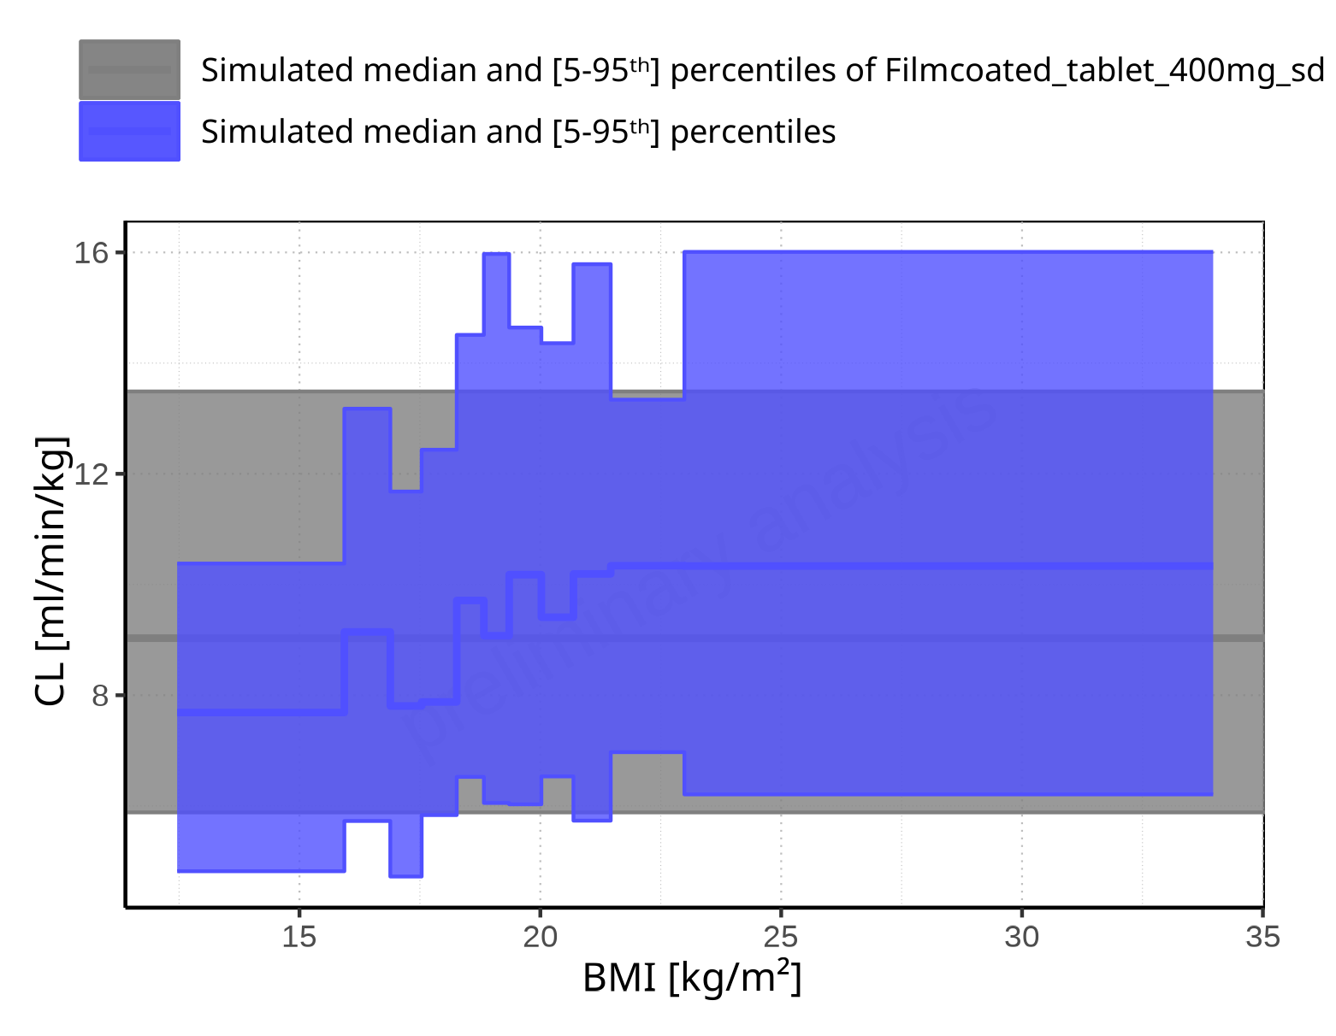

**Figure 2-302: BMI-dependence of CL for Larson 2013 8y-18y 400mg FCT meal in comparison to Filmcoated_tablet_400mg_sd. Profiles are plotted in a linear scale.**

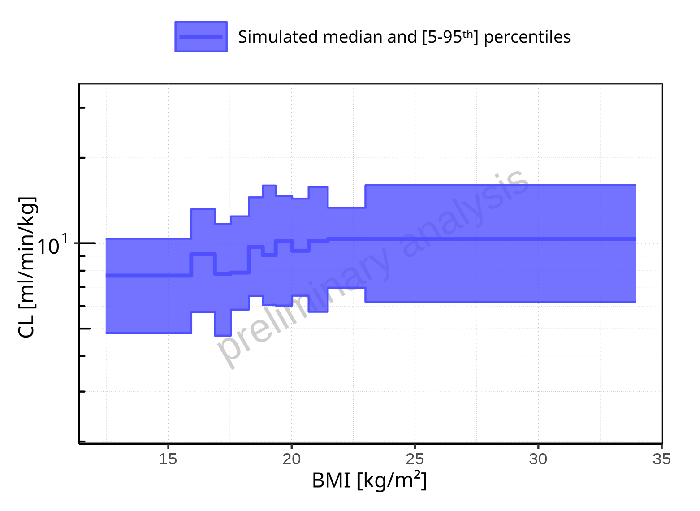

**Figure 2-303: BMI-dependence of CL for Larson 2013 8y-18y 400mg FCT meal. Profiles are plotted in a logarithmic scale.**

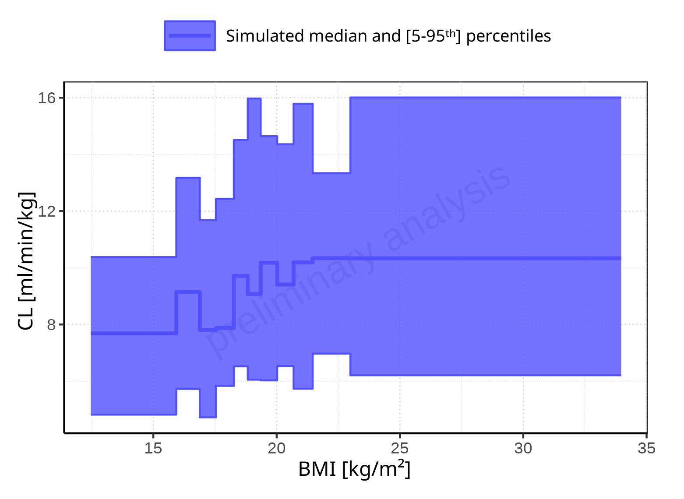

**Figure 2-304: BMI-dependence of CL for Larson 2013 8y-18y 400mg FCT meal. Profiles are plotted in a linear scale.**

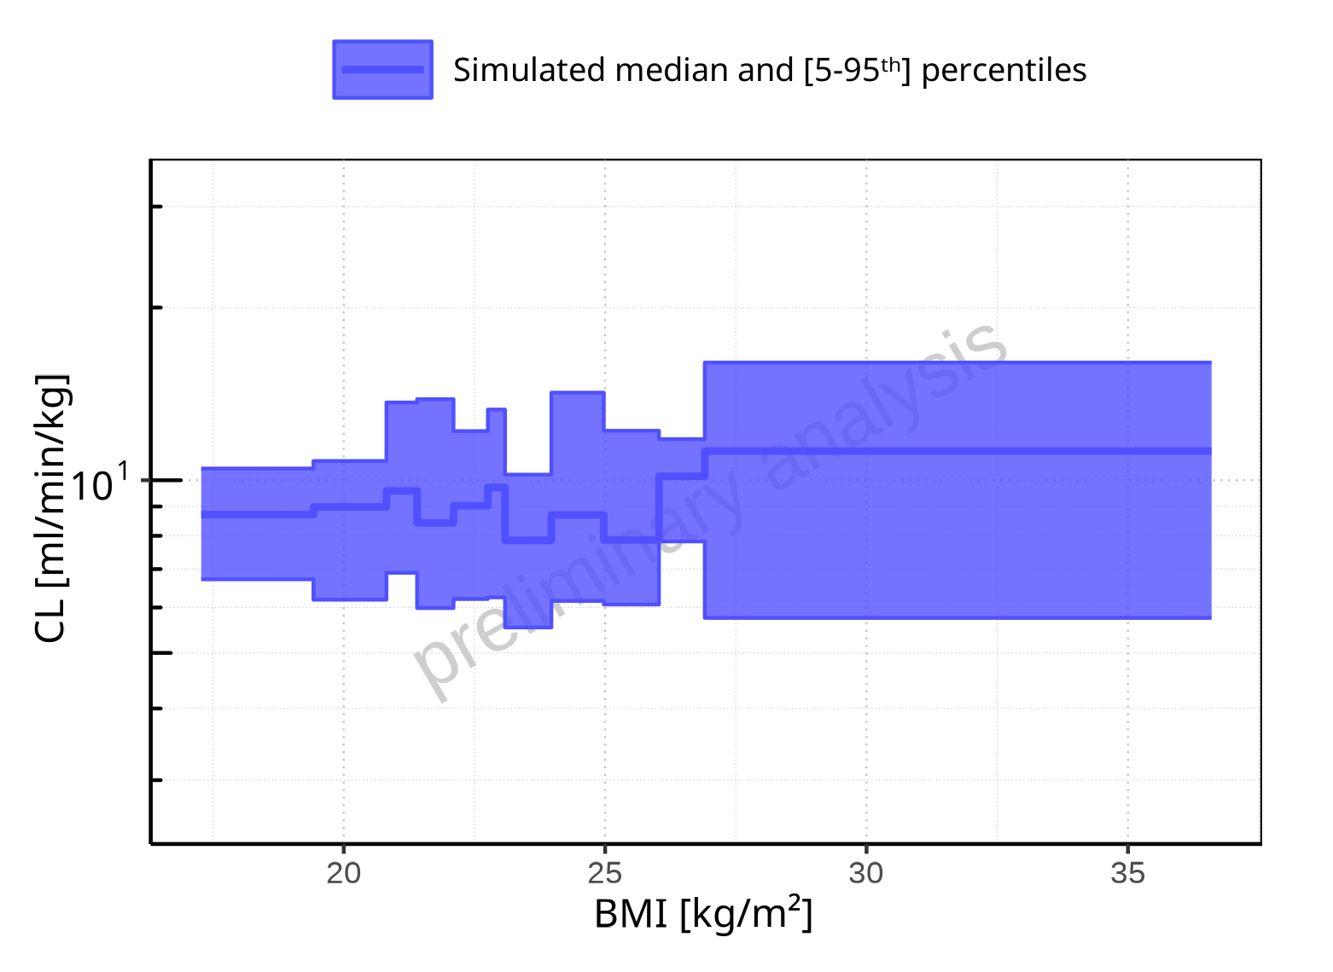

**Figure 2-305: BMI-dependence of CL for Filmcoated_tablet_400mg_sd. Profiles are plotted in a logarithmic scale.**

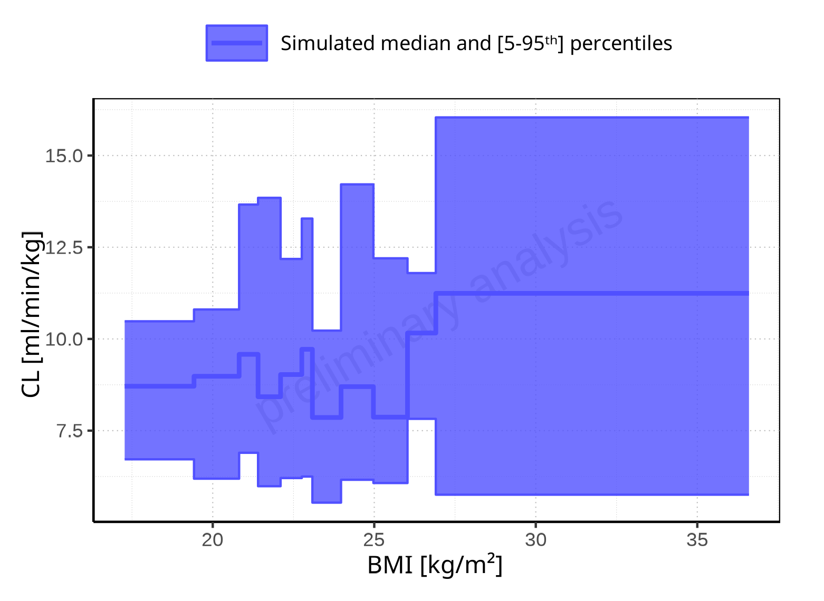

**Figure 2-306: BMI-dependence of CL for Filmcoated_tablet_400mg_sd. Profiles are plotted in a linear scale.**

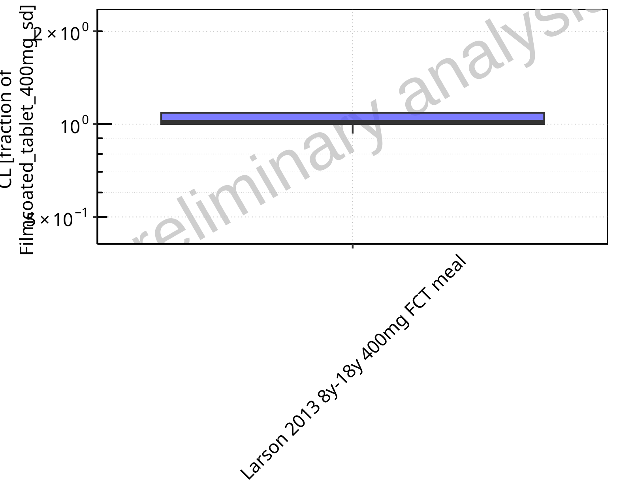

**Figure 2-307: Ratio of population summary statistics of CL of Raltegravir for Larson 2013 8y-18y 400mg FCT meal in comparison to Filmcoated_tablet_400mg_sd shown as box-whisker plot, which indicates ratios of the 5th, 25th, 50th, 75th, 95th percentiles in logarithmic scale.**

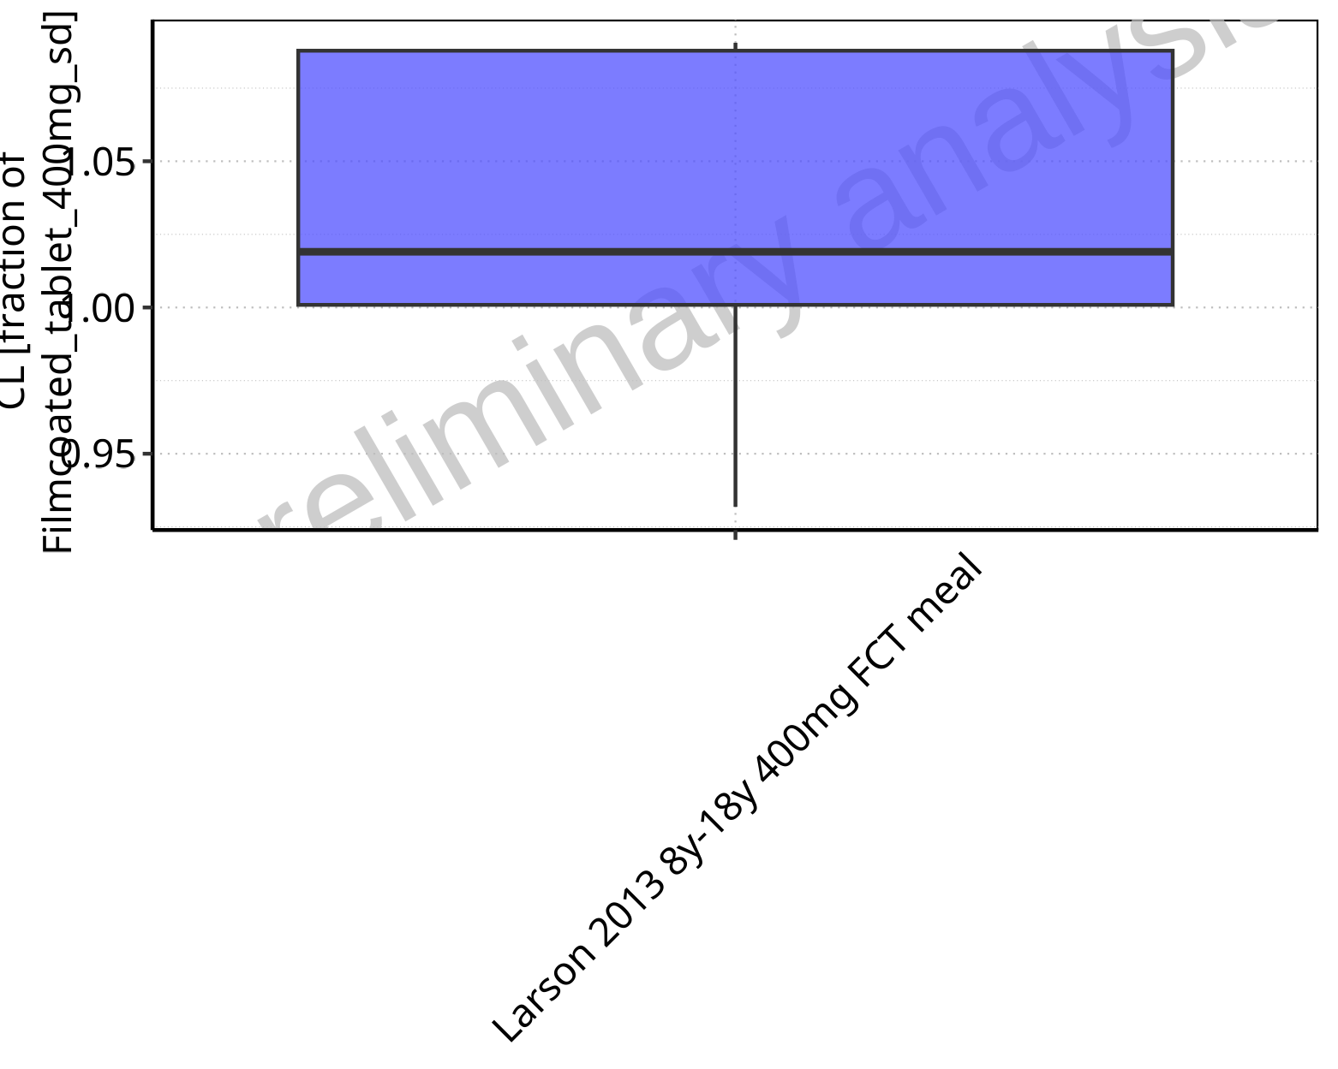

**Figure 2-308: Ratio of population summary statistics of CL of Raltegravir for Larson 2013 8y-18y 400mg FCT meal in comparison to Filmcoated_tablet_400mg_sd shown as box-whisker plot, which indicates ratios of the 5th, 25th, 50th, 75th, 95th percentiles in linear scale.**

**Table 2-22: Ratio of population summary statistics of CL of Raltegravir for Larson 2013 8y-18y 400mg FCT meal in comparison to Filmcoated_tablet_400mg_sd**

| Population | N | 5th pctl | 25th pctl | 50th pctl | 75th pctl | 95th pctl | Mean | SD | Geo Mean | Geo SD |
| --- | --- | --- | --- | --- | --- | --- | --- | --- | --- | --- |
| Larson 2013 8y-18y 400mg FCT meal | 497 | 0.93 | 1.00 | 1.02 | 1.09 | 1.09 | 1.03 | 1.13 | 1.02 | 1.04 |

### Vss

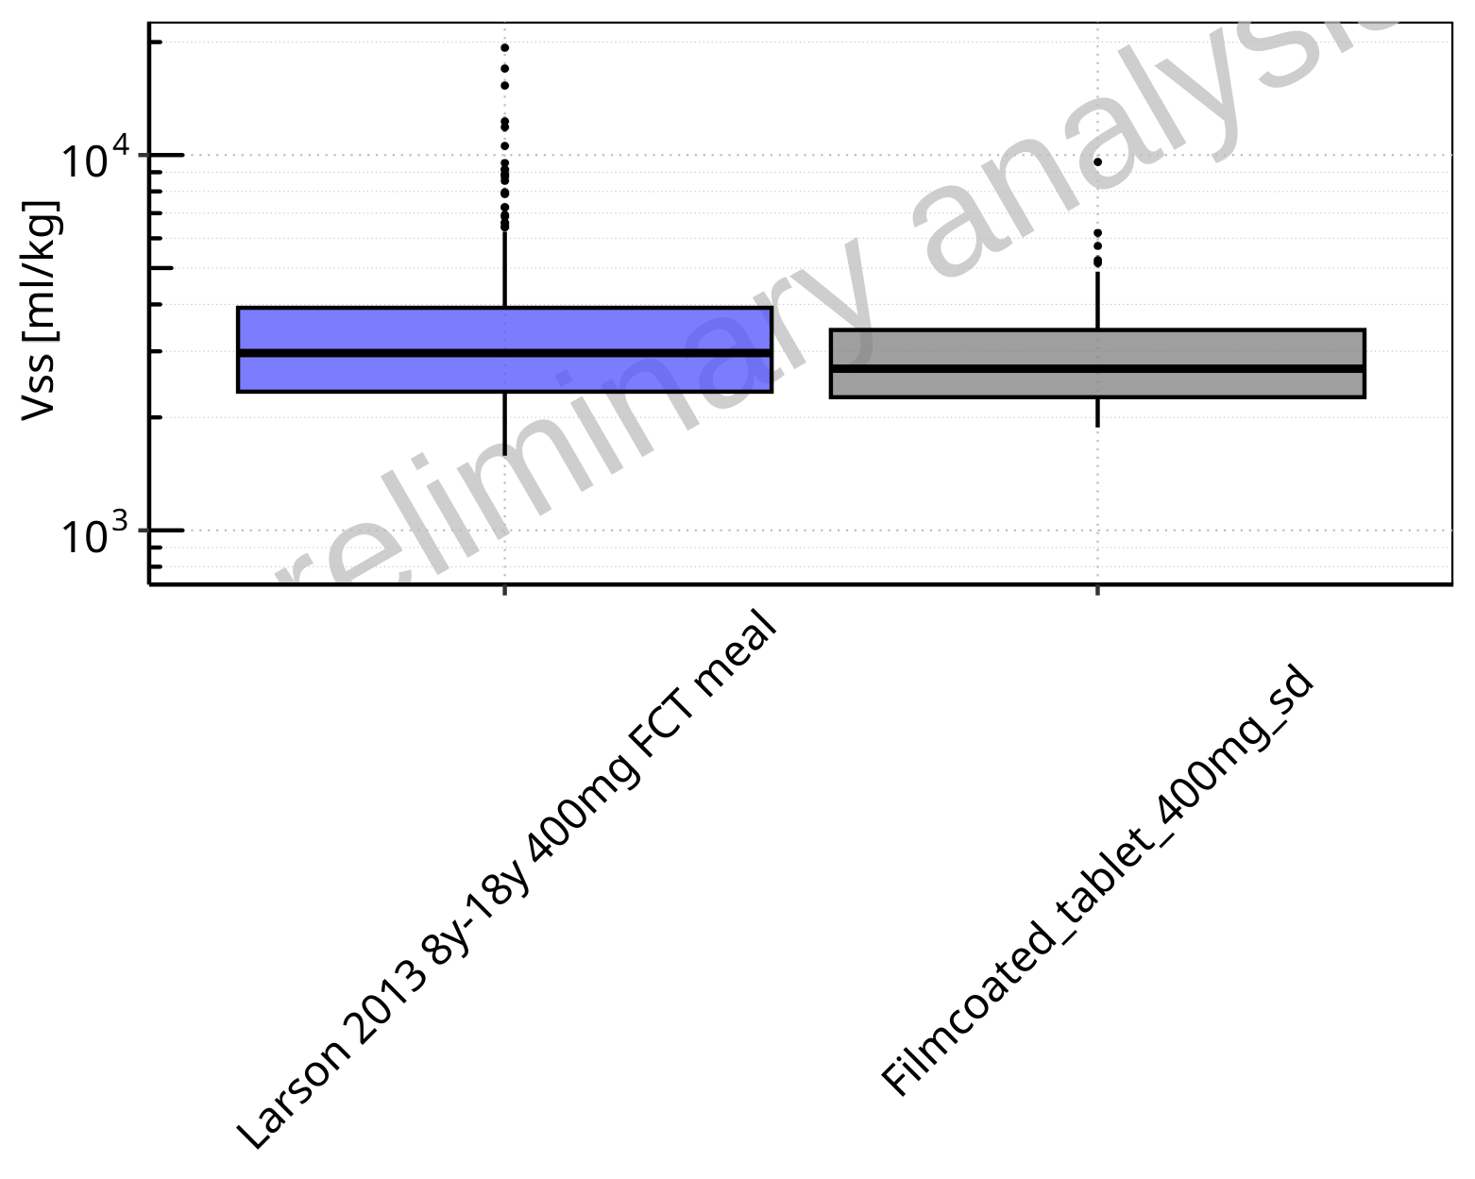

**Figure 2-309: Vss of Raltegravir for Larson 2013 8y-18y 400mg FCT meal, Filmcoated_tablet_400mg_sd shown as box-whisker plot, which indicates the 5th, 25th, 50th, 75th, 95th percentiles in logarithmic scale.**

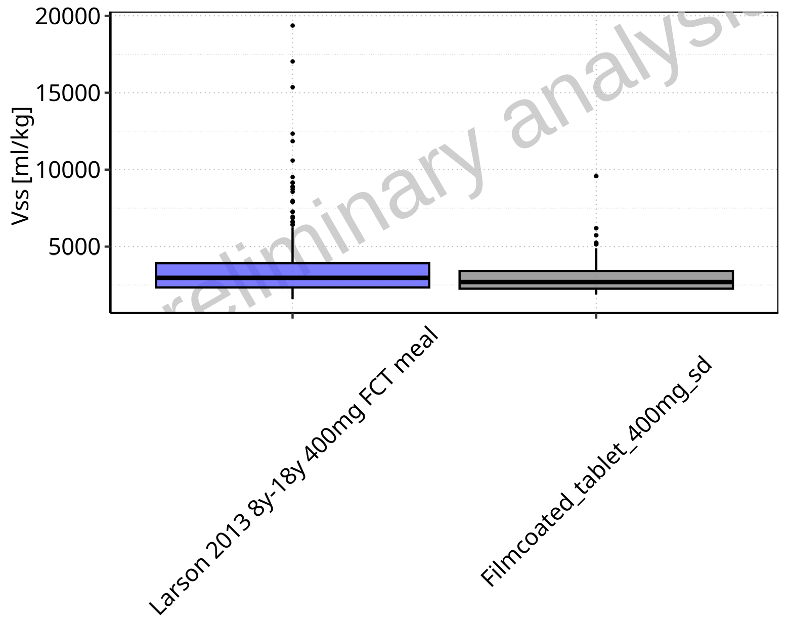

**Figure 2-310: Vss of Raltegravir for Larson 2013 8y-18y 400mg FCT meal, Filmcoated_tablet_400mg_sd shown as box-whisker plot, which indicates the 5th, 25th, 50th, 75th, 95th percentiles in linear scale.**

**Table 2-23: Population statistics summarizing Vss of Raltegravir for Larson 2013 8y-18y 400mg FCT meal, Filmcoated_tablet_400mg_sd reported in [ml/kg]**

| Population | N | 5th pctl | 25th pctl | 50th pctl | 75th pctl | 95th pctl | Mean | SD | Geo Mean | Geo SD |
| --- | --- | --- | --- | --- | --- | --- | --- | --- | --- | --- |
| Larson 2013 8y-18y 400mg FCT meal | 497 | 1581.09 | 2341.62 | 2968.06 | 3917.84 | 6249.02 | 3396.63 | 1880.06 | 3071.48 | 1.53 |
| Filmcoated_tablet_400mg_sd | 100 | 1880.27 | 2263.55 | 2695.83 | 3418.90 | 4890.56 | 2993.70 | 1138.98 | 2836.19 | 1.37 |

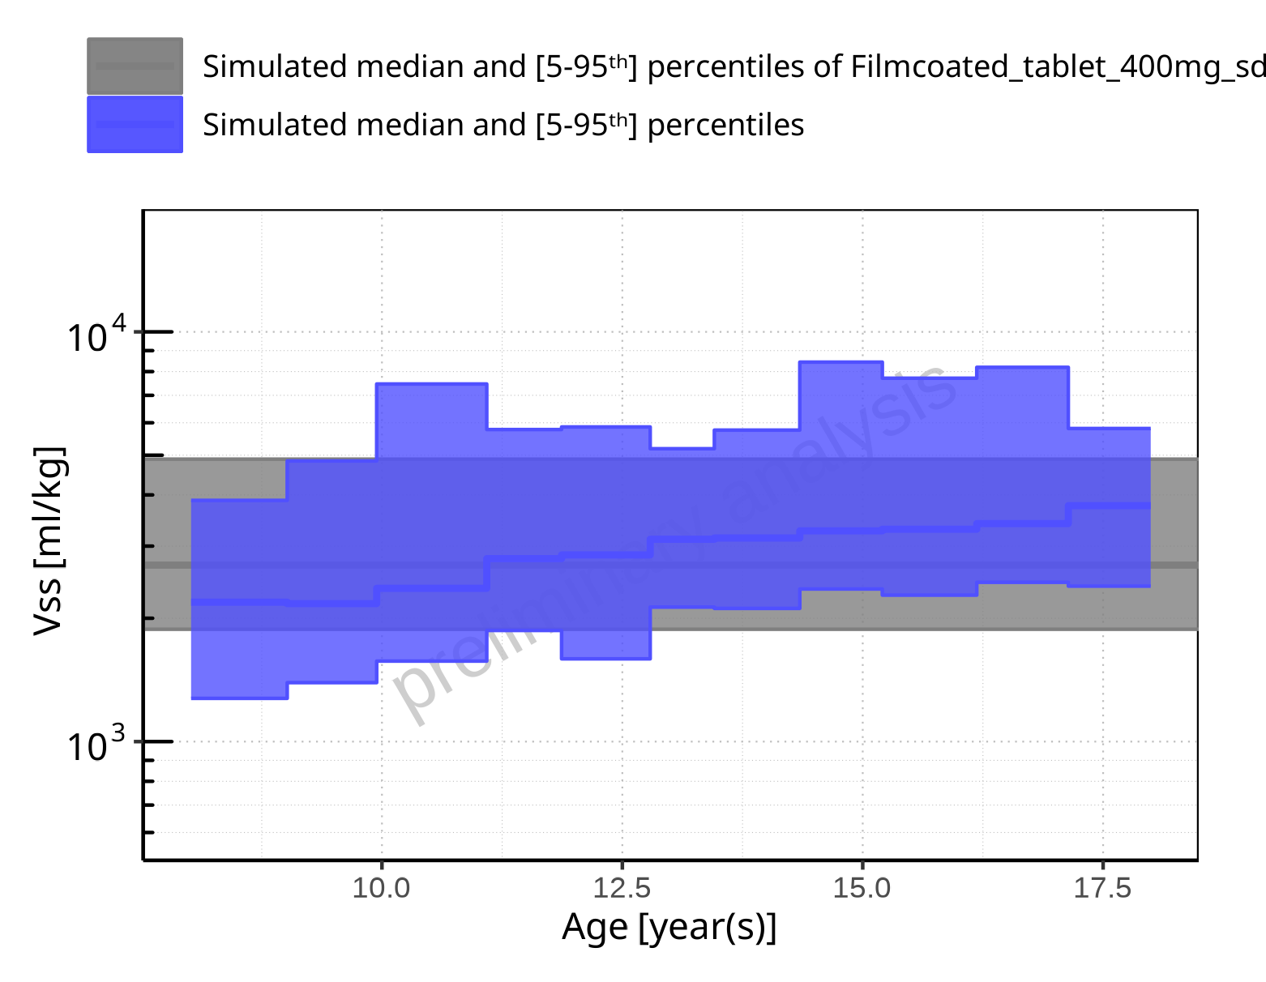

**Figure 2-311: Age-dependence of Vss for Larson 2013 8y-18y 400mg FCT meal in comparison to Filmcoated_tablet_400mg_sd. Profiles are plotted in a logarithmic scale.**

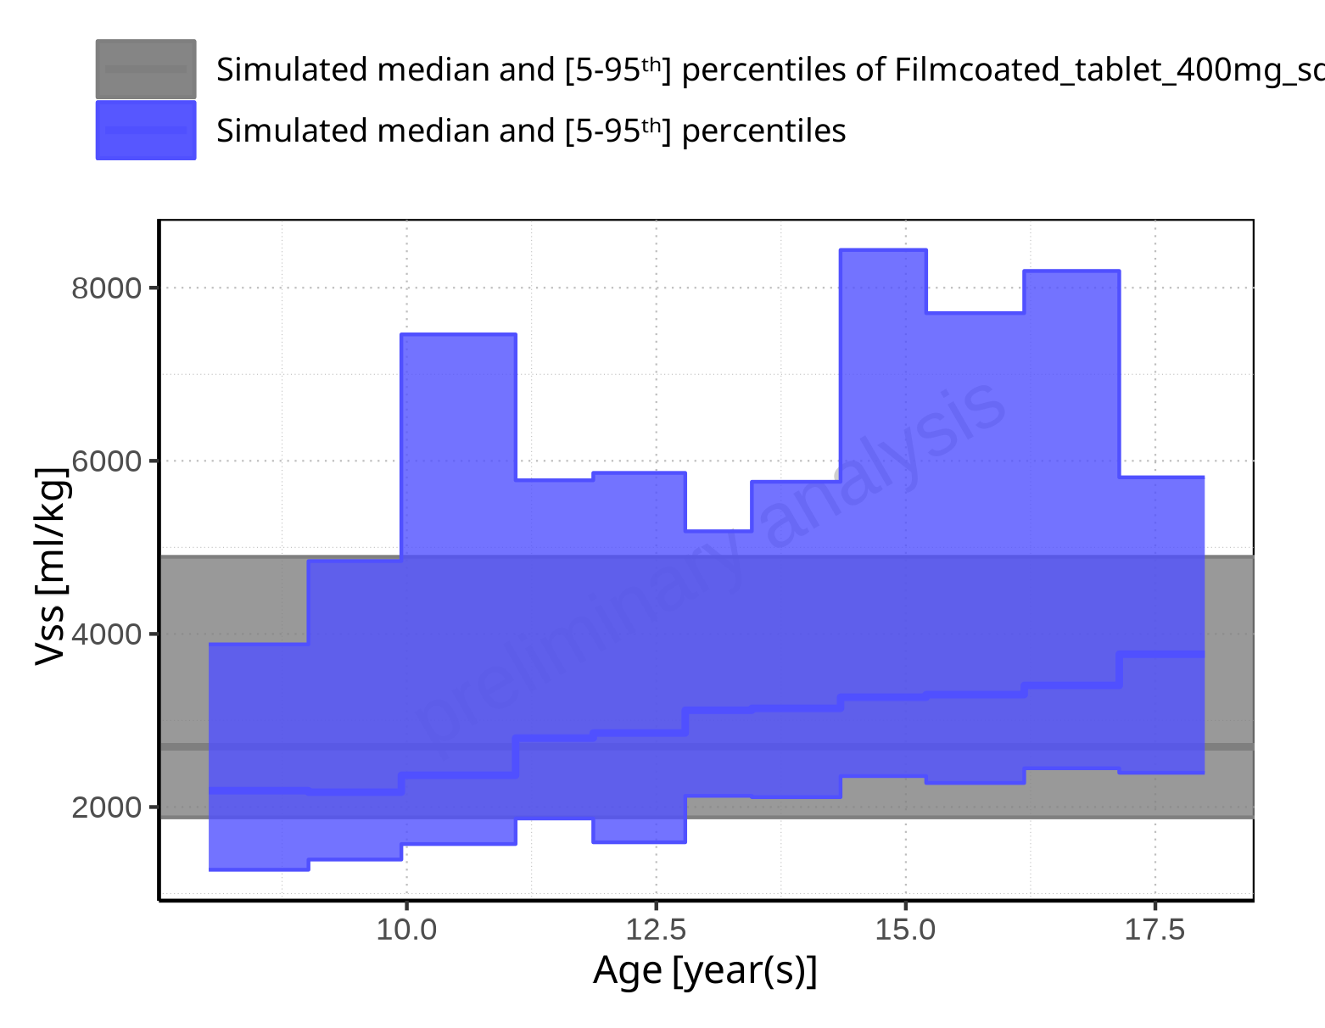

**Figure 2-312: Age-dependence of Vss for Larson 2013 8y-18y 400mg FCT meal in comparison to Filmcoated_tablet_400mg_sd. Profiles are plotted in a linear scale.**

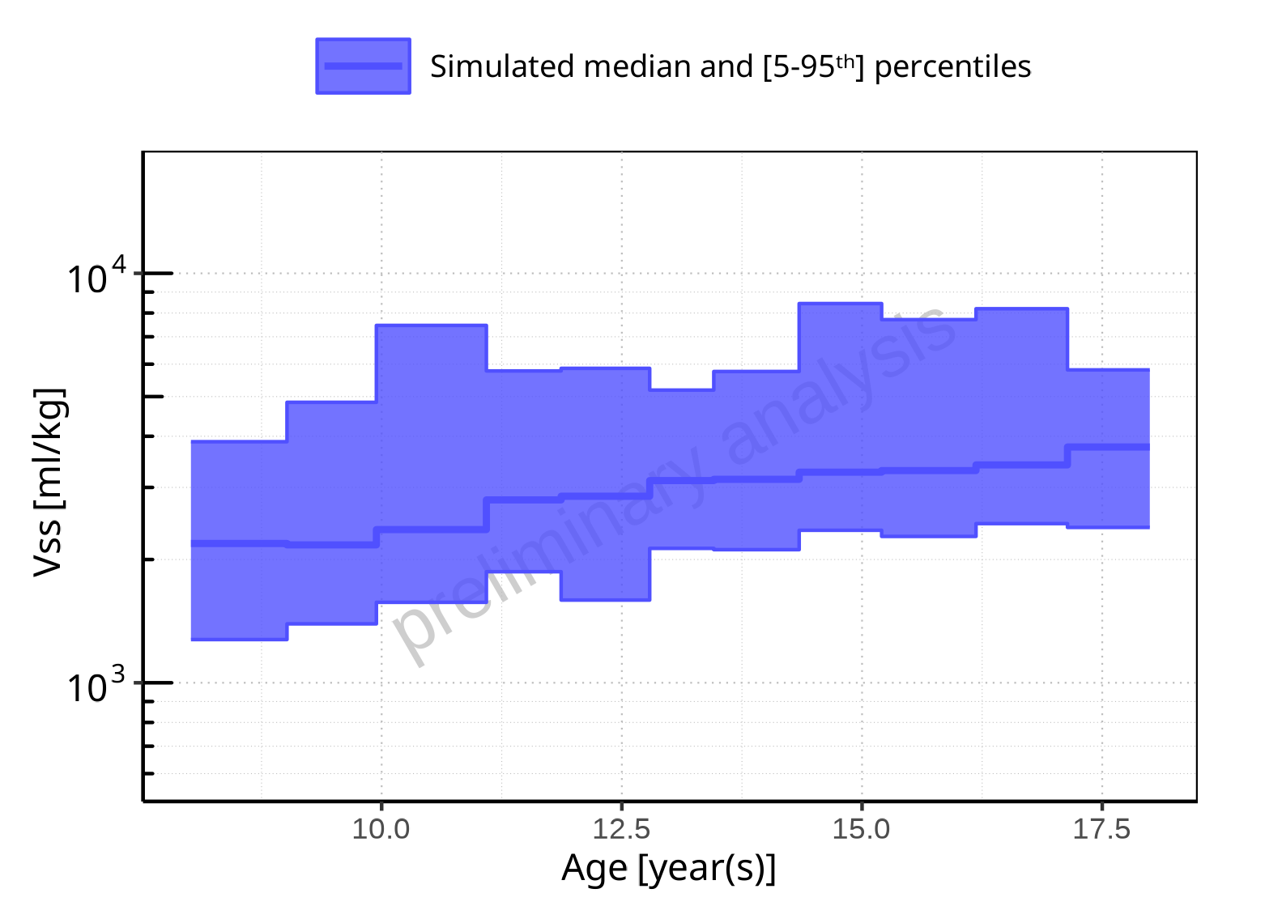

**Figure 2-313: Age-dependence of Vss for Larson 2013 8y-18y 400mg FCT meal. Profiles are plotted in a logarithmic scale.**

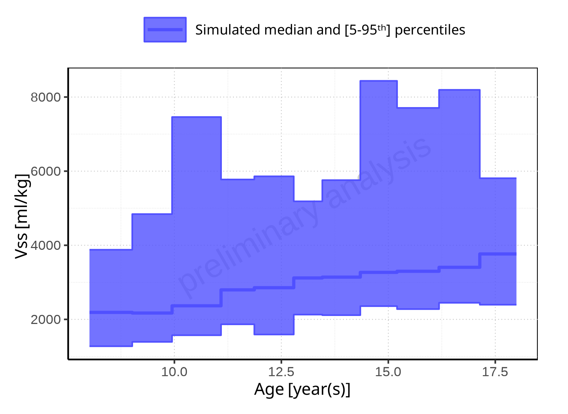

**Figure 2-314: Age-dependence of Vss for Larson 2013 8y-18y 400mg FCT meal. Profiles are plotted in a linear scale.**

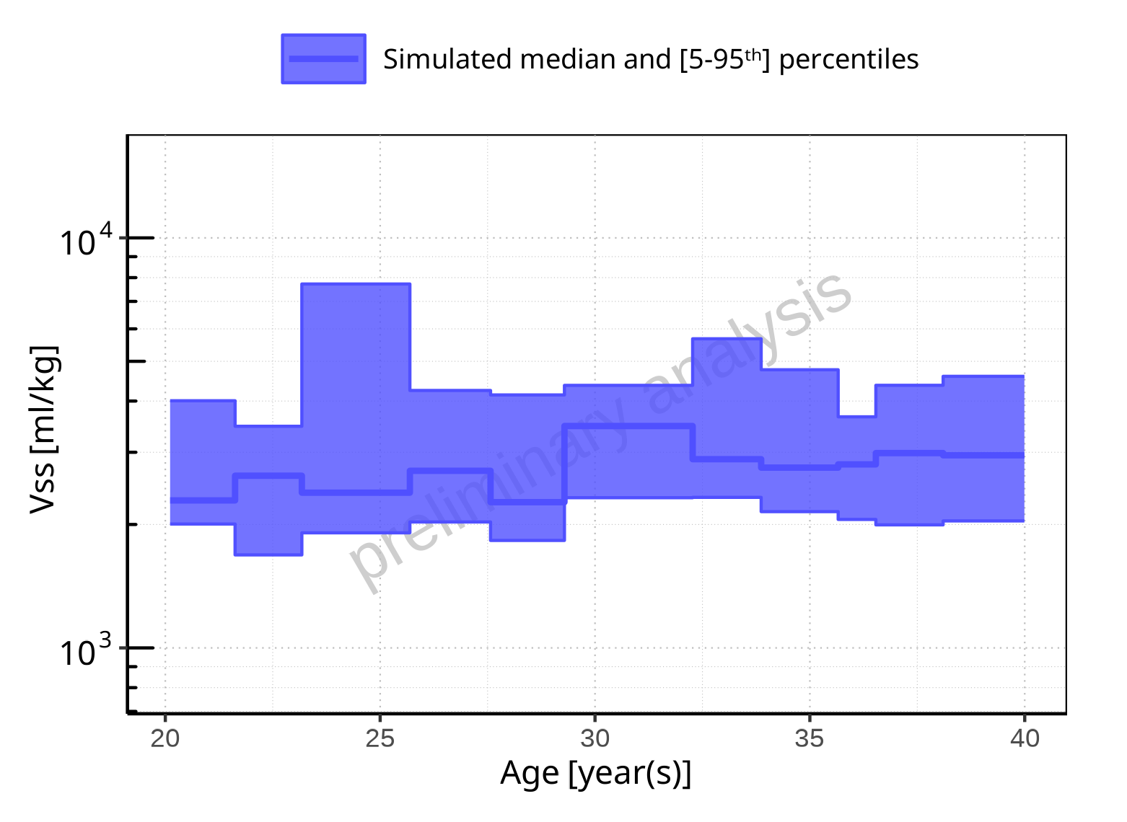

**Figure 2-315: Age-dependence of Vss for Filmcoated_tablet_400mg_sd. Profiles are plotted in a logarithmic scale.**

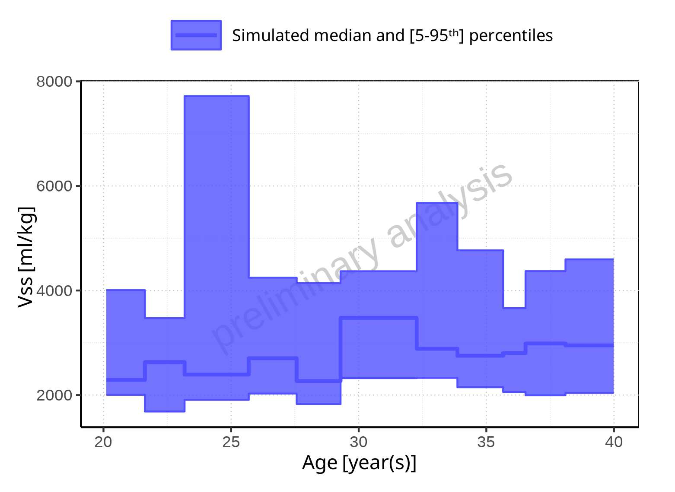

**Figure 2-316: Age-dependence of Vss for Filmcoated_tablet_400mg_sd. Profiles are plotted in a linear scale.**

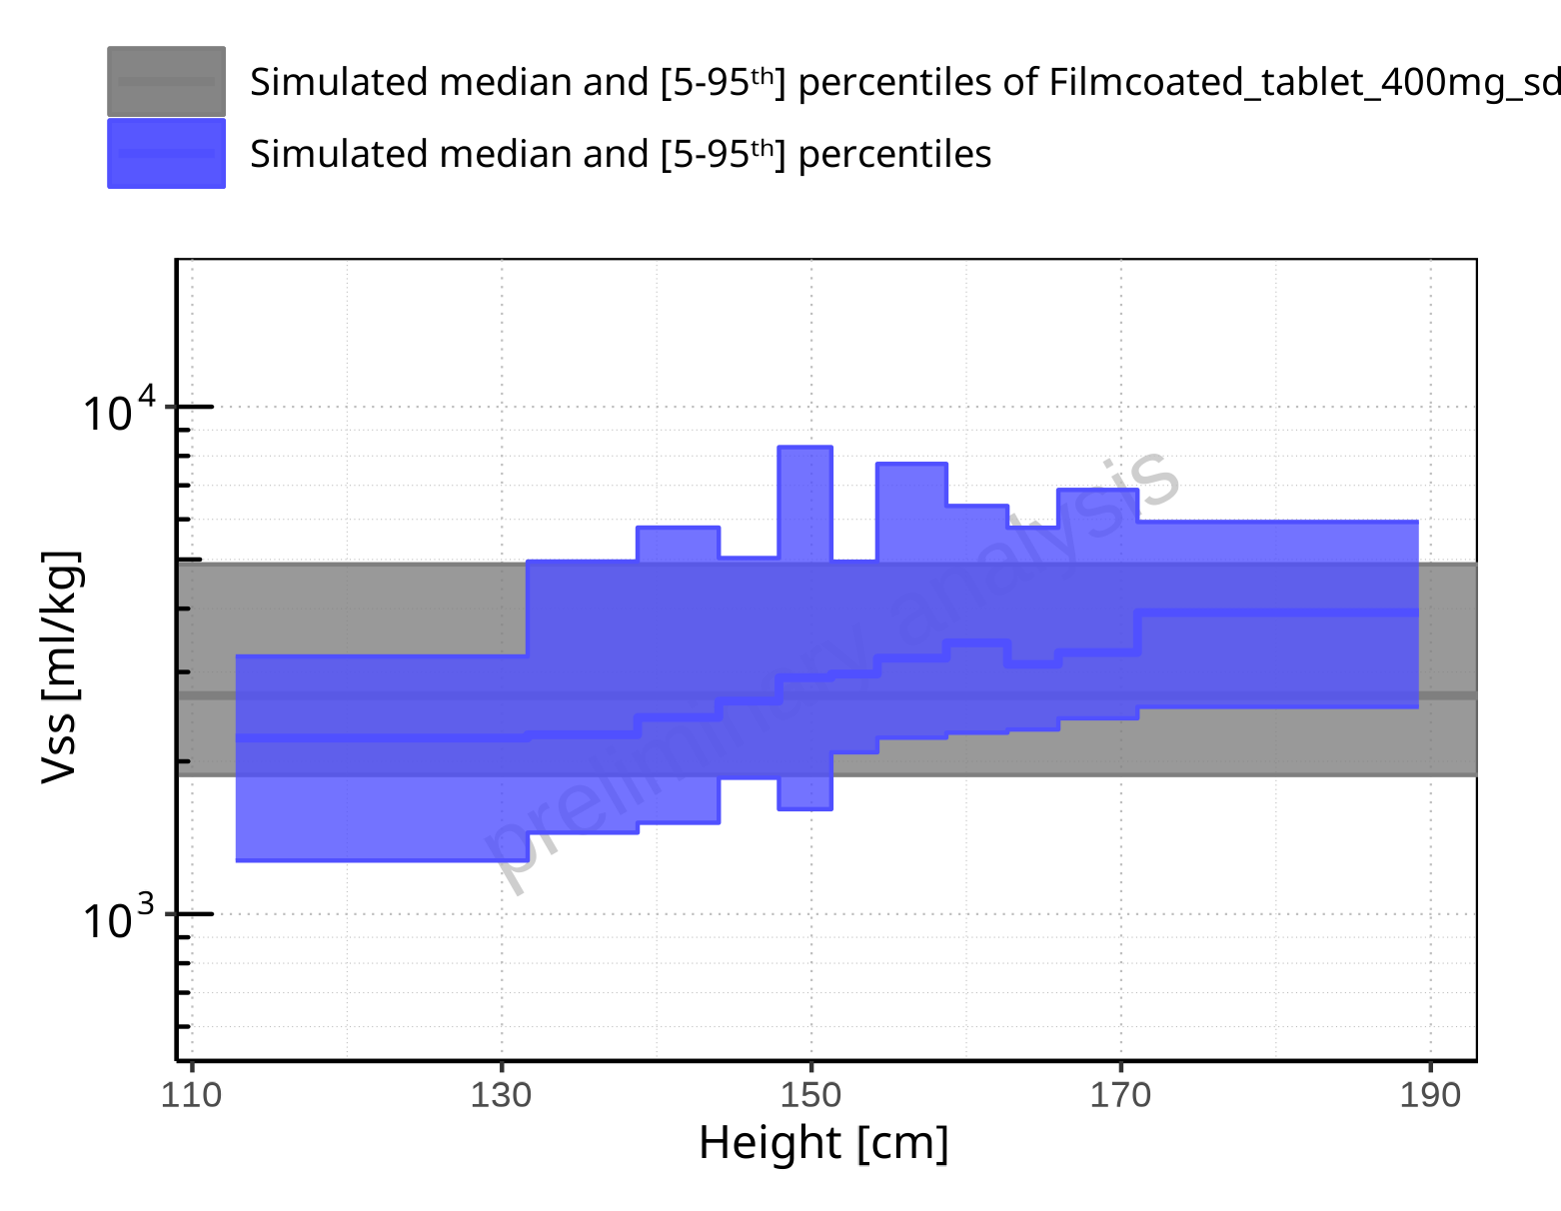

**Figure 2-317: Height-dependence of Vss for Larson 2013 8y-18y 400mg FCT meal in comparison to Filmcoated_tablet_400mg_sd. Profiles are plotted in a logarithmic scale.**

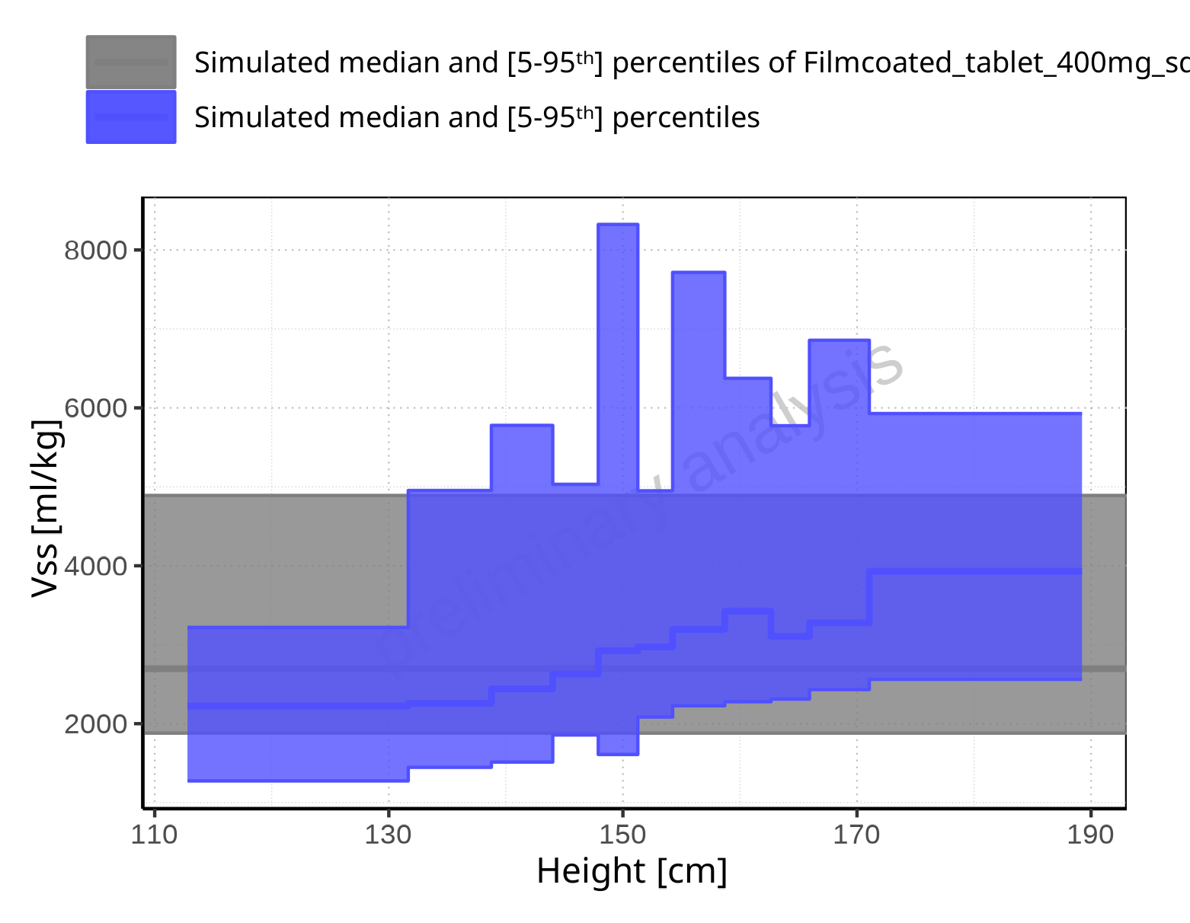

**Figure 2-318: Height-dependence of Vss for Larson 2013 8y-18y 400mg FCT meal in comparison to Filmcoated_tablet_400mg_sd. Profiles are plotted in a linear scale.**

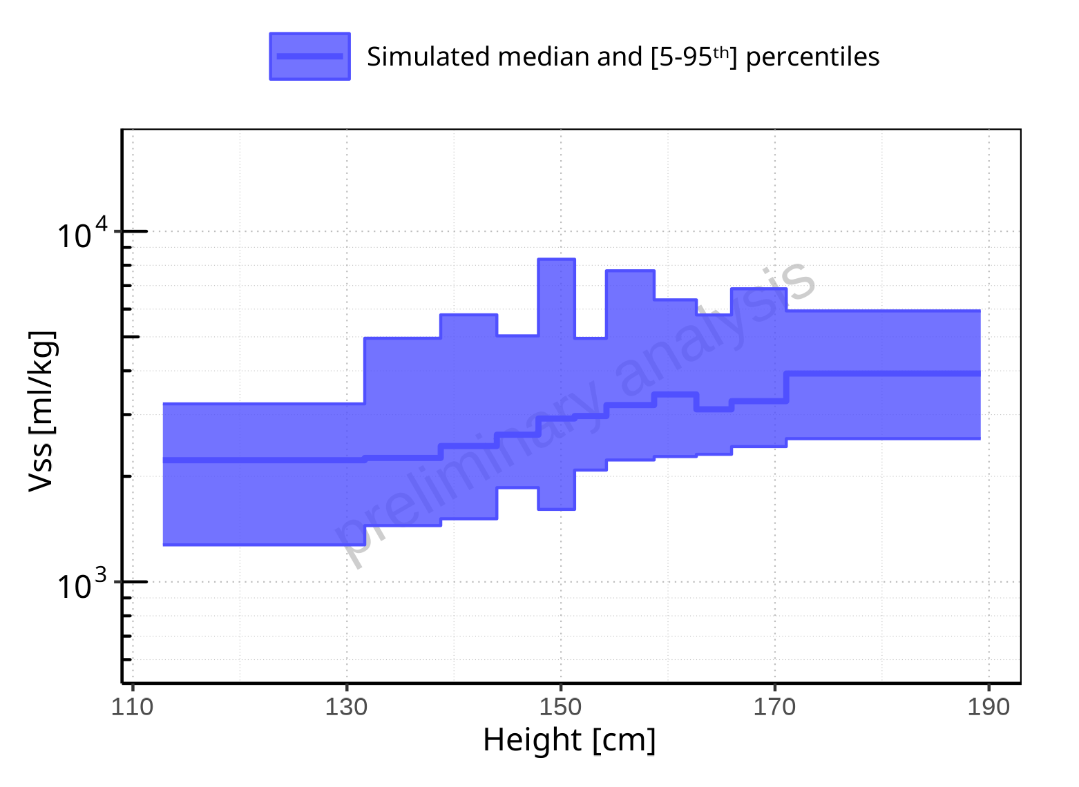

**Figure 2-319: Height-dependence of Vss for Larson 2013 8y-18y 400mg FCT meal. Profiles are plotted in a logarithmic scale.**

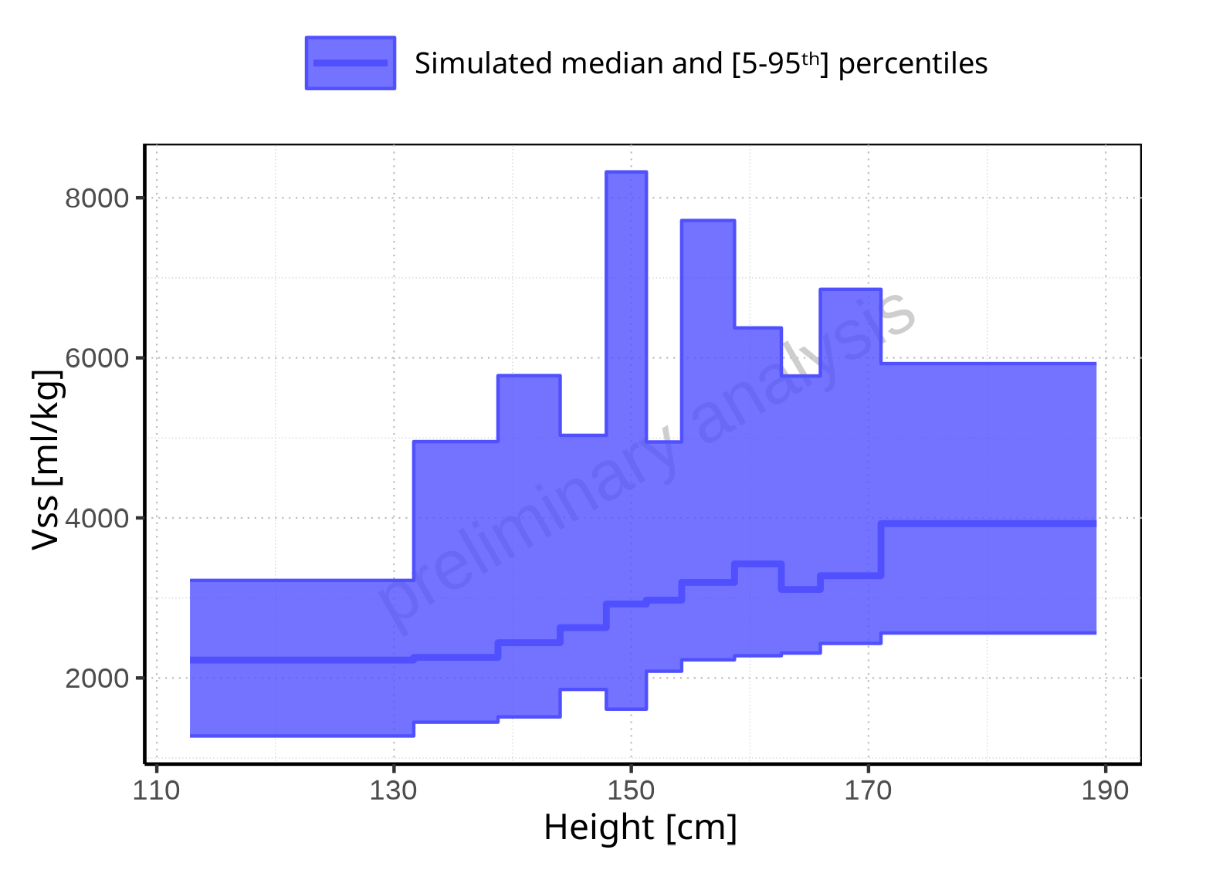

**Figure 2-320: Height-dependence of Vss for Larson 2013 8y-18y 400mg FCT meal. Profiles are plotted in a linear scale.**

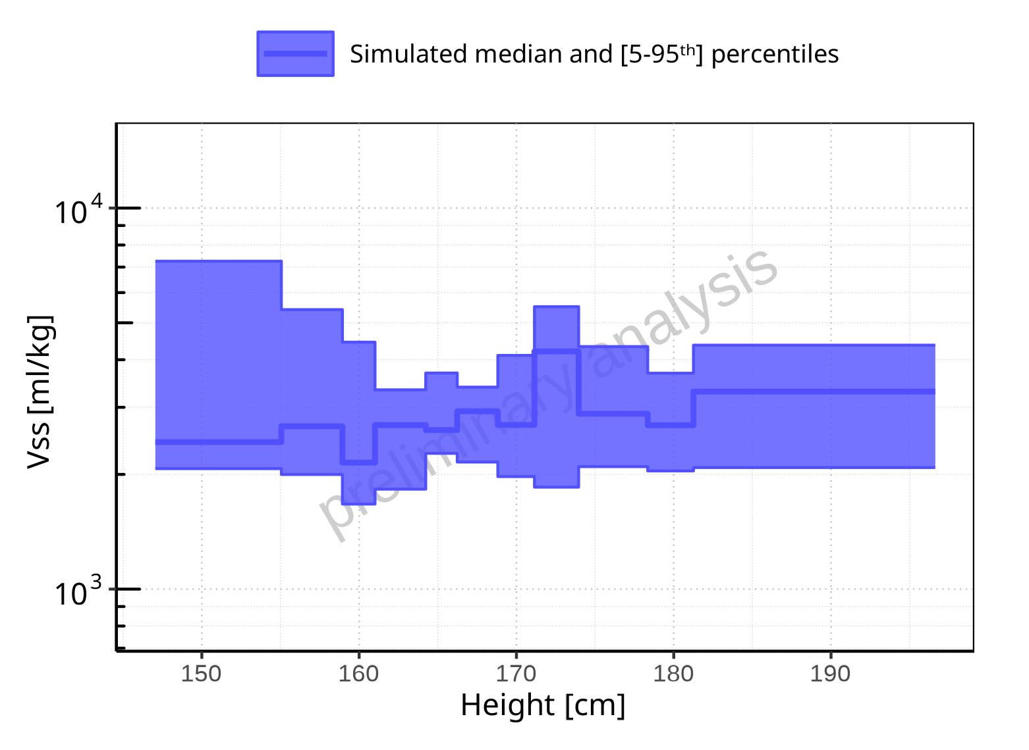

**Figure 2-321: Height-dependence of Vss for Filmcoated_tablet_400mg_sd. Profiles are plotted in a logarithmic scale.**

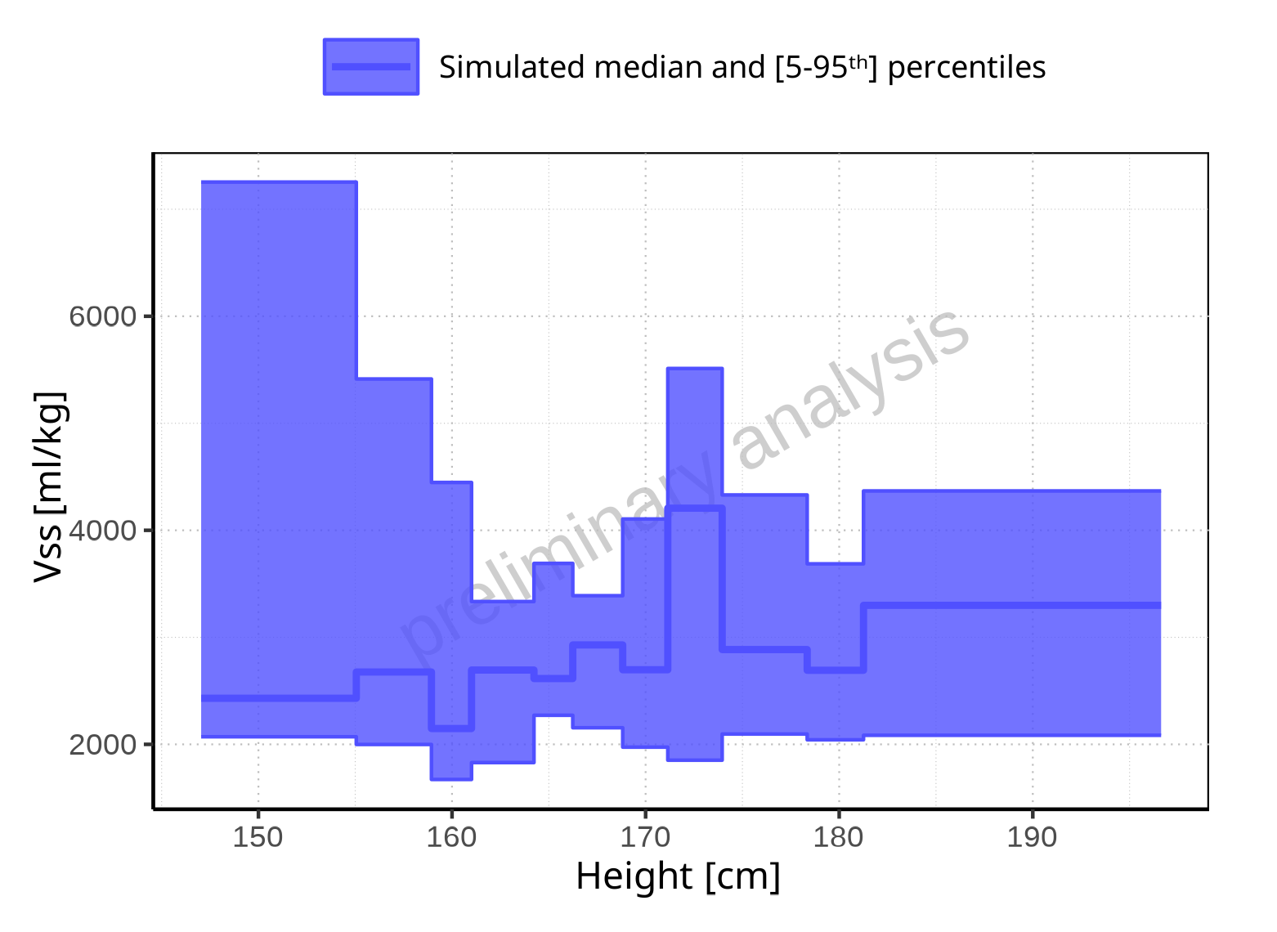

**Figure 2-322: Height-dependence of Vss for Filmcoated_tablet_400mg_sd. Profiles are plotted in a linear scale.**

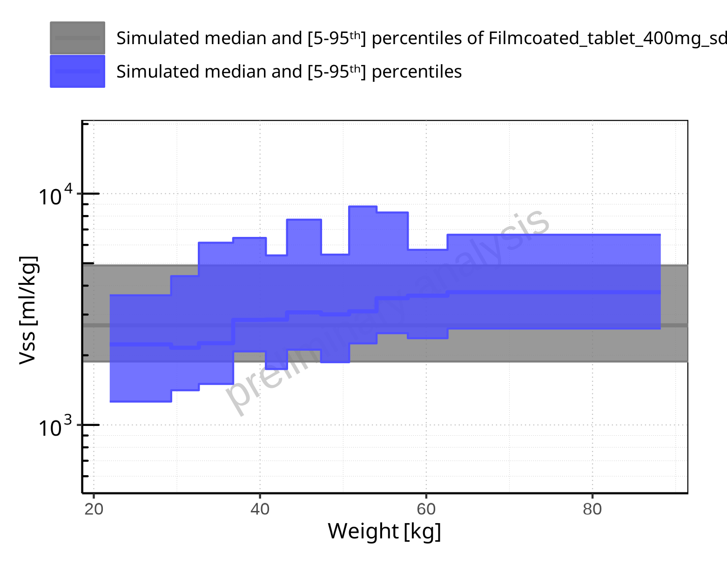

**Figure 2-323: Weight-dependence of Vss for Larson 2013 8y-18y 400mg FCT meal in comparison to Filmcoated_tablet_400mg_sd. Profiles are plotted in a logarithmic scale.**

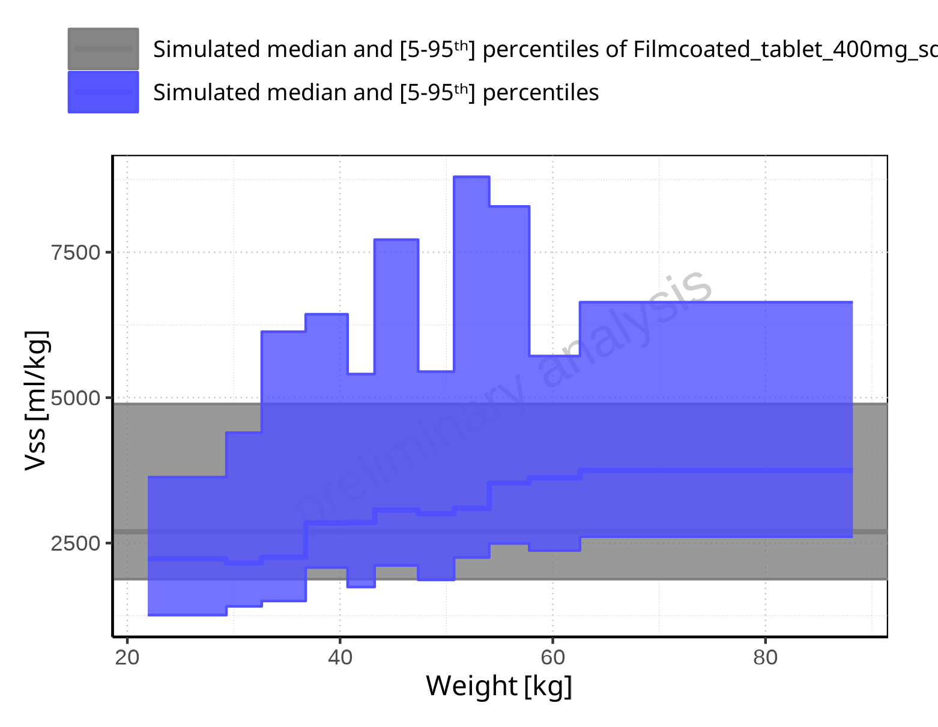

**Figure 2-324: Weight-dependence of Vss for Larson 2013 8y-18y 400mg FCT meal in comparison to Filmcoated_tablet_400mg_sd. Profiles are plotted in a linear scale.**

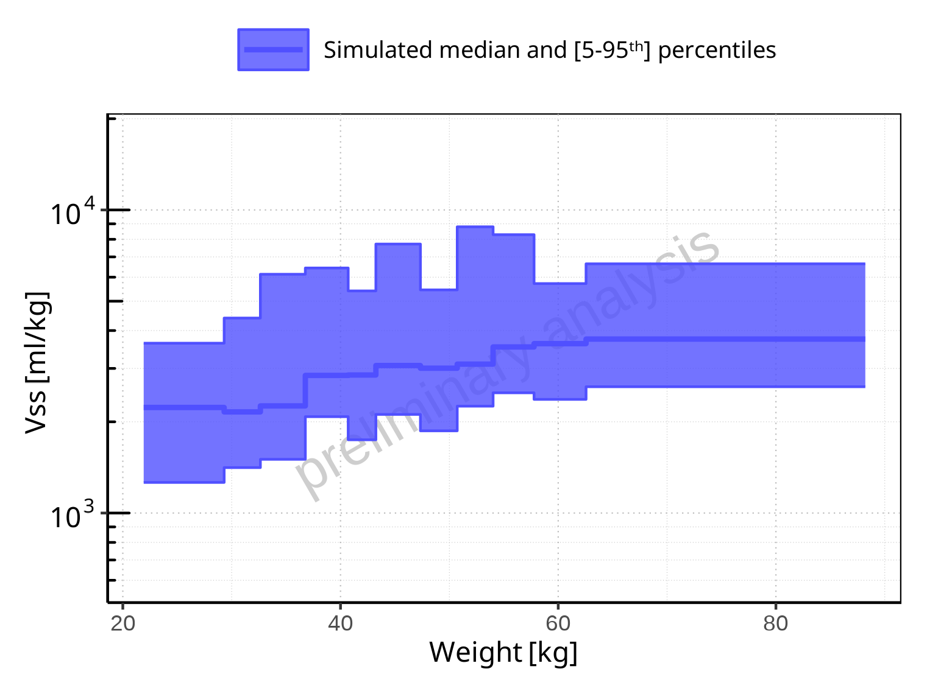

**Figure 2-325: Weight-dependence of Vss for Larson 2013 8y-18y 400mg FCT meal. Profiles are plotted in a logarithmic scale.**

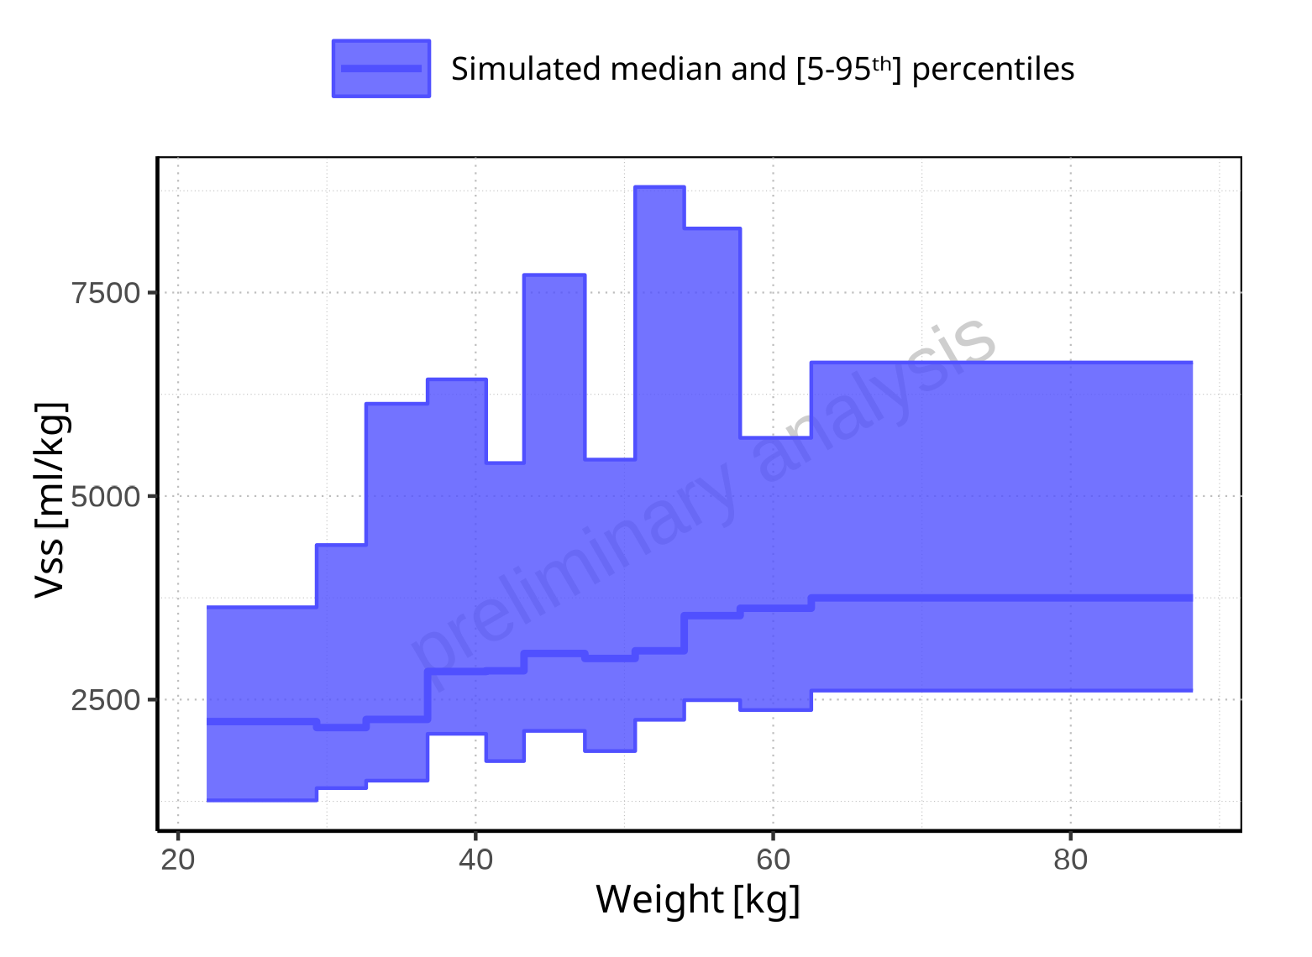

**Figure 2-326: Weight-dependence of Vss for Larson 2013 8y-18y 400mg FCT meal. Profiles are plotted in a linear scale.**

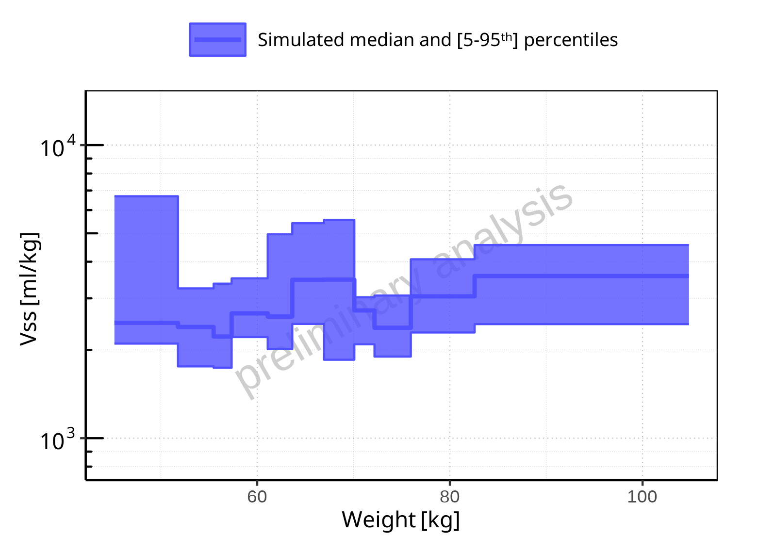

**Figure 2-327: Weight-dependence of Vss for Filmcoated_tablet_400mg_sd. Profiles are plotted in a logarithmic scale.**

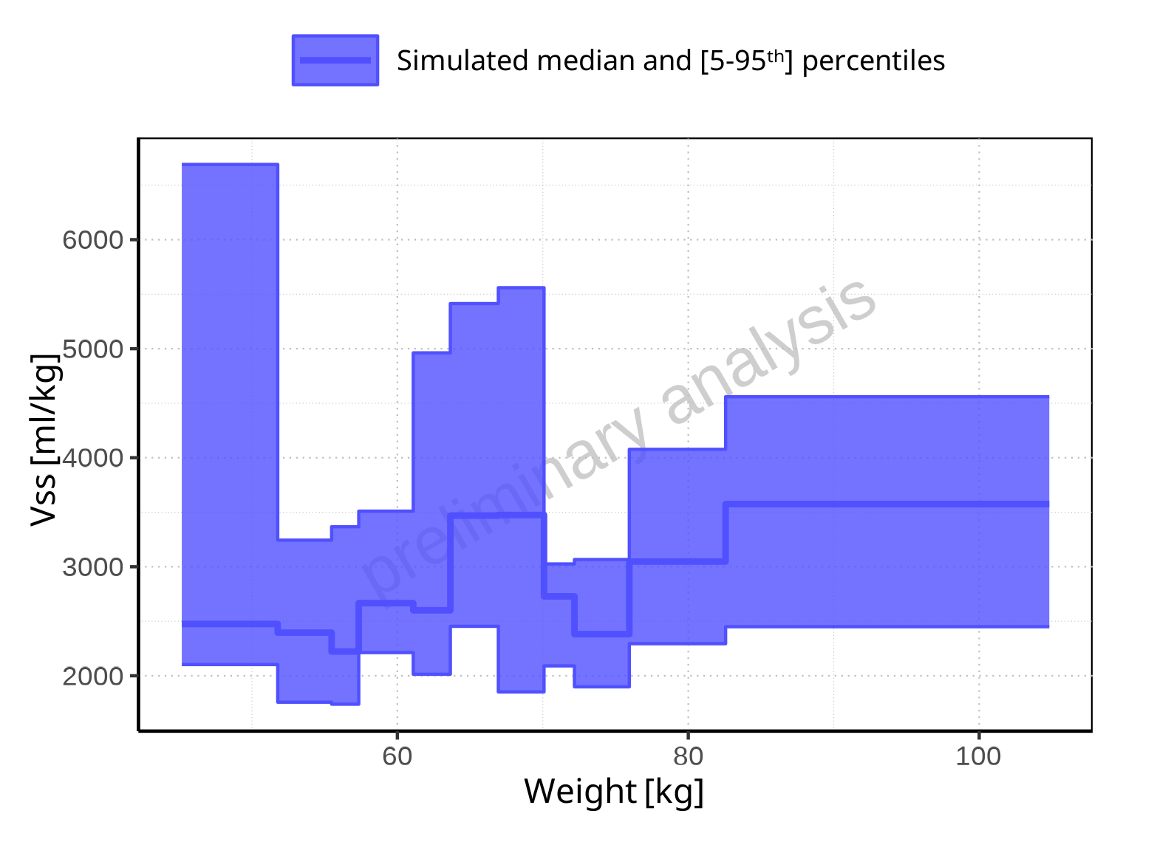

**Figure 2-328: Weight-dependence of Vss for Filmcoated_tablet_400mg_sd. Profiles are plotted in a linear scale.**

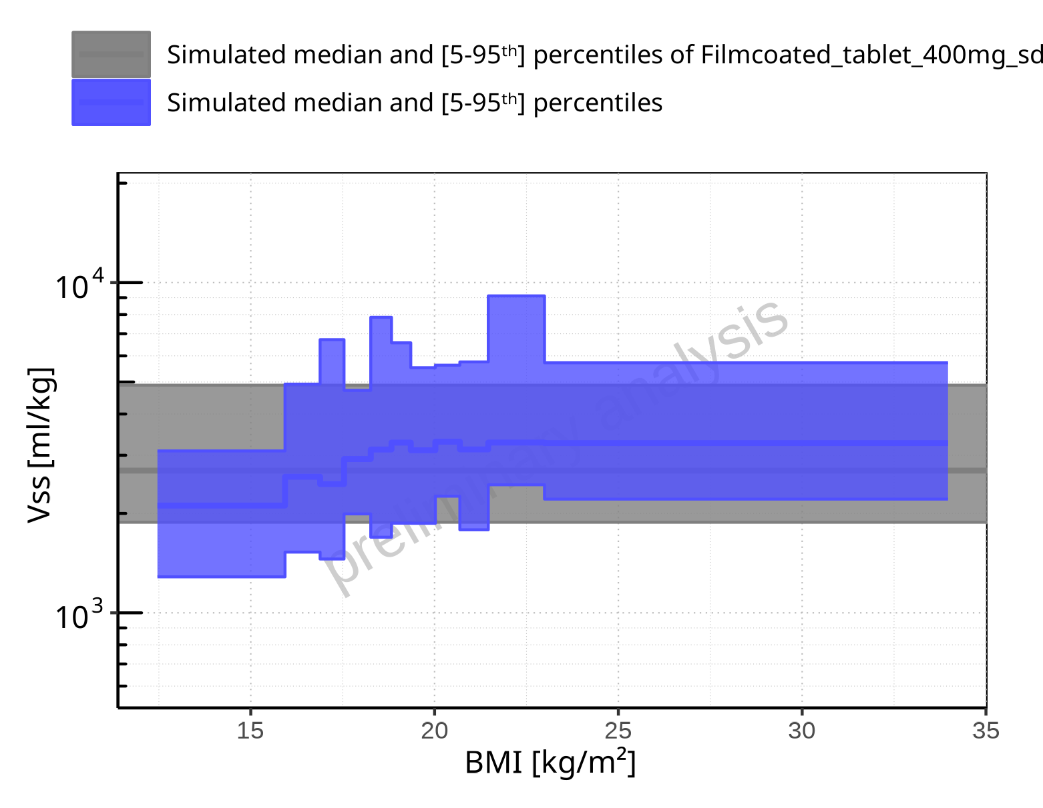

**Figure 2-329: BMI-dependence of Vss for Larson 2013 8y-18y 400mg FCT meal in comparison to Filmcoated_tablet_400mg_sd. Profiles are plotted in a logarithmic scale.**

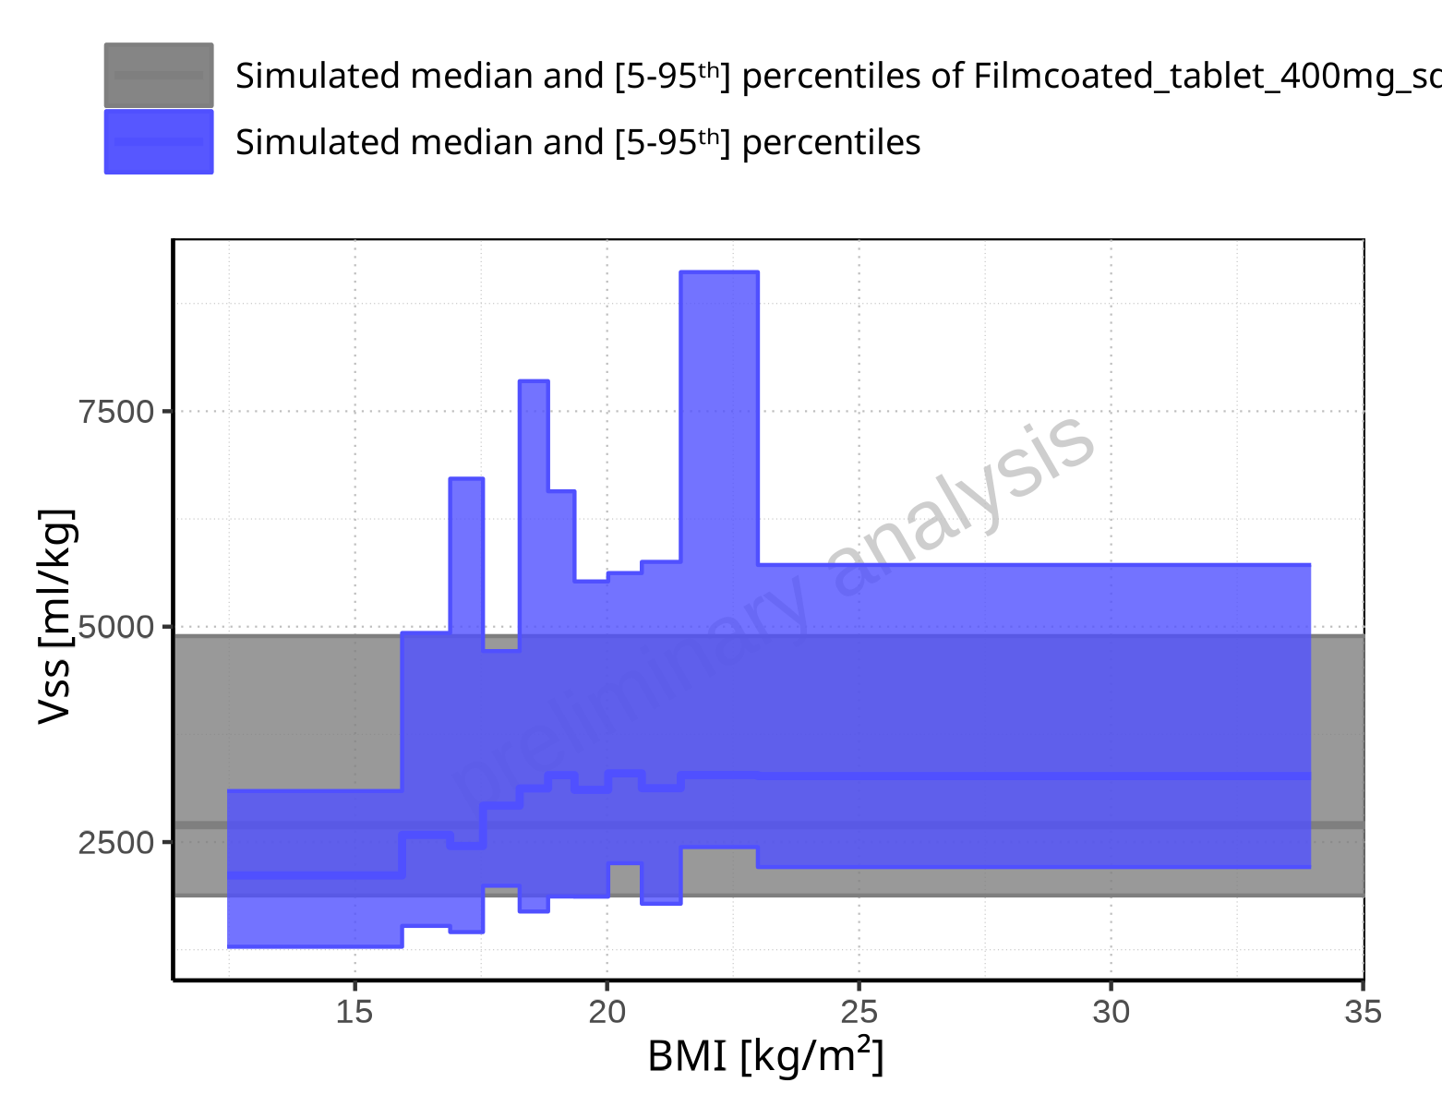

**Figure 2-330: BMI-dependence of Vss for Larson 2013 8y-18y 400mg FCT meal in comparison to Filmcoated_tablet_400mg_sd. Profiles are plotted in a linear scale.**

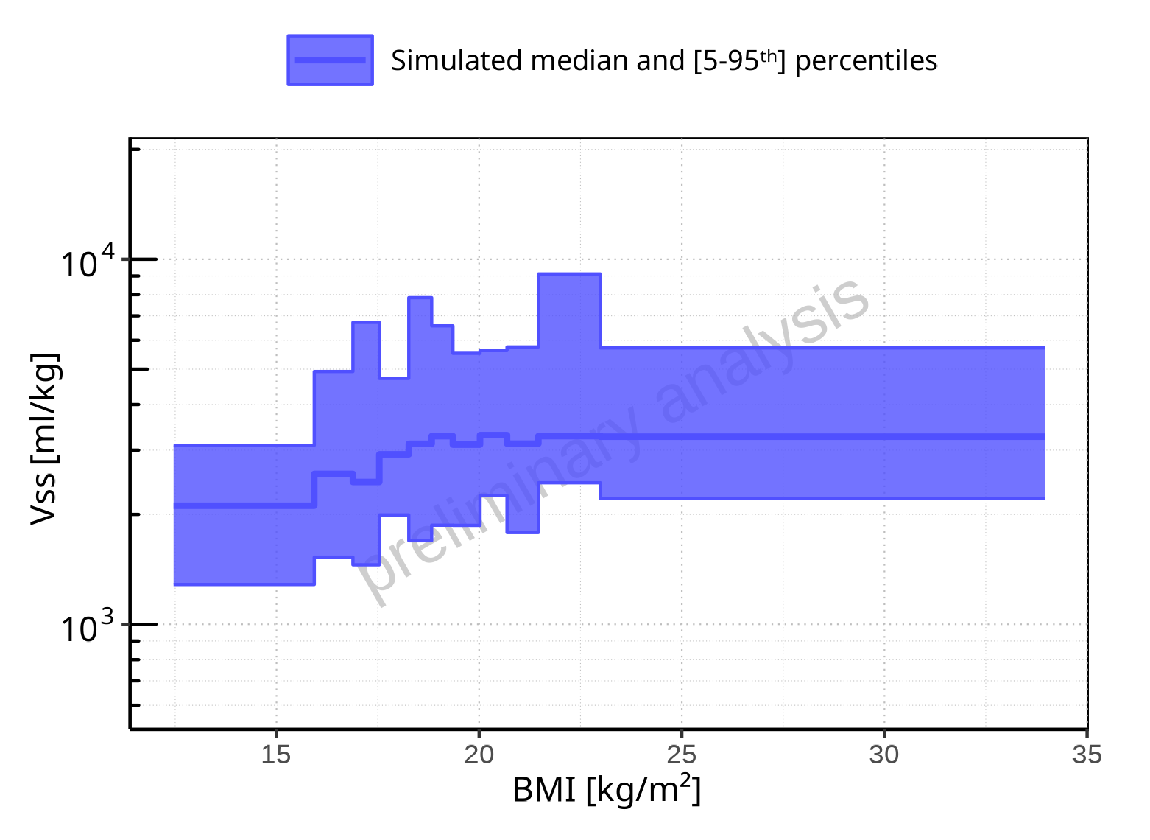

**Figure 2-331: BMI-dependence of Vss for Larson 2013 8y-18y 400mg FCT meal. Profiles are plotted in a logarithmic scale.**

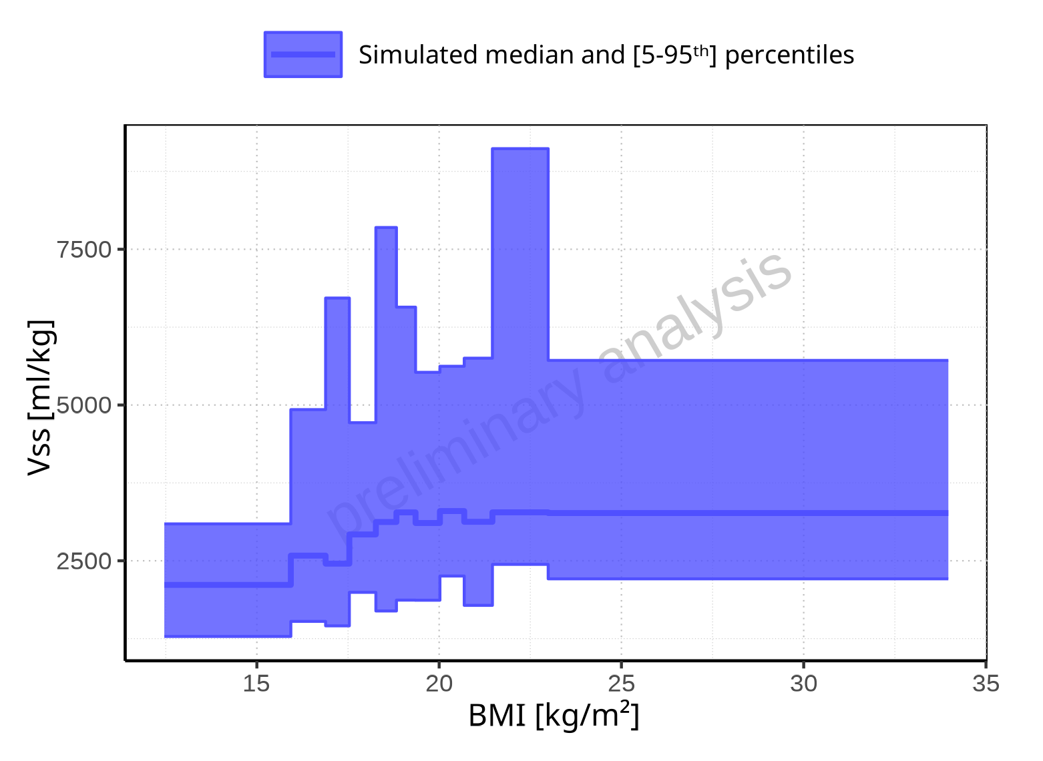

**Figure 2-332: BMI-dependence of Vss for Larson 2013 8y-18y 400mg FCT meal. Profiles are plotted in a linear scale.**

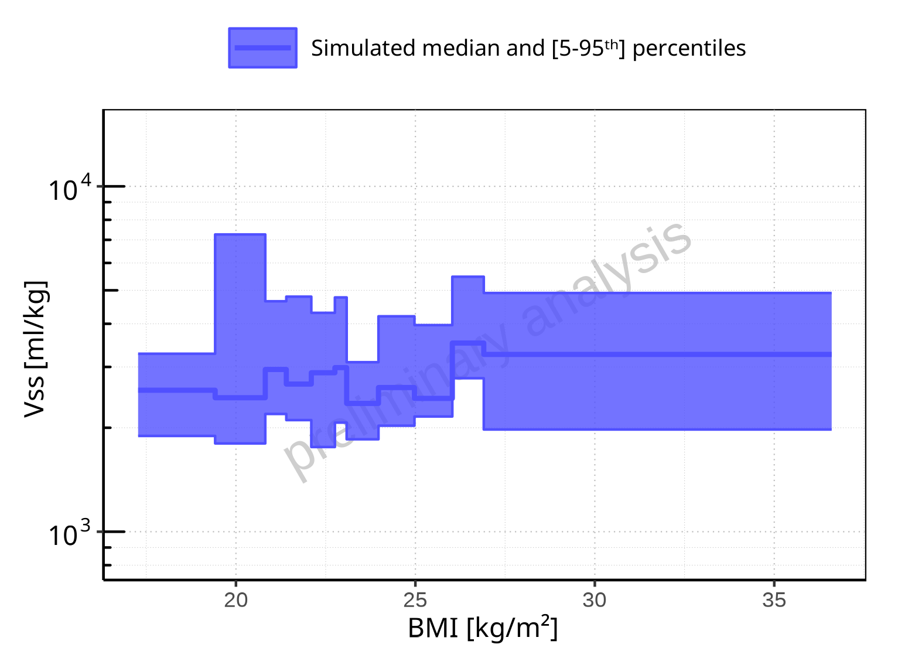

**Figure 2-333: BMI-dependence of Vss for Filmcoated_tablet_400mg_sd. Profiles are plotted in a logarithmic scale.**

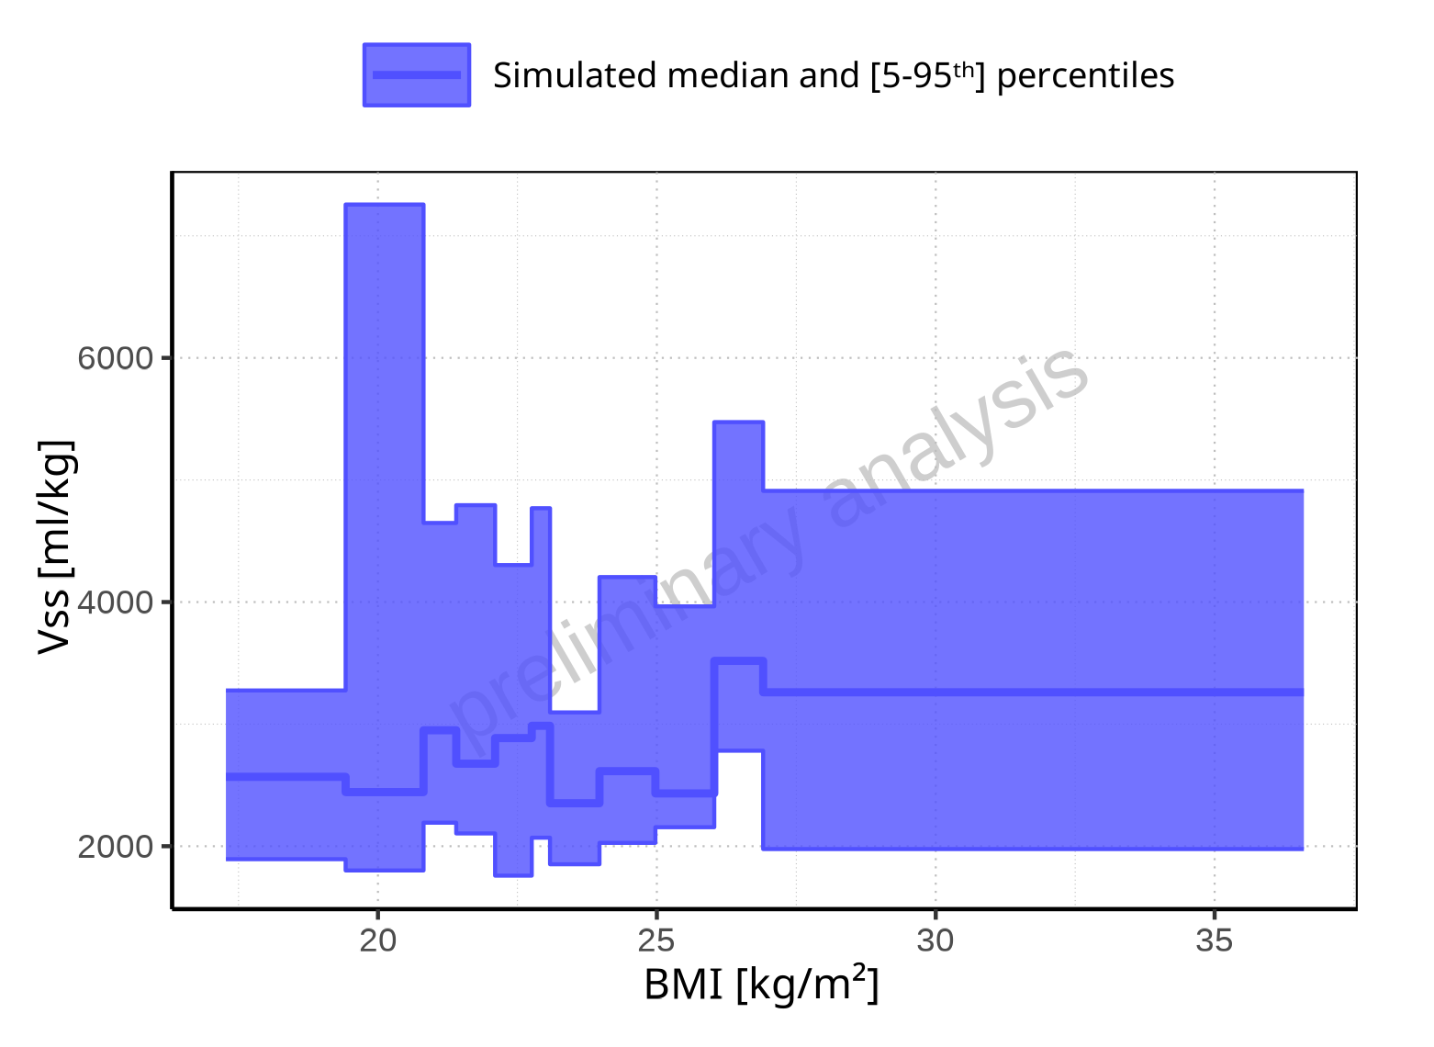

**Figure 2-334: BMI-dependence of Vss for Filmcoated_tablet_400mg_sd. Profiles are plotted in a linear scale.**

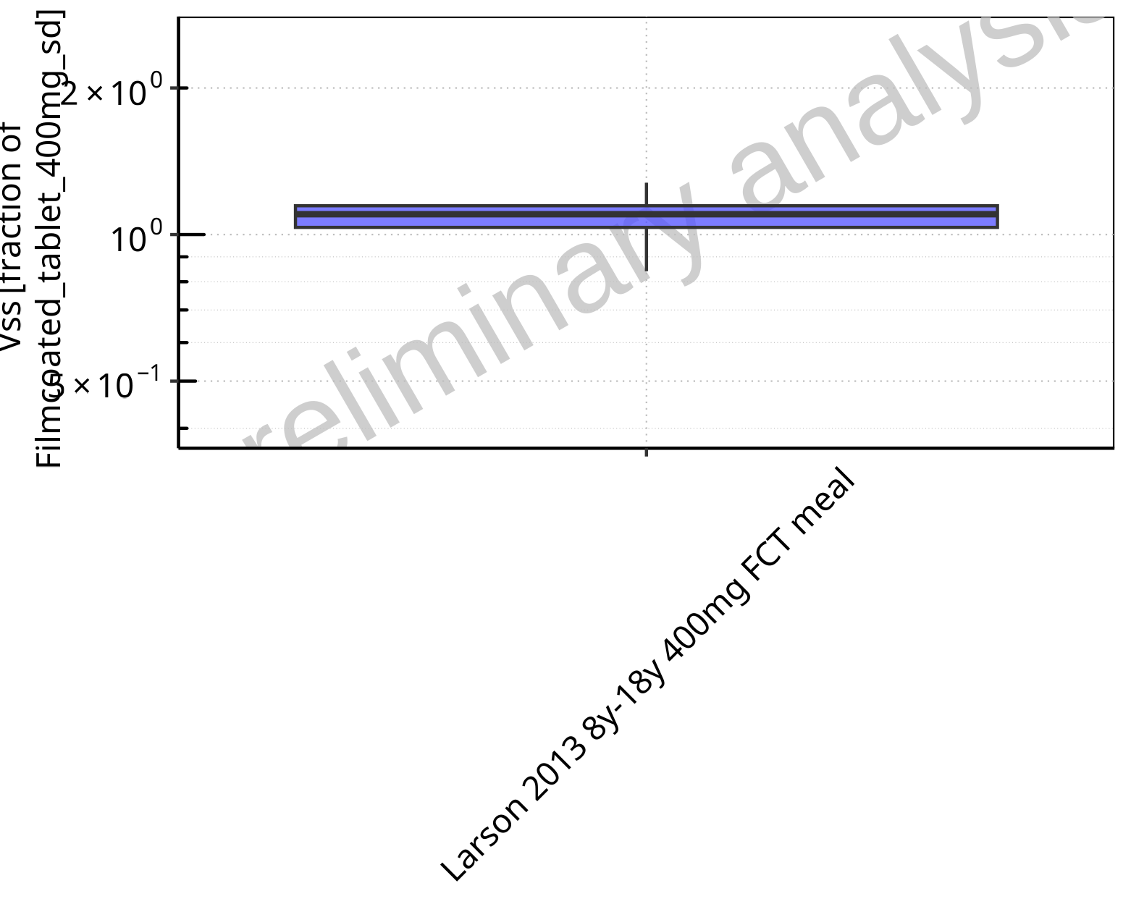

**Figure 2-335: Ratio of population summary statistics of Vss of Raltegravir for Larson 2013 8y-18y 400mg FCT meal in comparison to Filmcoated_tablet_400mg_sd shown as box-whisker plot, which indicates ratios of the 5th, 25th, 50th, 75th, 95th percentiles in logarithmic scale.**

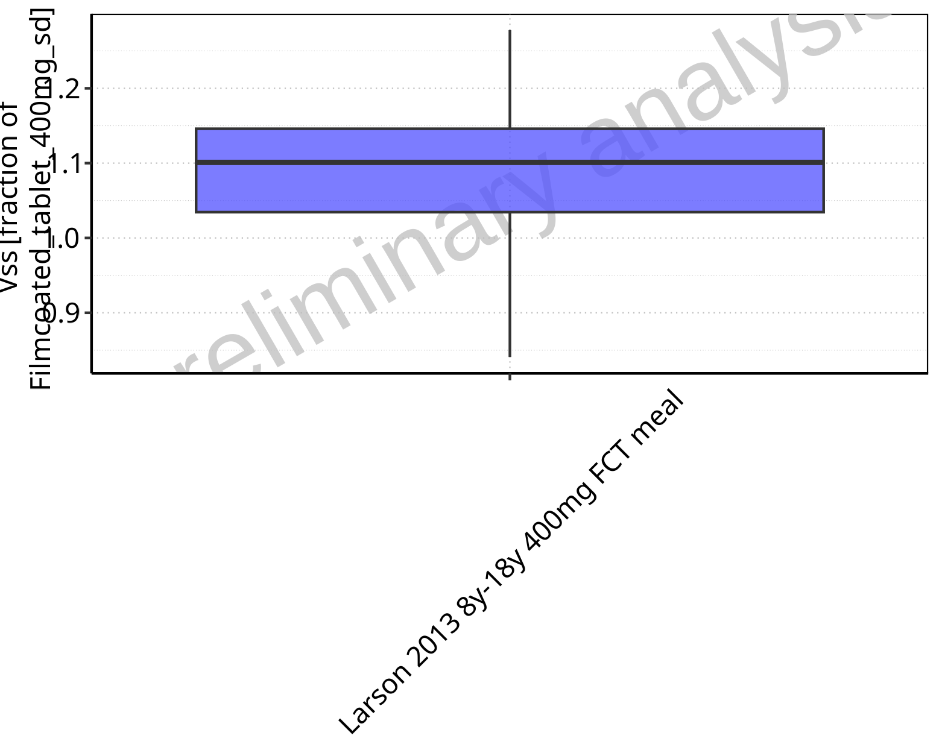

**Figure 2-336: Ratio of population summary statistics of Vss of Raltegravir for Larson 2013 8y-18y 400mg FCT meal in comparison to Filmcoated_tablet_400mg_sd shown as box-whisker plot, which indicates ratios of the 5th, 25th, 50th, 75th, 95th percentiles in linear scale.**

**Table 2-24: Ratio of population summary statistics of Vss of Raltegravir for Larson 2013 8y-18y 400mg FCT meal in comparison to Filmcoated_tablet_400mg_sd**

| Population | N | 5th pctl | 25th pctl | 50th pctl | 75th pctl | 95th pctl | Mean | SD | Geo Mean | Geo SD |
| --- | --- | --- | --- | --- | --- | --- | --- | --- | --- | --- |
| Larson 2013 8y-18y 400mg FCT meal | 497 | 0.84 | 1.03 | 1.10 | 1.15 | 1.28 | 1.13 | 1.65 | 1.08 | 1.12 |

### Vd

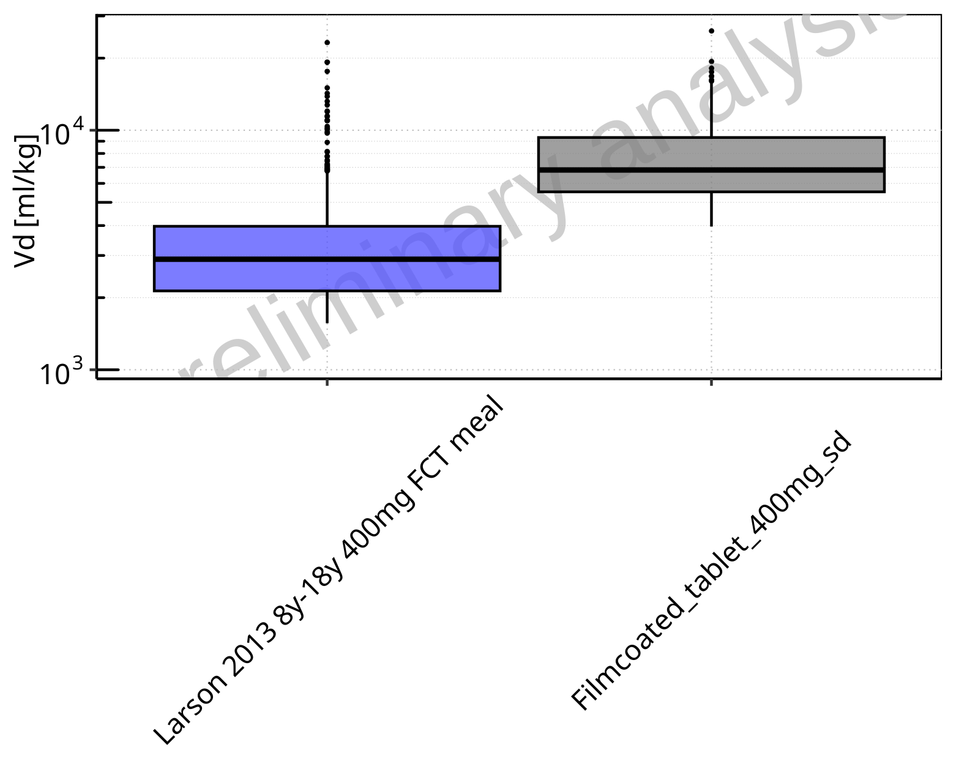

**Figure 2-337: Vd of Raltegravir for Larson 2013 8y-18y 400mg FCT meal, Filmcoated_tablet_400mg_sd shown as box-whisker plot, which indicates the 5th, 25th, 50th, 75th, 95th percentiles in logarithmic scale.**

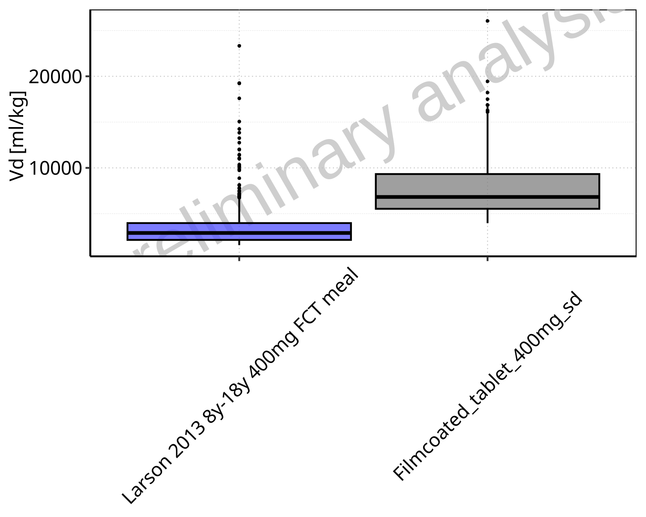

**Figure 2-338: Vd of Raltegravir for Larson 2013 8y-18y 400mg FCT meal, Filmcoated_tablet_400mg_sd shown as box-whisker plot, which indicates the 5th, 25th, 50th, 75th, 95th percentiles in linear scale.**

**Table 2-25: Population statistics summarizing Vd of Raltegravir for Larson 2013 8y-18y 400mg FCT meal, Filmcoated_tablet_400mg_sd reported in [ml/kg]**

| Population | N | 5th pctl | 25th pctl | 50th pctl | 75th pctl | 95th pctl | Mean | SD | Geo Mean | Geo SD |
| --- | --- | --- | --- | --- | --- | --- | --- | --- | --- | --- |
| Larson 2013 8y-18y 400mg FCT meal | 497 | 1564.17 | 2133.96 | 2893.52 | 3971.83 | 7809.40 | 3610.03 | 2601.88 | 3089.07 | 1.67 |
| Filmcoated_tablet_400mg_sd | 100 | 3961.86 | 5531.19 | 6823.96 | 9325.52 | 16886.12 | 8090.43 | 4000.17 | 7343.52 | 1.53 |

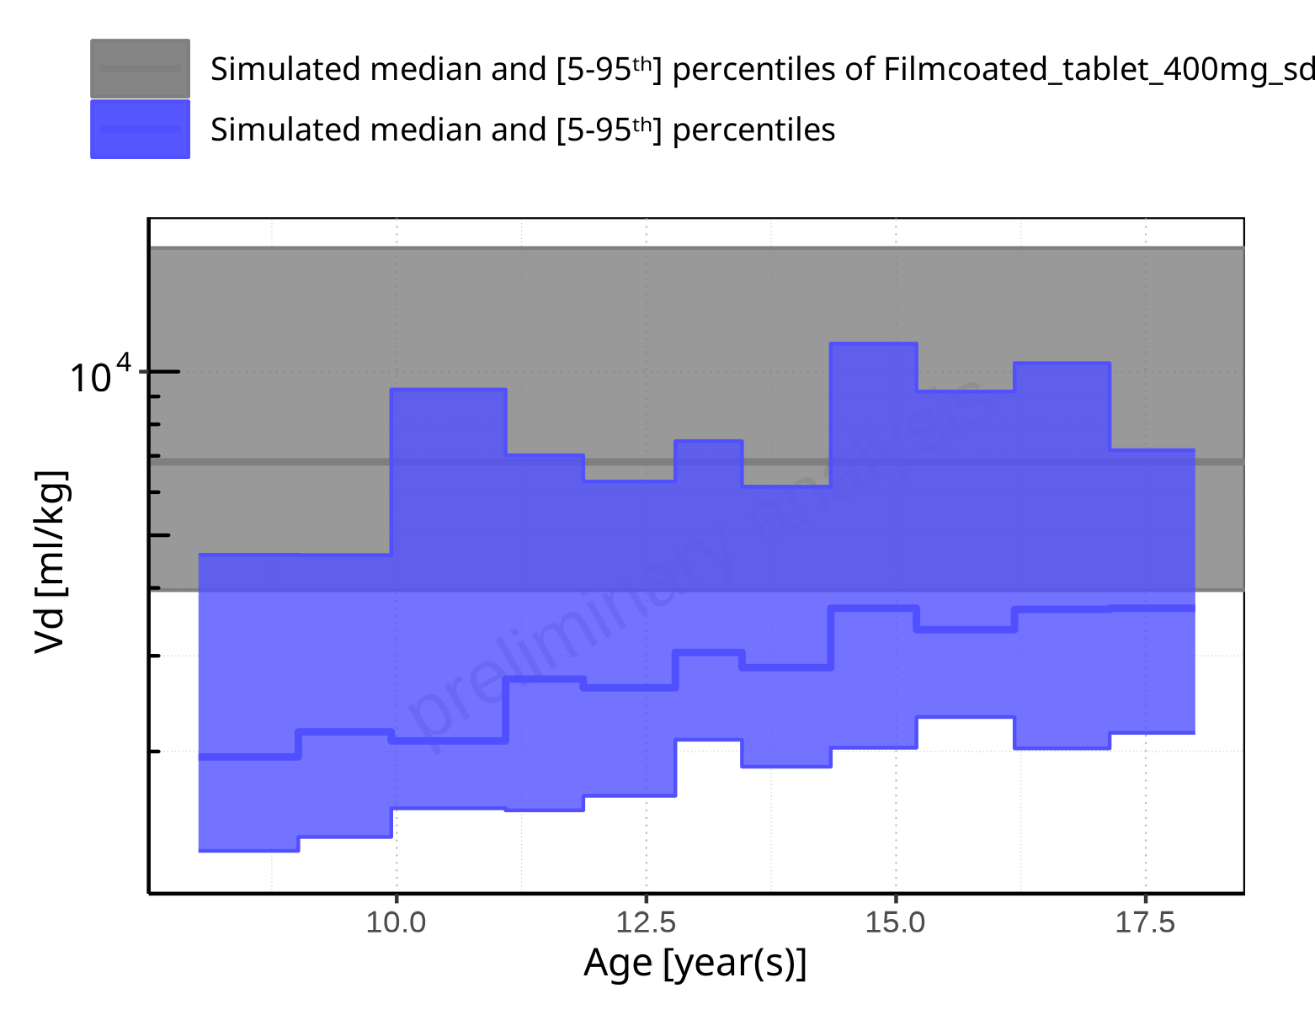

**Figure 2-339: Age-dependence of Vd for Larson 2013 8y-18y 400mg FCT meal in comparison to Filmcoated_tablet_400mg_sd. Profiles are plotted in a logarithmic scale.**

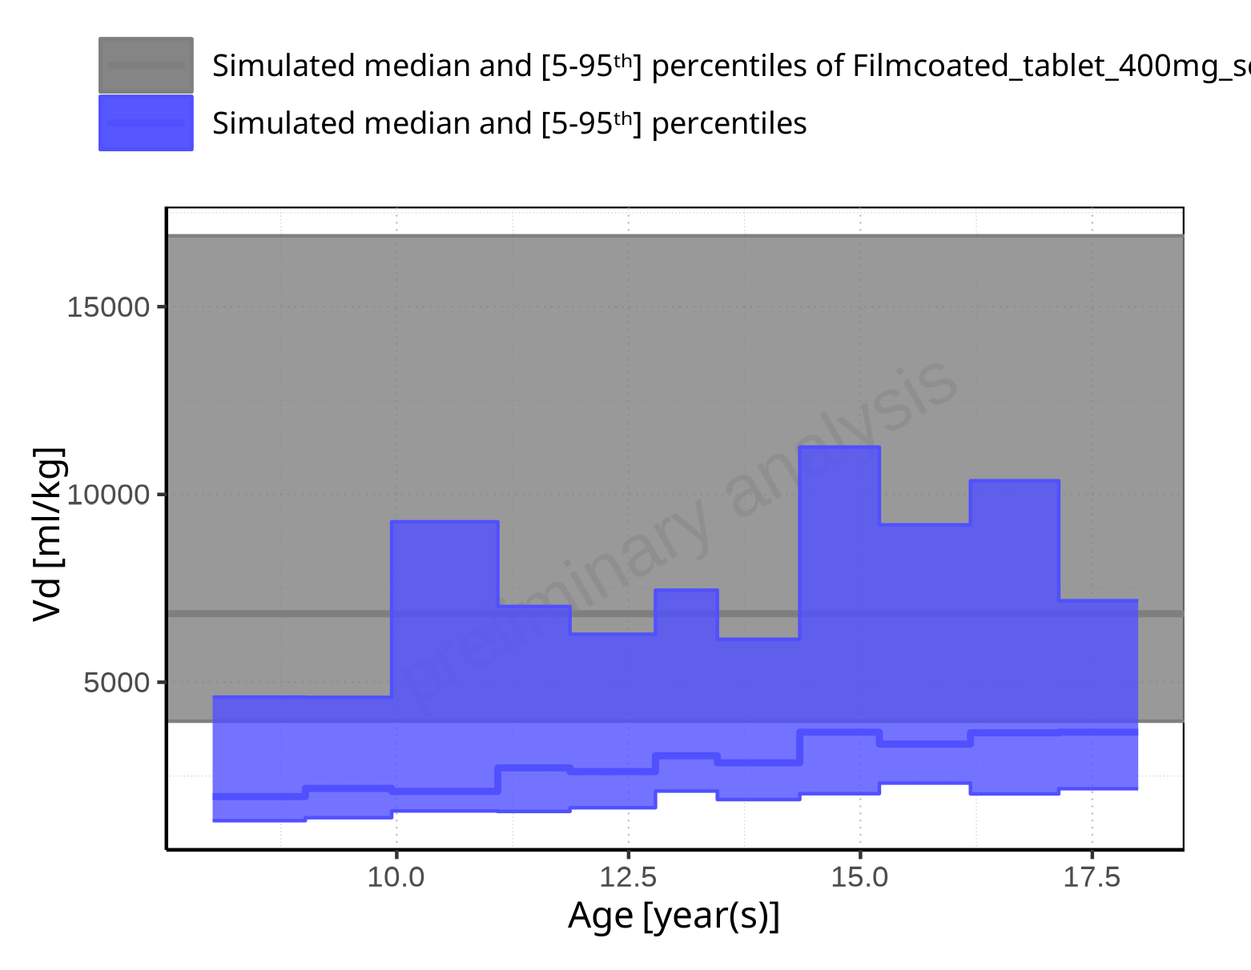

**Figure 2-340: Age-dependence of Vd for Larson 2013 8y-18y 400mg FCT meal in comparison to Filmcoated_tablet_400mg_sd. Profiles are plotted in a linear scale.**

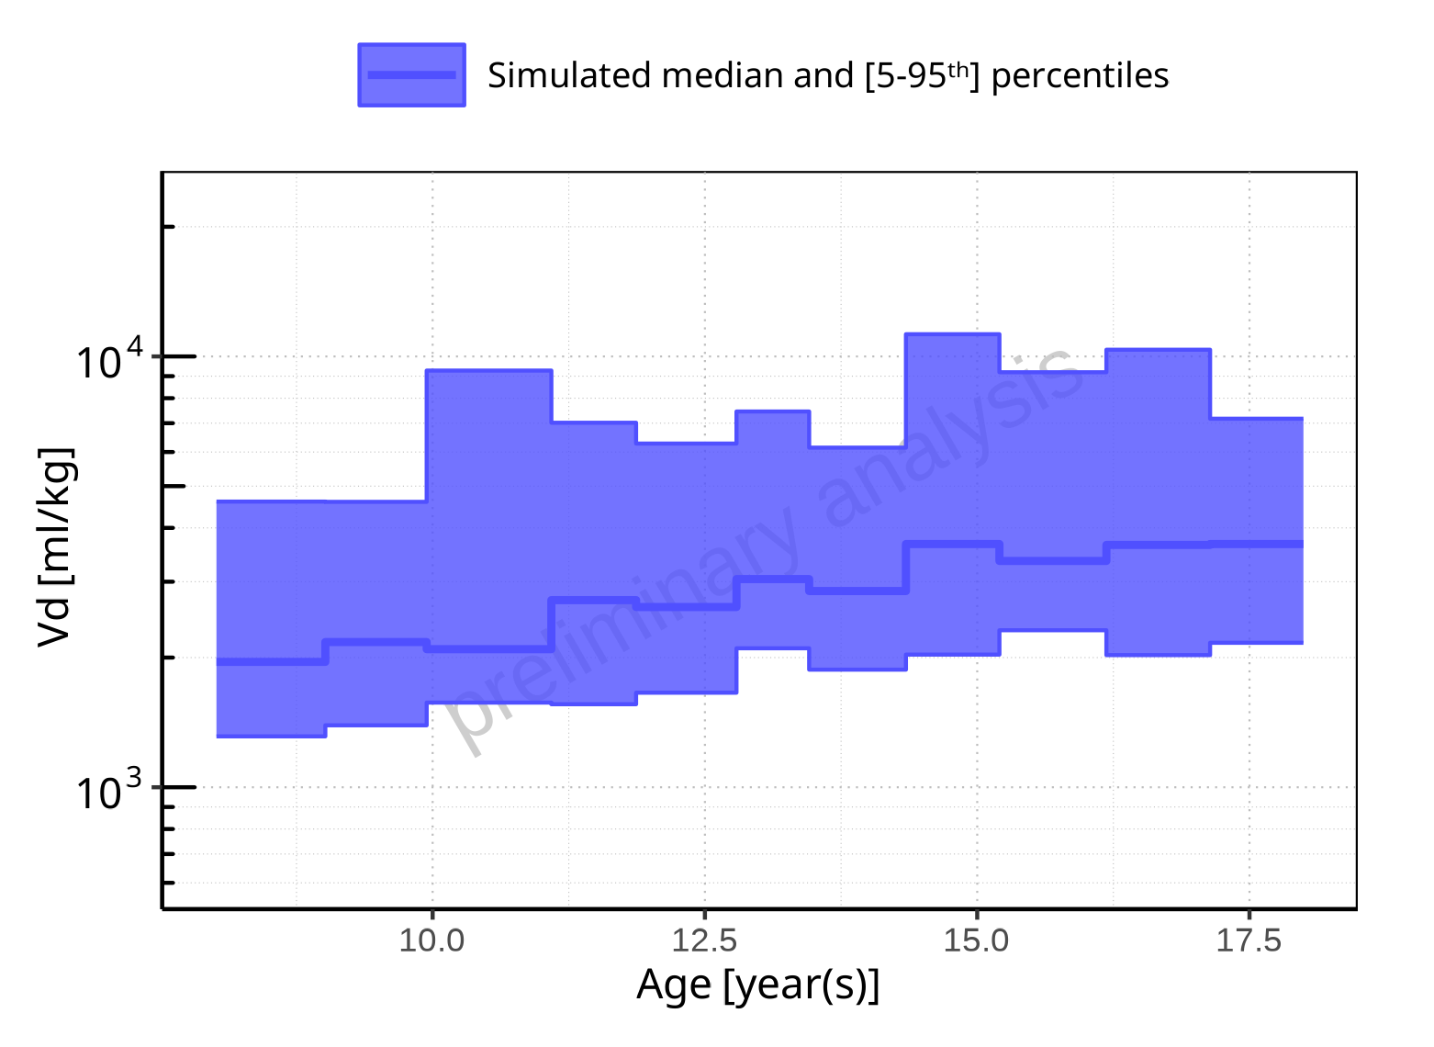

**Figure 2-341: Age-dependence of Vd for Larson 2013 8y-18y 400mg FCT meal. Profiles are plotted in a logarithmic scale.**

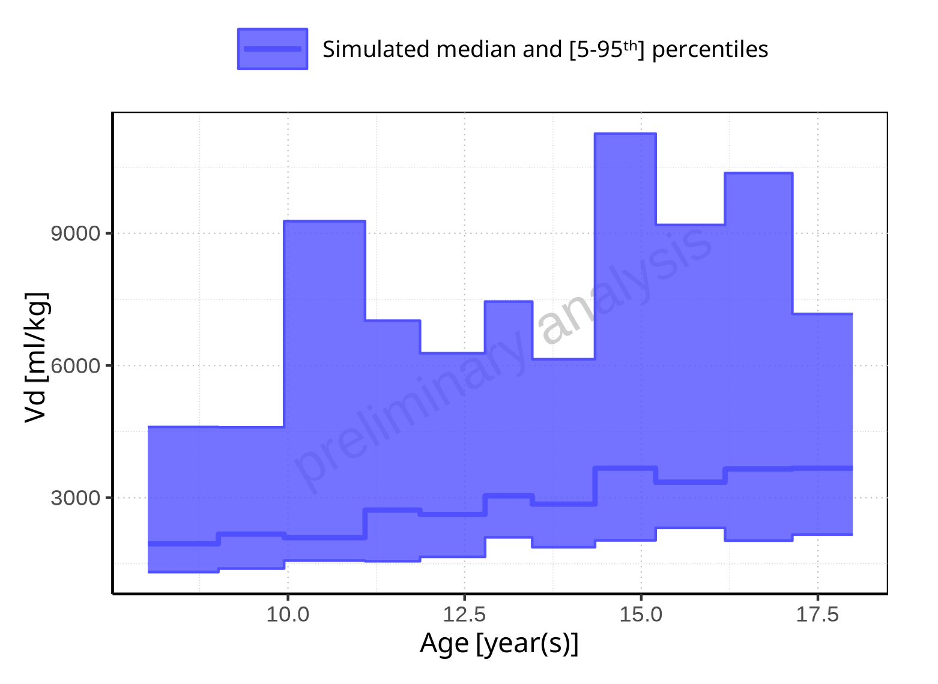

**Figure 2-342: Age-dependence of Vd for Larson 2013 8y-18y 400mg FCT meal. Profiles are plotted in a linear scale.**

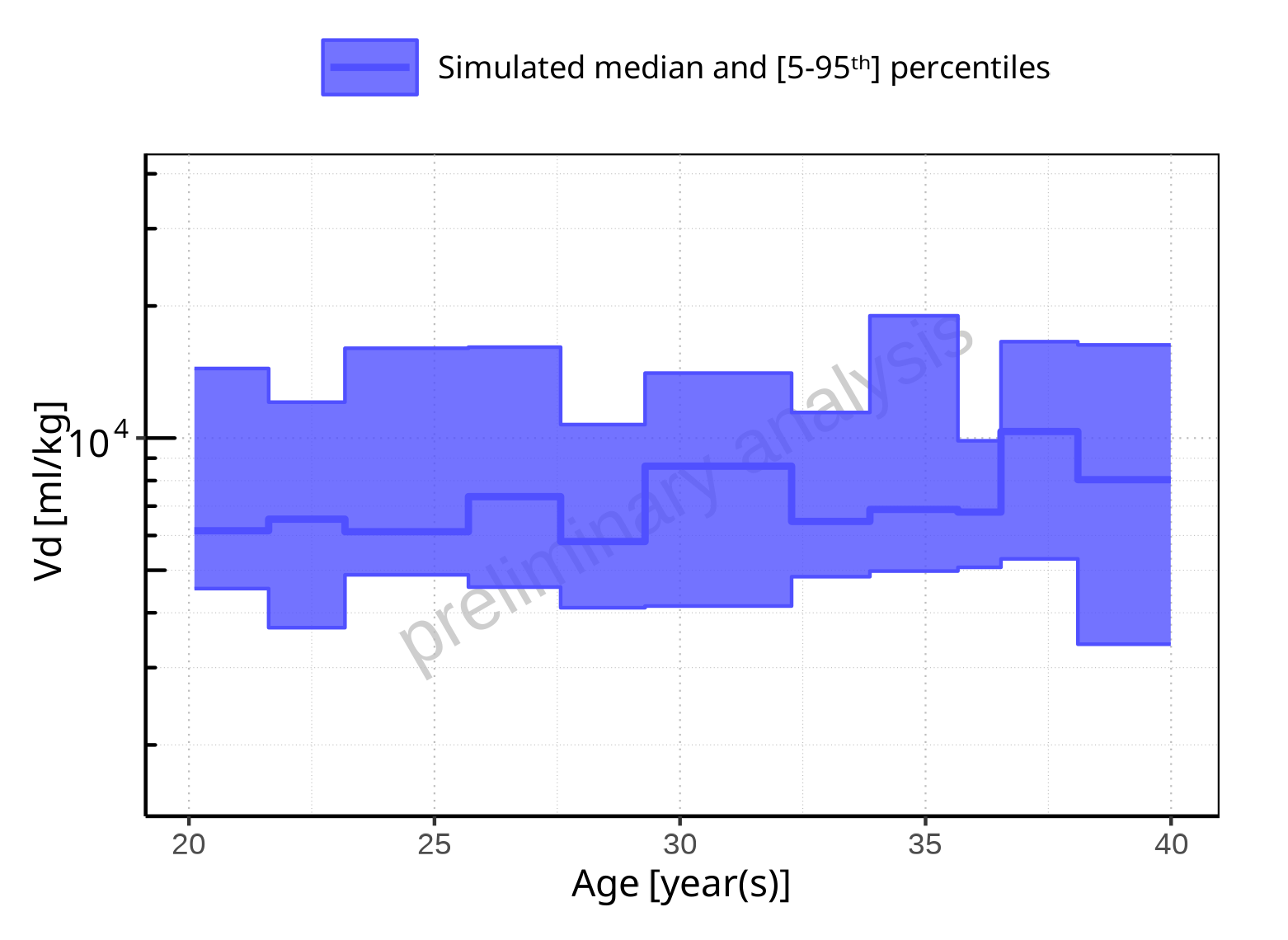

**Figure 2-343: Age-dependence of Vd for Filmcoated_tablet_400mg_sd. Profiles are plotted in a logarithmic scale.**

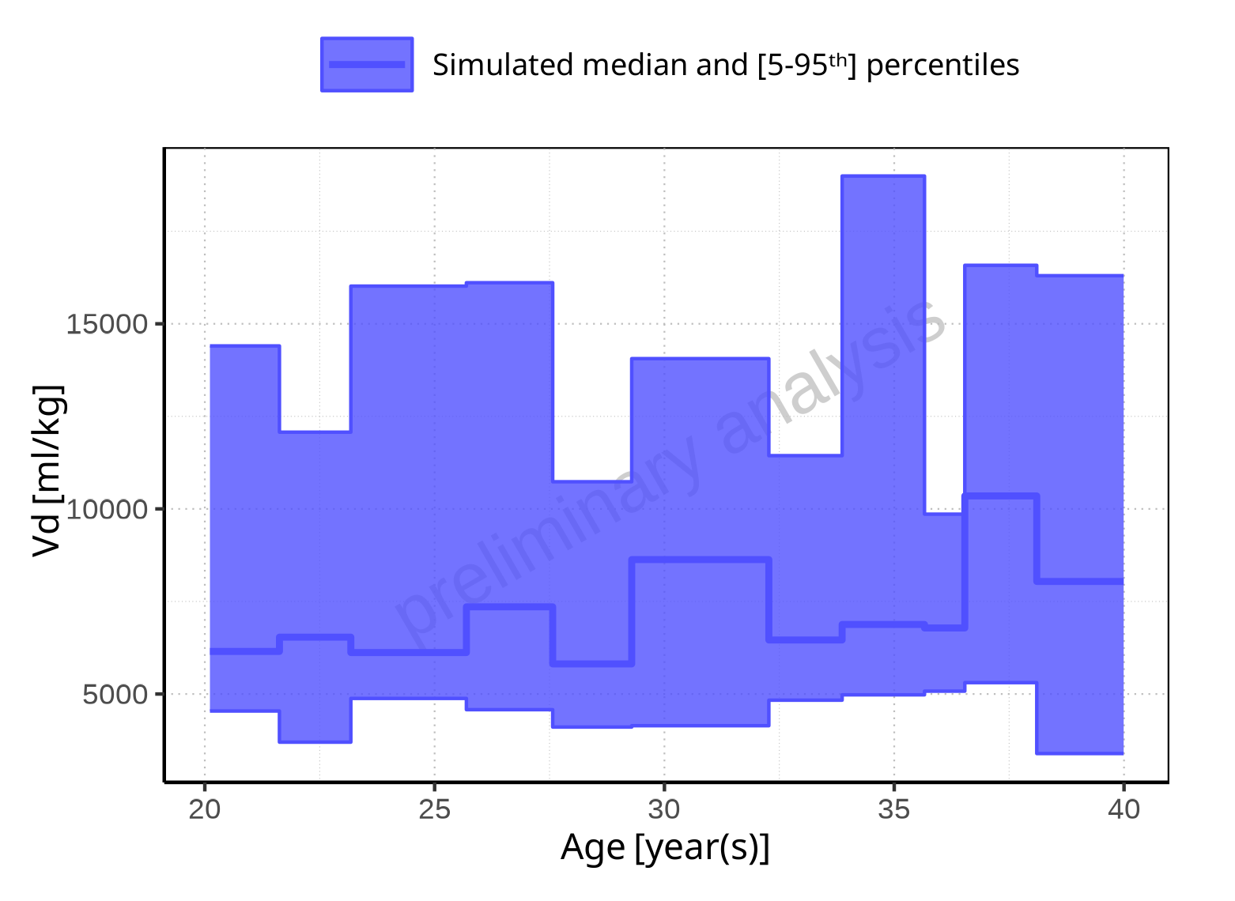

**Figure 2-344: Age-dependence of Vd for Filmcoated_tablet_400mg_sd. Profiles are plotted in a linear scale.**

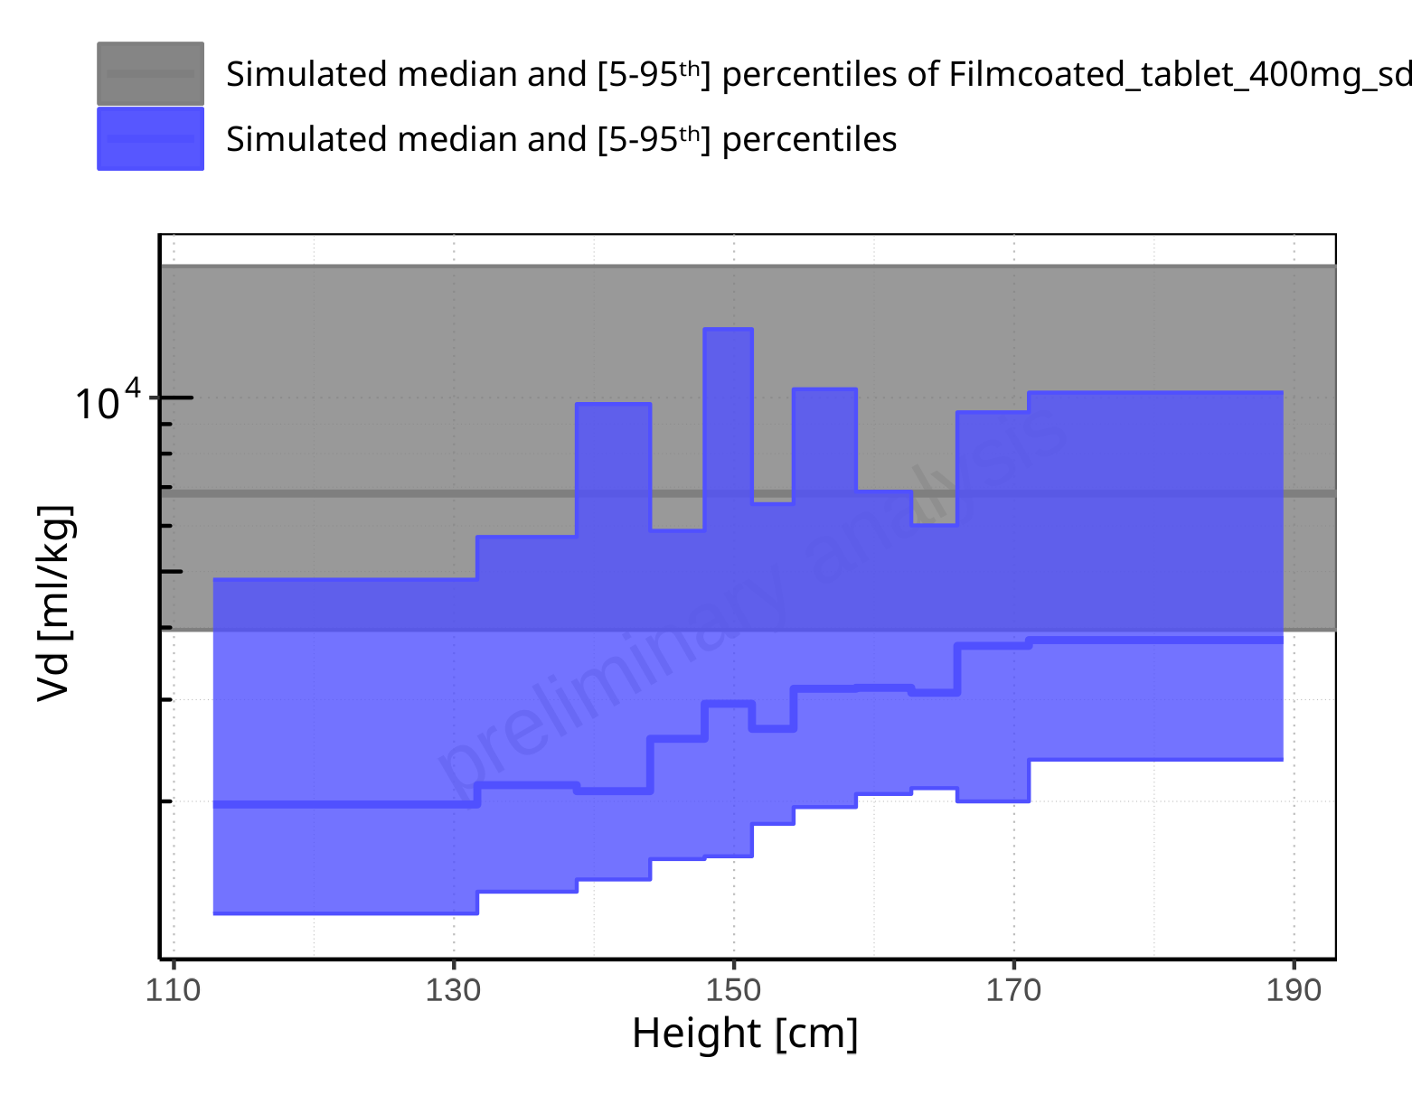

**Figure 2-345: Height-dependence of Vd for Larson 2013 8y-18y 400mg FCT meal in comparison to Filmcoated_tablet_400mg_sd. Profiles are plotted in a logarithmic scale.**

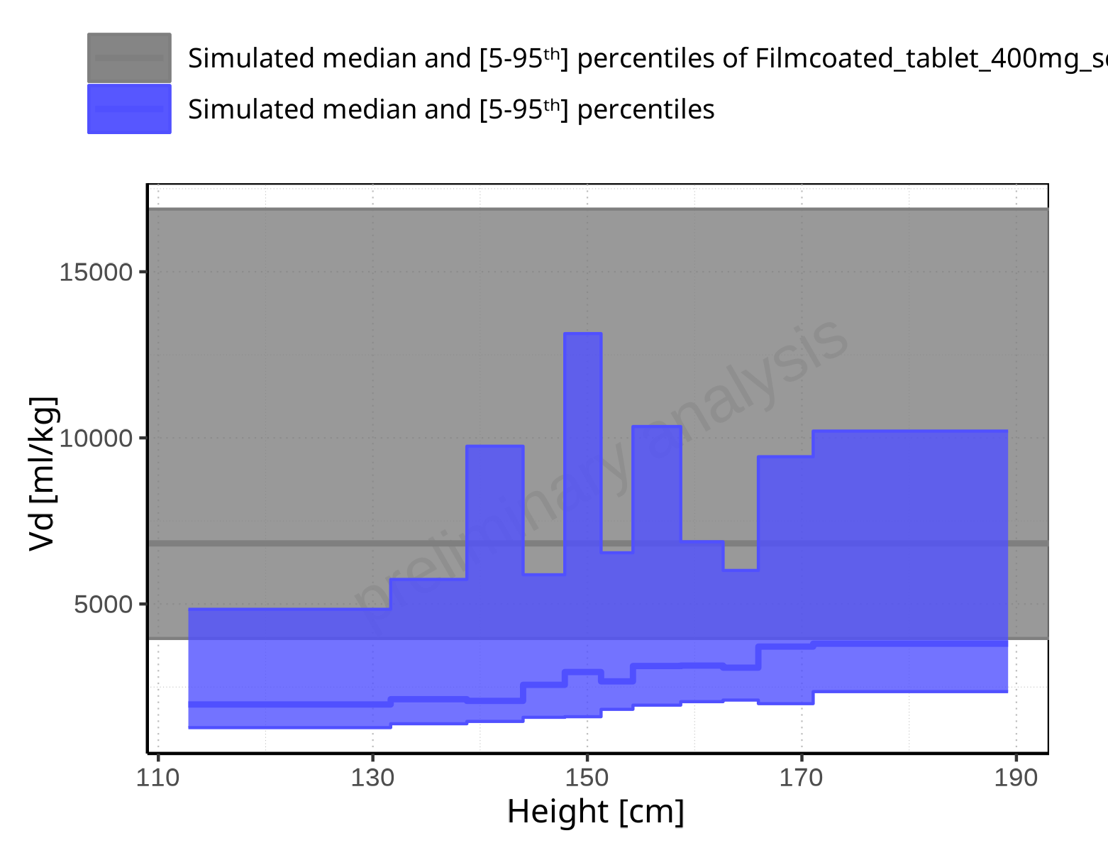

**Figure 2-346: Height-dependence of Vd for Larson 2013 8y-18y 400mg FCT meal in comparison to Filmcoated_tablet_400mg_sd. Profiles are plotted in a linear scale.**

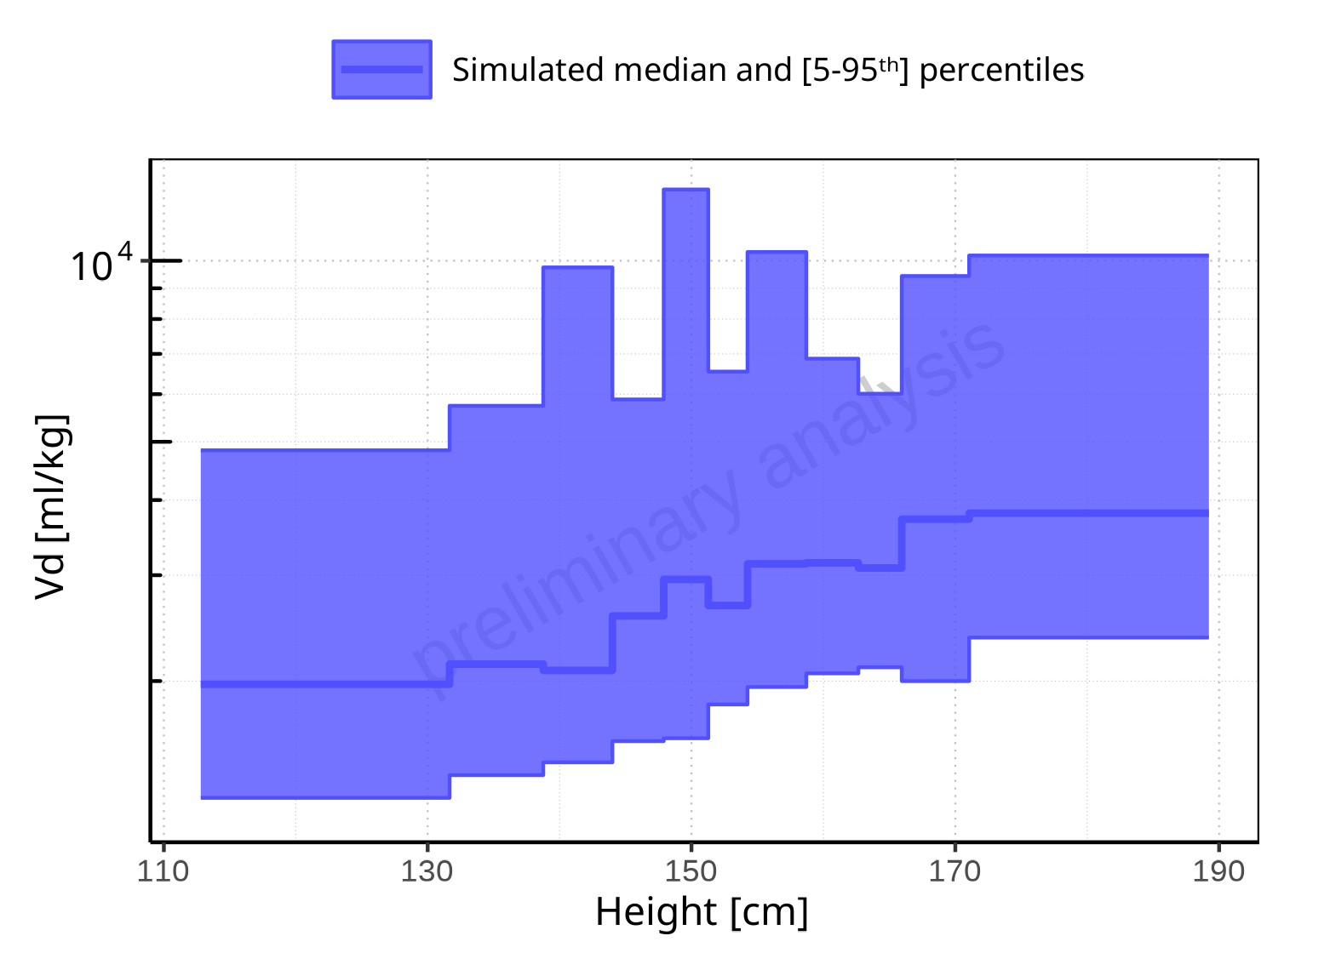

**Figure 2-347: Height-dependence of Vd for Larson 2013 8y-18y 400mg FCT meal. Profiles are plotted in a logarithmic scale.**

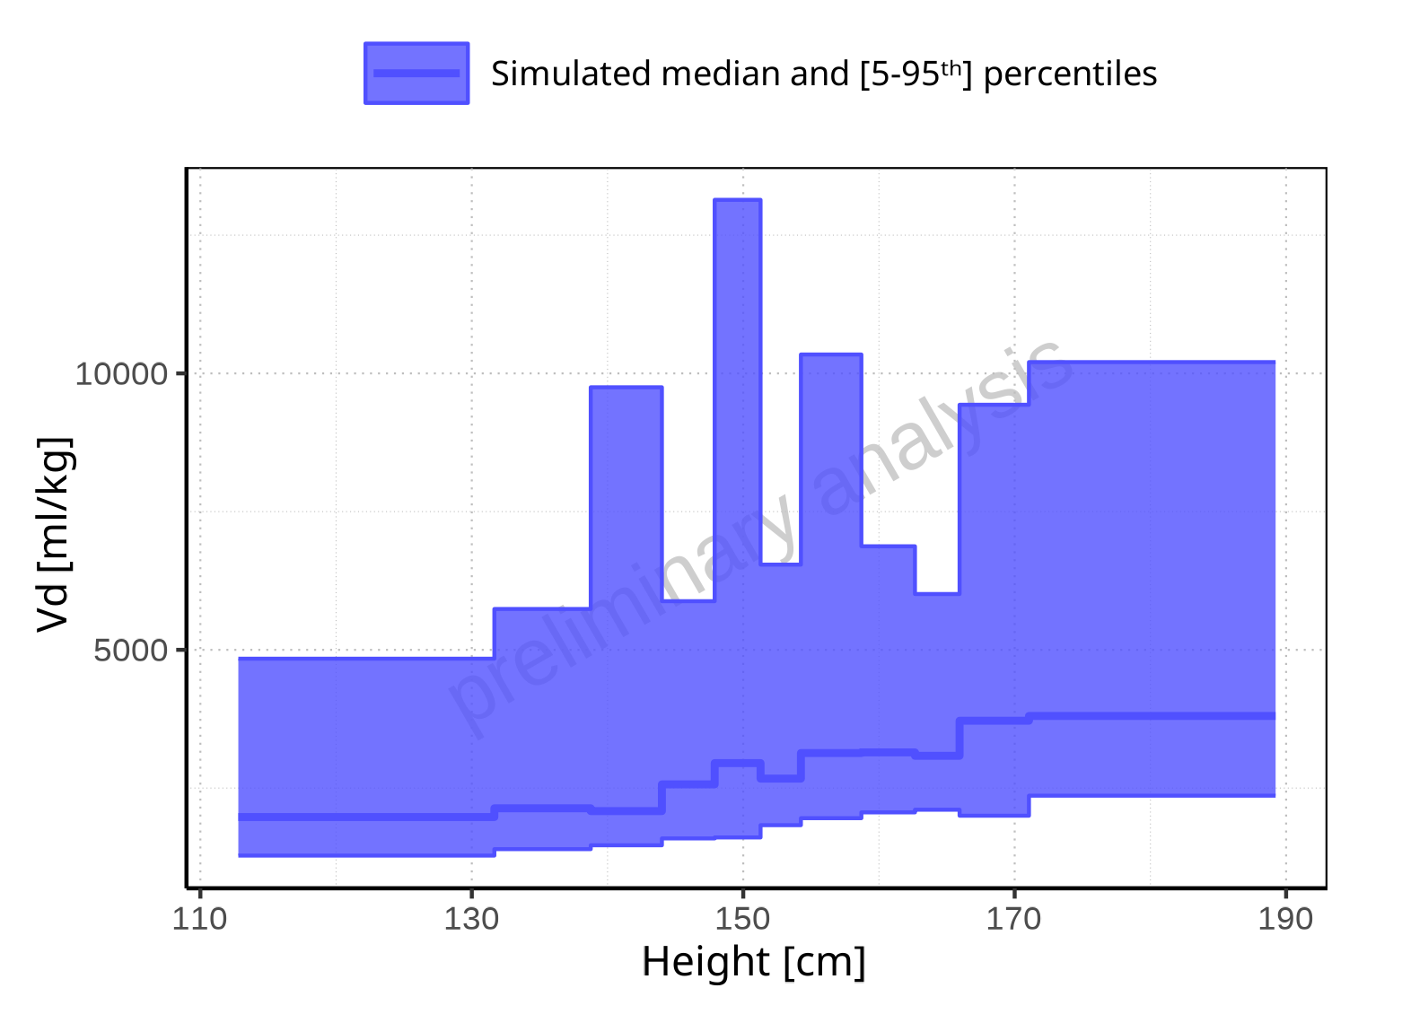

**Figure 2-348: Height-dependence of Vd for Larson 2013 8y-18y 400mg FCT meal. Profiles are plotted in a linear scale.**

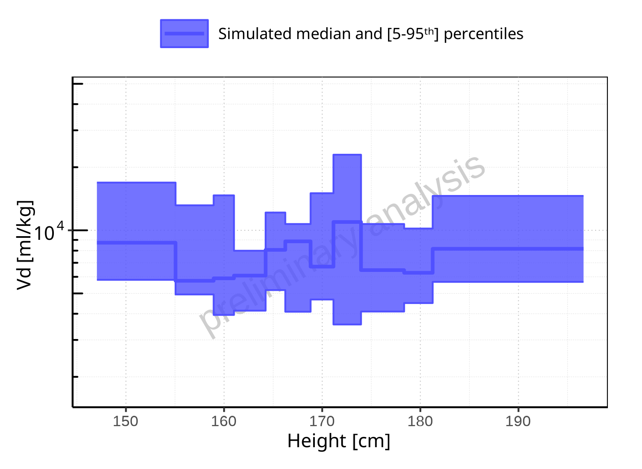

**Figure 2-349: Height-dependence of Vd for Filmcoated_tablet_400mg_sd. Profiles are plotted in a logarithmic scale.**

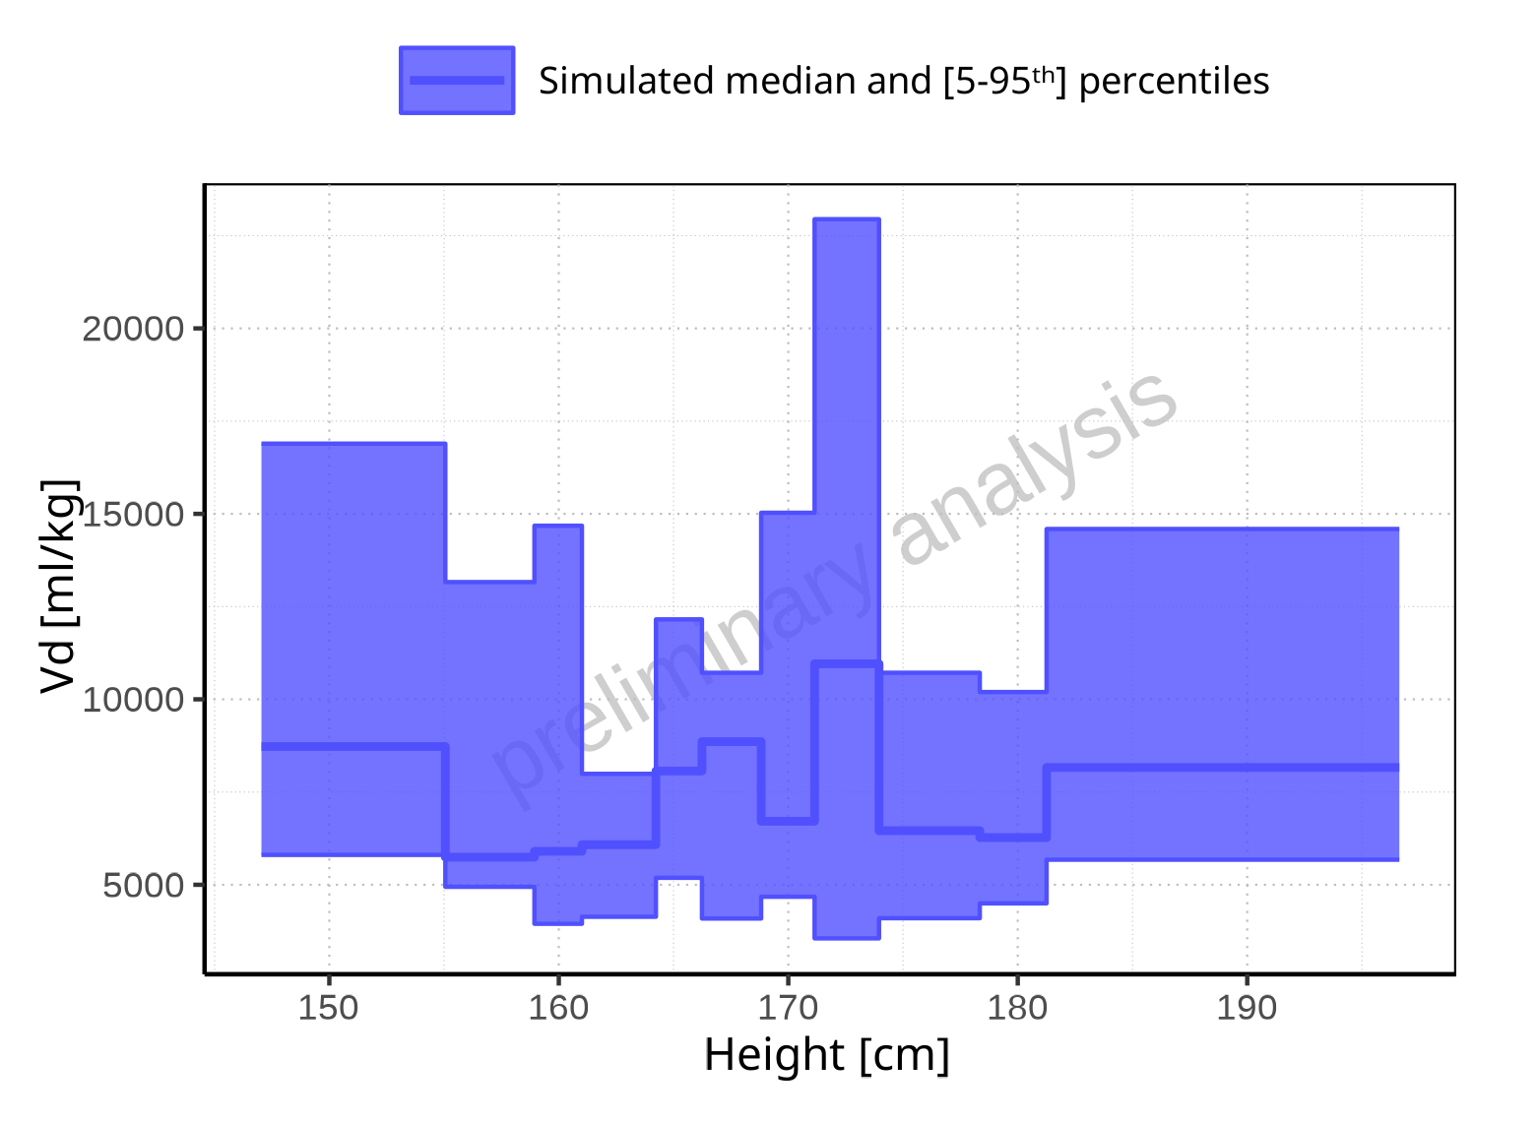

**Figure 2-350: Height-dependence of Vd for Filmcoated_tablet_400mg_sd. Profiles are plotted in a linear scale.**

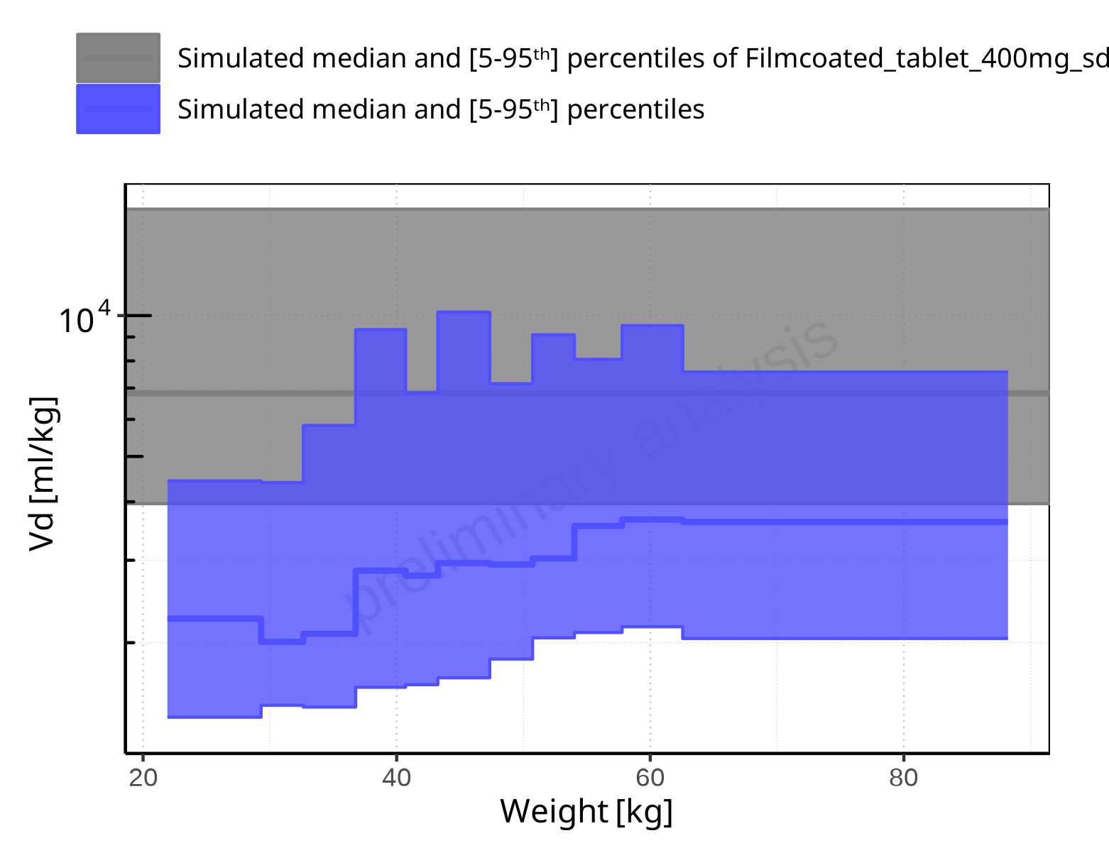

**Figure 2-351: Weight-dependence of Vd for Larson 2013 8y-18y 400mg FCT meal in comparison to Filmcoated_tablet_400mg_sd. Profiles are plotted in a logarithmic scale.**

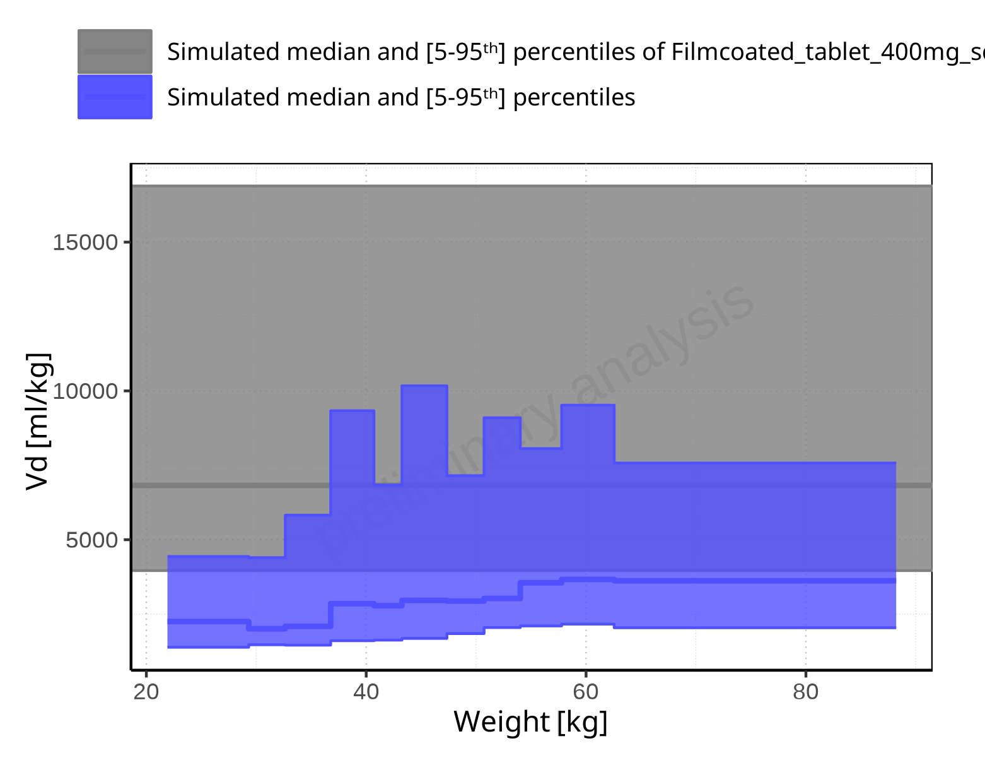

**Figure 2-352: Weight-dependence of Vd for Larson 2013 8y-18y 400mg FCT meal in comparison to Filmcoated_tablet_400mg_sd. Profiles are plotted in a linear scale.**

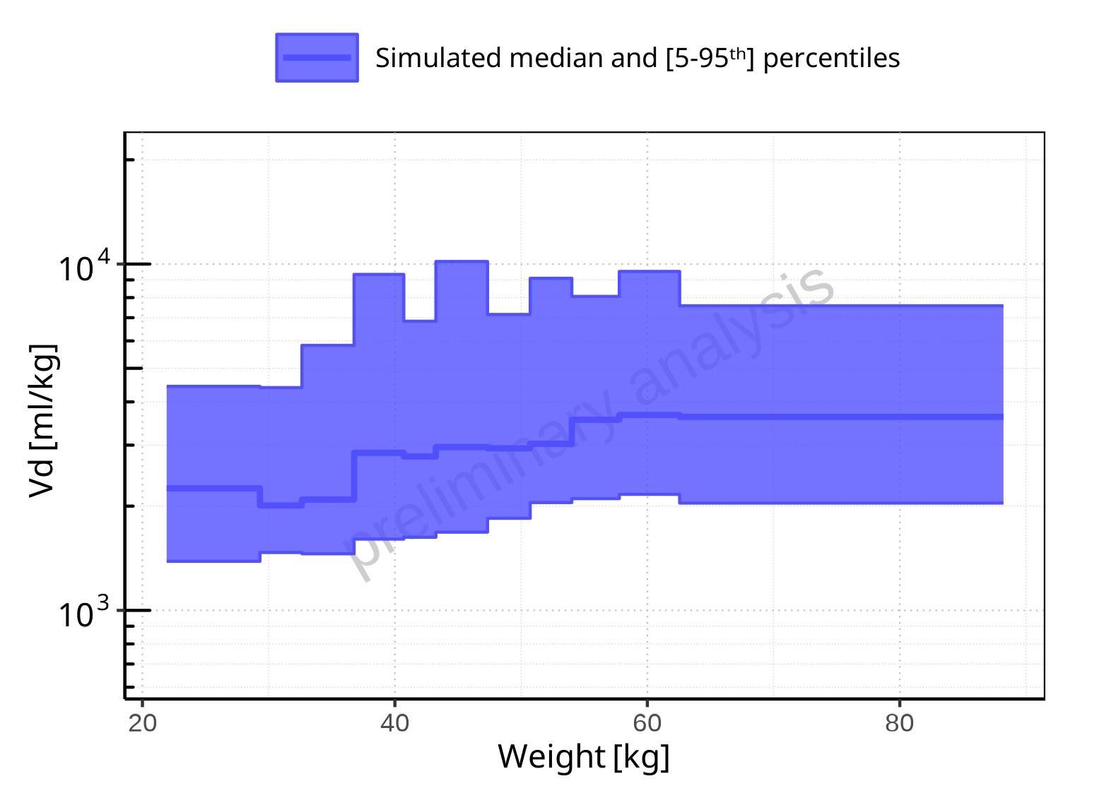

**Figure 2-353: Weight-dependence of Vd for Larson 2013 8y-18y 400mg FCT meal. Profiles are plotted in a logarithmic scale.**

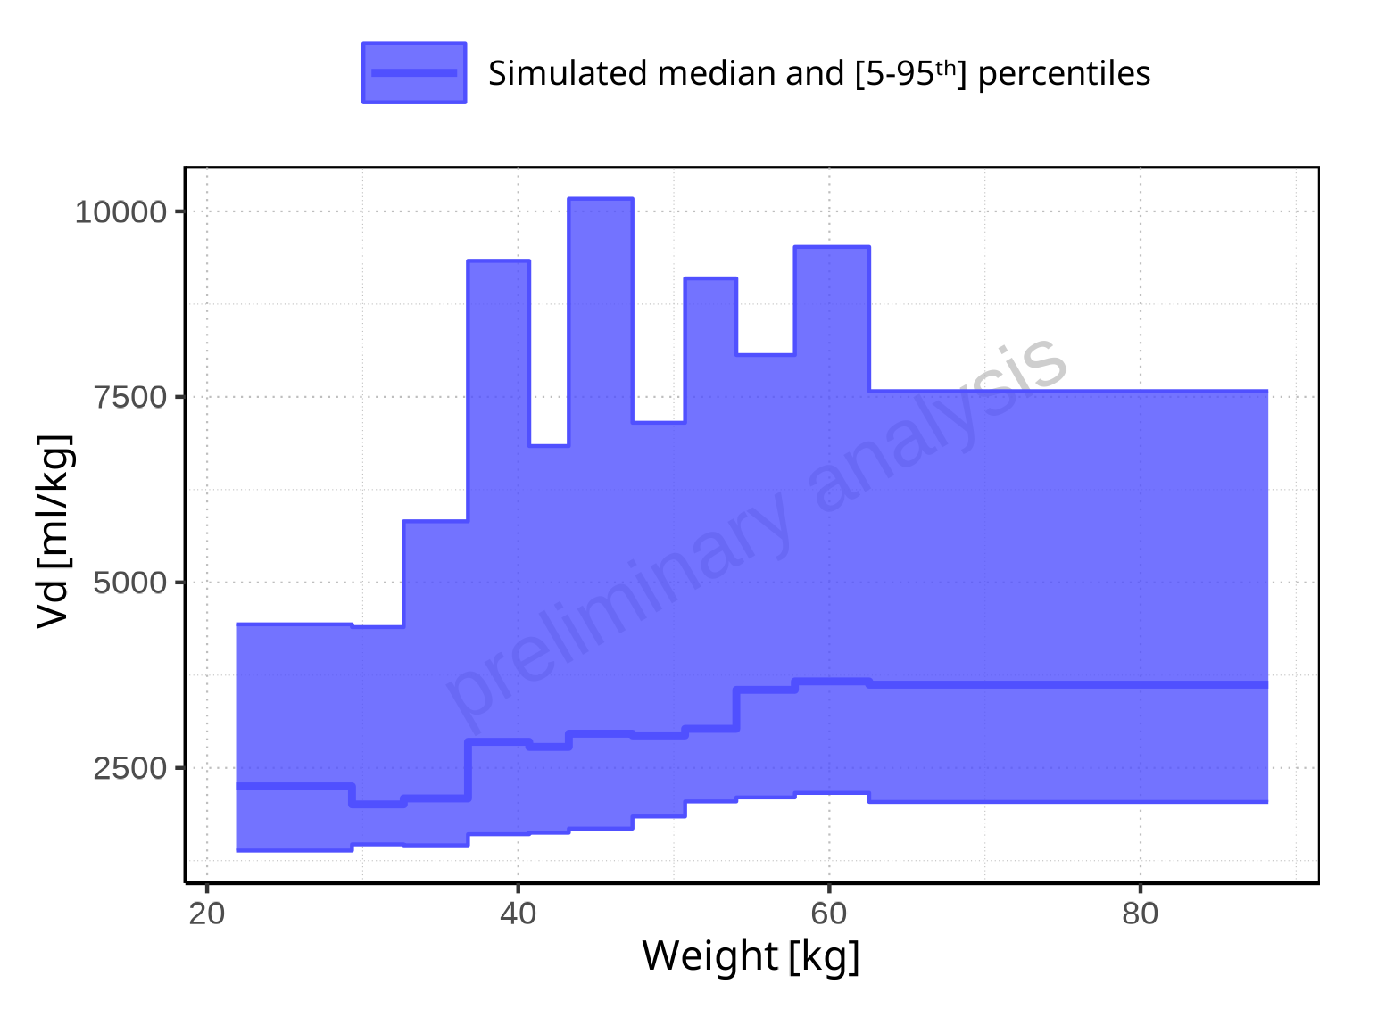

**Figure 2-354: Weight-dependence of Vd for Larson 2013 8y-18y 400mg FCT meal. Profiles are plotted in a linear scale.**

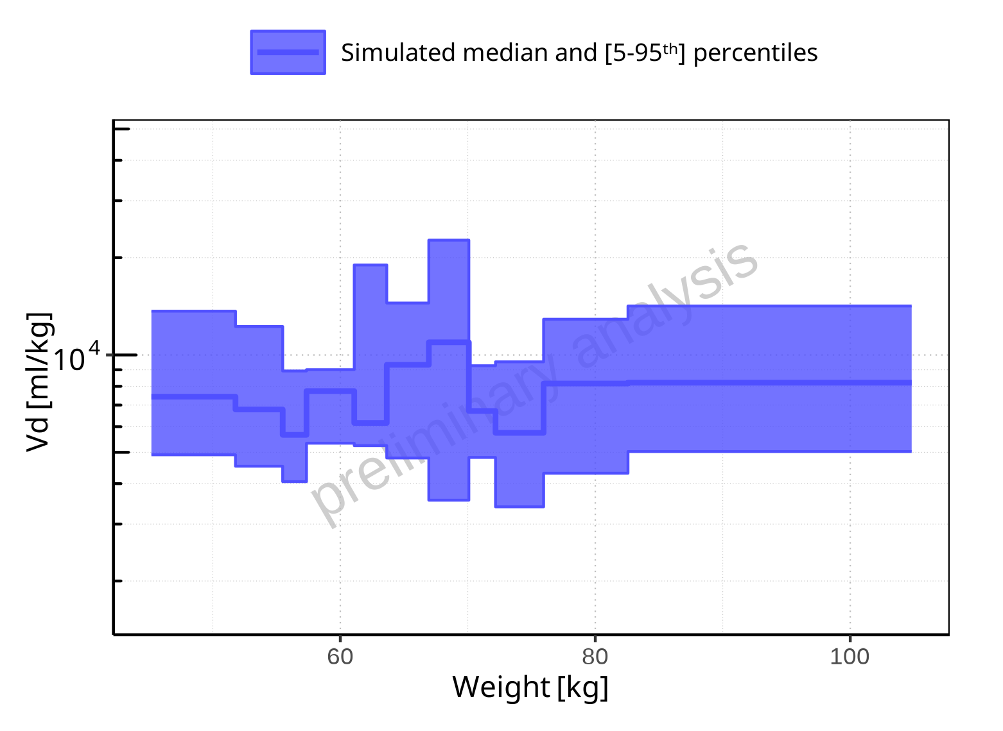

**Figure 2-355: Weight-dependence of Vd for Filmcoated_tablet_400mg_sd. Profiles are plotted in a logarithmic scale.**

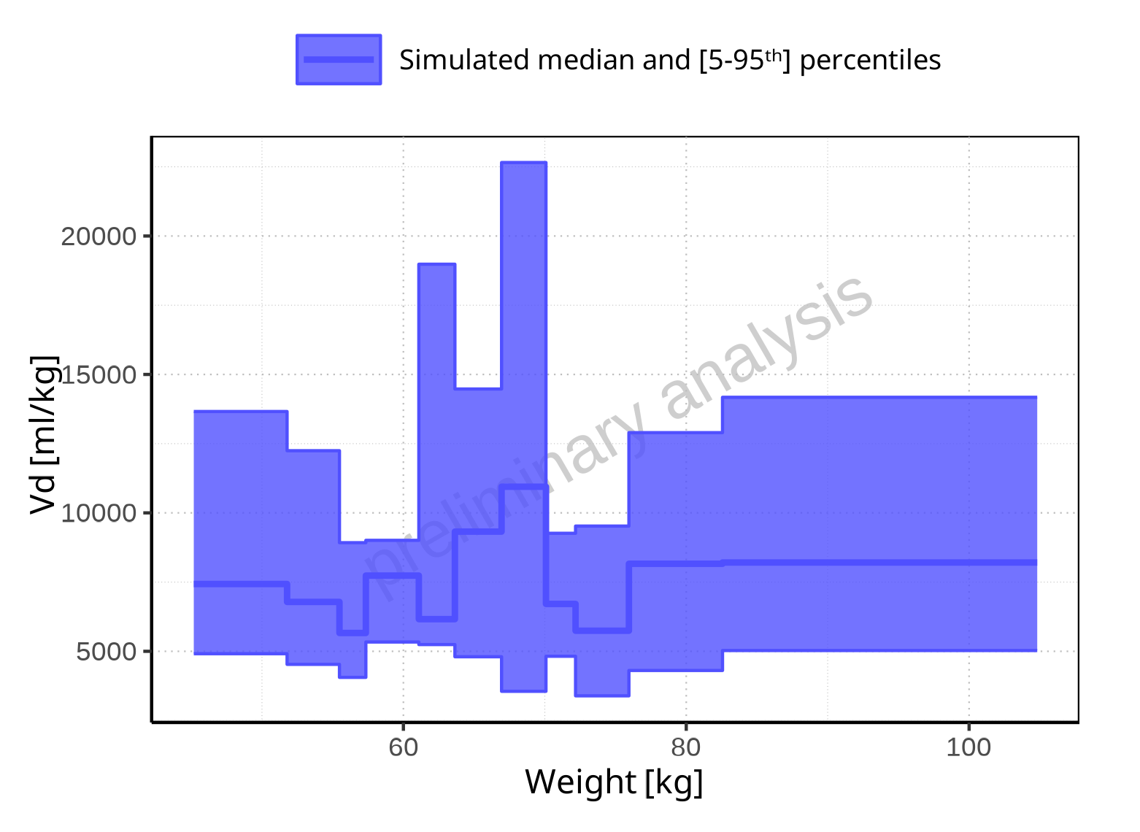

**Figure 2-356: Weight-dependence of Vd for Filmcoated_tablet_400mg_sd. Profiles are plotted in a linear scale.**

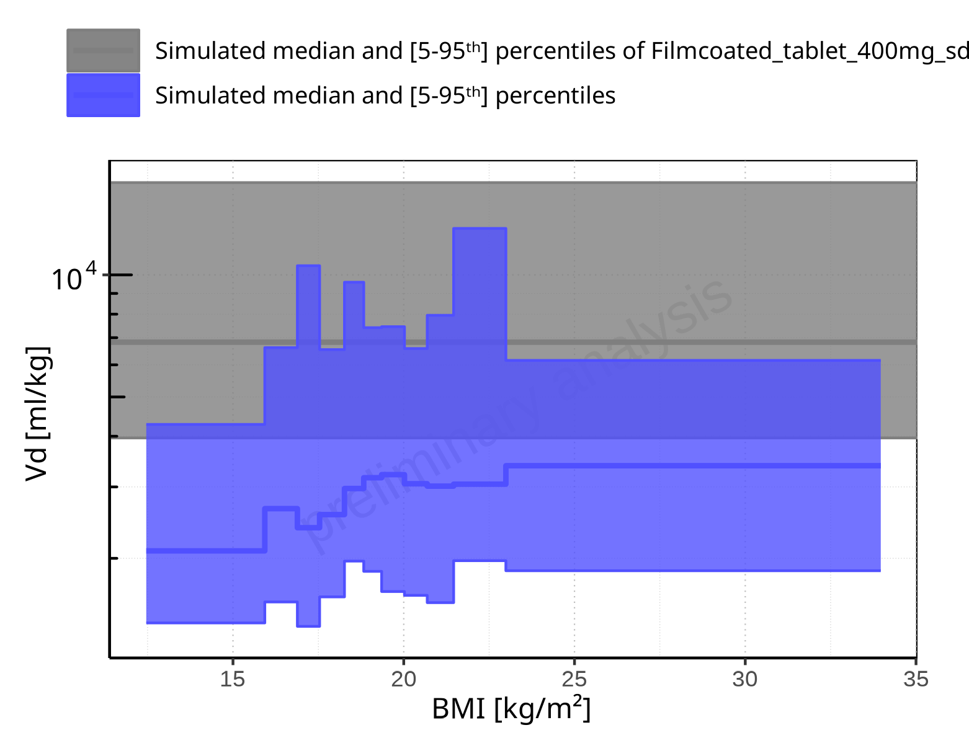

**Figure 2-357: BMI-dependence of Vd for Larson 2013 8y-18y 400mg FCT meal in comparison to Filmcoated_tablet_400mg_sd. Profiles are plotted in a logarithmic scale.**

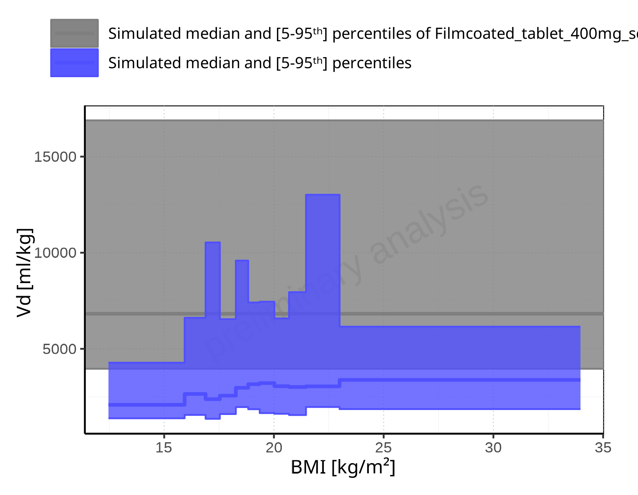

**Figure 2-358: BMI-dependence of Vd for Larson 2013 8y-18y 400mg FCT meal in comparison to Filmcoated_tablet_400mg_sd. Profiles are plotted in a linear scale.**

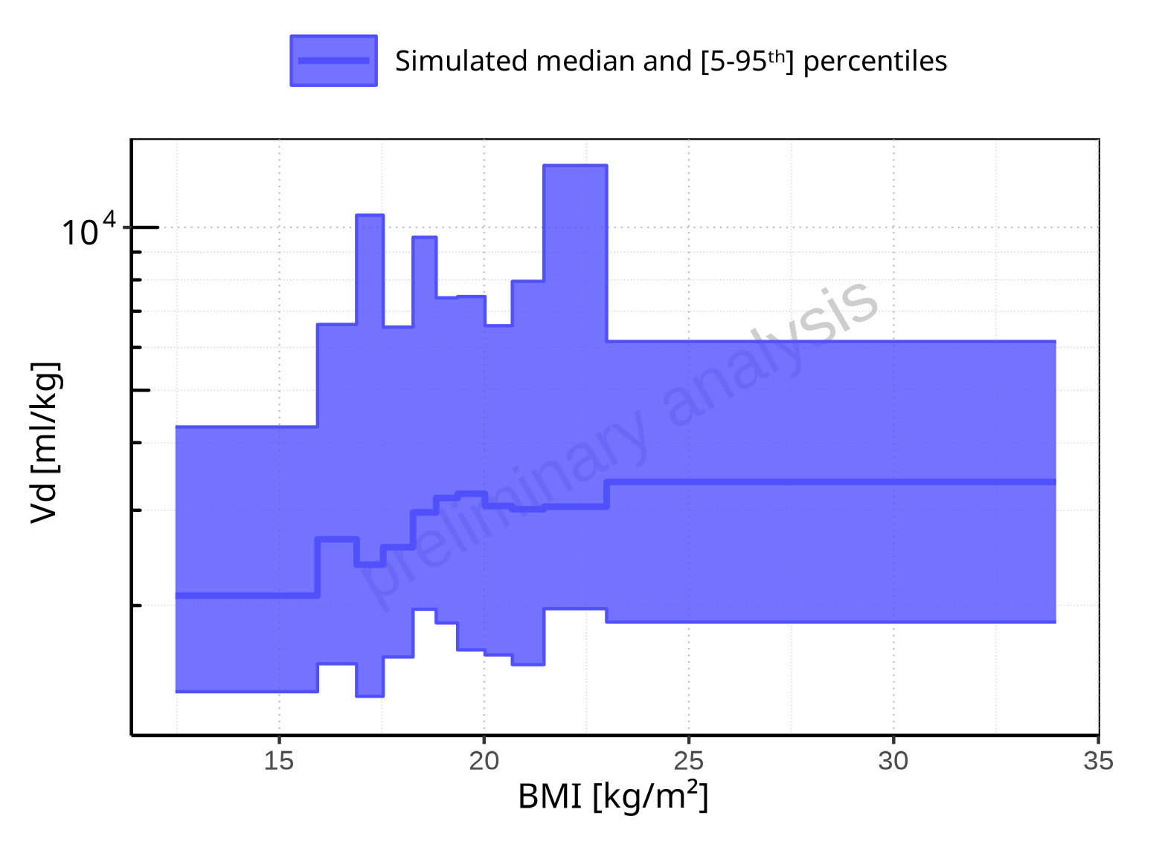

**Figure 2-359: BMI-dependence of Vd for Larson 2013 8y-18y 400mg FCT meal. Profiles are plotted in a logarithmic scale.**

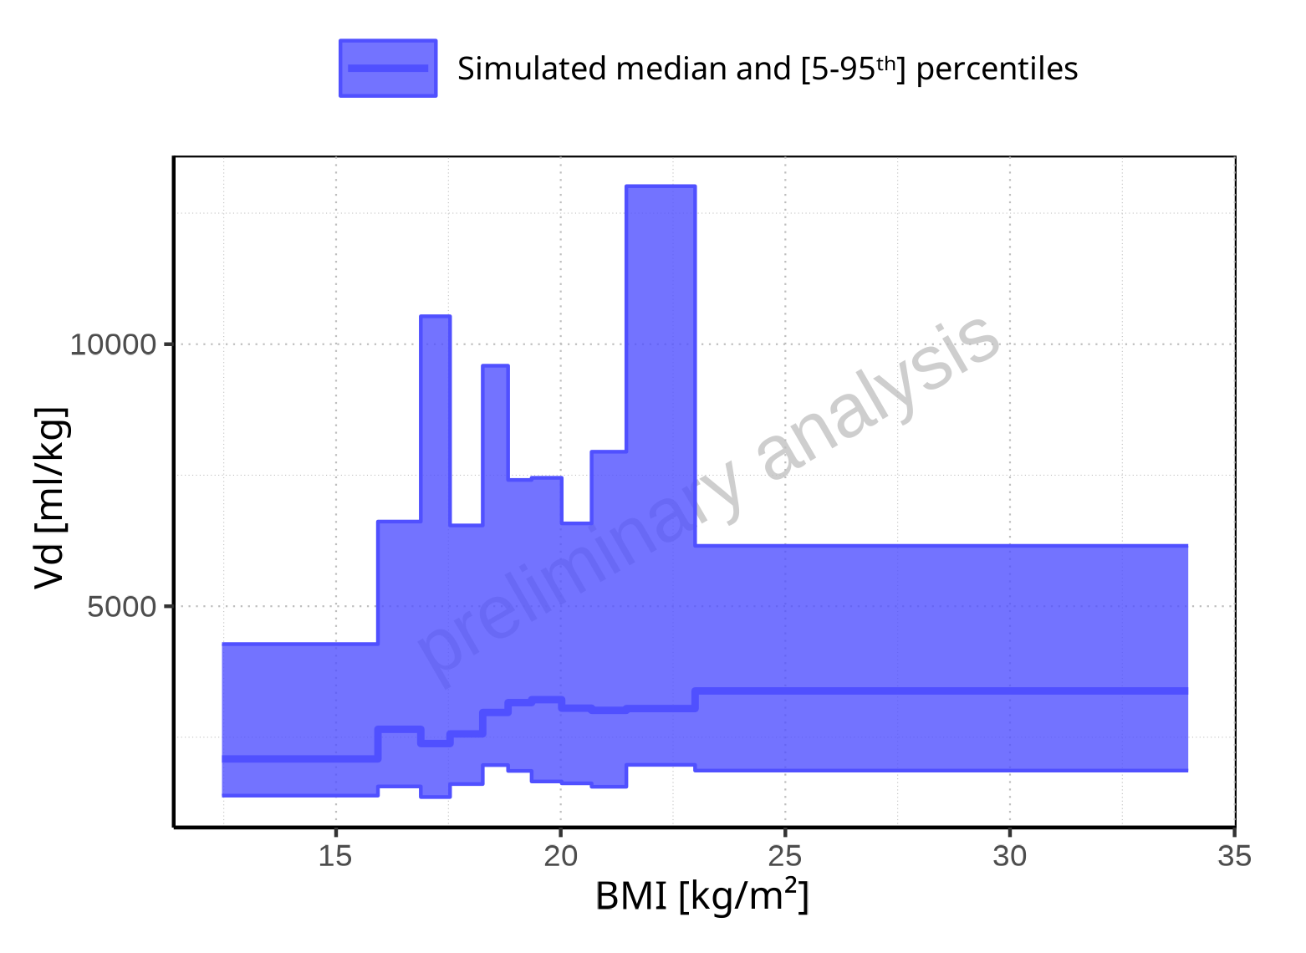

**Figure 2-360: BMI-dependence of Vd for Larson 2013 8y-18y 400mg FCT meal. Profiles are plotted in a linear scale.**

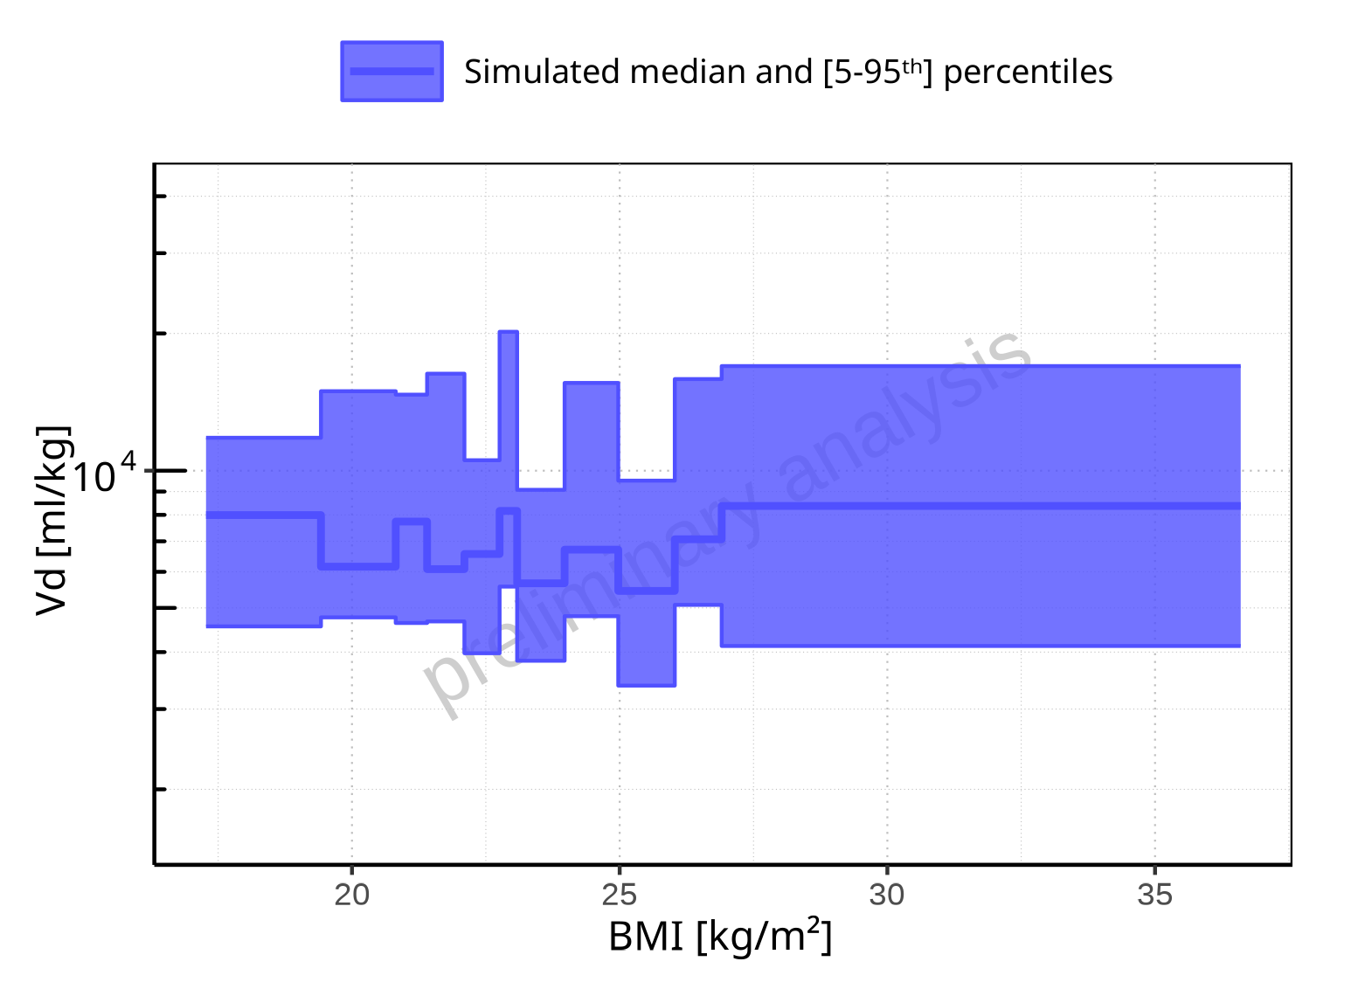

**Figure 2-361: BMI-dependence of Vd for Filmcoated_tablet_400mg_sd. Profiles are plotted in a logarithmic scale.**

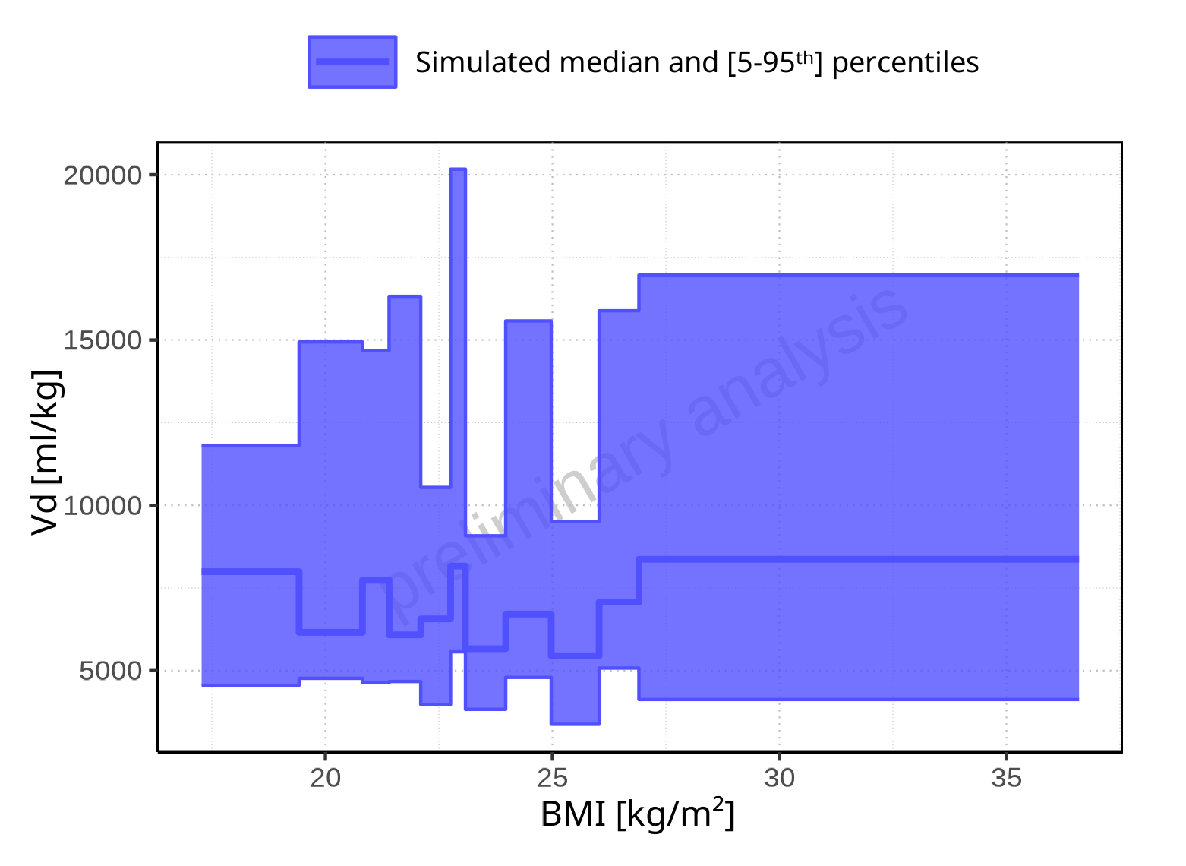

**Figure 2-362: BMI-dependence of Vd for Filmcoated_tablet_400mg_sd. Profiles are plotted in a linear scale.**

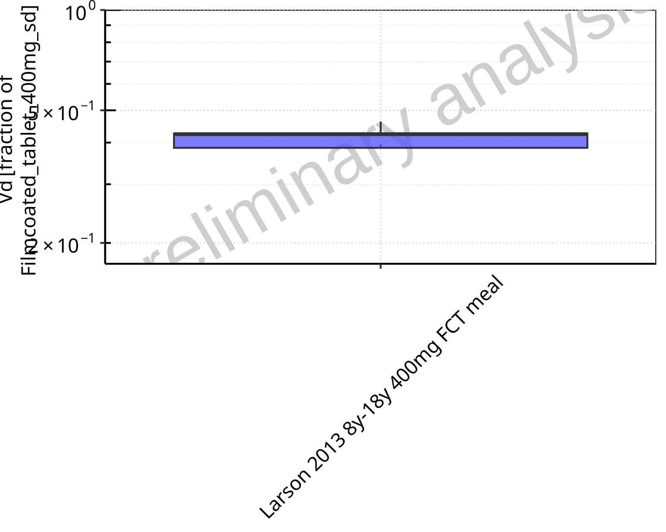

**Figure 2-363: Ratio of population summary statistics of Vd of Raltegravir for Larson 2013 8y-18y 400mg FCT meal in comparison to Filmcoated_tablet_400mg_sd shown as box-whisker plot, which indicates ratios of the 5th, 25th, 50th, 75th, 95th percentiles in logarithmic scale.**

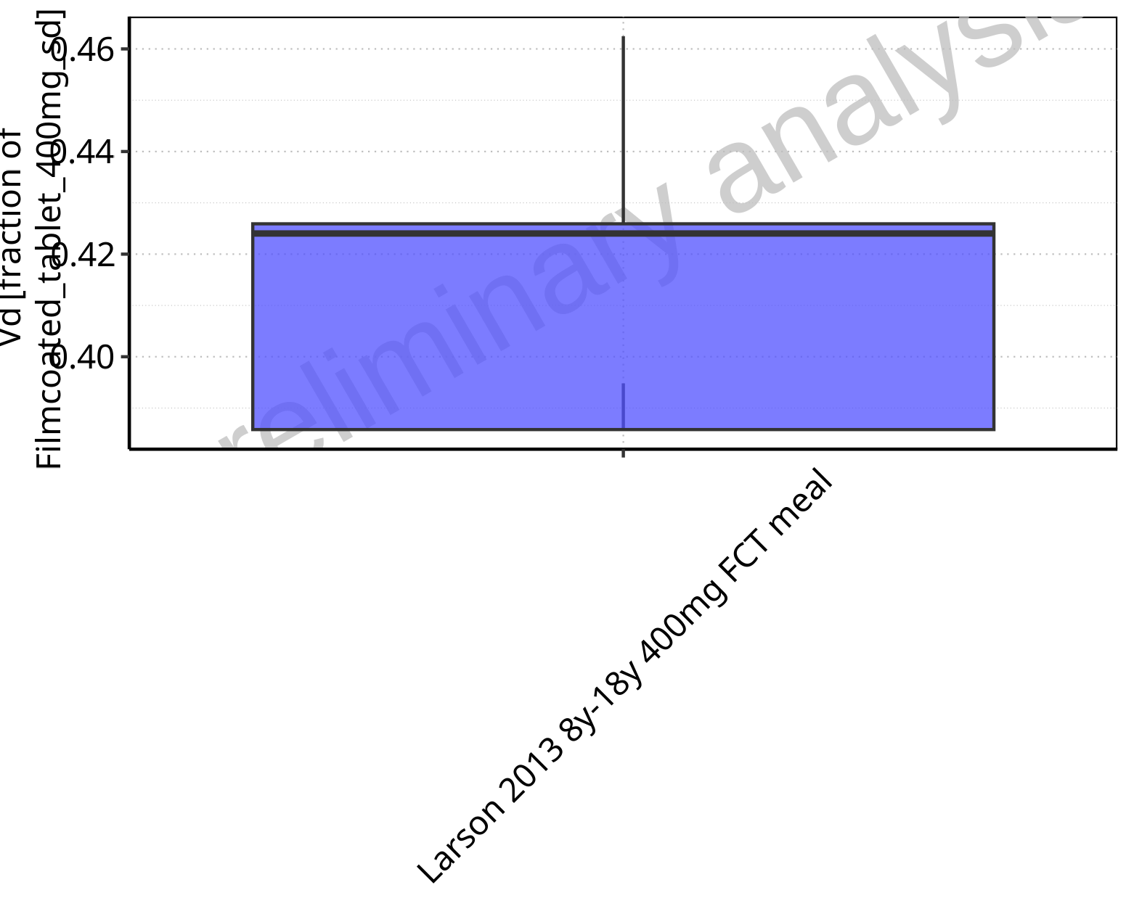

**Figure 2-364: Ratio of population summary statistics of Vd of Raltegravir for Larson 2013 8y-18y 400mg FCT meal in comparison to Filmcoated_tablet_400mg_sd shown as box-whisker plot, which indicates ratios of the 5th, 25th, 50th, 75th, 95th percentiles in linear scale.**

**Table 2-26: Ratio of population summary statistics of Vd of Raltegravir for Larson 2013 8y-18y 400mg FCT meal in comparison to Filmcoated_tablet_400mg_sd**

| Population | N | 5th pctl | 25th pctl | 50th pctl | 75th pctl | 95th pctl | Mean | SD | Geo Mean | Geo SD |
| --- | --- | --- | --- | --- | --- | --- | --- | --- | --- | --- |
| Larson 2013 8y-18y 400mg FCT meal | 497 | 0.39 | 0.39 | 0.42 | 0.43 | 0.46 | 0.45 | 0.65 | 0.42 | 1.09 |

# Time profiles and residual plots

## Time profiles and residual plots for Filmcoated_tablet_400mg_sd

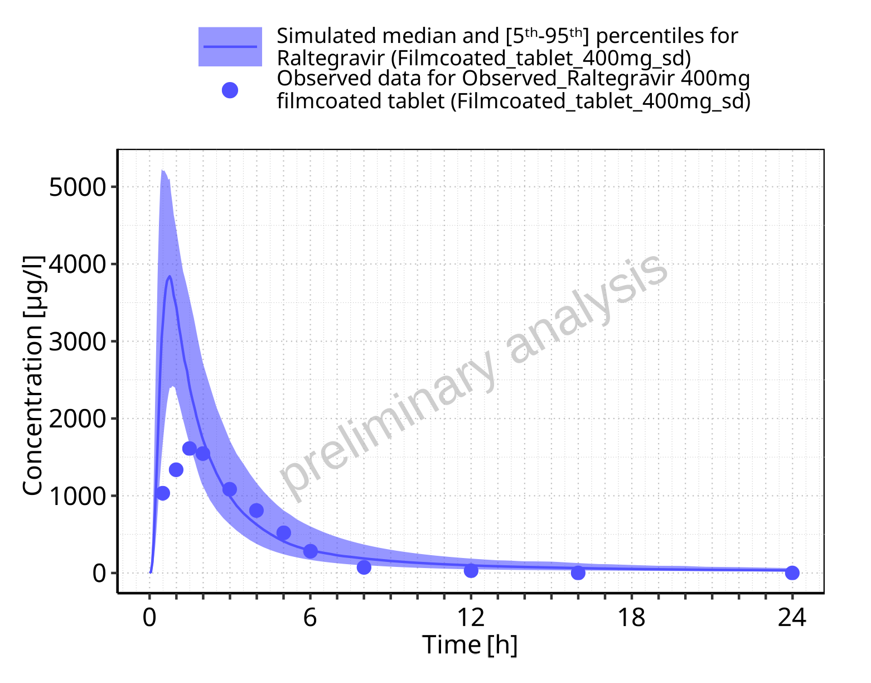

**Figure 3-1: Time profiles for Filmcoated_tablet_400mg_sd. Data source: Data/Raltegravir_PK.txt. Time profiles are plotted in a linear scale.**

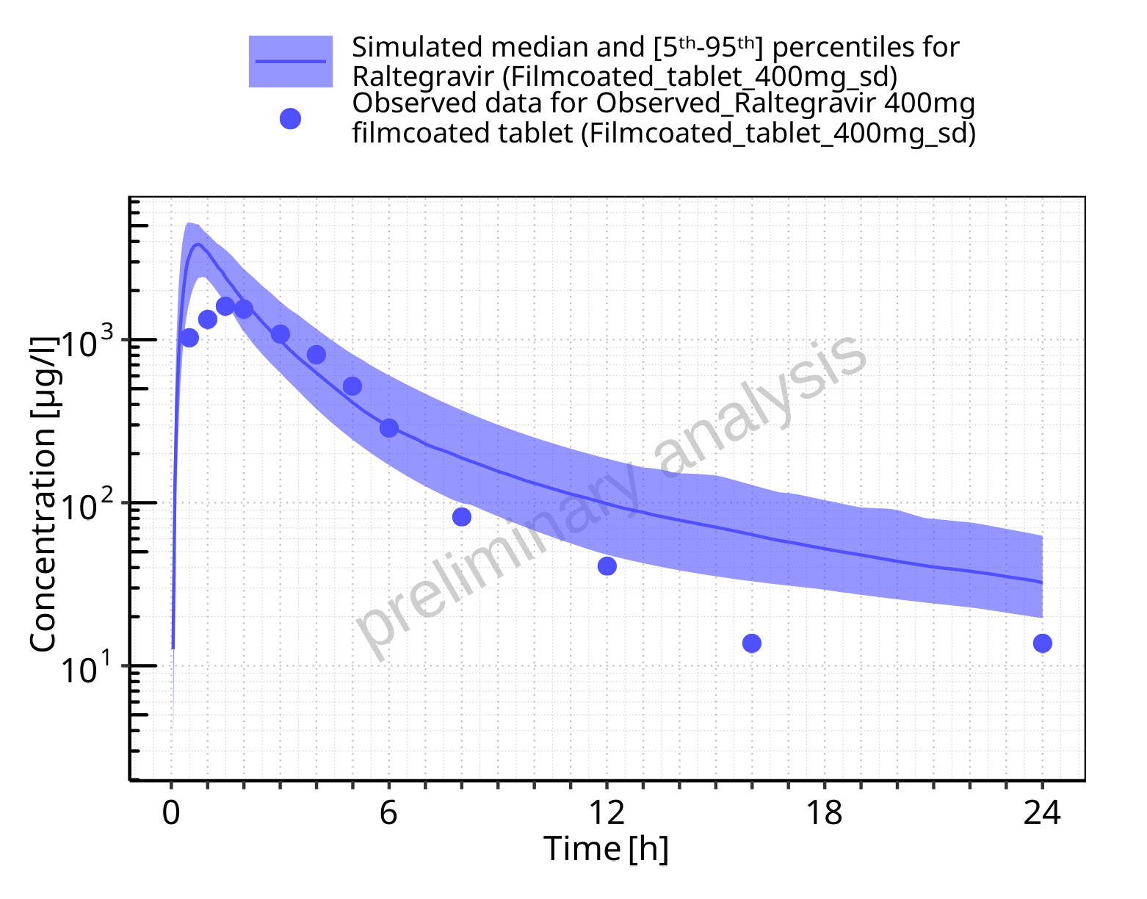

**Figure 3-2: Time profiles for Filmcoated_tablet_400mg_sd. Data source: Data/Raltegravir_PK.txt. Time profiles are plotted in a logarithmic scale.**

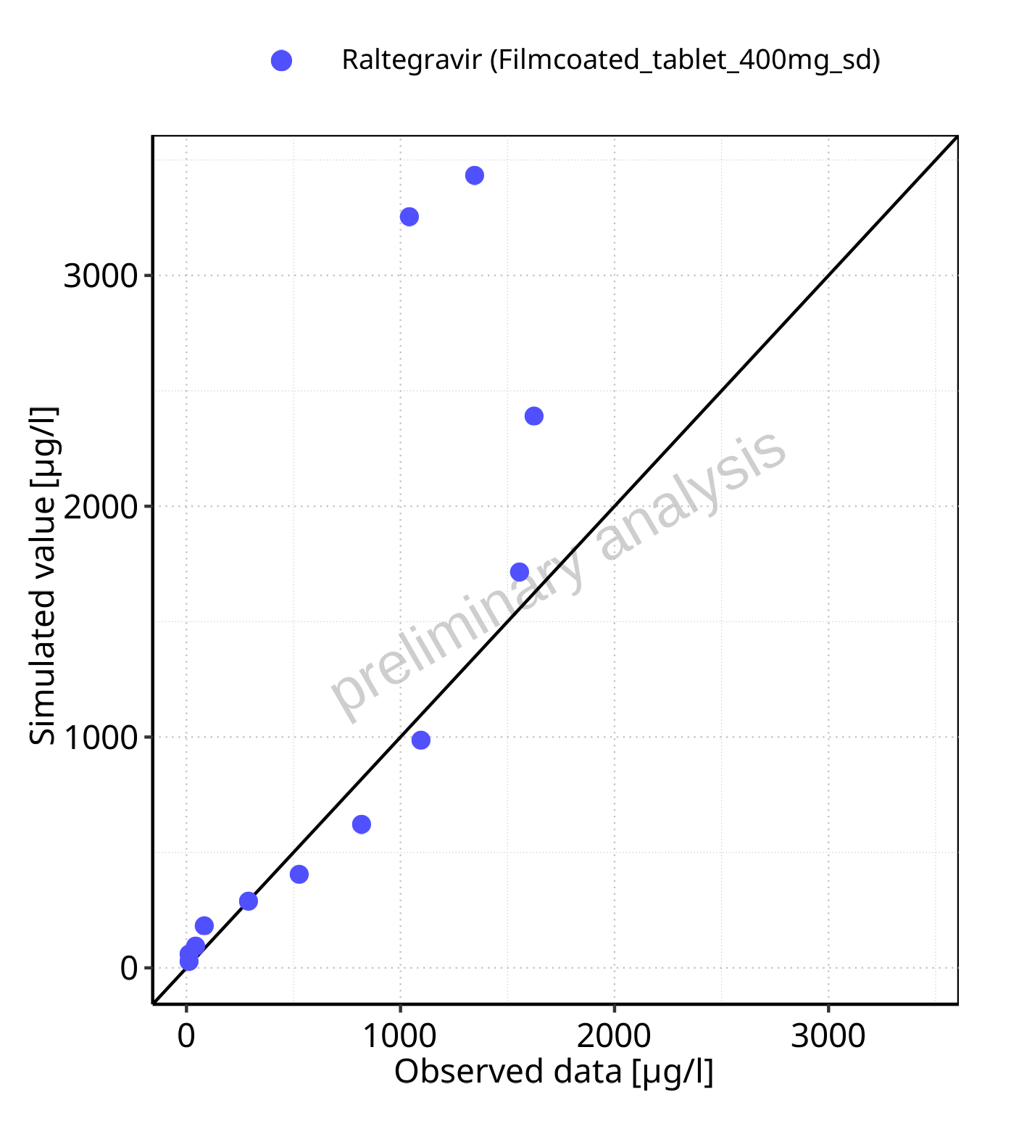

**Figure 3-3: Predicted (median) vs observed for Filmcoated_tablet_400mg_sd. Data source: Data/Raltegravir_PK.txt. Predictions and observations are plotted in a linear scale.**



**Figure 3-4: Predicted (median) vs observed for Filmcoated_tablet_400mg_sd. Data source: Data/Raltegravir_PK.txt. Predictions and observations are plotted in a logarithmic scale.**

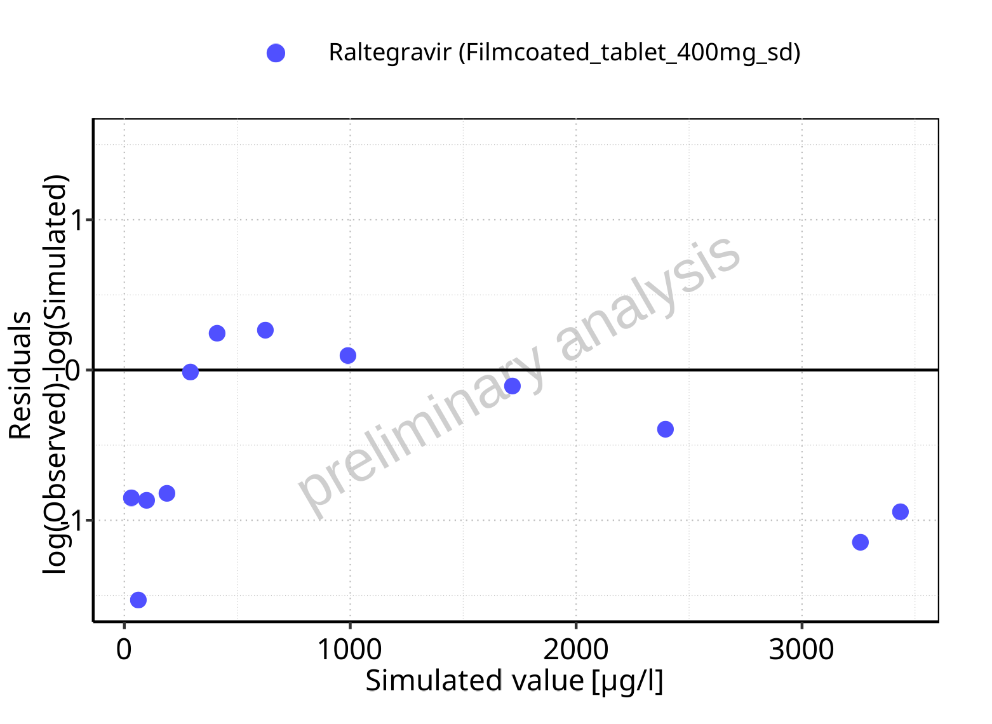

**Figure 3-5: Logarithmic residuals vs predicted (median) values for Filmcoated_tablet_400mg_sd. Data source: Data/Raltegravir_PK.txt.**

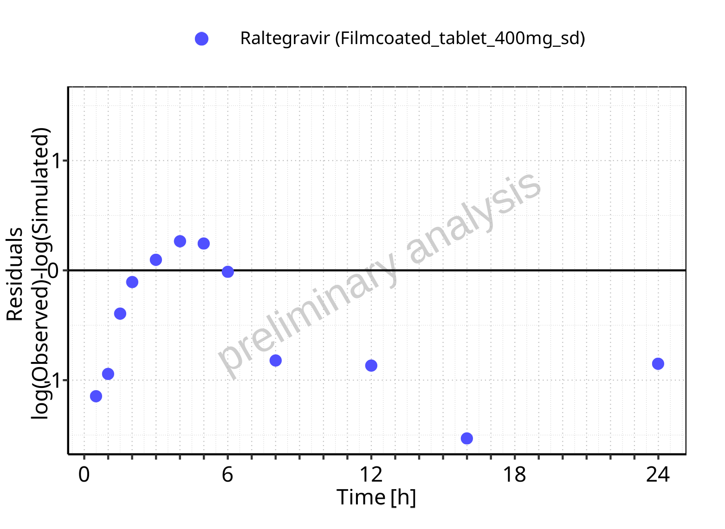

**Figure 3-6: Logarithmic residuals vs time values for Filmcoated_tablet_400mg_sd. Data source: Data/Raltegravir_PK.txt.**

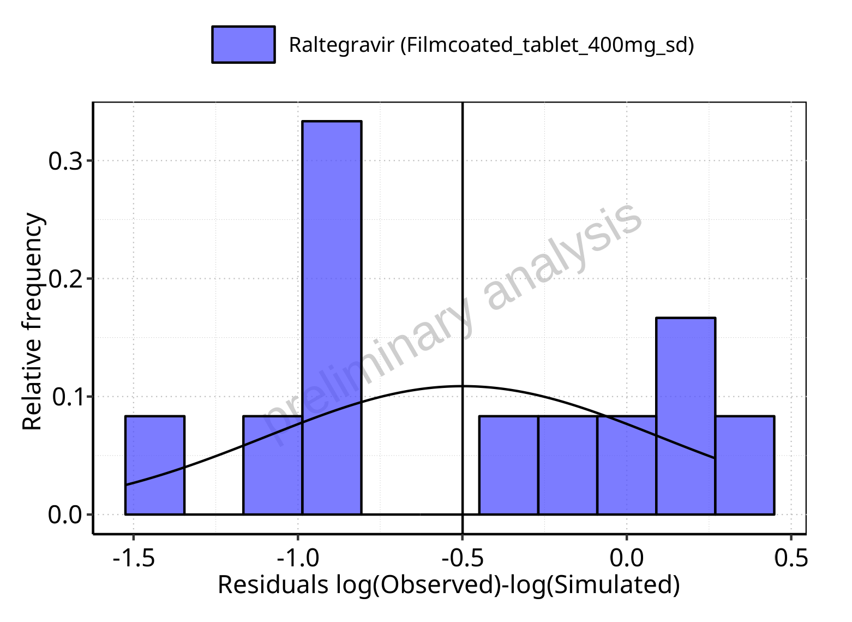

**Figure 3-7: Logarithmic residuals distribution (stacked) for Filmcoated_tablet_400mg_sd. Data source: Data/Raltegravir_PK.txt.**

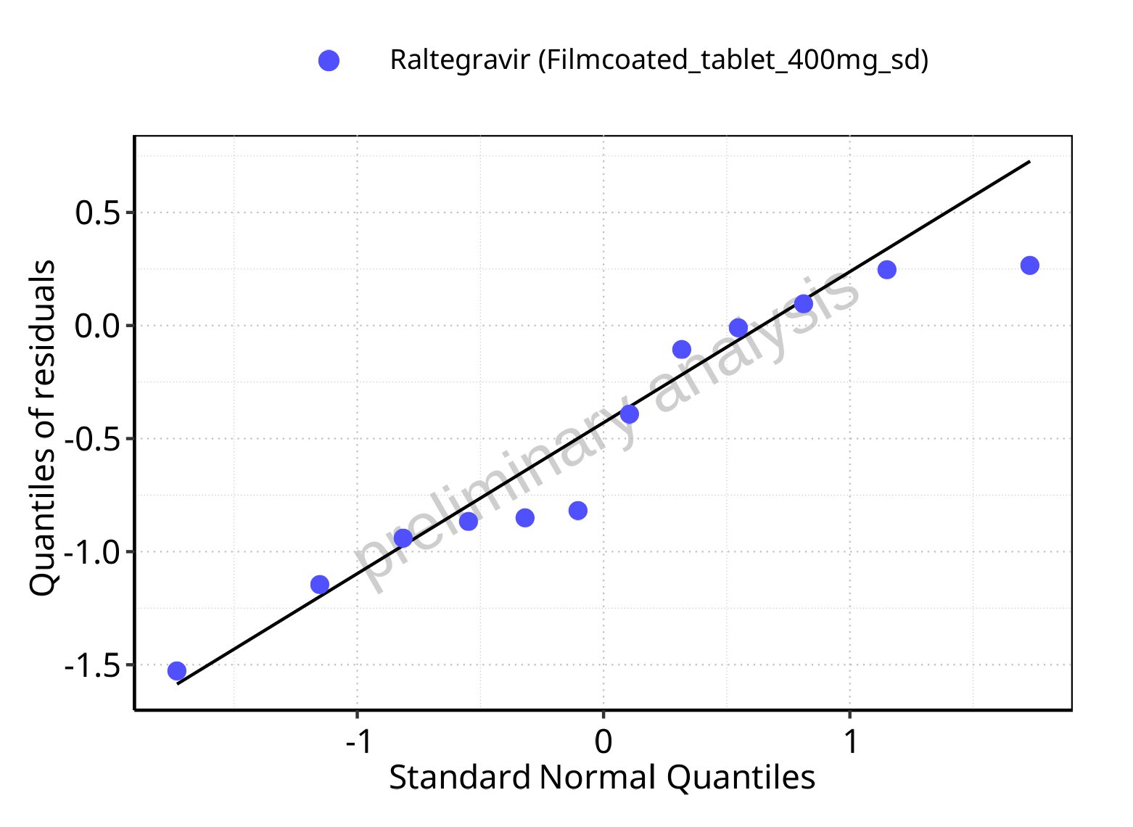

**Figure 3-8: Logarithmic residuals for Filmcoated_tablet_400mg_sd as quantile-quantile plot. Data source: Data/Raltegravir_PK.txt.**

## Time profiles and residual plots for Larson 2013 8y-18y 400mg FCT meal

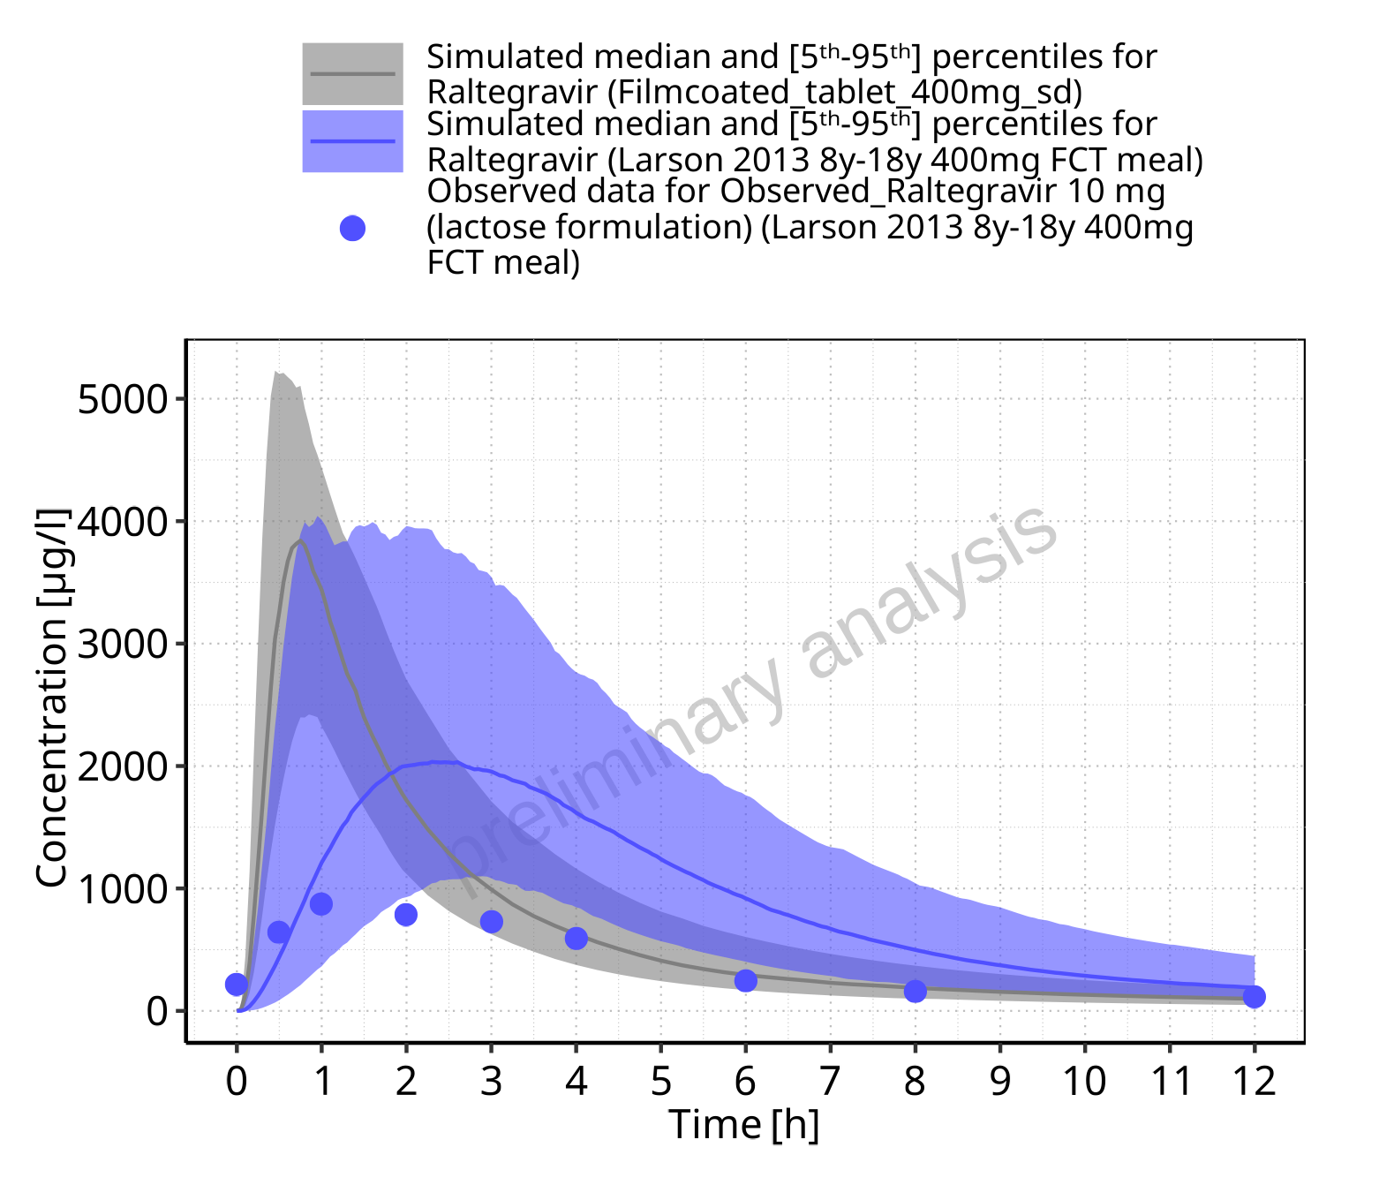

**Figure 3-9: Time profiles for Larson 2013 8y-18y 400mg FCT meal. Data source: Data/Raltegravir_PK.txt. Time profiles are plotted in a linear scale.**

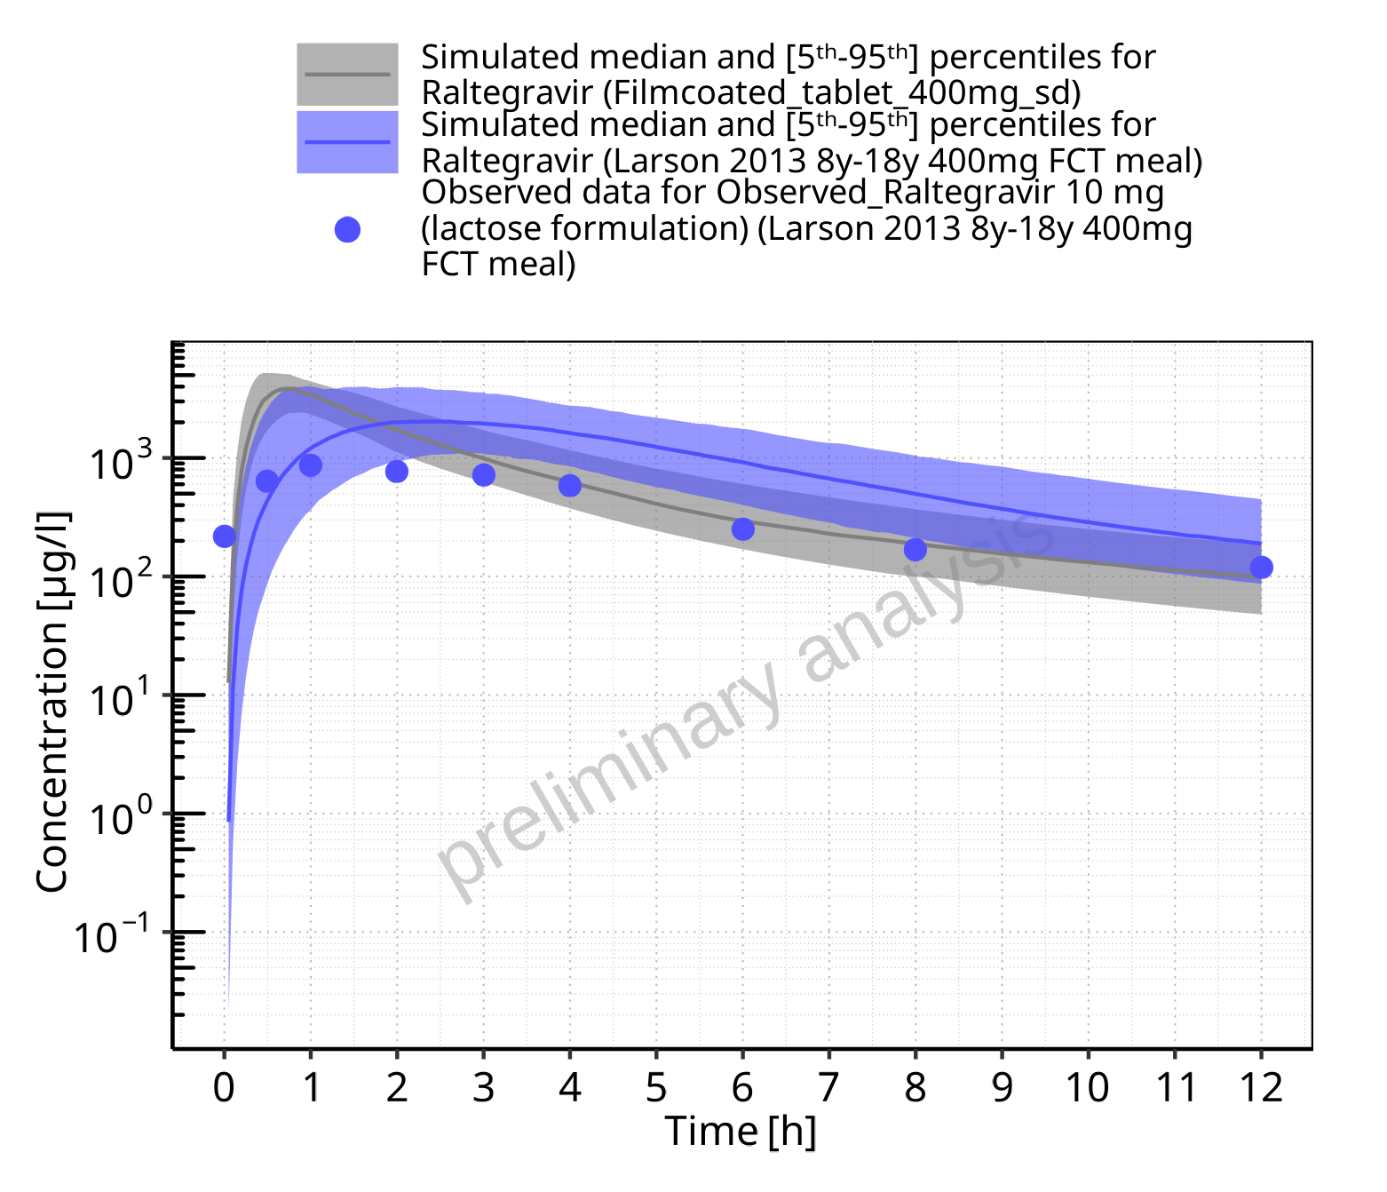

**Figure 3-10: Time profiles for Larson 2013 8y-18y 400mg FCT meal. Data source: Data/Raltegravir_PK.txt. Time profiles are plotted in a logarithmic scale.**

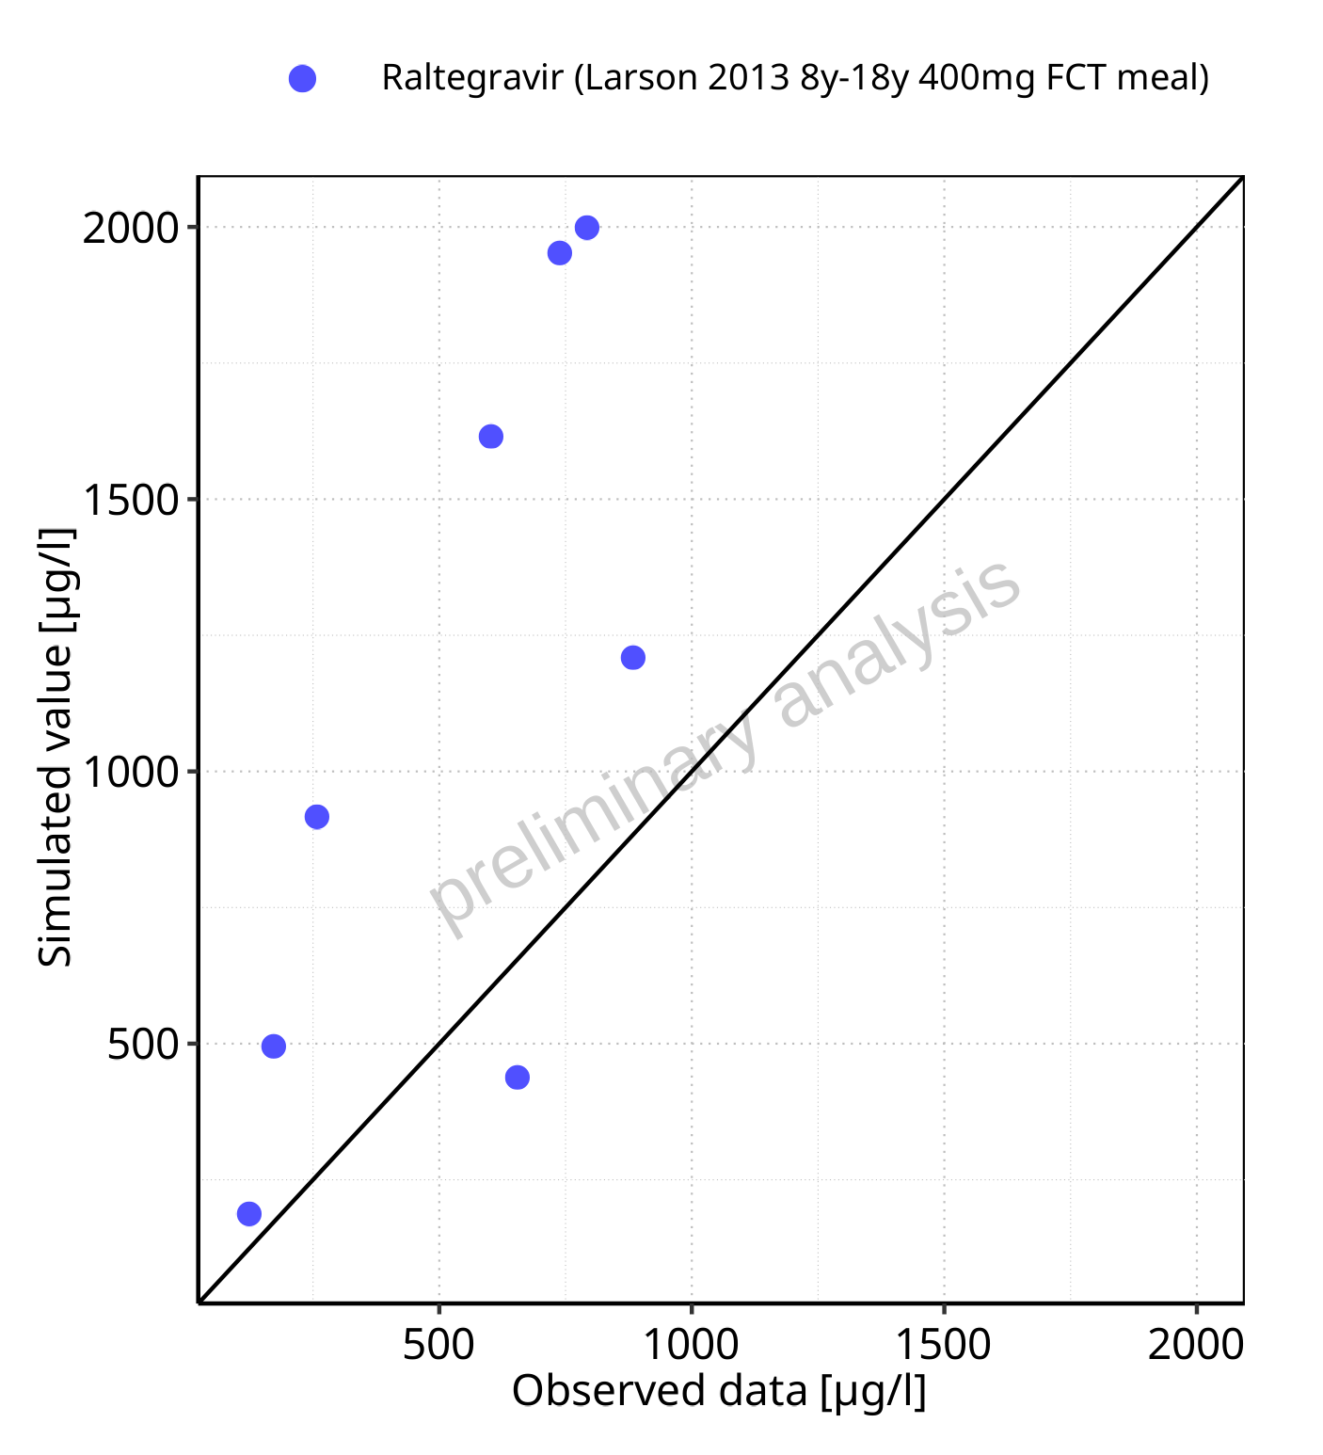

**Figure 3-11: Predicted (median) vs observed for Larson 2013 8y-18y 400mg FCT meal. Data source: Data/Raltegravir_PK.txt. Predictions and observations are plotted in a linear scale.**



**Figure 3-12: Predicted (median) vs observed for Larson 2013 8y-18y 400mg FCT meal. Data source: Data/Raltegravir_PK.txt. Predictions and observations are plotted in a logarithmic scale.**

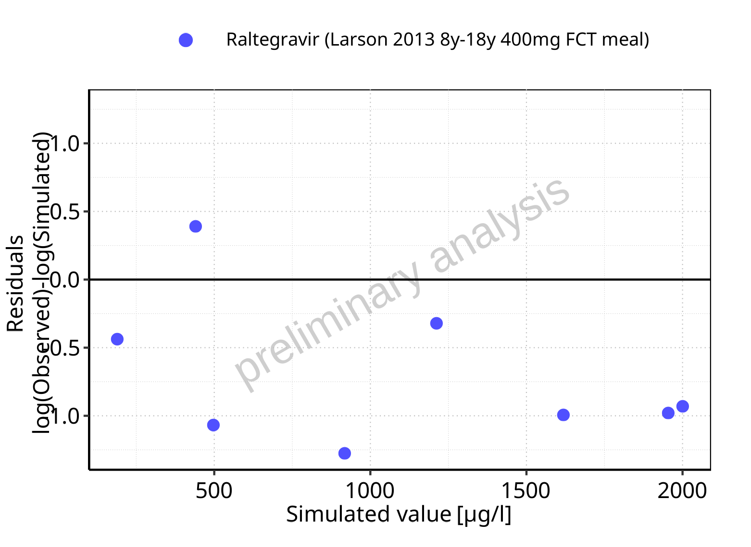

**Figure 3-13: Logarithmic residuals vs predicted (median) values for Larson 2013 8y-18y 400mg FCT meal. Data source: Data/Raltegravir_PK.txt.**

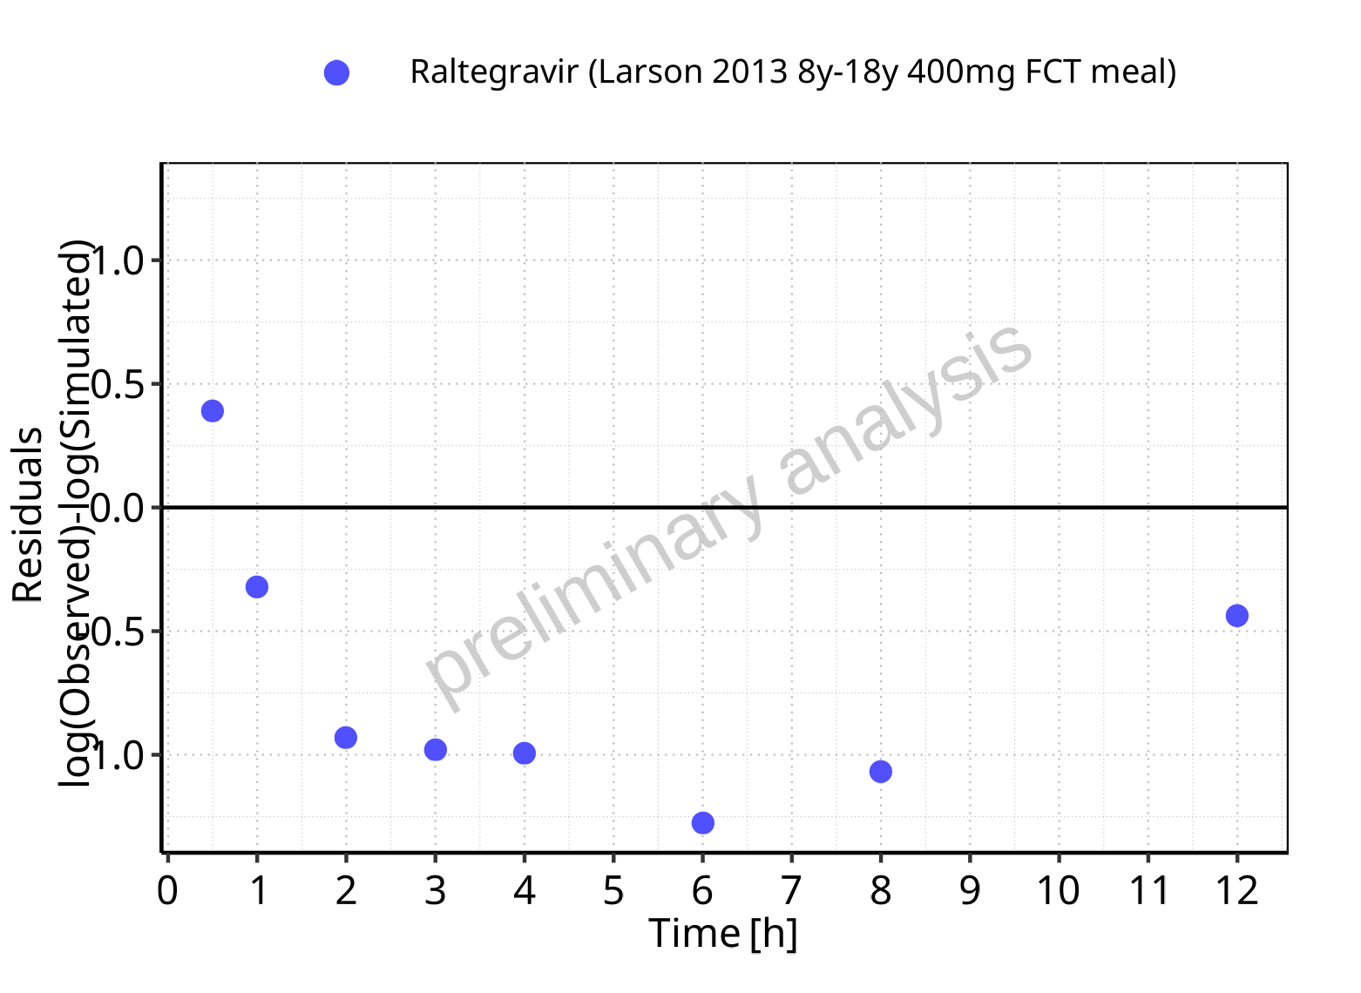

**Figure 3-14: Logarithmic residuals vs time values for Larson 2013 8y-18y 400mg FCT meal. Data source: Data/Raltegravir_PK.txt.**

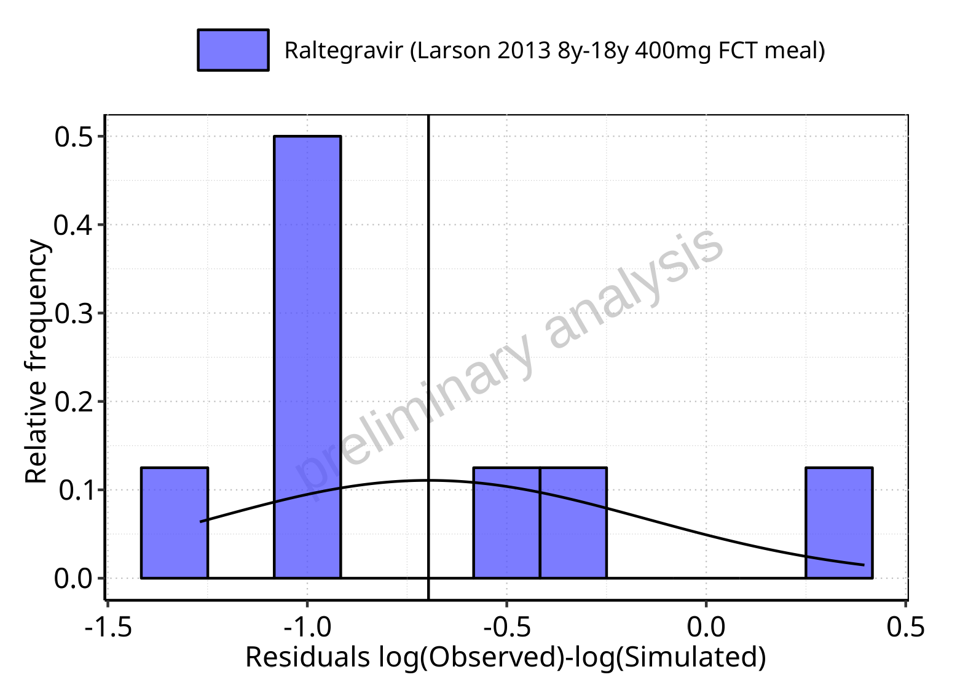

**Figure 3-15: Logarithmic residuals distribution (stacked) for Larson 2013 8y-18y 400mg FCT meal. Data source: Data/Raltegravir_PK.txt.**

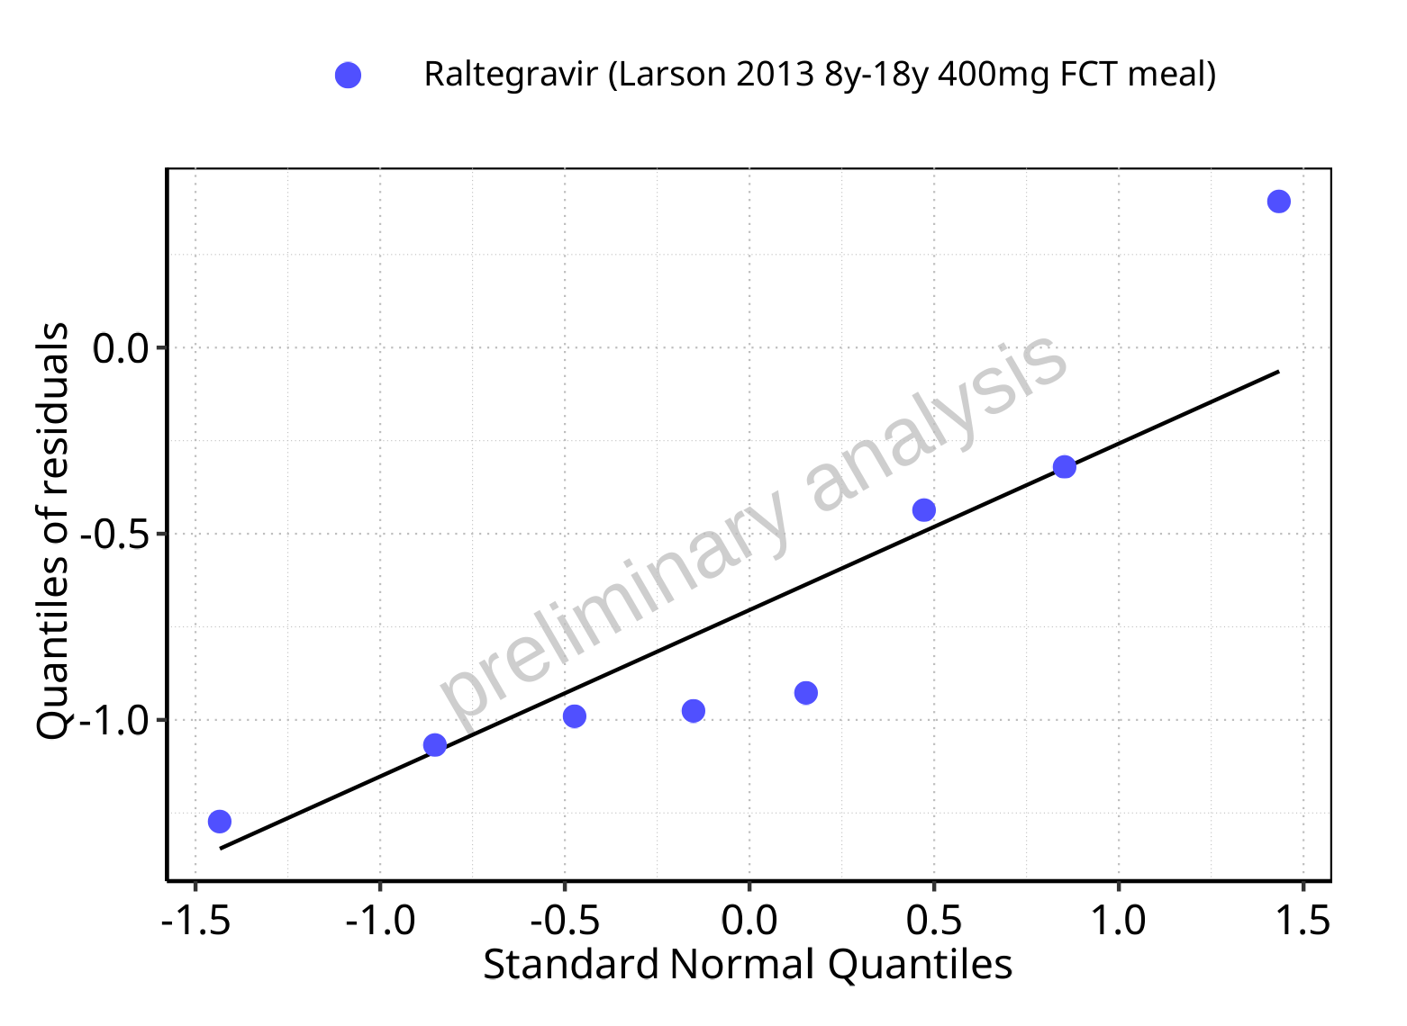

**Figure 3-16: Logarithmic residuals for Larson 2013 8y-18y 400mg FCT meal as quantile-quantile plot. Data source: Data/Raltegravir_PK.txt.**

## Residuals across all simulations

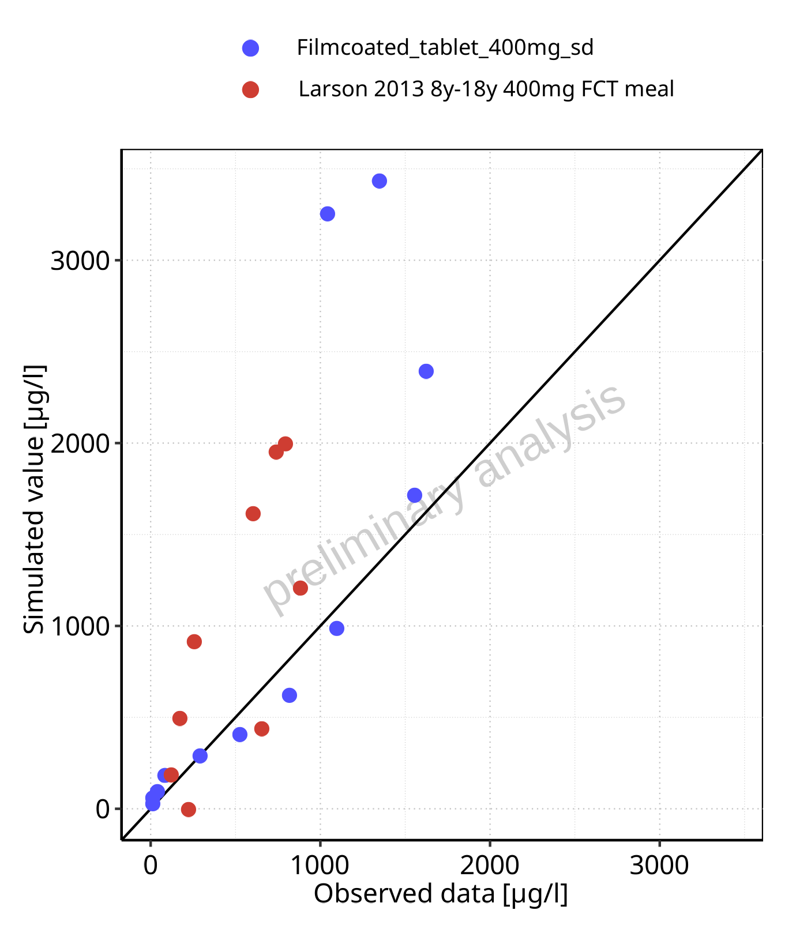

**Figure 3-17: Predicted vs observed for Raltegravir across Filmcoated_tablet_400mg_sd, Larson 2013 8y-18y 400mg FCT meal. Predictions and observations are plotted in a linear scale.**

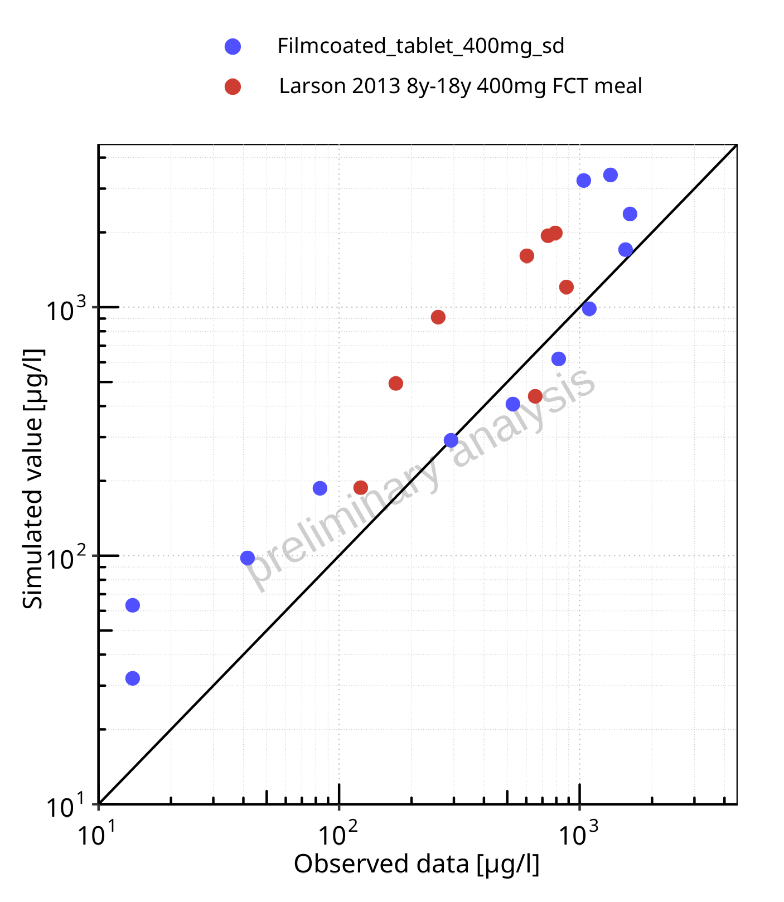

**Figure 3-18: Predicted vs observed for Raltegravir across Filmcoated_tablet_400mg_sd, Larson 2013 8y-18y 400mg FCT meal. Predictions and observations are plotted in a logarithmic scale.**

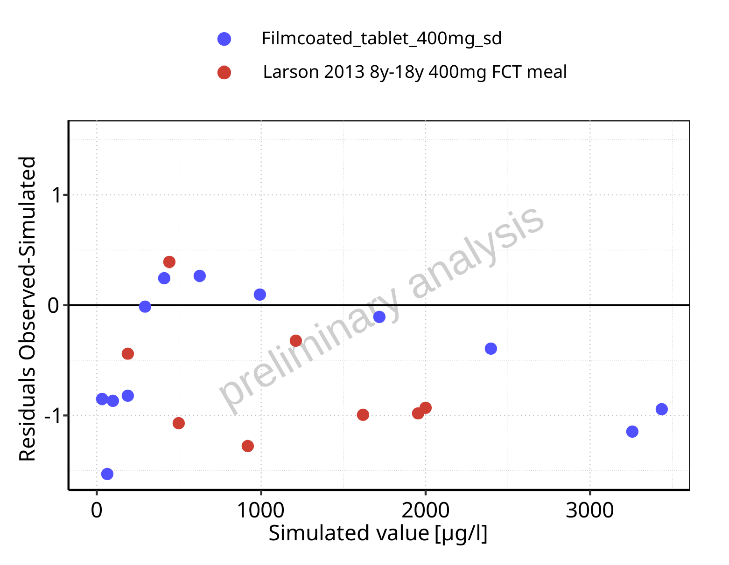

**Figure 3-19: Logarithmic residuals vs predicted values for Raltegravir across Filmcoated_tablet_400mg_sd, Larson 2013 8y-18y 400mg FCT meal.**

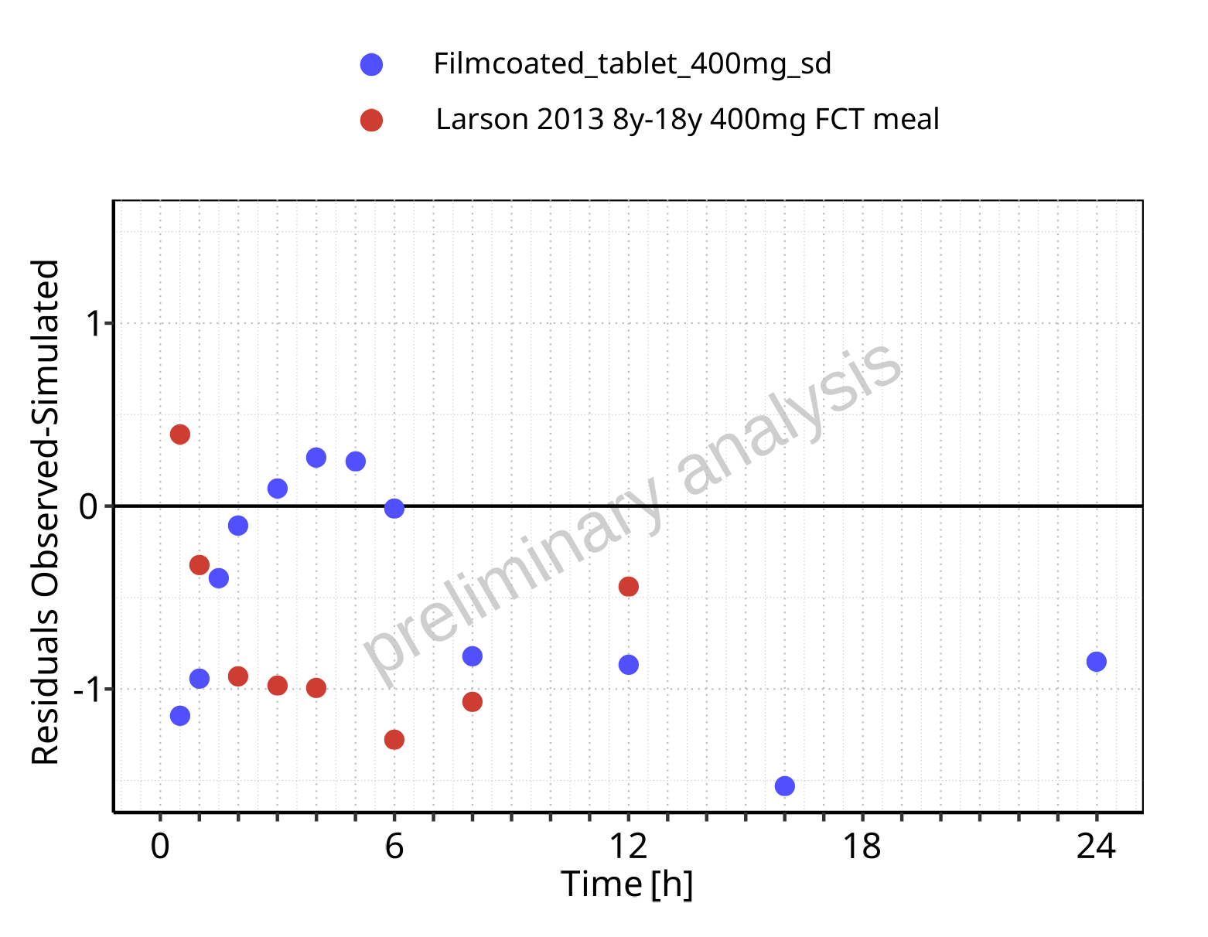

**Figure 3-20: Logarithmic residuals vs time values for Raltegravir across Filmcoated_tablet_400mg_sd, Larson 2013 8y-18y 400mg FCT meal.**

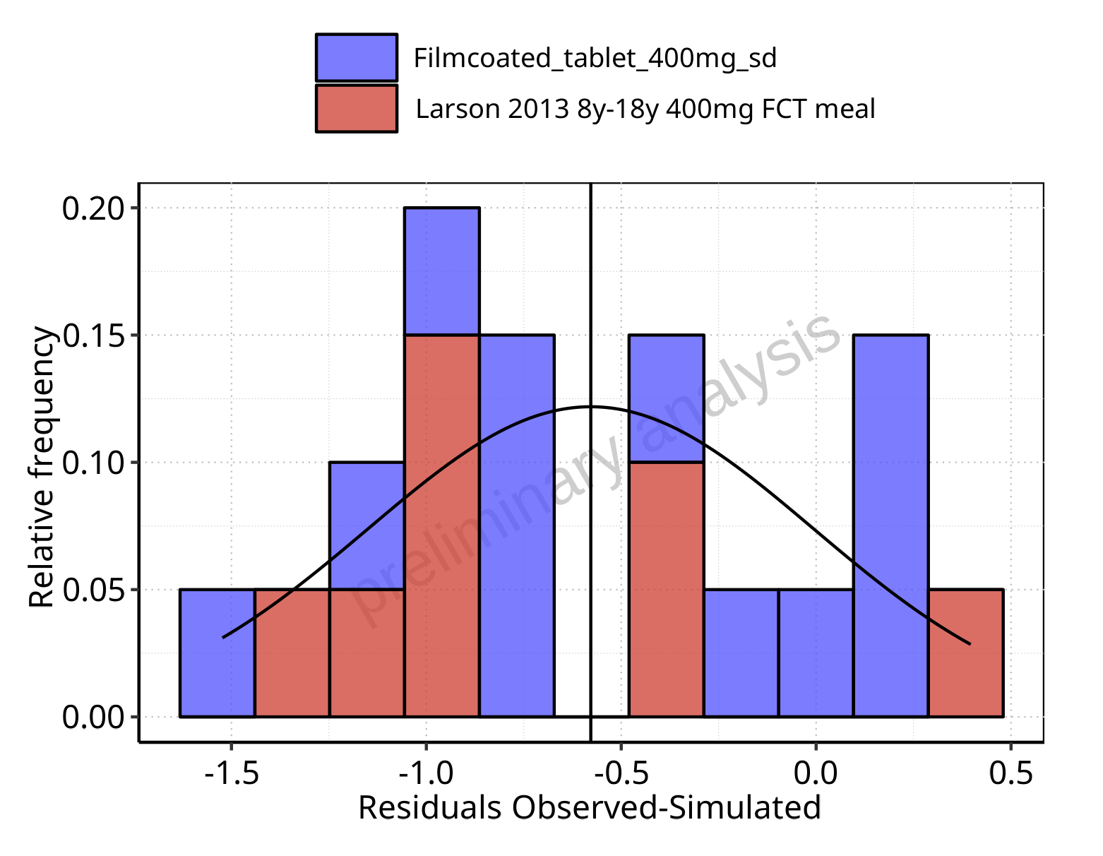

**Figure 3-21: Logarithmic residuals distribution (stacked) for Raltegravir across Filmcoated_tablet_400mg_sd, Larson 2013 8y-18y 400mg FCT meal.**

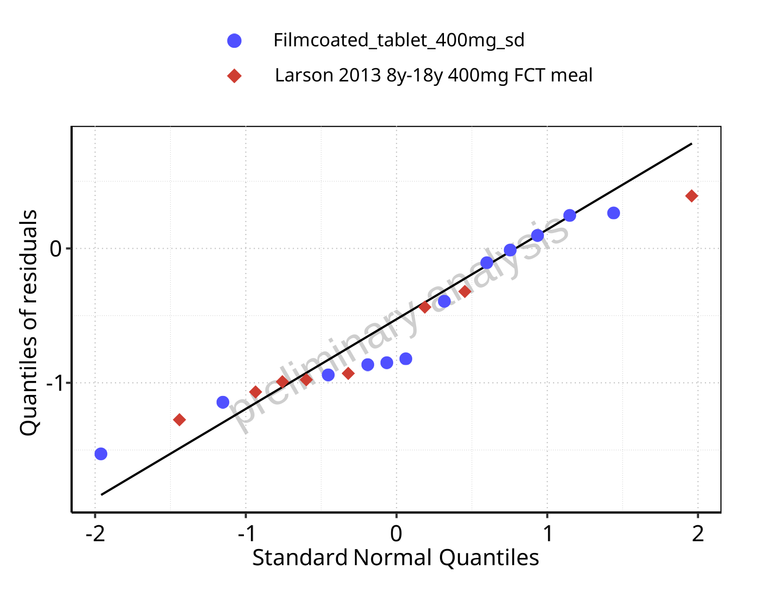

**Figure 3-22: Logarithmic residuals for Raltegravir across Filmcoated_tablet_400mg_sd, Larson 2013 8y-18y 400mg FCT meal as quantile-quantile plot.**

# Demography

## Age-dependence

### Height

#### For Larson 2013 8y-18y 400mg FCT meal

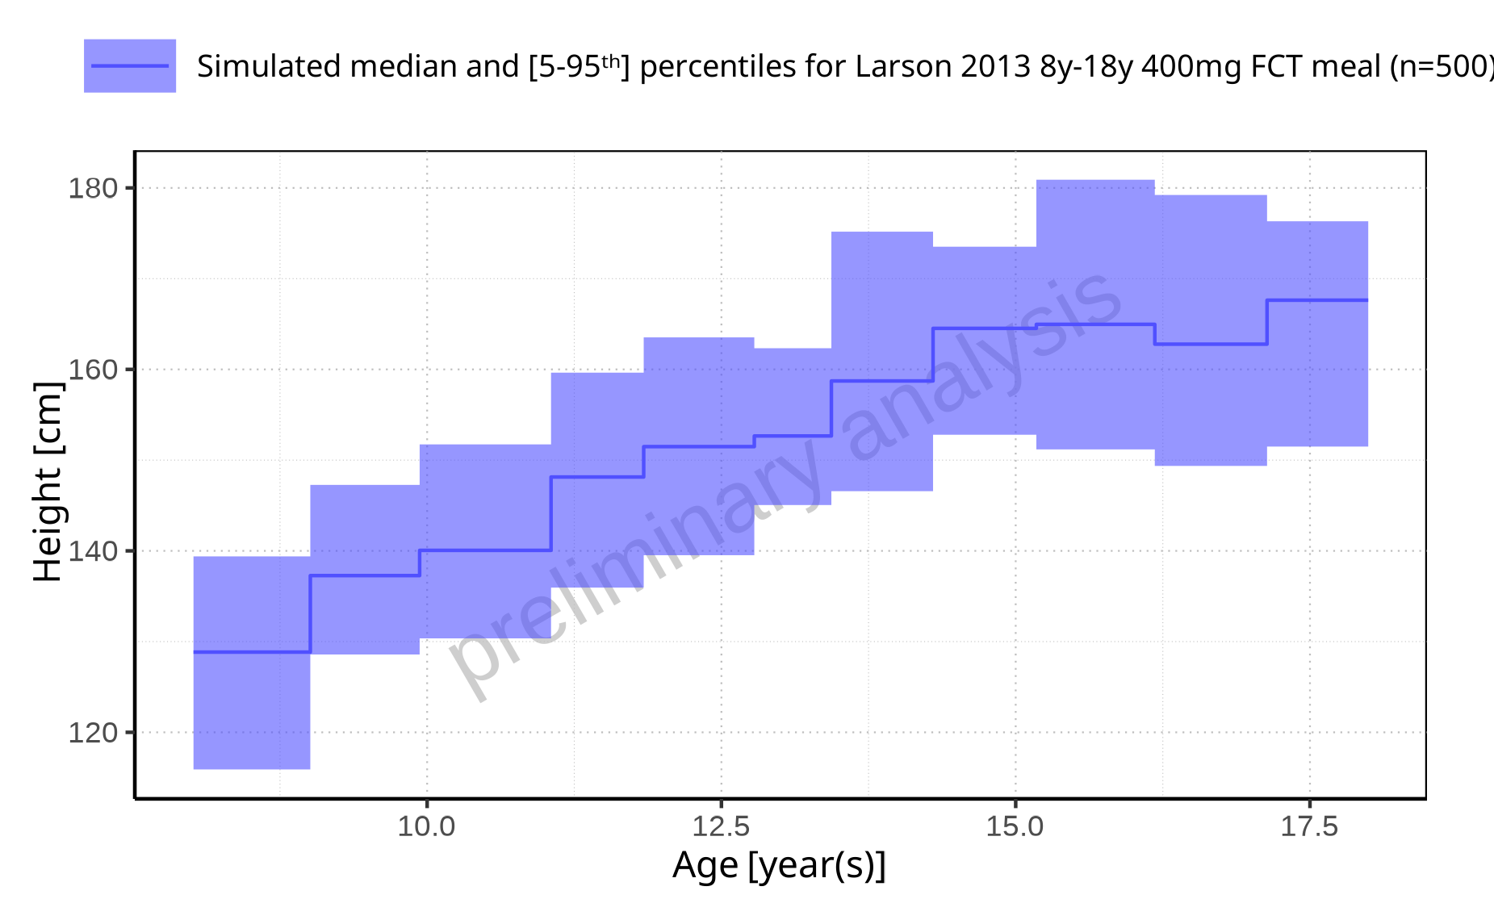

**Figure 4-1: Age-dependence of Height for Larson 2013 8y-18y 400mg FCT meal. Profiles are plotted in a linear scale**

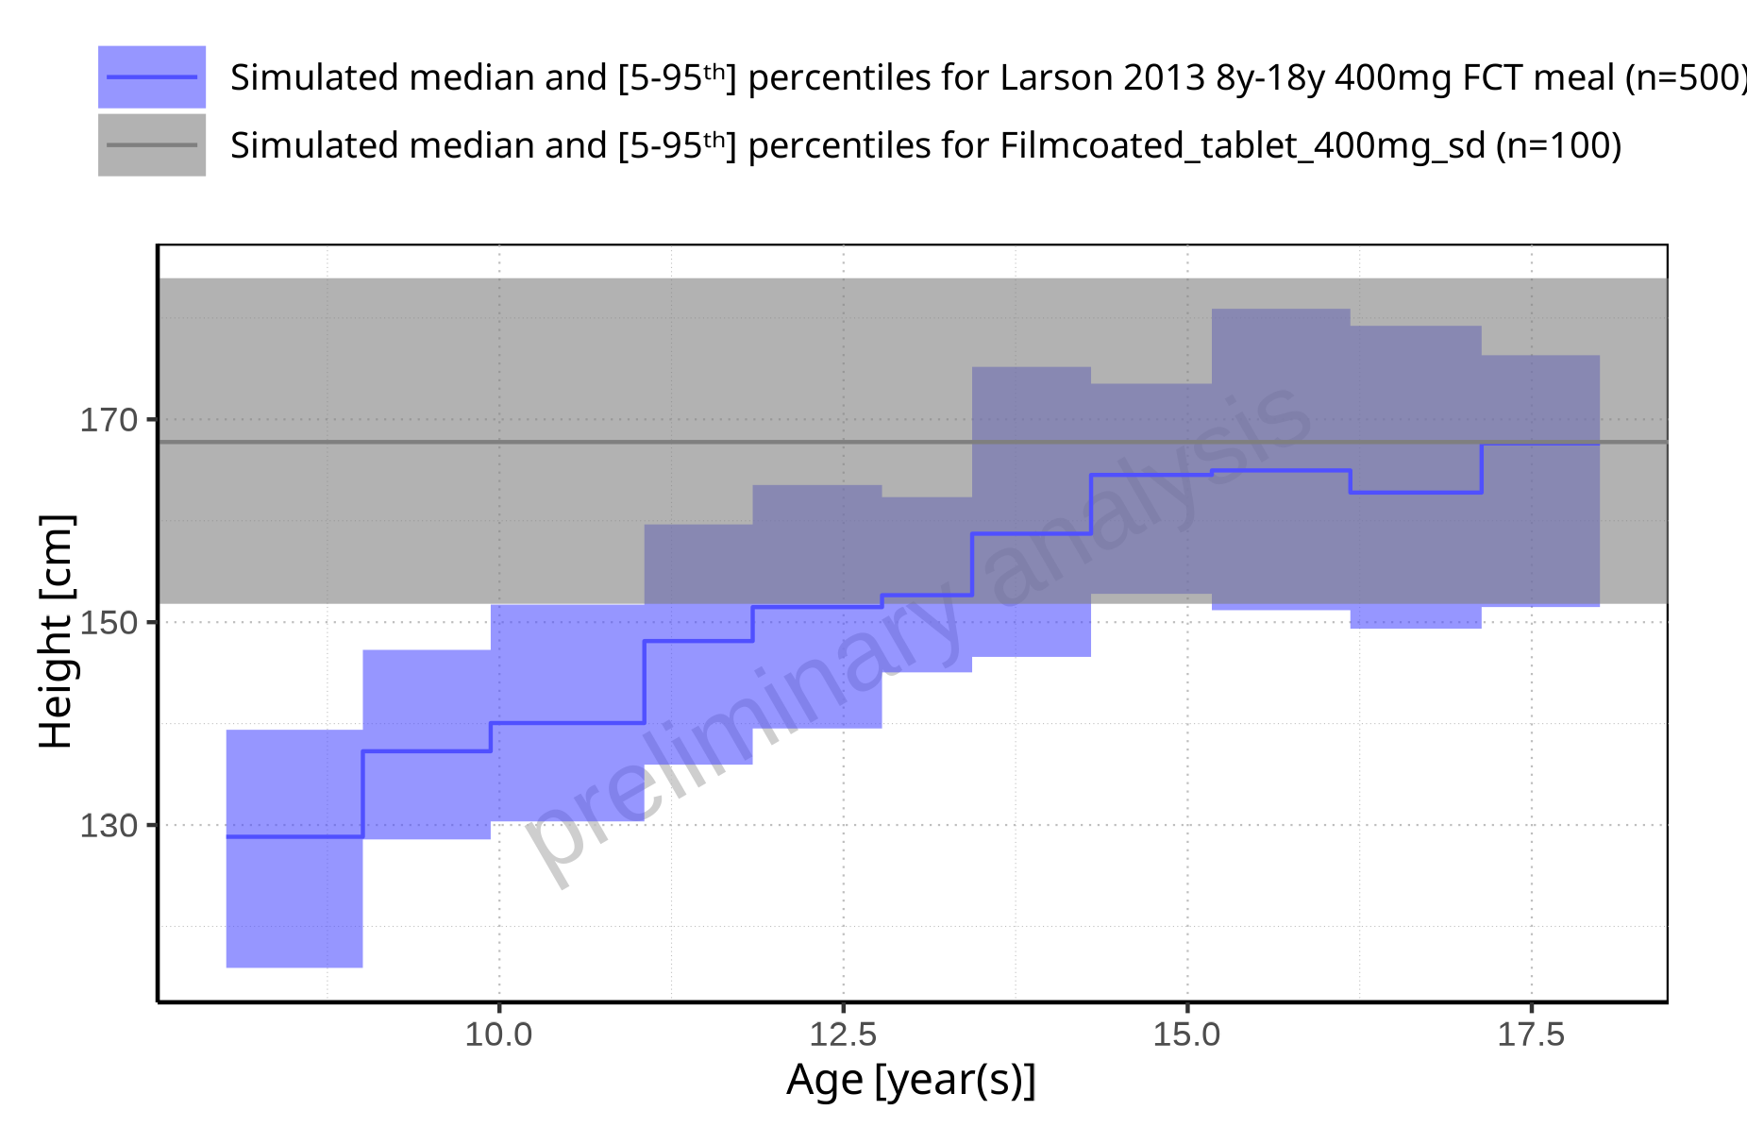

**Figure 4-2: Age-dependence of Height for Larson 2013 8y-18y 400mg FCT meal in comparison to Filmcoated_tablet_400mg_sd. Profiles are plotted in a linear scale**

#### For Filmcoated_tablet_400mg_sd

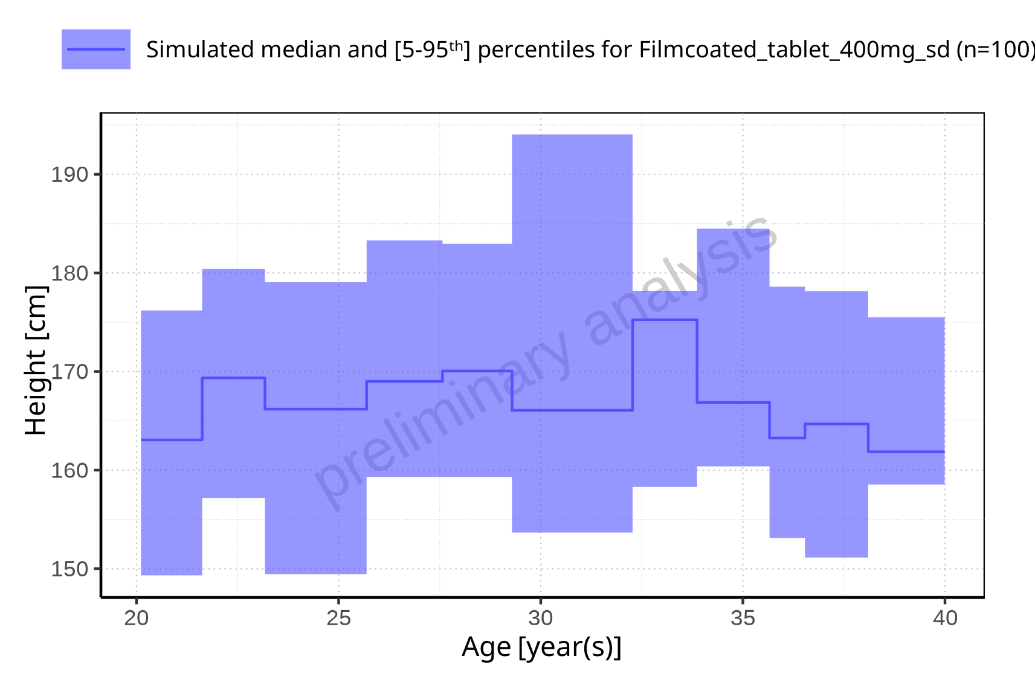

**Figure 4-3: Age-dependence of Height for Filmcoated_tablet_400mg_sd. Profiles are plotted in a linear scale**

### Weight

#### For Larson 2013 8y-18y 400mg FCT meal

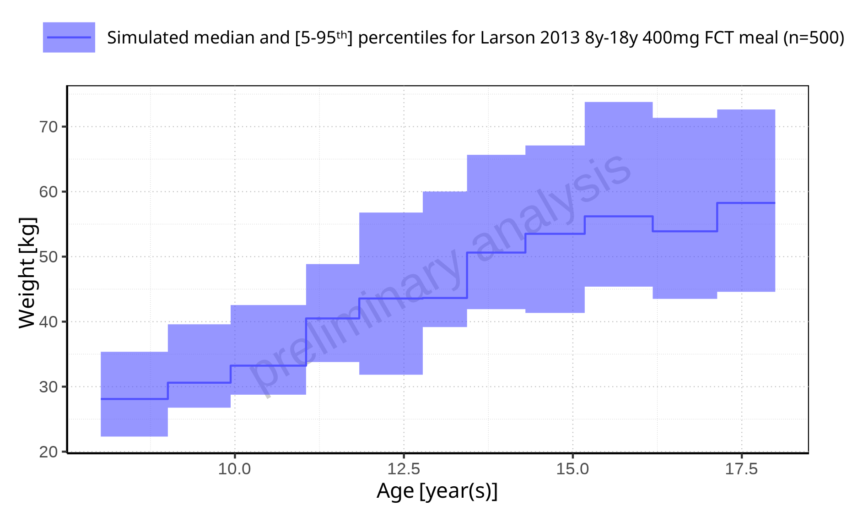

**Figure 4-4: Age-dependence of Weight for Larson 2013 8y-18y 400mg FCT meal. Profiles are plotted in a linear scale**

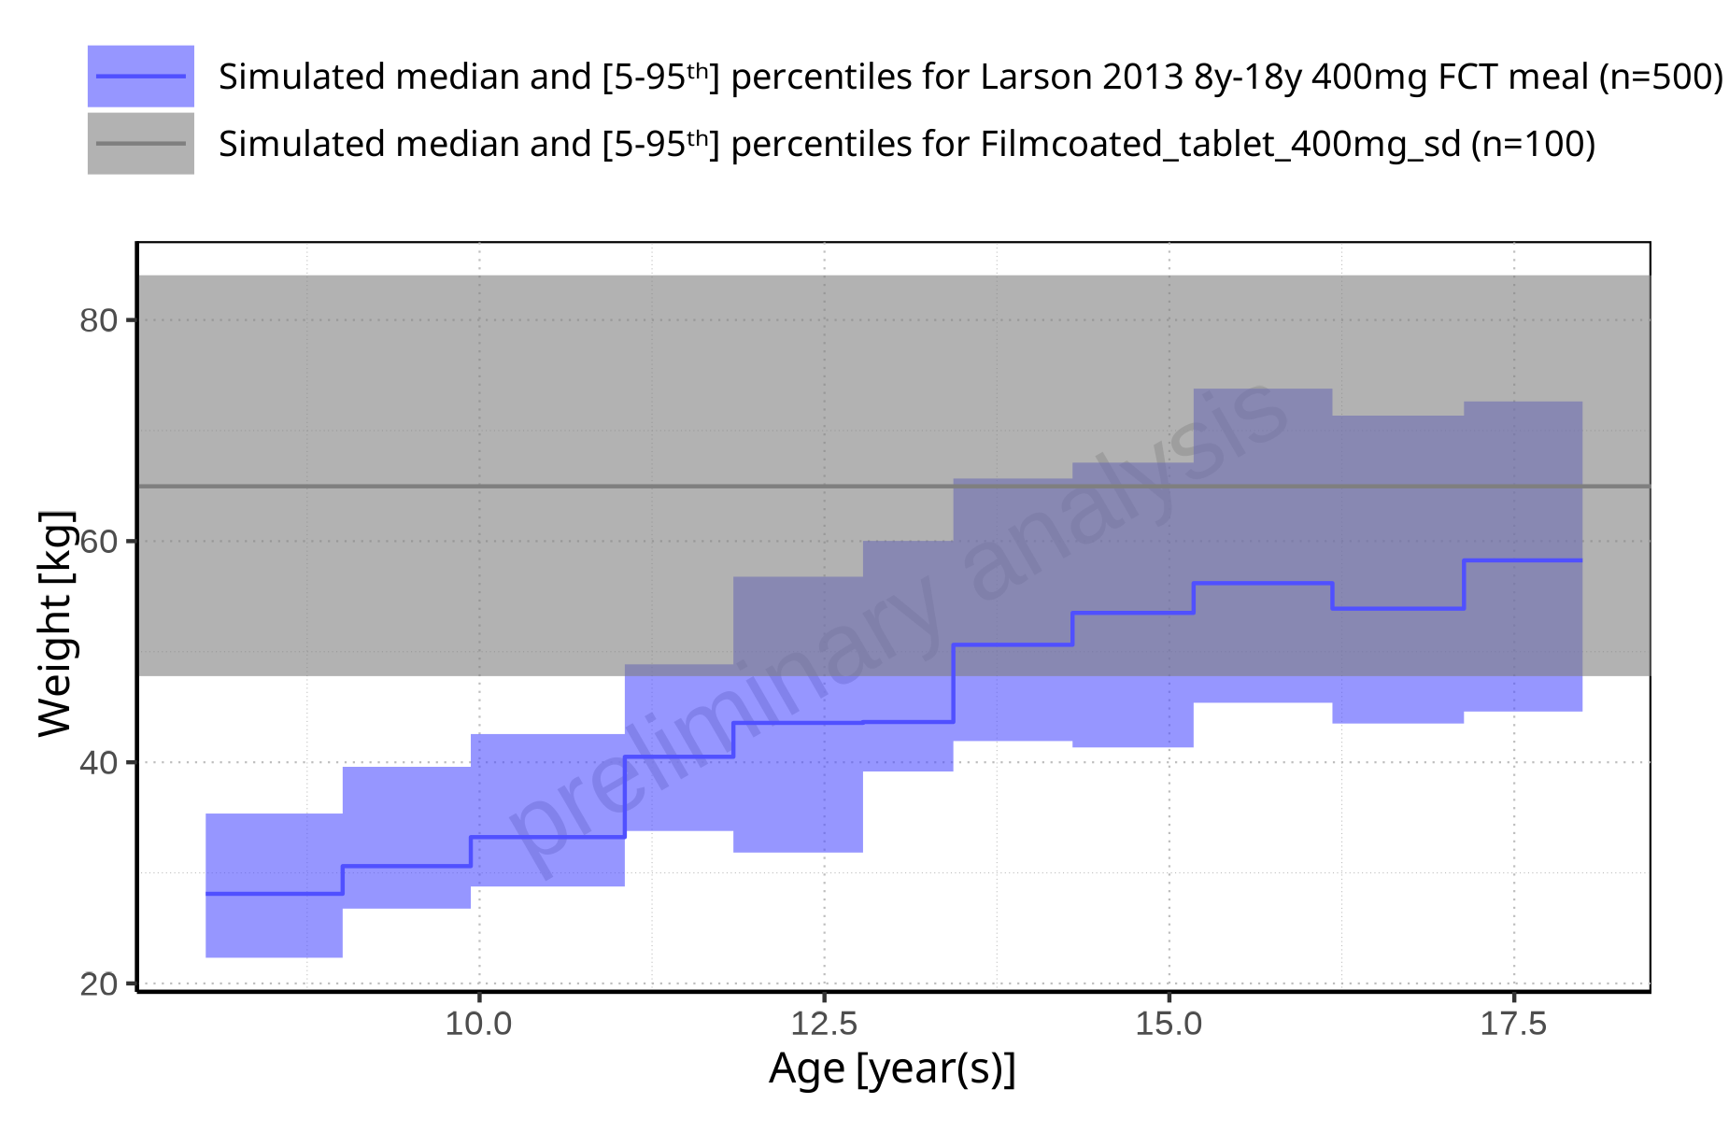

**Figure 4-5: Age-dependence of Weight for Larson 2013 8y-18y 400mg FCT meal in comparison to Filmcoated_tablet_400mg_sd. Profiles are plotted in a linear scale**

#### For Filmcoated_tablet_400mg_sd

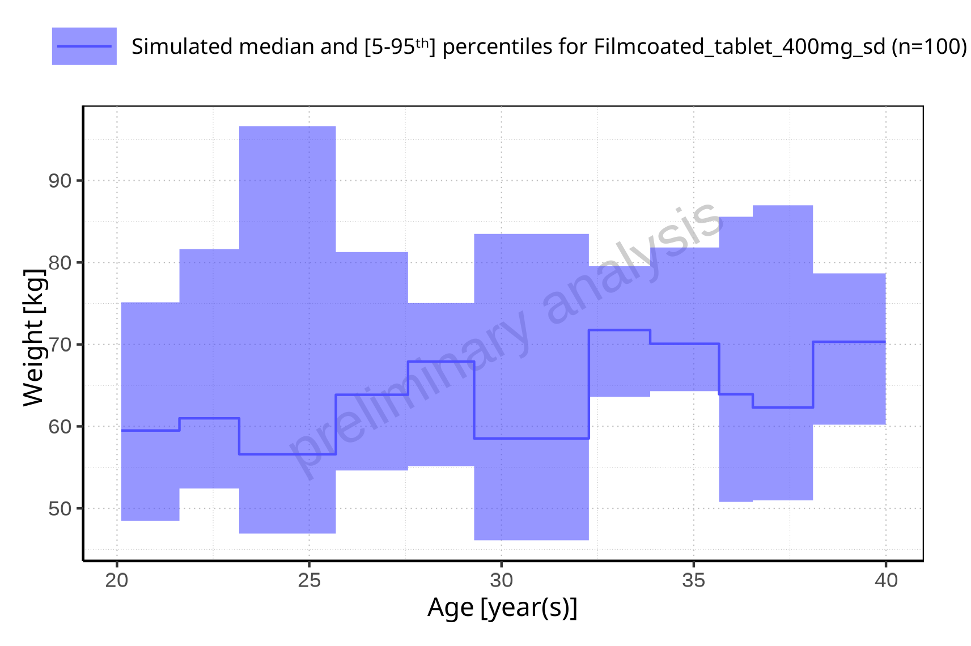

**Figure 4-6: Age-dependence of Weight for Filmcoated_tablet_400mg_sd. Profiles are plotted in a linear scale**

### BMI

#### For Larson 2013 8y-18y 400mg FCT meal

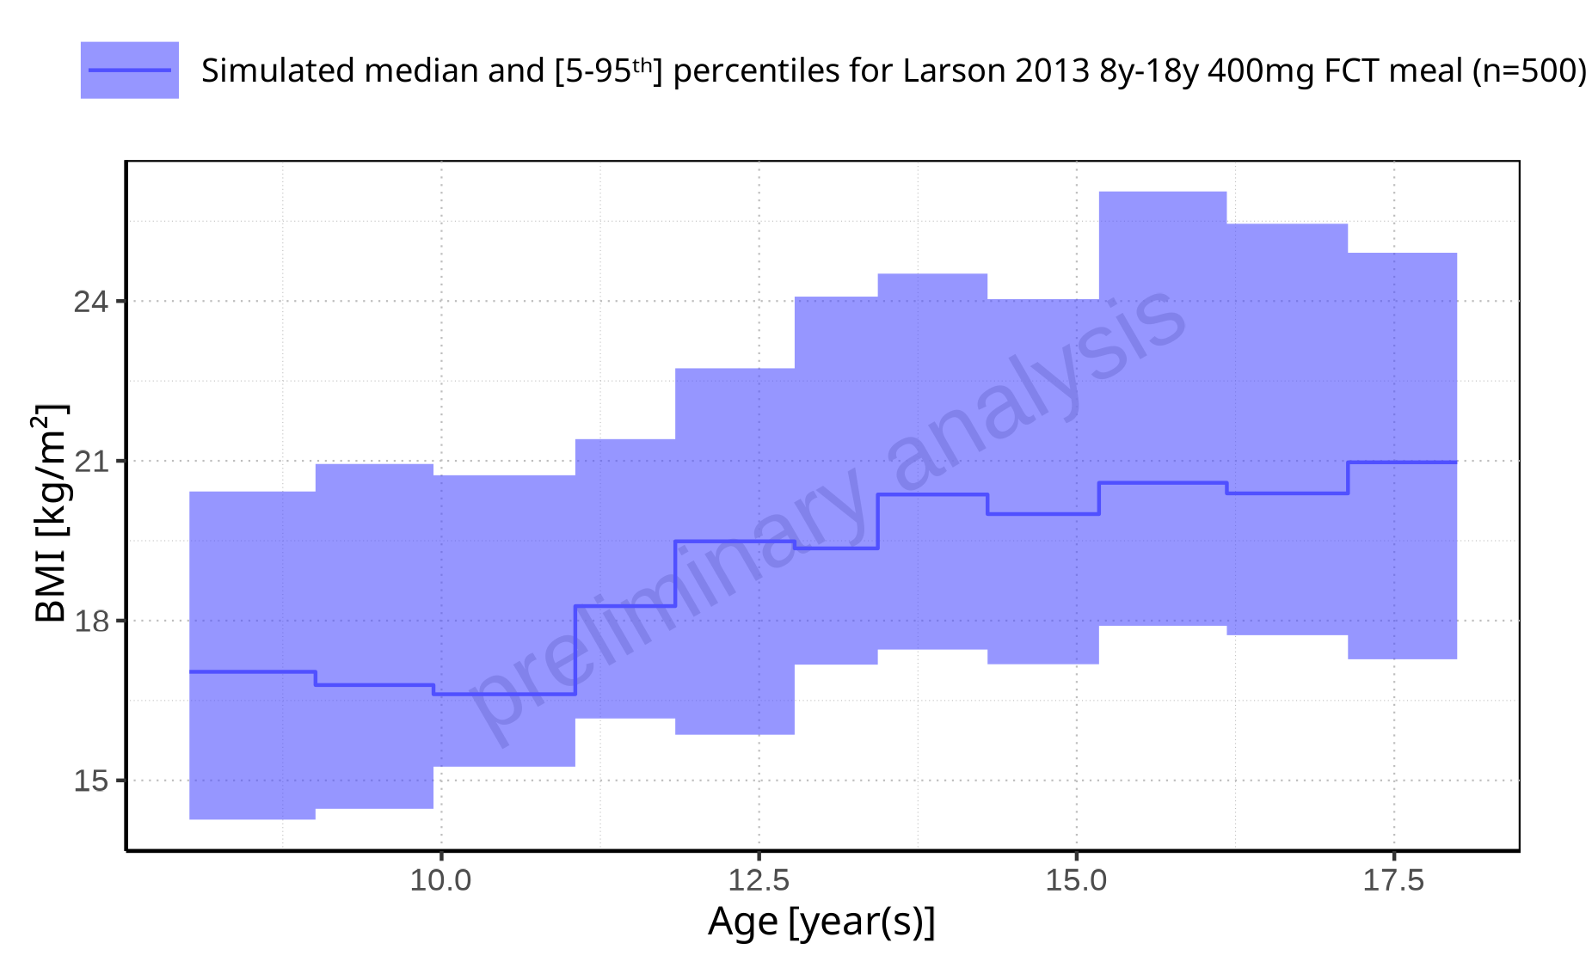

**Figure 4-7: Age-dependence of BMI for Larson 2013 8y-18y 400mg FCT meal. Profiles are plotted in a linear scale**

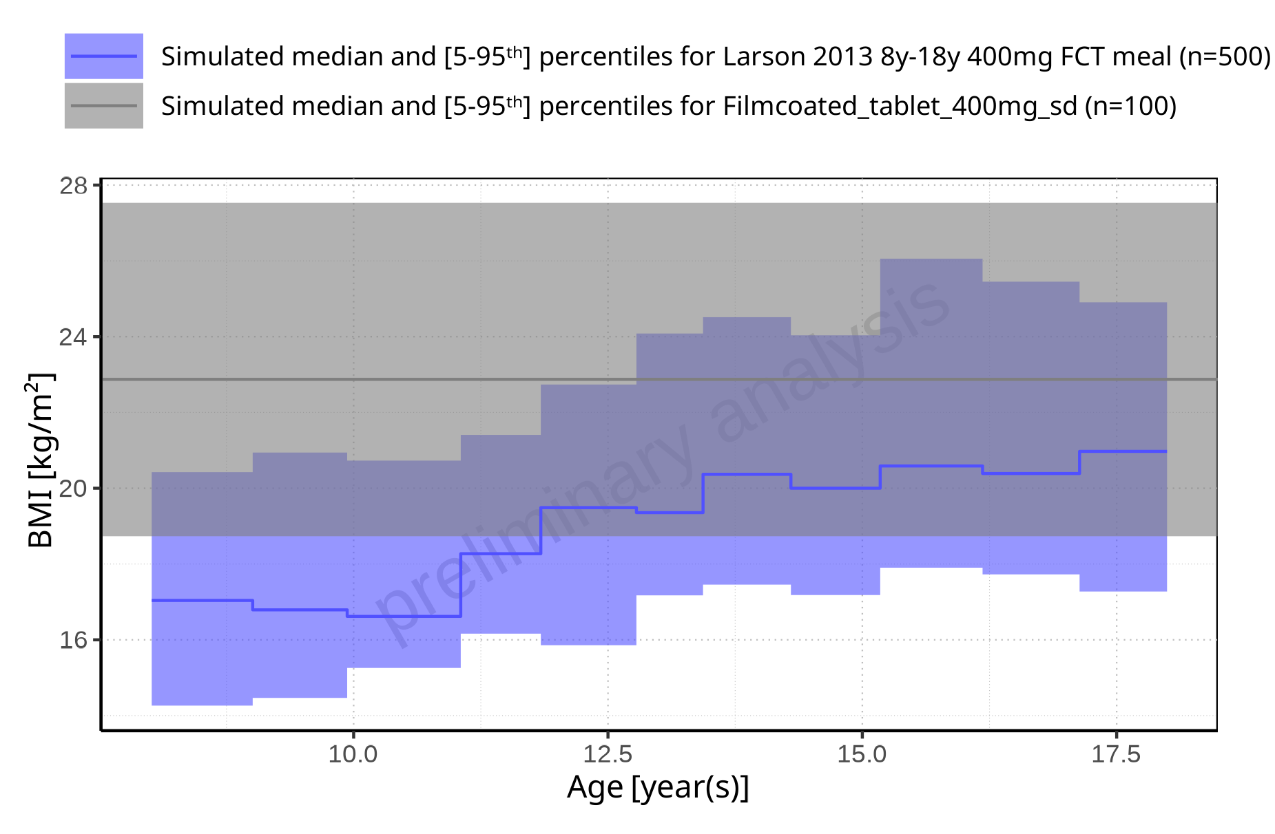

**Figure 4-8: Age-dependence of BMI for Larson 2013 8y-18y 400mg FCT meal in comparison to Filmcoated_tablet_400mg_sd. Profiles are plotted in a linear scale**

#### For Filmcoated_tablet_400mg_sd

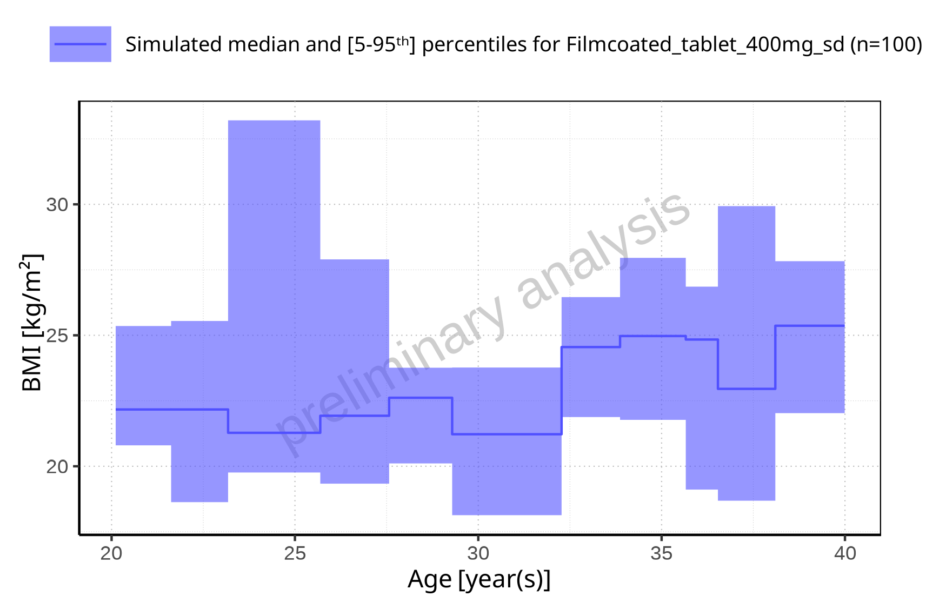

**Figure 4-9: Age-dependence of BMI for Filmcoated_tablet_400mg_sd. Profiles are plotted in a linear scale**